Chapter 10: The Toolkit Software: An Overview

The Toolkit includes software to support a database-driven community calendar. A community calendar is often a strong component of an on-line community presence. A calendar can be one of the most popular features of a site or it can make a site look very out of date. If you decide to take on a community calendar project, it is vital that you keep the calendar up-to-date; a persistently out-of-date calendar will turn users off to an entire community network.

In addition to the calendar, the Toolkit software includes an on-line forum tool, which supports on-line discussions between members of the community – such as a book club.

Many Web sites attempt to maintain a community calendar manually in HTML. Unless the staff dedicated to the community calendar is very conscientious, the calendar will almost certainly drift out of date or end up missing important information. Many users will look at an event calendar to judge the "activity level" of a site. If the calendar describes events that are two years old, there is a pretty good chance that the rest of the site is a little stale.

Dedicated staff can maintain a calendar by hand by simply editing HTML files, but it is very difficult to have a large amount of information that is up to date. By putting this information in a database, and viewing it based on the current date, it is far easier to keep the information current. It is also easier to have a group of people contribute to the calendar; each authorized person who has a new event to enter can quickly connect to the database, type the needed information into a few fields using a Web interface, and then resume unrelated tasks.

About the Software

The Community Toolkit includes software to provide an events calendar and on-line forum tool for the users of the software. The software is written to run on Windows NT 4.0 with Active Server Pages. The data is stored in Access databases so users can develop their own procedures for inserting data. The software is provided with full source code. It is intended as an example implementation for others to use and adapt. However it may be suitable for some organizations to use without any modifications.

The software is made up of several components:

- The Active Server Page (ASP) Code provides the ability to view and update calendars
- The Toolkit Administrator Tool controls the creating and deleting of calendars

The Toolkit CD-ROM and Web site each contain full documentation and several tutorials for the installation and operation of these components. This chapter is an overview of the process; the electronic documentation provides very complete, step-by-step instructions, with screen shots of each step along the way.

When this software was designed, its purpose was to serve as an example so sites could develop their own software. Out of the box, the software is sufficient to handle a reasonably wide variety of uses. Often the software includes configuration options to allow local customization without having to re-write code.

The ASP software comes packed in ZIP format. You must choose where you wish to extract the software – typically to C:\InetPub\wwwroot\Community\ –
and use an “unzip” utility to unpack the content to your server.

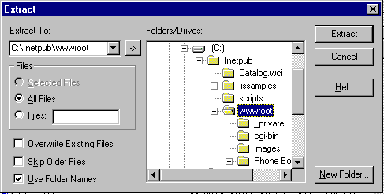

The Toolkit Administrator

The software is designed to allow a number of different databases to be hosted on the same server. Each database is separately administered. It is also possible to have multiple administrative entities that operate with various rights and privileges in a single shared database.

Running the Administrator
Since the system can support a number of different databases, the Toolkit Administrator is an application that is run on the server to create, and delete the different databases. Once a database is created, it is configured using the Web. At a minimum, the administrator tool must be run to create a single database. If the program is installed using the defaults, it can be found under Start | Programs | Community Toolkit | Administration.

These files this program operates on fall into roughly three categories:

- The database which stores the site information and the events
- A system DSN (Data Set Name) which allows the ASP code to access the database
- Several ASP files which are the entry points into the particular calendar

The basic functions in the program are Add Database and Delete Database. You can also use this tool to reset or unlock the administrator password as well.

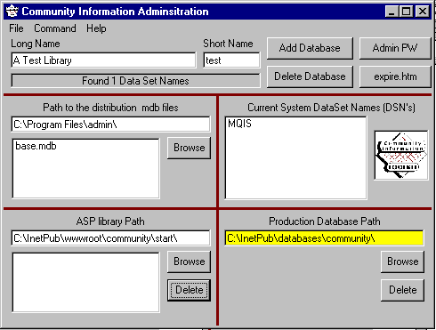

This program operates in three directories - in this section, we describe what should be found in each directory.

- Path to the distribution mdb files - This directory is created as part of the installation process. Its typical value is C:\Program Files\admin\. This directory contains many files but for the purposes of this tool, we only care about the file base.mdb. This is an access file with the "default" configuration for a database. During creation, a copy of this file is placed in the production database path. If you want to change the defaults for all new libraries, open this file in Access and carefully change the values.
- Production Database Path - This directory is where an Access database will be stored for each separate database. The short name is used to form the file name. The typical value for this directory is C:\InetPub\databases\community\. It is VERY important that this directory be backed up. If you move your site to a new server, this MDB contains all the information (events, forums, and configuration) for your site. The first time you add a database this directory may need to be created.
- ASP Library Path - This path is typically C:\InetPub\wwwroot\community\start\. This needs to be in the Web server space for the rest of the ASP files for the community toolkit. The start directory needs to be a subdirectory at the same level as the Admin and other directories. The name start can be anything that you want, but then the URLs will also change.

The Toolkit Administrator is used to create a new database on your server. When you complete the process, your server has the database infrastructure in place so that you can start creating calendar or forum entries. At completion you will see a screen that looks something like this:

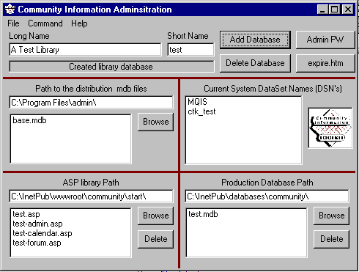

More detail can be found in the online documentation and on-line help for the tool.

On-Line Toolkit Administration
Once a database has been created, all of the remaining administration tasks are done on-line using the admin account created using the Administration tool described above. To get to the administration screen, you either enter the URL http://hostname/community/start/test.asp.

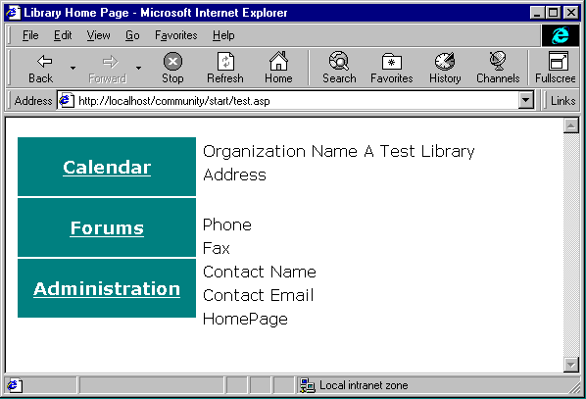

You will be brought to the starting page for the database and be presented with the choice to go into the calendar, forums, or administration. First we will explore administration.

At this screen you log into the system with the admin account and the password specified in the database creation step. You should change your passwords regularly. To prevent “attack guessing” assaults, your account will be locked if more than four bad password attempts occur in a row. The admin account can unlock any other account. If the admin account gets locked, you must physically visit the server and use the toolkit administration tool directly on the server console in order to re-enable Web access to administration.

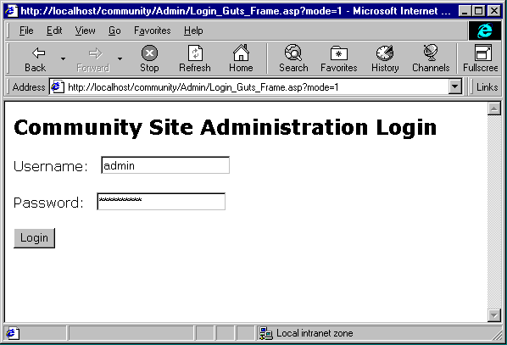
This is the starting page for the on-line administrator. You are presented with the different database areas which you can administer. A navigation bar across the top allows quick navigation back up to top level pages.

We will first look at Site Configuration. In Site Configuration, there are several areas that you can set:

- Basic site data such as organization name, address, phone, etc.
- Site look and feel settings such as copyright information, calendar views, site logos, and navigation options.
- Event control – the software either supports direct posting of events or a process which requires events to be approved before they are posted.
- Event indexing information such as audience type, meeting type and locally configured event field labels.
- Site security settings dealing with account lockouts and administration choices

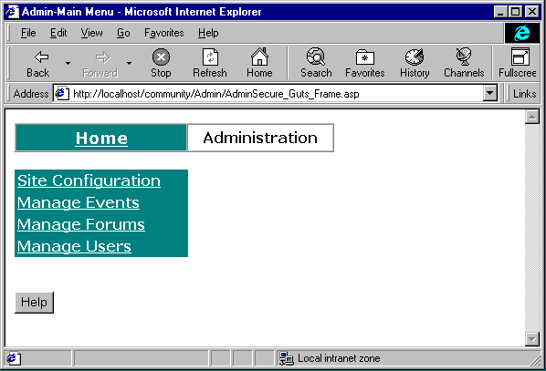

The form for site configuration is quite long. We will view it in parts. In the first part, you have the basic site information such as name, phone, etc.

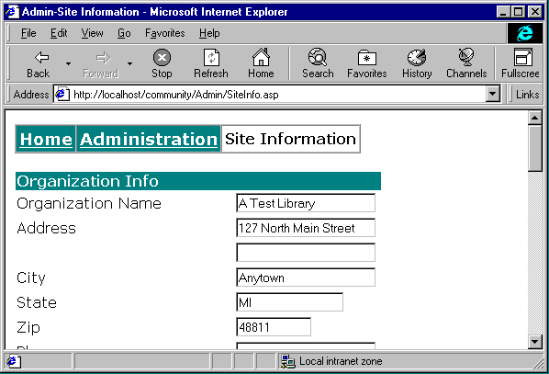

In this next site configuration screen, we continue with the basic information. We have the URL for the organization's home page, which is shown on the main start page. Later we will have a URL for the Home button on each calendar page.

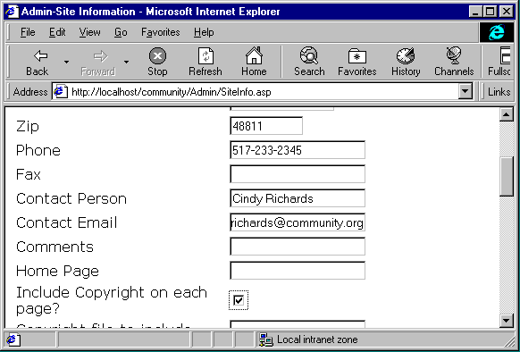

In the next screen, we can specify copyright information. By checking the copyright box and giving a path to a local file on the server, you can control the copyright statement on each page. The copyright file will be included directly into the output pages near the end. You can embed HTML information, such as a small image or a HREF in this file. Be careful not to introduce HTML syntax errors in the pages.

You also can specify a logo to be included automatically on each generated page. The logo must be a URL. You can use a local URL such as /community/images/logo.gif or you can use a fully qualified URL, such as:

http://smallville.org/community/images/logo.gif

On the following screen, you will also define basic features of your calendar. As we will see later, the calendar supports different “views” so that users can efficiently find the information they seek about upcoming events.

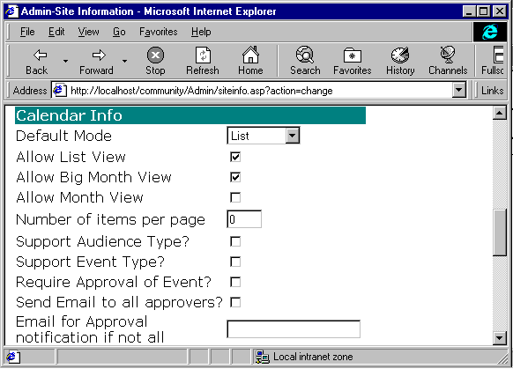

The next screen allows you to control remote access to the administrative tools.

- Only Allow Site Admin at local computer? Yes/No. If yes, all site administration must take place on the server.
- Only Allow User Admin at local computer? Yes/No. If yes, all user administration must take place on the server.
- Number of attempts before account is locked out: The number of failed login attempts before the account is locked.

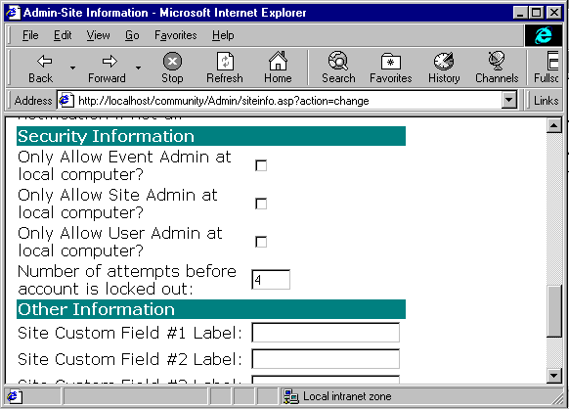

You can define up to three custom fields, whose meaning is unique to your site. You might populate these fields with any particular local information you choose.

User Administration

You will need to define users who are authorized to enter events and work with any forums you set up. Once you have defined a user, that person can enter the system and perform the administrative tasks you have authorized. At a later time, you can update the user’s record by revisiting the administrative screens. Click on “Manage Users” to do so.

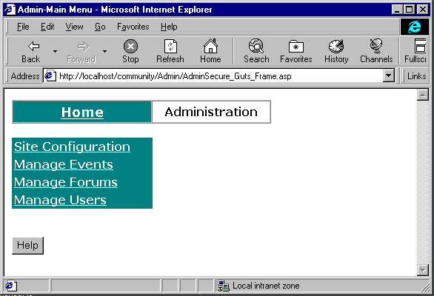

The following screen allows you to define new users.

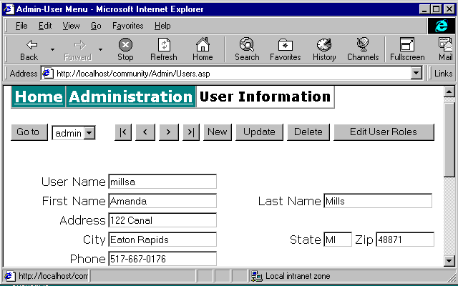

A given user can take on any of a number of different roles. Select “Edit Roles” to define which roles a user is authorized to assume.

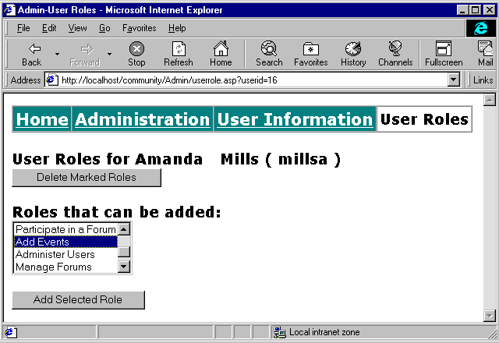

The list of roles is as follows:
- Add Events
- Approve Events
- Delete Events
- Edit Events
- Participate in a forum
- Moderate Forums
- Manage Forums
- Administer the Site
Multiple roles can be selected using the shift or control keys.

Entering Events
One of the basic activities is entering events into the calendar. You do not need to be an administrator to enter events into the calendar. The administrator can delegate the ability to enter events to another authorized user.

The interface and procedures change if you enable the event approval process. In this example, we will look at how you would use the software without the approval process. The on-line documentation shows how it changes with the event approval process in-place.

From the administration web menu, we select “Manage Events” when we want to add an event.

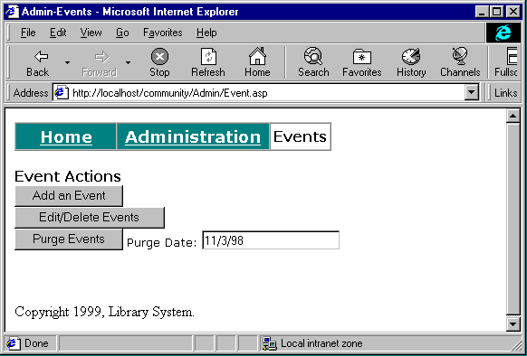

We select “Add an Event” and are taken to the event screen.

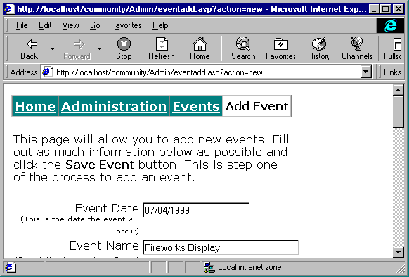

The software supports about 20 different fields for each event. Most are free form and optional. You can create an event with simply a date and title or they can be extremely complex using all of the fields which include URLs that point to maps, additional information, and photos. If you do not want to use a field, simply leave it blank. It will not be shown in any display.

Some of the interesting fields include:

- Publish date – Allows you to enter events which “appear” at a predefined date
- Informational URL – Allows you to give a URL for more information
- Photo and Map URL’s
- Audience type and Event type (if enabled)
- Locally defined fields such as language or GPS coordinates.

Again, the concept is to develop very flexible software that can handle a wide range of environments from very simple to somewhat complex.

Viewing Calendars
There are three basic views that can be combined to give your users the look and feel that you desire. By setting configuration values you can enable or disable any of the views. The views are:

- List View – The most powerful view – allows searching and easy navigation into the future and past
- Big Month View – Looks like a calendar – suitable for printing with a short description of each event
- Month View – Shows the calendar as a split screen with a small month image on the left and the events for a particular date on the right.

Users can switch between views (assuming that you allow them more than one view) using a drop down menu on each page. Each page also has a site configurable Home button that (optionally) appears on each page.

The following is the list view:

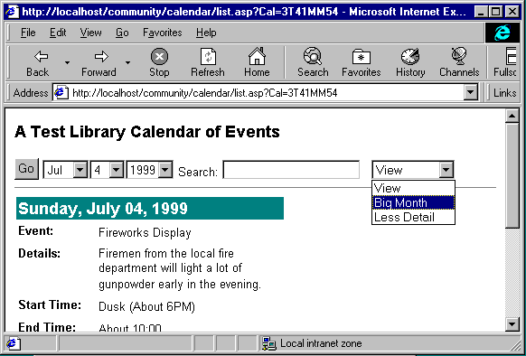

This list view does not include the Event Type or Audience Type and the events are shown with the “More Detail”. The user can quickly navigate to different dates using the drop-downs across the top. We can put in a search string in the field provided. If we had Event Type and/or Audience enabled, they would also appear at the top and be used as search options. The Go button is pressed to execute these requests. At the far left, you can switch views. The figure shows the user about to switch to the Big Month view.

This page looks forward from the starting date specified and continues searching for events until it finds a full page. If there are more events, the user is presented with Next 10 Events and Previous 10 Events buttons. This view has the advantage that it will look quite far into the future for events. It is the best view for searching. People can find a rodeo three years in the future with this page.

At the bottom, we have the "Home" button. Again, you can configure where this button goes. By default it goes to the database welcome screen. You can suppress the button completely or go to any URL that you like.

This is a screen shot of the “Big Month” view:

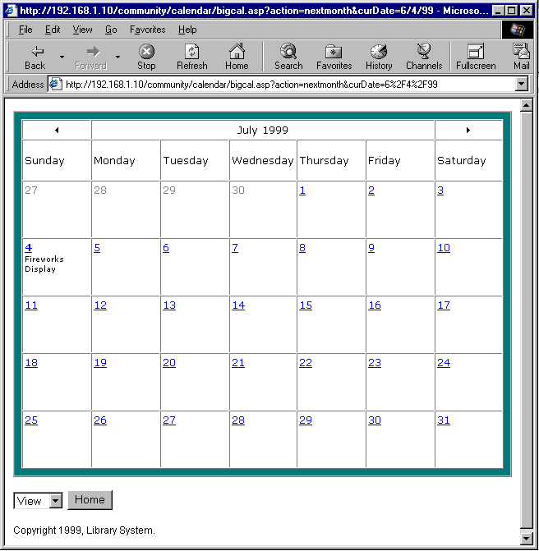

This view is best suited for view on a larger monitor and/or for printing. Each of the days of the month is a hot link back to the list view starting at that particular day.

The final view is the Month view:

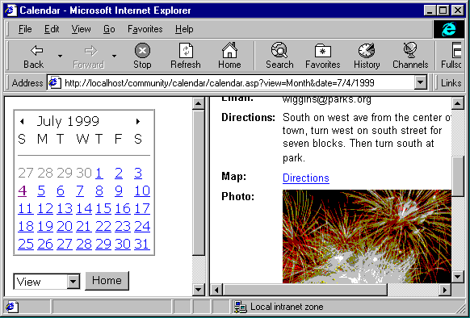

This view allows a navigation style similar to many personal productivity applications such as Microsoft Outlook.

Using the Administration configuration options, you can define a number of options related to your calendar’s global settings:

- Default Mode: The default mode the event calendar will appear for a user. Big Month, Month, or List.
- Allow List, BigMonth, Month View : You can use these to customize the types of views that your users can select. You need to select at least one and include the default view as one of those selected.
- Number of items per page: The number of event items displayed per page by default.
- Support Audience Type: Yes/No. Enable support for audience types.(e.g., children, families, seniors, etc.).
- Support Event Type: Yes/No. Enable support for event types. (e.g., meeting, concert, storytime, school, etc) Require Approval of Event: Yes/No. Require approval of new events. If this is not checked, events will appear as soon as they are submitted.
- Send Email to all approvers? Send an email message to ALL approvers when an event is awaiting approval.

The administrative panels allow you to vary the default appearance of the calendar in various ways. You’ll want to experiment with the options available to you. For instance, you can set up a split-screen view of the calendar:

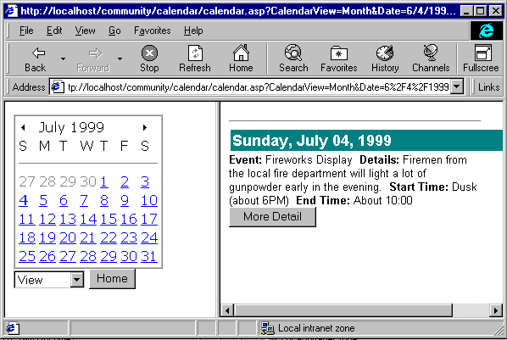

Each date on the calendar frame to the left is a hyperlink; the user can click it to see the events for that date.

Managing User Forums

To create or to manage a user forum, first log in under your Admin user ID. Then select Manage Forums as your menu option:

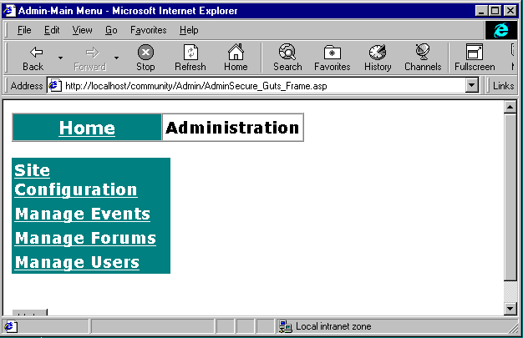

From the next menu you see, select Add Forum to create a new forum:

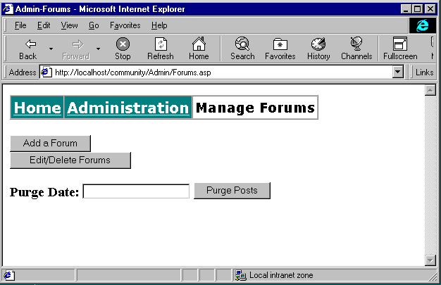

Next, specify the name and description of your new forum:

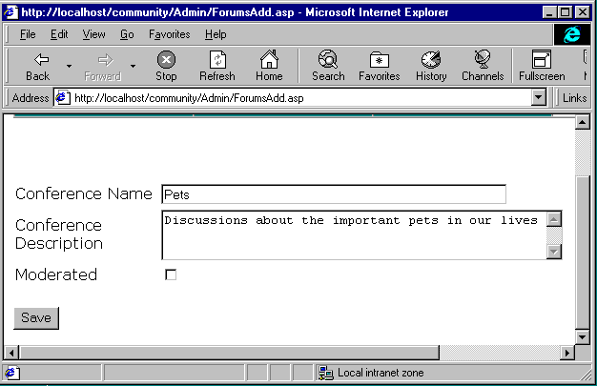

Let’s suppose we’ve created a new forum on pets.

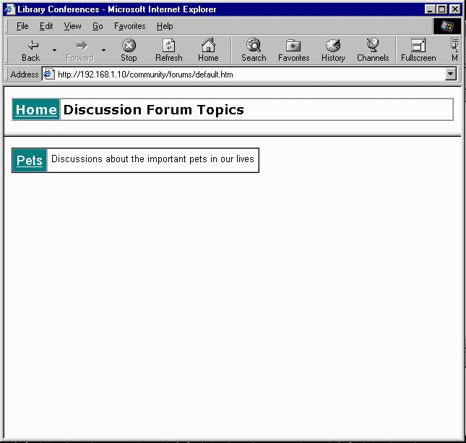

Our brand-new forum will have no entries. We can “seed” the discussion by posting a sample entry.

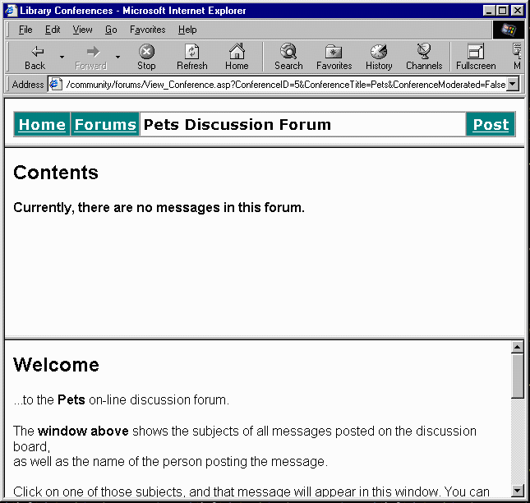

We can log in as a user authorized to post to the forum, and then post a “seed” message:

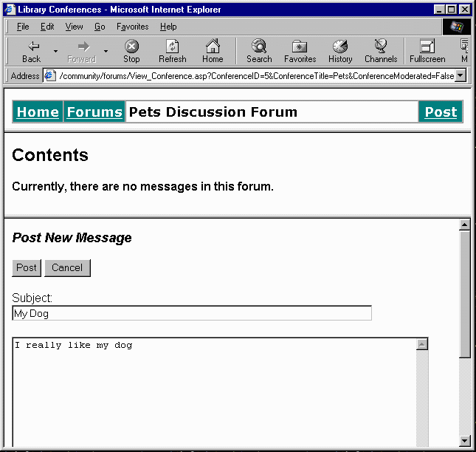

The forum requires very little administrative effort. Authorized users can post to the forum at will. Administrators can create new forums, or delete obsolete ones, as necessary.

Conclusion

The demonstration software included in the Toolkit is ready to use as delivered. The administration tool is intended to give most sites the flexibility they might need to customize the tools to meet unique local needs.

The Toolkit also includes the source code, or original programming, for the calendar, forum, and administrative components. Sites that wish to “tweak” or even substantially re-write these components are encouraged to do so.

