Chapter 12: Installing Windows NT & the Toolkit Software

Chapter 12 of this Guidebook is a “virtual chapter” provided in electronic form for those sites that intend to install Windows NT for their Web server and/or the Toolkit software. Because not all sites will choose to run their own servers or the Toolkit software, this content is omitted from the print edition.

The Toolkit Web site and CD-ROM provide the following:

- A detailed overview of installing Windows NT and Microsoft Internet Information Server (IIS) as a Web server environment.

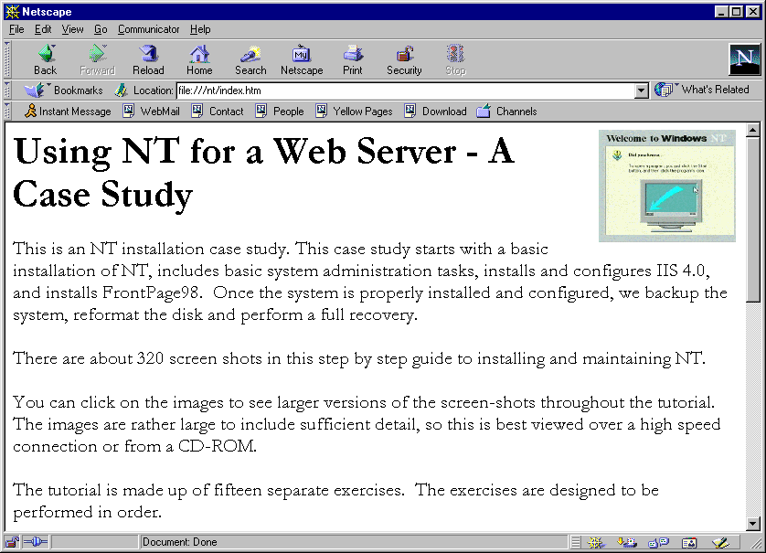

- A detailed overview of installing and administering the Toolkit software. (Chapter 10, which is provided in this printed Guidebook, is based in part on this tutorial.)

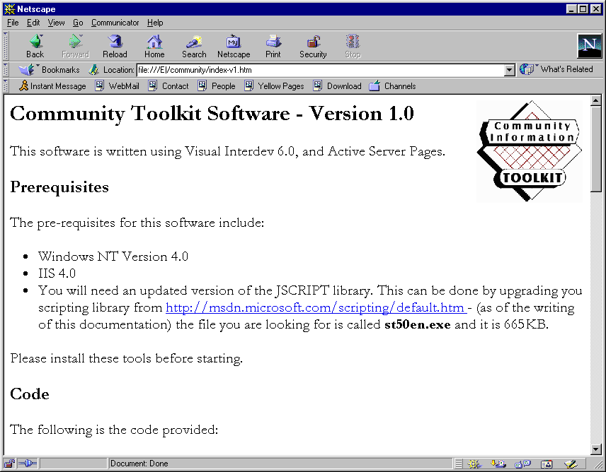

Both are presented in tutorial form, with extremely detailed, step-by-step instructions, including screen shots of what you will see on your server each step along the way. These tutorials are presented in HTML format and are suitable for printing for offline reading. Or, you may wish to bring up the tutorials on one computer and follow along as you do your installation. In all, over 100 pages of content are provided. See the Software section of the CD-ROM or Toolkit Web site for these tutorials.

