Chapter 2: Key Decisions

This chapter provides an overview of the main decision points you face as you undertake a new community information networking project. Chapter 11, Best Practices in Community Networking, offers a much more detailed examination of the issues involved, including hyperlinks to sites that exemplify the points under discussion. Chapter 11 offers comprehensive discussion of important considerations such as raising funds, building your content team, forging partnerships, and weaving your network into the fabric of the community – with real-world examples. Use this chapter as a “20,000 foot” overview of the topic; read Chapter 11 before you launch into your project in earnest.

There are several fundamental decisions you will need to make before you begin your foray into community networking.

- What is the scope of the project?
- Of the four cornerstones of community networking – Access, Information, Communication, and Commerce – which will you embrace?
- What is the shelf life of the content you’ll be putting online? That is, is the content more or less timeless in nature, or will it quickly become dated?
- Who will manage the project?
- Who will serve as content providers? Are there existing CI efforts with whom you can partner?
- What server technology will you use? Will you run your own server, or arrange to use space on someone else’s server?
- What computers and other content creation equipment will your content providers need?
- What authoring tools will you and your content providers use?
- Will your site include a live connection to a database that you maintain?
- What multimedia plugins will you require your users to install?
- What will you do to ensure compliance with copyright? Will you provide an official content policy?
- What mechanisms will you offer for feedback and group discussion?
- How will you promote your site?

If you take the time to think through these questions before you launch your project, your odds of success are much higher. Let’s consider each of these questions in a little more detail. After our discussion of each of these issues, we’ll conclude the chapter by considering how to use Internet tools to foster communications among your team members.

What is the Scope of the Project?

A community information project can vary in scope from the extremely broad to the extremely narrow. You might undertake a project that seeks to document every aspect of life in your community; conversely, you might choose to take on only a particular slice of content. A broad site might cover community events, meeting minutes for governmental bodies, elections information, community history, directory of community services, etc. A narrow site might take on only one of these topics – or even a narrow aspect of one of those topic areas.


If you’re going to take on a comprehensive perspective, you will want to take a realistic assessment of the amount of work required to compile and maintain the amount of content such a site implies – and ask whether the team you’re assembling will provide enough person-power to accomplish the task.

One way to magnify the horsepower dedicated to a comprehensive site is to partner with other agencies or groups, and divide the overarching site into smaller components – each of which is small enough so that each contributing group can handle the slice they’ve taken on.

Even in the case of a narrow topic area, you will still need to assess your goals for the site in terms of amount of content to be placed online. You may want to conduct a test to measure productivity. For instance, suppose you decide to digitize newspapers from 1880 to 1900. You may discover that there is a great deal of effort involved in scanning full-size newspaper pages and converting each page to a format that would be usable over the Web. Take the number of person hours it takes to do one single issue, and tally the number of person-hours available for conversion work in the next year. You may find that you will only get a fraction of the number of pages done in a year’s time than your dreams call for.

Having reached that conclusion, you might decide to scale back the project – for instance, you might choose to digitize only front pages above the fold, or pick one leading article from each day’s newspaper.

Another way to assess scope is to evaluate whether you want primarily to place original content on the Web yourself – or whether you want to be an organizing site, or portal, to other Web-based resources about your community. Public library CI sites may find the idea of being the community portal especially appealing.

Whether the scope is broad or narrow, it is far preferable to choose a scope of project that is realistically achievable with available staff and volunteer contributions. Many new Web publishing projects begin with lofty goals that can’t be achieved using the resources at hand.

Access, Information, Communication, and Commerce

This book, and the Toolkit in general, describe how to build a Community Information Network. By definition, information, or content, will be part of your project. But there are other components that many CI networks embrace:

Access: As this book goes to press, estimates are that between one-third and one-half of American homes have some form of Internet access. That number is expected to grow in coming years. Nonetheless, it tells us that one-half or more of American homes do not have Internet access. Although many people may have access at work, their ability to spend time participating in community networking on company time will be limited.

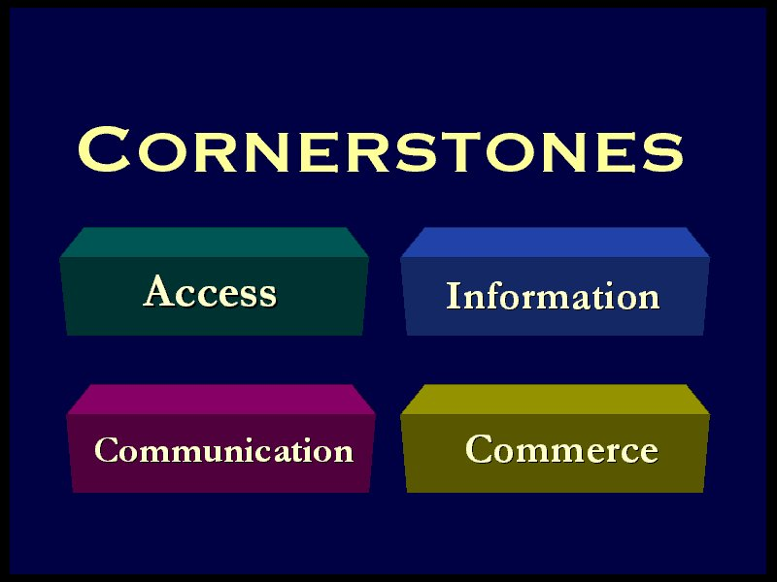

Throughout the history of community networking, pioneering projects have emphasized access. For instance, early Freenets provided dial-up access as an integral focus of their efforts.

As Internet access becomes more widespread, many publishers of information on the Web concentrate on the publishing aspect, while leaving the access question for others to worry about. You may want to identify agencies that provide open Internet access, such as community access centers, as partners for your project, or you may want to incorporate access of some sort as your own service.

A public-library-led CI network can take advantage of Internet access already provided in the library. Dr. Joan Durrance, a professor in the School of Information at the University of Michigan and a noted expert in community information networks, notes that the percentage of public libraries offering some form of Internet access has grown from under 20% to over 60% in the late 1990s.

Communication: Since the early days of online community networks, many projects have placed a great deal of emphasis on communication – whether it’s one-to-one communication, as between a citizen and a government official, or group communications, such as discussion groups on various topics of interest to the community.

Today, Internet-based community information projects can use a variety of mechanisms to support communication. The range of options varies widely. For instance, one simple approach is to publish a directory of agencies and government officials, and include e-mail addresses along with other kinds of contact information. (Of course, for this to be useful, you need to ensure that the people listed in the directory actually use the e-mail addresses you list for them; some officials or agencies may set up mailboxes and never use them.)

For group communications applications, a number of tools, both free and commercial, are available. Some tools are e-mail based, such as mailing list managers, which allow a group of people interested in a common topic to communicate via their familiar e-mail environment. Recently, Web-based discussion forums have become quite popular: all participants join discussions by simply pointing their browser at the URL of the forum itself. The Toolkit includes a demonstration Web-based community discussion forum tool for use on Windows NT servers. (See Chapter 10 for details.)

If you embrace group communications as part of your project, you will need to consider asynchronous versus real-time communications. An asynchronous tool allows everyone to participate at the time of their choosing. For any given topic (or “thread”), each participant’s comments are posted for others to see at a later time – whether two minutes or two weeks later. Bulletin boards, text-mode computer conferencing systems, and threaded discussion tools such as Usenet News are examples of asynchronous communications schemes.

Real-time tools, such as Internet Relay Chat (IRC) and more recent Java-and-Web-browser-based “chat rooms” let people talk in real time. Participants type comments into a dialog box, and each participant’s words appear more or less simultaneously on the screens of all participants.

Chat rooms and the like may seem appealing forms of communication, and they have their place in certain applications, but you will want to think twice before deploying them as part of your CI network. Because chat rooms require participants to “meet” in real time, you face a challenge getting a group of people together at any given time to carry on a meaningful discussion. Asynchronous communications can usually achieve a higher level of discussion among more participants.

Whatever group communications scheme you embrace, consider having moderators for your forums – people designated to monitor and guide discussions, and make sure conversations remain on topic and within the bounds of the topic area and rules of general civility. You may wish to adopt and publish guidelines for group communications as part of a formal “acceptable use policy” for your community information network.

Commerce: Traditionally, commerce has not been a major aspect of most community networking projects. Today, with Web-based e-commerce a popular aspect of life for many people, a new community information project may want to consider when e-commerce will be part of the project. E-commerce in the community context could mean any of the following:

- Registering a team in the softball league, and paying the registration fee online
- Renewing a book checked out at the local library
- Giving a donation to a community project
- Paying property taxes or parking fines

Electronic commerce tends to involve making online payments, and in most cases, this involves use of credit cards. (In some limited cases, online transactions are made using the banking system for check clearing, but this is not popular among consumers, and does not afford all the protections for consumer and “merchant” as credit cards provide.)

For some applications, you may not aspire to get into the business of online payments, but you may still want to use electronic commerce tools in order to assure privacy of communications. There are many examples of transactions that demand confidentiality but that do not involve the transfer of funds. You will need to use a Web server that supports encryption of data as it is transferred between your user’s browser and the server that processes transactions. The commonly used scheme for such encryption is SSL, or Secure Sockets Layer. Many Web servers today can support SSL or other kinds of encryption, as do popular Web browsers.

Encryption between your client’s browser and your server is necessary, but not sufficient. You will want to take steps to ensure that private data on the server and in associated databases will remain confidential and as free from risk of attack by site “crackers” as possible. For instance, you may wish to encrypt private data on the server. You will definitely want to pay attention to server security in general – who has access to the server, and what level of access is provided to each user. You will want to analyze access logs and exception reports to make sure crackers haven’t broken in.


If you embrace online payments as part of your project, you will need to work with a bank or other financial institution that participates in Internet-based transactions. These procedures require careful setup to handle all aspects of transaction handling. In most cases, the actual processing of the credit card transaction will occur on the server of your service provider or bank, not on your own server. You may find it appealing to use the services of an Internet commerce service provider. An example of such a company is CyberCash, which provides secure back-end servers that perform credit card authorizations and payments processing for a small percentage transaction fee.

With the help of a service such as CyberCash, you need not run a secure commerce server as part of your CI network per se; all of the secure transactions work is handled by the third-party service provider. Your server hosts the pages that users connect to in order to find out about and connect to your commerce application. Once the user fills out an initial form, any credit card information is delivered straight to the server of your intermediate service provider. This frees you from having to worry about the security of credit card information at your site.

Over time, city governments and other community agencies will find e-commerce services to be part of the package when they set up bank accounts, reducing or eliminating the need for intermediaries.

The 1998 report of the Michigan Information Technology Commission (MITC) calls for local governments to conduct business online:

All state and local government computer systems should allow citizens to electronically conduct business ranging from paying tickets and fines to applying for permits to reporting community nuisances…

“Electronically conducting business” will eventually become standard operating procedure as more and more local governments answer the MITC challenge. Community information networking projects are likely to help support such governmental e-commerce – or at least help serve as a gateway to such services.

What is the Shelf Life of the Content You Publish?

This is a simple question with profound implications. If your CI project is primarily historical in nature, then maintenance requirements will be relatively undemanding: prepare the content once, make it look spiffy, get it online, and you’re done.

On the other hand, if your site is primarily news or events-oriented, site maintenance can be a major burden. One saying captures it well: “Nothing is deader than a dead Web site.” If your customers come to your events calendar only to find a list of events from seven months ago, they’ll conclude your entire site is dead – even if the calendar is only a tiny fraction of overall content. Thus, it’s better not to undertake putting up content with a short shelf life if you don’t have staff or volunteer commitment to keep it up to date.

Shelf life presents a challenge and an opportunity. The most successful sites will make changes to their very first screen (sometime called the “splash screen”) frequently. For instance, you might,offer a “Spotlight” story on your initial screen, which you update daily, weekly, or monthly. But if you choose to offer a spotlight, it must be updated as promised, or your site will appear to be even “deader” than if you opt for static content on your initial page.

The most extreme case of information with a short shelf life is real time information. For instance, Miami’s Dade County Humane Society offers a “puppy cam” with a real-time photograph of a puppy available for adoption. That is the sort of service that can become highly visible; users will be frustrated if the camera is often down, or if it shows a puppy no longer up for adoption!

Who Will Manage the Project?

These days, team-based approaches to all sorts of work situations are in vogue, yet many projects fail in the absence of a clearly-defined leader. This is perhaps especially important for something as fluid as a Web site. Your CI team needs a leader, explicitly recognized as such by all team members and stakeholders. The leader needs to be empowered to make editorial, stylistic, and deadline decisions.

In fact, you may find it useful to identify specifically at the beginning of your project which members of the team have what responsibilities. The term “webmaster” is used commonly in the Web publishing community; unfortunately, the meaning of that term is somewhat fuzzy. It might be useful to think of your Web publishing project in terms analogous to those used in publishing a magazine:

- Who is responsible for the overall publishing project? In magazine publishing terms, this would be the “publisher.” This person sets overall policy and makes ultimate decisions about style, content, scope, frequency of publishing, and even whether to cease publishing.
- Who is responsible for general management and for arbitrating questions of interpreting policy as new content is published? This would be your “editor-in-chief.”
- Who handles day-to-day management of the publishing process, selecting and editing new content? You might think of this person as your “managing editor.”
- Who will design the graphical look and feel for your site – who will be your graphic designer and your art director?
- Who are your content providers? These are your “writers” or “reporters.”
- An “editorial board” may advise the publisher and the editor-in-chief – especially in terms of overall editorial policy and overall site design and look and feel. The board would not normally be involved in everyday content decisions.

Of course, for many projects, one person will wear multiple hats. In some cases, one person may wear all hats!

Who Will Serve As Content Providers? Are There Potential Partners?

President Kennedy once said “Success has a thousand fathers, but failure is an orphan.” At the beginning of a new CI project, lots of folks are likely to show enthusiasm for the undertaking. But who will actually do the heavy lifting? It’s a good idea to make a list of who will do what. Better yet, try to quantify each participant’s contributions in terms of number of hours of work per week, or number of pages of content put online.

Because many of the content providers will be providing volunteer labor, management can be a tricky aspect of the project. How do you fire a volunteer who isn’t meeting his or her commitment to provide content? Peer pressure may be one answer: hold weekly or bi-weekly content provider meetings, and keep minutes as to who promises to do what during each meeting.

Partners for your project may come from many places:

- The local newspaper may have an events calendar you can use on your site.
- A local Internet Service Provider (ISP) may offer some community information online. For larger cities, a national city guide such as Microsoft’s Sidewalk series may offer local information.
- A local civic group such as the Kiwanis or Rotary club may have information of community-wide interest.
- Churches and other non-profit organizations may offer information about services and projects.
- Various governmental agencies – city government, school districts, the local court system – each may contribute information about their own spheres of activity.
- The local travel and convention bureau will, out of its own interest, offer good information about tourist attractions, convention facilities, and accommodations.

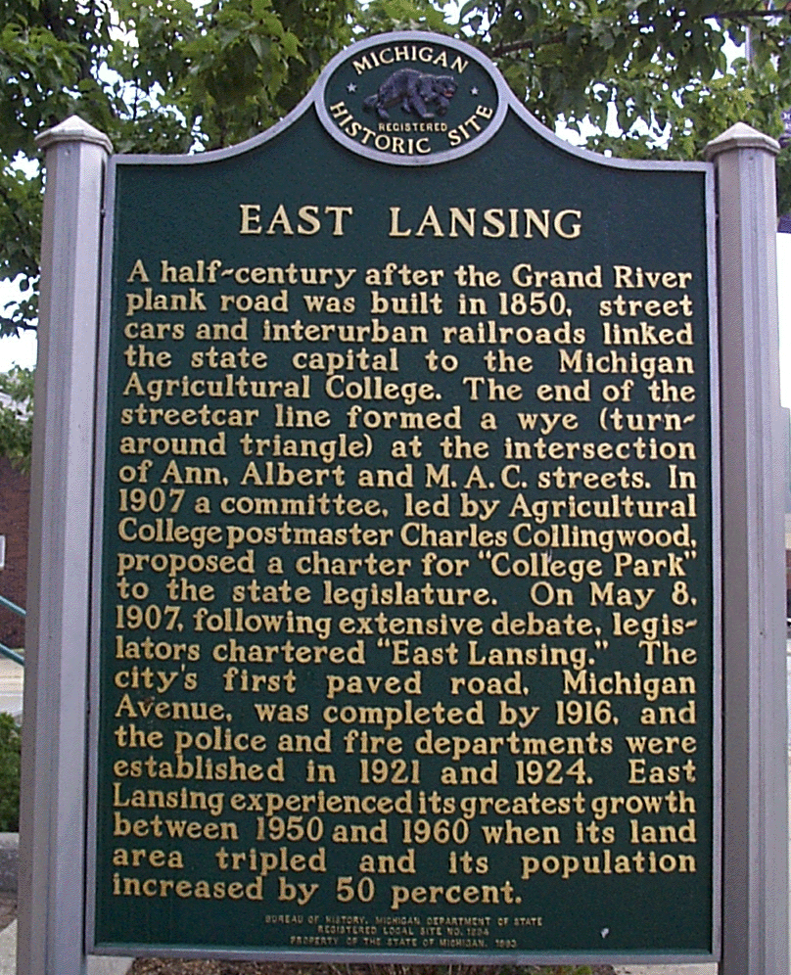
In each of these cases, the organization may offer material in a format such that you can “repurpose” it on the Web, translating from print or disk to HTML. Better yet, if they already offer the information on the Web, you can snap a hyperlink to their content, giving you and your users the benefit of their work with virtually no cost to you.

A partnership can be explicit – “You cover community events, we’ll cover town history” – or implicit, in the sense that you link instead of duplicating. For instance, suppose you want to offer a directory of city government offices and social service agencies in your community. You might construct this list by hand. To complement it, you might offer a link to a national telephone book service such as Switchboard (www.switchboard.com) or a Anywho (www.anywho.com). Similarly, you might offer specialized maps depicting particular points of interest in your community, while leveraging Mapquest (www.mapquest.com) for comprehensive mapping services.

In fact, everyone you might be tempted to consider a “competitor” might be a better thought of as a potential partner. If others do the work, you can get almost as much credit by offering a well-organized index of all relevant information.

What Server Technology Will You Use? On Whose Server?

In some ways, the choice of server technology may be the least critical decision you face. The goal of your project is to deliver content, not to embrace technology for its own sake. In fact, you may not want to run your own Web server at all. Consider the words of former State Librarian George Needham:

The important thing is access to information – that should be the bottom line that drives any decision. It's not necessary for the individual library to have the fanciest server or the fastest server –- the important thing is to work with the technological resources that are available on the local level and in the regional and statewide level. It may be that the most logical way for your community to proceed local library to proceed is to work with your library cooperative, or to work with Merit, or with one of the academic institutions in the community.

Chapter 9 discusses in detail the pros and cons of running your own server. It then provides an overview of what’s involved in running a server. Before you decide to run your own server, consider the information in that chapter.

An important point to consider: no decision involving your Web presence is permanent. You can start your CI project on an external server, and “grow your own” server administration competence at your leisure. Thanks to the hyperlinked nature of the Web, it is relatively easy to switch from one server to another – either gradually or via a rapid transition. (Be sure to note the discussion of relative versus absolute URLs in Chapter 4, so that you build portable pages.)

Chapter 3 offers more information on technology choices in general; Chapter 9 offers more information on choosing your server platform.

What Computers and Other Content Creation Equipment Will Your Content Providers Need?

For basic Web projects, your content providers can use just about any available personal computer with good success. Many content providers use an old ’486 system with 16 megabytes of memory and Windows Notepad to prepare content for the Web, and are quite happy.

As you move into more ambitious projects, you may want a more sophisticated workstation for content development. One possibility is to set up a “Content Creation Station” at your local library, and make it available to team members when they are working on a piece of content that requires high-end tools.

Here’s an example configuration of a Content Creation Station:

- “Wintel” PC (Intel or competitive processor running Windows) running a Pentium II or III at 400 megahertz or higher; or Apple Powermac G3 running at 400 MHz.
- At least 128 megabytes of memory.
- At least 8 gigabytes of hard disk. Modern PCs come with Ultra ATA IDE drives, which provide good performance for most tasks. If you’re venturing into video editing, you may want to obtain “ultra fast, ultra wide SCSI” disks.
- A system bus of 100 MHz speed.
- A monitor with a 17 inch or 20 or 21 inch screen.
- A high-end video card such as found on most of today’s new systems.
- A 64 bit sound card equivalent to a SoundBlaster (standard on today’s new systems).
- At least two Universal Serial Bus (USB) ports. This relatively new standard port is a superior way to connect external devices such as scanners.
- An Ethernet card for connection to your local network. Cards capable of connecting at 10 or 100 megabits per second into a network hub over “Cat-5” twisted pair cabling are the most common today.

With this station you will want to choose other tools as necessary:

- A flatbed scanner.
- A digital still camera.
- A still image or video capture card. Macintoshes and some PCs may come with good-quality video capture capability built-in. Add-on cards are available for those machines that lack this capability. Choose a PC with Firewire (IEEE 1394) if you intend to do digital video applications (or add a Firewire card later).
- Graphics editing software such as Paint Shop Pro, Photodeluxe, or Photoshop.
- Other authoring tools, such as Microsoft FrontPage, Adobe PageMill, or other tools discussed in Chapter 4.
- A good quality laser printer (available for under $500) and a good quality color printer (available for us little as $200).
- An Iomega ZIP or Jaz drive, or an Imation SuperDisk drive. The media for these drives hold from 100 megabytes to a few gigabytes and are useful for transferring or archiving work in progress.
- A CD-R drive, allowing you to “burn” your own CD-ROMs for transferring data easily and for archiving work in progress. Such drives are available for about $200, and CD-R blank discs are available for under $2.00 – even less in quantity. CD-R can be an extremely convenient addition to your set of tools.

See Chapter 6 for more information on scanners and graphics editors. See Chapter 4 (and the next section) for discussion of authoring tools. See Chapter 3 for a discussion of technology choices in general.

What Authoring Tools Will You and Your Content Providers Use?

The language of the Web – HTML – is intended to be quite standard. However, there is a wide range of authoring tools available for creating HTML pages. If each of your content providers selects a different authoring tool, it may be difficult to retain consistency, even though in theory all tools are writing to a common HTML standard. You may want to pick one (or two or three) authoring tools that are preferred for your CI project, and encourage content providers to adhere to your choices.

The recent trend in authoring tools is to move beyond “page editing” and into “site editing.” That is, tools such as FrontPage are integrated editors of entire Web sites. This can be a blessing for you as site administrator, but this does require learning the technology, teaching it to your content providers, and administering who can do what on the server when using the tools.

In some cases, you may need to install – or have installed – server extensions to accommodate the authoring tool, as may be the case when using FrontPage on Unix servers. Finally, you will probably find it unworkable to try to use more than one site-oriented authoring environment on a single Web project.

Chapter 4 offers more information on the wide variety of authoring tools now available.

Will Your Site Include a Live Connection to a Database?

Most content on the Web is “static” in the sense that an HTML document is prepared offline as a physical file, and that file is placed on the server. Until the author edits a copy of the file and replaces it on the server, it remains static.

For some applications, it is desirable to create a “live” connection to a database. An example would be a community calendar. Such a document could be prepared “by hand” and placed on the server as a static file on a periodic basis – say, once a month, in advance of the new month’s calendar. Conventionally, someone would have to edit a static HTML version of the calendar “by hand” – typically by copying the entire calendar to an editing workstation, and then republishing the entire file on the server.

By creating a database – using standard database management systems such as Microsoft Access, SQL, Oracle, Sybase, etc. – and a “live” connection from Web pages to the database, you can lessen the workload involved in maintaining the calendar and publishing calendar data on the Web. When an announcement of a new event arrives, the facts are placed directly into the database. Entry of the event can be accomplished through simple Web forms, or via direct access to the database, or both. The live connection allows a user to see the newly-cataloged event immediately after its posting to the database.

There are a number of tools that make it relatively easy to set up live connections between Web pages and a “back-end” database. Chapter 3 discusses these tools in the context of other technologies. Chapter 10 describes two database-oriented tools provided in this Toolkit: a community calendar and a community forum.

What Multimedia Plugins Will You Require Your Users To Install?

For certain kinds of content, it may be necessary to move beyond basic HTML, and into one of the myriad proprietary multimedia formats available on the Web today.

You need to ask yourself four basic questions before you leap into exotic multimedia formats:

- Do we really need to adopt this format in order to convey the content in question? Simpler is usually better when it comes to the Web.
- How hard is it to prepare content in this format? What authoring tools are required? How much do they cost?
- What challenge will this format present to users with low-end computers or slow network connections? If we do adopt this format, how hard will it be for our users to download and install any necessary plugins? How long does it take to download the plugin over a 28.8 kilobit / second modem? How easy is it to install once downloaded?
- How hard will it be to prepare content in this format in a way that is accessible to people with vision, hearing, or motor impairments?

If you have a compelling reason to move into a proprietary format, by all means do so. Chapter 3 will help you explore some of the technology choices you face, in terms of multimedia and more generally.

What Will You Do to Ensure Compliance with Copyright? Will You Offer a Content Policy?

The Web makes it trivially easy to “lift” digital content from other sites, and mass-produced scanners make it almost as easy to lift content from print media.

Unfortunately, what’s easy isn’t necessarily legal. Many new Web content providers believe they’re free to use anything that doesn’t have a copyright symbol next to it, or it’s OK to lift content from educational sites or elsewhere. This is not true; any original work is protected by copyright. Except for some narrow circumstances that allow limited “fair use” of copyrighted materials, it is impermissible to use others’ material unless:

- You have permission of the copyright holder.
- You have licensed the material from the copyright holder or an authorized agent.
- The work has lapsed into the public domain, its copyright having expired.
- The copyright holder has explicitly placed the work into the public domain.

If your content providers violate someone’s copyright and place the material on your CI Web site, you may find yourself with a “cease and desist” letter – or worse. To avoid this sort of situation, you’ll want to have an explicit policy stating that all content providers will respect the copyright of third parties. You might want to have new content providers sign an agreement to this effect.

You will also want to take care to define who will hold copyright to original material prepared for posting on your CI site. For instance, if the site is hosted by the local public library, and content is provided by a variety of local citizens, you will want to establish in advance a clear understanding as to whether the copyright will be held by the library, or by the authors with a perpetual license for the library to use the materials.

Another intellectual property issue arises if you choose to host your site at a facility other your own: you want to make it clear to your service provider that you own the intellectual property rights to your site’s content. This includes any HTML files, any data in databases you maintain, any chat or forum logs, and any server log files. You also want to make sure that your domain name is your intellectual property, not that of the service provider who may have assisted in its registration.

It’s a good idea to post such an “content policy” or “acceptable use policy” addressing copyright and other content issues. By stating up front what the goals of the site are and what kinds of content will be acceptable, you minimize confusion later. For instance, your policy might state that your site is not to include any commercial endorsements or advertising, and that the site is not to include any derogatory information about living individuals or community groups.

You will want to become familiar with the Digital Millennium Copyright Act, which imposes special responsibilities for online content hosts – and offers ways you can avoid liability. For pointers to information about the Act, see the American Library Association’s page on the topic at http://www.ala.org/washoff/copyright.html.

Feedback and Group Discussion

At the very least, you will want to create a mailbox for your Web team (e.g. webmaster@ci.smallville.mi.us) so that site visitors can send you comments.

You may be tempted to offer a “real-time chat” mechanism such as Internet Relay Chat or other real-time environments. While appealing at first, many sites find that real-time chat is only useful in fairly atypical, specific situations, and are not well-suited to a large, diffuse user base. Instead, if you want to foster online discussions, you probably want a non-real-time, or asynchronous forum – sometimes referred to as “computer conferencing.”

There are a number of tools for doing this; some are e-mail based, such as mailing list software that allows a defined group to carry on discussions via the familiar environment of e-mail. The most popular mailing list package is a commercial product called Listserv. (Although frequently used as a generic term, “Listserv” is a trademark of L-Soft International (www.lsoft.com) for their commercial mailing list product.) You might choose to install a software product such as Listserv, or you might consider a number of freely-available tools such as Majordomo.

As with any service you might wish to offer, you may want to consider outsourcing the hosting of a mailing list. There are a number of services that offer to host mailing lists on their servers for a monthly fee (including Lsoft, the vendor of Listserv.) Many ISPs also offer mailing list services.

If you use a mailing list service for group communication, be aware of two very different ways in which mailing lists are used:

- As a discussion medium: Any member of the mailing list can post any comment or question, and all members will see the posting. Mailing lists can be “moderated,” which means that a human manager of the mailing list will review each posting before it is forwarded to the subscription list, or unmoderated, which means everyone sees every posting.
- As an announcement medium: With this model, you use the same mailing list technology in announcement-only mode. Your subscribers cannot post to the mailing list; only the list owner can do so. This is extremely useful for regular announcements. For instance, you might set up a mailing list to which you post once a week a summary of what’s going on in your community – say in the form of new entries to your online community calendar – including always a reference back to the Web site for more information.

Regardless of which model pertains to a particular mailing list, note that modern mailing list tools and services generally offer Web-based mechanisms for list owners to configure and manage their mailing lists, as well as for end users to subcribe or leave a given list. In the past, users had to send commands to the mailing list server via e-mail; this was confusing and frustrating to many users. The bottom line: offer a simple Web form for subscribing to your mailing list, as well as a simple hyperlink to a Web-based archive of past postings, and your customers will be happier.

Another approach is to create a Usenet News group. Usenet is a venerable, tried-and-true discussion environment. Unfortunately, Usenet is more familiar to Internet veterans than it is to “newbies.” Users need to understand the layout and methods of Usenet; although Web-based Usenet gateways such as DejaNews (also known as deja.com) are popular, Usenet probably isn’t known to as wide an audience as is the Web. You may find that you reach more of your target audience if you rely on an e-mail-based mailing list, or Web-based conferencing, for your online discussion mechanism.

There are many Web-based conferencing tools, some free (public domain) and some commercial. This Toolkit includes a simple Web-based forum application to run on a Windows NT server. Popular commercial tools include Allaire Forums (www.allaire.com) and O’Reilly’s WebBoard (www.ora.com).

How Will You Promote Your Site?

There are a number of ways to promote your site, both on the Web and via more traditional means. Here are some simple ideas for promoting your site within your own community:

- Hold a live event to launch your site.
- Print a brochure describing your site. Or consider printing business cards with the site’s name and URL; business cards are more likely to go into a person’s pocket for later reference.
- Put up signs promoting the site – inside your library and perhaps even outdoors.
- Convince the local newspaper to feature your sites’ URL – if possible, as part of their regularly-printed directory.
- Persuade your local radio stations and television stations to run public service announcements touting your site.
- If your community has a channel on local cable television, that channel is likely to have an automated information service, scrolling a series of public service announcements when actual programming isn’t running. Try to get a blurb for your site (including its URL) shown along with other announcements.

See Chapter 11 to explore other promotion avenues. See Chapter 5 for a discussion of Web-specific promotion techniques.

Leveraging Free Internet Services for Team Members

Your content partners and your Web team in general will need to communicate regularly and frequently as you prepare and publish information. The most effective form of communication will probably be the traditional face-to-face meeting. Still, your team members may want to take advantage of Internet tools to communicate with one another in between meetings.

Recently, a number of free services have appeared on the Net – free e-mail, free Web publishing, free mailing list services, even free interactive, searchable calendars.

You almost certainly would never use any of these services in a visible way as part of your official site presence; most of them make money by inserting visible advertising into your content – and most community information sites would not want to have advertising co-mingled with official content. But these free tools can be very useful for your content providers – to communicate with other team members, to publish test pages, and to organize tasks and schedules.

Free e-mail services are available from numerous highly-visible sites: Hotmail (www.hotmail.com), Netaddress.com (www.netaddress.com), Yahoo, Netscape Netcenter, etc. etc. You may find such services an attractive alternative to providing new e-mail accounts on your own servers for each content provider. These services are accessible from any Web browser, requiring no special setup by the user. Signup is very straightforward. The services in many cases offer some advanced capabilities, such as e-mail folders, filtering of e-mail, forwarding, and scheduled e-mail (such as reminder notices).

Even if your content providers already have e-mail accounts at home or at work, separate mailboxes may be useful: their employer may restrict e-mail to work-related activities, or they may want to segregate mail related to your project from other kinds of mail.

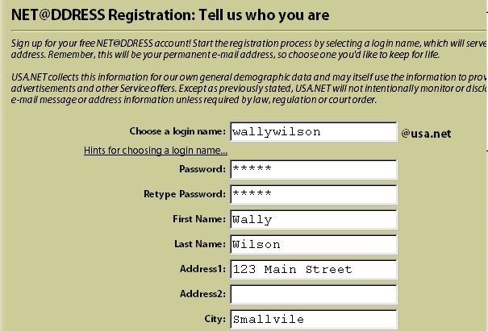

Free mailing list services allow your team to set up automated redistribution of messages to a defined group. You might use these services to create a mailing list for your content team. You can announce team meetings and deadline reminders on the mailing list. Team members might set up their own mailing lists for specific topics. Behavior of these mailing list services is analogous to the e-mail-based mailing list tools mentioned earlier in this chapter. Free mailing list services include Egroups and Listbot.

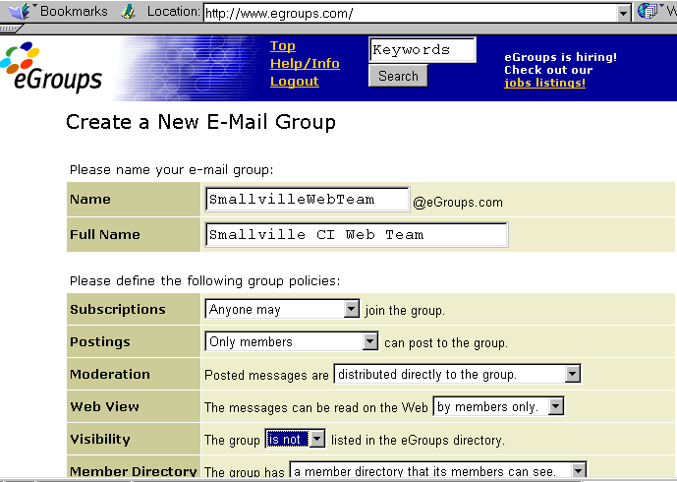

Free calendar services are available at Visto (www.visto.com), at Yahoo, and elsewhere. Such services provide ways to mark significant events as well as to organize “to do” lists. Although many of these services were intended to support personal (individual) calendars, they are perfectly suitable to use by your team. You may need to mark all of your events as “public” in order for other team members to see them.

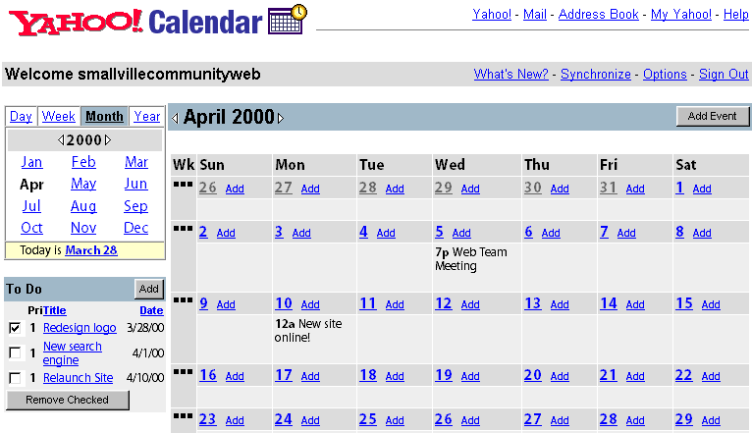

While perhaps usable for helping your CI team keep up with project deadlines, these tools are probably not good choices for a community calendar for the public at large. The Toolkit includes calendaring software suitable for publishing a calendar of events for your community. The Toolkit calendar is well-suited for an application where a small team of authorized calendar managers posts events data for members of the community at large to review and consult.

Using Your Own Services

Of course, you may want to provide online collaboration support to your content providers directly, hosting these services on your own servers. For instance, the calendaring application included in the Toolkit might be useful for publishing deadlines for tasks to be performed by your CI team. The Toolkit’s calendar software is intended for publishing a community events calendar, but you might use the very same software to set up a separate calendar to be used only by your Web content team. (The Toolkit calendar software makes it easy to set up more than one calendar on a single server.)

Similarly, if you want to take on the administrative overhead, you might choose to offer e-mail addresses and mailing list services on your own server on behalf of your team. Or you may choose to use free or for-pay services provided elsewhere. Like so many aspects of your CI project, it’s your choice.

