Chapter 5: Designing Your Web Site: Style and Architecture

Based in part on a related Toolkit Curriculum presentation by Todd White, Merit Inc.

Lou Rosenfeld, author of Information Architecture for the World Wide Web and president of the information architecture consulting firm Argus Associates, observes:

If a community information system is important, and maybe it’s the one major outlet for communication about an organization – it may only be a 15 page site – it still should be well-architected, because it may be the main face the world sees about that organization.

Rosenfeld continues,

There are three things that people have on their mind when they come to a site: “I have a task to do,” or “I’m interested in a certain topic,” or “I’m part of a certain audience that needs certain kinds of information.” They come with questions. A good organization scheme figures out which of those three (maybe a combination) are the important ways to organize the information in the site – by topic, by task, by audience.

Many new Web sites are put together with little or no advance design work. Many others are carefully designed, but from the perspective of the authors, not the users. If you design your Web site with audience-centered perspective, you are far more likely to build a successful site.

The design of your Web site can be almost as important as the content itself, in the sense that an unattractive design or an un-navigable site will turn off your visitors as soon as they arrive. “You can’t judge a book by its cover,” as the saying goes – but people do judge Web sites based on the first page they see on screen.

Probably the best way to get an understanding of what kinds of designs work best is to spend some time surfing the Web. That is the strategy we’ll take in this chapter. But in overview, we can make several observations about what constitutes a well-designed Web site. A well-designed site is:

- Well-organized
- Easy to navigate
- Attractive
- Useful
- Up-to-date

“Fair enough” you say – those all seem like worthwhile characteristics, easy enough to achieve. But as you tour the Web, unfortunately you encounter too many sites – including sites of highly-visible institutions – that fail to meet one of these basic tests.

There are some basic steps you can follow to help achieve a site that passes the muster of good design:

- Have a goal. Many sites are a hodge-podge of information. Without a goal, it’s impossible to say what does and doesn’t belong on the site. If you find that you’ve got more than one goal, consider launching a separate, distinct site for each.
- Target your audience. Too many sites try to be all things to all people. Just as every book or magazine or TV show has a target audience, your site is more likely to achieve focus if you know who your audience is. By asking who the audience is, you can think in terms of what information that audience will seek – and you can organize your site accordingly.
- Create a plan. Theoretically, any Web page can link to any other page. In practice, you’re probably going to have several major topic categories, and you’re going to want to organize your site in a way that reflects your topical organization. You may find it useful to create an outline, or even a wall chart, showing the overall layout of the site you are building.
- Select a Web service provider, and put a prototype of your site online. You might be your own provider, or you might obtain space on someone else’s server during the trial period. A prototype allows your team and any stakeholders in the community to evaluate the proposed new site.
- Try it out. It is important to test your site under a variety of possible user configurations. Try using different PCs – test the site on an old 486 with 8 megabytes of RAM. Try a PC with a 14-inch monitor and a mediocre video card. Try a variety of Web browsers – different versions of Netscape Navigator, Internet Explorer, as well as some of the less popular browsers, such as Opera or WebTV. Be sure to test over slow dial-up lines as well as fast connections
- Publish it, and maintain it: Once you’re happy with the site, it’s time to “go live” and put the site into production. Unfortunately, a Web site isn’t like a book; it’s never “done.” You’ll always have to monitor your site for outdated information and dead links (links to pages on your site or others’ sites that are no longer valid.)

A good reference for online information about site usability, with links to commentary by researchers and author in this area, is:

http://webreference.com/authoring/design/usability.html

The Good, The Bad, and The Ugly

Let’s consider some examples of what seems to work well, and a few examples of what doesn’t work so well.

Here is the main screen for the Michigan Electronic Library (MEL):

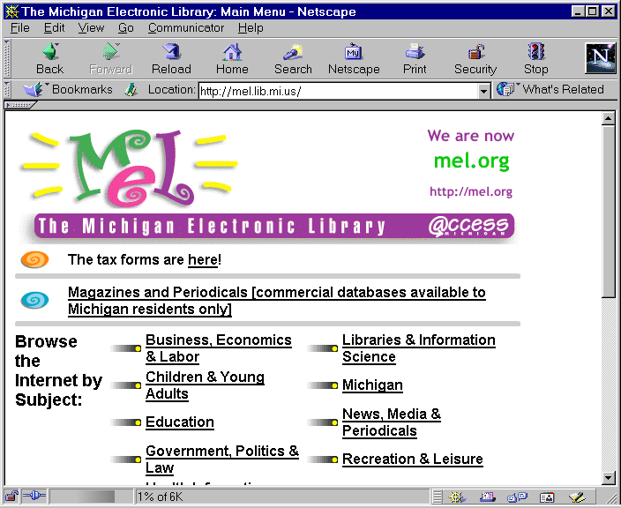

This screen is the soul of simplicity. MEL is a finding aid for locating high-quality Internet information sites by subject category. Note that the initial screen is uncluttered and relatively spare. The top of the page offers an attractive logo and pointers to frequently-sought information, but the “meat” of MEL – the subject catalog – follows immediately. A user doesn’t need to follow a bunch of hyperlinks to get to the catalog; in fact, in most cases, the user doesn’t even have to scroll.

The MEL design does not feature any animations, or blinking text, or scrolling marquees. In some quarters, the design might be considered staid – or even boring. Nevertheless, MEL users find the design quite workable. In fact, one group of satisfied customers is the visually impaired: they user Web browsers with audio “talker” technology to read the words on the screen to the user, and MEL’s simple, spare design works extremely well with such technology.

The goal of this page is to deliver information in a straightforward and easily navigated way. This page serves as a useful model for all community information sites.

Now let’s look at a random subject category in MEL:

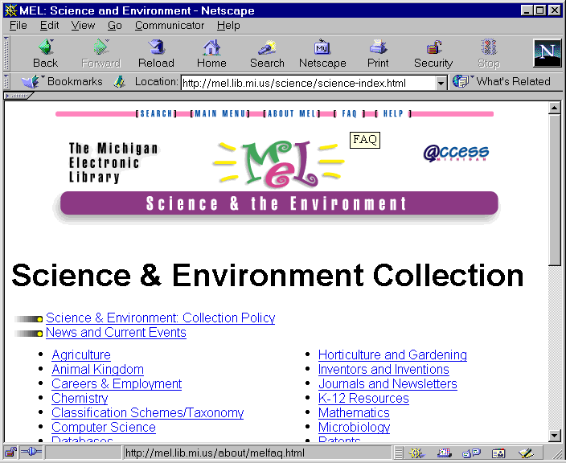

Notice how this “second-level” screen carries forward the theme set by the initial screen. The MEL logo is incorporated into a graphic that headlines the category we’ve chosen. Within the page, a simple two-column hierarchical menu is offered – much as we saw on the front page.

Above the logo is a menu bar that lets the user go to commonly-sought places on the MEL site – the home page (the initial screen), a search engine, an FAQ (Frequently Asked Questions document), an “About” file (telling about MEL itself) and a path to Help. Offering this menu bar on all pages means customers are very unlikely to find themselves lost.

If we scroll to the bottom of the page, we find more elements that are repeated on every page on the MEL site:

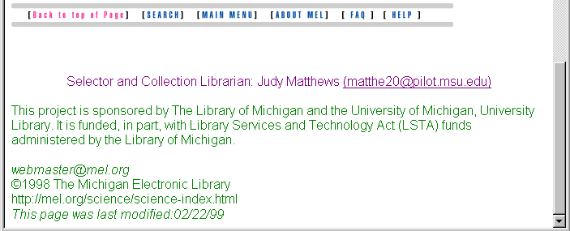

Here the reader can find the author of the current section of MEL (including e-mail address), some basic information about MEL, the e-mail address of MEL’s overall webmaster, copyright information, the URL of the page (useful for someone who sees a printout of the page without the URL automatically supplied) and the date of the last modification of the page. All of these pieces of information are potentially useful to a MEL customer; many sites would neglect to include them.

Finally, note that the MEL menu bar is repeated just above this “end matter” so that no matter where a user scrolls in the page, it’s easy to find a link back home.

Now let’s consider another page, one that offers links to academic departments of the University of Michigan:

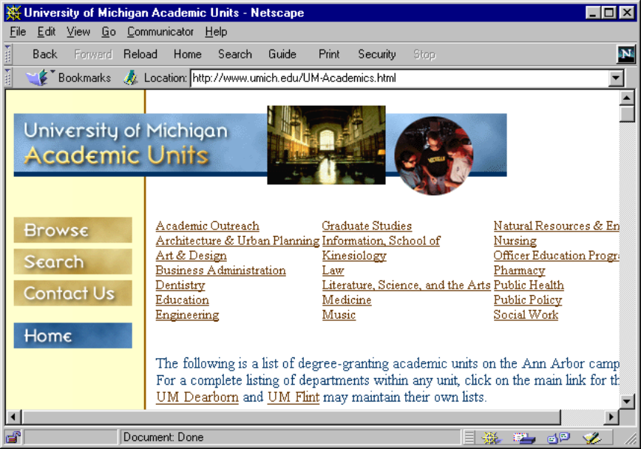

Just as MEL’s navigational hierarchy flows naturally from its subject hierarchy, here the university is offering a view of its various colleges (and departments) in a natural hierarchy. In fact, a menu of university colleges may be one of the few times when a departmental or organizational view is natural for customers to deal with; a community information site might better be organized around the services people seek or the questions they ask, rather than, say, the organizational structure of city government.

Note that just as with MEL we see a relatively spare design. The page incorporates some attractive images, but the sizes are kept relatively small, so that this page can load quickly even over a modem.

Now let’s look at an example of a site organized from the perspective of the different people who might visit it:

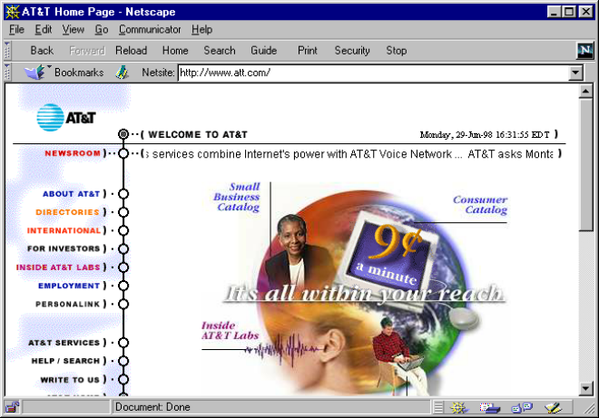

Many people might visit AT&T’s site: people seeking telephone service, people seeking to invest, people seeking employment. The site offers up-front links to serve all those potential visitors.

One principle of Web design is to minimize vertical scrolling:

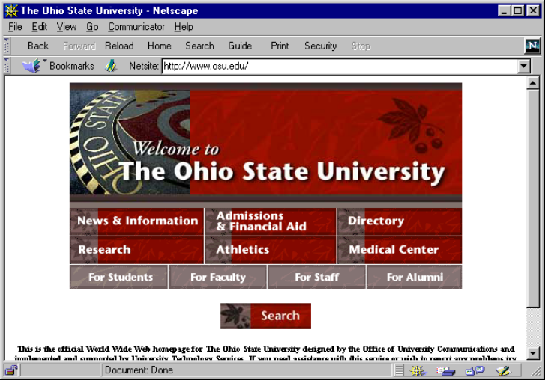

Here, Ohio State’s main page offers an attractive initial look and windows into information by major category as well as by audience type. Most users with common browsers and screen sizes will be able to display most of the initial screen with very little or no scrolling required. Virtually all users have computer monitors that display at least 640 pixels (dots) wide versus 480 pixels high; thus, if you keep your graphics under about 600 wide by 440 high, you’ll achieve the same result.

While as a rule vertical scrolling should be minimized, there are exceptions. If a given page is full of text to be read linearly, there may be circumstances where scrolling by use of the Page Down key does not inconvenience the user. Still, you will probably want to break up pages that require numerous strikes of the Page Down key.

While vertical scrolling is a matter of some editorial judgment, horizontal scrolling is almost always a mistake. By default, Web browsers will wrap text in such a way as to not necessitate a horizontal scroll bar. However, you may find that certain uses of tables, of extra-wide graphics, or of HTML “frames” may force the browser to put up a horizontal scroll bar. Horizontal scrolling is extremely tedious for the user and should be avoided at all costs. You will want to view your pages on a variety of window sizes and font sizes to make sure horizontal scrolling isn’t introduced for some users.

Here’s another page that offers a great deal of navigation while requiring very little if any scrolling:

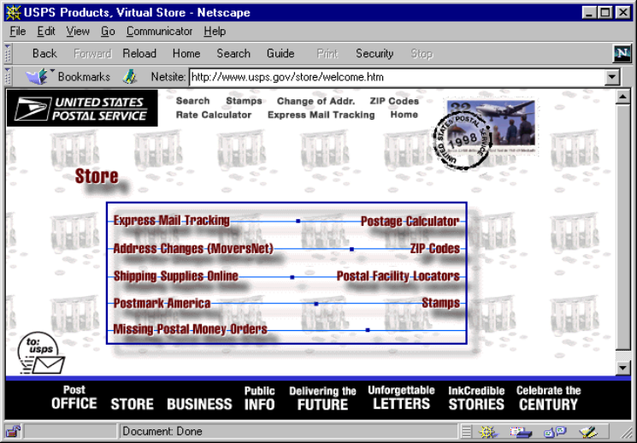

This Postal Service page gives customers quick access to the services and information they need.

The Postal Service site has a creative element many Web designers find popular: a background image. The background image is a small image file, typically a GIF file, specified on the <body> tag, e.g.:

<body background=”http://www.smallville.mi.us/background.gif”>

Alas, some webmasters lose sight of good design when they incorporate background images into their pages. For instance:

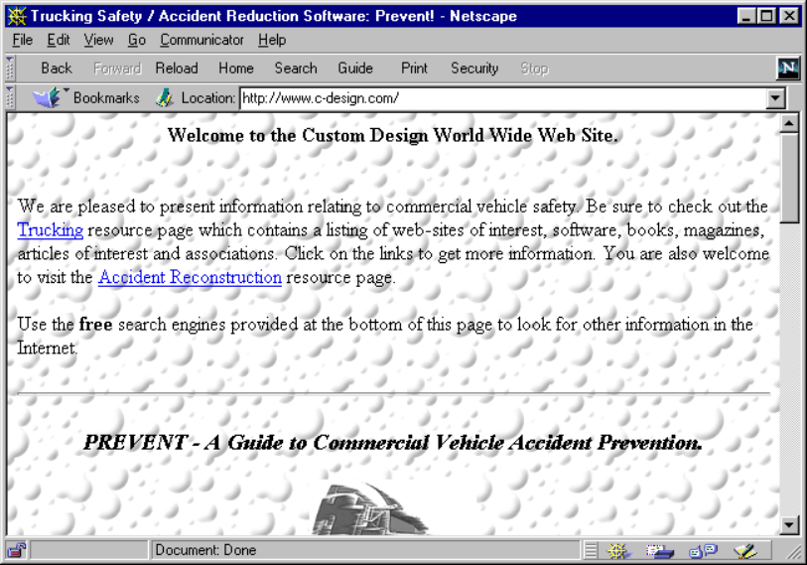

Here, the background image is close in color and contrast to the text – so much so that it interferes with readability. The best background images are subtle – the author uses a graphics editor to adjust color, brightness, and contrast so that the image shows subtly behind the text, instead of competing with it.

Now let’s consider a site that uses image maps as a navigational tool:

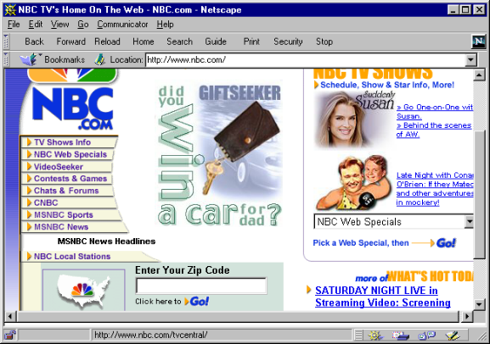

The menu of items under the NBC.com logo is an “image map.” The customer can position the cursor on any of the choices, click on the choice, and be transported to the page desired. This is a textual image map, an attractive alternative to HTML menus.

Now let’s consider how one might use the tables feature of HTML to gain control over precise layout of page elements:

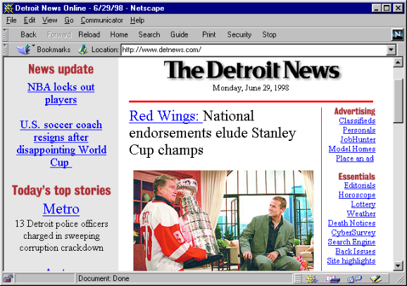

Here, the Detroit News has used tables in an elaborate fashion to give the basic look and feel of a newspaper front page to their Web home page. If you visit their site (www.detnews.com) and invoke the View Source feature of your browser, you’ll see that the HTML to accomplish this is fairly complicated. The News has established a basic template file that can be “filled in” with each day’s new content. You might want to use an authoring tool with page layout capabilities, such as Adobe Imagestyler, if you need to accomplish a layout design with very specific control over element locations.

Tables can be used in simpler ways to create a basic menu structure that looks attractive on screen:

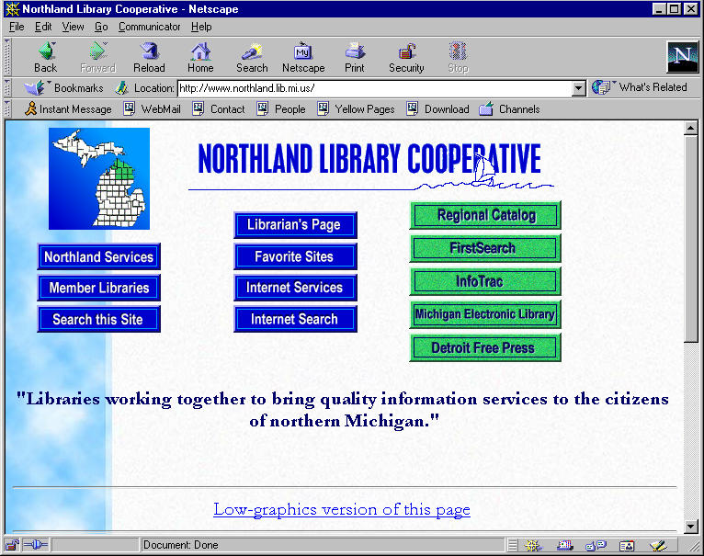

Here the site authors offer visitors a straightforward menu of services, arranging the list horizontally as well as vertically, thanks to tables.

Frames

Ever since Netscape introduced frames as a feature of HTML, they have been controversial. Frames give the author a way to cram more information into a browser screen than monitor real estate allows. In a nutshell, you have a set of separately scrollable panels within the browser window; the user can (generally) scroll through and enlarge or shrink each panel, or scroll within the panel, as desired.

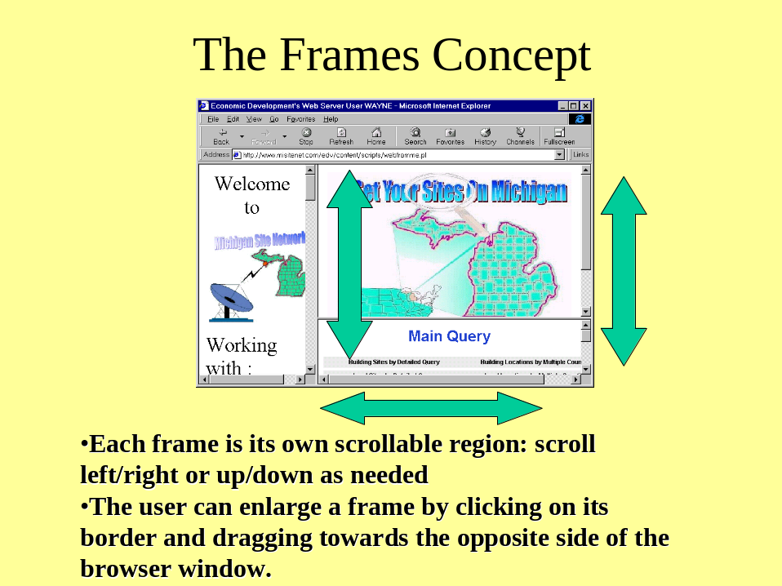

Frames are controversial because they can lead to confusing, almost un-navigable sites. Frames are probably the most effective when one frame is used as a menu frame, and another, larger frame is used to house content. Pages that have three – or more, heaven forfend! – frames tend to leave the user wondering where he or she is supposed to click next.

It’s possible to create borderless frames (frameborder=”0”) and to disable resizing of the frame (noresize) and with no scroll bars (scrolling=”no”). This can lead to a very attractive effect which can also be very intuitive; however, you can also make it impossible for users to find what they’re looking for. For instance, if you disallow scrolling, and the user’s browser window and font selections make it so that an entire menu doesn’t fit on screen, the user will have no way to select the menu options that don’t fit.

Thus, if you decide to use frames and turn off scrolling, resizing, and borders, you’ll want to make sure that the page works for most users from most environments.

You can provide much of the functionality of frames while avoiding some of these risks by using tables. Tables divide a single browser window into multiple table cells, which are inherently non-scrollable. You can specify borderless table cells and yield nice results; here is an example:
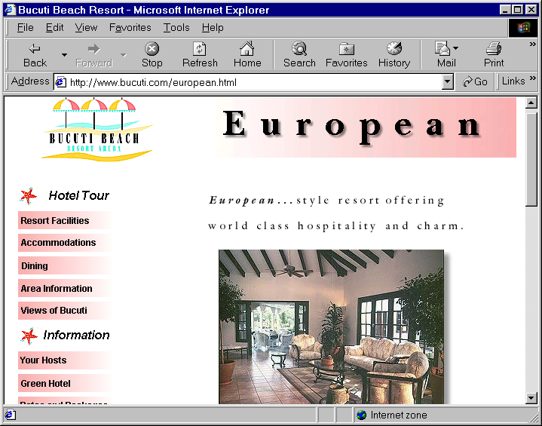

To Be Avoided

A number of pitfalls await the new webmaster. Here are a few traps to avoid:

- Don’t hand-code your word wrapping. New HTML coders tend to use the <br> tag to hand-insert carriage returns. Avoid the temptation to do this. The browser will wrap text for you based on the font size and the window size.
- Don’t design for the computer on your desk. Design your pages to work with a variety of window sizes and browsers. If you make it beautiful for your screen, don’t assume it’s automatically beautiful on other people’s screens.
- Don’t blink. It’s tempting to use the blink tag to highlight text. Most readers find this annoying. Avoid it.
- Counters. There are a number of services that offer counters, odometer-like inline images that show how many visitors your site has had. Including a counter on a page is usually a sign of a beginning or amateur site. Use Web log analysis tools to find out your usage patterns. If you publish this information, do so discreetly, not on every page via counters.
- Don’t overload your menus with narrative. One of the great strengths of HTML is the ability to add a hyperlink in the middle of a sentence, wherever it seems natural to do so. This tempts some webmasters into the trap of lavishing annotation on all their menu pages, to the point where every menu of choices becomes War and Peace. It takes the user time to wade through all the annotation, if the user has to do this every time he or she visits the menu page, the user is likely to find the site an unfriendly place to visit.

Promoting Your Site

Chapter 2 and Chapter 11 each provide some ideas on promoting your site via conventional means. You can also promote your site in several ways using the Web itself.

One very simple step is to make sure that your site has a good, single page that does a good job of explaining what the site is about, who the target audience is, and who is the sponsor. This page should include very basic information about the site in context – including city name, state, and e-mail, telephone, and snail mail contact information. Such a page can be indexed by search engines, helping people who look for specific information by using such tools to locate your site.

You can control, or at least influence, how search engines index your site. The <meta> tag allows you to provide your own description and keywords of your site. (Such information is called “metadata” or data about data; hence the name of the tag.) Altavista offers these examples of meta tags to provide a description or abstract as well as keywords:

<META name="description"
content="We specialize in grooming pinkpoodles.">
<META name="keywords"
content="pet grooming, Palo Alto, dog">

If you don’t supply a description via a meta tag, Altavista and other services will examine each page of your site and try to concoct a description from the title and the initial text on your site’s page. If you supply keywords, your keywords will be used in lieu of the words found when the indexer examines your page.

To learn more about meta tags, visit Altavista’s explanation of them at:

http://www.altavista.com/av/content/addurl_meta.htm

You could add meta tags to every page on your site. In general this may be helpful to some users, but it is not essential. It is, however, important to have a good description and set of keywords on the main, or initial, or home page of your site.

The major search engines each apply their own strategies for discovering new and changed pages on the Web. In theory they will eventually find every page on every server, but studies have shown that every engine has holes in its coverage; it may be weeks or months before a given search engine discovers your site. The major engines allow you to submit your new starting URL for inclusion in the index, greatly speeding your appearance in their indexes.

Services have evolved that allow you to submit your site once, and the service takes care of submitting it for inclusion in all the major search engines. The best-known of these are:

SubmitIt www.submit-it.com
Net Creations Postmaster www.netcreations.com/postmaster

These tools offer limited submission services for free, and more comprehensive services for a fee.

Finally, some tools will help you tailor your Web site for the most favorable treatment by search engines. An example is WebPosition (www.webposition.com). In essence, their creators have reverse-engineered the ranking algorithms of the search engines, and their tools allow you to tailor your site’s content for the best ranking in the “hit list” a user sees when doing searches. Not surprisingly, studies show that the higher your site appears in the hit list, the more likely you are to receive traffic. Appearing in the first 10 hits is far more likely to lead a user to your site than appearing as hit number 234.

Some such services even advise that you create a separate, unique starting page for each major search engine, each tuned to that engine’s quirks in ranking hits. Some sites even pursue higher rankings by using CGI scripts to determine which search engine is “crawling” their site, in order to deliver a different home page automatically depending on which search engine is visiting! Whether such extremes are worthwhile is open to debate.

In general, it is easy to become too obsessed with “hits” or “page impressions.” Most community sites are not going to see traffic in the millions or even thousands of hits per day – and that is perfectly acceptable. The goal is delivering quality content to interested users in the community, not to become the next Yahoo. In general it is probably more fruitful to work on building a useful, usable site with worthwhile content than it is to play search engine ratings games.

Besides the use of the meta tag, you can also use the Internet and the Web to promote your site in other ways. Examples include:

- One popular and effective technique is to find sites similar to your own, and make deals with the sites’ webmasters for reciprocal links.
- You should also seek out directories and catalogs of sites similar to yours – same topical theme or geographic area or audience – and submit your site for listing in their databases. In particular, community sites in Michigan should seek to have their sites listed in MEL. (See www.mel.org/michigan.)
- You may want to create an announcement-only mailing list, and announce new features of your site via that list. People who subscribe to your announcement list are by definition interested in your site; you satisfy their interest and promote your site by periodically communicating with them.

Final Thoughts on Design

Many of us find it worthwhile to hire a professional to help with interior decorating or choosing the right stain for the exterior of the house. Similarly, many new Web sites enlist the services of a skilled designer in order to devise the site’s basic site look and feel. Once that look and feel has been established, it may be possible for existing staff, or members of your CI team, to carry the design forward.

One way to do this is to work with the designer to create a series of “template” pages that provide a standard form for each of the various kinds of pages you need on the site. When you add a new page, simply copy the template and use it as a starting point. In this fashion, your new pages benefit from the expertise of the designer, without having the designer re-craft each and every page on the site.

Eventually, most Web sites find that it is time to refresh or replace the basic design altogether. At such a time, you may want to once again enlist outside help.

Whether your initial design is done by a team member or a “hired hand” it’s often useful to prototype several competing designs. And when you’re considering whom to work with to do your basic design, ask to see a portfolio of prior work. Good designers will have such a portfolio on the Web. For instance, consider a sample from the portfolio of Erik Larson, a Web designer based in Chicago:

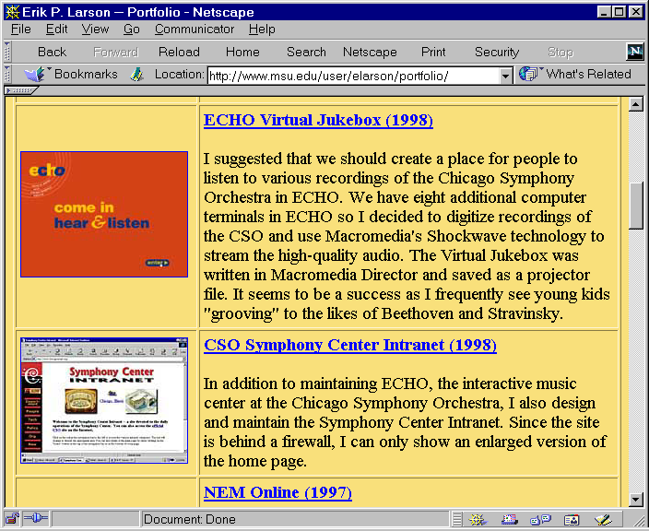

A User-Centered Site

We began this chapter with the observations of an expert in designing usable sites, who observed that users come to your site with certain kinds of questions – of needs. Many Web design experts emphasize user-centered design as the most important way to build a site that actually achieves its goals. If you include end users in the meetings of your design team, and let end users review prototypes of the new site, you stand a good chance of building a user-centered site. Listen to what your users say about how they want to use your – their – site.

