The Library Network
Short Guide to WinFTP

WinFTP is one gateway to allow you easy access to your Web pages. This short guide will explain how to use the features of WinFTP.

Logging On to WinFTP

Before you can alter your Unix space, you must first log on, using WinFTP. Logging on is easy, simply fill in the following information:

Host Name: | tln.lib.mi.us
User ID: | your login/account name
Password: | your password

This is the minimum necessary information. Once you’ve entered this information, simply click on the connect or OK button and you will be connected to the TLN Server.

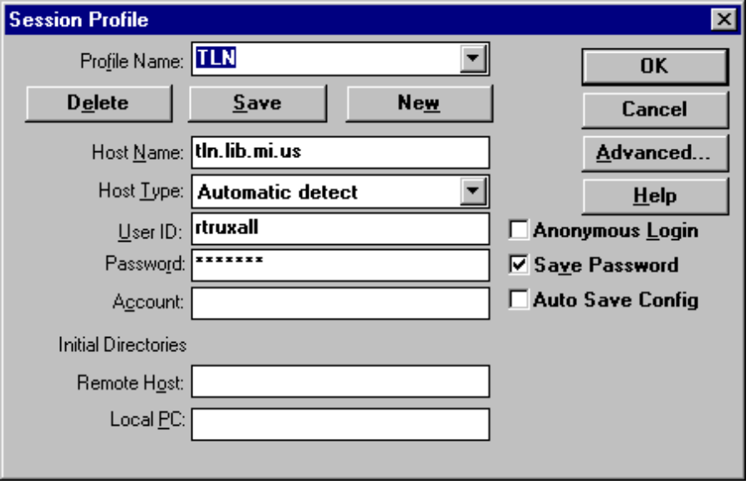

Saving Your Configuration

What you don’t want to do is type all of the above information every time that you want to alter your Web pages. You can save your configuration information so that you do not need to retype information. To save your configuration simply fill in the following information:

Profile Name/Config | whatever name is memorable to you
Host Name: | tln.lib.mi.us
User ID: | your login/account name
Password: | your password
Saving a Password from Session to Session

This is the minimum information for a saved configuration. Once you’ve entered your information, you can check the Save Password box so that you don’t have to type your password every time you want to login. However, in a multiple user environment (like a library), I would not recommend saving your password. This would allow anyone who uses that particular computer to login as you, thus making your files and information unsecure. On a home or private computer, I would recommend saving your password.

Using a Saved Configuration

Once you’ve saved a Configuration, you can access that configuration by pulling down the Profile Name/Config menu and selecting the profile that you want to use.

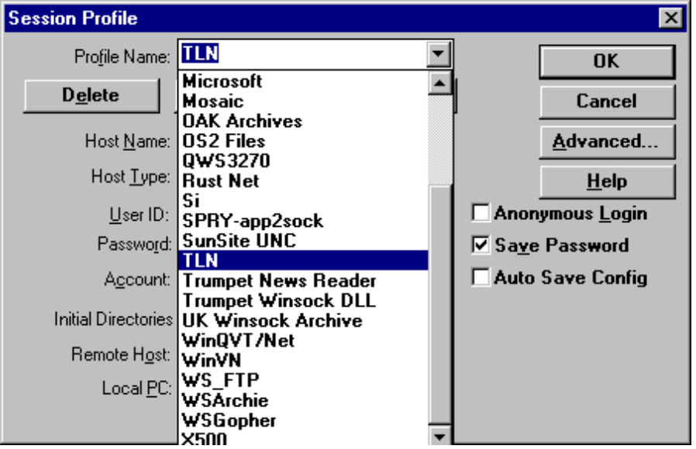

Buttons in WinFTP

When you’re connected to a server, the Screen is divided into four parts. Each of the parts are described below:

Top Left Side | directories on your computer
Bottom Left Side | files on your computer
Top Right Side | directories on the TLN Server
Bottom Right Side | file on the TLN Server

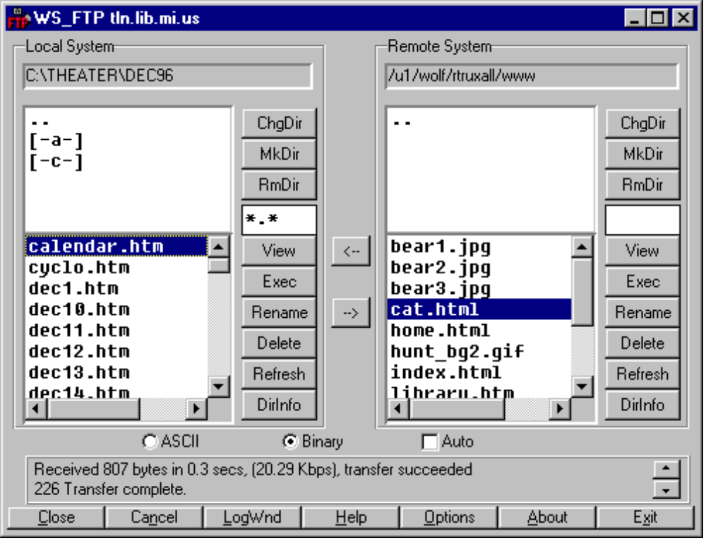

From this screen, you can manipulate all of the files on both your computer or floppy disk, or on the TLN Internet Server. This includes, uploading files, downloading files, deleting and renaming files.

To manipulate files, you can use the buttons to manipulate your files. The buttons have the same effect on both your computer and the TLN Server. The buttons are described below:

ChgDir | Allows you to change to a particular directory. Only use this button if you know the directory path that you want to change to, since you will have to type it in.
MkDir | Allows you to create a new directory.
RmDir | Allows you to delete a directory
View | Allows you to View the contents of a document. This will only work with text files, unless you alter the default configuration of WinFTP.
Exec | Allows you to execute a file. If the file is on the TLN server, the file will be first transferred to your computer and then executed.
Rename | Allows you to rename files.
Delete | Allows you to delete files. To delete more than one file simultaneously, simply hold down the control key and highlight the numerous files that you want to delete.
Refresh | Will retrieve the newest version of a directory list. Use this button after you add a new file to a directory so that you can see the file in the list.
DirInfo | Will show you information about the directory listed. Information includes file name, modification dates, and permission information.

