Writing a CloudCollab Portlet
July 5, 2009
Version 0.1.2
Charles Severance (csev@umich.edu)

Overview

The goal of the CloudCollab project (www.cloudcollab.org) is to build simple learning tools that can be hosted on Google App Engine and integrated into any Learning Management System that supports the Simple LTI or BasicLTI protocols. CloudCollab will also be used to develop reference implementations of IMS standards to form a simple stand alone LMS as well.

A key benefit of building a tool in CloudCollab is that it can function in both iframe environments like Sakai, Angel, and Blackboard and non-iframe environments like Facebook. Over time other markup approaches can be supported such as Web Services for Remote Portlets (WSRP) without requiring changes to your tools.

Building a portlet in CloudCollab may seem initially more complex than building a servlet but the benefits of supporting many authentication and markup approaches should outweigh the additional effort. This document focuses on the unique aspects of writing a portlet as compared to writing a servlet.

Introduction

We write CloudCollab tools as "portlets". A portlet is bit of reusable code that can be used in multiple contexts. For example, a properly written portlet in CloudCollab can be used in the following ways with no changes to the tool code itself:

- In a window or iframe all by itself
- As part of a portal page with portal navigation surrounding the tool and the tool markup(s) merged into the background document
- As part of a portal page operating within a div using Ajax interactions
- As a Facebook application

The tool must also function with or without cookies enabled and with or without JavaScript enabled – all with no changes to the tool code.

Writing a web application to work in all the above environments with all the permutations is pretty challenging – so it is pretty convenient to delegate all of the complexity to the CloudCollab framework.

The CloudCollab framework also deals with logging in and establishing the context of the request (user, course, role, and organization).

To accomplish this, your application cannot simply generate its entire HTML output from the templates. When the tool is being used in the different environments, we must generate different HTML for the following situations:

- The tool must generate an HTML fragment instead of an HTML document. A fragment is the material within the body tag but does not include the body tag

- The material in the head section of the document (title, JavaScript libraries, and CSS) must be separately communicated so they are placed in the proper head for the overall document.

- Certain HTML tags, such as anchor tags and form tags must be generated very differently for different environments. So the tool must call utility methods to produce the URLs instead of just making the URLs as strings in the Python code or in the templates.

- Different environments use GET and POST differently so instead of defining a get() and post() methods, we create methods called doaction() and getview(). The doaction() method processes the data from incoming posts but does not generate markup. The getview() method generates the markup.

These are described in the remainder of this document.

Pre-Requisites

This document assumes that you are familiar with developing App Engine web applications. CloudCollab Portlet patterns are a variation on an App Engine webapp pattern. You should review the material in the book:

http://oreilly.com/catalog/9780596800697/

Or review material online at

http://www.appengine.com/

Before starting this development. You should have App Engine installed and verified as working before starting this activity (again see www.appenginelearn.com).

If you want to play with the application a bit, see wiscrowd.appspot.com – which should have a relatively recent version of the application.

You should also have Subversion (SVN) installed on your system and available at the command line since you will be getting the source out of SVN. You can install SVN on your computer from http://subversion.tigris.org/.

Getting Started

You can check out the code for cloudcollab from the source code repository using Subversion by typing the following in a command line interface. The checkout should produce a subdirectory called wiscrowd from wherever you run the checkout (co) command.

svn co http://cloudcollab.googlecode.com/svn/tsugi/trunk wiscrowd

Once the checkout completes, this is like any other App Engine application and can be started as follows using the Google App Engine run-time.

dev_appserver.py wiscrowd

You should be able to navigate to the main page at http://localhost:8080/. You can either login using the Google Login or you can use the build in LTI launch to simulate an incoming launch using LTI. Note that if you have cookies off, the Google Login won't work but the LTI login will work.

Once you are logged in, you should see the default applications:

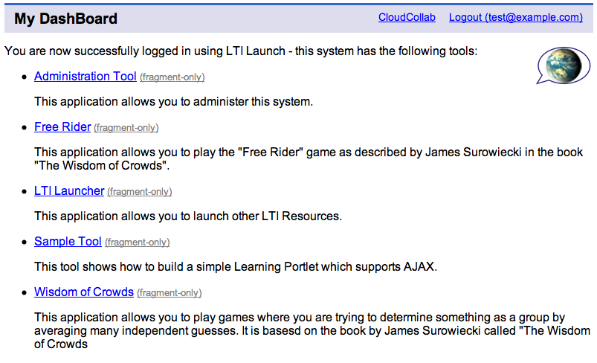

Adding a New Module

Go into the wiscrowd/mod folder and make a new folder that will be the name of your module. Go into that folder and create a file called __init__.py and put a single blank line in the file (this is how Python identifies a module). Then add a file named index.py with the following contents:

from core import tool
from core import learningportlet

def register():
return tool.ToolRegistration(TrivialHandler,
'Trivial Tool',
'This tool is very very trivial')

class TrivialHandler(learningportlet.LearningPortlet):

def doaction(self):
return None

def getview(self, info):
return 'Hello from getview()'

Your directory structure should look as follows:

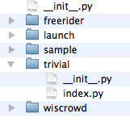

Then stop and restart your application so it re-checks for new modules and you should see your new module in the list:

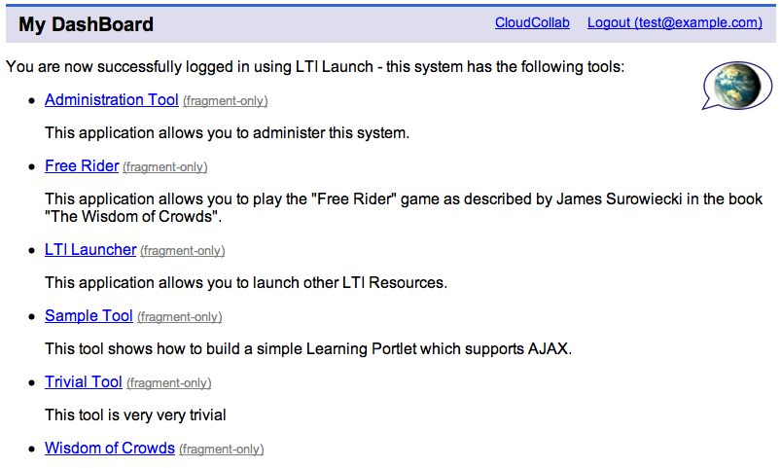

When you click on the tool link, you see the tool output in the portal. If you click on "Fragment Only" you see your tool in a stand-alone window (i.e. if it were in an iframe).

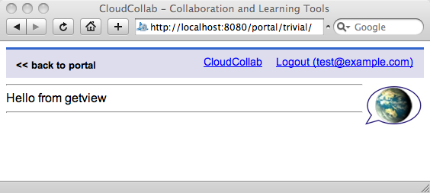

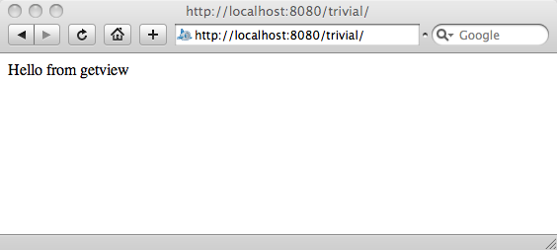

You can already see how the framework produces different views of the portlet based on the URL. If the path starts with "portal", the markup appears in the portal with all the surrounding navigation. If the URL goes directly to the tool, no navigation is included.

Once you have restarted the application and your tool has been registered – you can make changes to your tool without restarting the application. It only scans the wiscrowd/mod folder for new applications at startup time. But once it knows that an application exists – the application works like any other App Engine application where you make a change and press "Refresh".

Lets take a look at the sample application code and see what the various elements do.

def register():
return tool.ToolRegistration(TrivialHandler,
'Trivial Tool',
'This tool is very very trivial')

We need to define this function to inform the CloudCollab tool registration process the name of our tool, a description of our tool and which class that handle the requests for the tool.

class TrivialHandler(learningportlet.LearningPortlet):

def doaction(self):
return None

def getview(self, info):
return 'Hello from getview()'

We do not see the get() and post() methods in our handler. The CloudCollab framework (i.e. the LearningPortlet class) receives the GET and POST requests and handles them. The framework does a lot of setup and then calls our doaction() and getview() methods when appropriate.

On a GET request, the framework only calls the getview() method. Sometimes if the user requests a refresh in their browser the getview() may be called again. So the getview() code should not make any changes to data – it should just generate and return markup. On a simple GET request, the info parameter will be None.

In the simplest case, a POST request calls doaction() to handle the post parameters, making any changes to data in the data store or memcache, etc. Then the framework calls getview() to generate the markup for the portlet to complete the POST request. The doaction() can optionally return some information (similar to "flash" in Ruby) which will be passed into the following getview() call. The most common use of the info is to include a message like "Record Successfully Added" or "Failed to post Message" so that the call to getview() can display a message. The info data is only passed for the immediate next call to getview().

You should not assume that there will be any POST data present in the request when getview() is called. It is very common to process a POST calling doaction(), then redirect the browser to re-retrieve the same URL with a GET which calls getview() to generate the markup. This pattern avoids the "Would you like to repost form data?" question when the user presses refresh after a post and it avoids letting the user buy the same book twice by reloading the page in their browser. However this "redirect after POST" pattern is not used when processing POST requests coming on over AJAX nor is the pattern used when the application is used in the Facebook framework.

The portlet writer does not have to worry about when or if this redirect is done – that is handled by the portlet framework. The portlet writer simply needs to write proper doaction() and getview() methods and let the framework do the complex decision making depending on the ultimate destination of the markup.

Adding a Form to the Application

Now we will add a form to our application and use it to play a number guessing game.

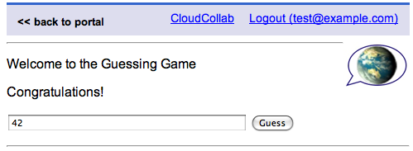

First we modify our index.py file as follows:

class TrivialHandler(learningportlet.LearningPortlet):

def doaction(self):
logging.info("doaction action=%s" % self.action)
guess = self.request.get('guess')
try:
iguess = int(guess)
except:
return 'Please enter a valid guess'

if iguess == 42:
return 'Congratulations!'
elif iguess < 42:
return 'Your guess %s is too low' % iguess
else:
return 'Your guess %s is too high' % iguess

We now have added code to the doaction() method to process the incoming post request. We use the self.request.get() to retrieve the guess string from the form. We then convert to an integer. We are returning a value – in this case it is simply a string to be passed into getview() to be used later. The rest of the logic of the doaction() method parses the guess and checks it to see if it is correct and produces the proper message.

def getview(self, info):
rendervars = dict()

if isinstance(info,str):
rendervars['msg'] = info

rendervars['formtag'] = self.getFormTag()
rendervars['formsubmit'] = self.getFormSubmit('Guess')

return self.doRender('index.htm', rendervars)

In the getview() code, we are going to render a template so we need some render variables. If the info is defined we put that into the render variables.

The frameworks provides us with a simple doRender() method that takes the name of a template file from the templates folder and renders it with the given dictionary as its render variables.

We also call the framework to generate a form tag for us and generate a form submit button for us. If you were to look at the strings that were returned from these calls, they would be quite complex HTML. The HTML generated will depend on how the portlet is used. You do not need to worry about the contents of these strings, you simply must call the framework to generate the form tags.

Similarily, we call getFormSubmit() to generate the HTML for a submit button with a title of "Guess".

The doRender() method is a convenience method defined for us as part of the LearningPortlet class. The first parameter is a template name and the second parameter is the render variables in a dictionary. The directory structure looks as follows:

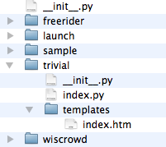

We pass the strings for the form tag and form submit button into the template. Our template looks as follows:

<p>Welcome to the Guessing Game</p>
{% if msg %}
<p>{{msg}}</p>
{% endif %}
{{ formtag }}
<input type="text" name="guess" size="40">
{{ formsubmit }}
</form>

You can see that we simply emit the form tag and submit button from the strings stored in the render variables.

You can experiment with the application, guessing low, high, correct, and sending in non-numeric values to verify proper operation.

Using the Session

You have access to a session. The framework maintains the session regardless of whether or not your tool is being used in an environment where cookies are supported. By default, your portlet will always be given a session unless you are this method to your class:

class TrivialHandler(learningportlet.LearningPortlet):

def requireSession(self):
return False

If you do not include this method, your portlet will get a session by default. Since we did not include this method, we have a session already.

Your session can be accessed in self.session – it is basically a dictionary object and supports all of the dictionary methods. We can add a total guess counter by adding a few lines to our handler:

class TrivialHandler(learningportlet.LearningPortlet):

def doaction(self):
guess = self.request.get('guess')
try:
iguess = int(guess)
except:
return ' Please enter a valid guess'

self.session['guesses']=self.session.get('guesses',0)+1

if iguess == 42:
return 'Congratulations!'
elif iguess < 42:
return 'Your guess %s is too low' % iguess
else:
return 'Your guess %s is too high' % iguess

def getview(self, info):
rendervars = dict()

if not info is None:
rendervars['msg'] = info

rendervars['guesses'] = self.session.get('guesses', 0)
rendervars['formtag'] = self.getFormTag()
rendervars['formsubmit'] = self.getFormSubmit('Guess')

return self.doRender('index.htm', rendervars)

And adding a line to our template:

<p>Welcome to the Guessing Game</p>
{% if msg %}
<p>{{msg}}</p>
{% endif %}
<p>Guess Count: {{ guesses }}</p>
{{ formtag }}
<input type="text" name="guess" size="40">
{{ formsubmit }}
</form>

Now our program will use the session to count up the number of guesses.

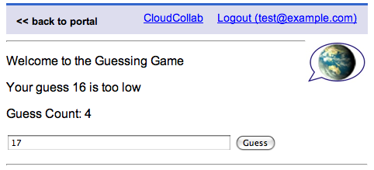

Next we will take a look at handling multiple actions.

Controllers, Actions, and Resources, Oh MY!

The CloudCollab environment is "opinionated" about URL formatting. It enforces a REST-style Model-View-Controller on the URLs. Incoming URLs are parsed and we call utility routines like getFormTag() to generate our URLs in the outgoing HTML. Incoming URLs to the application can take many forms depending on where the markup is being used and whether or not there is a context identifier in the path:

/controller/action/resource
/portal/controller/action/resource
/controller/portlet_div_d1234/action/resource
/controller/12345/action/resource
/portal/controller/12345/action/resource
/controller/12345/portlet_div_d1234/action/resource

You can look at the URLs and generated source form time to time to see the way that the framework generates URLs, form tags, etc. But in general, your portlet should not attempt to parse the self.request.path itself.

The framework knows all the URL patterns and parses the URLs automatically and leaves the values in the self.controller, self.action, and self.resource variables.

When the framework generates the form tag, or other HTML snippets, it accepts keyword-style parameters allowing you to specify the controller, action, and resource values to be put on the ultimate URL.

In the next version of our application, we will add a reset button to reset the game counter back to zero. We could do this as a simple link – but we will do it as a button in the form so it looks nicer:

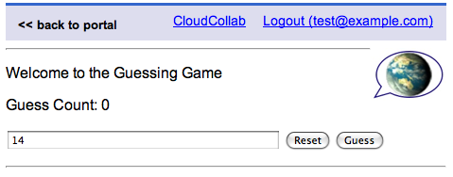

We do not want pressing Reset to submit the form – we want it to be a GET so we request a Form Button. This request is similar to how you would add a "Cancel" or "Apply for Account" buttons to a form as follows:

def doaction(self):
logging.info("doaction action=%s" % self.action)
if self.action == 'reset':
self.session.delete_item('guesses')
return "Guess count reset!"

guess = self.request.get('guess')
. . .

def getview(self, info):
rendervars = dict()

if not info is None:
rendervars['msg'] = info

rendervars['guesses'] = self.session.get('guesses', 0)
rendervars['formtag'] = self.getFormTag()
rendervars['formsubmit'] = self.getFormSubmit('Guess')

rendervars['formreset'] = self.getButton(
'Reset Game Data',
action='reset')

return self.doRender('index.htm', rendervars)

When we come into the doaction() method, we check to see if we are doing the reset action. We log the action for debugging so make sure to add "import logging" to the top of your source file.

If a reset has been requested, we clear the number of guesses in the session and return an approprate message. In the getview() method we add code to generate the HTML for a non-submitting form Button by calling self.getButton() with a parameter of action='reset'.

We then include the HTML for the new "Reset" button in our templates/index.htm as follows:

<p>Welcome to the Guessing Game</p>
{% if msg %}
<p>{{msg}}</p>
{% endif %}
<p>Guess Count: {{ guesses }}</p>
{{ formtag }}
<input type="text" name="guess" size="40">
{{ formsubmit }}
{{ formreset }}
</form>

You might want to display your application in the "portal view" and in the "stand-alone" view and look at the source to see how the Reset button is accomplished. You also might want to view your application with JavaScript turned off in stand-alone iframe mode to see how it operates.

Generating HTML With Helpers

The full call to getFormTag() is as follows:

def getFormTag(self, attributes={}, params={},
action=False, resource=False,
controller=False, context_id=False):

The attributes are a dictionary of tag attributes to be put on the form tag. An example of the attribute parameter might be:

{ 'class': 'myform', 'style': 'color:red; border: 1px, solid, yellow;' }

The params is a dictionary with a set of parameters to be placed on the URL. These will be properly encoded before they are placed on the URL.

The action, resource, controller, and context_id parameters allow you to generate URLs specifying the action, a resource, or even making a url to a different controller. The context_id and switching contexts should generally be ignored unless you are building a portal or content aggregator. The context_id (i.e. placement) must start with a number.

The action and controller strings should not have any slashes in them.

The following are the other URL/Path Generating calls.

def getFormTag(self, params={}, attributes={}, action=False, resource=False, controller=False, context_id=False):

def getButton(self, params={}, attributes={}, action=False, resource=False, controller=False, context_id=False):

def getFormSubmit(self, text, attributes={} ) :

def getAJAXPath(self, params={}, action=False, resource=False, controller=False, context_id=False):

def getAnchorTag(self, text, params={}, attributes={}, action=False, resource=False, controller=False, context_id=False):

The getFormSubmit() generates the submit button and does not take any of the URL setting parameters because the URL for the form is set on the getFormTag() call. The getAJAXPath() is used to generate a path suitable for making AJAX requests back to the application. The AJAX URL can be used for GET or POST.

The getAnchorTag() returns the entire anchor tag including the clickable text. This replaces the <a href=… > structure to make sure we stay in a div if we are in a div.

Looking At the Context Through API Calls

The CloudCollab framework automatically handles establishing the context (i.e. who the user is and which course they are coming from). This is stored in the variable self.context.

There is a set of convenience methods available from the context. You would be well-served to use these methods instead of relying on the underlying contex data model which is described later.

self.context.isAdmin()
Is True if the current user is the administrator of this instance of CloudSocial. This person must be the administrator per the Google App Engine.

self.context.isInstructor()
The current user is the instructor in the current course.

self.context.getUserName()
Looks at the various user fields (not all will be defined) and finds a reasonable short name to display.

self.context.getCourseName()
Looks at the various course fields (not all will be defined) and finds a reasonable short name to display.

self.context.dump()
Returns a string dumping the values in the context.

As experience is gained, further convenience methods will be added.

You can also access the low level data in the course context:

Contents of: self.context.user
course_scoped=False
sourced_id=None
email=test@example.com
firstname=Charles
lastname=Severance
locale=en_US
user_id=test@example.com

self.context.user.user_id
This is an opaque identifier that uniquely identifies this user. This should not contain any identifying information for the user. Best practice is that this field should be a LMS-generated “primary key” to the user record – not the “logical key”. If the LMS uses the “logical key” as the only key for a user then this field may have to be that key. It does mean that that LMS will be unintentionally revealing identifiable information to the external tool through this field.

self.context.user.course_scoped
This is True if the current user is scoped to the current course. This has to do with how the CloudCollab framework handles multi-tenancy. If this is False, it means that the user is scoped within the current organization.

self.context.user.sourced_id
This is an optional field. This is likely to be the “logical key” of the user’s record if the user account is coming from some enterprise source. If the Proxy tool and External Tool share a common source of Student Information Data such as IMS Learning Information Services, this field is the IMS LIS account.

Contents of self.context.course
code=Info 101
course_id=12345
name=SI101
title=Introductory Informatics
sourced_id=None

self.context.course.course_id
This is an opaque identifier that uniquely identified the course that contains the Proxy Tool that is doing the launch. In Sakai this is the siteId. This field is required.

self.context.course.name
This field is optional – it is information for display to the user - it is a short version of the course on the order of 20 characters or less.

self.context.course.title
This field is optional – it is a longer title for the course – on the order of 80 characters or less.

self.context.course.sourced_id
This is an optional field. This is likely to be the “logical key” of the user’s record if the user account is coming from some enterprise source. If the Proxy tool and External Tool share a common source of Student Information Data such as IMS Learning Information Services, this field is the IMS LIS account.

Contents of self.context.org
course_scoped=False
name=SO: Self Organization
org_id=localhost
title=The self-organizing organization.
url=http://www.cloudcolab.com

self.context.org.org_id
Best practice is to use the DNS of the organization.

self.context.org.course_scoped
This is True if the current organization is scoped to the current course. This has to do with how the CloudCollab framework handles multi-tenancy. If this is False, it means that the organization is a known global organization within the instance of CloudCollab.

self.context.org.title
This is a user visible field – it should be about the length of a “line” or 80 characters or less. This should be a name that would make sense to the users of the LMS system if they saw it in a user interface.

self.context.org.name
This is a user visible field – it should be about the length of a “column” or about 20 characters or less. This should be something that would make sense to the users of the LMS system if they saw it in a user interface.

self.context.org.url
This URL should match the org_name and org_title– i.e. if it were used as a link with the org_name or org_title as the text of the link – it should make sense to the end-user.

Setting Header Material For the Result

TODO: Need to specify how to set the title for the portlet and request the loading of particular CSS or Javascript libraries.

For now, the portal-view and standalone view includes jQuery and jQuery Form support.

Adding Your Application to Facebook

TODO: There is an early version of Facebook support in CloudCollab but the support is not yet generalized.

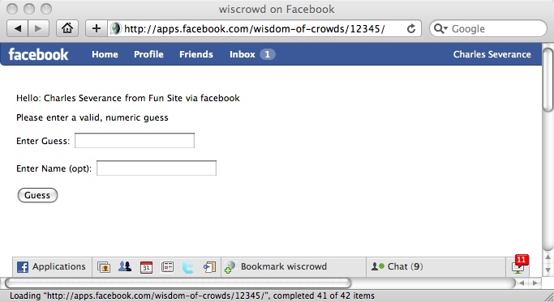

When Facebook support is generalized, this section will go though what you need to do to add an application to Facebook and then connect that application to a tool or tools running in CloudCollab.

Architecture Philosophy of CloudCollab Portlets

The approach here is heavily influenced by the portlet approach used in JSR-168, Web Services for Remote Portlets (WSRP), and Ruby on Rails – particularly the helper pattern form Ruby is the pattern for getFormTag() and its compatriots. Much of the approach is also informed by the architecture of Sakai 1.x, 2.x, and 3.x.

The pattern of these portlets is an attempt to get as much benefit as possible from a framework with as little negative impact to developers. This is still evolving and comments on this architecture are welcome and should be sent to csev@umich.edu.

The word "portlet" is taken from the Java notion of portlet as defined in JSR-168 and JSR-286.
If you need to learn about programming the Google App Engine see www.appenginelearn.com
It would be nice to turn these into Django Template Plugins in some future version when we figure that bit out. It would be more convienent.
At some point I should redo the JavaScript for these buttons to generate more Fluid-like HTML so as to be more accessible.

