Using The Pre-Alpha CloudSocial
Charles Severance
April 18, 2008

Note: CloudSocial is still pre-alpha – we are giving accounts out by request to collaborators. Please join the Google Group for CloudSocial:

http://groups.google.com/group/cloudsocial

This is the best place to get questions answered about CloudSocial.

First, log into api.cloudsocial.org and you will see the following screen:

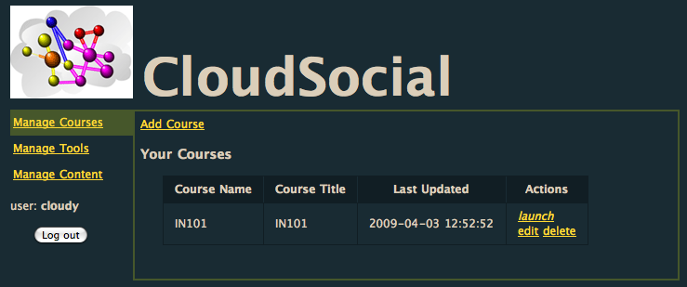

In order to use CloudSocial, content must be authorized via an API Key. You only need one key for all of the content under a domain. Enter the domain and a title and press enter.

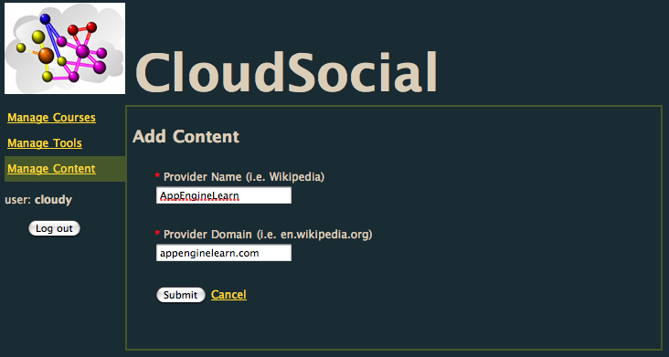

You will be given an API key for the domain.
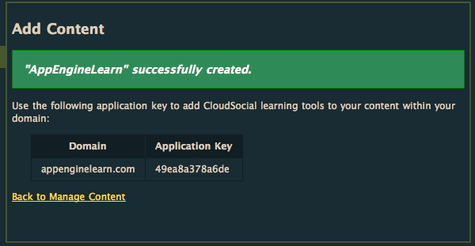

Take this API key and place the following JavaScript in your content pages right before the </body> tag (i.e. near your Google Analytics script if you use Analytics) :

<script type="text/javascript"
src="http://api.cloudsocial.org/js/ile-main.js">
</script>
<script type="text/javascript">
ile_init("49ea8a378a6de");
</script>

Put in your API key in the ile_init() call. As a side note, the CloudSocial run-time currently checks for a valid API key but does not check the domain name at this time. As another side note, "ILE" stands for Inverted Learning Environment.

Next, make a tool. A tool is pretty simple – it is a URL that responds to the IMS Simple Learning Tools Interoperability protocol (simplelti.appspot.com). We have some toy tools up and running to play with at wiscrowd.appspot.com.

Select "Manage Tools" and add a new tool. The name, publisher and description can be anything. The tool url is either an IMS LTI tool or just a web page. If you select direct launch – CloudSocial does not do the LTI protocol to the URL – it just puts the URL into the iframe directly. The direct launch is a nice way to make screen shots and impressive demos really quickly without having to learn and deploy IMS LTI for your tools.
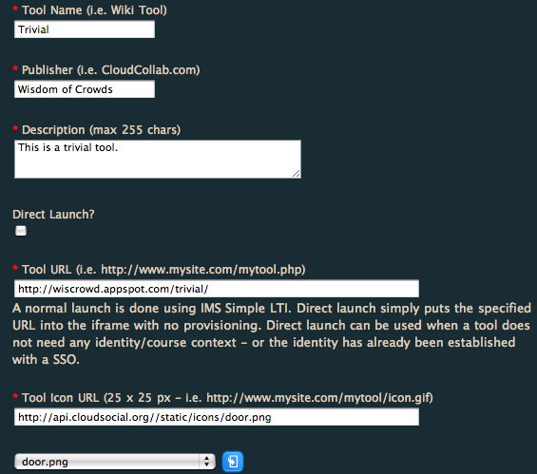

In this example, we are doing a real LTI tool using wiscrowd. We are also picking our tool icon from the stock icons form CloudSocial. The icon url can be any image url from any server if you like.

If you feel like it, you can visit www.tsugiproject.org (a.k.a CloudCollab) and download your own set of sweet IMS LTI tools and build a few more and host them in the Google AppEngine (www.appenginelearn.com).

Once you have saved your tool you can make a course under "Manage Courses" and add a course. The default content will be the URL that your course will go to by default unless the LMS launches through CloudSocial to different content. This URL should have the JavaScript described above installed.

For a basic test, you can use

http://api.cloudsocial.org/sample.php

This has the JavaScript and pre-registered API code (see view source for details).
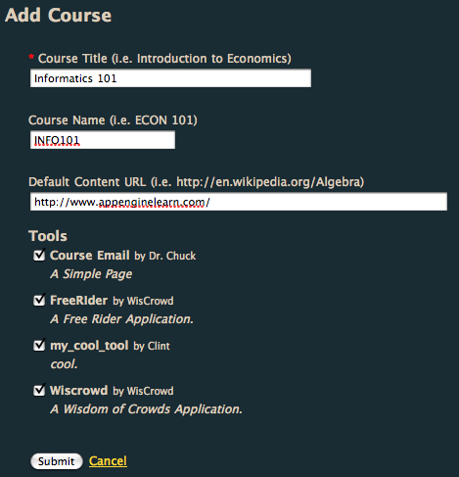

Pick whichever tools you want to use for this particular course.

Once your course is completed and saved, you can launch it from the course listing.

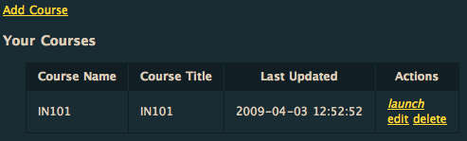

Your course web site should come up with the CloudSocial menu and you should be able to launch tools as shown below:

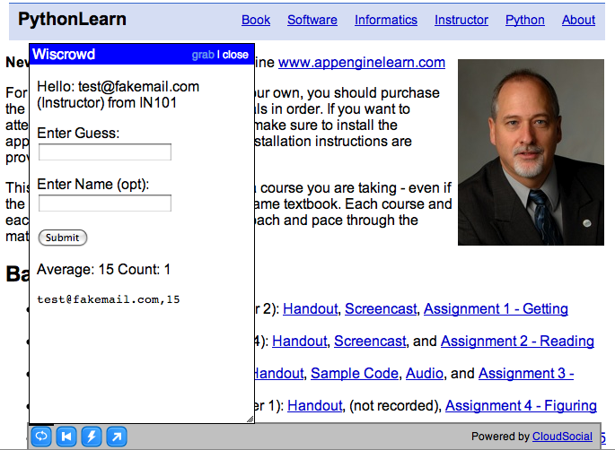

You have now exercised the basic functions of CloudSocial. As you can see we are just getting started.

Next Steps

The "launch" from CloudSocial is not how this is supposed to work – you are supposed to launch content through CloudSocial. But this requires an LMS system that supports IMS LTI. We have modules for both Sakai, Melete and Moodle to do this but so far these modules are generally not available in production systems.

Send a note to the dev list if you need instructions on how to "launch through" CloudSocial from an LMS that supports IMS Simple LTI.

And always, comments welcome.

