**Charles Severance: Research Statement**

**May 7, 2017**

**Overview**

Prior to my hiring as a Clinical Assistant Professor in 2007, I led the project to build the Sakai [1] open source Learning Management System (LMS). Sakai reached a 6% market share [2] in the highly competitive LMS marketplace. Since coming to the University of Michigan, I have been instrumental in developing and encouraging the adoption of standards for interoperability of LMSs with external tools and content. Roughly, this journey involved first engineering the standards and then, in the period following my promotion to Clinical Associate Professor in 2010, evangelizing for adoption for those standards, which involved both technical and organizational efforts. Because of the widespread adoption of some of these standards, we have a marketplace with a large number of third-party add-ons that can be relatively easily integrated into the smaller but still substantial number of LMS systems. In my current research work, I continue to pursue a vision of greater modularity, where individual instructors will be able to easily assemble tools and materials for a course, regardless of what LMS they use.

**Challenge: Engineering IMS Learning Tools Interoperability 1.0**

IMS Learning Tools Interoperability (LTI) is the standard that allows a learning tool (e.g., Piazza or MyMathLab) to be built and hosted outside of a Learning Management System (i.e. Blackboard, Sakai, Desire2Learn, or Moodle) and then “plugged into” an LMS. Prior to IMS LTI, each LMS vendor had their own proprietary way to add a new tool to their system. In most cases, developers were required to pay to join a developer network before they could read the commercial vendor’s integration documentation and start work. Once an LMS supported LTI, not only was the documentation freely available, but a tool developer could build a single LTI integration and have their tool installed in any LMS that supported LTI.

After two previous failed efforts, in 2009 a newly reformed technical working group co-chaired by staff from Pearson and Blackboard proposed a vision for LTI that I thought was too complex to be practical, so I started my own sub-effort that I called “Basic LTI” where I tried to extract the minimum viable subset of their work that could be used as an interim stepping stone to their broader vision. I worked on this smaller document and it was published in 2010 and ultimately was named “Learning Tools Interoperability 1.0”. The larger remaining work effort was retitled as LTI 2.0 and continued to evolve as a draft.

LTI 1.0 [3] was very much a *minimum* viable product. To install an externally hosted LTI 1.0 tool into an LMS, you needed a URL for the tool, and a key and secret which you would enter the LMS. In the example below, my external Python auto grader is hosted at a website that I run on pr4e.dr-chuck.com. The consumer key and secret are recorded in a database at that site, so that when connections come from Coursera using that key and secret, the external tool will be able to use them as part of an authentication protocol. The external tool would reliably be given details about the student’s identity, which course they were coming from, and their role in the course.

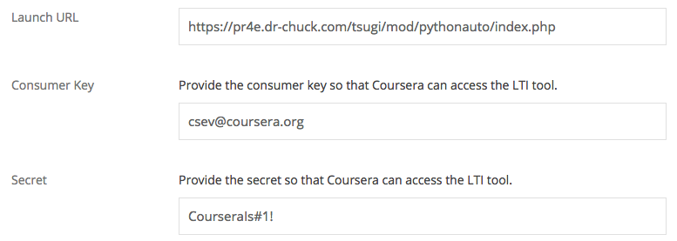

*Coursera LTI 1.0 Authoring Dialog*

I was and continue to be very proud of the LTI 1.0 specification. It represented six years of my effort, hundreds of meetings and presentations as well as many software prototypes built and discarded. LTI 1.0 was simple to understand and I provided open source sample code to implement an LTI 1.0 tool and code to add LTI to a Learning Management System. It was easy enough for tool writers and LMS developers to understand and it provided a simple model for installation and integration.

While the simplicity and limited functionality were key to eventual widespread adoption of LTI 1.0, this did not happen immediately. At the time it was approved, no LMS except Sakai and Desire2Learn [4] had support for the standard, and together they represented only about 12% of the LMS market. Blackboard held over 60% of the market and was in no hurry to adopt the standard.

In addition, the limited functionality of LTI 1.0 meant that even after adoption, there would still be more work to do. One missing critical feature was the ability for a third-party application to return grades back to the LMS.

I was promoted to Clinical Associate Professor in 2010. My research efforts since then have largely been devoted to evangelizing for adoption for LTI 1.0, which involved both technical and organizational efforts, and to developing follow-on protocols and services that addressed the missing features of LTI 1.0.

**Challenge: Learning Tools Interoperability in 100% of the Marketplace**

I added a simple grade return web service protocol to LTI and published it as LTI 1.1 in March 2012. LTI 1.1 was the first version of LTI that was truly a viable “minimum viable product”. 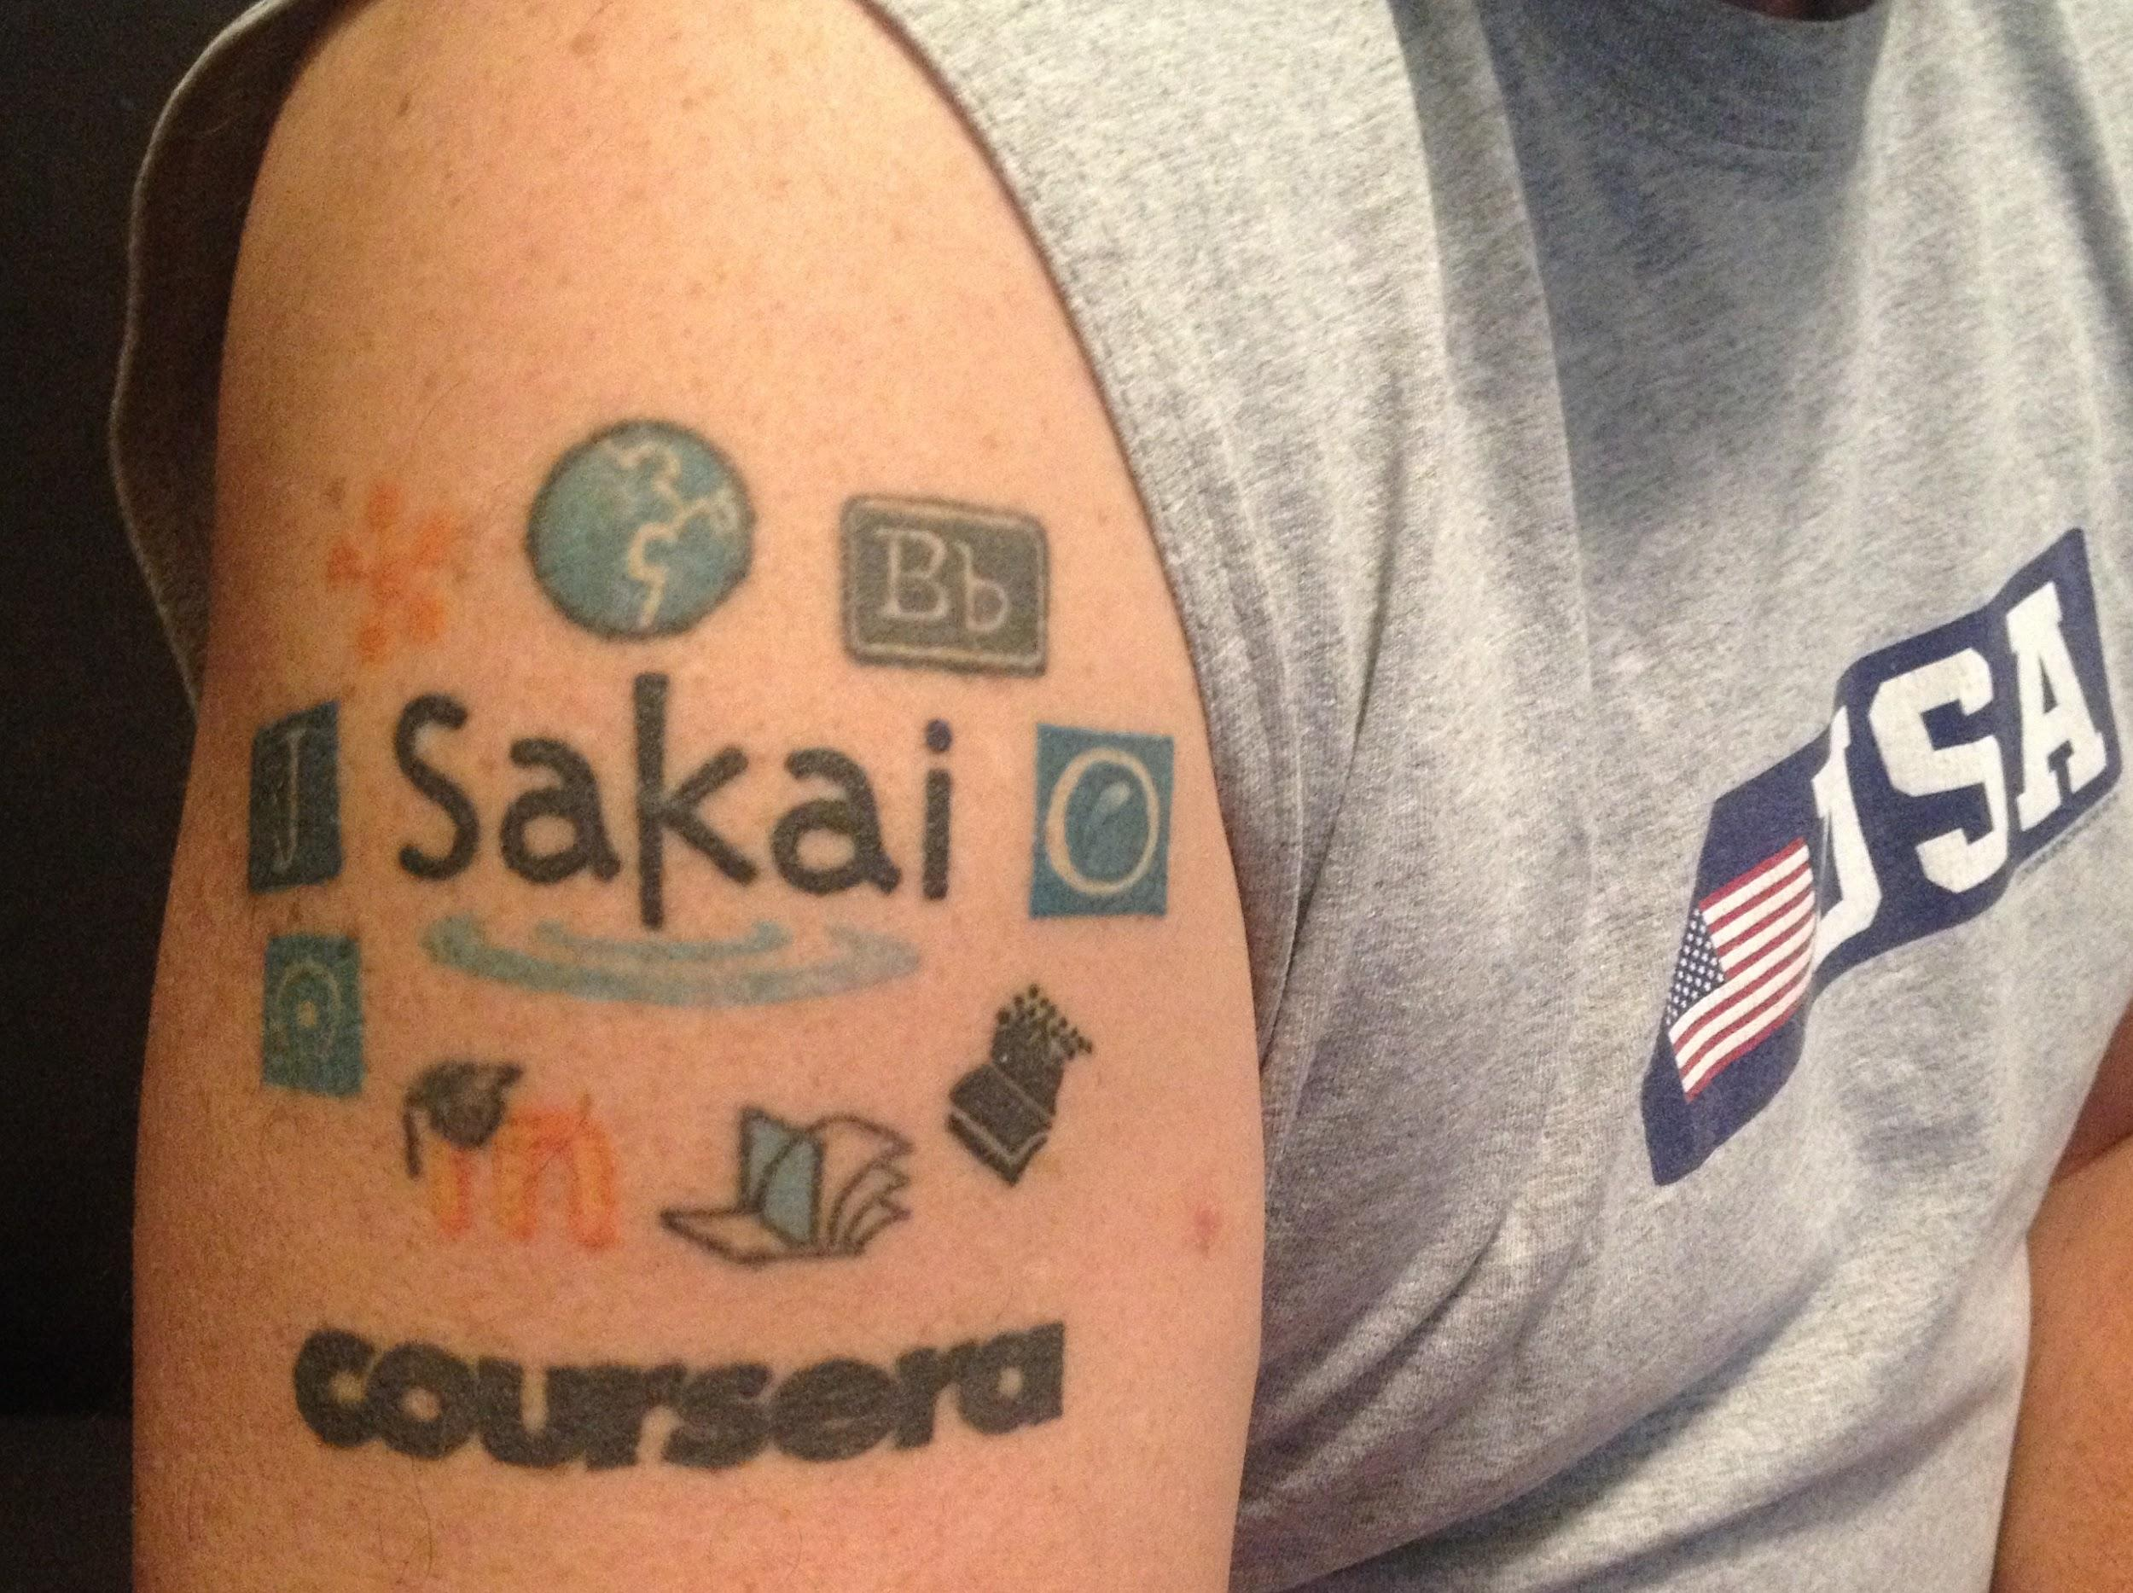

Once LTI 1.1 was released, I personally wrote and contributed an LTI 1.1 implementation for several popular open source LMS systems including Moodle [5], ATutor [6], and OLAT [7]. I wrote the IMS certification suite [8] used to test and certify LMS systems and tools as meeting the specification. The certification suite ran a set of tests on the candidate software and issued the a compliance certificate once the software passes all the tests. By providing certification of LMS systems and external tools, users were assured that the certified products would work well together.

I continued to attend meetings and gave numerous presentations [9] to encourage vendors to adopt LTI. As part of my “marketing push” for LTI 1.1 adoption, I publically promised all the major LMS vendors that if they would implement the LTI 1.1 standard and pass certification, that I would tattoo their logo on my right shoulder. I called it “The Ring of LTI Compliance” [10]. Ultimately 11 vendors were added to my tattoo with the most recent addition being Coursera when I helped add LTI 1.1 support to their platform in 2014.

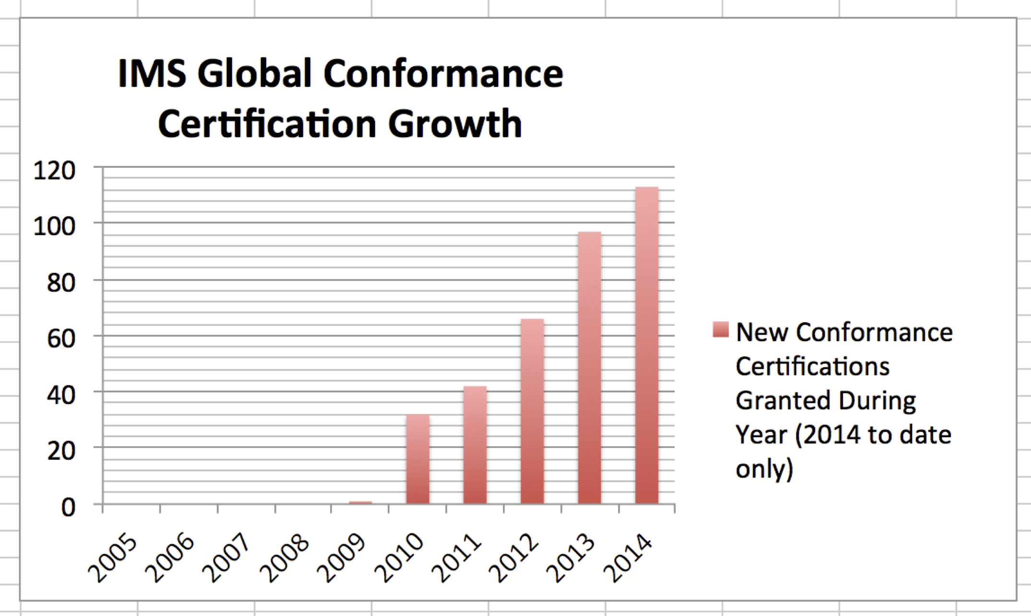

**LTI Certification Growth**

There are about 400 tools and LMS systems that are currently certified as compliant with LTI and the numbers continue to grow.

Once LTI 1.1 was solidly successful, I stepped back and let others take leadership roles in the evolution of LTI. I participated in the LTI 2.0 effort, building the first LMS reference implementation of the far more complex specification. Even though LTI 2.0 was completed and published in 2014 [11], its market adoption is quite limited because of unnecessary complexity. My Sakai LTI 2.0 implementation is one of the few LMS systems to achieve LTI 2.0 certification - even three years later. There is some hope that LTI 2.1 will be released in 2017 and will see better market uptake.

I still participate in the IMS LTI working group and am the only member of the working group that was one of the original founders in late summer 2004. In 2017, I received the William H. (Bill) Graves Leadership Award [12] for having “..made an extraordinary difference in realizing the mission of the IMS Global Learning Consortium”.

**Challenge: Best Practices in Using Standards**

Since 2008, I have been the “mentor” for well over 100 companies, university projects, and LMS vendors as they added LTI support to their applications. In the beginning, I was just glad to see more tools using LTI, but over time it became increasingly frustrating that almost no one ever had time to use LTI in an elegant manner. I saw flashes of brilliance in a few LTI implementations, but most of the tools treated LTI as just another “single-sign-on”. Tools also never bothered to re-style themselves to achieve a seamless look-and-feel between the tool and the LMS.

So while we had lots of LTI compliance and lots of innovative tools were available to instructors using LTI, it was getting a reputation of being ugly and clunky.

So in 2013, I started my Tsugi (Japanese for next - 次) project - [www.tsugi.org](http://www.tsugi.org) with an eye to building a software library and framework to capture best practice around using LTI and other IMS specifications. With the Tsugi library, tool developers would no longer need to read IMS specifications. They would simply use Tsugi’s APIs and they would be able to produce functional, performant, compliant, and beautiful LTI applications.

I used Tsugi initially to develop a set of LTI tools to support rich assessments for my Programming for Everybody (Python) MOOC in Coursera (2014) [13]. My first two external tools built using the Tsugi library were a Python auto grader and a Peer grading system. These tools have been in production since 2014 supporting over a million students in my Coursera MOOCs.

Tsugi has evolved into both a set of run-time libraries for LTI tools as well as a hosting environment where these tools can be installed, hosted, and managed. Tsugi’s goal is to lay the groundwork to enable an “App Store for Education” where instructors search for tools, find them and pull them into their courses within their LMS systems as easily as one adds a new application to an iPhone.

Increasingly, as companies or developers ask me for guidance using LTI, I tell them either to just use Tsugi or read the Tsugi source code and when they understand it completely go ahead and do their own implementation.

**Challenge: Next Generation Digital Learning Environment (NGDLE)**

In 2015, many thought leaders in the educational technology space began to imagine that the market for learning technology was on the cusp of a significant transformation. The idea is that an enterprise-wide monolithic Learning Management System (LMS) is slowly giving way to a Learning Technology Platform [14] - a Next Generation Digital Learning Environment made up of portable, interoperable, and component-based elements of software and content. The vision was that the market would move toward a place where applications and content are chosen from a diverse ecosystem of "Application Stores" and "Content Repositories" and seamlessly composed to make learning experiences.

Also in 2015, my university decided to switch from Sakai to Canvas as our enterprise LMS. While this was personally disappointing to me, I used the LMS transition as my own experimental Next Generation Digital Learning Environment laboratory. I decided I would build a “personal learning object repository” where all of my educational content and tools would be hosted *outside* of the LMS and integrated into the LMS using Learning Tools Interoperability, Common Cartridge, and IMS Content Item [15]. I felt that this approach would make it so I would barely notice whether I was teaching in Sakai, Canvas, Coursera, edX or any other learning system. Instead of “authoring a course” in each platform - I would just link existing course elements into the new platform.

This research effort became my Koseu (Korean for course - 코스) project - [www.koseu.org](http://www.koseu.org). The idea of Koseu is to manage all my course materials and Tsugi applications in GitHub. I would include a bit of metadata in GitHub that described how all the learning objects fit together to form a course. These materials would then be hosted on a web site along with the Koseu and Tsugi software. Using LTI, Common Cartridge, and Content Item, these materials would be imported into whatever LMS I was using at the time.

I used this approach from Fall 2015 through Winter 2017. It took no more than 10 minutes per week to import each week’s content into Sakai or Canvas. Further, I could share a single copy of my content and autograders between my on-campus courses in Canvas and Sakai and my MOOC courses on Coursera.

Koseu and Tsugi are incubating open source projects in the Apereo Foundation - [www.apereo.org](http://www.apereo.org). My hope is that, by providing a concrete example, they will help to inspire the transition to a more modular, Next Generation Digital Learning Environment that other thought leaders and I have envisioned.

**Looking Forward**

My focus over the past 3-4 years has moved away from engineering and evangelizing new interoperability standards for learning systems and toward making the best possible use of those standards to enhance teaching and learning at scale.

The new architecture for a learning platform (NGDLE) is emerging and I expect to work to stay at the forefront of whatever is coming next. At this point Tsugi and Koseu are both at a very early stage of development and yet they are the best example of a deeply-integrated learning object repository and learning application store using standards.

The Sakai Foundation experienced financial difficulties [16] in 2010 and I joined the board of directors to help find a solution. For the next three years, I was part of a transition team that defined and created the Apereo Foundation [17]. Apereo was a broader non-profit and covered all of open source in higher education (i.e. the equivalent of the Apache Foundation, but for education). Sakai joined the new foundation as one of many open source projects. I am now the chair of the Sakai Project Management Committee (PMC) [18].

Sakai has an important role to play in exploring the NGDLE going forward. An essential cornerstone of the NGDLE is that LMS systems form an important part of the new NGDLE learning ecosystem, but those LMS systems must evolve to accept more and more functionality and content from external sources.

Canvas is increasingly satisfied with the status quo in the marketplace given that in 2016, Canvas was selected for 77% of the new LMS installations and soon will have the largest LMS market share, rapidly eroding the Blackboard (#1) and Moodle (#2) market share. History has shown that once an LMS vendor solidly controls the largest market share and can comfortably sit on a billion dollars of revenue, they switch from the role of “disruption through innovation” and to the to the role of “defend the status quo”. When this happens, Sakai will once again move into the role of the “small feisty innovative disruptor”.

Working at the nexus between Sakai, Tsugi and Koseu puts me in a strong position to influence the next phase of the LMS market. Going forward I want open source implementations of the NGDLE to be the first products in the marketplace. When we founded Sakai in 2004, we were already seven years behind Blackboard’s market leading LMS. Going forward, I want to accelerate innovation toward the NGDLE so that the open source Tsugi, Koseu, and Sakai are the market-defining products in this emerging market.

**References**

I keep these in a separate document for now.

<https://docs.google.com/document/d/1EquY0ESsOscB32QPLmNTgjhwJ0FLkqPnLi3GNHfmoHk/edit>