Chapter 5: Sharing Your Internet Connection
For many households, sharing a high-speed Internet connection is a primary motivation for building their home networks. Sharing a fast pipe to the Internet allows every PC in the home to participate in the broadband experience. Some households may not yet have a broadband Internet connection, but still will choose to share a single dial-up modem connected to a single computer. In previous chapters we have explored your options for getting Internet service to your home, and we have explored how to build a basic home network. In this chapter, we will tie these concepts together, and explain how to share your Internet connection over your new home network.

There are four basic approaches to sharing your Internet connection:

- Rent additional addresses from your ISP.
- Use a specialized hardware router/gateway intended for the residential market.
- Use built-in features of your operating system to set up a gateway computer.
- Use third party routing software on a gateway computer.

Let’s explore each of these approaches.

Approach 1: Rent Additional Addresses From Your ISP

If you have an “always-on” Internet connection – the kind of connection offered by cable modem and DSL providers – then a very simple option is often available to you. Your provider may allow you to “rent” additional addresses for a small monthly fee.

Usually this entails only a small increase in your overall monthly fee; typically it’s about $5.00 per additional address. Many providers will provide up to four additional addresses for your home.
If you choose this approach, sharing your connection among multiple computers is quite simple. Typically, your provider will have given you a cable or DSL modem with a single Ethernet port; instead of running an Ethernet cable from the modem to a single PC, you will connect that port to your Ethernet hub/switch, and in turn you will run additional Ethernet cables from the hub/switch to each of the additional computers in the home. Many hub/switches have a special port intended for connecting to other network devices such as your broadband modem; often this port will be labeled “Uplink” on the hub/switch. In other cases, the hub/switch may have a port with a switch next to it that allows the port to become an Uplink port.
In some cases, your cable or DSL modem may come with additional ports, so that you need not bother with an external hub or switch. You simply plug each computer’s Ethernet cable into an available port

The additional addresses are the maximum simultaneous addresses you can have active at any one time. In most cases, you will pay for the additional IP addresses you subscribe to regardless of how often you use the additional addresses in a given month. If you sign up for four additional addresses at $5.00 each, you’ll pay the $20 premium even if you only use one computer during the month.
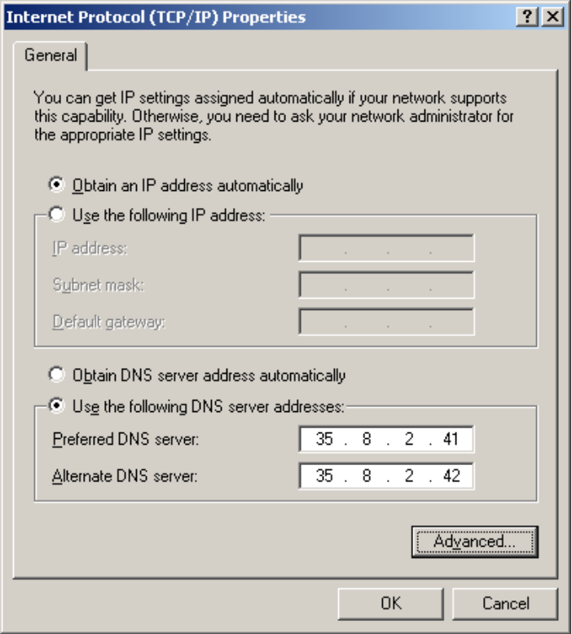
Whether you have a single computer to connect, or multiple computers, your ISP will determine whether you use static (or “fixed” IP addresses, or whether you are assigned dynamic addresses. When you have static addresses, you are told what IP address is “yours;” the same address(es) will be used by you for the life of your subscription to that provider’s service. For instance, an address such as 198.109.162.194 might be assigned for your first computer. You will type the assigned address into a configuration screen in your operating system, and the computer will “wake up” knowing that it “owns” the assigned address every time you reboot the computer.
Many home networkers prefer static IP addresses because they make it easier to play real-time Internet games; they make it easier to connect using real-time desktop conferencing programs such as NetMeeting or CU-SeeMe; in some cases, you may be able to run a Web or FTP server in your home with your static IP address. (Many ISPs discourage or forbid home broadband subscribers running servers on their networks.)
However, your provider may charge a premium for static IP addresses, or may simply not offer this option. When you use the alternative, dynamic addressing, each computer that you connect to the network will have its address assigned as it boots. You will configure each computer to request an IP address at startup, and the ISP will provide the IP address via the broadband modem to each computer as it makes that request. An Internet standard called DHCP (for “Dynamic Host Configuration Protocol”) makes this all possible. In theory, every time you reboot a given computer, it might be assigned a new address. In practice, many DHCP services tend to re-assign the IP address your computer used most recently.
Some providers may offer a hybrid option, in which a single static address is offered for one computer, along with up to three additional addresses assigned dynamically. Because there is the number of IP addresses available to all ISPs worldwide is finite, most providers’ offerings for home subscribers discourage static IP addressing in favor of dynamic addressing.
If most of your Internet usage involves e-mail, Web surfing, downloading files, and the like, you may not care one way or the other about static versus dynamic addressing. Some people actually prefer dynamic addresses, because your computer is somewhat less visible as a target for hackers when its address changes from time to time.
Obtaining additional IP addresses from your ISP may be very appealing because of its simplicity. However, you may want to consider the next option, using a cable/DSL router, if you have several computers to connect, especially if you expect to continue to share your broadband pipe for many months.

Approach 2: Use a Broadband Router to Share Your Connection
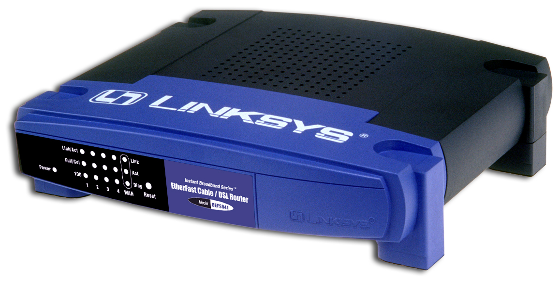
A home broadband router, sometimes called a Cable/DSL router, is a hardware device that serves as the connection point between your broadband modem and your home network. (Sometimes these devices are called “broadband gateways” or similar terms.) Vendors such as Linksys, D-Link, and Netgear were the first to offer home broadband routers at popular prices. Mainstream networking vendors such as 3Com and Intel also offer broadband routers; Apple also has popular home router products. Originally retailing for $250 or more, today basic versions of these devices are commonly available at prices under $100. At such low prices, a broadband router is a very attractive alternative for sharing your broadband Internet connection:
- At today’s prices, a broadband router can pay for itself in less than a year by allowing you to avoid fees from your ISP for multiple IP addresses.
- Broadband routers act as firewalls, providing a considerable improvement in security compared to exposing your home computers directly to the Internet.
- Compared to dedicating a PC as your connection sharing device (discussed later in this chapter), a broadband router can be more reliable, simpler to administer, and far easier on your electric bill.
- Most ISPs are only willing to offer four IP addresses per household; if they offered more than that number, they fear subscribers would use the broadband pipe to support a business. Your broadband router can theoretically share your high-speed pipe among 50 or more computers. In practice, very few homes will have 50 PCs on the network, but with multiple PCs, laptops, and a growing range of IP-enabled devices, many homes will need more than four IP addresses at a time.
- Some ISPs limit the operating environments they support; they may not support the Macintosh, or they may not support Linux. Your broadband router provides your home network with a standard IP network, usually via Ethernet, so that any device you possess that is designed to support Internet standards can join the network.
- Broadband router/gateway devices store their configuration in non-volatile EEROM, so that if there is a power outage, they simply come back up in a few seconds or so with the configuration intact.
- You do not have to administer software on a broadband router; you do not have to install, upgrade, or maintain software components. This makes life simple. (However, most router/gateway units allow you to upgrade their internal software over the Web, allowing you to take advantage of new features or bug fixes).
In brief, we highly recommend broadband routers for sharing your high-speed Internet connection.

Network Address Translation
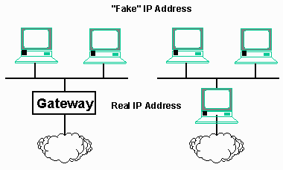
When you choose the broadband router option, you will tell your ISP or broadband provider that you only need support for one Internet device. In turnm your ISP or broadband provider may assign you a single static IP address, or they may give you the right to obtain a single IP address using DHCP. In either case, your broadband router will perform a bit of magic in order to extend your network to multiple computers. This magic is known as “network address translation” or “NAT.”

In a nutshell, your broadband router/gateway will take the one IP address assigned by the ISP, and use that address for all communications to and from the provider – and hence to/from the global Internet. Within your home network, your router/gateway will communicate to each of your computers using specially-assigned IP addresses. The end result is each of the computers on your network behaves as if it has its own direct Internet connection, but the outside world only “sees” the IP address that’s assigned to your router/gateway device.

The addresses that you assign to the computers within your home network only need to be consistent within your local area network. In theory, you could use any range of IP addresses for your home network. However, at some point, there is a very small possibility that an IP address that you have randomly chosen might conflict with a real IP address. This would lead to confusion between local addresses and well-known addresses on the global Internet. For instance, if you chose a local address that happened to correspond with, say, whitehouse.gov, your computers wouldn’t know how to connect to that famous Web server. While this might only happen once in several hundred million connections to the Internet, it is a situation to avoid.
Fortunately, the designers of the Internet anticipated this problem. They reserved several special address ranges for this purpose. These ranges are called non-routable addresses. These special addresses are handled differently by the routers that move traffic from place to place across the Internet. Internet routers, including your home router/gateway, will not route packets identified as non-routable across the global Internet.. They assume that traffic to or from non-routable addresses are intended only for local consumption.
The following are the standard non-routable IP address ranges:

10.*.*.*
172.16.*.* through 172.31.*.*
192.168.0.* through 192.168.255.*

Under network address translation, computers on the local network use addresses to communicate with one another – or to send traffic to the global Internet. Any traffic intended for computers on your home network will be automatically sent or received to those local computers. However, any traffic intended for the global Internet will be intercepted by your router and translated. For instance, a home network might have ten computers assigned addresses from 192.168.1.100 through 192.168.1.109. Let’s assume the computer that has been assigned 192.168.1.105 requests the home page for whitehouse.gov. The router/gateway will see the request and translate it, forwarding the request to the whitehouse.gov server, but under the unique IP address assigned to the router itself. As far as whitehouse.gov is concerned, the request came from the router; it has no idea that the computer that your have assigned 192.168.1.105 even exists. When whitehouse.gov sends the home page back, your router will forward the packets that make up the page back to the local 192.168.1.105.

These non-routable address ranges may be used by many different homes – or even large corporations – for internal purposes. Each organization will use some sort of translating gateway to connect to the Internet, allowing all of its computers to send and receive data over the Internet. This ability to employ translating gateways allows far more computers to use the Internet at once than the number of possible unique IP addresses. The process is somewhat analogous to local extensions within a business telephone system. Only one phone number is advertised to the external world, but every employee has a telephone on his or her desk that can make or receive telephone calls. The difference is that the “local extension” numbers for your home network will always be invisible to the outside world – the global Internet. Your router/gateway takes care of managing which packets are destined for which computer in your home network.

You will notice that addresses of the form 192.168.1.* are used quite a bit in the examples throughout this book. That range of addresses is commonly chosen by vendors of home networking devices that perform network address translation, such as router/gateway devices. (Incidentally, the
10.*.*.* address space, which is seldom used in home networking, is so large that an entire corporation could use the addresses internally for about 16 million computers. This could be accomplished with a single – but very large – address translating gateway.)

It is not necessary for you to understand the exact mechanics of how network address translation works in order to set up and use your home gateway/router. Those readers who desire a more complete understanding of the process may wish to refer to Appendix D.

Setting Up a Home Broadband Router
Setting up a broadband router/gateway for your home network can be surprisingly simple. Here is an overview of the typical process:
- Sign up for broadband service, and have your cable or DSL modem installed. You may wish to install the service on a single computer in your household, following the standard instructions your ISP gives you. This will verify that the broadband service is functional.
- Purchase a cable/DSL router. These devices are available at popular consumer electronics stores and are also available from catalog or Web vendors of computer accessories. If you have not already built a home network, you may wish to buy a cable/DSL router that also acts as a multi-port switch. If necessary, buy additional Ethernet cables.
- Connect an Ethernet cable between your new router/gateway and the cable/DSL modem. Your router may have a port labeled “WAN” for “Wide Area Network;” connect from this port to the Ethernet port on the cable/DSL modem.
- Connect an Ethernet cable between at least one of your computers and your new router. Open a Web browser. Point the Web browser to a special address defined by the vendor; a typical address would be http://192.168.1.1. (Does that address look familiar? It’s one of the “non-routable” addresses we described above. Your router may be pre-configured to look for a Web connection at this address.) You will use your Web browser to set up and manage your router. Log into your router’s configuration screens using its default password.
- Follow the vendor’s instructions to configure the router. You may have to enter certain information unique to your broadband service provider’s service offerings.
- Configure each computer on your network to connect to the router. Typically you will set each computer up to ask for its IP address using DHCP.
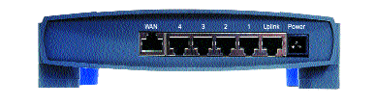
This photograph shows the set of Ethernet ports provided on a popular cable/DSL router from Linksys. The router offers a WAN port for connecting to your broadband modem, four ports for connecting to individual computers, and an Uplink port, for optionally connecting to another hub or switch. With the Uplink port, you could extend your network to support a large number of computers or other devices.
All of the ports on this router are standard Ethernet ports. All of these ports accept standard Ethernet (10baseT, or twisted pair) style cables. You connect to the modem, or to your computers, or to a hub/switch, using standard Ethernet cables. Linksys and other vendors offer cable/DSL routers in a variety of other configurations:
- Single port: The router/gateway has only two Ethernet ports: one to connect to your broadband modem, and one Uplink port to connect to a hub or switch to serve other computers.
- Non-Ethernet Wired Connections: Instead of Ethernet ports, the router might provide other kinds of connections. For instance, it might provide one or more HomePNA ports, so that you can connect to computers in other parts of your house over existing home telephone wiring. (In this case, those computers in remote rooms in your house will use HomePNA adapters instead of Ethernet adapters, and they will connect to telephone wiring in order to communicate with the router.)
- Wireless Options: Instead addition to Ethernet ports or other wired ports, the router might have built-in support for an in-home wireless network, such as IEEE 802.11b. Such routers feature rabbit-ear style antennas in order to send and receive data over radio waves. (In this case, any computers connecting wirelessly will also have special 802.11b adapters with their own built-in antennas.)
Here is an example of the main configuration screen for the basic Ethernet-based Linksys router/gateway in our example:
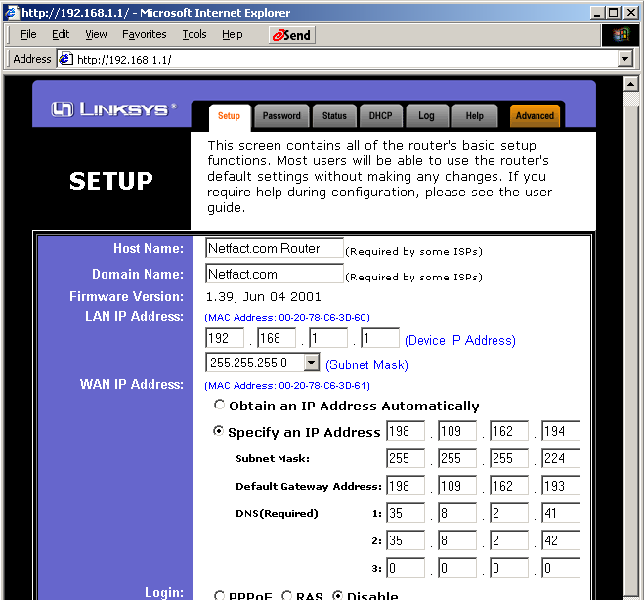
Let’s examine some of the settings on this configuration screen. The “Host Name” and “Domain Name” are optional; you might have to set these to correspond to values given by your service provider.
The “Device IP Address” is the IP address that will be used internally in order to communicate with the router itself from other computers on your home network. In this case we’ve left the value at the default of 192.168.1.1.
In this case, the service provider has supplied a static IP address for the customer to use (presumably for a single computer, not for our router/gateway). We provide the ISP’s supplied address in the appropriate boxes. In case your provide uses dynamic addressing, which is perhaps more common unless you have paid extra for a static IP address, you would select the radio button next to “Obtain an IP Address Automatically.”
The bottom portion of this configuration screen has additional settings that you may have to specify when connecting with some broadband providers:
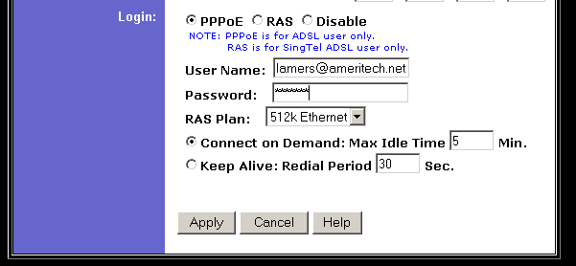

The “Logon” section of the configuration panel applies when your ISP requires you to log onto the broadband service.

For instance, many DSL providers use a protocol called PPPoE (“Point to Point Protocol over Ethernet”) to send and receive TCP/IP data over the DSL connection. You would click the radio button for PPPoE, and fill in the user ID and password supplied by your broadband provider. “Connect on Demand” would be a typical setting for this environment. If a DSL connection is not already active, it will be opened when one of the computers on your network initiates Internet traffic. The process of logging into your PPPoE connection is very fast – so fast that you will probably not even notice as the login takes place. (You can visit the router’s “Status” screen to see if the router is currently logged into your DSL service.) Most cable modem providers do not employ PPPoE (as of this writing in any case); you would leave the radio button at the default of “Disable” in that case.
The following configuration screen determines whether your router will assign IP addresses to computers on your network, or whether you will assign addresses manually yourself.
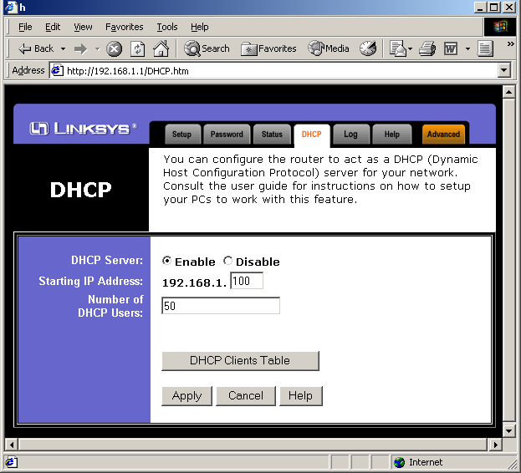
In this case we’ve configured the router to assign IP addresses to computers on our network. It will respond to DHCP requests as your various computers are booted, assigning up to 50 addresses starting at 192.168.1.100.
It is your choice as to whether you want the router to assign addresses to computers on your home network, or whether you want to do so manually. If you have a variety of computers on your network – and especially if you have computers such as laptops that enter and leave your home network from day to day – you may find it most convenient to let the router assign addresses. (In particular, if your laptop computer moves between a home network and a work network, it may be more convenient to set up the laptop for dynamic addressing in both environments.)
On the other hand, if your home network itself is static – if you have a handful of computers that don’t come and go – you may wish to assign addresses yourself. You will assign addresses in a nonroutable address range – typically 192.168.x.x – on each of the computers on your network. You’ll need to keep up with which computer has been assigned which address.
Your broadband router may have a feature that allows you to “expose” a single computer on your home network to the Internet. In effect, the router will forward any traffic destined for the address that your ISP assigned to your account to the computer you specify. Some routers such as those from Linksys refer to this one special computer as the “DMZ host” (a reference to the military abbreviation for “demilitarized zone”). Typically this option makes sense when your ISP has assigned you a static IP address, and when it allows you to run a server. In this case you also will probably want to assign a static local address to the computer that will field such requests. The configuration screen for this feature is quite simple:
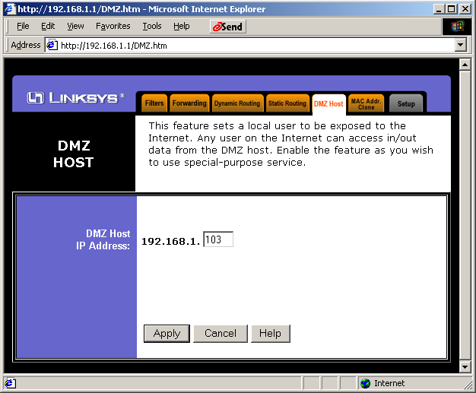
Some broadband routers may provide a more sophisticated mechanism for “forwarding” requests to computers on your network. This feature allows you to forward specific kinds of requests to specific hosts on your network. For instance, suppose you run an FTP server and a Web server on your home network. You might configure your “port forwarding” in this manner:
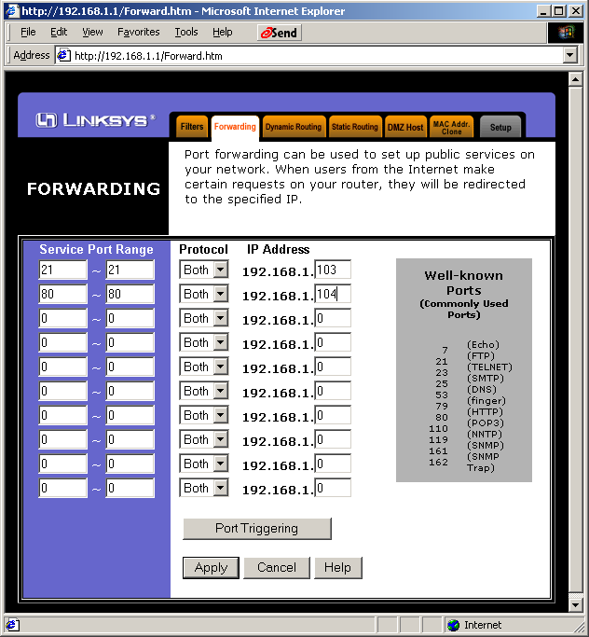
Here we specify which services go to which computer on your network by following the convention of how Internet “ports” are assigned to services. By convention, TCP port 21 corresponds to FTP services, and port 80 by default corresponds to Web services. In this sample screen, we have specified that port 21 requests will be handled by the computer on your home network that has been assigned the local address 192.168.1.103, and Web requests will be fielded by the computer assigned the local address 192.168.1.104. Obviously, this is a rather advanced application to which most home networks won’t aspire.
For home networks connecting to ISPs over ISDN there are special router products as well. The 3Com OfficeConnect LanModem (3C892) is a popular example. This unit connects to an ISDN line and offers a built-in 4-port Ethernet hub for connecting to your home computers and provides two POTS connections for a FAX or old-style telephone. It provides NAT and DHCP services for the computers on your home network.
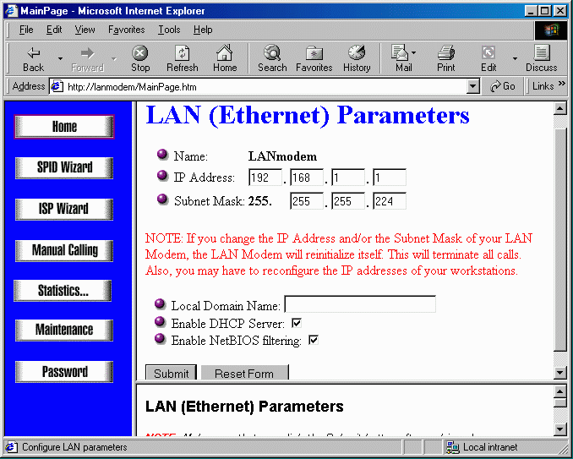
The Apple Airport unit is a very flexible and inexpensive home network gateway. It performs the same functions as the 3Com Office Connect except that it utilizes a standard analog modem. In addition to acting as a router, the Airport also has a wireless network card built-in and can act as the gateway between your wireless network, Ethernet network and the modem connected to the Internet.
To configure the Airport, you must use software which is provided for Macintosh computers. Even though the Airport must be configured using a Macintosh, its routing and wireless gateway are completely standard so they both can be used by Macintosh and PC computers. The following screen configures the basic LAN parameters. In this example, we configure it to use DHCP and NAT. The Airport can be configured to serve DHCP addresses on the wireless network, both the LAN and the wireless network, or not serve DHCP at all.

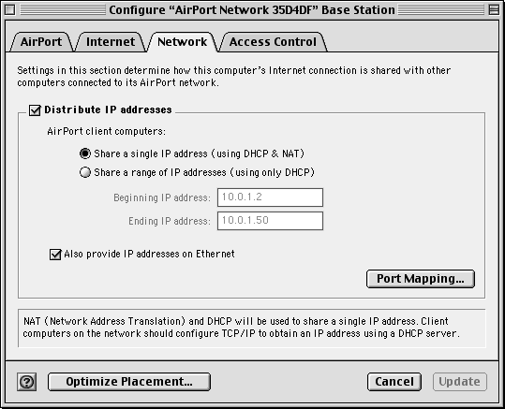

Approach 3: Use Operating System Internet Connection Sharing

Another way to share your Internet connection among the computers in your home is to use sharing features built into your operating system. For instance, recent versions of Windows include a feature known simply as “Internet Connection Sharing” (or “ICS”) that provides functionality similar to that provided by a hardware broadband router/gateway:

- ICS provides IP addresses to other computers on your home network, responding to their DHCP address requests.
- ICS provides Domain Name System service for other computers, fielding lookups for local computers on your network, and forwarding requests for host names on the global Internet to your ISP’s domain name servers for resolution.
- If you connect to your ISP via a modem, ICS automatically dials your ISP’s modem pool when any of the computers on your home network initiates Internet activity.

Windows ICS can support a mixed-platform network; for instance, you could have Windows, Macintosh, and Linux computers relying on a single Windows PC running ICS for their Internet connectivity. ICS was introduced in Windows 98 Second Edition, and is part of the ME, 2000, and XP editions of Windows.

Unfortunately, the steps involved in setting up ICS vary among the various versions of Windows. The good news is that Microsoft has added “wizards” to Windows ME and to Windows XP (home and professional versions) to simplify the process of setting up ICS. The process is simple.

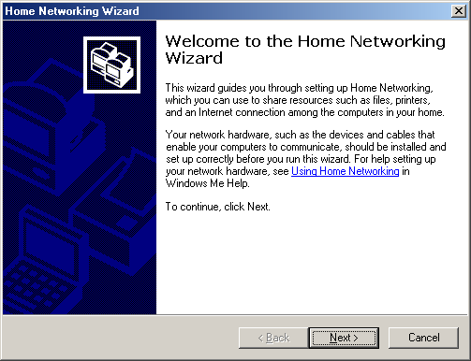

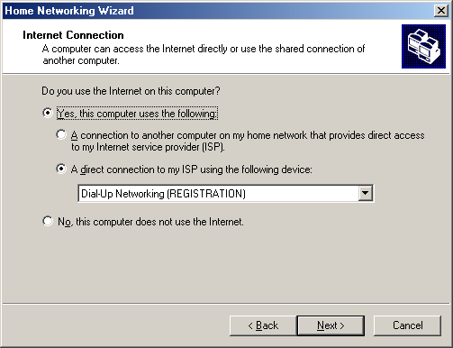

Next, you specify how to log onto the Internet from the gateway computer:

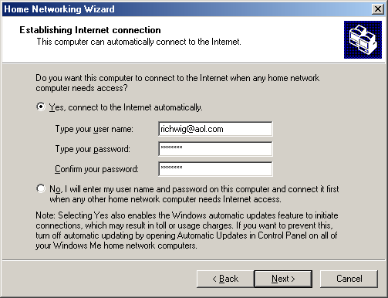
Next you can have the gateway computer create for you a floppy disk that you will then use to set up the other computers on your network. These computers can be running any version of Windows since Windows 95.

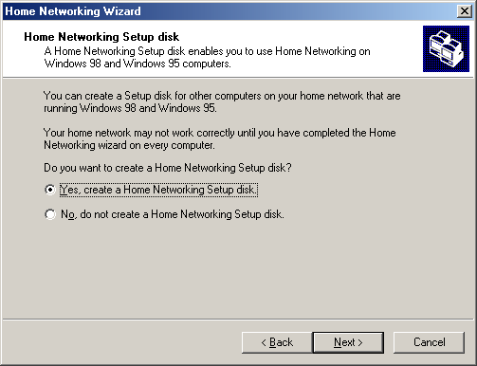

In practice we feel this floppy-based setup process is not the best approach for our readers. It is quite simple to configure each computer on your network to obtain its own IP address automatically; if you do this simple process by hand, you will have greater command of how your network functions. (Plus the setup floppy won’t work on Mac or Linux machines you may have.) For “client”sharing computers running Windows, this means simply specifying “Obtain an IP Address Automatically” so that upon startup each PC will ask for an address under DHCP. Similarly, for Mac, Linux, or other client computers on your home network, enable DHCP as you would if you shared using a broadband router/gateway.

When you finish with the Home Networking Setup Wizard, you will probably need to reboot the gateway computer.

Of course, Windows isn’t your only option for computer-based sharing of an Internet connection. Computers running Linux can serve this function very well. Or, as we discuss in the next section, you may choose to use third-party software on an computer –Windows, Mac, Linux, or otherwise.

Approach 4: Connection Sharing with NAT Software

We have seen how to share your Internet connection using services provided by your ISP, or by using a hardware router/gateway box, or by using Internet connection sharing features of your operating system. Now let’s consider a fourth approach: sharing your connection with specialized gateway software.

This approach is quite similar to using built-in operating system sharing features. You might use third-party gateway software in order to exploit special features beyond those of your operating system, or if the computer you are dedicating to the gateway function doesn’t run an operating system with built-in connection sharing.

Two popular sharing programs are Sygate and Winroute.

Installing and configuring this software is relatively straightforward (especially if you have been reading carefully up to now). We will take a look at a few of the configuration screens of the Sygate package performing network address translation between a phone modem connection and the home LAN.
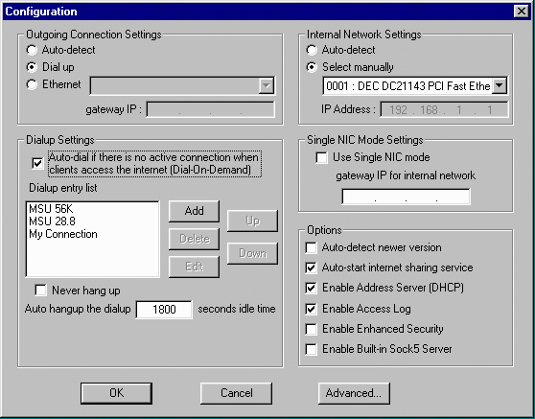
The Sygate configuration screen is logically laid out, with the left hand side describing the connection to the Internet (which happens to be dialup in this case). It can pick among several dial-up connections and switch from one to another when a busy signal is encountered. Sygate will automatically dial the modem connection when it receives network data destined for the Internet.
On the right hand side, it describes the connection to the Local Area Network. In the example, the address of the network card is 192.168.1.1 (a logical address for a "gateway"). In addition, there are check boxes to indicate whether or not we will be acting as a DHCP server on the local area network.
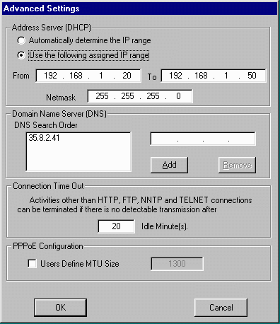
If we click on the Advanced button, we can configure the DHCP server and domain name server for the system. We can set the range of DHCP addresses which we will provide to clients. By limiting this range somewhat, we can also have static addresses on the LAN outside the range of 20-50. These static addresses can still use the gateway to connect to the Internet. We can also specify a Domain Name Server (always a numeric address). In the case of a dialup connection, this will be generally set as part of the PPP initialization. However if your Internet connection is a cable modem or other technology, you may have to hand-enter an address for the DNS server.
It is common for these gateways to act as a proxy domain name server. When Sygate replies to a DHCP request, Sygate indicates that its own gateway address (192.168.1.1) is what the client system should use for its DNS service. This way, Sygate software can reply to the DNS requests using a local value for a domain name lookup. This also gives Sygate some time to start to dial up the Internet before the client computer times out waiting for a network connection. By seeing the DNS packet, Sygate immediately knows that the next operation is very likely to be a connection to an Internet host. It also turns out that most network programs are willing to wait about 30 seconds for a response to a domain name query. However they typically only wait about 10 seconds before giving up on a connection to an IP address. By delaying the response to the DNS packet, Sygate can give itself about 40 seconds to dialup and initialize the network connection. All the client computer sees is a 30-40 second wait and then the page simply appears.

As is the case with operating-system-level connection sharing, even when your system is operating as a gateway, you can still use it as a workstation. The load on the system caused by performing the gateway functions is very small.
As with operating system sharing, rebooting the gateway computer disconnects all current network connections, and the system generally will be left on all the time. If the gateway system is not turned on when someone wants to use the Internet, you must boot it before you can use the Internet anywhere else in the house.
If most of the computers on your network spend their time surfing the Web, it is also possible to set up a “proxy Web server” on one computer. That computer “owns” the connection to the Internet, and the other computers have their Web browsers configured to use its services for Web connections. Although this solution is quite limited compared to general Internet connection sharing, some home networks may wish to implement it. We describe Web proxy serving in Appendix E.

Conclusion
Ultimately, configuring Internet sharing is relatively straightforward. You can easily choose between a hardware or software solution. The configuration is surprisingly similar between the hardware and software solutions - this is because they ultimately are solving the same problem.
Software solutions generally have more flexibility and more logging options but are less convenient as they place one of your computers into a "server" role for the rest of the home. Hardware solutions are more expensive, but are generally more reliable.

