1: Your Wireless Home Network

Wireless Home Networking: The Right Choice?
It seems as if everyone you know has a wireless computer network in their home. So you decide to take the plunge. You buy a device they suggested at the local electronics store. You stare at the box. This gizmo is a “wireless access point and broadband router” – whatever that means. You wonder: did I buy the right thing? Is this what I need? How hard is it going to be to set this thing up?
Fear not. You made an excellent choice. With this device you can:
- Build a home network, connecting your desktop and laptop computers together, without running any new wires in your home.
- Share files, printers, and applications software across all your computers. For instance, you can sit on your deck using your untethered laptop, and print the final chapter of your new novel to the printer that’s connected to the computer in your upstairs office.
- Share a broadband Internet connection among all of the computers in your home. Everyone enjoys a high-speed connection, no one waits for modems to connect, and the phone line is never busy while Junior downloads MP3 files.
And the best news of all: it’s not as hard as you think to set up your home network and begin to enjoy its many benefits.

Why Do I Need a Home Network?
We build home networks for the same reasons why workplaces built networks of personal computers in the 1980s. As the personal computer revolution unfolded, we quickly learned that it didn’t make sense to put a high-speed laser printer on every desktop. Local area networks evolved, so that people in a workgroup could share such expensive devices. LANs also made it easy to share files among people working on common projects, to share printers, and to share high-speed Internet connections.
The same logic applies in your home.
Even if you only have two computers in your household, building a home network makes sense. Suppose, for instance, that your pointy-haired boss demands a report first thing tomorrow morning. You bring your work home. You have a family PC in your basement, connected to a cable modem and a laser printer. You’d much rather work on the report upstairs near your family, the dog, and the flickering flames in the fireplace. You could use your laptop computer from the office, but you need to check information on your company’s intranet to complete the report. Dial-up Internet access would be too slow – besides, you want to sit at the coffee table, and there isn’t a nearby telephone jack. So it seems you’re doomed to spend the evening in the cold, dank, lonely basement.
You know your office laptop computer is wireless-ready, because you usually surf the Web while the boss drones on in the conference room. Can you use this laptop for wireless access at home? Not only is the answer yes, it’s also simple. Instead of plugging the basement PC directly into the cable modem, you plug your new “wireless access point and broadband router” into the cable modem. In turn, you plug your basement PC into the access point / router.
After just a little bit of setup effort you’ve got a home network. Your laptop joins the network wirelessly. It shares your cable modem Internet connection, letting you surf the Web and download files from the office at high speed. The only time you need to visit the basement is to pick up drafts of your report – which you send from the laptop to the basement directly, all wirelessly. Thanks to home networking, you spend the evening with your family as you work.
Figure 1.1 depicts a simplified view of your new home network. Your laptop uses its wireless adapter to communicate over radio waves to your wireless access point / router, which in turn routes communications through your cable modem to and from the Internet (so you can connect to your company intranet) and to the basement PC (so you can print drafts of your report on its connected printer).
[MikeL: should we make the above paragraph all part of the caption for Fig 1-1?]
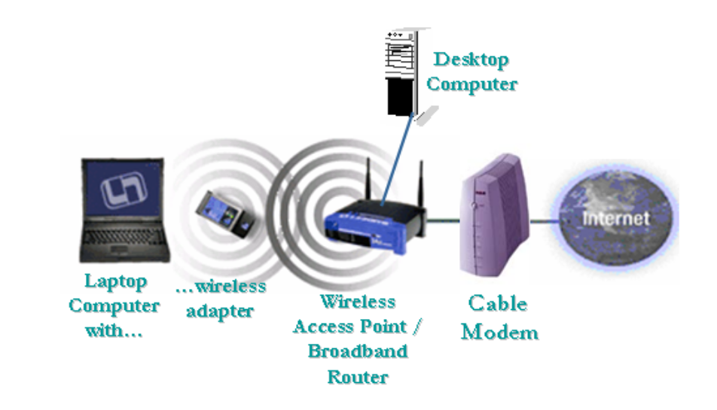
- Simple Network with Laptop and Wireless Access Point
Replace figure with ORA-drawn artwork

It’s All about Sharing
[MikeL – Pls change section titles you don’t like to whatever you do like.]
So it makes sense to build a home network even if you have only two computers to connect. These days, though, many households find themselves using more than two computers in the home. For instance, suppose you acquire a new “main” computer and you decide to keep the old one for the kids to use. (Of course, the kids are the ones whose game software demands the most computer horsepower, so maybe they get the new computer). As time goes by, more and more households have more computers than they have humans.
Your home network lets you make economical use of the computers and the printers and other peripheral devices in your home. Just as your office won’t put a $5000 high speed color laser printer on your desktop, few homes need more than one high-quality printer. Once you’ve set up your home network, any member of the household, using any computer in your home, can print to any printer in the house.

Sharing a Broadand Connection
Sharing your Internet connection is another compelling reason to build a home network. Just as you wouldn’t add a new telephone line and modem for every computer in a modern office, you want to share your Internet connection among all the computers the household uses. You could share an old-fashioned dial-up Internet connection among all the computers in your home network; one computer with a modem shares its modem with the other computers on the network. However, if you thought your dial-up modem was slow, wait till you try sharing it. More and more households choose a broadband Internet connection, typically a cable modem or a DSL subscription
You may wonder “What the heck is broadband?” Terms like “broadband” or “high-speed” are always relative. In today’s world, home broadband connections typically can download data at about one megabit per second. In practical terms, this means Web pages display much faster, and file downloads that would take an hour complete in a few minutes.
Remember that old saying that a chain is as strong as its weakest link? Your home network will be as fast as its slowest link. If you choose dial-up for your home’s Internet connection, you’ll be communicating at 56 kilobits per second. Consider the speeds your network might employ:

Type of Connection | Speed at which it downloads data | Time Required to Download a 100 kilobyte Web page | Time Required to Download a 10 megabyte MP3 file
Dial-up modem | 56 kilobits / second | 14 seconds | 143 seconds
DSL or Cable Modem | 512 kilobits / second, up to 1 megabit second or more. (A “megabit” is 1000 kilobits.) | Under 2 seconds | Under 16 seconds
WiFi Network | 10 megabits / second, up to 54 megabits / second | 1/10th of a second | 1 second

Tip: These numbers are theoretical. In the real world, a number of factors influence your actual network performance: how congested the Internet his, how busy the remote server you’re connected to is, and even the performance of your own computer. Your cable modem or DSL provider may claim that their service is “50 times faster than dial-up.” This overstates the actual performance you’ll see – but you will find residential broadband dramatically faster.
Having everyone in the household share a dial-up modem connection is like having everyone ride in a van that never goes faster than 10 miles per hour: Everyone is sharing, but no one is moving very fast.
See Chapter 3 for more information on choosing a broadband service.

Imagine the Possibilities
[MikeL: You thought the above section title was too cute. Pls feel free to substitute. Would “Endless Possibilities” work better for you?]
The possibilities for using your home network are endless. Consider one scenario:
- Mom realizes at work that she forgot to program the TiVo to record The Sopranos. She fires up her Web browser and connects to the home network. A quick transaction lets her program the TiVo to schedule that recording you just can’t refuse.
- Dad is attending a conference in Tokyo. The conference hotel provides guests with wireless Internet access, so he uses the same wireless-enabled laptop that he employs at home and in Ann Arbor to surf the Web and to download the PowerPoint slides he left back home. Next he uploads some photos he took with the digital camera that he bought in Akihabara. Then he fires up NetMeeting for a real-time video chat with the family 12,000 miles away.
- Mandy takes notes for her college class using a Tablet PC. When she gets home she plops on the couch to continue her school work. A term paper is due tomorrow, so she connects to her university’s Virtual Private Network (VPN) to access library databases and to compare notes in her virtual study group. She sends drafts of her paper to the downstairs laser printer wirelessly.
- Brent uploads digital video that he shot of the school play to the family PC in the basement. He’d rather sit in his bedroom while he edits, so he uses the remote terminal server feature in Windows XP to take over the console of the basement computer. Later he’ll play Everquest with competitors in four countries around the world.
- Anyone in the family can use a Web browser to check on her from anywhere, anytime, thanks to a Webcam pointed straight at her cage.
All of this may sound like something out of the Jetsons. Au contraire! Off-the-shelf products make every aspect of this scenario perfectly plausible today.

The Building Blocks of Your Home Network
It takes only a few building blocks to build your home network. That “wireless access point and broadband router” that you just bought makes it all possible. Let’s consider that device. It packs a lot of power into a small box. It connects to your broadband Internet service; it communicates with all your wireless computers; it protects your network from external hacking; and it lets you add wired connections to computers when you chose to do so.
To accomplish all this, your access point / router takes on roles for which industrial networks typically use several devices. It performs all these roles:
- A wireless access point. Sometimes called a base station, an access point serves as the hub of your wireless network. Any computer in your house that’s equipped with wireless capability communicates with the access point using radio signals, just as a cordless telephone sends and receives radio signals to its telephone base station. With its dual antennas your access point may even resemble the base station for a telephone. (In fact, your many cordless telephones use the same radio frequencies as nearby wireless access points.)
- 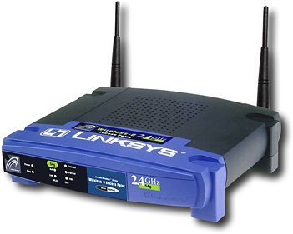
Linksys Wireless-G Access Point

- A broadband router. Sometimes called a cable/DSL router or a residential gateway, a broadband router connects your home network to your Internet connection. You can buy access points that aren’t routers or routers that aren’t wireless access points, but you may find it convenient to let one box handle all the roles.
- A firewall. Firewalls filter the kinds of traffic allowed into your network, protecting your computers from certain kinds of attack. That may sound dramatic, but once your computers are connected to the Internet at high speed and always turned on, they become targets for hackers. Chapter 4 covers the kinds of attacks your computes confront, and how to secure your home network against them.
- A switch. Many access point / router manufacturers incorporate a 4 port switch into their products. Sometimes you may find it convenient to use wiring to connect some of your computers into your home network. If your access point / router includes a “switch,” this makes it easy. You will use conventional Ethernet cables to connect a port (or jack) on the computer to a port on the access point / router. (Yes, we admit it, even in this book on wireless networking: sometimes a wired connection makes more sense.)
Tip: An Ethernet cable looks like a fatter version of the wire that connects home telephones to the wall jack. Most new computers these days come with an Ethernet port, because Ethernet is the standard way to wire local area networks in offices worldwide. Even if you use wireless for all your computers, you’re still likely to use one wired Ethernet connection: between your access point / router and your cable or DSL modem.
Your wireless access point / broadband router offers remarkable capabilities for a small investment. It serves as your basic building block, letting you network two computers or ten. Remember that example of the boss’ report? Figure 1-3 shows how you can build a home network supporting a wireless laptop and a wired computer.
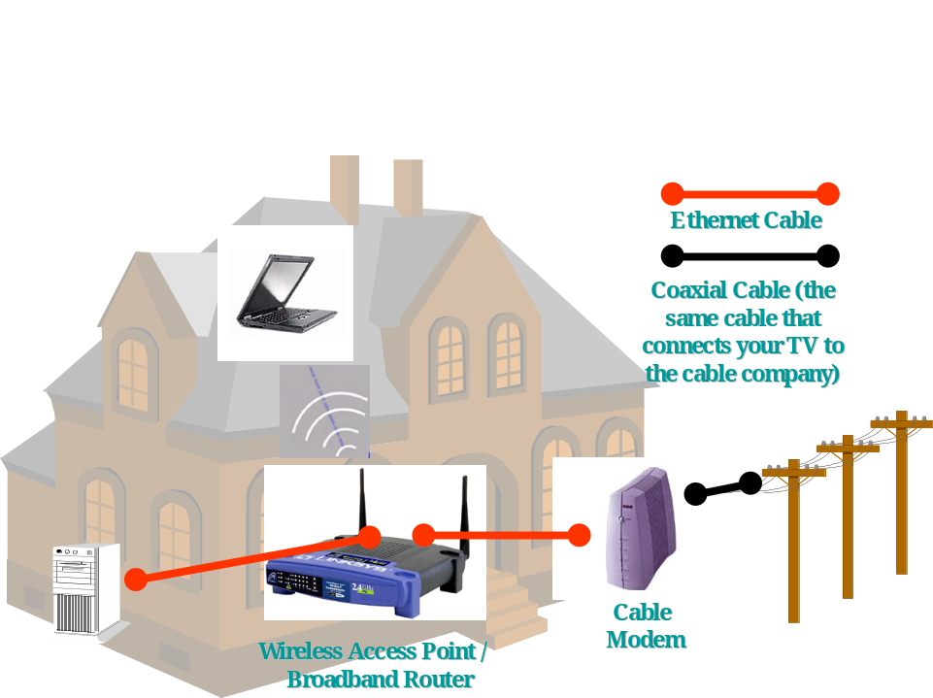
- A Simple Home Network
Redraw using ORA art
Here’s how all the parts fit together:
- Your cable modem connects to the local cable company (and to the global Internet) over the same coaxial cable that plugs into your television.
- Your wireless access point / router connects to the cable modem using an Ethernet cable. Your basement computer connects to the access point using another Ethernet cable.
- Your laptop computer upstairs connects to the access point / router using radio signals.
If this all sounds complicated, don’t worry. Setting up this basic home network can be quite easy – perhaps not quite as simple as plugging a lamp into an electrical outlet, but much simpler than wiring a home theater. Chapter 2 walks you thow a case study showing how to build a home network; Chapter 4 gives you detailed advice on choosing and configuring your access point / router

Should I Buy a Particular Brand of Networking Equipment?
Fortunately for you, a number of leading vendors compete for the home broadband market. Competitors include aggressive small firms such as Linksys, D-Link, and Netgear, as well as more familiar names such as Microsoft, HP, Apple, and Siemens. You’re the winner of this competition, as companies vie to pack ever more capability into these remarkable small boxes. Competition also means prices are now quite affordable.
There are variations among vendors and models. Some models are easier to install. Some work better than others. Some vendors offer better technical support – and better Web sites with easy-to-find documentation and drivers.
- 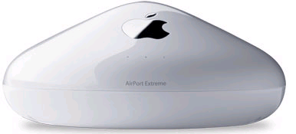
Apple Airport Extreme Access Point
Generally, though, you need not fret as to whether you bought the right access point/router. With a modicum of effort, you can make most models serve your home networking needs quite well.
The other good news is that these devices adhere to standards. This means you can buy an access point from Linksys and a so-called “WiFi” adapter card for your laptop from Microsoft, and they will usually play nicely together.

Tip: The industry uses several terms for wireless networking, including WiFi, which refers to the predominant family of wireless standards. A consortium promotes the WiFi standards, just as industry groups defined the Compact Disc standard in the Eighties.
An international engineering organization, IEEE, defines technical specifications for how wireless devices work: what part of the radio spectrum they use, and how they talk to each other. They name their WiFi standards under the umbrella of “IEEE 802.11”. In this book the terms “wireless home network” or “WiFi” or “802.11” all refer to the same thing. The same WiFi family of devices works in your home network, in many office wireless networks, and in wireless “hot spots” in airports and Starbucks.
Some people prefer to buy all of their networking gear from one vendor; that way, if there are technical problems, there’s no finger-pointing between tech support departments. But if you’re using an IBM ThinkPad from the office with built-in wireless support, you should have no trouble making it connect to your access point, no matter who markets the access point you choose to buy. (Note, however, that Apple does not market its equipment for Windows-only networks, so you’ll want at least one Mac in the family if you choose an Apple access point.)

Planning Your Home Network
Some experts advise you to expend a great deal of effort in planning your home network. Our approach is more casual. We suggest that you start with the wireless access point / router, and build your network from that foundation. Many households will be perfectly happy to wirelessly connect all their computers to their access point / router. An all-wireless home network requires virtually no planning: you simply plug the access point / router into your cable modem or DSL modem, add wireless adapters to your computers that lack them, and you’ve built your network.
Unfortunately, wireless may not reach every nook and cranny in your house. WiFi networks normally extend a few hundred feet. Several factors limit the reach of your wireless network:
- How thick are your walls and floors? What are they made of? WiFi signals pass through certain materials better than others. Don’t expect WiFi to pass through large amounts of metal, for instance. (For this reason, we don’t suggest wireless if your home is a prison.)
- How many walls and floors are there between your access point and each computer that you’re trying to connect?
- What else competes for radio space? The most popular WiFi standard shares “spectrum” with two other popular devices: your cordless phone and your microwave oven. Some households experience a drop in wireless network performance when these competing devices are in use.
- What are your neighbors up to? If your home is close to neighbors who also run a wireless network, you may find yourself competing for radio bandwidth. (And if you and your neighbors don’t pay attention to security, you may find yourselves also sharing personal files wirelessly. This gives entirely new meaning to the phrase “Network Neighborhood.” See Chapter 4.)
You may discover that you need more capability than your access point /router provides. If this proves to be the case, it’s easy and inexpensive to add other networking devices later. For instance, as you’ll read in the case study in Chapter 2, one of your authors discovered through experimentation that the wireless access point in his basement wouldn’t serve the home office on the second floor. The simple answer was to extend the network using existing phone lines in the house, using Home Phoneline (sometimes called HomePNA) adapters. It’s fine for you to assume wireless for your home network at the beginning, and add alternatives if need be.
However, there’s a huge exception to this line of thinking. If you’re building a new house, you should consider carefully which rooms in the house are candidates for computers, or home entertainment (stereo, cable TV, or video) or wired telephones. One author (the other one) built a new house recently, and he chose to run cables for his high-speed home computer network, for cable TV, and for telephones to every room in the house. (Yes, even the bathrooms. This is an extreme position that we do not advocate for all households.) If you are building a new home, consider running wires for data, audio/video, and telephone before the drywall goes up; it’s so much cheaper than running wires after the home is completed, you may want to wire the whole abode during construction.
Even in existing homes, a wired connection or two may be the best choice. For instance, let’s say your main desktop computer and your cable or DSL modem sit in the basement, 10 feet apart from each other. (For some reason, basements are popular in this regard.) You may choose to use an Ethernet cable to plug your close-by computer directly into the access point. On the other hand, for your laptop computers that tend to move around, or for computers upstairs that aren’t conveniently wired into the access point, wireless may be the most convenient solution.
The bottom line? Some home networks will be all-wireless; some will be all-wired; many will be a hybrid, using wireless for some connections, Ethernet for others, and existing telephone lines – or even electrical power lines – for the rest.
Let’s assume you’ve bought a wireless cable/DSL router with a four port switch. (If you have not already purchased your router, please consult Chapter 4 to help decide which one to purchase). This table summarizes your choices for expansion.
What Connects My Computers? | What Additional Devices Do I Need? | Why Would I Use This? | What’s the Downside?
Radio waves | A wireless adapter for every computer you connect. (Some newer laptops have WiFi built in. Few desktop computers come with wireless built in.) | You don’t need to run any wires. Your laptop connects to the home network from anywhere without plugging it in. | Wireless may not reach your entire home.  You need wireless adapters for each computer.  Security requires attention.
Ethernet cables | Probably none. Most new computers, whether desktop or laptop, have Ethernet ports built in. Simply run an Ethernet cable from the computer to the access point / router. | It’s convenient: your computer is near your router.  Wireless doesn’t reach, and you’re willing to run Ethernet cables.  You need speed. (Wired Ethernet can move data far faster than other options.) | You have to run cables to each room – hard to do in existing homes.
Existing telephone wiring | A Home Phoneline (also called HomePNA) adapter to plug into your access point / router, and a Home Phoneline adapter for each computer. | Wireless doesn’t reach, and there are phone lines in the rooms where the computers are. | Limited to 10 megabits /second (plenty fast for most purposes.)
Existing electrical wiring | A HomePlug (also called Home Powerline) adapter to plug into your access point / router, and a HomePlug adapter for each computer. | Wireless doesn’t reach; every room in your home has power outlets, so HomePlug will reach any place you can plug into a power outlet. | Limited to 14 megabits /second.  Security requires attention.
Should we add a chart explaining kilobit/megabit/gigabit? Here, or earlier?
Of course, before your launch into building your home network, you want to do some planning. In general, starting out with wireless is simple and inexpensive, and it meets the needs of many households. If wireless doesn’t fit your needs now, or if your needs change, you can easily incorporate other options later.

Wireless Worries
You may have some specific concerns about wireless home networking.

What about Security?
You may have read horror stories about people breaking into home or business wireless networks. It’s true: someone physically close to your network – within a few hundred feet -- could break into it, using a computer that’s capable of connecting to a WiFi network. The perpetrator could be someone in a neighboring home, or it could be someone “war driving” through the neighborhood, armed with a wireless-capable laptop and some special software. Unfortunately, many vendors ship access points that “out of the box” are wide open to attack. Fortunately, it’s relatively easy to secure your wireless network; Chapter 4 tells how. Once you’ve taken steps to secure your network, you can rest easy. (However, if you notice the same strange van driving slowly through your neighborhood every day, you might contact Neighborhood Watch – especially if the van sports lots of antennas.)
What Will My Home Network Cost?
[MikeL wants less detail on pricing; Pogue wants more.]
Your wireless network will cost less to build than you may think. Prices for access point / routers and other networking gear for the home vary. The latest and greatest routers, sporting the most features and the newest variants of the WiFi standard cost more.
Expect to spend about $100 for an access point / router with 4 port switch. For each computer you want to connect wirelessly, expect to spend about $50 for an adapter. (Of course, you don’t need to add an adapter if your laptop comes with WiFi built in.)
For each wired (Ethernet) connection, plan on $20 or so for cable (depending on length). Any computer bought recently will have Ethernet support built in. If yours doesn’t, you can buy adapters for about $20 to $40.
If you need to add Home Phoneline or Home Powerline connections to your network, expect to pay $100 for an adapter to plug into your access point / router, and $100 for an adapter for each computer.
When you add it all together, you can build a typical home network with two or three computers for around $300.
You’ll find the most popular home networking brands – Linksys, D-Link, Netgear, and Microsoft – in major electronics stores as well as at online stores such as Amazon or PC Connection. Frequently you’ll find rebates or discounts in retail stores or online.

Can’t I Save Money By Using a Computer as My Internet Gateway?
Your neighbor brags that her son Biff runs a Linux computer as the center of the family network instead of a standalone access point / router. Windows XP and Mac OS-X make it easy to do likewise. However, we don’t suggest dedicating a PC as your home gateway, because:
- The PC that serves as your gateway has to be left on all the time. This costs wear and tear on the computer. A standalone access point / router also consumes far less power than a PC; you could save enough in electricity costs in one year to pay for your standalone gateway.
- If your gateway computer crashes or breaks, every computer in the house loses its Internet connection.
- Setting up an access point /router is trivial. You may need to add network adapters to the PC that you choose as your home gateway. It’s much easier to set up a standalone wireless access point than to install a wireless card in a desktop PC and configure it to serve the rest of the home network.
- Your access point / router acts as a firewall, protecting all of your computers from some forms of hacker attack.
You can show these reasons to the neighbor kid and he’ll quarrel with every point. He’ll tell mom and dad they are better off using a real computer as the home network hub. More power to them! It’s your neighbor that has to live with Biff, not you.

What Operating System Should I Run?
You can connect computers running just about any operating system to your home network. For Windows users, we strongly suggest that you run Windows XP. You can choose either Windows XP Home or XP Professional, but note that Microsoft deliberately has limited the networking capabilities of XP Home. (In fact, limited networking capability is one factor that distinguishes the XP Home edition from Professional.)
For Mac users, we suggest running OS-X. This version of the Mac operating system is based on a full-featured version of UNIX, and it’s ready for networking Macs together – and it’s also ready to support a home network that includes both Macs and Windows PCs.
If you follow our advice to run XP or OS-X, you will find the task of building your network far less daunting. Unless your computer is quite old, you should be able to upgrade the operating system to XP or OS-X easily. If you choose, for instance, to include Windows 98, Windows ME, Windows 2000, Linux, or Mac OS-9, we can’t fit all the advice you need into this book; go to the web site associated with the book for help.

Which Wireless Standard Should I Use?
When you’re shopping for equipment to build your home network, look carefully at the boxes. Unfortunately, this may seem more complicated than decoding health claims on a bottle of diet supplements.
Some devices will say they support the “IEEE 802.11b” standard. Look very carefully: that lower case “b” at the end is important. This is the version of WiFi that’s most popular for access points and for the network adapters that add WiFi to your computers. You’ll find other devices that are labeled 802.11g (or sometimes “Wireless G”). Still other boxes will be labeled 802.11a. Most home networks use 802.11b; increasingly, home networks will use 802.11g. You can buy wireless adapters that work with both standards. This is a very good idea, especially for laptops that you’ll use at a “hot spot” at a Starbucks or an airport lounge.

This may seem confusing. Chapter 4 sorts through all of these variants for you. For now, be aware that the differences can be important. You don’t want to buy an access point that can’t talk to you’re the networks you want to use – whether it’s your own wireless network at home, or a wireless “hot spot” on the road. . Read all the labels carefully before you buy.

The Future of Home Networking
This is a book about home networking. Our primary focus is home computer or data networking: sharing Internet connections, files, printers, and more. But we live in a world of “convergence” – where we use one network for many applications:
  - Home entertainment networking: making high-quality video and hi-fi audio available in various rooms throughout your home.
  - Home automation: controlling appliances (lights, sprinklers, even the stove).
  - Home security: monitoring for break-ins, flood, fire; security cameras.
  - Communications: communicating within the home and with others around the world, in voice, text, still image, and video.
The future promises (or threatens) to bring all of these applications into a single home network. We won’t think of separate networks for each application – we’ll think of one home network tying them all together. Already we see:
  - HP’s Digital Media Receiver 5000 is a box that looks like a home stereo component. Plug it into your home theater setup, and you can browse your digital photographs or listen to your MP3 files stored on any PC on your home network. The receiver connects to your network either over WiFi or Ethernet.
  - The popular TiVo personal video recorder now connects to your home network. (TiVo boxes let you record television shows you like on a hard drive, and play them back at your convenience. A TiVo gives you power over your television viewing; you skip commercials and watch what you want when you want.) TiVo has added Web programmability: you can schedule recording from anywhere in your house – or anywhere on Earth. And you can view recorded programs using any computer on your home network.
  - Lansonic’s Digital Audio Server holds 350 CDs in MP3 format, and serves music over your home network.
It’s too soon to predict how home networking convergence will unfold. Will the computer be the center of it all, as Apple, Microsoft, and various PC manufacturers assume? Or will “set-top” boxes – set atop or near your television – become the hub? Or will the Linksyses and Netgears of the world tie it all together?
Or – don’t laugh – will your refrigerator serve as the hub of your home network? LG and other appliance manufacturers already market Internet refrigerators: food central becomes Internet central. An early LG model features a 15 inch touchscreen for television viewing – or for Web surfing and e-mail – as well as hi-fi speakers for FM radio or MP3 listening. This fridge even comes with a remote control.
Is this visionary, or is it ridiculous? Early reviews of the Internet refrigerator tend to believe latter. In many homes, though, the kitchen is the one room where everyone congregates every day. Many households use the fridge as a family communications center, with appointments, photos, and notes plastered over the doors. And, of course, the refrigerator is always turned on. You fridge might be the most logical place in the home for an Internet device. You could check the traffic Webcam, send a note to your boss saying you’ll be telecommuting, or double check that recipe you read online as you plan a trip to the grocery store.
Predicting Internet futures is notoriously foolish. During the Internet bubble, untold billions were invested in Internet telephony, while no one paid attention to music over the Net. Today, using the Internet for long distance telephone calls remains a niche market, while Napster and its successors captivated millions of users and decimated the recording industry. We can’t tell you if the Internet fridge, or the Internet automatic sprinkler system, or the next application du jour will change your life. We are confident, however, that your home network will.

