Chapter 4: Installing Your Home Wireless Router
Now that you have a high speed connection installed and running, it is time for you to install your home router. If you have not already done so, you will purchase your home router using some of the advice in this chapter. Hopefully you read the last chapter while your high speed connection was installed and were able to gather necessary information which will make installing your router quick and painless.
As you go through the chapter, you might wonder why we take so many steps and check everything after every step with some type of diagnostic tool. Actually, there may be a bunch of times as you are going through the steps in the chapter that your router is working fine. From time to time you might just want to fire up a browser and go to www.google.com. Part of our goal in this chapter is to show how to test your router and connection using a series of very simple and focused tests.
You have a much better chance of fixing a problem if you know exactly what does and does not work. If you fire up a browser and don’t get your main page, then there might be hundreds of things which might be wrong. By slowly and methodically checking each little piece of the network by itself, you will be able to isolate the problem and provide a few things to check to resolve the problem.
This chapter is a supplement to the documentation which comes with your router. It is also a supplement to calling technical support for your ISP and/or router vendor. In some places we suggest calling technical support with particular questions. Sadly, we only have space for a complete example for one brand of router – luckily router configuration is very similar from vendor to vendor so you should be able to apply the concepts in this section to your particular router.

Purchasing Your Home Router
Before purchasing your router, there are a few steps that you should take:
- Consult the previous chapter and research whether or not your ISP supports (formally or informally) home routers or even sells a router.
- Read reviews of routers online. You will typically find that most reviews are pretty glowing because most home routers are well engineered and easy to use. You may learn about additional features such as support for a network attached printer or support for an external modem for a particular router.
- Examine the web site for the vendor of the routers that you are considering. Pay particular attention to the technical support section of the web site. One of your goals when selecting your router is to select a router from a company which is committed to the consumer/home marketplace.
- Consult with people that you know who have the same ISP to find out if they have any experience with a particular model.
The good news is that most home routers are pretty good products. You should select a mainstream brand such as LinkSys, DLink, SMC, or NetGear. You should also purchase your router from a local electronics vendor – often there are rebates of up to $50 on these products, so if you are willing to wait and shop a bit, you can get a very good deal.
You should purchase a home router with wireless connectivity built in. If you already have a home router, (as silly as it might seem) your life will probably be simpler if you simply replace it with a wireless-enabled router.
Note: If you insist on a separate wireless access point or your ISP has provided a router without wireless, look for a configuration option for the access point which suppresses the wireless access point doing any type of address manipulation. This option may be called “Bridge Mode”, “Transparent Mode”, or something similar. By selecting this option the access point simply forwards network traffic between the wired and wireless portions of the network without any modification, allowing the home router to control all of the addressing and traffic management.
Unless you set this feature, and your wireless access points has router features, it may want to provide dynamic addresses, and do address mapping for the wireless computers while the home router provides these for the wired portion of your network. The home router also needs to provide an address to the wireless gateway. (Are you confused yet?) While some people might look at this as a challenge (it can be done), for most people unless you are getting some free hardware from your-brother-in-law, it is not worth the effort.
Another other reason to keep your wireless gateway in transparent mode is that certain types of file sharing and printer sharing between your wired and wireless network will only work when the gateway is operating in transparent mode.

Choosing Your Wireless Technology
The wireless technology field is still evolving with significant new technologies being released every 2-3 years. Perhaps the most important aspect of wireless technology is to understand where you are in this transition.
At the time of the writing of this book, the two best wireless technologies for home use were 802.11g and 802.11b. The 803.11g is a newer standard and provides better performance than the 802.11b standard and interoperates with 802.11b.
In general, you should choose 802.11g equipment for your home. While there is a slight increase in cost, over time, 802.11g will simply replace 802.11b and if you are starting fresh you might as well have a technology which will last as long as possible.
However 802.11b is already deployed at many locations ranging from offices to coffee shops, and hotel conference rooms. While your shiny new 802.11g card should work fine in this environment, it might not hurt to carry around a “legacy” 802.11b card when going to a new location with wireless networking. In addition, there are 802.11b products for PDAs and printers and built into a number of different portable computers. By choosing 802.11g, you get the best of bother worlds.

Installing the Router: The Easy Scenario
A Brief History of Wireless Networking
During the late 1990’s, a number of different wireless networking technologies were developed. Some were proprietary from a single vendor; others were based on an emerging standard called IEEE 802.11. Much of the technology research was initially based on military applications for undetectable data transmissions.
In 1999, there was a wide variety of competing technologies without compatibility between them, wireless access points cost $1500, and wireless cards were $450 (believe it). Then Apple computer adopted one of the technologies in their Airport line of wireless networking (an IEEE 802.11b variant based on a technology called Direct Sequence Spread Spectrum). Apple drove the price down considerably for this technology ($299 for a base station and $99 for a card).
Other vendors followed suit and began to produce 802.11b/DSSS compatible low-cost cards aimed at the PC market. As demand and production increased, we see the low prices of today.
The 802.11b protocol was limited to 11Megabits per second. Once 802.11b was adopted widely, the standards community worked on producing higher performance wireless networking. There were two approaches – 803.11a used a higher frequency (5 GHz) and 802.11g used the same frequency (2.4 GHz) in a new way. Both provided higher performance, but 802.11g could be made to be compatible with the large installed base of 802.11b.
If you have a Cable Modem and use an XP computer, the installation process may be exceedingly trivial. You can try the steps in this section to quickly get your home network up and running. If this approach works for you, it is because you don’t need to change the default settings on your router (i.e. the factory settings are sufficient) and your cable modem gives out dynamic addresses without requiring any “coaxing”.
This is a surprisingly common situation because both the cable modem ISP and the router manufacturer are motivated to reduce technical support calls as much as possible. If you encounter problems during this procedure simply go to the next section where you will go through the steps more slowly and you will be given instructions on how to solve problems which you encounter.
This section is all about being optimistic and being successful on your first try:
- Power off your cable modem and computer.
- Unplug the Ethernet cable from your computer to the cable modem (if necessary)
- Connect an Ethernet cable between the “WAN” port on your home router and the Ethernet port on your cable modem
- Connect an Ethernet cable between your computer and one of the LAN ports on the home router
There are often up to 4 LAN ports on a home router – it does not matter which port you use.
- Turn on the cable modem and wait until it is up
This can take up to two minutes – see Chapter 3 for a discussion about how to know when the cable modem is up.
- Turn on the home router
Assuming that your home router and cable modem have activity lights, you should see a brief flurry of network activity within 15 seconds of turning on the home router. This activity is the router asking the modem for an address and establishing its “uplink to the Internet”.
- Power up your computer and log in (if necessary)
- Check to see if there is a network icon in the system tray. If there is a network icon with a red “X” then something is wrong with the Ethernet connection to the home router.
You may see more than one network icon in the system tray. Wireless connections are always shown in the system tray. Ethernet connections are only shown in the system tray if they are down. The only one which needs to be up at this point is your Ethernet local area network connection. It is quite common for the other network connections (say wireless) to be down.
- Open your web browser. If you can surf the web, you are done!
Make a resolution to call your ISP technical support and thank them for providing a very easy to use service. Also you might call your home router and thank them for providing such good default settings on their router.
If these steps work, congratulate yourself on making a good choice for your ISP and home router. You should probably still read the next section because it contains important information on diagnosing problems with your network. You will set up your wireless connection later in this chapter.

Installing the Router: Slow and Sure
In this section you will bring up your home router. Some of the steps will apply to cable modems and others will apply to DSL. If you encounter errors, you will take steps to identify and fix them. Hopefully by the end of the section your home router will be installed, configured, and you will be surfing the web.
You will probably have documentation which came with your home router. This section is intended as a supplement to the vendor documentation for the home router. Most home router documentation is very well written (again they save money if you can get this done without calling them). The router documentation will be most useful when you are configuring the router – we have chosen to use a D-Link BEL-814b for the examples in this section.
Once you have made it through this section, the hard part of building your home network is over so stick with it until you are successful. You can do it! At times, where we think that you may need to call technical support, we try to provide you with the right questions to ask technical support. The authors would like some feedback if you think that the procedure could be improved.

Sending Data Between the Router and Your Computer
Your first goal is to install the home router and have it assign your computer a network address and verify that this worked. In this phase, there is no difference between a DSL and cable modem connection.
The steps might seem to be a little obsessed with checking everything in great detail one tiny component at a time, but this will help you quickly spot problems and solve them.
Following the steps will also introduce you to the tools that you will need to use to diagnose problems later if you experience connection problems.
- Power off your cable modem and computer.
- Unplug the Ethernet cable from your computer to the cable modem (if necessary)
- (Optional) If you installed the ISP-provided software as described in the previous chapter you may want to remove it at this time.
Another approach is to leave the software installed and try to complete the steps in the section. If you encounter a problem, then you can uninstall the vendor software, and then come back to this point and restart. (I.e. if you are going to skip this step – leave a small breadcrumb so you can find your way back).
- Connect an Ethernet cable between the “WAN” port on your home router and the Ethernet port on your cable modem
This port may have a number of different labels. Many routers have a single Ethernet port for the “WAN” connection and four Ethernet ports for the “LAN” connection. Other labels for the WAN port might include “Modem” or “uplink”.
- Connect an Ethernet cable between your computer and one of the LAN ports on the home router
There are often up to 4 LAN ports on a home router with a built-in switch – it does not matter which port you use.
- Turn on the cable modem and wait until it is up
This can take up to two minutes – see Chapter 3 for a discussion about how to know when the cable modem is up.
- Turn on the home router
- Power up your computer and log in (if necessary)
- Check to see if there is a network icon in the system tray. If there is a network icon with a red “X” then something is wrong with the Ethernet connection to the home router.
You may see more than one network icon in the system tray. Wireless connections are always shown in the system tray. Ethernet connections are only shown in the system tray if they are down. The only one which needs to be up at this point is your Ethernet local area network connection. It is quite common for the other network connections (say wireless) to be down.
- ( Possible Problem) If the network icon is indicating that your Ethernet connection is down, double click on the broken network icon in the system tray to bring up the Network Connections window. You can also reach this screen using the Start -> Control Panel -> Network Connections.
Make sure that the broken connection is actually the Ethernet (a.k.a. Local Area Connection or LAN) connection.
- 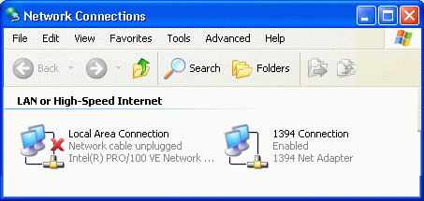
- The Network Connections dialog shows the dial-up, LAN, and other connections. It allows you to find the properties and change the settings for any network connection. In this figure, the status indicates that network cable is unplugged.
There are generally three reasons why your Ethernet connection will appear to be broken:
- (Solution) The cable is actually unplugged, or plugged into the wrong connector on the router, or the router is not turned on. Check to see if there is a small green light (called a “link light”) on the router where you have plugged in your computer. Most desktop network adapters have a link light which you can also check. Increasingly portable computers do not provide a link light. You can check to see if it is a link light by unplugging and re-plugging the Ethernet cable. A link light is always lit when the cable is plugged in and properly connected on the other end.
- (Solution) The connection is disabled (the status window will say disabled. To re-enable, right click and select “Enable”. The most likely reason that a LAN connection would be disabled is that you inadvertently disabled the connection while trying to fix something. Another possible culprit might be the “ISP-Provided Software” described in the previous chapter.
- (Solution) The device driver for the network adapter is installed improperly. With Windows XP and increasingly built-in network adapters this is unlikely.
- If your Ethernet connection is up, check to see whether or not your computer can exchange data with the router by going into the control panel. Start -> Control Panel -> Network Connections
- 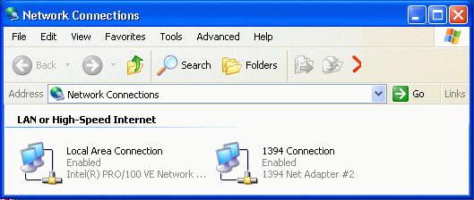
- The Network Connections Dialog allows you to see all of your network connections including dial-up and local area network.
- Double click on the Local Area Network Connection followed by the Support tab.
- 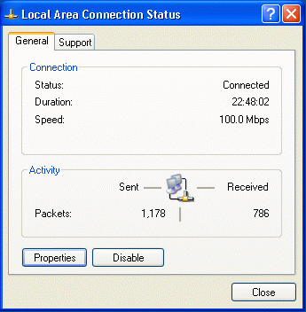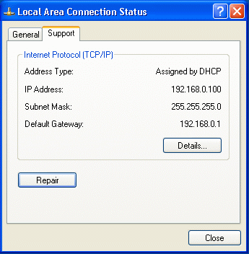
- The Connection Status dialogs provide a wealth of information, allow you to view/set the properties, disable the adapter (i.e. turn it off), and repair the network addresses. The Repair button refreshes the dynamically retrieved IP Address by re-contacting the home router.
If you see an IP address that starts with “169.” it is a bad indication – it usually means that your computer could not get a dynamic address from the home router. If you see an address which starts with “192.” Or “10.” It is a good indication that your computer and the home router are exchanging data.
- To make completely sure that your computer and the router (“Default Gateway” on this screen) are exchanging data, press the “Repair” button.
- 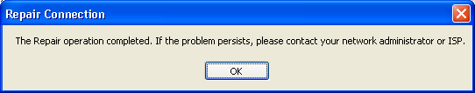
- If all is well, you should see this screen in less than five seconds. When it fails it can take up to 30 seconds.
If this operation fails, there are several possible reasons (listed from most likely to least likely):
- (Possible Solution) You have connected the Ethernet cable from your computer into the “WAN” port instead of the “LAN” port. This would give a valid “link” indication (Step nn above) but not provide your computer with a dynamic address. Consult the vendor documentation for the home router to make sure that you have connected the cables properly.
- (Possible Solution) The home router is configured incorrectly – you may have to consult the vendor documentation to reset it to defaults.
- (Possible Solution) Your computer is set to use a static IP address. This can be checked by Start -> Control Panel -> Network Connections -> Right Click your LAN connection and Select Properties -> Then select “Microsoft TCP/IP” and press the “Properties” button.
- 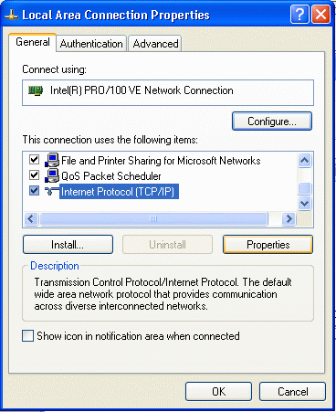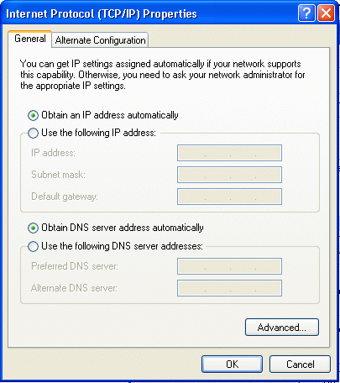
- Both the IP address and DNS Service should be set to dynamic as the addresses should come from the home gateway. If you change these values you should restart the system and redo the steps in this section.
If you have a network service which provides you with a static address, the static address will be used by the router – you will configure that into the router (See Appendix B). At this point, set your computer to use dynamic addressing so it can communicate with the router.
- As a final step, you should power off the modem, home router, and your computer, and then power them on and go through this section again to make absolutely sure that you can communicate between your computer and the router.
Once you have successfully connected your computer to the home router and verified that your computer can actually communicate with the router, it is time to configure the router.

Configuring your Home Router
Now that you have made the connection between your computer and the home router, we will connect to the home router and configure it using a web browser. Some steps may be slightly different depending on your Internet Service Provider. You should also consult the home router documentation during these steps as some details may be different for your particular router.
You will configure your home router using a web browser. You must determine which URL to use to connect to the home gateway. Once you enter the proper URL into your browser and you will be brought to a log in page. There are a number of ways which you can determine the URL to use to communicate with the home router (in order of decreasing preference):
- The vendor documentation tells you which URL to put into the browser. (This is the preferred approach)
- The home router intercepts all of the domain name requests and always routes your browser to point to the home router. So when you start your browser and it thinks that it is going to http://www.google.com/ (or some other page on the network) it gets faked into going into the router login screen.
If neither of these approaches works, you have a right to be a bit grouchy at the vendor documentation. Sometimes the faking of the DNS does not work properly and you have to figure out the URL for yourself using the following steps:
- If your Ethernet connection is up, check to see whether or not your computer can exchange data with the router by going into the control panel. Start -> Control Panel -> Network Connections
- Double click on the Local Area Network Connection followed by the Support tab.
- You have seen this dialog before. The “Default Gateway” is the address of the home router. It is also that address which your workstation will use to get to the “Internet”. That is why it is called the “Gateway”.
- Connect to the router in this particular example at http://192.168.0.1/
Once you have determined the URL to connect to the router, you should bookmark it for future reference.
Once you are connected to the gateway log into the gateway using the account and password from the vendor documentation. Routers are usually shipped from the factory with a default password or no password. You will be able to change the password once you have logged in.
- 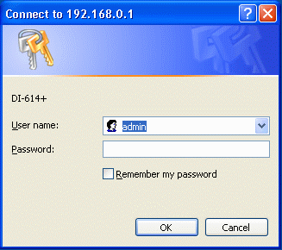
- The router log-in dialog may appear in a separate box as above or inside your browser window.
You should not worry about the security implications lack of a password and a well-known account on the home router because by default as it comes from the factory it can only be configured from the local network side. About the only possible security problem is if your neighbor connected to your wireless network between the time when you turned on the home router and when you set a password on the home router. Even so, one of your first steps after logging in to the router should be to change the password.
- In this particular router you press the Tools tab to go to the password screen. Enter your desired password twice and press Apply.
- 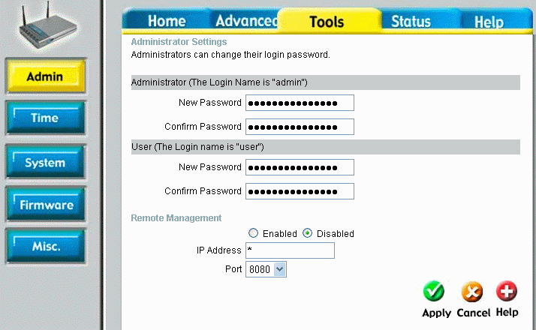
- For this particular router, the most important password is the administrator password. It allows you to make any change to the router. The user password allows some information to be viewed but not changed.
Note that this router is configured to prohibit any type of remote management (i.e. from the Internet) as it comes from the factory. There is almost no reason to enable any type of management from the Internet side of the router. Allowing this has the potential for a large security hole.
The next two sections will be different depending on whether or not your Internet Service is Cable Modem or DSL. If you have a wireless or other type of Internet service and your ISP uses dynamic addressing (i.e. DHCP) then you will probably do an adapted version of the Cable Modem Section.
In the router which is used in these examples, there is a wizard which asks a few questions and then automatically configures the router. If your router has such a wizard, feel free to use it and follow the vendor documentation. Chances are very good that it will work quite well. However, if something fails, you might want to come back and try the process again more slowly with more explanation.

Connecting Your Router to a Cable Modem
To configure the Internet (or WAN) side of your router, you must get to a screen which allows you to select the Internet connection type and then configure that internet connection. If your ISP connection is a DSL connection skip ahead to that section.
First we will go through a set of steps for the most common scenario. If those steps work, then you are done. If not, your Cable Modem ISP has some special requirements which we will cover later in the section.
- Go to the configuration for the WAN/Internet Connection - press Home and then WAN.
- 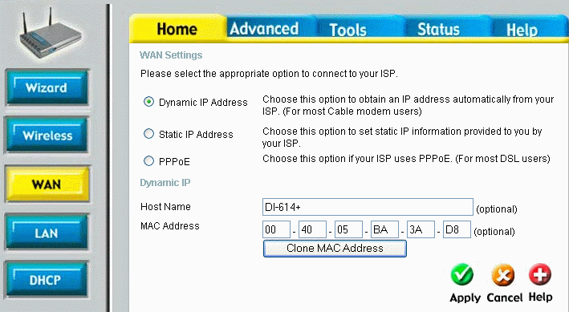
- Generally, the host name and MAC Addresses can be ignored on this screen. If you have a particularly obsessive-compulsive ISP, these values may be important. Appendix B covers setting these options.
- Set the connection to Dynamic IP Address (May also be called DHCP) and press Apply. The router will reboot itself. This only takes a few seconds.
- Navigate to the status page by pressing Status. Look at the WAN section of the display.
- 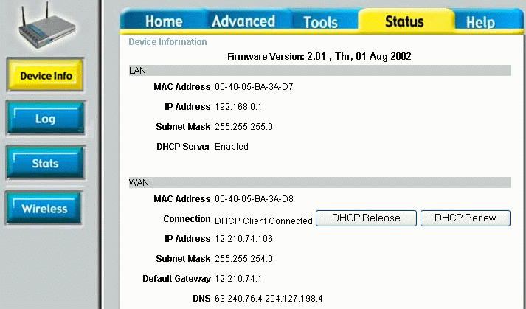
- We can see that the WAN connection now has an IP Address (assigned by the ISP/Modem). If there is an IP address, then your configuration is complete. If you come to this screen and there is no IP Address, simply press the DHCP Renew button to try to retrieve an address.
Sometimes the router will not actually retrieve its address until it receives some traffic destined for the Internet. In order to test that the router is configured properly, we want to force it to retrieve the address while we are watching.
- If you want to explore some more, press the DHCP Release button to “give up” your IP address.
- 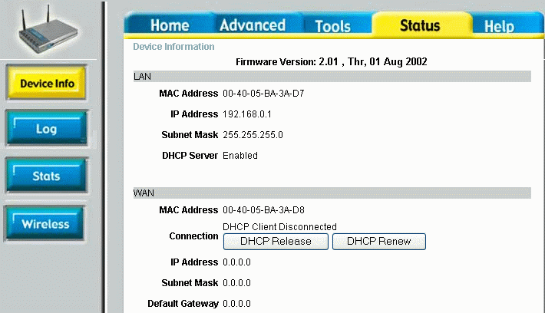
- You now have no address for the Internet connection for the router. You would also get this screen if there were some incorrect configuration for the WAN connection.
- To get the IP address back, simply press the DHCP Renew button. After a few seconds (and perhaps pressing a Continue button), you should again see a status display with an IP Address successfully assigned.
If you have gotten an IP address at this point then you have successfully configured the router so you can skip the rest of this section. However, you might want to skim the rest of this section to see what could have gone wrong in this process. Your ISP may require additional configuration of the MAC address or the hostname. Detailed instructions on advanced configuration are in Appendix B.
- At this point, it might be a good idea to take a look at the log which is built into your router. Press the Status tab and the Log button.
- 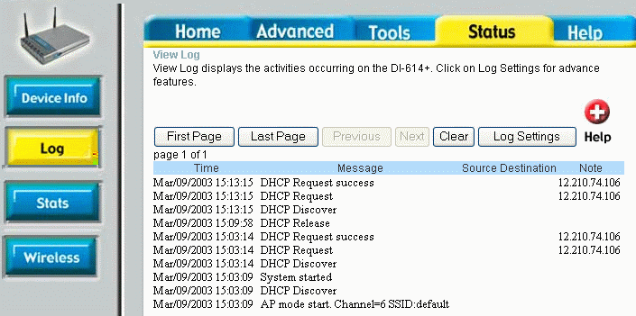
- In the log, you can see each of the operations as they took place. You can see when the router requested a DCHP address and when the cable modem supplied the DHCP address.
If you have not yet gotten an address successfully it can either be because of a physical connection problem, or a configuration problem.

Connecting Your Router to a DSL Modem
In this section, you will configure your connection to your DSL modem if you have DSL service. Connect to the router as described above and log-in using the password for the router.
- Go to the configuration for the WAN/Internet Connection - press Home and then WAN.
- 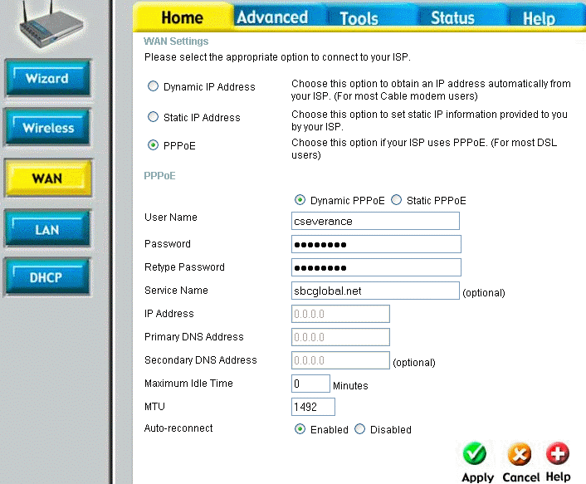
- In this router, as soon as you select “PPPoE” radio button the bottom half of the screen changes to prompt you for the necessary PPPoE parameters.
- Select PPPoE (Point-to-Point Protocol over Ethernet), enter you username and service name which are assigned to you from the ISP, as well as the password for your account. Depending on the router that you have, the user name and service name may be combined using an at-sign (@). In this example, the combined account would be cseverance@sbcglobal.net. This account and password will have been given to as part of your ISP installation. If you connected a single computer to your DSL modem, you used this account and password as part of that configuration process. DSL can support static IP addressing, but the most common by far is Dynamic Addressing. Then press Apply to reconfigure and reboot your router.
- Navigate to the status page by pressing Status. Look at the WAN section of the display.
- 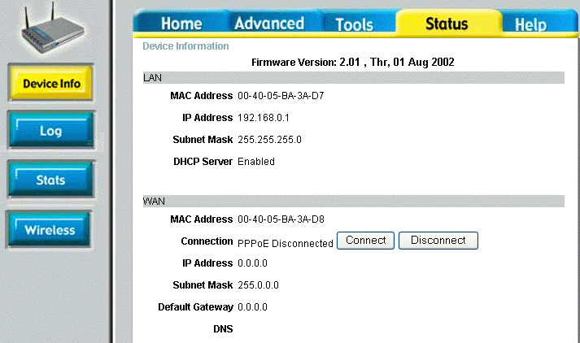
- It is always bad news when you see an IP address of 0.0.0.0. Your data is not going anywhere. In this situation it is normal because the PPPoE has not been connected because the router has not yet seen any traffic destined for the Internet.
- Press Connect to make the PPPoE connection to the modem. Wait a few moments while the connection is made. If things are workingf, it should take only a few seconds.
- Navigate back to the status page on the router.
- 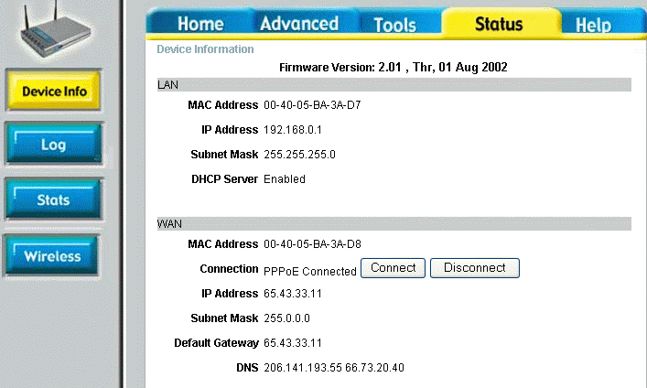
- We can see that the WAN connection now has an IP Address (assigned by the ISP/Modem). If there is an IP address, then your configuration is complete and your connection should be working.
- Test the connection by navigating to the “ping” tool. Press the Tools tab and the “Misc” button. Enter a well-known host name in the ping field and press “Ping”.
- 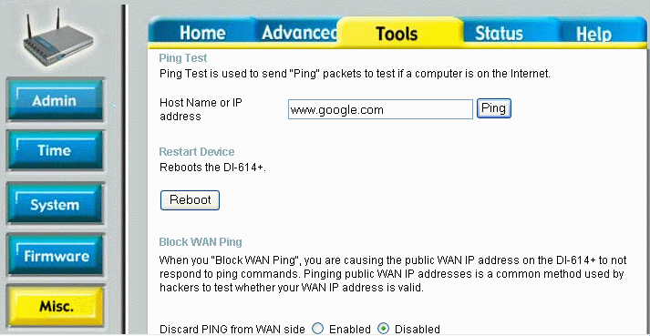
- It is very convenient to have a tool to test the WAN side of your network from within the home router. This way you can isolate and test the WAN uplink by itself.
- When you get a successful ping response, you can press Continue.
- 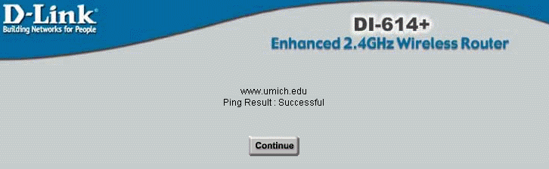
- Like most of the operations in this chapter, when things work, they work in a few seconds. A failure may take quite a long time, say up to 30 seconds.
If the ping fails, you will get one of two messages. If the ping result complains about “Unknown host” then there may be a problem with the Domain Name Resolution Server in your configuration or you may have miss-typed the name of the host (make sure not to include http:// or any thing else). If the message comes back with a “Time out”, then the host name was resolved successfully (i.e. your router is communicating with its name server), but the host did not response to the ping. Some hosts are configured to ignore the ping messages so you might want to try a few well-known hosts before you give up and call technical support. Also, you might just start up a web browser and attempt to connect to a well-known web site as a test. You might also want to try a ping to a numeric address (See Appendix C for details on how to find a numeric IP address).
You have now established your connection between your router and your ISP. Generally, it is relatively straightforward to get DSL working with your router.

Bringing up Your Wireless Network
Generally, the factory settings on the wireless portion of your gateway are sufficient to make your initial wireless connection between your computer and the wireless router. However you may want to look at the wireless configuration screens for your router using your wired connection before you “sever the cord”.
- Press the Home tab and the wireless button on your router to see the wireless configuration.
- 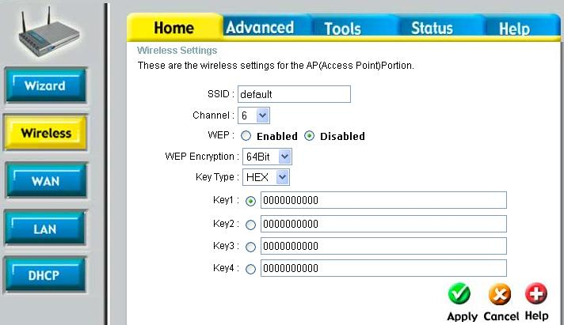

- In this display, the SSID is the “network identifier”. The SSID allows a number of different base stations to operate independently within the same physical area. The wireless card in your computer associates itself with a particular network base station using its SSID.
For the next steps, you can leave the SSID set to its default value and WEP (Wireless Equivalent Privacy) should be disabled. After you establish basic wireless connectivity you will enable and configure security in the next chapter. The channel should be left at the default. Later you may also need to change the channel for your base station depending on how close you are to other base stations.
- Disconnect your wired network and install your wireless card in your computer by following the instructions for the wireless card. Many cards have driver support built into Windows XP, so you may not even need to insert any driver software. Once the wireless adapter is installed reboot the computer. When the computer reboots the wireless card automatically searches for the available networks and notified you in the system tray with a small message.
- 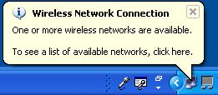
- If you miss the “little balloon” when the system encounters a new SSID for the first time simply Right-Click on the network icon on the system tray and select View Available Networks.
Generally, the operating system does not want to connect to a wireless network automatically unless you “approve” it first. Once you indicate that you trust a particular network the operating system will automatically associate with that network each time your computer boots up. This way, your computer will not add itself to an insecure network which your neighbor has unless you authorize it.
- Click on wireless network icon in the system tray to bring up the Wireless Network Connection dialog.
- 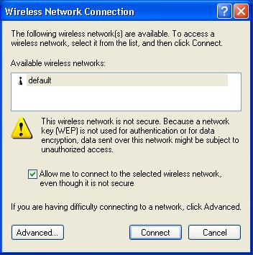
- Given that you have not yet turned on security, the system demands that you accept that the network is not secure. When you are connected to an insecure network anyone within wireless range can monitor your network data or even join your network so the system is making sure that you are willing to make the connection (i.e. you trust this network).
- Select the checkbox to connect to the insecure network and press Connect.
- 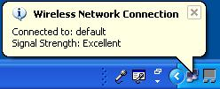
- Once you have given your approval to connect to the wireless network, your computer is automatically connected to the network. Your computer requests an address from the router and brings up an Internet connection.
If all has gone well, at this point you should be able to bring up your browser and surf the Internet. However, just because your computer has associated itself with a particular SSID, it does not mean that we are really communicating sufficiently for network traffic so you need to perform some simple connectivity tests (similar to what you did with the wired connection).
- Click on the network icon in the system tray to examine the detail of your wireless connection. Click on the Support tab to see the detail of the network settings.
- 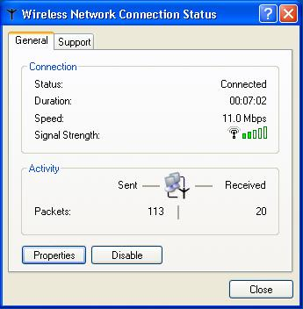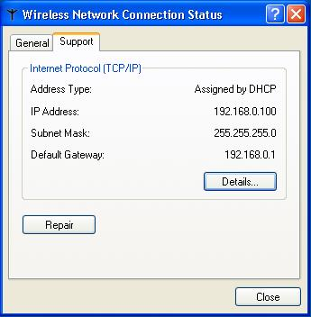
- For a wireless connection, the status dialog provides a nifty signal strength meter in addition to the other information which is provided for wired networks.
You can see the signal strength between your base station and the wireless adapter in your computer. You can use this indication to help place your wireless base station effectively in your home. Under the support tab you can see the address which the router ahs assigned to your computer. Like the wired connection, if you see an IP address that starts with “169” it is a bad indication – it usually means that your computer could not get a dynamic address from the home router. If you see an address which starts with “192” or “10” it is a good indication that your computer and the home router are exchanging data.
- To make completely sure that your computer and the router are exchanging data, press the “Repair” button.
The system should respond in less than 5 seconds indicating that the repair operation was completed. When it fails it can take up to 30 seconds. If this operation fails, the problem is most likely the configuration of your wireless client.
- If you are having a problem, you can explore and troubleshoot the wireless client configuration, right click on the wireless network connection icon in the System Tray, select View Available Wireless Network Networks and then click on the Advanced button.
- 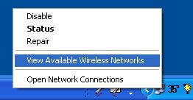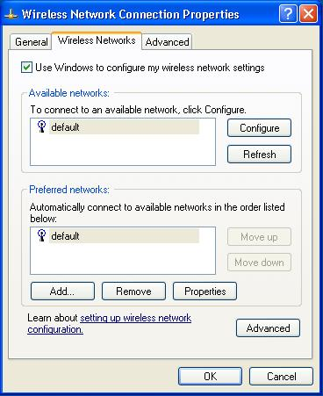
- This dialog box allows you to configure how your computer in how it works with a number of different wireless networks as you move from home to work, to the coffee shop. You can separately alter the configuration for each of the wireless networks that you work with. If you get too many networks in this dialog, simply remove them. The next time you encounter the network, it will be “noticed” and you will be given the option to approve it.
You may find success, making changes to the configuration for your particular network connection, but it is actually unlikely that this will solve your problem. A better approach is to go back to the beginning of this process and set things up. Perhaps you will have to reset your wireless router to factory settings, remove the base station using this dialog, and again try to set up the wireless network from the beginning.
Once you have your wireless network operating in insecure mode, you will reconfigure the wireless network to add security.

Summary
It would be good if Internet Service Providers could read this chapter, and configure their ISP service to make things as simple as possible. The home router manufacturers have certainly done everything they could possibly do to make things easy for you. They provide options in the routers to adapt to the ISP idiosyncrasies – your job is to work with your ISP’s technical support and documentation to figure out which set of features your ISP supports.
The good news is that over time, ISPs are generally motivated to make your life simpler, removing those features which make their service harder to use and harder to configure. In the long run it saves them technical support cost.
The “even better” news is that once your base station is properly configured the rest of your home network setup is relatively straightforward.

