Chapter 6: Extending Your Network
Now we will explore putting together the basic hardware necessary to make a network throughout your home. We will start with the most basic connection - twisted pair Ethernet. In later chapters, we will explore more exotic technologies such as wireless or phone-line networking.
Ethernet networking is generally and least trouble free connection if you can run the wires to the locations where you want to use your computers. Even if you have support for wireless computing in your home, you will probably still use Ethernet for a few of the computers in your home.

Ethernet Cabling and Network Hardware
There are two basic forms of Ethernet cabling - Coax cable and twisted pair. Since the mid-1990's, the industry has gone completely to the twisted pair approach. The original Ethernet design from the 1960's consisted of a single cable which was connected along the back of each computer. The cable looked like the typical cable used for cable television today. When a computer sent data out to the network, all of the computers "saw" all of the data going across the network. Much like a two lane road, there were "traffic rules" about when you could "jump on" to the network and when you had to wait to let traffic pass by.
- 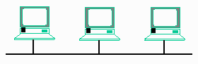
While this approach was simple and allowed a single long cable to be fed along the back of many computers, simplifying wiring costs, it did not work very well when one person disconnected the cable, effectively removing half of the computers from the network.

Twisted pair wiring and network hubs solved the problems of Coax cable Ethernet. In twisted pair, the computers are wired in a star configuration. Each computer had a dedicated connection back to the hub and when one computer was disconnected or had a problem, the rest of the network was unaffected. But because Ethernet was well established and the protocols which used Ethernet depended heavily on a broadcast medium, inside the hubs all of the ports were electrically connected together. One many hubs with activity lights, all of the lights seem to blink at the same time. This is because the traffic is being sent out on all of the ports at the same time. This means that a 10Mb/sec hub can only move 10Mb/sec total regardless of the number of computers connected to the hub. Hubs are still widely used in many low-traffic situations such as a home or small office when there are less than 10 computer systems connected to a network.
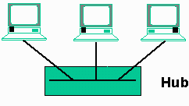

The next major step in the evolution of network equipment was the switch. Because the Ethernet protocol assigns a unique network address to each network card, it was possible for a switch to automatically "learn" which computer systems were located on which ports. When a switch first comes up, it acts like a hub, copying all incoming data to all the ports at the same time. But as the data is transmitted, the switch looks at the source address of each packet of data and makes a note which port it received the data. When a packet arrives for that workstation, the switch only copies the data to the proper port. Once a switch has identified which workstation(s) are on which port, the data is only copied to the appropriate port. This means that a 10Mb/sec switch with 8 ports is capable of up to four simultaneous data transfers at the same time for a total of 40Mb/sec overall. Some traffic (such as ARP packets - described previously) are special broadcast packets which are copied to all the connections of a switch. Switches work very well in networks from 5-250 computers because much more aggregate traffic can be moved through a switch. Switches are generally reasonably priced and have very good performance. In very large networks, their primary limitation has to do with how they handle broadcast traffic.
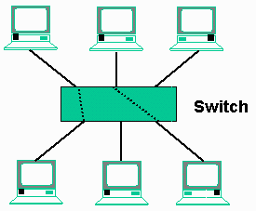
Switches have an added advantage in that most switches allow you to mix and match between different speed Ethernet equipment. The most common application of this is to use a combination of 10Mb/sec and 100Mb/sec Ethernet equipment in the home. Because switches are making dynamic connections for each packet, two 100Mb/sec computers can be moving data at 100Mb/sec, while two 10Mb/sec computers move data at the slower rate. A switch can even slow down the data, allowing data to be transparently moved between a 100Mb/sec computer and a 10Mb/sec computer.
In a home network environment a switch is generally preferable unless the cost gets too high. The price of an 8-port switch is pretty reasonable, but 16-port switches become more expensive because their typical application is in a business environment.

Network Design
It is possible to connect a number of hubs and switches together to form your network. This can allow you some flexibility in wiring. For example, you can run one wire to a room, and using a hub within the room you can connect several computers to your home network. Using multiple hubs is called cascading. Cascading is made much simpler when your hub has an uplink port. Most of the ports on your hub are wired in the standard manner to connect to a workstation. One some hubs, one of the ports are wired both as a normal port and as an uplink port. You cannot plug a cable into both the uplink port and the corresponding workstation port at the same time. The five port hub pictured here can either function as a hub for five workstations or as a hub for four workstations with an uplink.
- 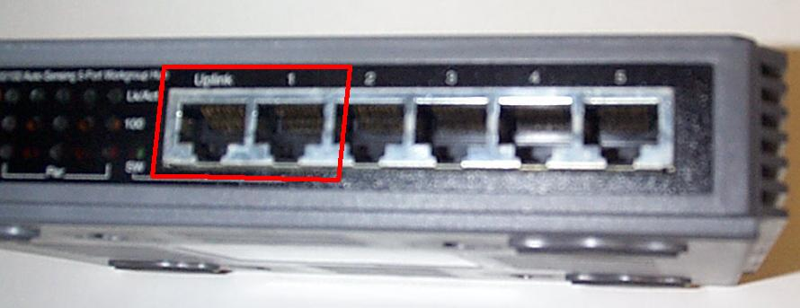

This diagram shows three four port hubs properly connected together with the maximum number of workstations attached to each hub. The top hub (root) has two workstations connected and uses two of its workstation ports up provide uplink connections for the lower hubs. Its uplink connection is not used. The two lower hubs, each have three workstations connected and their uplink port connects to the top hub. The workstation port port associated with the uplink port is not connected to anything.
- 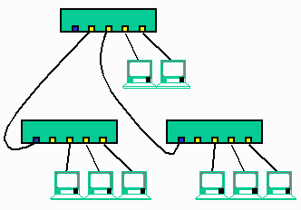
When cascading hubs together, you cannot connect beyond three levels from the "root" hub to the end hub. The previous figure shows a two-level cascade. While this seems to be a somewhat limiting factor, with three levels of 24-port hubs, you can have over 10,000 computers. Also, switches do not have any "cascading" limitation like hubs. Because of this, you can think of any port on a switch as at "level zero" in terms of cascading.

In a hub, the only difference between a normal port and an uplink port is simply which signals are routed to which connectors in the cable. So "port 1" and the uplink port are the same port with slightly different wiring configurations. As a matter of fact, if you do not have an uplink port, you can use a normal port on the hub to make the uplink connection, but the cable must be a special cross-over cable or a cross-over adapter must be used. But most seasoned network professionals tend to avoid cross-over cables like the plague. The problem happens when your identical looking cross-over cable ends up in a box with a bunch of normal cables. For this reason, many cross-over cables are made out of red cable or specially marked in some other way.

Phone Line and Power Line Networking
If your home is already built, and you don't feel like climbing around in the attic, cutting holes in your walls, and fishing wires through walls, you may find it more practical to use the existing wiring in your home to build your home network.
You can do data networking over your existing phone lines or over the power lines in your home. These protocols share the existing wiring in your home and coexist peacefully with the current uses of your wiring.

Using One Wire for Two Purposes
Both of these protocols can share the physical wiring by adding a "modulated" signal on the existing wiring. By modulating data at a relatively high frequency (MHz) the data signals "pass right by" the normal signals on the wires. Power signals operate at 60Hz and voice telephony operates from 0-6000Hz (the range of human hearing). The data signals are at such high frequencies that they are not anywhere near a frequency that you would notice in the form of a hum or other form of interference.
- 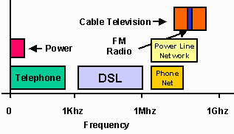
While this may seem daunting, it happens all of the time in Cable Television. One cable carries over 100 channels of information. Each channel is modulated to use a different frequency range on the cable and so they do not interfere with one another. Your television simply must tune to the right frequency to extract the desired signal.
Phone line and power-line wiring use the same approach. When sending data, they modulate it up to a high frequency and send it across the cable. The receiving network cards are tuned to the frequency so they get the signal. At the same time, your telephone responds to a much lower frequency so the high-frequency data passes right by. Similarly in power line networking, your hairdryer is "tuned" to 60Hz and so the high frequency data is completely ignored by the hair dryer.
Now of course, there are very significant technical details to make these protocols work reliably under a wide range of network conditions and wiring configurations. It has taken many years of research into both technologies to arrive at well-engineered standards which work reliably.
Early on, there were a number of competing "standards" for this type of technology, forcing you to purchase all of your equipment from one vendor. Thankfully in recent years, most of the vendors have chosen to conform to standards which makes the equipment from different vendors interoperable. Standards are very critical to networking equipment because they protect your investment over time. A standard means that if you purchase your network cards from one vendor and a home gateway from another vendor they will work together.

Installing Telephone Line Networking Technology
The physical topology for telephone wiring is to take single pair of wires and run to each wall outlet. At some point, the wires are all connected together. There is no "hub" for the wires, they are physically connected together on a terminal block or the wires are twisted together. In some homes, the wires simply run from one plug to the next through the walls. In other homes, the wires are all run back to a central location and connected. The home wiring is also physically connected to the wire which runs to the telephone company.
- 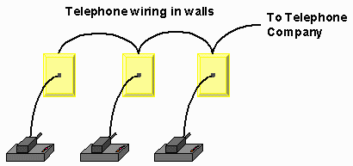
This approach makes it quite easy to add another phone extension or wire a new jack. It is also why you can hear a conversation when you pick up any phone. On the other hand, if you have two phone numbers for your home, they will be wired on separate pairs. Most phone jacks are wired with at least four wires (two pairs) and are capable of supporting two phone numbers in one jack if wired properly. Because phone line networking depends on the wires being physically connected, all of your phone line network equipment should connect to "line 1" or "line 2". Unless you do something special, you will be using "line 1" for your phone line networking. If, for some strange reason, you have a reason to use two separate phone lines for phone line networking, you will need some sort of hardware or software gateway to make them appear as a single network.
- 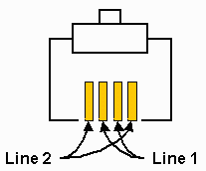
To use the phone line for data networking, you must install a network adapter which supports the phone-line protocols such as the Intel AnyPoint Home Network Card. These cards install in the exact same manner as an Ethernet card, but their connector is a telephone line connector. Some of the adapters will connect to your computer using a USB port and others will be built-in PCI cards. You use a standard telephone cable to connect the adapter to the telephone outlet.
- 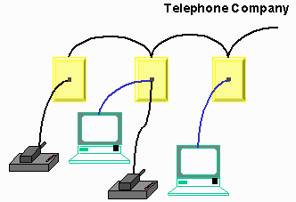
If you want to use a phone and computer at the same location, you can use a simple phone-line jack doubler. Some of the phone line network equipment provides a "loop through" telephone jack so you don't have to run a wire all the way back to the phone jack at the wall to connect the telephone, modem, or fax machine.
- 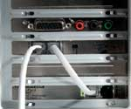
You will install the proper device drivers for the network equipment following the manufacturer instructions. Once the computers are rebooted, you should have basic network connectivity between the computers with the ability to share files and printers. At this point, there is absolutely no relationship between your phones and your computers. It is like you have a basic two-station Ethernet network - except for the fact that you did not have to run any new wires.
Sharing an Internet connection in a phone line networking environment is not really that different from sharing an Internet connection in a standard Ethernet environment, you have several options:
- Have one computer act as the Internet gateway. You install a phone line network card and either an Ethernet card or modem (depending on your Internet service). Then you can run a software network gateway such as Sygate (www.sygate.com), WinRoute (www.winroute.com), Windows Internet Connection Sharing (ICS), or other products. The software will manage forwarding packets between your phone line network and the Internet. Some phone line connectivity kits will include connection sharing software and instructions for its setup.
- You can purchase a bridge to connect your phone line network to your Ethernet network and connect any number of Internet connection sharing solutions (hardware or software) to the Ethernet portion of your network.
If you are sharing a connection using a modem, the connection may seem a bit strange at first. You will actually have to make two connections to the phone jack. One for the phone line networking and another for the modem.

Phone Line Networking Technology
Phone line networking has become increasingly sophisticated over time. Most vendors comply with a standard called the HomePNA (Home Phone Line Architecture - www.homepna.org) specification. This specification is also an approved international recommendation G.989.1 (Phone line Networking Transceivers - Foundation). There are HomePNA compliant products from a number of vendors, ranging from network cards, to print servers to home gateways. There are two versions of HomePNA - Version 1.0 which runs at 1Mbps and Version 2.0 which runs at 10Mbps. The Version 2.0 equipment is upwards compatible with the earlier equipment.
HomePNA chooses a frequency that is high enough that it does not interfere with the frequencies used by Digital Subscriber Loop (DSL) Internet service. It is possible for standard telephone service (POTS), DSL, and HomePNA to coexist on the same wiring without interference.
The HomePNA protocol essentially is an Ethernet-style protocol with adaptations to the physical, electrical, and modulation requirements necessary to operate on telephone lines. There are several advantages to this approach. First, many higher level network protocols, TCP/IP, Microsoft File and Print Sharing, and Novell Netware, all are highly adapted to operate well in an Ethernet environment. Because of Ethernet's beginnings as a single wire protocol, Ethernet protocols are well adapted for the phone line wiring environment. A second advantage to using the Ethernet protocol as the basis for HomePNA is that it is possible to develop a bridge which transparently converts from one physical media (phone line) to another physical media (10BaseT - or twisted pair Ethernet).
One of the flaws of early phone-line networking was that it was difficult to use a mix of standard Ethernet equipment and phone line networking equipment. Now vendors have developed a relatively inexpensive bridge which has a HomePNA port and an Ethernet port on the back. These bridge units tie the two networks together to make them appear as a single network. With this bridge, you can use Ethernet (even 100Mb/sec Ethernet) in your "main computer room" and connect the rest of the house using phone line networking. This way you can have the best of both worlds.
The advantages of phone line networking include:

- Uses existing wiring in your home for data while allowing you to continue using the telephone
- Cabling is very inexpensive and readily available
The disadvantages and limitations of phone line networking include:
- The network adapters are more expensive - on the order of $100 as compared to an inexpensive Ethernet adapter for less than $10. However as phone line networking catches on and the manufacturing volumes go up, it is quite reasonable to expect that phone line networking adapters will drop in price.
- You will have to purchase extra equipment to bridge between any standard Ethernet and your phone line networking equipment.
- The total phone wire length in your home needs to be less than 1000 feet. For most homes less than 10,000 square feet this is not a problem.
- The protocol can support up to 50 computers - again for most homes, this is not a problem.
It is important to note that the HomePNA protocol was designed to solve the problem of home networking and as such, may not work well in a small to medium sized business environment.
With the standardization of the phone-line network protocols, and the strong support from a wide range of vendors, phone line networking is a good bet for existing homes which you do not want to rewire. But make sure that you look closely at what it will take to share your Internet connection or interoperate with an existing Ethernet network.

Power Line Networking
The adoption rate for power line networking is not as rapid as phone line networking. While the basic idea of modulating the data at a high frequency is the same, power line networking faces several challenges:
The voltages and amperages present at a wall plug are much higher so the physical equipment to connect to the power lines must be more rugged than for telephone lines.
While the basic frequency of AC current is 50-60Hz, equipment such as fluorescent light fixtures and microwave ovens cause a wide range of higher frequencies to be present in the power line, potentially causing interference with the data transmissions.
While these are interesting challenges, they have been solved in the current generation of power line based network equipment. Like phone line networking there is an industry association which is promoting a standardized approach to power line technology across multiple vendors. You can get a good overview of the standards and products for power line networking at the HomePlug Powerline Alliance (www.homeplug.com) page.
The primary advantages of power line networking are:

- There are a lot or power outlets in the typical home
- Everywhere there is a data outlet, you have power (and vice vesa :) )
If you imagine some ultimate "future home" where data networking is simply assumed for every single gadget in the home, a single connector which includes both power and data is preferable to having to run two completely different types of wires to every location.
Some locations such as a warehouse or other commercial space may have very little phone or network wiring.
So while power line has not made a great impact in the home network arena to date, it has some very attractive features and shows great potential.

Conclusion
Both phone line and power line networking have the benefit of allowing you to build a network with no "new wires". The cost of the network adapters for these "more exotic" technologies will be somewhat higher than a "tried and true" Ethernet solution. But the cost will be far lower than the cost of hiring a carpenter to cut holes in your walls for Ethernet.
Phone line networking is becoming a relatively mature market with the release of HomePNA 2.0 with the accompanying support from the hardware vendors. By adding a HomePNA to Ethernet bridge, you can create a nicely integrated home network using both technologies where appropriate.

Power line networking has some definite advantages over phone line networking, but power line networking has had a much slower acceptance in the market place. However, there may be some applications for which power line networking is the only practical solution.

