Appendix B: Advanced Configuration for Cable Modem Connections
If your cable modem does not respond to a basic Dynamic IP address request, we will have to work a little harder. This appendix covers some additional configuration options which you may need to perform to get your router up and running. Of course you should recheck the cabling and make sure that everything is plugged in and that the cable modem is up and online. Assuming that everything is plugged in properly and the cable modem is online, the configuration problems will likely is one of the following:
- The cable modem is setup to only provide the address to a particular host name.
- The cable modem is set up to only provide the address to a particular Ethernet adapter.
- You have static IP service rather than dynamic address service.
Each of these concepts will be covered in a separate section.

Setting the Host Name
The first step is to determine whether or not a host name is needed. Increasingly, cable modem providers do not require a hostname as it tends to increase the installation complexity and increase support calls (and cause sections just like this to get written).
- Look in the paperwork which was provided with your initial cable modem service. The hostname might be buried in that paperwork. If you installed the ISP provided software, you may have entered the hostname from the paperwork into the installation process.
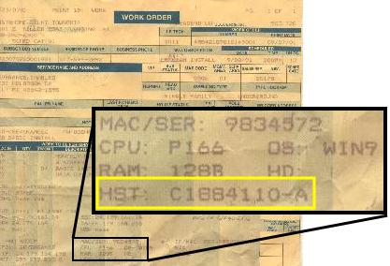
- You can call your ISP technical support and ask them, “Does my service require a host name to get a DHCP address? What should I put in as the host name for my computer?”
If technical support seems to have no idea at all about answers to either question, then chances are pretty good that it is not required. For those ISPs which require the host name, you can bet that technical support has to solve problems all the time when someone reinstalls their operating system and loses a required hostname.
One trick of technical support is to not answer the question that you ask, but instead make you go through a bunch of meaningless steps (is it plugged in, check this, de-install that, etc.) which allows them to set the agenda. Sadly while it makes them feel better it usually messes up your system. Generally you should try to set the agenda for tech support calls and stick to your guns. Ask your question and if they try to answer a different question ask your question again. At some point, you can ask to talk to “second level technical support”. Every single question which we tell you to ask technical support should be well understood by first level support and second level support should know off the top of their heads. Of course, before you call technical support make sure that everything is plugged in. You would be surprised at how often stuff is just not plugged in correctly.
- If you had a single computer connected to the cable modem initially, the cable modem may have “adopted” the name of that computer as the host name it demands. You can find the host name of a computer by right-clicking on the My Computer icon, selecting Properties, and then selecting the Computer Name tab.
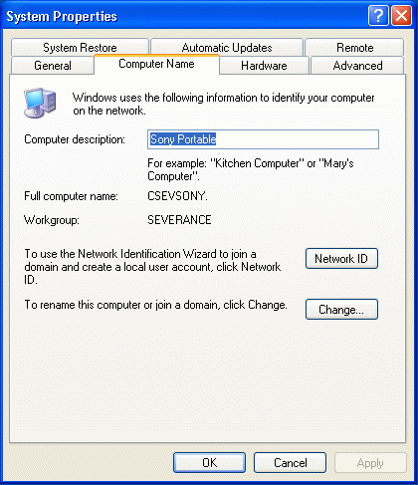
In this example, the computer name is “CSEVSONY”.
- Once you have determined the host name, go to the WAN configuration screen set the host name and restart the router by pressing Apply followed by Continue after the router restarts in a few seconds.
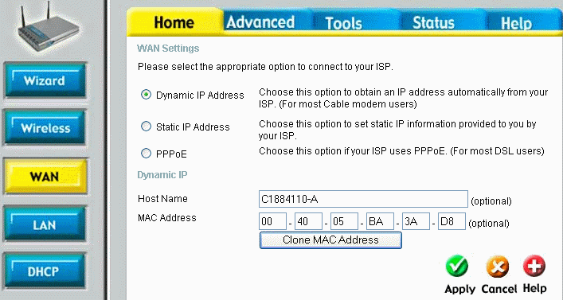
- After the router resets you need to check to see if we received a DHCP address by pressing the Status tab and the Device Info button.
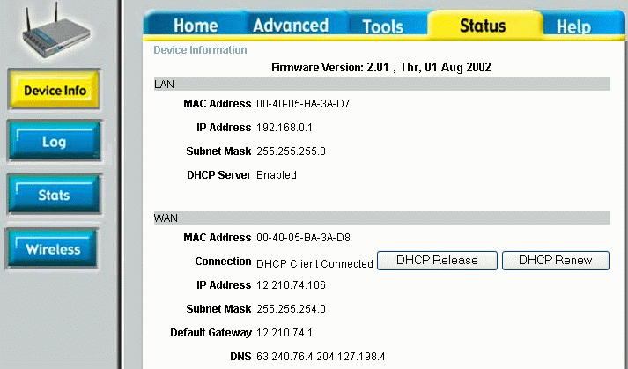
If you did not get an address, feel free to try to do a DHCP Renew and see if you get an address. Renewing the DHCP address is always a good test to determine if the router is talking to the Cable Modem. Sometimes things happen too quickly during a reboot and you have to manually force the DHCP Renew operation.
You can actually go through this process several times if you are trying to “guess” a few different hostnames. The good news is that for those ISP’s that do not require a host name, they generally ignore whatever is in this field.

Setting a MAC Address for your Cable Modem
Some Internet Service Providers try to limit which computer can connect to their cable modem by demanding that the dynamic address request come from a particular computer or network card. Every Ethernet adapter ever built has a unique serial number. This is a 48 bit number and is usually written as a series of six hexadecimal numbers, often separated by colons like 06:FE:44:00:08:64.
Usually the ISP will not know in advance the exact Ethernet serial number of your computer so they simply grab the serial number of the first computer which connects to the modem after it is installed and remembers that serial number for future reference and demands to only talk to that computer unless you call technical support and beg them to allow a new address.
Most ISP’s have learned that demanding a particular MAC address is far more bother than it is worth in terms of the number of unhappy technical support calls that it causes. So most cable modem ISPs do not demand a particular MAC address.
- Call technical support and ask them, “Does my cable modem require a particular MAC address to give out a DHCP address? You should be prepared to tell them the definition of MAC Address (Serial number for an Ethernet adapter) and/or DHCP (Dynamic IP) address. If have no clue about that question, ask, “What if I removed my network adapter from my PC and installed a new one, will my cable modem continue to work? If not, what should I do or is there some configuration option that you have to change?” (See how we cleverly sugar-coated the question of whether or not the Ethernet serial number matters?)
In a way, much like host name, if level one technical support has never heard the words “MAC Address”, then it is probably not a critical configuration option.
- On the particular router, there is a “Clone MAC Address” button. This is worth a try, but you should make sure to be using the computer which was initially connected to the cable modem before you purchased the router.
- We can manually do the same operation even if your router does not have the “Clone Address” capability. On the computer which was originally connected to the cable modem, Start -> Control Panel -> Network Connections -> Local Area Network Connection -> Support tab (we have been here several times now) and then press the Details button.
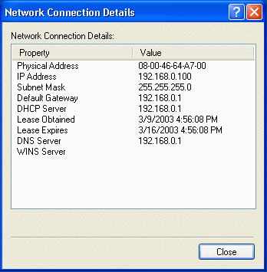
The “Physical Address” is the Ethernet address. As you can see it is six two-digit hexadecimal numbers. Hexadecimal means that in addition to the digits 0-9 we use the letters from A-F as well – that makes sixteen digits – real cool computer dudes just call this “Hex”. You might try to impress tech support by throwing the word “Hex” in during a call some time. Here is a scenario: they say: Can you read me the MAC Address? You say: You mean the six hex numbers? They say: Yes, those numbers (with a newfound respect for just how cool you really are).
- Simply transcribe the numbers into the MAC Address field on the router and press Apply and then continue to restart the router.
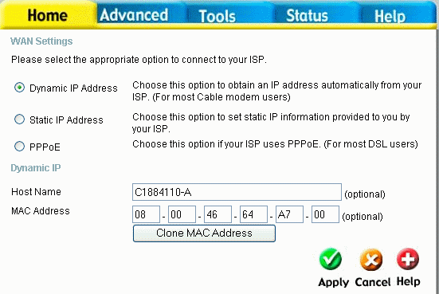
- When the router resets again check to see if we received a DHCP address by pressing the Status tab and the Device Info button.
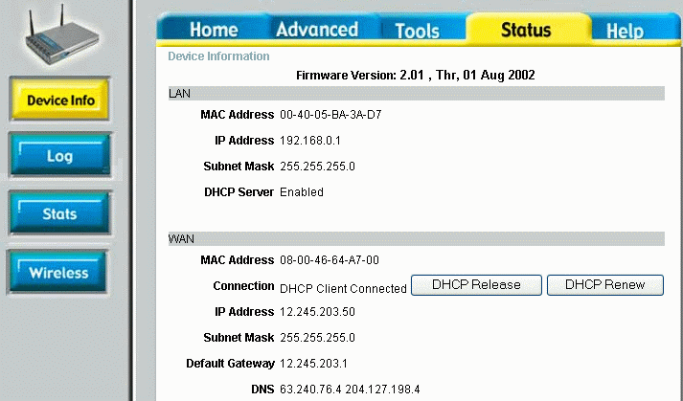
If when you first go to the status page, it appears that you did not get an address, feel free to try to do a DHCP Renew and see if you get an address after a renew. You can see that we have an IP address and that the MAC address has changed on the WAN side of the router.
You will note that the LAN (Local Network) side of the router has a different MAC address. That is because there are two separate Ethernet adapters in the router and they have two serial numbers. Just for fun, take a look back up at the MAC address for the LAN and WAN before we changed the WAN Mac address. You will notice that they are nearly the same. That is because the first three numbers indicate which manufacturer and the last three numbers indicate the serial number within manufacturer.

Connecting to your ISP with a Static IP Address
Chances are good that if you have a static IP address, you already know about it because you had to special order it and probably pay extra for it. Configuration with a static IP address is very simple. There are three numbers which all must be provided by your Internet Service Provider. You cannot guess these numbers – if you don’t know them you must call technical support.
- Go to the Home tab and Select the WAN button. Select the Static IP option and a number of new configuration options will appear.
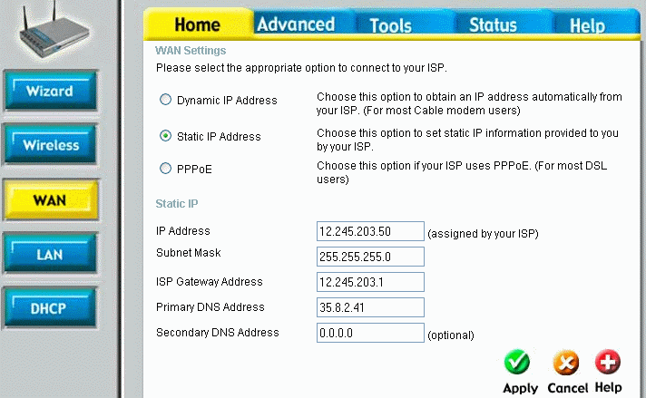
You should be given at least four (IP Address, Subnet Mask, Gateway Address, and Domain Name Server). The names may be slightly different, but they should be very close.
- Simply fill in the numbers as given, press Apply then Continue to reboot the router. Then navigate to the Status page.
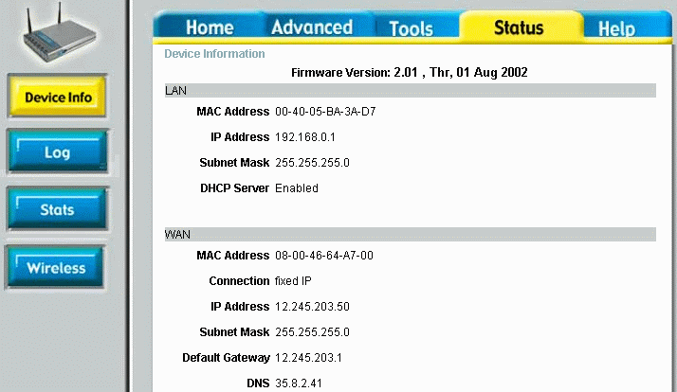
The “DHCP renew” button is now gone! Because the address are no longer externally set, you can no longer use the retrieval on an IP address as a test for network connectivity. However on this router (and on most others), there is a tool which can be used to test to see if your static address is set properly.
- Navigate to the Tools tab and press the MISC button. Enter a host name such as www.google.com in the Host Name field and press Ping.
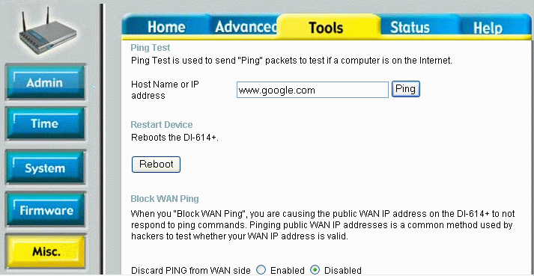
Ping sends a single packet to the host and tests to see if there is basic network connectivity to that host.
- If the ping was successful, the system responds with the following:
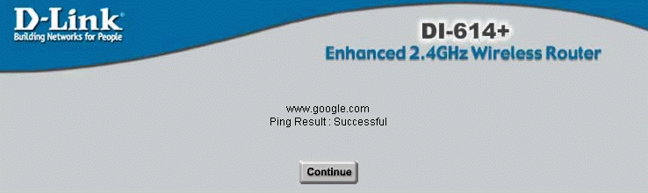
If the ping failed, you will get one of two messages. If the ping result complains about “Unknown host” then there may be a problem with the Domain Name Resolution Server in your configuration or you may have miss-typed the name of the host (make sure not to include http:// or any thing else). If the message comes back with a “Time out”, then the host name was resolved successfully (i.e. your router is communicating with its name server), but the host did not response to the ping. Some hosts are configured to ignore the ping messages so you might want to try a few well-known hosts before you give up and call technical support. Also, you might just start up a web browser and attempt to connect to a well-known web site as a test.
Static IP addresses are actually much less complex than dynamic IP addresses – once you get the numbers right there is actually very little which can go wrong. If you are having problems with a Static IP configuration, it is usually because there is a basic cabling problem, or you have the wrong numbers, or you have mistyped the numbers. Generally, with the tools described inside this section, you will be able to work with your ISP technical support to get things working quite quickly.
About the only time that a static IP address will give you trouble is if your ISP reorganizes their network, and forces you to change your address. Generally they will contact with the new information and the date and time that you will need to make the change.

