3: Installing a Broadband Internet Connection
In this chapter you go through all of the steps from choosing and ordering your internet service provider and establishing your first high speed internet connection. If you have access to more than one type of broadband Internet service, congratulations – you have the opportunity to evaluate and choose between them. This section will give you some guidance in making the choice.
This chapter covers the different types of Broadband Internet service providers including, Cable Modem, Digital Subscriber Loop (DSL), and fixed wireless. There are many other ways to get Internet Service which are covered in Appendix A and you can create a home network using nearly any ISP. If you do not have access to any broadband internet service provider, see the website associated with this book for additional detail on building a home wireless network using non-broadband Internet Service Providers.
Once you have chosen you high-speed Internet Service provider, you will walk through the installation and initial set up process. As you go through the process of researching, selecting, and installing our high speed network, you will always keep in mind that our ultimate goal is to install a home router capable of supported both your wireless and wired home network.
Even if you already have high-speed service, you will want to skim through the chapter for tips on how to work with you Internet Service provider when installing your home router.

Choosing Your Broadband Internet Service Provider
There is a continuous debate as to whether cable modem service is better than DSL service. The various companies will try to convince you to choose their service based on some subtle technical argument about the underlying technology. While you may want to consider the underlying technology in your decision, it is far more important to choose based on the features of the service, quality of technical support, and your overall confidence in the company providing the service.
An important component of your mission in choosing you ISP is to choose one that will be friendly to your home router and home network. Thankfully, most ISPs are willing to (at least grudgingly) allow home routers. Some ISPs have actually realized that home routers reduce technical support problems and support you in your effort to install a home router.

Researching Potential Internet Service Providers
The first place to begin your research is on the web. You can quickly determine whether or not a potential national ISP such as AT&T, Comcast, or SBC/DSL “has a clue” by looking at their web site. If you have a problem after you have purchased the service, you will spend a lot of time looking through the site for help – you might as well explore the site before you make the purchase. A mature ISP will have a robust web site with answers to hundreds of technical questions already available. If you are looking at a smaller local ISP, you may need to talk to other customers or call the technical support directly to assess the quality of their support. A local ISP may provide excellent technical support over the phone but have a rather poor technical support web site.
Looking at a vendor site, you should be able to easily determine pricing and features. Here are the important features to research:
- While each technology has theoretical maximum speed, you will usually have a connection which has been “throttled down” based on what you are willing to pay. Most services give you a faster “download” speed than “upload” speed. For basic web surfing, the lowest speed connection (384 kbps download/128kbps upload) will be quite sufficient. However, if you intend to watch live video, download media, you will need a download speed of at least 768kbps. If you intend to run a small server, do video conferencing, or even telecommute and need to send large attachments via E-Mail, you will want at least 300kbs in upload speed.
- Most services provide dynamic addresses. These are fine unless you want to run a small server in your home. Static addresses will often add about $15.00 to the monthly cost of most services.
- Most providers include a complete suite of supporting services including e-mail accounts and personal web space for family members. One nice feature to look for is an included dial-up account. This can be nice for those times when your high speed access is down or if you travel.
The next step is to assess the service provider’s telephone technical support capabilities. As broadband Internet has become more common, technical support has improved dramatically. As you gain skills (by reading this book), you will be able to communicate with technical support in an increasingly sophisticated manner.
Services Comparison
We took a look at two national providers and found the following information (as of the writing of the book):
- SBC/Yahoo: DSL, 384kbps/128kbps, dynamic IP address, 5 accounts, and free nationwide dialup. $39.95 / month
- SBC/Yahoo: DSL, 1.5Mbps/256kpbs, 5 static IP addresses, 10 accounts, and free nationwide dialup. $79.95 / month
- Comcast: Cable Modem, 1.5Mbps/256kbps, dynamic IP address, leased modem, 6 accounts. $45.95 / month
Technical support is typically arranged into several levels. Level one support often has minimal training and is prepared to answer a set of stock questions with some stock pre-prepared answers. Second-level technical support staff members are often technically-savvy and have their own home network and like talking to knowledgeable customers. Once they know that you are a knowledgable customer they may deviate from the “script” and actually answer your questions.
The first exercise is to simply talk to the first-level technical support and ask them some questions. You may feel uncomfortable about doing this, but remember that you are the customer and are about to give them a cash flow of $600 per year if they keep you happy. You can open the conversation using one of the following scenarios:
Researching Using User Forums
You may find a number of sites where users talk about their broadband internet providers. An example site is www.broadbandreports.com. Often these sites have detail right down to your zip code. If you decide to look at these sites, remember to take everything that is said with a grain of salt. There is almost never any positive commentary on these sites. People love to go on about their horror stories and then when they realized that they made a tiny mistake and everything got fixed – they never retract their stories. Also there are very few people who are happy with a service who go through the problem of registering for a forum just to record their satisfaction. So if you want to take a look, dig carefully through the rhetoric to find pieces of factual information and not people who are just plain angry.
- If you have no service – Hello I am considering purchasing your high speed Cable/DSL service and would like to ask a few questions. Am I talking to the right person?
- If you already have one service and are talking to the other service – Hello, I am considering switching my Cable/DSL service to your DSL/Cable service and have a few questions. Am I talking to the right person?
- If you already have high speed service and are talking to your service provider – Hello, I currently have your service and am considering installing a home router and have a few questions. Am I talking to the right person?
Once you are “talking to the right person”, ask some combination of the following questions: Do home routers work with your service? Do you recommend a particular brand? Can I purchase a home router which comes with the service? If so, how much does it cost? Is there a place on your web site which I can get help on setting up my modem router? Does your Cable/DSL modem support Ethernet, USB, or both?

The ideal outcome of your research is an ISP which meets your needs in terms of price, features and performance and can recommend and provide some minimal support for our home router. The next best (typically more expensive) option is to purchase a recommended home router with your service.
Calling Technical Support
We performed the experiment with two national high speed ISPs. We did not identify ourselves as book authors and were able to get reasonable answers to all of our questions from the first representative that we contacted. This is they said (as of the writing of the book):
AT&T does not prohibit home routers. If you want them to help diagnose your connection problems you must reconnect a single computer to the modem. The support web site mentions LinkSys routers and has some limited support information. Their cable modem provided both Ethernet and USB connectivity.
SBC/Yahoo does not prohibit routers. If you want them to help diagnose your connection problems, you must reconnect a single computer to the modem and reinstall the vendor-provided software on that computer. They do have a home router that they recommend for sale in their online store. It costs $280 and if you purchase their router, they will provide technical support on that router. Their modem provided both Ethernet and USB connectivity.
Some ISP's will have different prices depending on whether or not you own a modem. The alternative is to lease a modem at a typical cost of $5.00 per month. Given that broadband modems often range in price from $50 - $100, this might seem like an attractive option with a payback as short as a year. We generally recommend against purchasing modems. Some modems work better than others and it is nearly impossible to know which ones work better in your neighborhood unless you are the technician who diagnoses service outages all day long.
By making the modem the responsibility of the ISP, when the little green "up" light goes out, it is completely their problem. The last thing that you want is for a technician to come out and declare that your modem is bad when they cannot figure out the real problem. Then you buy another modem, and it still does not work - they then come back, slap their forehead, and say, "Oh! I should have checked for the filter adjustment thingy!". But now you have a perfectly fine spare modem and your $100 investment just became $200. If you lease the modem and they come out and the problem seems to be mysteriously solved by switching modems, they just leave the other modem and you are back up.
You must also make sure that you get a modem with an Ethernet connection. Modems will generally have a USB, Ethernet, or both connections to connect to your computer/home network. The USB connection is completely useless and a modem which only supports USB is also worthless. A USB modem requires that you only connect a single computer to the modem, and that computer will probably have to run a particular version of a particular operating system. This is because you need to have a driver for that particular modem for your operating system. There are some horror stories in regards to USB modems. One example of this was that people with a particular USB cable modem could only use Windows-98 a year after Windows XP was out (another good reason not to buy your modem) - the ultimate solution was that the vendor replaced the modems with newer modems.
By getting a modem with Ethernet capabilities you can install a home router and provide a seamless, extensible network in your home. As part of your initial conversations with technical support for your ISP make sure to ask whether or not the modem that you are getting supports Ethernet.
Why do ISP vendors "like" USB?
When placing the order or talking to technical support, they may "push" you to choose a USB modem and push you away from a home network. They do this because they think that it simplifies their technical support. A typical technical support approach is to assume that customers are pretty clueless. By forcing you into a single computer with one wire, and running one operating system which they specify with software and installation procedures that they provide, they can guarantee that you will be able to self-install your modem and network, saving them phone calls (and money). The problem with this approach is that they do not understand that your home network will evolve dramatically over time as new equipment is invented and added.

High Speed Network Installation
Your involvement in the installation of your high speed network service (a joyous occasion in many households) depends greatly on your service provider and the technology which is used by that service provider. We will cover both cable and DSL scenarios which can help provide insight into your particular scenario.
One of the overriding goals of the service provider is to limit the number of "truck rolls" which are necessary to accomplish the installation. The cost of a service technician (to the company) to come to your home ranges from $50 to $500 depending on whether they have to come into your home and how long they must work to solve any installation problems. Because this cost is generally not passed on to you, there is high motivation for the company to avoid sending out a technician.
If your installation will include a service technician coming to your home, the more organized that you are before the technician arrives, the more likely that you will get your network running quickly. You should know where you want the modem to be installed. You should have a computer ready to connect to the modem. You should have cable or telephone (depending on the technology) plug in the area where you want the modem installed. You should know where the cable/phone comes into your home. And you should have the area relatively clear so the technician does not have to climb over your collection of antique plates, obsolete computer parts, or dirty laundry to perform the installation.
Often you can learn valuable information by talking with the service technician while they are performing the installation. You might even find out that she has her own home network gateway using their service. But you should not try to pressure the technician into doing any additional technical support. It is not their job to provide home network assistance and they may get in trouble if you call later and complain that their advice caused you a problem.

Cable Modem Installation
The first step in the installation of the cable modem is to reconfigure your cable connection so that the "cable modem channels" are actually sent to your house. Cable modems use particular channels on your CATV much like HBO or pay-per-view. Depending on the technology, your service provider may or may not have to roll a truck and climb a telephone pole to enable these new channels. In addition, some systems have physical filters installed which remove the network and other data frequencies from the cable which comes into your home. These filters must also be removed. Often all of this activity can be performed without entering the house so you do not have to meet the technician.
Once the signal is in the home, the cable modem must be installed. Often, cable is routed around the home using "splitters". Each splitter takes one input signal and provides one to six output signals. Splitters can be used when in the cable which is used to connect the cable modem, but they should be high quality and the as few splitters as possible (preferably one).
- 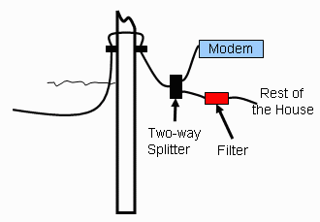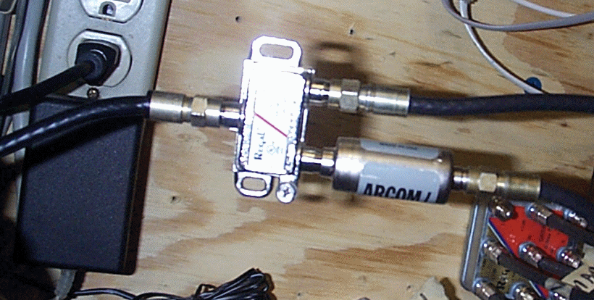
- Wiring a cable modem
If you can install your cable modem near the location where the cable enters the house, a clever installer may install a filter to remove the cable modem signal from the rest of the house to insure that your CATV signal is as clean as possible. The filter also helps the cable company by reducing interference from the rest of your house back into the CATV system so it is a win-win situation to have the filter installed as shown.

DSL Modem Installation
DSL installation can range from extremely simple to impossible. We will focus on the simplest case and then cover some of the more complex issues. The most important issue is for the phone cable which comes into your house to be of sufficient quality and not too far away from the central office. As part of the ordering process for DSL, they will look up your telephone number in a database which has a good notion of the length and type of your phone connection.
Once the database indicates that your phone line is sufficient to support DSL, an order will be placed. The phone company will reconfigure your line to support DSL and a technician will come to your home and verify that the DSL signal reaches your home. This is generally done without entering your home. Once the technician has verified that your line works, they will ship you a DSL modem with installation instructions.
These instructions are generally very well written and easy to follow for the average homeowner. However, we suggest that you read this entire chapter before performing the installation so you can best plan your installation.
- 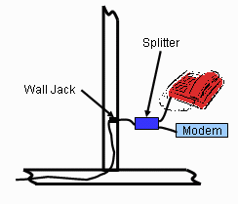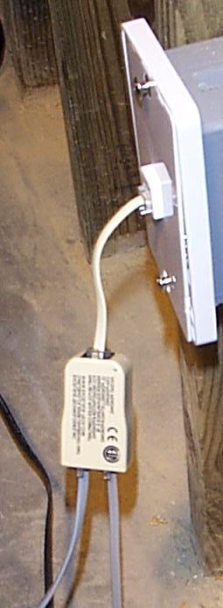
- Installing a DSL Modem
When you install a DSL modem, you will typically have to install a line filter/splitter. This is needed because the DSL signals are higher frequency signals which are generally ignored by standard telephone equipment. The splitter is just an added protection to make sure that none of the high-frequency DSL signal goes to the standard telephones. This reduces the complaints from people who hear some weird background noise on their phones. This splitter will not prohibit the use of a FAX or even a standard analog (i.e. 56kb) modem on the phone line.
This ability to "re-use" existing wiring to and inside your home is one of the advantages of DSL technology. Because all of the telephone wiring in a home is wired in parallel, it does not matter where you place the DSL modem.
However, like with the cable modem, if you can install your DSL modem near where the phone line enters the house, you can use the splitter to remove the DSL signal from all of the phone jacks in the home by connecting the home phone wiring to the standard phone output of the splitter.
At some point, even though the database indicates that the phone cabling to your home can support DSL, there may be some problem with the cabling. The solution can range from pulling a new cable to your home, or using a different set of pairs in the cable to your home. The good news is that this is something that the phone companies are very good at diagnosing and solving without requiring you to help them to troubleshoot the problems. If you encounter this type of problem, is may delay the installation or make it impossible. In these situations, you need to be patient and keep talking to the internet service provider or the phone company as they work through the installation.

Bringing Up Your Modem
Once your modem has been plugged into the phone jack or a cable TV connection, it is time to power up the modem. You may be doing this step or a service technician may be doing this step, but from your perspective, it is actually quite similar whether or not you have DSL or Cable.
From your perspective, bringing up your modem either works or it does not. If it is plugged in properly and it does not establish its connection with the ISP, you will need some help from technical support.
This all important step may involve a lot of complex mechanisms, but the whole process usually comes down to a single light or LED on your modem. The light may be labeled "Online", "Ready", "DSL", "Connection", "Uplink", or some other label, but what it is ultimately indicating is that there is a successful communication path to the ISP. This does not mean that you can send and receive network data but simply that the modem is successfully "talking to the mothership".
- 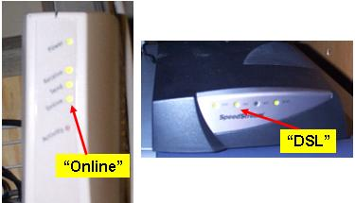
- The all important light on the modem
Note: pictures are only place holders - we will shoot higher quality pictures before we are done.
You should get to know the patterns for this light. The most important things to know are: Which light is the important one? How long does it normally take for the light to come back on after you power cycle the modem? Is there a sequence of lights which come up before the "ready" light is on? What do those lights mean? Often the documentation which comes with the modem is pretty unreadable, but if you search through it, you can learn what each of the lights mean.
If the low-level modem communication between the modem and the ISP is not working, all other troubleshooting effort is pointless.
Even though it is generally not possible for you to solve a problem with the modem's low-level communication without help from technical support, there are a few concepts that might help you when talking to technical support:
- Because CATV cabling is a shared media, cable modems have serial number information in them - you cannot simply switch modems without talking to technical support.
- Because DSL modems are connected to "your" phone line, the serial number of the modem is less important. Even so, you should never switch a DSL modem unless directed to do so by technical support.
- Both cable and DSL modems maintain a low level connection with the ISP at all times whether or not you are connected to or using the Internet.
- Cable modems actually maintain two connections. Some cable modems have separate lights for indicating a successful downstream connection and a successful upstream connection. There are generally more problems with the upstream connection than the downstream connection. If your television signal is working and you don't get a downstream indication, it is likely that there is a widespread outage and the ISP is already working on it. If you get a downstream indication but not an upstream indication, then the problem is more likely to be localized to your home or neighborhood.
Most cable modem and DSL ISPs actively monitor every modem whether it is up or down. If your whole neighborhood has an outage, they will most likely know it before you do and scramble a truck to figure out and fix the problem. However if there is only one modem down, they will assume that you have simply turned it off so if you are having an outage, you will have to call them.

An ISP Provided Home Router
If you have chose to purchase a home router from the ISP either the technician will install the router or you will be provided self-install instructions install it. Once the router has been properly installed, you should be able to connect a computer using a wired or wireless connection, and get an address. You should probably skip to the section titled "Connecting your computer to the home router" in Chapter 4. If your home router is from AOL, see the section on AOL in this chapter.

Connecting the First Computer to the Cable Modem
Unless you have purchased a home router from your ISP, the typical next step in the installation is to connect a computer to the modem. If a technician is installing your service, they will generally connect a test computer to the modem to perform a basic test to insure that the next work is up and functioning. Once they have verified that the modem is operational, they will then leave it up to you to connect your computer to the modem.
This may seem like a simple proposition, but it is often a place where problems begin. Most of the problems which you will have over time will be because of the vendor provided software which you installed in this step.

Installing the ISP-Provided Software
The ISP-provided software starts out with good intentions but ends up causing as many problems as it ultimately solves. The vendor supplied software intends to take a single computer which has never been connected to the network, and has no network software installed, and attempts to configure your high-speed modem, reconfigure the networking in your computer and install a bunch of software which you probably don't even want or need with a single click. While this may be ideal for a single person living alone who will never own more than one computer who never leaves the house and who never wants to use wireless, it is far too restrictive for the large majority of homes which need high speed service.
Once you have properly constructed your home network and installed the home router, you will probably not want the vendor supplied software installed on any of the computers in your house. The home router will perform all of the necessary functions of the vendor software, and you will use your other Internet tools (browsers, e-mail readers, etc.) exactly the same ways as you use them at work or over your dial-up connection.
Unfortunately most ISP's will insist that you have the ISP provided software installed on a single computer and connected directly to the modem before they will help you with technical support.
How you approach the vendor software depends on your technical skills and the resources which you have available. This list gives you some of the options that you have available:
Cable Modem: Slight Advantage
There is one subtle advantage of the Cable modem over DSL in the case of connecting a computer to the modem for diagnostic purposes. Most cable modems use a protocol called DHCP (Dynamic Host Control Protocol) to establish the initial network connection between the modem and the computer while DSL modems use a protocol called PPPoE (Point-to-Point Protocol over Ethernet). PPPoE is a way of using software to pretend that the modem is just a really-really fast analog modem, rather than a true network device.
Virtually every network-capable operating system has built-in support for DHCP so it is likely that you can connect your computer directly to the modem without installing the ISP software.
- Don’t install the vendor provided software at all. When the modem has been installed skip to Chapter 4, attach your home router and bring it up. This is not as silly as it sounds. For generic DSL and cable modems this is a reasonable approach. If it fails, you can always come back and install the vendor supplied software. This approach is also an excellent approach if your computer is a Macintosh, Linux or other non-Windows system.
- Install the vendor provided software and configure the modem, and uninstall the software later when you have your home router up and running. If you have connection problems, you will have to reinstall the vendor software. For this approach, you should look carefully under Start -> Control Panel -> Add/Remove Programs before and after you install the vendor software so you can be sure to remove all the components of the vendor software.
- Install the vendor supplied software on a separate bootable partition or even on a separate computer.
If you choose to install the vendor-supplied software, it is a good idea to take notes about the sequence of steps that you went through in case you need so redo the process later.

Essential Configuration Information
At the end of this entire process there are a number of pieces of information which are part of your configuration for your network connection. As you go through the process of installing your service. You may get this information from technical support, or from written information which comes with your installation kit. You will need this information when you configuring your home router.
- For DSL, the most important information is your account and password.
- For a cable modem, you may not need any configuration information at all. But for some services, you may need to know a host name or a MAC address which is authorized to connect to the cable modem.
As you go through the process, it will be very helpful to take notes. Part of your goal during the installation process is to learn the necessary information to install your home router.
MAC Address
Every Ethernet adapter manufactured has a unique serial number associated with the adapter. This Media Access Control (MAC) address is a 48-bit number and is usually written as a sequence of six two-digit hexadecimal numbers like 08:00:48:04:2E:3F. Some cable modem ISPs configure your modem to only talk to a single MAC address. Luckily most home routers have the capability to masquerade with any MAC address which you specify through configuration.

High Speed Access through America Online (AOL)
America Online is the most popular dial-up Internet Service provider. Many people converting to high speed access will be converting from AOL dial-up access. In some areas, AOL users may be able to upgrade to DSL service from AOL.
If you are an AOL user, you may have two options in terms of how to upgrade to a high-speed service.
- Select a DSL package from AOL. This will include both the high speed access and your AOL account(s) for a single fee.
- Get high speed access from any other provider and maintain your AOL account using your high speed ISP to make the connection. AOL calls this configuration "Bring your own access".
There are advantages to each of the choices AOL has made it so that the bundle of AOL DSL is more attractive. If you use another high speed provider, then you will have to pay $15.00 per month to maintain your AOL accounts beyond the cost of your high speed access.
The advantages of using the AOL/DSL bundle:
- Excellent technical support - AOL is the number one ISP for a reason - they know how to help people keep their computers connected even with limited technical expertise. AOL/DSL will provide you with a home wireless router which they will support.
- Reduced cost as described above
- If your family members with AOL accounts, they can all be logged in at the same time. If you “bring your own access”, only one of your accounts can be logged in at the same time.
The disadvantages of the AOL/DSL bundle:
- All computers which connect to the network must have the AOL/DSL software installed to participate in the network.
- Before any computer can connect to the Internet (i.e. use a web browser), it must first be logged into AOL/DSL.
- Only computers which support the AOL client (typically only Macintosh and Windows) can connect to the network. This may limit the ability of a telecommuter to connect a work-provided computer to your home network.
So overall, the AOL/DSL package is very attractive for the home where users are already heavily into AOL. If you are not already an AOL customer it is not a recommended option. By choosing a non-AOL high-speed provider (including some other DSL provider such as SBC/Yahoo) and setting up your home network and using the "bring-your-own-access" AOL feature, you get the best of both worlds for a moderate increase in cost.

Summary
This chapter covers a lot of ground and it would be nice if you had a precise set of instructions as to how to choose and install your high-speed Internet service. Part of the goal of these early chapters is to get to a point where networking is simple, reliable and uniform in your home.
The challenge comes from the fact that there are many different service providers, each with their own set of configurations. Part of the process of installation your high speed service is to learn the idiosyncrasies of your high speed provider so that you can most effectively install your home router as described in the next chapter.

