Chapter 4: Installing Your Home Wireless Router
Note to Chuck: Play with XP PPPoE – a possible addition to Chapter 3
Note to Rich: In Chapter 1 We need a Strategy section which describes how 2-4 work (i.e. the path might be weird – read them all before you start to get context) Then go through the steps. At the end of 4, things become really simple.
Todo: Testing the connection IPCONFIG, etc
Todo: Operating in a congested environment
Now that you have a high speed connection installed and running, it is time for you to install your home router. If you have not already done so, you will purchase your home router using some of the advice in this chapter. Hopefully you read the last chapter while your high speed connection was installed and were able to gather necessary information which will make installing your router quick and painless.
As you go through the chapter, you might wonder why we take so many steps and check everything after every step with some type of diagnostic tool. Actually, there may be a bunch of times as you are going through the steps in the chapter that your router is working fine. From time to time you might just want to fire up a browser and go to www.google.com. Part of our goal in this chapter is to show how to test your router and connection using very simple and focused tests.
You have a much better chance of fixing a problem if you know exactly what does and does not work. If you fire up a browser and don’t get your main page, then there might be hundreds of things which might be wrong. By slowly and methodically checking each little piece of the network by itself, we will hopefully isolate the problem and provide a few things to check to resolve the problem.
This chapter is a supplement to the documentation which comes with your router. It is also a supplement to calling technical support for your ISP and/or router vendor. In some places we suggest calling technical support with particular questions. Sadly, we only have space for a complete example for two brands of router – luckily router configuration is very similar from vendor to vendor so you should be able to apply the concepts in this section to your particular router.

Purchasing Your Home Router
Before purchasing your router, there are a few steps that you should take:
- Consult the previous chapter and research whether or not your ISP supports (formally or informally) home routers or even sells a router.
- Read reviews of routers online. You will typically find that most reviews are pretty glowing because most home routers are well engineered and easy to use. You may learn about additional features such as support for a network attached printer or support for an external modem for a particular router.
- Examine the web site for the vendor of the routers that you are considering. Pay particular attention to the technical support section of the web site. One of your goals when selecting your router is to select a router from a company which is committed to the consumer/home marketplace.
- Consult with people that you know who have the same ISP to find out if they have any experience with a particular model.
The good news is that most home routers are pretty good products. You should select a mainstream brand such as LinkSys, DLink, SMC, or NetGear. You should also purchase your router from a local electronics vendor – often there are rebates of up to $50 on these products, so if you are willing to wait and shop a bit, you can get a very good deal.
You should purchase a home router with wireless connectivity built in. If you already have a home router, (as silly as it might seem) your life will probably be simpler if you simply replace it with a wireless-enabled router.
Note: If you insist on a separate wireless access point or your ISP has provided a router without wireless, look for a configuration option for the access point which suppresses the wireless access point doing any type of address manipulation. This option may be called “Bridge Mode”, “Transparent Mode”, or something similar. By selecting this option the access point simply forwards network traffic between the wired and wireless portions of the network without any modification, allowing the home router to control all of the addressing and traffic management.
Unless you set this feature, and your wireless access points has router features, it may want to provide dynamic addresses, and do address mapping for the wireless computers while the home router provides these for the wired portion of your network. The home router also needs to provide an address to the wireless gateway. (Are you confused yet?) While some people might look at this as a challenge (it can be done), for most people unless you are getting some free hardware from your-brother-in-law, it is not worth the effort.
Another other reason to keep your wireless gateway in transparent mode is that certain types of file sharing and printer sharing between your wired and wireless network will only work when the gateway is operating in transparent mode.

Choosing Your Wireless Technology
The wireless technology field is still evolving with significant new technologies being released every 2-3 years. Perhaps the most important aspect of wireless technology is to understand where you are in this transition.
At the time of the writing of this book, the two best wirless technologies for home use were 802.11g and 802.11b. The 803.11g is a newer standard and provides better performance than the 802.11b standard and is upwards compatible with 802.11b.
In general, you should choose 802.11g equipment for your home. While there is a slight increase in cost, over time, 802.11g will simply replace 802.11b and if you are starting fresh you might as well have a technology which will last as long as possible.
However 802.11b is already deployed at many locations ranging from offices to coffee shops, and hotel conference rooms. While your shiny new 802.11g card should work fine in this environment, it might not hurt to carry around a “legacy” 802.11b card when going to a new location with wireless networking. In addition, there are 802.11b products for PDAs and printers and built into a number of different portable computers. By choosing 802.11g, you get the best of bother worlds.

Installing the Router: The Easy Scenario
A Brief History of Wireless Networking
During the late 1990’s, a number of different wireless networking technologies were developed. Some were proprietary from a single vendor, others were based on an emerging standard called IEEE 802.11. Much of the technology research was initially based on military applications for undetectable data transmissions.
In 1999, there was a wide variety of competing technologies without compatibility between them, wireless access points cost $1500, and wireless cards were $450 (believe it). Then Apple computer adopted one of the technologies in their Airport line of wireless networking (an IEEE 802.11b variant based on a technology called Direct Sequence Spread Spectrum). Apple drove the price down considerably for this technology ($299 for a base station and $99 for a card).
Other vendors followed suite and began to produce 802.11b/DSSS compatible low-cost cards aimed at the PC market. As demand and production increased, we see the low prices of today.
The 802.11b protocol was limited to 11Megabits per second. Once 802.11b was adopted widely, the standards community worked on producing higher performance wireless networking. There were two approaches – 803.11a used a higher frequency (5 GHz) and 802.11g used the same frequency (2.4 GHz) in a new way. Both provided higher performance, but 802.11g could be made to be compatible with the large installed base of 802.11b.
If you have a Cable Modem and use an XP computer, the installation process may be exceedingly trivial. You can try the steps in this section to quickly get your home network up and running. If this approach works for you, it is because you don’t need to change the default settings on your router (i.e. the factory settings are sufficient) and your cable modem gives out dynamic addresses without requiring any “coaxing”.
This is a surprisingly common situation because both the ISP and the router manufacturer are motivated to reduce technical support calls as much as possible. If you encounter problems during this procedure simply go to the next section where you will go through the steps more slowly and you will be given instructions on how to solve problem which you encounter.
This section is all about being optimistic and being successful on your first try:
- Power off your cable modem and computer.
- Unplug the Ethernet cable from your computer to the cable modem (if necessary)
- Connect an Ethernet cable between the “WAN” port on your home router and the Ethernet port on your cable modem
- Connect an Ethernet cable between your computer and one of the LAN ports on the home router
There are often up to 4 LAN ports on a home router – it does not matter which port you use.
- Turn on the cable modem and wait until it is up
This can take up to two minutes – see Chapter 3 for a discussion about how to know when the cable modem is up.
- Turn on the home router
Assuming that your home router and cable modem have activity lights, you should see a brief flurry of network activity within 15 seconds of turning on the home router. This activity is the router asking the modem for an address and establishing its “uplink to the Internet”.
- Power up your computer and log in (if necessary)
- Check to see if there is a network icon in the system tray. If there is a network icon with a red “X” then something is wrong with the Ethernet connection to the home router.
You may see more than one network icon in the system tray. The only one which needs to be up at this point is your Ethernet local area network connection. It is quite common for the others to be down.
- Before you try to surf the web, check to see whether or not your computer can exchange data with the router by going into the control panel. Start -> Control Panel -> Network Connections
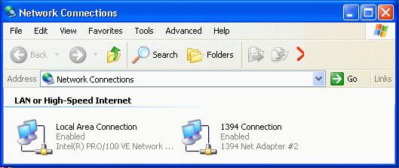
- Double click on the Local Area Network Connection followed by the Support tab.
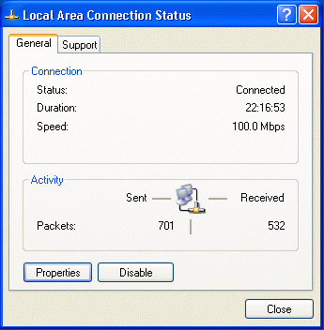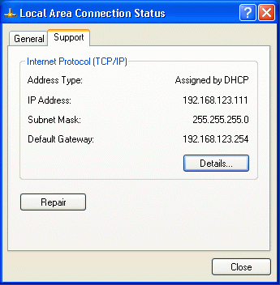
If you see an IP address that starts with “169.” it is a bad indication – it usually means that your computer could not get an address from the home router. If you see an address which starts with “192.” or “10.” it is a good indication that your computer and the home router are exchanging data.
- To make completely sure that your computer and the router (“Default Gateway” on this screen) are exchanging data, press the “Repair” button.
The system should respond in less than 5 seconds with the following screen:
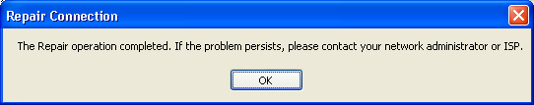
When this operation works, it takes 2-3 seconds. When it fails it can take up to 30 seconds. If this operation fails, there are several possible reasons (from most likely to least likely):
- Close all of the status windows which were opened in the previous steps and open your web browser. If you can surf the web, you are done!
Make a resolution to call your ISP technical support and thank them for providing a very easy to use service. Also you might call your home router and thank them for providing such good default settings on their router. (Just kidding).
If these steps work, congratulate yourself on making a good choice for your ISP and home router. You should probably still read the next section because it contains important information on diagnosing problems with your network. You will set up your wireless connection in a later section.

Installing the Router: Slow and Sure
In this section you will bring up your home router. Some of the steps will apply to cable modems and others will apply to DSL. If you encounter errors, you will take steps to identify and fix them. Hopefully by the end of the section your home router will be installed, configured, and you will be surfing the web.
You will probably have documentation which came with your home router. This section is intended as a supplement to the vendor documentation for the home router. Most home router documentation is very well written (again they save money if you can get this done without calling them). The router documentation will be most useful when you are configuring the router – we have chosen to use a LinkSys BEL-814b for the examples in this section.
Once you have made it through this section, the hard part of building your home network is over so stick with it until you are successful. You can do it! At times, where we think that you may need to call technical support, we try to provide you with the right questions to ask technical support. The authors would like some feedback if you think that the procedure could be improved.

Sending Data Between the Router and Your Computer
Your first goal is to install the home router and have it assign your computer an address and verify that this worked. In this section, there is no difference between a DSL and cable modem connection.
The steps might seem to be a little obsessed with checking everything in great detail one tiny component at a time, but this will help you quickly spot problems and solve them.
Following the steps will also introduce you to the tools that you will need to use to diagnose problems later if you experience connection problems.
- How do you restart numbering –delete this ?? /Chuck
- Power off your cable modem and computer.
- Unplug the Ethernet cable from your computer to the cable modem (if necessary)
- (Optional) If you installed the ISP-provided software as described in the previous chapter you may want to remove it at this time.
Another approach is to leave the software installed and try to complete the steps in the section. If you encounter a problem, then you can uninstall the vendor software, and then come back to this point and restart. (i.e. if you are going to skip this step – leave a small breadcrumb so you can find your way back).
- Connect an Ethernet cable between the “WAN” port on your home router and the Ethernet port on your cable modem
This port may have a number of different labels. Many routers have a single Ethernet port for the “WAN” connection and four Ethernet ports for the “LAN” connection. Other labels for the WAN port might include “Modem” or “uplink”.
- Connect an Ethernet cable between your computer and one of the LAN ports on the home router
There are often up to 4 LAN ports on a home router with a built-in switch – it does not matter which port you use.
- Turn on the cable modem and wait until it is up
This can take up to two minutes – see Chapter 3 for a discussion about how to know when the cable modem is up.
- Turn on the home router
- Power up your computer and log in (if necessary)
- Find the network icon in the system tray. If it has a red “X” then something is wrong with the connection to the home router.
You may see more than one network icon in the system tray. The only one which needs to be up at this point is your Ethernet local area network connection. It is quite common for the other connections to be down. Windows reports any time a commonly used connection is down. You can find our which connection is down by clicking on the icon in the system tray to bring up a status screen.
- ( Diagnostic ) If the network icon is indicating that your Ethernet connection is down, double click on the network icon in the system tray to bring up the Network Connections window.
Make sure that the broken connection is actually the Ethernet (a.k.a. Local Area Connection or LAN) connection.
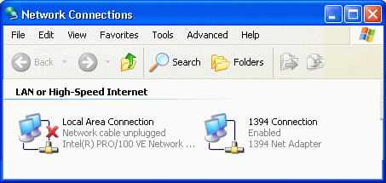
There are generally three reasons why your Ethernet connection will appear to be broken:
- The cable is actually unplugged, or plugged into the wrong connector on the router, or the router is not turned on. Check to see if there is a “link light” on the router where you have plugged in your computer. Most desktop network adapters have a link light which you can also check. Increasingly portable computers do not provide a link light. Note to Chuck – Picture of a link light.
- The connection is disabled (the status window will say disabled. To re-enable, right click and select “Enable”. The most likely reason that a LAN connection would be disabled is that you inadvertently disabled the connection. Another possible culprit might be the “ISP-Provided Software” described in the previous chapter.
- The device driver for the network adapter is installed improperly. With Windows XP and increasingly built-in network adapters this is usually pretty unlikely.
- If your Ethernet connection is up, check to see whether or not your computer can exchange data with the router by going into the control panel. Start -> Control Panel -> Network Connections
- Double click on the Local Area Network Connection followed by the Support tab.
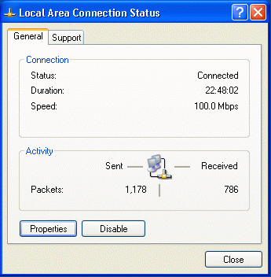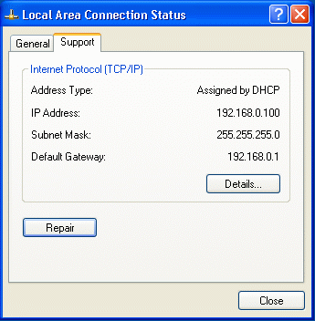
If you see an IP address that starts with “169.” it is a bad indication – it usually means that your computer could not get a dynamic address from the home router. If you see an address which starts with “192.” Or “10.” It is a good indication that your computer and the home router are exchanging data.
- To make completely sure that your computer and the router (“Default Gateway” on this screen) are exchanging data, press the “Repair” button.
The system should respond in less than 5 seconds with the following screen:
When this operation works, it takes 2-3 seconds. When it fails it can take up to 30 seconds. If this operation fails, there are several possible reasons (from most likely to least likely):
- You have connected the Ethernet cable from your computer into the “WAN” port instead of the “LAN” port. This would give a valid “link” indication (Step nn above) but not provide your computer with a dynamic address. Consult the vendor documentation for the home router to make sure that you have connected the cables properly.
- The home router is configured incorrectly – you may have to consult the vendor documentation to reset it to defaults.
- Your computer is set to use a static IP address. This can be checked by Start -> Control Panel -> Network Connections -> Right Click your LAN connection and Select Properties -> Then select “Microsoft TCP/IP” and press the “Properties” button.
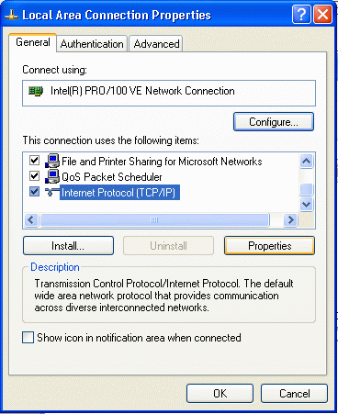
Both the IP address and DNS Service should be set to dynamic.
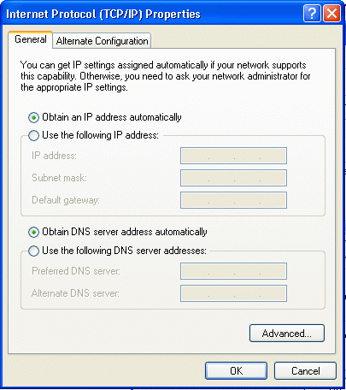
If you change these values you should restart the system and redo the steps in this section.
Note: If you have a network service which provides you with a static address, the static address will be used by the router – you will configure that into the gateway later. At this point, set your computer to use dynamic addressing so it can communicate with the router.
- As a final step, you should power off the modem, home router, and your computer, and then power them on and go through this section again to make absolutely sure that you can communicate between your computer and the router.
Once you have successfully connected your computer to the home router and verified that your computer can actually communicate with the router, it is time to configure the router.

Configuring your Home Router
Now that you have made the connection between your computer and the home gateway, we will connect to the home gateway and configure it using a web browser. Some steps may be slightly different depending on your Internet Service Provider. You should also consult the home router documentation during these steps as some details may be different for your particular router.
You will configure your home router using a web browser. You must determine which URL to use to connect to the home gateway. Once you enter the proper URL into your browser and you will be brought to a log in page. There are a number of ways which you can determine the URL to use to communicate with the home router (in order of decreasing preference):
- The vendor documentation tells you which URL to put into the browser. (This is the preferred approach)
- The home router intercepts all of the domain name requests and always routes your browser to point to the home router. So when you start your browser and it thinks that it is going to http://www.google.com/ (or some other page on the network) it gets faked into going into the router login screen.
If neither of these approaches works, you have a right to be a bit grouchy at the vendor documentation. Sometimes the faking of the DNS does not work properly and you have to figure out the URL for yourself using the following steps:
- If your Ethernet connection is up, check to see whether or not your computer can exchange data with the router by going into the control panel. Start -> Control Panel -> Network Connections
- Double click on the Local Area Network Connection followed by the Support tab.
- The “Default Gateway” is the address of the router. You can connect to the router in this particular example at http://192.168.0.1/
Once you have determined the URL to connect to the router, you should bookmark it for future reference.
Once you are connected to the gateway log into the gateway using the account and password from the vendor documentation. Routers are usually shipped from the factory with a default password or no password. You will be able to change the password once you have logged in.
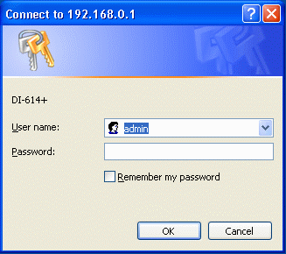
The log-in dialog bam appear in a separate box as above or inside your browser window.
You should not worry about the security implications lack of a password and a well-known account on the home router because by default as it comes from the factory it can only be configured from the local network side. About the only possible security problem is if your neighbor connected to your wireless network between the time when you turned on the home router and when you set a password on the home router. Even so, one of your first steps after logging in to the router should be to change the password.
- In this particular router you press the Tools tab to go to the password screen. Enter your desired password twice and press Apply.
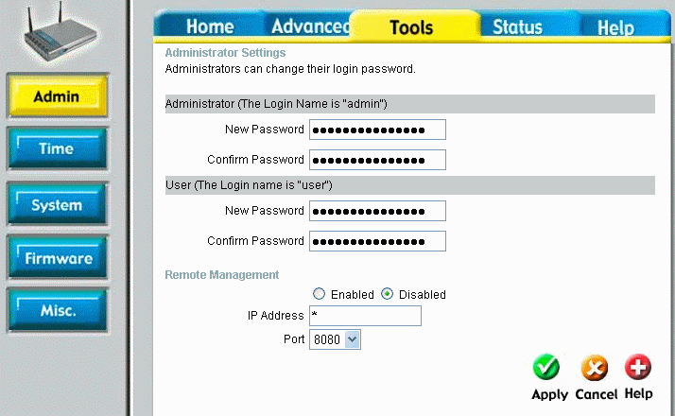
Note that this router is configured to prohibit any type of remote management (i.e. from the Internet) as it comes from the factory. There is almost no reason to enable any type of management from the Internet side of the router. Allowing this has the potential for a large security hole.
- To continue with the next steps go back to the main screen of the router by pressing Home.
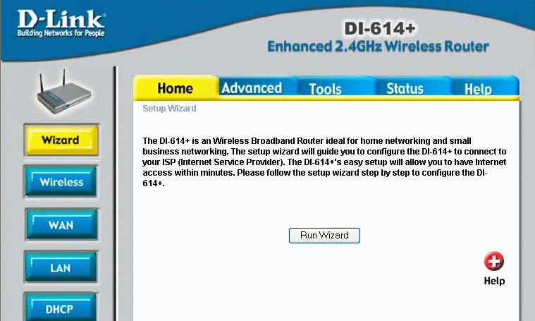
The next two sections will be different depending on whether or not your Internet Service is Cable Modem or DSL. If you have a wireless or other type of Internet service and your ISP uses dynamic addressing (i.e. DHCP) then you will probably do an adapted version of the Cable Modem Section.
In the router which is used in these examples (a Linksys DI-614+), there is a wizard which asks a few questions and then automatically configures the router. If your router has such a wizard, feel free to use it and follow the vendor documentation. Chances are very good that it will work quite well. However, if something fails, you might want to come back to this section and try the process again more slowly with more explanation.

Connecting Your Router to a Cable Modem
To configure the Internet (or WAN) side of your router, you must get to a screen which allows you to select the Internet connection type and then configure that internet connection. If your ISP connection is a DSL connection skip ahead to that section.
First we will go through a set of steps for the most common scenario. If those steps work, then you are done. If not, your Cable Modem ISP has some special requirements which we will cover later in the section.
- Go to the configuration for the WAN/Internet Connection - press Home and then WAN.
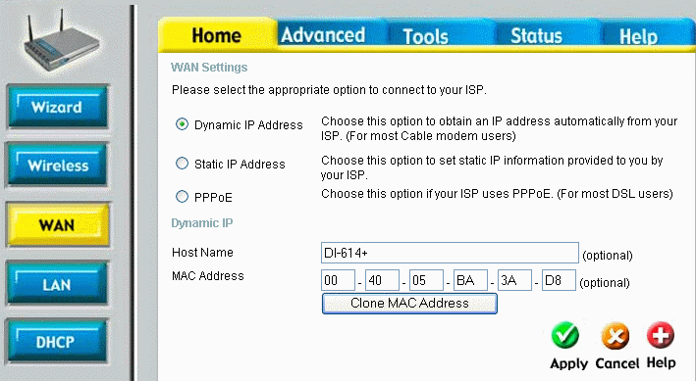
For now, we will assume that the MAC Address and Host Name do not matter so for now, leave them set to whatever is on your screen.
- Set the connection to Dynamic IP Address (May also be called DHCP) and press Apply. The router will reboot itself. This only takes a few seconds.
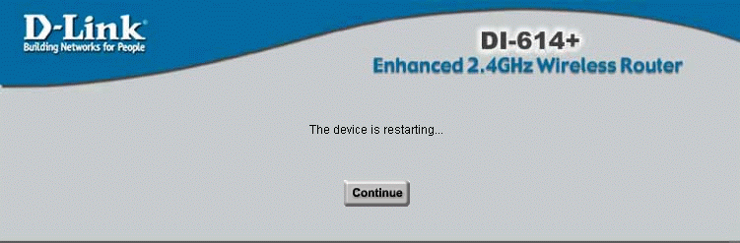
- Navigate to the status page by pressing Status. Look at the WAN section of the display.
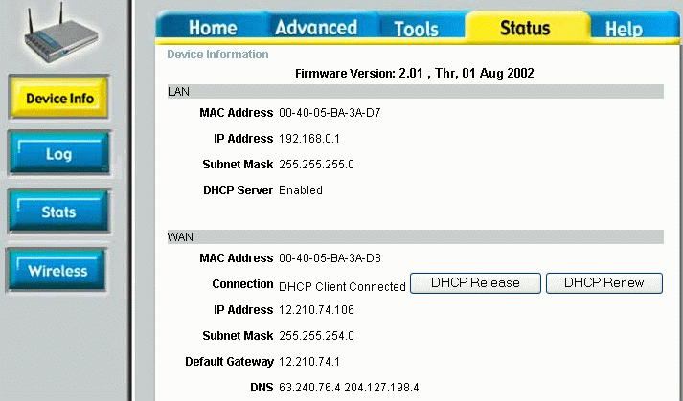
We can see that the WAN connection now has an IP Address (assigned by the ISP/Modem). If there is an IP address, then your configuration is complete.
- If you want to explore some more, press the DHCP Release button to “give up” your IP address.
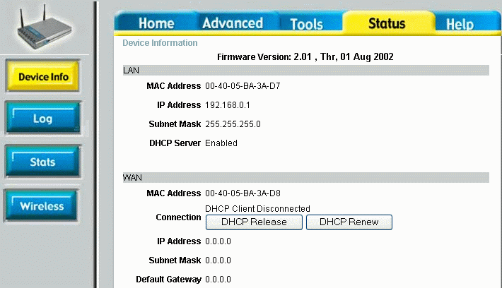
You now have no address for the Internet connection for the router. You would also get this screen if there were some incorrect configuration for the WAN connection.
- To get the IP address back, simply press the DHCP Renew button. After a few seconds (and perhaps pressing a Continue button), you should again see a status display with an IP Address successfully assigned.
If you have gotten an IP address at this point then you have successfully configured the router so you can skip the rest of this section. However, you might want to skim the rest of this section to see what could have gone wrong in this process.
- At this point, it might be a good idea to take a look at the log which is built into your router. Press the Status tab and the Log button.
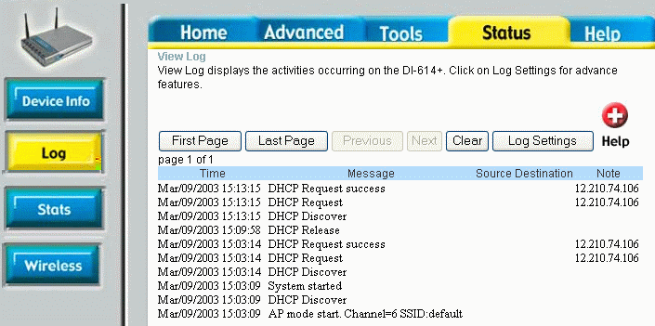
In the log, you can see each of the operations as they took place. You can see when the router requested a DCHP address and when the cable modem supplied the DHCP address.
If you have not yet gotten an address successfully it can either be because of a physical connection problem, or a configuration problem.

Advanced Cable Modem Configuration
If you did not successfully get an address in the preceding section, we will have to work a little harder. Of course you should recheck the cabling and make sure that everything is plugged in and that the cable modem is up and online. Assuming that everything is plugged in properly and the cable modem is online, the configuration problems will likely be one of the following:
- The cable modem is setup to only provide the address to a particular host name.
- The cable modem is set up to only provide the address to a particular Ethernet adapter.
- You have static IP service rather than dynamic address service.
Each of these concepts will be covered in a separate section.

Setting the Host Name
The first step is to determine whether or not a host name is needed. Increasingly, cable modem providers do not require a hostname as it tends to increase the installation complexity and increase support calls (and cause sections just like this to get written).
- Look in the paperwork which was provided with your initial cable modem service. The hostname might be buried in that paperwork. If you installed the ISP provided software, you may have entered the hostname from the paperwork into the installation process.
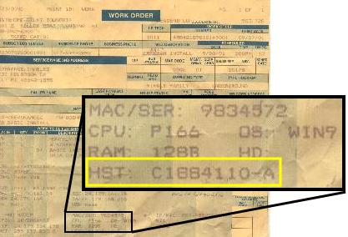
- You can call your ISP technical support and ask them, “Does my service require a host name to get a DHCP address? What should I put in as the host name for my computer?”
If technical support seems to have no idea at all about answers to either question, then chances are pretty good that it is not required. For those ISPs which require the host name, you can bet that technical support has to solve problems all the time when someone reinstalls their operating system and loses a required hostname.
One trick of technical support is to not answer the question that you ask, but instead make you go through a bunch of meaningless steps (is it plugged in, check this, de-install that, etc.) which allows them to set the agenda. Sadly while it makes them feel better it usually messes up your system. Generally you should try to set the agenda for tech support calls and stick to your guns. Ask your question and if they try to answer a different question ask your question again. At some point, you can ask to talk to “second level technical support”. Every single question which we tell you to ask technical support should be well understood by first level support and second level support should know off the top of their heads. Of course, before you call technical support make sure that everything is plugged in. You would be surprised at how often stuff is just not plugged in correctly.
- If you had a single computer connected to the cable modem initially, the cable modem may have “adopted” the name of that computer as the host name it demands. You can find the host name of a computer by right-clicking on the My Computer icon, selecting Properties, and then selecting the Computer Name tab.
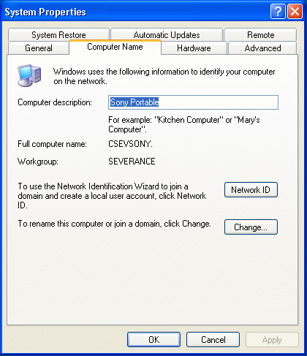
In this example, the computer name is “CSEVSONY”.
- Once you have determined the host name, go to the WAN configuration screen set the host name and restart the router by pressing Apply followed by Continue after the router restarts in a few seconds.
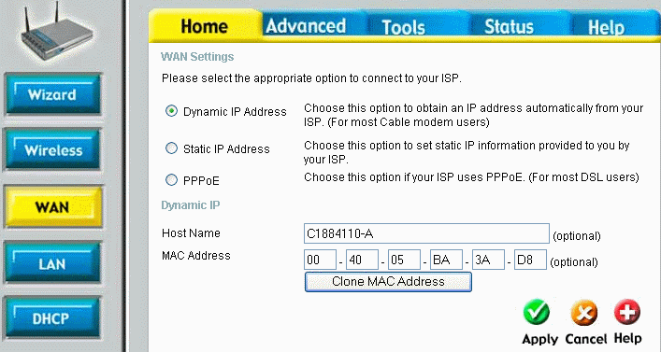
- After the router resets you need to check to see if we received a DHCP address by pressing the Status tab and the Device Info button.
If you did not get an address, feel free to try to do a DHCP Renew and see if you get an address. Renewing the DHCP address is always a good test to determine if the router is talking to the Cable Modem. Sometimes things happen too quickly during a reboot and you have to manually force the DHCP Renew operation.
You can actually go through this process several times if you are trying to “guess” a few different hostnames. The good news is that for those ISP’s that do not require a host name, they generally ignore whatever is in this field.

Setting a MAC Address for your Cable Modem
Some Internet Service Providers try to limit which computer can connect to their cable modem by demanding that the dynamic address request come from a particular computer or network card. Every Ethernet adapter ever built has a unique serial number. This is a 48 bit number and is usually written as a series of six hexadecimal numbers, often separated by colons like 06:FE:44:00:08:64.
Usually the ISP will not know in advance the exact Ethernet serial number of your computer so they simply grab the serial number of the first computer which connects to the modem after it is installed and remembers that serial number for future reference and demands to only talk to that computer unless you call technical support and beg them to allow a new address.
Most ISP’s have learned that demanding a particular MAC address is far more bother than it is worth in terms of the number of unhappy technical support calls that it causes. So most cable modem ISPs do not demand a particular MAC address.
- Call technical support and ask them, “Does my cable modem require a particular MAC address to give out a DHCP address? You should be prepared to tell them the definition of MAC Address (Serial number for an Ethernet adapter) and/or DHCP (Dynamic IP) address. If have no clue about that question, ask, “What if I removed my network adapter from my PC and installed a new one, will my cable modem continue to work? If not, what should I do or is there some configuration option that you have to change?” (See how we cleverly sugar-coated the question of whether or not the Ethernet serial number matters?)
In a way, much like host name, if level one technical support has never heard the words “MAC Address”, then it is probably not a critical configuration option.
- On the particular model of Linksys, there is a “Clone MAC Address” button. This is worth a try, but you should make sure to be using the computer which was initially connected to the cable modem before you purchased the router.
- We can do the same operation even if your router does not have the “Clone Address” capability. On the computer which was originally connected to the cable modem, Start -> Control Panel -> Network Connections -> Local Area Network Connection -> Support tab (we have been here several times now) and then press the Details button.
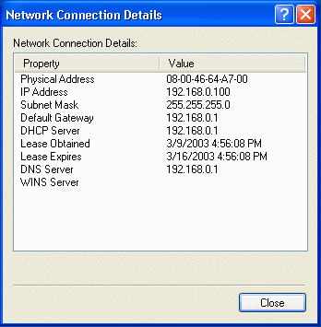
The “Physical Address” is the Ethernet address. As you can see it is six two-digit hexadecimal numbers. Hexadecimal means that in addition to the digits 0-9 we use the letters from A-F as well – that makes sixteen digits – real cool computer dudes just call this “Hex”. You might try to impress tech support by throwing the word “Hex” in during a call some time. Here is a scenario: they say: Can you read me the MAC Address? You say: You mean the six hex numbers? They say: Yes, those numbers (with a newfound respect for just how cool you really are).
- Simply transcribe the numbers into the MAC Address field on the router and press Apply and then continue to restart the router.
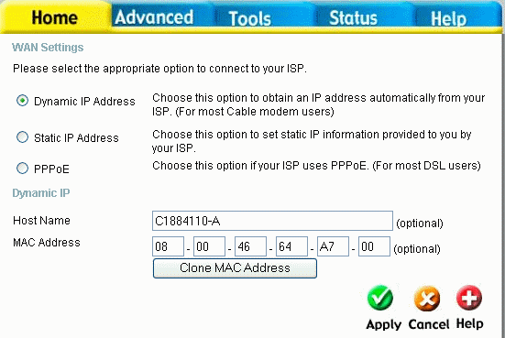
- When the router resets again check to see if we received a DHCP address by pressing the Status tab and the Device Info button.
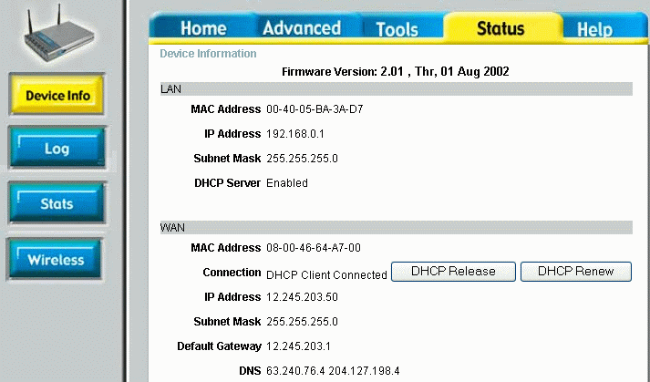
If when you first go to the status page, it appears that you did not get an address, feel free to try to do a DHCP Renew and see if you get an address after a renew. You can see that we have an IP address and that the MAC address has changed on the WAN side of the router.
You will note that the LAN (Local Network) side of the router has a different MAC address. That is because there are two separate Ethernet adapters in the router and they have two serial numbers. Just for fun, take a look back up at the MAC address for the LAN and WAN before we changed the WAN Mac address. You will notice that they are nearly the same. That is because the first three numbers indicate which manufacturer and the last three numbers indicate the serial number within manufacturer.
Connecting to a Cable Modem (or any other ISP) with a Static IP Address
Chances are good that if you have a static IP address, you already know about it because you had to special order it and probably pay extra for it. Configuration with a static IP address is very simple. There are three numbers which all must be provided by your Internet Service Provider. You cannot guess these numbers – if you don’t know them you must call technical support.
- Go to the Home tab and Select the WAN button. Select the Static IP option and a number of new configuration options will appear.
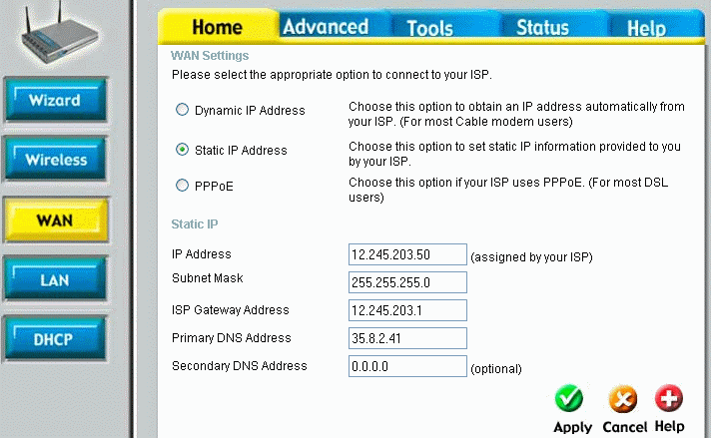
You should be given at least four (IP Address, Subnet Mask, Gateway Address, and Domain Name Server). The names may be slightly different, but they should be very close.
- Simply fill in the numbers as given, press Apply then Continue to reboot the router. Then navigate to the Status page.
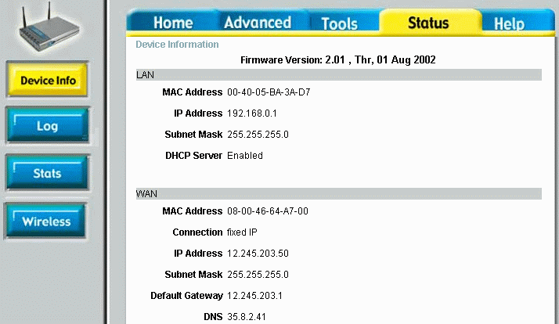
The “DHCP renew” button is now gone! Because the address are no longer externally set, you can no longer use the retrieval on an IP address as a test for network connectivity. However on this router (and on most others), there is a tool which can be used to test to see if your static address is set properly.
- Navigate to the Tools tab and press the MISC button. Enter a host name such as www.google.com in the Host Name field and press Ping.
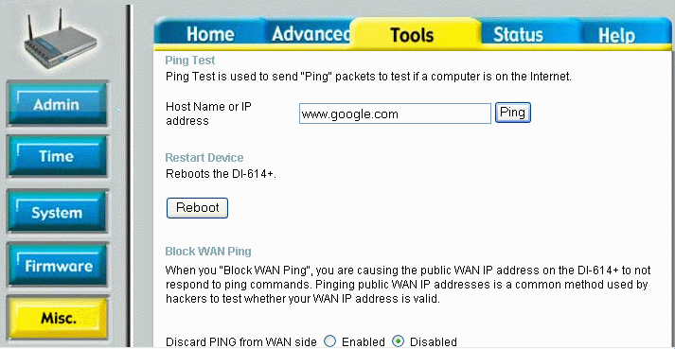
Ping sends a single packet to the host and tests to see if there is basic network connectivity to that host.
- If the ping was successful, the system responds with the following:
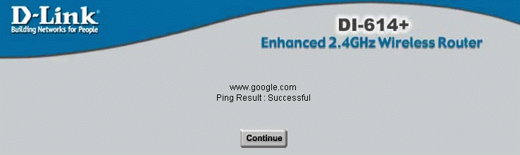
If the ping failed, you will get one of two messages. If the ping result complains about “Unknown host” then there may be a problem with the Domain Name Resolution Server in your configuration or you may have mis-typed the name of the host (make sure not to include http:// or any thing else). If the message comes back with a “Time out”, then the host name was resolved successfully (i.e. your router is communicating with its name server), but the host did not response to the ping. Some hosts are configured to ignore the ping messages so you might want to try a few well-known hosts before you give up and call technical support. Also, you might just start up a web browser and attempt to connect to a well-known web site as a test.
Static IP addresses are actually much less complex than dynamic IP addresses – once you get the numbers right there is actually very little which can go wrong. If you are having problems with a Static IP configuration, it is usually because there is a basic cabling problem, or you have the wrong numbers, or you have mis-typed the numbers. Generally, with the tools described inside this section, you will be able to work with your ISP technical support to get things working quite quickly.
About the only time that a static IP address will give you trouble is if your ISP reorganizes their network, and forces you to change your address. Generally they will contact with the new information and the date and time that you will need to make the change.

Connecting Your Router to a DSL Modem
If your broadband connection is DSL, then it is generally simpler to configure your home router. Connect to the router as described above and log-in.
- Go to the configuration for the WAN/Internet Connection - press Home and then WAN.
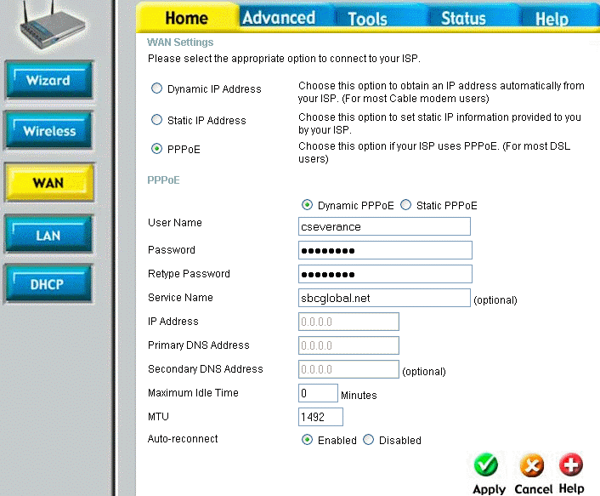
- Select PPPoE (Point-to-Point Protocol over Ethernet), enter you username and service name which are assigned to you from the ISP, as well as the password for your account. Depending on the router that you have, the user name and service name may be combined using an at-sign (@). In this example, the combined account would be cseverance@sbcglobal.net. This account and password will have been given to as part of your ISP installation. If you connected a single computer to your DSL modem, you used this account and password as part of that configuration process. DSL can support static IP addressing, but the most common by far is Dynamic Addressing. Then press Apply to reconfigure and reboot your router.
- Navigate to the status page by pressing Status. Look at the WAN section of the display.
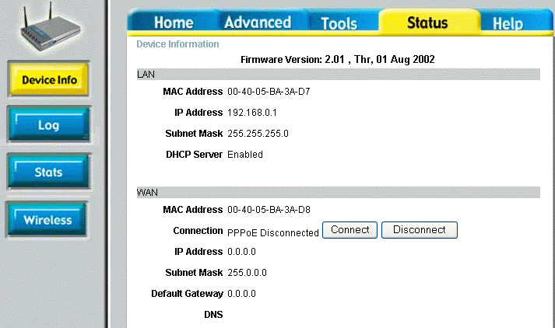
We can see the WAN connection is not yet connected.
- Press Connect to make the PPPoE connection to the modem. Wait a few moments before pressing continue.
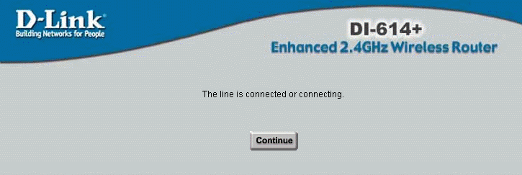
- Navigate back to the status page on the router.
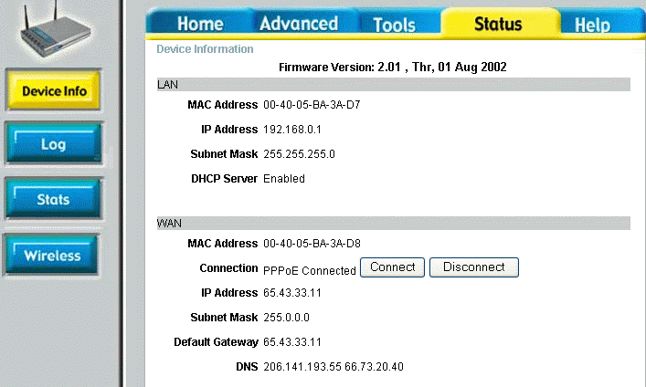
We can see that the WAN connection now has an IP Address (assigned by the ISP/Modem). If there is an IP address, then your configuration is complete. Part of the reason that you may have to force the connection to happen is that the router will generally not make the connection until some you send some network traffic to the router. By forcing the connection here you can test and make sure that it will work.
- Test the connection by navigating to the “ping” tool. Press the Tools tab and the “Misc” button. Enter a well-known host name in the ping field and press “Ping”.
- When you get a successful ping response, you can press Continue.
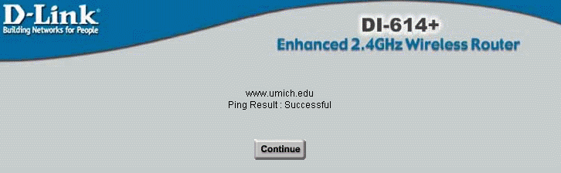
You have now established your connection. Generally, it is relatively straightforward to get DSL working with your router.

Testing Your Network Connection
By this point your network should be operational. Your workstation is talking to your router (you are using that connection to configure the router) and your router is talking to the Internet as tested by the ping command from the router to the Internet.
At this point, you should be able to go to a web site in your browser and have it work fine. If this works, congratulations – you can skip ahead to the wireless configuration. In this section, we will look at a few tools and techniques that you can use to diagnose the problem.
IPCONFIG /RELEASE
IPCONFIG /RENEW
PING
TRACERT
REBOOT

Bringing up Your Wireless Network
Generally, the factory settings on the wireless portion of your gateway are sufficient to make your initial wireless connection between your computer and the wireless router. However you may want to look at the wireless configuration screens for your router over your wired connection before you “sever the cord”.
- Press the Home tab and the wireless button on your router to see the wireless configuration.
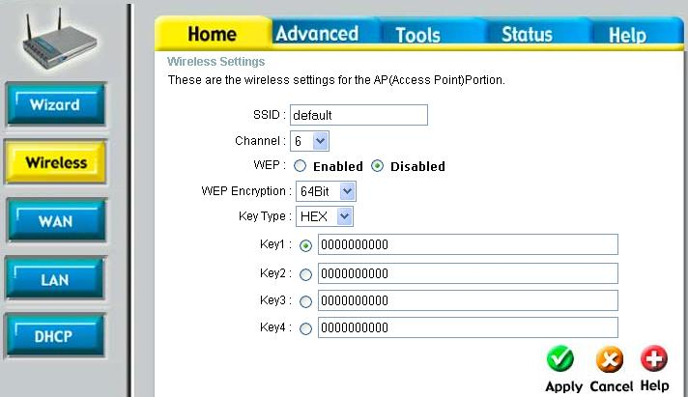
In this display, the SSID is the “network identifier”. The SSID allows a number of different base stations to operate independently within the same physical area. The wireless card in your computer associates itself with a particular network base station using its SSID. For the next steps, WEP (Wireless Equivalent Privacy) should be disabled – once you establish basic wireless connectivity. The channel should be left at the default. Later you may also need to change the channel for your base station depending on how close you are to other base stations.
- Change the SSID value to some value that you will recognize and press Apply and the system will reboot to apply your configuration changes. Reestablish your connection to the router to check that your configuration has actually been changed.
Now it is time to disconnect your wired network and install your wireless card in your computer by following the instructions for the wireless card. Many cards have driver support built into Windows XP, so you may not even need to insert any driver software.
- Once the wireless adapter is installed you should reboot the computer. When the computer reboots the wireless card automatically searches for the available networks and notified you in the system tray with a small message.
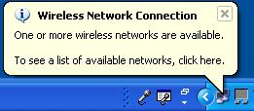
Generally, the operating system does not want to connect to a wireless network automatically unless you “approve” it first. Once you indicate that you trust a particular network the operating system will automatically associate with that network. This way, your computer will not add itself to an insecure network which your neighbor has unless you authorize it.
- Click on the system tray to bring up the Wireless Network Connection dialog.
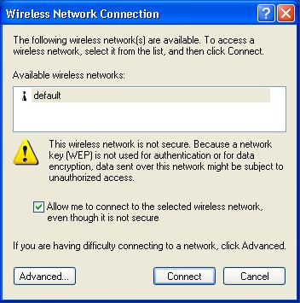
Given that you have not yet turned on security, the system demands that you accept that the network is not secure. When you are connected to an insecure network anyone within wireless ranges can monitor your network data or even join your network.
- Select the checkbox to connect to the insecure network and press Connect.
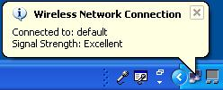
Once you have approved the wireless network, your computer is automatically connected to the network. Your computer requests an address from the router and brings up an Internet connection. If all has gone well, at this point you should be able to bring up your browser and surf the Internet.
- Click on the network icon in the system tray to examine the detail of your wireless connection. Click on the Support tab to see the detail of the network settings.
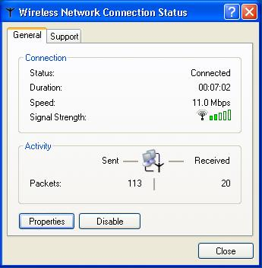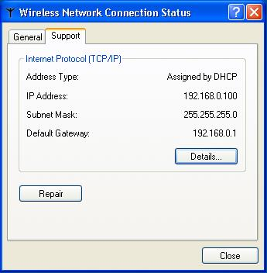
You can see the signal strength between your base station and the wireless adapter in your computer. You can use this indication to help place your wireless base station effectively in your home. You should make sure that the number of received packets is greater than zero. If there are no received packets, it probably means that communication has not been effectively established. Under the support tab you can see the address which the router ahs assigned to your computer. Like the wired connection, if you see an IP address that starts with “169” it is a bad indication – it usually means that your computer could not get a dynamic address from the home router. If you see an address which starts with “192” Or “10” it is a good indication that your computer and the home router are exchanging data.
- To make completely sure that your computer and the router are exchanging data, press the “Repair” button.
The system should respond in less than 5 seconds with the following screen:
When this operation works, it takes 2-3 seconds. When it fails it can take up to 30 seconds. If this operation fails, the problem is most likely the configuration of your wireless client.
- If you are having a problem, you can explore and troubleshoot the wireless client configuration, right click on the wireless network connection icon in the System Tray and then click on the Advanced button.
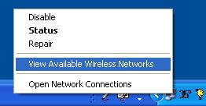
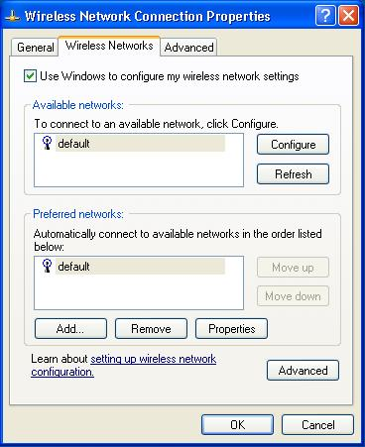
You may find success, making changes to the configuration for your particular network connection, but it is actually unlikely that this will solve your problem. A better approach is to go back to the beginning of this process and set things up. Perhaps you will have to reset your wireless router to factory settings and again try to set up the wireless network from the beginning.
Once you have your wireless network operating in insecure mode, you will reconfigure the wireless network to add security.

Securing Your Wireless Network
Given that any of your neighbors can join your wireless network and/or monitor activity, it is a good idea to put security on your network. Putting basic security on your network is not very difficult and works quite well with a variety of vendor equipment.
The security which you will use is called WEP (Wireless Equivalent Privacy). WEP is a way of encrypting the data moving between your wireless adapter and the base station. In addition, wireless clients cannot join the network unless they know the password. This is equivalent to a wired connection where you cannot connect to the network unless you can find a plug which plugs into the network.
WEP is based on a shared secret key which is 64, 128 or 256 bits long. Different wireless adapters will support different key lengths. If you have a number of adapters from different vendors, you may have to experiment with a key length which will allow them all to work. Most adapters support at least 128 bit keys, so it is a good basic choice.
These keys can be expressible as ASCII strings or as Hexadecimal strings.
- Connect to the router and navigate to the wireless section of the configuration screen by pressing the Home tab and the Wireless button. Set the SSID to some reasonably recognizable network name (this is case sensitive), enable WEP, set the key length to 128 bits, and specify a 13 character ASCII (text rather than numbers) key.
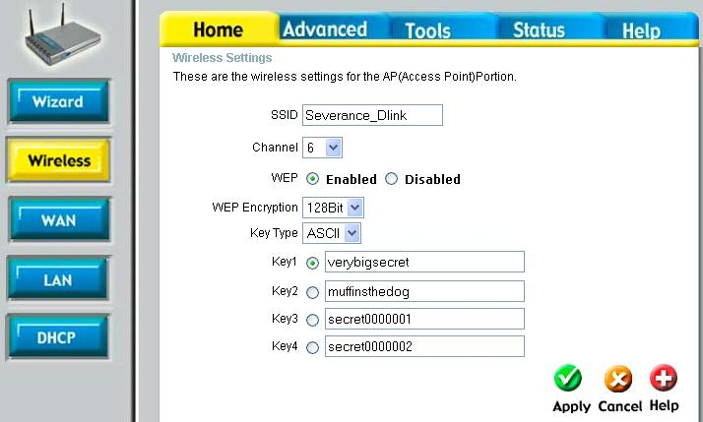
ASCII keys are quite convenient. Windows XP supports either Hexadecimal (numeric) or ASCII keys – if you are using other operating systems or some vendor’s wireless adapters, you may have to use a hex key because a client configuration tool only supports HEX keys.
- Press Apply to reconfigure and reboot your router. You will lose your wireless network connection. Windows will immediately notify you via the system tray that the wireless network connection has been lost.
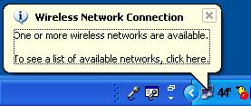
- Click on the balloon dialog or right click on the network icon in the system tray and select View Available Networks to bring up the Wireless Network Connection dialog box. Enter the secret key which you used in your router configuration (twice) and press the connect button.
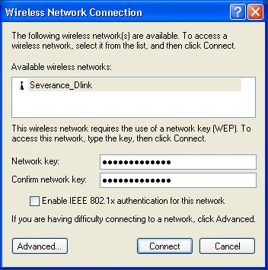
Once you press Connect, your wireless adapter will attempt to “plug into” the wireless network using the key provided. Much like plugging a network cable into a router which is not powered on there is not a lot of difference between what you see when the key is right versus a wrong key. You will not see a dialog box which says “incorrect password”. It simply will not work.
- To test your connection, bring up a web browser or Click on the wireless adapter in the system tray, select the Support tab and attempt to perform the repair option. If the repair operation completes in several seconds, you have set the key properly. If the repair operation fails you probably have an incorrect key.
- To change the key, simply click on the wireless adapter icon in the system tray to bring up the Wireless Network Connection dialog (above), enter the right key and press Connect, and then retest.
- If you absolutely cannot re-establish the wireless connection (isn’t security great!), you may have to re-connect using an Ethernet cable to reconfigure the wireless connection or even reset the router back to factory configuration and start over.
Once you have your wireless connection working with one computer, repeat the procedure on the other wireless computers in your home. Windows XP remembers the wireless key so you will only have to enter the key once each time you change the key. In addition, Windows XP also remembers a different key for each SSID (wireless network identifier) that you interact with. So if interact with a wireless network at home, at work, and at the coffee shop, they can all have passwords which you enter once and Windows uses the appropriate password for the connection as you move from base station to base station.

Locating your Wireless Base Station in Your Home
Once your system is up and running solidly, can install it in its final location in your home. Because wireless networking works with relatively low power your reception will depend on the placement of the base station.
First place the base station is its most convenient and survey your home using the built-in signal strength indicator.
- Click on the wireless network icon in the system tray.
The signal strength indicator indicates how well the wireless adapter is communicating with the base station. At each place sit for a few moments, look at a web page, and then open the status dialog box. This way you can get a good map of the coverage of your home and find where you have problem spots.
As you get farther away and the signal is going through walls and floors (especially concrete) you may lose the signal completely. In this case you have one of three possible options:
- Move the base station
- Adjust the base station antenna’s (if they are adjustable)
- Purchase an additional antenna from the base station manufacturer
The best location for a base station is in the center of the area which you are trying to cover both horizontally and vertically. This limits the distance between your adapter and the base station.
If your base station has an antenna, it is probably a dipole antenna where most of the signal is concentrated in the horizontal direction. This wireless equipment is allowed to emit only a limited amount of wireless radiation, so the antenna designers try to direct the radiation where it can do the most good. In general the goal is to send the energy out in the horizontal plane to maximize coverage. This also means that there is a weak area directly above the antenna.
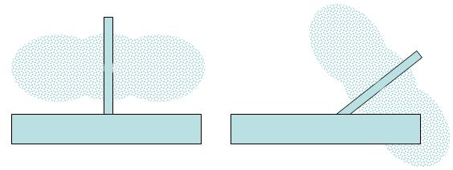
If you live in a ranch house or a single floor apartment, then this is a good approach. However if you live in a multi-story home, then this might not be the best approach. You can send some of the signal vertically by repositioning the antenna. You have to think of the signal pattern as a thick “plate” coming out of the antenna as you move it around. You can experiment to see if you can aim your antenna just right to get a good signal right into the den.
Some units have two antennas, so you can aim them independently to improve coverage.
Don’t expect to get too much improvement by antenna aiming however because the effect of distance and intervening walls and floors have a much greater impact than antenna aiming.
You might also investigate purchasing an external antenna for your base station. Base station vendors often sell approved external antennas (a good way to make money when the base station costs $50.00). But be very careful when purchasing an external antenna. Nearly all external antennas are trying to improve the range of the signal. They do this by making the signal pattern even more constricted than the standard antennas so the signal can travel farther.
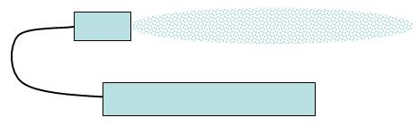
To improve coverage in your home you will need an omni directional antenna with a signal pattern than is either a sphere or a half-sphere. Before purchasing any antenna make sure to find the graph of the signal intensity.

Operating in Congested Environments

Summary
It would be good if Internet Service Providers could read this chapter, and configure their ISP service to make things as simple as possible. The home router manufactures have certainly done everything they could possibly do to make things easy for you. They provide options in the routers to adapt to the ISP idiosyncrasies – your job is to work with your ISP’s technical support and documentation to figure out which set of features your ISP supports.
The good news is that over time, ISPs are generally motivated to make your life simpler, removing those features which make their service harder to use and harder to configure. In the long run it saves them technical support cost.

