1: Your Wireless Home Network

Wireless Home Networking: The Right Choice?
It seems everyone you know has a wireless computer network in their home. So you decide to take the plunge, and you buy a device they suggested at the local electronics store. You stare at the box. This gizmo is a “wireless access point and broadband router” – whatever that means. You wonder: did I buy the right thing? Is this what I need? How hard is it going to be to set this thing up?
Fear not. You made an excellent choice. With this device you can:
- Build a home network, connecting your desktop and laptop computers together, without running any new wires in your home.
- Share files, printers, and applications across all your computers. For instance, you can sit on the deck using your untethered laptop, and print the final chapter of your new novel to the printer in the upstairs office.
- Share a broadband Internet connection among the multiple computers in your home. Everyone enjoys a high-speed connection, no one waits for modems to connect, and the phone line is never busy while Junior downloads MP3 files.

Of Access Points and Routers
Let’s examine what you just bought. It packs a lot of power into a small box. It serves as:
- A wireless access point. Sometimes called a base station, an access point serves as the hub of your wireless network. Any computer in your house connects wirelessly to your home network by sending and receiving radio signals to and from the access point.
- A router. Sometimes called a cable/DSL router or a residential gateway, a broadband router connects your home network to your Internet connection. We suggest cable modem and DSL connections where possible; some readers of this book may use their routers to connect their home networks to dial-up, satellite, or even “fixed wireless” links to their Internet Service Providers.
- A firewall. Firewalls filter the kinds of traffic allowed into your network, protecting your computers from certain kinds of attack. That may sound dramatic, but once your computers are connected to the Internet at high speed and always on, they become targets.
- A switch. Many access point / router manufacturers incorporate a 4 port Ethernet switch into their products. This makes it easy for you to connect computers using conventional Ethernet wiring when that happens to be convenient. (Yes, we admit it, even in this book on wireless networking: sometimes a wired connection makes more sense.)

Do the Make and Model Matter?
Fortunately for you, a number of leading vendors compete for the home broadband market. Competitors include aggressive small firms such as Linksys, D-Link, Netgear, as well as more familiar names such as Microsoft, HP, and Siemens. You’re the winner of this competition, as companies vie to pack ever more capability into these remarkable small boxes. Competition also means prices are now quite affordable.
There are variations among vendors and models. Some models are easier to install. Some work better than others. Some vendors offer better technical support – and better Web sites with easy-to-find documentation and drivers.
- 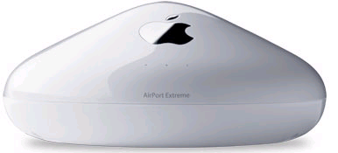
Apple Airport Extreme Access Point

Generally, though, you need not fret as to whether you bought the right access point/router. With a modicum of effort, you can make most models serve your home networking needs quite well.
The other good news is that these devices adhere to standards. This means you can buy an access point from Linksys and a so-called “WiFi” card from Microsoft, and they will usually play nicely together. Some people prefer to buy all of their networking gear from one vendor; that way, if there are technical problems, there’s no finger-pointing between tech support departments. But if you’re using an IBM Thinkpad from the office with built-in wireless support, you should have no trouble making it connect to your access point, no matter who the vendor.
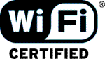
Tip: The industry uses several terms for wireless networking, including WiFi, which refers to the predominant family of wireless standards. A consortium supports the WiFi standards, just as industry groups defined the Compact Disc standard in the Eighties.
An international standards body, IEEE, creates standards that specify how wireless devices work: what part of the radio spectrum they use, and how they talk to each other. Their numbering scheme uses IEEE 802.11 for various WiFi standards. The most common wireless devices conform to 802.11b, which operate in the 2.4 gigahertz range and move data at up to 11 megabits per second.
When we say “wireless home network” or WiFi or 802.11, we refer to the same thing.

Why Do I Need a Home Network?
We build home networks for the same reasons why workplaces built networks of personal computers starting in the 1980s. As the personal computer revolution unfolded, we quickly learned that it didn’t make sense to put a high-speed laser printer on every desktop. Local area networks evolved, so that people in a workgroup could share such expensive devices. LANs also made it easy to share files among people working on common projects, and to share high-speed Internet connections.
The same logic applies in your home. Many households find themselves with more than one computer these days. Maybe you’ve acquired a new desktop PC and you’re not ready to retire the old one, or maybe mom and dad share one computer, and the kids play games and manage their MP3 audio collections on another. Often, the household includes one or more laptop computers.
Your home network lets you make economical use of the computers and the printers and other peripheral devices in your home. Just as your office won’t put a $5000 high speed color laser printer on your desktop, few homes need more than one high-quality printer.
- 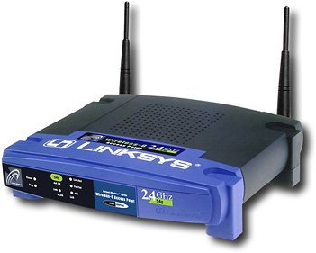
Linksys Wireless-G Access Point
Sharing your Internet connection is a compelling reason to build a home network. Just as you wouldn’t add a new telephone line and modem for every computer in a modern office, you want to share your Internet connection among all the computers the household uses. More and more households choose a broadband Internet connection, typically a cable modem or a DSL subscription. (As this book goes to press, the percentage of U.S. households with broadband connections is about 30%, and growing fast.) You can even share an old-fashioned dial-up Internet connection among all the computers in your home network – though the experience is nowhere near as satisfying as sharing a broadband pipe to the planet.
Tip: Having everyone in the household share a dial-up Internet connection is like having everyone ride a van that never goes faster than 10 miles per hour: everyone is sharing, but nobody’s moving very fast. We urge everyone to consider broadband. See Chapter 3 for more information on choosing a broadband service.

Imagine the Possibilities
The possibilities for using your home network are endless. Consider one scenario:
- Mom realizes at work that she forgot to program the TiVo to record The Sopranos. A quick Web transaction solves that.
- Dad is at a conference in Tokyo. The same Wifi-enabled laptop he uses at home and in Ann Arbor allows him to surf the Web and to upload the PowerPoint slides he left back home. He uses NetMeeting for a video chat with the family.
- Mandy takes notes for her college class using a Tablet PC, and prints them out wirelessly at home. She connects to her university’s Virtual Private Network (VPN) to check grades on her last quiz and to access library databases. While she works, she listens to MP3 music archived on the main PC.
- Brent uploads digital video he shot at school to the family editing PC in the basement – but he uses the PC in his bedroom as a remote terminal. While he is editng the video, he notices that Dad just connected in Tokyo so they chat for a moment about how Brent actually won a game in Chess Club for the first time. Later he’ll play Everquest with people in four countries around the world.
- The family dog has a webcam pointed at her cage. Anyone in the family can check on her from anywhere, anytime.

Planning Your Home Network
Some experts advise you to expend a great deal of effort in planning your home network. Our approach is more casual. We suggest that you start with the wireless access point / router, and build your network from that foundation. Many households will be perfectly happy wirelessly connecting all their computers to their access point / router. An all-wireless home network requires virtually no planning: you simply plug the access point / router into your cable modem or DSL modem, add wireless adapters to your computers without them, and you’ve built your network.
Unfortunately, wireless may not reach every nook and cranny in your house. WiFi networks normally extend a few hundred feet. Several factors limit the reach of your wireless network:
- How thick are your walls and floors?
- What are your walls and floors made of? WiFi signals pass through certain materials better than others. Don’t expect WiFi to pass through large amounts of metal, for instance. (For these reason, we don’t suggest wireless if your home is a prison.)
- How many walls and floors are there between your access point and the computer you’re trying to connect?
- What else competes for radio space? The most popular WiFi standard shares “spectrum” with two other popular devices: your cordless phone and your microwave oven. Some households experience a drop in wireless network performance when these competing devices are in use.
- What are your neighbors up to? If your home is close to neighbors who run a wireless network, you may find yourself competing for radio bandwidth.
If it proves necessary to supplement your access point, it’s easy and inexpensive to add other devices and capacity later. For instance, as you’ll read in our case study in Chapter 2, one of your authors found through experimentation that the wireless access point in his basement wouldn’t serve the home office on the second floor. The simple answer was to extend the network using existing phone lines in the house, using Home Phoneline adapters.
There’s a big exception to this line of thinking. If you’re building a new house, you should consider carefully which rooms in the house are candidates for computers or home entertainment (stereo, cable TV, video) or telephone lines. One author (the other one) built a new house recently, and he chose to run cables for telephone, for cable TV, and for his high-speed network to every room in the house. (Yes, even the bathrooms. This is an extreme position that we do not advocate for all households.) If you’re building a new house, it is much cheaper and easier to wire the whole abode before the drywall goes up.
Even in existing homes, a wired connection or two may happen to be convenient. For instance, let’s say your main desktop computer is 10 feet away from your cable or DSL modem – for some reason, basements are popular in this regard. In this case, you may choose to use an Ethernet cable to plug those close-by computers directly into the access point. For your laptop computers that tend to move around, or for computers upstairs that aren’t conveniently wired into the access point, wireless may meet your other needs.
Tip: An Ethernet cable looks like a fatter version of the wire that connects home telephones to the wall jack. Most new computers these days come with an Ethernet port, because Ethernet is the standard way to wire local area networks in offices worldwide. Even if you use wireless for all your computers, you may still use one wired Ethernet connection: between your access point / router and your cable or DSL modem.
The bottom line? Some home networks will be all-wireless; some will be all-wired; many will be a hybrid, using wireless for some connections, Ethernet for others, and existing telephone lines – or even electrical power lines – for the rest.
Let’s assume you’ve bought a cable/DSL router with a four port switch (if you have not already purchased your router, please consult Chapter 3 to help decide which Router to purchase). This table summarizes your choices for expansion.
What Connects My Computers? | What Additional Devices Do I Need? | Why Would I Use This? | What’s the Downside?
Radio waves | A wireless (WiFi, or 802.11) adapter for every computer you connect. (Some newer laptops have WiFi built in. Few desktop computers come with wireless built in.) | You don’t need to run any wires. Your laptop works anywhere without plugging it in. | Wireless may not reach your entire home.  You need wireless adapters for each computer.  Security requires attention.
Ethernet cables | Probably none. Most new computers, whether desktop or laptop, have Ethernet built in. Simply run an Ethernet cable from the computer to the access point / router. | It’s convenient: your computer is near your router.  Wireless doesn’t reach, and you’re willing to run Ethernet cables.  You need speed. (Wired Ethernet can move data far faster than other options. | You have to run cables to each room – hard to do in existing homes.
Existing telephone wiring | A Home Phoneline adapter to plug into your access point / router, and a Home Phoneline adapter for each computer. | Wireless doesn’t reach, and there are phone lines in the rooms where the computers are. | Limited to 10 megabits /second.
Existing electrical wiring. | A Home Powerline adapter to plug into your access point / router, and a Home Powerline adapter for each computer. | Wireless doesn’t reach, and every room in your home has power outlets. | Limited to 14 megabits/second.  Security requires attention.
Of course, before your launch into building a home network, you want to do some planning. We like starting with wireless because it’s simple and inexpensive, and it meets the needs of many households. If wireless doesn’t fit your needs now, or if your needs change, you can easily incorporate other options later.
- 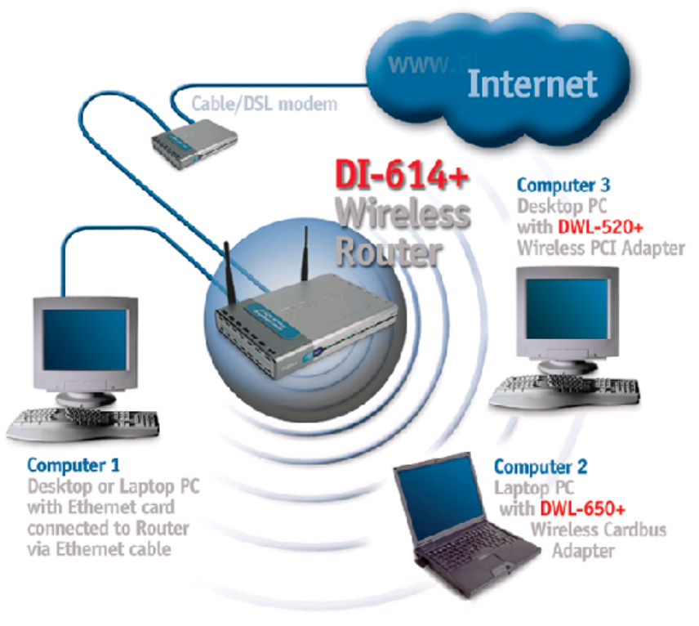
Re-draw this as ORA artwork, losing proprietary D-Link info

Wireless Worries
You may have some specific concerns about wireless home networking.

What About Security?
You may have read war stories about people breaking into home or business wireless networks. It’s true: someone close enough to your network can break into it, using a computer that’s capable of connecting to a WiFi network. That could be someone in a neighboring home, or it could be someone “war driving” through the neighborhood, armed with a wireless-capable laptop and some special software. Unfortunately, many vendors ship access points that are wide open to attack out of the box. Fortunately, it’s easy to secure your wireless network; Chapter 3 tells how. Once you’ve taken steps to secure your network, you can rest easy. (However, if you notice the same strange car slowly driving through your neighborhood every day, you might have cause for concern – especially if you see lots of antennas on it.)
What Will It Cost?
Your wireless network will cost less to build than you may think. Expect to spend about $100 to $150 for an access point / router with 4 port switch. For each computer you want to connect wirelessly, expect to spend about $50 for an adapter, if it doesn’t already have wireless capability.
For each wired (Ethernet) connection, plan on $20 or so for cable (depending on length). Any computer bought recently will have Ethernet support built in. If yours doesn’t, you can buy adapters for $20 to $40.
If you need to add Home Phoneline or Home Powerline connections to your network, expect to pay $100 for an adapter to plug into your access point / router, and $100 for an adapter for each computer.
In order to insure that your home network remains reliable and you have ready answers to technical questions, purchase this book.
In short: most home networks cost only $200 or so to build.

Can’t I Save Money By Using a Computer as My Internet Gateway?
Your neighbor brags that her son Biff runs a Linux computer as the center of the family network. Windows XP and Mac OS-X make it easy to do likewise. We don’t suggest dedicating a PC for this purpose, because:
- The PC that serves as your gateway has to be left on all the time. This costs wear and tear on the computer, and money. You might spend more on electricity in a year than you would on a standalone access point / router (which consumes far less power).
- If your gateway computer goes down breaks, every computer in the house loses its Internet connection.
- An access point /router is easy to set up. It’s much easier to set up a standalone wireless access point than to install a wireless card in a desktop PC and configure it to serve the rest of the home network.
- Your access point / router acts as a firewall for all of your computers.
You can show these reasons to the neighbor kid and he’ll quarrel with every point. More power to them! It’s your neighbor that has to live with Biff, not you.

What Operating System Should I Run?
You can connect computers running just about any operating system to your home network. For Windows users, we suggest running Windows XP. You can run Windows XP Home or XP Professional. Note that Microsoft has limited the networking capabilities of XP Home deliberately – in fact, that’s one of the main points distinguishing the Home version from Professional
For Mac users, we suggest running OS-X. This version of the Mac operating system is based on a full-featured version of Unix, and it’s ready for networking Macs together – or a network with Macs and Windows PCs.
If you follow our advice to run XP or OS-X, you will find the task of building your network far less daunting. Unless your computer is quite old, you should be able to upgrade the operating system to XP or OS-X easily. If you choose, for instance, to include Windows 98, Windows ME, Windows 2000, LinUX, or Mac OS9, Windows CE (on a PDA), or PalmOSS computers to the mix, we can’t fit all the advice you need into this book; go to the web site associated with this book.

Which Wireless Standard Should I Use?
Three variants of wireless networking are available today:
- IEEE 802.11b: Sends and receives in the 2.4 gigahertz radio frequency at 11 megabits / second. This is the most mature standard, and it’s the one you’ll encounter in “hotspots” as you travel with your laptop computer.
- IEEE 802.11a: Operates in the 5 gigahertz range at up to 54 megabits / second. Because this standard is new and because it uses radio frequencies that are different than 802.11b, this standard encounters less competition from other users. However, if you put an 802.11a card in your laptop, it’s far less likely to work at a hotspot on the road.
- IEEE 802.11g: The newest standard in the family, 802.11g operates at 2.4 gigahertz on your radio dial at speeds up to 54 megabits / second.
We suggest that you choose access points and adapters that work with 802.11b. This gives you the most flexibility. Be sure to read the labels carefully before you buy an access point or adapter. If you buy an access point that only handles 802.11a and interface adapters that only handle 802.11b, your access points and your computers won’t be able to communicate.

The Future of Home Networking
Networking computers in your home co-exists with other applications:
  - Home data networking: primarily concerns connecting computers.
  - Home entertainment: concerns making television and hifi audio available in various rooms in your home.
  - Home automation: concerns controlling appliances (lights, sprinklers, even the stove).
  - Home security: Monitoring for break-ins, flood, fire; security cameras.
  - Communications: concerns text, audio, and video communications within the home and with others around the world.
The future promises convergence of these kinds of applications. We won’t think of separate networks for each application – we’ll think of one home network tying them all together. Already we see hints of this:
  - Lansonic’s Digital Audio Server holds 350 CDs in MP3 format, and serves music over your home network.
  - The popular TiVo personal video recorder now connects to your home network. You can schedule recording from anywhere in your house – or anywhere on Earth. And you can view recorded programs using any computer on your home network.
Some highly-touted forms of home applications convergence seem a bit silly today. LG and other manufacturers have developed Internet refrigerators – food central becomes Internet central. An early LG model features a 15 inch touchscreen for television or for Web surfing and e-mail; hi-fi speakers for FM radio or MP3 listening; and a remote control.
Is this visionary or is it ridiculous? Early reviews of the Internet refrigerator tend towards the latter. In many, homes, though, the kitchen is the one room where everyone congregates every day. Many households use the fridge as a communications center, with appointments, photos, and notes plastered over the front. The fridge might be the most logical place in the home for an Internet device. And, of course, the refrigerator is always turned on. You could check the traffic Webcam, send a note to your boss saying you’ll be telecommuting, or double check that recipe you read online as you plan a trip to the grocery store.
It’s hard predicting Internet futures. Using the Internet for long distance telephone calls remains a niche market, while MP3 downloads captivated millions more. We can’t tell you if the Internet fridge or the Internet automatic sprinkler system will change your life. We are confident, however, that your home network will.

