Chapter 5: Advanced Wireless Networking

Securing Your Wireless Network
Given that any of your neighbors can join your wireless network and/or monitor activity, it is a good idea to put security on your network. Putting basic security on your network is not very difficult and works quite well with a variety of vendor equipment.
The security which you will use is called WEP (Wireless Equivalent Privacy). WEP is a way of encrypting the data moving between your wireless adapter and the base station. In addition, wireless clients cannot join the network unless they know the password. This is equivalent to a wired connection where you cannot connect to the network unless you can find a plug which plugs into the network.
WEP is based on a shared secret key which is 64, 128 or 256 bits long. Different wireless adapters will support different key lengths. If you have a number of adapters from different vendors, you may have to experiment with a key length which will allow them all to work. Most adapters support at least 128 bit keys, so it is usually a safe choice.
These keys can be expressible as ASCII strings or as Hexadecimal strings.
- Connect to the router and navigate to the wireless section of the configuration screen by pressing the Home tab and the Wireless button. Set the SSID to some reasonably recognizable network name (this is case sensitive), enable WEP, set the key length to 128 bits, and specify a 13 character ASCII (text rather than numbers) key.
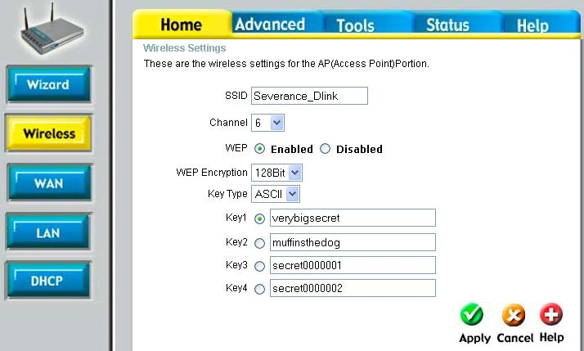
ASCII keys are quite convenient. Windows XP supports either Hexadecimal (numeric) or ASCII keys – if you are using other operating systems or some vendor’s wireless adapters, you may have to use a hex key because a client configuration tool only supports HEX keys.
- Press Apply to reconfigure and reboot your router. You will immediately lose your wireless network connection. Windows will immediately notify you via the system tray that the wireless network connection has been lost.
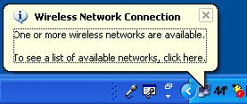
- Click on the balloon dialog or right click on the network icon in the system tray and select View Available Networks to bring up the Wireless Network Connection dialog box. Enter the secret key which you used in your router configuration (twice) and press the connect button.
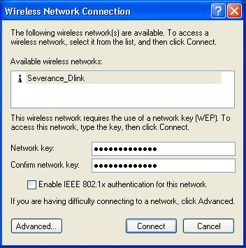
Once you press Connect, your wireless adapter will attempt to “plug into” the wireless network using the key provided. Much like plugging a network cable into a router which is not powered on there is not a lot of difference between what you see when the key is right versus a wrong key. You will not see a dialog box which says “incorrect password”. It simply will not work.
- To test your connection, bring up a web browser or Click on the wireless adapter in the system tray, select the Support tab and attempt to perform the repair option. If the repair operation completes in several seconds, you have set the key properly. If the repair operation fails you probably have an incorrect key.
- To change the key on your workstation, simply right click on the wireless adapter icon in the system tray to bring up the Wireless Network Connection dialog (above), enter the right key and press Connect, and then retest.
- If you absolutely cannot re-establish the wireless connection (isn’t security great!), you may have to re-connect using an Ethernet cable to reconfigure the wireless connection or even reset the router back to factory configuration and start over.
Once you have your secure wireless connection working with one computer, repeat the procedure on the other wireless computers in your home. Windows XP remembers the wireless key so you will only have to enter the key once each time you change the key. In addition, Windows XP also remembers a different key for each SSID (wireless network identifier) that you interact with. So if interact with a wireless network at home, at work, and at the coffee shop, they can all have passwords which you enter once and Windows uses the appropriate password for the connection as you move from base station to base station.

Locating your Wireless Base Station in Your Home
Once your system is up and running solidly, can install it in its final location in your home. Because wireless networking works with relatively low power your reception will depend on the placement of the base station.
First place the base station is its most convenient location and survey the wireless signal strength throughout your home using the built-in signal strength indicator.
- Click on the wireless network icon in the system tray.
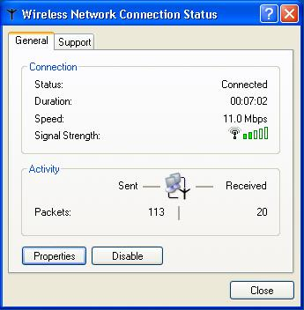
The signal strength indicator indicates how well the wireless adapter is communicating with the base station. At each place sit for a few moments, look at a web page, and then open the status dialog box. This way you can get a good map of the coverage of your home and find where you have problem spots.
As you get farther away and the signal is going through walls and floors (especially concrete) you may lose the signal completely. In this case you have one of three possible options:
- Move the base station
- Adjust the base station antenna’s (if they are adjustable)
- Purchase an additional antenna from the base station manufacturer
The best location for a base station is in the center of the area which you are trying to cover both horizontally and vertically. This limits the distance between your adapter and the base station.
If your base station has an antenna, it is probably a dipole antenna where most of the signal is concentrated in the horizontal direction. This wireless equipment is allowed to emit only a limited amount of wireless radiation, so the antenna designers try to direct the radiation where it can do the most good. In general the goal is to send the energy out in the horizontal plane to maximize coverage. This also means that there is a weak area directly above the antenna.
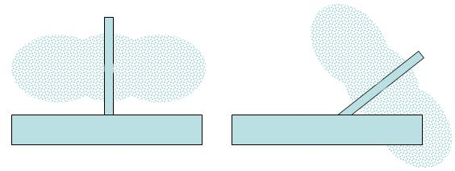
If you live in a ranch house or a single floor apartment, then this is a good approach. However if you live in a multi-story home, then this might not be the best approach. You can send some of the signal vertically by repositioning the antenna. You have to think of the signal pattern as a thick “plate” coming out of the antenna as you move it around. You can experiment to see if you can aim your antenna just right to get a good signal into the den.
Some units have two antennas, so you can aim them independently to improve coverage.
Don’t expect to get too much improvement by antenna aiming however because the effect of distance and intervening walls and floors have a much greater impact than antenna aiming.
You might also investigate purchasing an external antenna for your base station. Base station vendors often sell approved external antennas (a good way to make money when the base station costs $50.00). But be very careful when purchasing an external antenna. Nearly all external antennas are trying to improve the range of the signal. They do this by making the signal pattern even more constricted than the standard antennas so the signal can travel farther.
There are three types of antennas which you will encounter:
- Omni directional – A circular pattern in the horizontal direction and a figure-eight shape in the vertical direction.
- Patch – A directional antenna which focuses nearly all of its energy to one side. These may or may not be symmetric in the horizontal and vertical directions. These are generally mounted on one side of the area which needs to be covered.
- Directional – Focuses all the energy in a small cone. Used to significantly extend the range of the signal. You must carefully aim these directional antennas but they can send the signal several miles even at very low power.
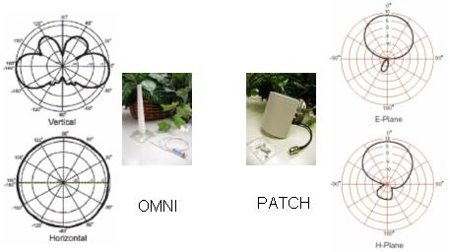
Unless you are trying to send a signal a great distance, you should probably use a centrally located (both vertically and horizontally) omni directional antenna which works much like the built-in antenna, but is more sensitive. A second choice might be to place a patch antenna on one of the outside walls of the area which you intend to cover. The patch antenna should be centered vertically in the space which you intend to cover.
Note – We might want to borrow some pictures from the 802.11 book

Operating in Congested Environments
When you are operating in a congested area with a number of base stations within range, you may have to manage your channel number. While your access point has a number of different channels, when you are trying to avoid overlapping signals and performance degradation, the only useful channels are 1, 6, and 11. Depending on how friendly you are with your neighbors, you may be able to ask them what channels their base stations are using. If you cannot talk to the owners of the base stations, you might have to use the process of elimination to determine which channel will work best for you. Given that most base stations automatically default to channel 6, choosing something other than channel 6 is likely to improve your performance.
The closer you are to the other base stations, the more important it is to avoid overlapping channels to insure reasonable performance from your wireless network.
The wireless adapters in your workstations automatically look across all of the channels so you do not need to alter any client configuration when you change your base station channel configuration.

Summary
It would be good if Internet Service Providers could read this chapter, and configure their ISP service to make things as simple as possible. The home router manufactures have certainly done everything they could possibly do to make things easy for you. They provide options in the routers to adapt to the ISP idiosyncrasies – your job is to work with your ISP’s technical support and documentation to figure out which set of features your ISP supports.
The good news is that over time, ISPs are generally motivated to make your life simpler, removing those features which make their service harder to use and harder to configure. In the long run it saves them technical support cost.
The “even better” news is that once your base station is properly configured the rest of your home network setup is relatively straightforward.

