Chapter 7: Using Your Home Network

Virtual Private Networks
Virtual Private Networks (VPN) are a way to describe the act of creating a "new" network using the underlying capabilities of an existing network. One major application of VPN technology is to produce a corporate Intranet using a number of connections to the public Internet rather than direct connections using leased lines. There are obvious security concerns which must be solved to keep folks on the Internet from having access to corporate servers or data as it crosses the Internet. But two short high speed connections to the Internet can cost far less than one long connection between two corporate routers.
There are three basic concepts which allow a VPN to use the public Internet to implement a VPN:
- Encapsulation
- Tunneling
- Encryption
In a traditional Intranet, locations are connected by a long-distance leased line connected to routers at each location. When data needs to be transmitted from one location to another, the data is simply copied from one local area network, sent across the leased line, and then copied onto the local area network at the destination. Because the leased line is dedicated, typically no encryption is necessary.
- 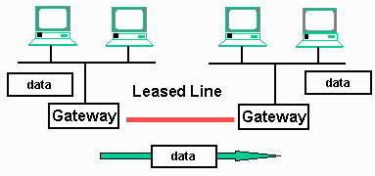
In a VPN environment the process to move data from one location to another is quite different. The routers are replaced by VPN-capable routers. When a packet needs to be moved to the remote location, it is copied off the local area network and encrypted. Then the data is placed in TCP/IP packets (encapsulation) and sent across the Internet to the destination VPN router. At the destination, the data is reassembled as necessary, then decrypted and copied onto the local area network at the destination. This concept of encapsulating data in another protocol and sending it across the net is called tunneling. In a way the data is sent from the source to the destination through a "tunnel".
- 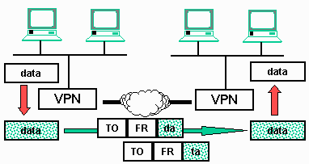
The net result is the same whether a VPN or Leased line is used to move the data. There may be cost and performance differences between the two approaches. Usually the VPN is less expensive, but sometimes, VPN gives better performance than a leased line solution.

Using a VPN from A Single Computer
While this technology allows two geographically distributed local area networks to appear to be connected, the more common scenario that you will use in daily life as a business traveler or as a telecommuter is connecting a single computer to the VPN so that you can access your corporate network in a secure and convenient manner. This is usually done by running VPN software in your computer. While there are a number of different technologies used to implement a VPN, Microsoft included a basic VPN client in all of its operating systems since Windows-95. Many VPN routers will support the Microsoft variant of VPN because client software is readily available under Windows operating systems.
Once the VPN adapter is installed on your computer, all of the VPN processing is done in software on your computer. The data is encrypted, encapsulated, and broken into packets in software in your computer. Then the packets are sent to the corporate VPN system across the Internet where they are decrypted and reassembled, and copied onto the local area network on the destination LAN. This allows you to operate as if you were directly connected to the corporate LAN, reading E-Mail, accessing files, and other operations.
- 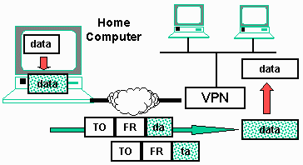
Security is paramount to all VPN operation. There is the obvious password and account which gives you access to the VPN. Many companies add some type of external randomly generated security keys from a vendor such as SecureID (www.securid.com). These external security keys generate continuously changing random numbers. Each user has a SecureID which is generating the same number sequence as the SecureID system is generating on the corporate LAN. You will only be granted access if you can enter the number displayed on your SecureID and it matches the number generated at the corporate LAN.
You can make use of your VPN; you must install and configure the PN software for your computer. If you are using the Microsoft VPN adapter, it is available as an adapter in the network control panel. It makes sense that the VPN software appears to be a "virtual" network card. The VPN adapter is acting as a network card, accepting data packets and sending them to the VPN gateway.
In addition to installing the software, you will also have to configure a few options for your particular VPN. Because VPN technology is evolving rapidly and there are many different protocols, software suites, and configuration options for each VPN, the best bet is to get help (or at least detailed instructions) from your corporate IT department.
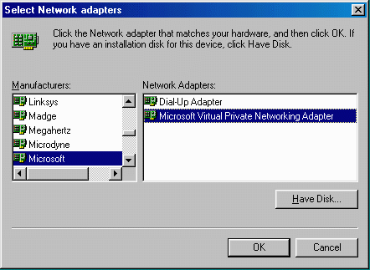
Once configured properly, VPN is very easy to use, secure, and cost effective. While it is out of the scope of this book, you can set up your own VPN using a combination of the VPN software in Windows-98 and the VPN server software included in NT 4.0 and NT 2000. Building the remote end of a VPN using Windows 2000 is actually quite straightforward.

Conclusion
In addition to Internet connection sharing, printer sharing and file sharing are an important benefit of a home network. Using workgroup style networking under Microsoft windows operating systems is relatively easy to configure and very convenient to use.

