Appendix C: Diagnosing Problems
By this point your network should be operational. Your workstation is talking to your router (you are using that connection to configure the router) and your router is talking to the Internet as tested by the ping command from the router to the Internet.
At this point, you should be able to go to a web site in your browser and have it work fine. If this works, congratulations – you can skip ahead to the wireless configuration. In this section, you will use a few tools and techniques that you can use to diagnose the problem. These tools are available from the command prompt.
- Start a command window using Start -> Programs -> Accessories -> Command Prompt. Then type the command IPCONFIG – you will see a printout of the addresses which your network connections are using.
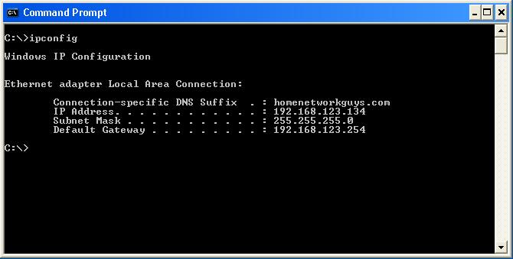
You can see the address which is assigned to your network adapter (IP Address) as well as the address of the router (Default Gateway). If the address assigned to your network adapter starts with “169”, then your connection is probably not working.
- To renew the address, use the command IPCONFIG /release followed by IPCONFIG /renew.
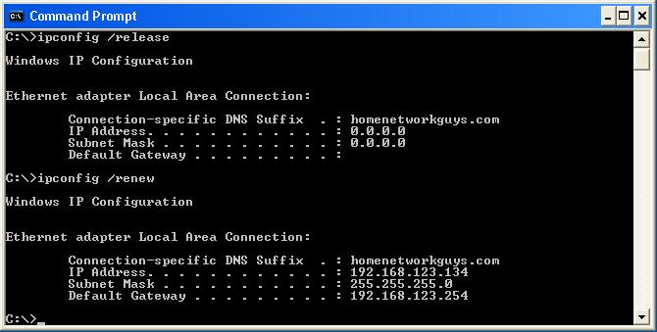
Like the Repair operation described above, the renew operation should take a few seconds. If your router is not communicating with your network adapter, the renew operation may take over a minute. At the end of each IPCONFIG command you will see the current network settings.
There is a subtle difference between the Repair operation and the release followed by the renew operation. The Repair operation “refreshes” the existing address (unless it is a 169 address) which is assigned to your adapter. The release and renew operations truly discard the current address (a reboot also does this) and re-request the address. If you are changing your connection from one brand of router to another, or moving your connection from your modem to your router, where the address needs to completely change you should use the combination of the IPCONFIG /release and IFCONFIG /renew operations rather than the Repair operation.
- The next command to explore is the ping command. The ping command sends a single packet of data to an address on the network and records how long it takes to receive a reply from that address. Use the ping command to ping the IP address of your network adapter (IP Address).
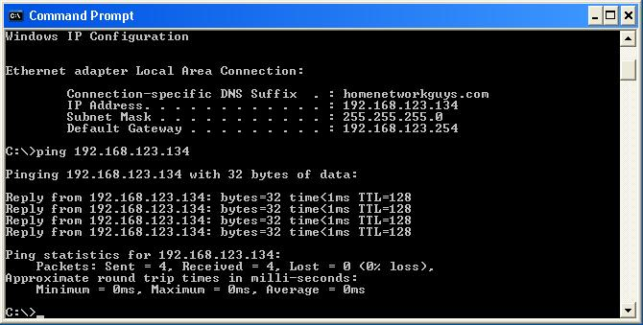
If this does not work, then you have a real problem. The ping command sends 5 packets and then times them. The time is reported in milliseconds (ms) which is a 1/1000th of a second. So 250ms is 1/4 second. Since this data is not even leaving your computer, your time should be very quick. In this example it is faster than 1/1000th of a second.
- Next ping the address of your router (default Gateway). This tests your local area network connectivity.
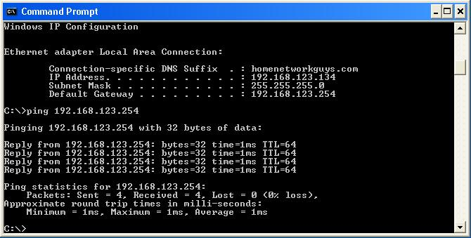
- Next, ping a numeric address outside your network. A good way to find a numeric IP address is to use ping with a common domain name (see next step) on a system that is working and connected to the Internet and then write down the numeric address which is displayed in the ping output.
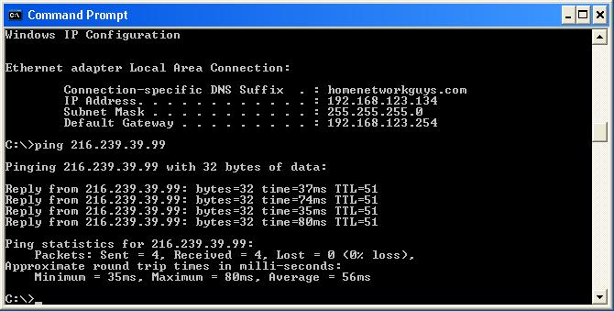
You might have to call a friend and ask them to run the ping command to get the numeric address to use in the ping command. If this fails, then it is most likely that your modem is not properly connected to the Internet.
- Next ping a common internet address such as www.google.com.
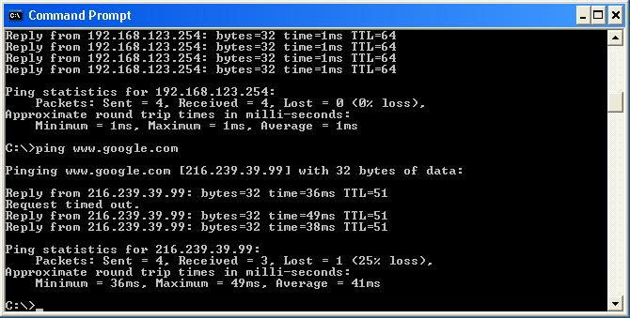
If this step fails and the preceding step succeeds, then you are having a problem with domain name resolution. Make sure to test a few hosts before you declare your system as not working.
If the ping command to a symbolic name works, then your network is in good shape and things should work quite well. If this ping command works, but you are having problems with your browser, your problem might be browser configuration. The most likely culprit is a browser proxy setting. You should not be concerned if you see a lost packet from time to time – especially for busy hosts like Google.
- To look at the proxy setting in Internet Explorer, Select Tools -> Internet Options -> Connections -> LAN Settings.
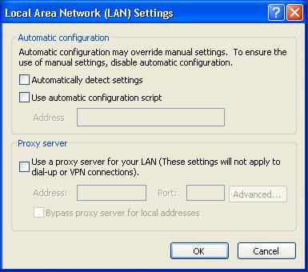
If the proxy server is selected, it may be the cause of your problems. De-select the proxy check box and retest your connection.
- Run the command tracert to either a numeric or domain address.
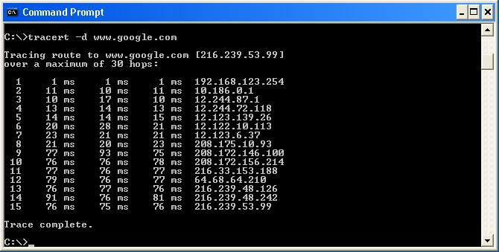
This command traces a set of data packets as they cross the network. It can be used to see “how far” packets go before they are lost. It can also who how long each network hop takes. This command is also useful at times when your connection is inexplicably slows. The tracert command may be able to isolate the segment of the network which is causing the slow-down. You can remove the “-d” option from the tracert command if you want to see the symbolic host names of the routers which are handling your data. It can be funs to see the various places where your data goes as it crosses the Internet.
The tracert output also includes timing information as your data is sent across the network. Each of the network hops is separately timed and the time is reported in milliseconds.
These commands allow you to probe your network connection in great detail to help you diagnose problems with your home network.

