M E M O R A N D U M

March 20, 2018

To: Awesome Sakai Community

Fr: Dr. Chuck

Su: Logo Survey Results

Hi all - here are the results of the Sakai logo brainstorm survey.

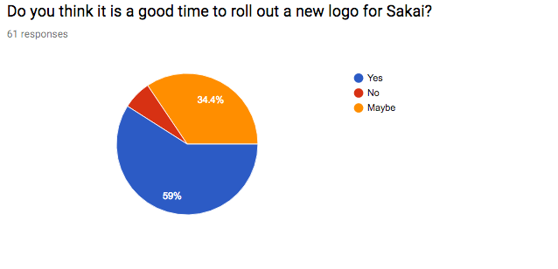



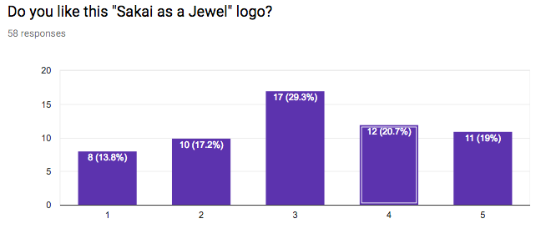



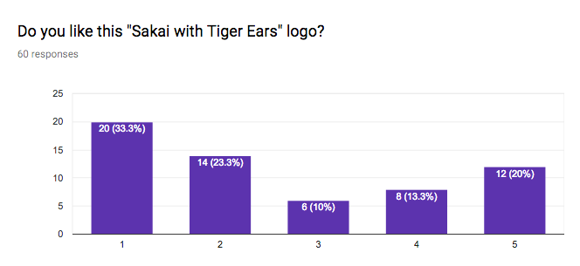

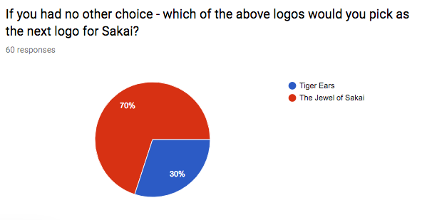

Comments

Its a great logo (2)

The 12 release \*could\* be a good time to roll out a logo. On the whole, I'm going with the "simpler is more memorable" line, but there isn't a great deal in it between the two...

non-so-important - features are more vital for growth.

I do not like the light blue color, nor the ufo like shape, not even the font for Sakai. I think Sakai should move forward to a logo that speaks of future, less flat and static, with more dramatic colors.

I think it would be good to modernize, but I don't care for these choices. The idea of a jewel is good, but this implementation is not. (It looks like sticks in a scoop of vanilla ice cream, not a jewel.) The tiger ears make me think of cat pics on the internet - which are silly and fun for some, but certainly not indicative of an important piece of software.

I don't know which is the main goal here, but if it's renewing the brand to create the perception of a new refreshed Sakai then I think that those two logos won't work. They are almost the same than the old one. Ripples, and Text typography... My two cents. Involving community on those aspects is a good initiative, Kudos for you.

Emerge, flourish, brighten, enlighten, spread like a ripple effect, lot of open ends to connect to, future perspective, glass bowl are words that come to the mind looking at the logo. All related to what Sakai wants to bring to education. The tiger’s ears take away the attention from all of the above...

Looks very like the current logo, we need something new in my opinion, Sakai is an alive project and probably needs a new concept.

I can see the evolution of the logo, but the "Tiger ears" are much better. Because of including the mascot a little bit :-)

In my opinion Sakai logo needs a more radical change, but putting blue icon to the left of "Sakai" text is a good idea, it seems more like a "logo" than the current one.

No comments beyond what I’ve said in previous emails.

Nothing specific

They're not reflecting a big change

The "jewel of Sakai" makes me think of the "Saturn of Sakai" or (blush) the "nipple of Sakai". I like its symmetry and it works as a logo, I'm just not sure it works for Sakai. "Tiger Ears" or "Tiger Rising" is a little bit like the omniscient Sakaiger watching over the Milky Way galaxy or the planet Saturn, rendering judgement. So I like it even less than the Saturn of Sakai. I understand the need to update the Sakai image, and I think your instructions to the designers (an evolution, not a rebranding) is spot on. But I'm afraid neither of these is particularly compelling.

Most universities probably set their own logos in the portal header. But the Sakai logo and name is still important for to show of which system their learning management system is built upon. Even though it just might end up in the footer - if at all.

The jewel I thought was a sun at first - but a Sakai shining forth is still as good as Sakai the jewel of LMS'.

Sakaiger rules!

Tiger ears is a bit cliquish. Only insiders know about Sakaiger.

Sakai should have a new logo. Brands change over time and ours is dated.

The cat logo is not professional enough to appeal to high-level decision makers. It could be fun for in-house comm and conferences, but not the wider corporate/academic audience, esp. if we want to be taken seriously in academia.

Let's do it.

Sakaiger Forever!

Keeping a chain of history is great. I think the jewel logo does that.

Tiger Ears looks a bit more like Devil Horns to the community I would suspect because it is not well known (outside the community) what the mascot for Sakai is even. I didn't know until I had been to the conference and it was one of the items on the bingo cards, and I had been working with the application for several months already. My only concern with "Sakai as a Jewel" would be that it also could be an illustration of an explosion. Definitely like it better than our current logo though :)

I like the idea of modernizing our current logo without changing too much. I think it needs to gradually evolve rather than change significantly all at once.

I prefer the original over these options. The current logo looks more professional than these two options, which are just alternatives of the original. Any new logo should likely be significantly different (not have any rings, for example).

These are too similar to the old logo and rather mundane. Might as well stick with the old logo if these are the only choices. I would say the "jewel" logo looks to be more of a light beacon rather than a jewel. As an idea it's not bad, but adds nothing to the actual logo itself unless it's somehow integrated into the Sakai text.

If the Sakai-ger was also featured in other promotions, the identification of tiger ears with the logo would be strengthened. Otherwise, the new logos are both sufficiently abstract, that they could be misinterpreted, I believe.

The first logo, make more freedom sense

I love the Sakaiger. I wish he was on more stuff/merch, etc.

If there is a need to change the logo, I do not feel like either of these is changing that much. I think it only takes the current logo and tweaks it for the worse.

I think Sakai needs to pick a unique font for the word Sakai. The logo can then consist of the the word Sakai in that font with graphic or design like the tiger ears or gem on the "S". This would allow the logo to be shortened to just the "S" for smaller cases like a favicon, app icon, etc.

Everything that implies that Sakai is renewing is absolutely needed. A new logo is a big (and simple at the same time) way to do that.

I think I would have benefitted from seeing a few other logos. Although I chose the tiger, I think I may have preferred another alternate.

Love the Sakaiger ref but most won't understand it - maybe that's a good way to get new people to dig deeper - or maybe not.

I like the current version of the Sakai Logo. It's simpler than these and keeps consistency. I'm also not a fan of Sakaiger.

I don't like either. What are we trying to convey in the logo? #1 looks like a spaceship and #2 I know is a cat, but someone might see something else like the horns of the Dark Lord.

I like the first because it is more 'business like'.

It might be time to update the logo and the "jewel" idea is much more generic and easily accepted. The ears are nice and I think should still form part of the mascot part of it.

Having a new, clean logo is important for us being able to present Sakai in a modern, professional way. Love the first logo.

Dunno

I think we need to promote items better, I liked the cat logo previously.

I love the Sakaiger, but feel the platform has matured past the cartoony aspect of it. He should be a Easter egg somewhere. I prefer the first logo "jewel" but don't get the significance - is it a sunrise?

The jewel looks more like a space ship to me. :) I love the Sakiger and tiger ears concept. Seems like a marketing platform that is already in place and can be leveraged.

I would like to suggest bright colour as current one looks dull. A jewel should be bright.

The logos aren't really new. They just move around the existing design elements and in one case add an element, and in the other add two elements. As far as what I think of the designs is concerned, I'm sorry to say that when I saw the "Jewel of Sakai", I immediately thought of a flying saucer, not a jewel. As for the "Tiger Ears" design, it's cute, but the ears are too much of an inside "joke" and don't add anything of value that attracts newcomers to the brand. Why not just add the whole Sakaiger instead? Indeed, simply using the old Sakai logo with the Sakaiger added in some way would be better.

Like Jewel logo

Everyone has his/her own interpretations on the whole or part of the shape. We could collect the interpretations to superimpose on the new logo.

I have strong feelings that this logo competition should be offered to the Sakai community to find alternative logos. It does not need to be paid, but the community itself is most likely to understand the concept. There are people in the community that do have skills to help with the re-design, and part of this should be discussed with the marketing team. Unfortunately, the logos above are not good. The first one looks like a UFO not Jewel, and there is not enough flow in the second Tiger Ears logo - so it looks random especially from an outsider (esp university leaders). And as much as we love our Sakaiger mascot, at some point cats are going to not be the current geek trends, which means our logo will become even more obscure. Does not seem like these logos are linked properly to longer term strategies.

As already discussed, Tiger Ears reminds me "Sakaiger."

I agree with a logo that refreshes our look. While the Tiger Ears are fun, they're not all that meaningful outside the community. The Jewel logo is far superior.

No comment

Reaffirming identity and showing evolution in the NGDLE

Ok, It's ok, It's a little bit improvement, I would like to see a deeper work, but I know there is no very much resources.

What are you hoping to accomplish with this rebranding?

Newer logos are high def, they "pop" and often are 3D... gradient to the colors

The tiger ears are too ambiguous if you don't already know what they are.

The tiger ears seem like an interesting concept that could be expanded, but having the ears over the jewel seems too busy.

I would keep the typography as it is. The image/icon could still evolve a bit more or even be changed. The cat is cute and maybe it could gain more protagonism in the logo and not just appear as the ears... have a full cat head. Just my 2 cents.

Please no childish tiger logo

I think launching a new logo with Sakai 12 is a great idea. I like change and new though