A Primer on the
IMS Learning Tool Interoperability Standard

Introduction
Today’s education market includes a growing number of high quality, web-based applications that enhance teaching and learning. These applications range from general communication tools for chat and virtual classrooms to domain-specific learning engines for particular subjects like mathematics or history.
Ideally, any Learning Management System (LMS) ought to provide access to these myriad learning applications. It ought to be possible to mix-and-match these applications within the context of any given course. To this end, some LMS vendors have developed proprietary extension frameworks which make it possible to “plug-in” external applications. Instructors and students navigate into the learning applications by traversing carefully crafted hyperlinks, and data flows between the two systems via custom communication protocols.
While these proprietary solutions often work nicely, they have a high total-cost-of-ownership because each integration represents a point solution that must be re-invented for each LMS / learning application pair.
The IMS LTI standard aims to deliver a single framework for integrating any LMS product with any learning application. This document introduces the conceptual foundations and architectural principles that underlie the LTI standard.

Objectives
The objectives of the LTI standard are:
- To define a deployment framework so that learning applications can be “plugged” into an LMS without needing to write new integration code for each partner application.
- To define a standard process for building links from the LMS to resources within external learning applications.
- To guarantee secure communications between the LMS and the external learning applications.
- To enable the exchange of enterprise data between the systems – including data related to courses, persons, rosters, and outcomes.
- To define a protocol for launching an external application from an LMS in a way that supports single-sign-on and which preserves the learning context and user roles within that context.
- To make links to external applications portable by defining data elements that can be embedded in IMS Common Cartridges.

Key Concepts
The LTI standard is principally concerned with the integration of LMS products and learning applications, but the in the specification they are Tool Consumers and Tool Providers. We use these more abstract terms because the LTI standard may ultimately be used to plug tools into applications beyond what we think of as a traditional LMS product.
The LTI standard has many of the features of the proprietary extension frameworks but in LTI, all of the operations are performed using a Service Oriented Approach over Web Services. This allows a Tool Provider to be written in any programming language and to be hosted on a completely different system than the LMS that launches the tool.
Once the Provider tool has been registered (i.e. installed) in the Tool Consumer (i.e. LMS), the Tool Consumer sends various messages to the Tool Provider to perform various operations and communicate information to the Tool as shown in Figure 1.

Terminology



Tool Provider. A Tool Provider exposes interfaces to one or more tools. As illustrated in Figure 1, it is useful to think of the Tool Provider as a wrapper around a tool. In this sense, the Tool Provider represents the entire system of Tool plus its interfaces.
Create Link
Create Link
Launch Request
Course Copied
Course Deleted
Course Deleted
Tool Consumers
Tool
Tool Provider
Figure 1. Message Handlers for a Tool
In this illustration, the Tool Provider surrounds a Tool and exposes Message Handlers that receive messages from Tool Consumers in the cloud. The Message Handlers appear as mail slots. Each Message Handler receives a specific type of message.
Message Handler. The interfaces to a Tool are called Message Handlers. The Tool Provider defines a collection of Message Handlers, each of which receives a specific type of message.
Message. A message is a packet of information delivered to a Message Handler. For the most part, messages are delivered as simple HTTP POST requests. Thus, each Message Handler advertises a URL to which its messages can be posted. There are two main types of messages: Tool Launch Requests and Event Notifications.
Tool Consumer. Instructors and students typically access Tools by activating links from within an LMS. But the LTI standard supports other scenarios, too. For example, you might want to launch a learning tool from Facebook, or your Google home page. Any system that offers access to a Tool is called a Tool Consumer.
Tool Proxy. By now, it should be clear that the Tool Provider and the Tool Consumer are generally on separate systems. In order to provide access to a remote Tool, the Tool Consumer must have some internal representation for the Tool that records information about the security contract between the two systems. This representation of the Tool with the Tool Consumer is called a Tool Proxy. Tool Proxies have a full life-cycle: they are registered with the Tool Consumer through a well-defined deployment process, administrators can make them available to instructors and students or hide them, they can be upgraded to new versions, or removed entirely from the Tool Consumer.
Tool Consumer Runtime. The Tool Consumer Runtime is a component of the Tool Consumer system that manages interactions with remote Tool Provider systems. It provides interfaces that allow new Tools to be registered with the Tool Consumer, and it facilitates the launching of Tool resources from within the Tool Consumer system.
Context. Links for Tools typically appear in the context of some course. But they may appear within other types of groups. For example, links might appear within the context of a student organization, club, study group, etc. Since Tools may be launched from many different types of contexts, the LTI Specification rarely uses the term “course” and instead uses the more general term “context.”
Resource Link. The Tool Consumer uses Resource Link entities to generate clickable links within its user interface. Each Resource Link has a title which defines the text that should appear in the clickable link plus an optional description which should appear alongside the link. The Resource Link also contains a collection of Tool Settings which are passed to the Tool as parameters when the link is clicked.
Most LMS products have some sort of content organizing system which holds media for courses. The content system might contain HTML documents, streaming video, PowerPoint presentations, etc. which tend to be organized in some folder structure. Conceptually, an LTI Resource Link is like a custom media type that can be added to a folder. When the Tool Consumer renders this media type, it displays a clickable link plus a description.
Each Resource Link within a Course Context has its own unique identifier that is passed to the Tool Provider as part of any messages that are sent from the Tool Consumer to the Tool Provider regarding the Resource Link. This allows the Tool Provider to have different configuration or setup information for each Resource Link within a course (i.e. a Context).
Menu Link. As we have seen, Resource Links appear within the content system of an LMS or some other Tool Consumer. It is also possible to embed links to Tool resources from within the navigation panels or menu structures of the Tool Consumer. These types of links are called Menu Links. Menu links function outside of a particular Context.
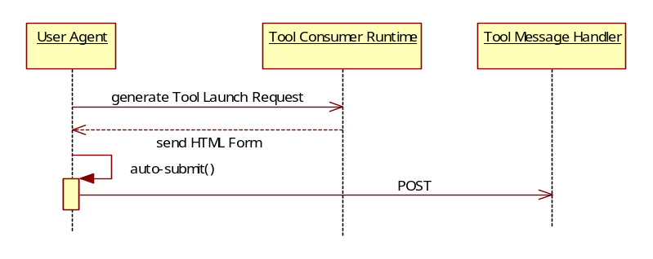
Tool Settings. The Tool Consumer stores settings for each Tool at three different scopes: system, context, and link. Each Resource Link and each Menu Link defines a collection of Tool Settings that are specific to the link. When a link is clicked, the Tool Consumer passes these settings to the Tool Provider along with the identifiers associated with the links and the settings from the context and system scopes.
Figure 2. Tool Launch Sequence
The properties of a Reso
Security Profile. A Security Profile explains how to secure communications when exchanging messages or invoking web services. The LTI standard defines several different Security Profiles. The Tool Consumer and Tool Provider must form an agreement about which profiles they will use.
Having introduced the key concepts featured in the LTI standard, let’s examine some of the processes that build on these concepts.

Tool Launch
Instructors and students launch Tool resources by clicking links in the Tool Consumer. But these links do not point directly at the Tool Provider system.
Instead, they point at the Tool Consumer Runtime. When a link is clicked, the Tool Consumer Runtime assembles all the information that must be passed to the Tool, and it sends this information to the user’s browser in an HTML form.
The user never sees this form because the data are contained in hidden fields, and the form is auto-submitted (via a Javascript event) to the appropriate Message Handler in the Tool Provider as soon as it is loaded into the browser. Figure 2 illustrates the Tool Launch Sequence.
Once the launch request is received, the Message Handler may choose to redirect the user's browser to some other URL, or it may render the requested user interface straight-away.

Tool Deployment
During deployment, the Tool Consumer and the Tool Provider exchange profiles that describe their respective capabilities and interfaces, and the two systems agree on a Security Contract. The contents of the profiles are shown schematically in Figures 3 and 4.
Tool Consumer Metadata
Vendor Information
Capabilities List
List of supported Security Profiles
Tool Consumer Profile
Figure 4. Contents of a Tool Consumer Profile
Web Services
The LTI standard provides formal definitions for a wide range of capabilities. Each capability corresponds to a tiny bit of functionality. The Tool Consumer publishes a list of its capabilities in its profile.
For example, the Tool Consumer would declare the localization capability if it can render text associated with a Tool in multiple languages based on the user's locale and a corresponding language pack provided by the Tool. Similarly, the Tool Consumer would declare the course-update-notification capability if it is able to notify Tools whenever the properties of a course change. In all, there are several dozen different named capabilities.
Unlike the Tool Consumer, the Tool does not explicitly declare any capabilities in its profile. Instead, the Tool advertises a collection of Resource Handlers, Event Handlers, Menu Links, and Outcome Handlers. Each handler implies a capability to handle certain types of messages. Thus, whereas the Tool Consumer Profile might declare the course-update-notification capability, the Tool Profile would advertise the existence of a course-updated Event Handler that receives notifications whenever the properties of a course change. Figures 5 and 6 show the correspondence between these elements in the respective profiles.
The Tool Consumer Profile contains two other key pieces of information. It contains a listing of web services that are available to the Tool and a listing of the security profiles that the Tool Consumer supports.
The Tool Provider uses Tool Consumer web services for a variety of purposes. For example, it might use an IMS LIS Person Manager web service to pull personal information about instructors and students from the Tool Consumer. Or, after a student completes a quiz, the Tool Provider might push a score into the online LMS gradebook via the LIS Outcomes Manager web service.
During the deployment process, the Tool Provider inspects the Tool Consumer profile and verifies that the Tool Consumer can meet its needs. The Tool Provider confirms that the Tool Consumer supports the minimal set of capabilities required by the Tool. It confirms that the Tool Consumer offers the all web services that the Tool needs, and it confirms that the Tool Consumer supports an agreeable set of security policies.
Tool Metadata
Vendor Information
Resource Handlers
Menu
Links
Outcome Handlers
Tool Profile
Figure 3. Contents of a Tool Profile
Event Handlers
Once the Tool Provider is satisfied, it passes a Tool Proxy Registration Request to the Tool Consumer by invoking an operation on the Registration web service, as illustrated in Figure 8. The registration request contains three key pieces of information: a Tool Profile, a collection of system-wide Tool Settings, and a Security Contract.

<capabilities>
<capability name="course-update-notification"/>
…
</capabilities>

Figure 5. Snippet from Tool Consumer Profile

<messages>
<message name="course-updated" path="course/update"/>
…
</messages>

Figure 6. Snippet from Tool Profile
Upon receiving the request, the Tool Consumer creates an internal representation of the Tool. This representation is called a Tool Proxy. It contains all the information from the registration request. Whenever the Tool Consumer needs to send a message to the Tool Provider, it discovers the URL for the appropriate Message Handler by examining the Tool Proxy.
After a Tool Proxy has been registered with the Tool Consumer, a system administrator must explicitly make the tool available for use. As a consequence of this activity, the administrator grants the Tool Provider access to data within the Tool Consumer via the web services that were declared in the Tool Consumer Profile.
Once a Tool Proxy is available, instructors and course builders may choose to enable the tool in the context of their courses. We say that a binding is created between the course context and the Tool Proxy. Once a binding is established, it can be enabled or disabled.

Security
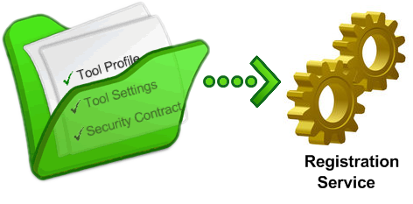
The LTI standard supports a number of different security profiles, each of which specifies a different approach to securing communications between the Tool Consumer and Tool Provider.
Figure 7. Tool Proxy Registration Request

Also known as a resource bundle.
The Registration Web Service must be declared in the Tool Consumer Profile – just like any other web service. This is how the Tool Provider discovers the URL for the service.

