REPORT

1. Class diagram

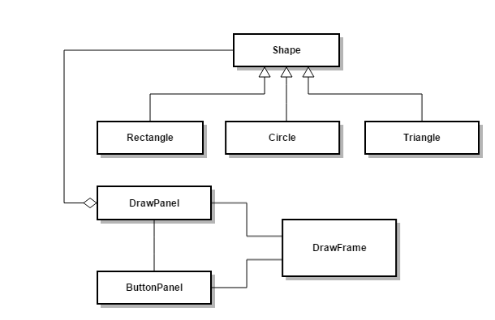

1. Sequence diagram

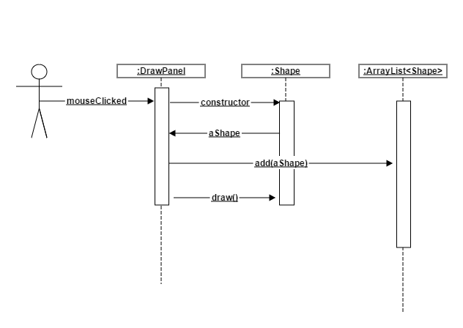

1. Explanation

* Class Shape is the general shape for all kind of shapes. All shapes will have
  + Position
  + Draw method
* Each specific shape will override the draw method to draw in its way
* When user click:
  + A specific shape will be created (currently there are Rectangle, Triangle and Circle). This shape will call draw method to draw itself
  + This shape will be added to a list of shapes
* When the window needs to repaint, in DrawPanel, method paintComponent will be called, it will loops through all shapes in its list, call the draw method of them. Each shape will draw the corresponding shape based on its type.