**Basic freeSurfer Stuff (Basic being the key word)**

**Garrett M. Black**

**Random Notes**

* When naming files or folders that you are going to use for freeSurfer do not use spaces, symbols (ex- &) or forward slashes (/). Instead connect\_words\_using\_underscores. For some reason freeSurfer can’t handle spaces and stuff.
* For links to tutorials on pretty much everything: <http://surfer.nmr.mgh.harvard.edu/fswiki/FsTutorial/ControlPoints>
* Pay attention for the difference between -- and - in commands. Some commands required two dashes and others require only one.
* You can ensure that you’re correct in your paths and file names by beginning to type them, then tabbing to complete them. If there is an error nothing will happen when you hit tab.
* Pay attention to which version of freeSurfer you are using and which type of machine you are using. There have been papers published demonstrating that there are statistical differences in the results of each version and operating systems. Once you start a project make sure to use only that version of freeSurfer or operating system for the duration of the project.
* Most macs will open their terminal shells in bash, and freeSurfer uses the tcsh terminal window. So, if it opens in bash type “tcsh” on the command line to switch it. Do this each time you open a new window.
* A common error you will come across is “ERROR: input(s) cannot have multiple frames!” To fix this problem use the follow commands:
  + cd $SUBJECTS\_DIR /[subjid]/mri/orig
  + mv 001.mgz multiframe.mgz
  + mri\_convert –nth 0 multiframe.mgz 001.mgz
* There are some good training videos here: <https://www.youtube.com/channel/UCruQerP8aa-gYttXkAcyveA>
* <https://surfer.nmr.mgh.harvard.edu/fswiki/FreeviewGuide/FreeviewWorkingWithData/FreeviewEditingaRecon>

**Installing FreeSurfer**

* Download freeSurfer: <https://surfer.nmr.mgh.harvard.edu/fswiki/Download>
  + You will need to register for a license when you do this, and the download takes a few hours
  + The license will be emailed to you. Copy the three lines from the license into a .txt file on your desktop named license.txt
* Once downloaded double click the image to install it. Click continue, agree, install, through everything until it says installation complete
* Open a terminal window and enter the following into the window: cd ~/Desktop
  + Then enter: sudo mv license.txt /Applications/freeSurfer/.license
  + You will get a message asking for your password, enter it and continue
* Next, enter: cd ~
  + Then enter: sudo nano .profile
    - The terminal will create a new file to write in. Put the following two lines into the new file:
      * export FREESURFER\_HOME=/Applications/freeSurfer
      * source $FREESURFER\_HOME/SetUpFreeSurfer.sh
    - When you’re finished press CTRL + X and then Y to save and exit.
* Open a new terminal to see if everything installed correctly. If it worked you should see the two lines you just entered in the terminal window.
* If you’re still having problems you can watch the tutorial for the installation here: <https://www.youtube.com/watch?v=UmQ3ciDSbzM>

**Defining the SUBJECTS\_DIR variable**

* Defining the SUBJECTS\_DIR variable, also called setting the environment, is simply a process of telling the computer through the terminal the location of a directory of interest. That directory of interest is the subjects directory.
* Remember that a “directory” is the same thing as a folder. Think of your subjects directory simply as that, the folder with all of your subjects of interest in it.
* The environment is set to the directory that you want your output data to go if you are working with commands that have outputs (ex- recon-all, aparcstats2table, etc.) **OR** it is set to the directory that contains the data for all the subjects you are working with (i.e.- when using tkmedit or tksurfer). These will most often be the same thing.
  + setenv SUBJECTS\_DIR /[path to directory]
  + **EXAMPLE:** setenv SUBJECTS\_DIR /Volumes/fhss/Research/Gale-Research/Epilepsy/Epilepsy\_freesurfer
    - In this example Epilepsy\_freesurfer would contain all of the subjects
  + Check that you’re in the right place with: echo $SUBJECTS\_DIR

**Working with DICOM Files**

* DICOM files (.dcm) are the output file format that you will receive most frequently from the MR scanner. There are usually about 160 DICOM files for a normal length scan, but there can be fewer, or greater, and still work.
* NIFTI (.nii) or .IMA files are other possible formats that can work as well, but DICOM is the preferred format. If possible, use DICOM. If using NIFTI or IMA the process is the same as using a DICOM file.
* When you receive data from the scanner you will typically receive a number of different protocols (i.e. T1, T2, DTI, fMRI, STI) for each subject. You need to recognize which protocol to use. Freesurfer uses a T1 weighted image, usually with the mprage sequence, so look for those keywords in the folder name.
* The first step in freesurfer is to convert the DICOM files into an .mgz format, the format freesurfer uses. The output will be a single file called orig.mgz. The steps are as follows when working with new data:
  + 1- Create a folder/directory where you want your freesurfer data to go
  + 2- Set your environment to the newly created folder. This is where your subject folder and orig.mgz will go.
    - **EXAMPLE:** setenv SUBJECTS\_DIR /Volumes/fhss/Research/Gale-Research/Epilepsy/freesurfer
  + 3- Use the following command (this will run for about 2-5 minutes):
    - recon-all -i /[path to first DICOM file] -subjid [name of your output file]
    - **EXMAPLE:** recon-all -i /Volumes/fhss/Research/Gale-Research/Epilepsy/BNI\_Epilepsy\_data/700/3D\_AX\_OK\_IM\_0001\_0001.dcm -subjid 700
      * **Note:** There are three parts of this command “recon-all” “-i [path]” and “-subjid”. All are required.

**Running Initial Recon-all**

* After you get your orig.mgz file run the recon-all command to collect data. For further information regarding recon-all see <https://surfer.nmr.mgh.harvard.edu/fswiki/recon-all>. For future reference, there are many flags in addition to the -all flag that can more thoroughly specify which parts of recon-all you want to be run. The –all flag simply means that you want all of the recon-all steps to be run. This process takes about 24 hours and requires 1 complete processor. Using a dual-core MacPro can run 7-8 subjects at a time, a single core iMac can run 1, and the super computer can process as many as needed.
  + recon-all -s [subject] -all
  + **EXAMPLE:** recon-all -s 3510 -all

**Creating Thickness Stats Tables**

* A large part of freeSurfer deals with cortical thickness and subcortical volumes. FreeSurfer refers to cortical areas as parcellations (hence the aparc.stats files) and subcortical volumes as segmentations (hence the aseg.stats files). All thickness and volumes files are found in the stats folder. Here we’re going to talk about the thicknesses, or aparc.stats files. There are two different kinds of aparc.stats files. The first are simply labeled ?h.aparc.stats and the second are ?h.a2009s.stats (?h = lh or rh). The two different files contain separate parcellations of the brain. The ?h.aparc.annot is the Desikan-Killiany Atlas, and the ?h.aparc.a2009s.annot is the Destrieux Atlas. For a visual representation see: <https://surfer.nmr.mgh.harvard.edu/fswiki/CorticalParcellation>. Also, as you can probably see, data from the right and left hemispheres are collected separately and combined in Excel. The thickness measurements are in mm.
  + aparcstats2table --hemi ?h --subjects [subject1 subject2 etc.] --parc aparc --meas thickness --ta [table\_name.xls]
  + (Again, note the double dash --)
  + **EXAMPLE:** aparcstats2table --hemi lh --subjects 3507 3509 3510 3511 --parc aparc --meas thickness --ta lh\_thickness.xls
* You will know your table was successfully created when you see the line in the terminal say “writing [table\_name.xls]”
* Occasionally there will be errors with this step. If that is the case make certain that your SUBJECTS\_DIR is set correctly, and that will usually fix the problem.
* After your table has been created you can view it by using the vi command
  + vi [table\_name.xls]
  + **EXAMPLE:** vi lh\_thickness.xls
* Use the up and down arrows to view the entire table, it is also easier if you make the terminal the width of the screen
  + Use command+c to copy the data and paste it into an Excel sheet
  + When you do this you will generally need to separate the data into columns.
    - Select the cells of the first column of data
    - Go to the data tab and use the text-to-columns tool
    - Select Delimited, select “tab” and “space”
      * Note: When selecting the cells in the first column you will want to select different data separately, for example delimit the row with the parcellation names and the rows with thicknesses separately.
* Exit the table in the terminal without saving changes by using the command :q! (the colon is part of it.)
* A final note about creating these files, there is additional information that you can gather about these parcellations. As you saw in the example, you can find thicknesses, and this is the one you will do most often. But you can also gather data on area, volume, and meancurv. For more information: <http://surfer.nmr.mgh.harvard.edu/fswiki/aparcstats2table>.

**Creating Volumes Stats Tables**

* Unlike the parcellations, which are separated into right and left hemispheres, segmentations include the entire brain, so you will only have to do the asegstats2table once per group of subjects. The numbers that this table contains are volumes and represented in cubic millimeters (mm^3).
  + asegstats2table --subjects [sub1 sub2 sub3 etc.] --meas volume --ta [table\_name.xls]
  + **EXAMPLE:** asegstats2table --subjects 3501 3502 3503 --meas volume --ta 3500\_volumes.xls
* The remainder of the procedure is the same as aparcstats2table. Use the vi command to view the table and command+c to copy and paste in excel then organize it.

**Executable Files**

* Executable files are useful when you need to process a number of commands that you do not want to execute individually. You can put a number of commands in a file and launch them in consecutive order.
* To make an executable file, first create a plain text document (.txt) in text edit that contains all of the commands you want to run. For example:
  + recon-all -s 1234 -all
  + recon-all -s 2345 -all
  + recon-all -s 3456 -all
* After creating the document you will need to change the permissions of the file. Change your working directory to the location of your file.
* To change the permissions of the file type in the command: chmod 774 [file\_name.txt]
* Finally, to launch an executable file type in: ./[file\_name.txt]

**Tkmedit**

* The tkmedit command is used to view any of the .mgz files created in the recon-all stream (ex- orig.mgz, brainmask.mgz, wm.mgz, T1.mgz etc.)
* Tkmedit can be used to check the quality and accuracy of segmentations and parcellations performed by freeSurfer, and to correct any errors if necessary.
* To view .mgz files:
  + tkmedit -s [subject] [file].mgz -aux [file2].mgz -surfs
  + **EXAMPLE:** tkmedit -s 3505 brainmask.mgz -aux wm.mgz -surfs
* The -aux flag loads an auxiliary volume which can also be viewed in addition to the main volume. The -surfs flag loads the pial and white matter surfaces (pial = red, white = yellow). Freesurfer calls the cortical surface the pial surface.
* For more on the basics of tkmedit see: <http://surfer.nmr.mgh.harvard.edu/fswiki/tkmedit>
* Generally you will want to load the brainmask.mgz as your main volume to ensure that the skullstrip and parcellations were completed correctly.
* Once files are loaded you can edit them with a number of different tools. There are a few problems that are fairly common to look out for:
  + Dura mater picked up as grey or white matter (this happens most frequently when the skull strip was poorly done)
  + Skull picked up as grey or white matter (this happens a lot where the sphenoid bone goes over the temporal lobe)
  + The image is either too dark or washed out for freeSurfer to work with, so the pial and white matter surfaces don’t line up with the brainmask volume.
  + There is too much TBI for freeSurfer to handle
  + There is motion or other types of artifact
* Some of these problems are fixable, some are not, so just use judgment regarding how you are spending your time editing. FreeSurfer is awesome, but it has limits.
* The tools used to edit are the control points tool and voxel edit tool
  + Control Points
    - <http://surfer.nmr.mgh.harvard.edu/fswiki/FsTutorial/ControlPoints_tktools>
    - During the automatic processing stream recon-all freeSurfer attempts to normalize the intensity of the voxels throughout the brain to compensate for uneven signal intensity throughout the brain during the scan. Ideally, this would make all the white matter the same intensity and likewise for the grey matter. However, this does not always happen and white matter is often not classified correctly due to low intensity voxels.
    - If the issue is on a branch of white matter place the control point at the base of the branch in the very center. Make sure to put your control points only on white matter. Never place a control point in a location ifyou are unsure if it is white or gray matter. A note about control points: they can be powerful and actually ruin your data, so be conservative with them. As you practice you will recognize if a particular subject needs few or many control points.
    - C:\Users\Garrett\Desktop\icon_control_points.gif 🡨 This is what the control points tool looks like on the GUI (Graphic User Interface)
    - You can place control points with a left click, and you can remove a control point with right click
      * **Note:** If you ever work on a file where you have added or removed control points you need to save it before closing out of tkmedit with “File 🡪 Save Control Points.”
  + Voxel Edit Tool
    - The voxel edit tool can be used to edit white matter or gray matter. White matter can be added or removed and gray matter can be removed
    - <http://surfer.nmr.mgh.harvard.edu/fswiki/FsTutorial/WhiteMatterEdits_tktools>
    - <http://surfer.nmr.mgh.harvard.edu/fswiki/FsTutorial/FixingGeomInaccuracies>
    - <http://surfer.nmr.mgh.harvard.edu/fswiki/FsTutorial/PialEdits_tktools>
    - When you want to make white matter edits I recommend loading brainmask.mgz as a main volume and loading wm.mgz as the -aux volume.
      * Toggle between these two volumes with Ctrl+1 and Ctrl+2
      * To edit the auxiliary volume instead of the main volume, on the GUI: tools 🡪 configure brush info 🡪 aux
    - I recommend reading the tutorial; it explains how to go about making edits very clearly. Reviewing and editing is a tedious process and will take a lot of practice, so don’t get frustrated when you spend hours editing and problems still don’t resolve. It happens frequently. Sometimes you just can’t fix a scan. Again, be wise with your time. It is also important to remember that you can still use a well segmented/parcellated area even if another area that you are not interested incorrect.
    - Some tips:
      * White matter tracts can be off because they can have a hole of missing voxels. Filling these holes can fix the problem
      * The pial surface is based on the white matter so fixing the white matter will often fix the pial surface problem
      * Be conservative with grey matter your delete, don’t overdo it
      * In this GUI you will need to double click in each box to control them
      * The red crosshair cursor is important for two reasons: #1- when you use the magnifying glass it will zoom in on the location of the crosshair. #2- when switching planes, the voxel that the crosshair is on is what the brain rotates around.
    - Again, **don’t forget to save your work!**
  + After you have edited (either white matter or control points) you will need to run the subject through the recon-all stream again. You do not need to use the -all flag:
  + If you use control points (or do anything else) you need to use the following command:
    - recon-all -autorecon2-cp -autorecon3 -subjid [subject]
    - steps 12-31
  + If you make white matter edits (or pial surface, NO control points used):
    - recon-all -autorecon2-wm -autorecon3 -subjid [subject]
    - steps 15-31
  + If you ONLY make pial surface edits:
    - recon-all -autorecon-pial -subjid [subject]
    - steps 21-31

**Talairach Edits**

* Using the talairach is another way to edit brains. A little background: The talairach step in the recon-all stream takes the brain and aligns it with the standardized coordinate system for areas of the brain that was established by Jean Talairach. Fun fact: the talairach coordinate system of the brain was created as a “standard” but was created from a 60-year-old dead French woman’s brain which was smaller than average, so there are some limitations.
  + tkregister2 --mgz --s [subject] --fstal --surf orig
* You can get more help with the command: tkregister2 --help
* The key to talairach edits is to align the subject with the talairach template. Generally this step already does a pretty good job, but occasionally you have to align this manually. To do this follow the instructions here (the user interface is pretty friendly): <http://surfer.nmr.mgh.harvard.edu/fswiki/FsTutorial/Talairach_freeview>
* Like the page on the link above states, you will need to save and rerun recon-all when you’re done editing.

**Tksurfer**

* The tksurfer tool is useful to get a 3D image on which you can check to see if freeSurfer made errors during the recon-all stream. On the image these will appear as projections, divots, or loops on the brain surface. You really don’t use tksurfer too much, but it can be used to compare areas on the brain and their cortical thickness. Plus it’s a cool way to see the 3D rendition of the brain.
  + <http://surfer.nmr.mgh.harvard.edu/fswiki/TkSurfer>

**QDEC Analysis**

* <http://surfer.nmr.mgh.harvard.edu/fswiki/FsTutorial/QdecGroupAnalysis_tktools>
* The freeSurfer Instruction document will give you the best instructions for QDEC:
* Here’s some background information on QDEC: “Qdec is a single-binary application included in the FreeSurfer distribution. QDEC is an acronym for Query, Design, Estimate, Contrast. It is intended to aid researchers in performing inter-subject / group averaging and inference on the morphometry data (cortical surface and volume) produced by the FreeSurfer processing stream. Qdec is a GUI front-end to a 'statistics engine' (the mri\_glmfit binary, included in FreeSurfer, currently fills this role) intended to:
  + select the subjects meeting the criteria under study
  + generate the necessary input to the stats engine, which, for mri\_glmfit, includes:
    - a **Design** matrix (called **X** in the GLM equation) containing the explanatory variables,
    - a parameter **Estimate** matrix (called **A** in the GLM equation), and
    - the **Contrast** vector(s)
  + generate and optionally display the output data and/or images”
* Before you can start doing QDEC make sure you have an fsaverage subject in your directory. FreeSurfer provides one, but if you are working with children you may need to create your own.
  + If the freeSurfer provided fsaverage is not in your subjects directory you can manually put one there with the following set of commands
    - cd $SUBJECTS\_DIR
    - if (! -e fsaverage) ln -s $FREESURFER\_HOME/subjects/fsaverage
* The first step to a QDEC analysis is to smooth each subject. This is done by:
  + recon-all -s [subject] -qcache
  + This will take about 30 minutes per subject
* Second, you will need to create tables containing your variables. There are two separate kinds of tables you’ll need to make.
  + The first: qdec.table.dat
    - This table contains your subjects, and discrete and continuous variables.
    - In the terminal use: vi qdec.table.dat (make sure your SUBJECTS\_DIR is set and your working directory is in the same location)
    - When in vi click “i” for “insert.”
    - Now open Excel and create a table of the data you need with the first row being the labels for each column (ex- fsid, gender, SES, age, etc.)
    - Copy and paste this table into the vi terminal. Make sure that in the terminal the columns are aligned or it will not work!
  + The second: [factor].levels
    - You will need to create a text file for each discrete factor (categorical data) listed in your qdec.table.dat folder, the most common are gender and injury classification
    - This is simply the options for each discrete variable listed in column format in a text file.
      * Ex- For the variable gender. Create a file named gender.levels that has “male” and “female” aligned in column format.
    - You create this in the same way as the qdec.table.dat table with vi.
      * Note: For your .levels files make sure your spelling and capitalization is the same as in the qdec.table.dat file
* Next, in your subjects directory you will want to create a folder named “qdec”
  + Review: To review before opening QDEC, in the subjects directory there should now be subject folders, an fsaverage folder, [factor].levels files, a qdec.table.dat file, and a folder named “qdec”
* To open your QDEC GUI use the command: qdec &
* When QDEC is open you will want to open your data table (that is the qdec.table.dat) with File 🡪 Load data table
* When the data table is loaded you will see your variables loaded onto the subjects tab
* To run analyses change to the design tab. You will need to select your measure and hemisphere, you can leave the smoothing at 10 (unless you’re doing LGI then change the smoothing to 5)
* Next select the variables that you want to include in your analysis. For example, if you want to compare the cortical thickness between TBI and control subjects you would select injury (or whatever you called it in the qdec.table.dat file) and select analyze
* When the analysis is complete QDEC will automatically change you to the Display tab and show an inflated image of a hemisphere. Under Description on the left side, select the analysis that you performed
  + If any significant results are present, areas of the brain will light up on the inflated surface. Blue will signify a negative correlation and red will signify a positive correlation.
* Finally, to run a correction for multiple comparisons, in the Monte Carlo Null-Z Simulation, select your threshold. Then if you have an idea which direction the correlation should go, you can change the sign with the next button. Select the “Run” button. Results will change and often disappear when running the correction for multiple comparisons.

**Longitudinal Processing**

* The longitudinal processing steam is for when you have two or more time-point scans for the same subject. It is slightly more involved than the other processing streams we have discussed. The first step is the same as regular DICOM data with the recon-all -i command. After that it gets different. You need to create a “base” template for each subject’s time points. After this, you process each subject compared to the base. So, if you have two time points for each subject you will be running the recon-all stream 4 times for that subject. If that does not make sense take a look at this page (especially section 3, Workflow Summary) and it should help clarify.
  + <http://freesurfer.net/fswiki/LongitudinalProcessing>

**Local Gyrification Index (LGI)**

* The local gyrification index is a measure of cortical folding. Its purpose is to reveal the amount of cortex that is buried in the sulci. More folding = larger gyrification index. Less folding = smaller gyrification index.
* To use LGI you are required to #1 have MatLab and the Image Processing Toolbox installed correctly and #2 have completed the recon-all -all processing stream.
* The command for LGI is: recon-all -s [subjid] -localGI
  + This will produce files named lh.pial\_lgi and rh.pial\_lgi in the subjects surf directory.
* The LGI becomes useful because you can load it into QDEC and use it as another measure (like thickness or area) to do group analysis
* To load the LGI data into QDEC first process each subject with the command (after doing the recon-all -localGI command):
  + recon-all -s [subjid] -qcache -measure pial\_lgi
* Next, change directory to your qdec folder, and using vi create a file called .Qdecrc and inside the file type in “MEASURE1 = pial\_lgi” then save and quit with shift+zz
* Now you should be able to open qdec and use the pial\_lgi as a measure in the group analysis

**Using the Super Computer**

* Some general advice for the supercomputer
  + You will need to request an account from <https://marylou.byu.edu> and get it approved by your lab director
  + Once you are on the supercomputer you need to install freeSurfer. You can either download it and install it from scratch, or you can contact Marylou support and they can help you copy the program from another user’s account to yours
  + Once you have your account set up you will need to organize your folders so that you know where your data is. I created a raw data folder, a processed data folder, and a folder for my scripts.
* There are two ways of connecting to the supercomputer that you need to be familiar with. First is the ssh (secure shell) terminal window. Second is the sftp (safe file transfer protocol ) window. We’re actually going to start with sftp here, then discuss ssh.
* To connect to the supercomputer using sftp you will use the command in your terminal window: sftp [user\_name]@ssh.fsl.byu.edu
  + Ex. sftp gblack@ssh.fsl.byu.edu
* This allows you to move files to the supercomputer from your local machine and from the supercomputer to your local machine.
  + Once you are connected to the supercomputer it is easiest to use this terminal by visualizing it as two terminals, one local and one on the super computer.
  + When you want to do anything on the local machine you need to put “l” in front of the command. For example to list things on your local computer use “lls” and to list your items on the super computer use “ls” and to change your directory on the supercomputer use “cd” but to change directory on your local machine use “lcd”
* To move a file (or directory) from your local computer to the super computer follow the following steps
  + First, change your local directory (remember, “lcd”) to the location of your subjects
  + Second, change your directory on the super computer to the location you want them to go (“cd”)
  + Third, is a little more tricky. It’s called safe file transfer protocol, not safe folder transfer protocol, meaning we can’t send a whole folder up to the supercomputer (which in your case is mostly anything you work with). So to get around this problem we zip our files to upload. Use the command: tar -zcvf [subjid] subjid.tar.gz
    - Ex: tar -zcvf 3507 3507.tar.gz
  + Fourth, now that your directory is tarred you want to upload it onto the supercomputer. Simply type: put [subjid].tar.gz
    - Ex: put 3507.tar.gz
    - You should see it uploading with a counter tracking the percentage of where it is at
  + Fifth, once it is uploaded you will need to untar the file back to the folder format so you can use it. To untar a file use the command: tar -zxvf [file]
    - Ex: tar -zxvf 3507.tar.gz
* Once you have completed your work on the supercomputer and want to bring the information back to your local machine you reverse the process of putting the file on the supercomputer
  + First, change your directory on the supercomputer to where the subjects are
  + Second, change your local directory to where you want them to go
  + Third, tar the folders into tar.gz files
  + Fourth, send the files to your machine from the supercomputer using the command: get [subjid].tar.gz
  + Fifth, once they’re on your local machine you can just double click the tar.gz. files and they will decompress into the individual subject folders
* The next way to connect to the supercomputer that you need to be familiar with is the ssh window. We use the ssh window to actually work on the supercomputer. The sftp window is used to move files to and from the supercomputer, but the ssh window is the interface you will use to interact with the supercomputer.
* To gain a secure connection to the supercomputer use the following command: ssh [user]@ssh.fsl.byu.edu
  + Ex: ssh gblack@ssh.fsl.byu.edu
    - Once you type this in you will be prompted to enter your password to log on. Enter your password (you will not see any characters as you enter it) and push enter
* Once on the supercomputer change your directory to where you keep your data
* You will need to put two different files in this location. These files are your script generator and input. You can make them the first time then just copy them later to different locations for different projects. They are as follows on the next three pages:

This is the script that you will use to run subjects on freeSurfer on the supercomputer. It can be found on the R drive in the lab. This script was created by Tricia Merkley. Use the vi command to create a file to put this script in.

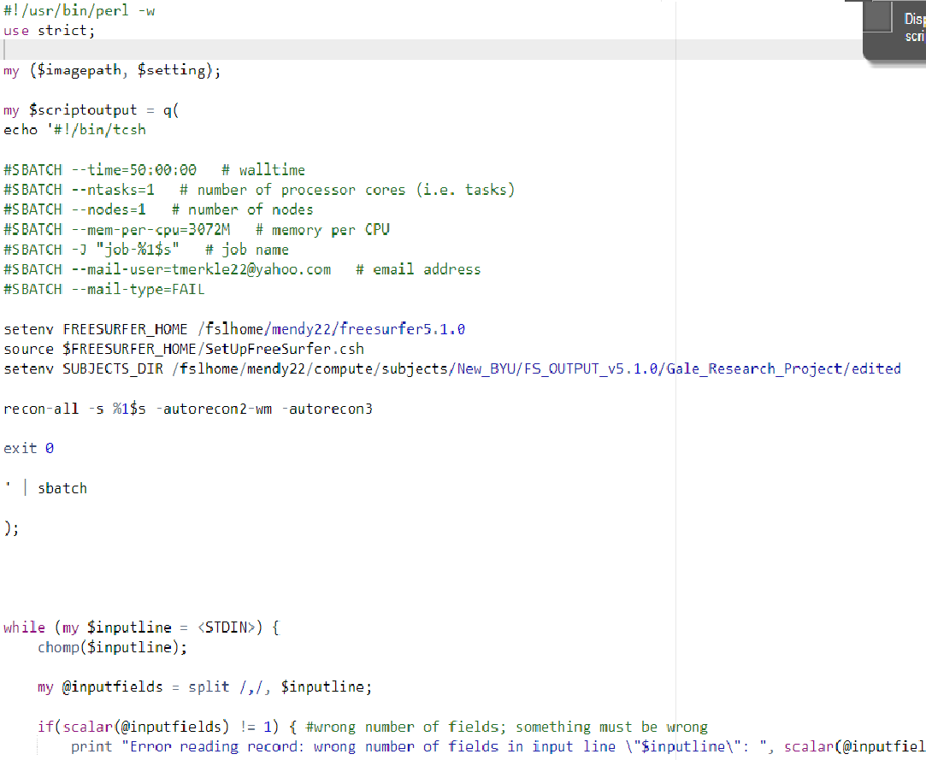The only things you will ever change are the email address, your FREESURFER\_HOME, your SUBJECTS\_DIR, the recon-all command, and the number on the second to last line (i= 1).

Change to your email address. The supercomputer will send you an email if your run fails.

Change to your freeSurfer\_home:

/fslhome/gblack/freeSurfer 🡨 that’s mine

Change to where your data is, or where you want your output data to go. Can be the same place.

Last, change this to a two if you have two input fields (-s and -i). Aka- if you’re running it for the very first time put a 2 here and where the 1 is in the recon-all command line. There is an example on the next page.

Change your recon-all command to match what you’re doing. So you can see this is for rerunning scans after they’ve been edited.

Here’s the second example:

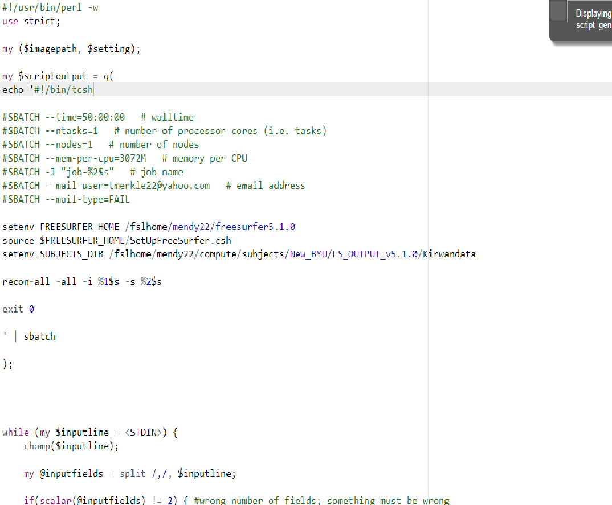

Here is an example of the other script with two inputs. The only things that are different are the numbers in the recon-all command and the !=2 in the last line.

The second file you will need is your “input” file. Create it using the vi command. All it needs to contain is the path to each of the directories, then the directory name separated by a comma (no space).

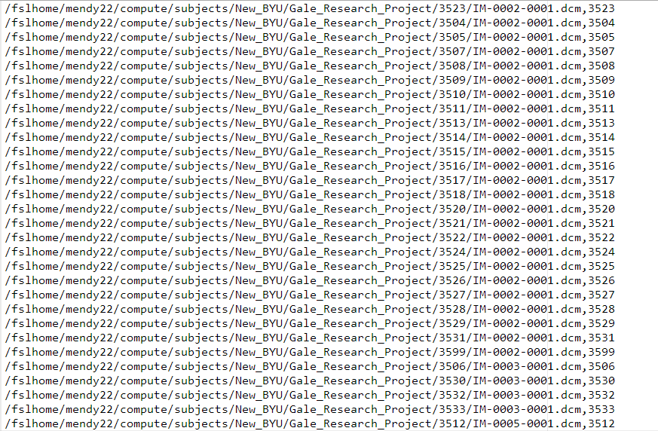

Subjid

Path. This path goes to the first image, and that’s what you do for the first run through recon-all from raw images, but for any time after that simply end the path with the subjid.

* Once you have created these files in your directory you’re ready to go. Simply use the following command to set it off:
  + ./[script\_gen\_file\_name] < [input\_file\_name]
  + Ex: ./script\_gen\_gale\_2014 < BCM3T\_edit2
* If you have errors it will tell you immediately more often than not
* If it launches smoothly then come back about 18-24 hours later and it should be complete to retrieve using sftp and bring back to your local machine