Megan Garfield

V.1  9/30/19

The Storm

**Table of Contents**

Game Overview…………………………………………………………………

Market Analysis………………………………………………………

Player Controls………………………………………………………

Technical Requirements………………………………………………………

Player Experience ………………………………………………………

Game Flowchart………………………………………………………

Game Interface ………………………………………………………

Game Perspectives ………………………………………………………

Player Character ………………………………………………………

Non-Playable Characters ………………………………………………………

Game World ………………………………………………………

Game Resources ………………………………………………………

Scoring ………………………………………………………

Game Style ………………………………………………………

Game Extras ………………………………………………………

**Game Overview**

**Summary**

The Storm gives players a chance to play through one of the biggest and most meme-d events of recent history: the raid of Area 51. Your mission is to free as many aliens as you can and return with not only new friends of another intelligent species, but all the long awaited technology and secrets hidden between the walls of the secret base that is Area 51. However, you must also survive the onslaught of bullets and advanced alien weaponry from the guards that will stop at nothing to protect their “property.” In this top-down, bullet-hell style true-to-history, completely historically accurate survival game, players will get to really see what it was like that fateful day, when Area 51 was finally taken over.

**X-Statement**

The Storm is a zany, unique, funny take on the greatest battle that has ever occurred in human history: like Hotline Miami but set in the Arizona desert, with aliens.

**Main Game Objectives**

* Survive
  + It is primarily a bullet hell game in which players have to dodge and attack guards shooting at them
* Collect
  + The goal is to get as many aliens and as much technology out as possible without dying. Each level will contain a certain amount of each collectible type, and players will need to get a certain percentage of each before being able to progress to the next level.
* Level Up
  + As players collect more and more technology/weaponry and allies (the aliens) they have the ability to level up their character to take on the bigger guards and bosses as the levels progress
* End Game – Dismantle the entire base
  + The end of the game will be a big alien boss that actually works for government to keep all the other aliens locked up. The player has to take this boss down and free everyone, essentially shutting down the entire base to win.

**Market Analysis**

**Target Market**

The target market of this game will be children, teens, and young adults, seeing as they are the demographic that partook the most in the phenomena that became the massive online presence it was. The “raid of Area 51” was heavily meme-d and shared throughout all the major social media spheres such as Twitter, Instagram, Snapchat, and especially Facebook since that is where it originated, specifically among younger generations. It will likely appeal to the young adults and below because of how wildly popular the idea/event became, and many, many of this age demographic hopped on the bandwagon and also made jokes, images, and memes about the topic. They will be familiar with the jokes and terminology used, but also enjoy the playability of it, bringing a crazy, real event where nothing actually happened and that many could not actually attend to life in their own homes, with all the action and hype that surrounded it.

**SWOT Analysis**

Strengths – internal attributes and resources that support a successful outcome

* Funny and engaging dialogue/story line/item descriptions
* Entertaining gameplay
* Good balance of challenge and ease to upgrade

Weaknesses – internal attributes and resources that work against a successful outcome

* Length of the story/time to develop
* Pacing

Opportunities – external factors that the entity can capitalize on or use to its advantage

* The cultural hype surrounding the Area 51 raid
* The tendency for people to hop on bandwagons and enjoy many different versions of one joke/jokes about one thing

Threats – external factors that could jeopardize the entity’s success

* The time frame in which the game is released; the event has come and gone and attention spans don’t last long, by the time the development has been completed, it may be long gone from many’s memories.

**Unique Selling Point**

One of the most unique selling points of this game is that it capitalizes on such a huge part of popular culture and adapting it into a playable game. The story is funny and compelling in a way that uses the short attention spans of many younger people as well as the tendency to attach themselves to larger jokes for fun and community.

**Player Controls/Technical Requirements**

**Controls**

Keyboard

* WASD or arrow keys to move
* SPACEBAR for shoot
* Z for power up use
* M for character upgrade Menu

**Technical Requirements**

There are no specific technical requirements other than a laptop with a keyboard. It should be readily accessible to a wide range of people.

**Game Outline**

**Player Experience**

The player experience will be a top-down view of the layout of the building/room they are in, with all of the guards in the area attacking. The player tries to release as many aliens as they can, and each alien has its own backstory and ally buffs for the player that they can utilize to progress further. Each collectible will also have a funny/interesting backstory or ability for the player to use or enjoy reading about, all based on the large amount of memes that came out of the event.

**Game Levels**

The game progresses linearly from level to level, between 20-30 levels initially, ending in an alien boss. Each level is short, but gets harder with better items and allies to unlock. There are a specified number and type of guards in each level, again increasing in numbers and strength as levels go along.

Mini-boss 1: Level 10. A very large guard with a lot of health that uses an alien weapon to spawn smaller guards around him continuously. Must kill main guard and any minion guards that survive past killing the main one.

Mini-boss 2: Level 20. Alien that has been brainwashed into fighting the player. Player must either destroy the mind control device or kill the alien. If they save it, it will be a powerful ally later on, if they kill it they do not get this bonus.

Final boss: Level 30. A huge alien that has been working for the government to keep all the other aliens in captivity, major health bar, and has many abilities to attack, such as a cage to keep the player in place for a few seconds if it can trap them, or different strengths of weapons.

**Game Flowchart**

??

**Game Interface**

Walls/Obstacles

Collectible

Enemies

Alien

Cage

Player

Mini Map

The game interface will consist of the player in a top down view, with only a portion of the level visible on the main camera. There will be a mini map in the corner displaying a larger portion of the level and where each item, alien, obstacle, and guard is located at the moment. Cages will need either need keys or passcodes to unlock, or the player can attempt to pick the lock in a mini game.

**Game Perspectives**

The game perspective will be top-down the whole way through, except specific story points in which things needs to be explained. Then there will be cut scenes or characters appearing on screen in a sort of visual novel type sequence.

**Player Character**

* Skills
  + Ability to shoot (increases with better weapons)
  + Run/Sprint
  + Lock pick ability for releasing aliens
  + Melee (increases with better weapons)
* Combat
  + Shoot a gun/throw projectiles
  + Melee at close range
* Bonuses/Power Ups
  + Increased strength
  + Better Weapon
  + Better Armor
  + Longer Sprint
  + Unlockable Allies

**Non-Player Characters**

* Enemies
  + Guards
    - Weak – Early Levels, Pre mini boss 1
    - Medium – Middle Levels, between mini boss 1 and 2
    - Strong – End Game, between mini boss 1 and the big boss
  + Minion Aliens
    - Interspersed between all levels, ability to save them rather than kill them
* Bosses
  + Mini Boss 1
    - Level 10
    - A very large guard with a lot of health that uses an alien weapon to spawn smaller guards around him continuously
    - Must kill main guard and any minion guards that survive past killing the main one.
  + Mini Boss 2
    - Level 20
    - Alien that has been brainwashed into fighting the player. Player must either destroy the mind control device or kill the alien.
    - If they save it, it will be a powerful ally later on, if they kill it they do not get this bonus.
  + End Boss
    - Level 30
    - A huge alien that has been working for the government to keep all the other aliens in captivity, major health bar, and has many abilities to attack
      * cage to keep the player in place for a few seconds if it can trap them
      * different strengths of weapons.
* Allies
  + Aliens that are unlocked throughout the game
  + 20-25 aliens to potentially save
  + Backstories particular to each alien
  + Abilities unique to each alien the player can use
  + Can only ask up to 3 to help at a time, the rest are released (cannot get them back)

**Game World**

The base of Area 51 is the setting of this story. Higher levels mean the player is descending deeper into the lower floors of the base, causing them to look darker and more severe. All industrial/futuristic looking with many silvers and metal looking textures. Players must free a certain percentage of aliens in a level and then find the stairs hidden somewhere in 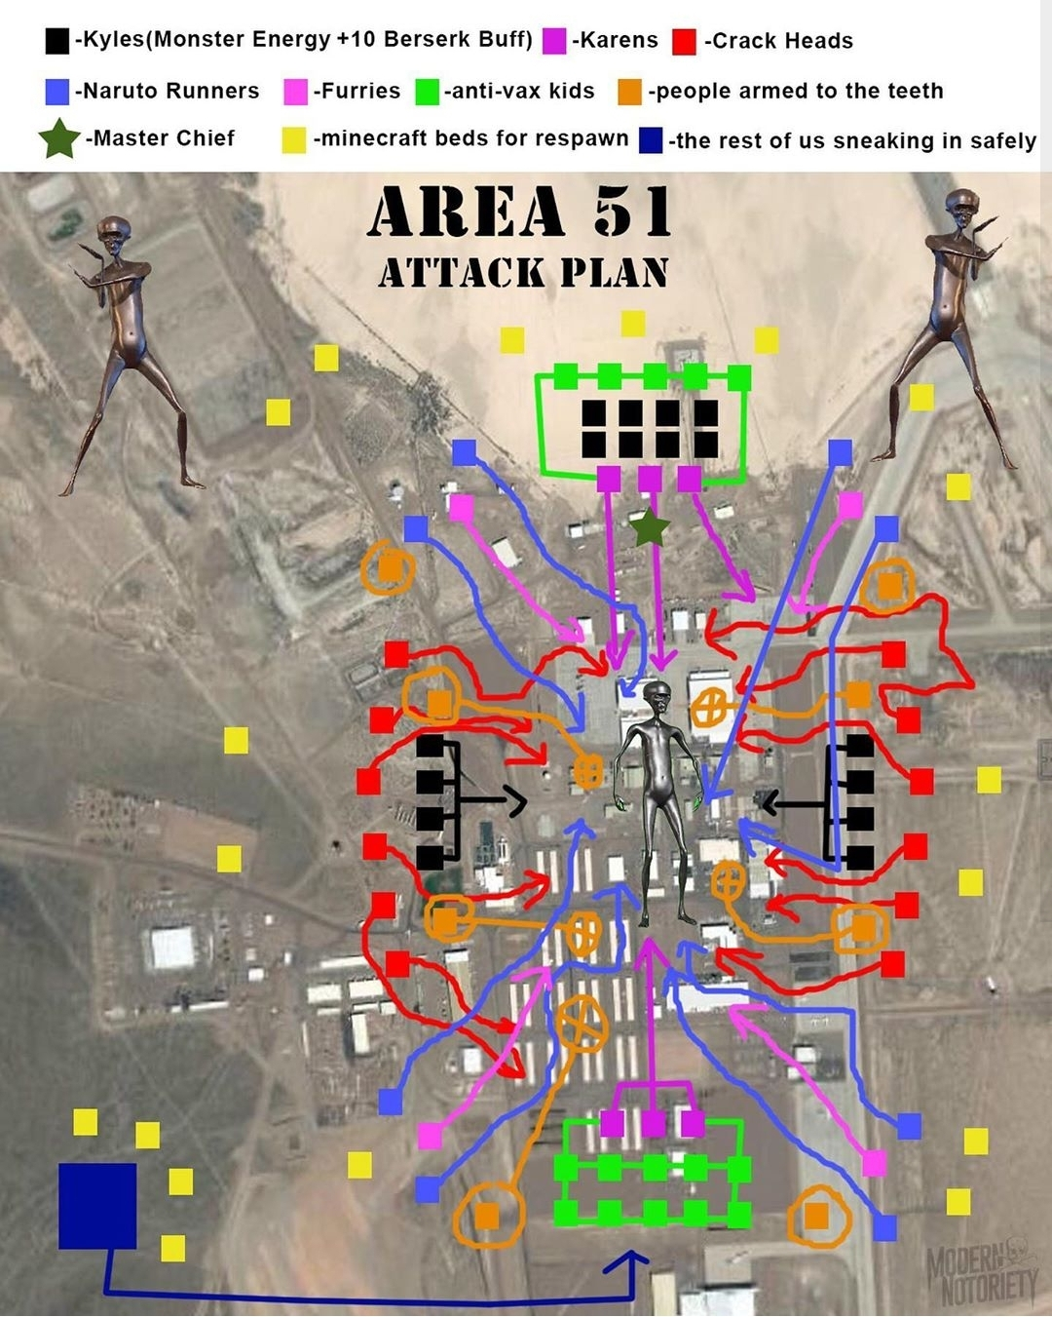the level to progress to the next level.

Starting level will be laid out somewhat like this and early levels may progress from building to building rather than down, but once the player hits level 8 they will definitely be progressing downwards.

**Game Resources**

There will be a health bottom and inventory system at the bottom of the screen, similar to Minecraft’s inventory system. The player may also pull up a more detailed inventory (pausing the game) with descriptions of each item and ally they have collected.

**Scoring**

Scoring will be based on time and collectibles. Each level will be rated a score of 1-3 alien ships based on the following criteria: aliens saved, items collected, time taken, and guards killed. There will be save checkpoints after every level, so there is no need to replay levels unless the player wants to go back and find every collectible and ally they can unlock.

**Game Style**

The game artwork will be simplistic 16-bit style similar to Stardew Valley with cut scenes being higher quality images and pictures. The music will be grainy, sci-fi-esque loops to fit with the theme of the game.

**Story Board**

You are simply another person that decided to respond to the Area 51 Facebook event. However, getting into the base was a lot easier than you expected. As you walk up, you realize there is carnage everywhere. You showed up a day too late! They weren’t expecting anyone to come today, and they weren’t prepared.

Scene 00 – Tutorial, Pick up weapons from dead guards, setting: outside walking up to the base

Scene 01 – Inside the Hangar, Planes/Jets around, crates/boxes, no aliens in this level, this is the cover story for the base

Scenes 02-04 – Aliens to unlock, low level guards that walk in set patterns until player is seen, many different rooms connected (Binding of Isaac style)

Scene 05 – Big Boss 1, Essentially a “Chad,” uses a cloning gun to spawn smaller guards that attack you.

Weaknesses: Legs (he skips leg day), hair (takes time to adjust)

Powers: smolder – pauses player for ~1 sec, clone, no attack power (clones do all the attacking, he’s actually a wimp that hides behind others despite appearances)

Scenes 06-09 – Same as 02-04 but with higher level guards

Scene 10 – Big Boss 2, Marvin the Martian is brainwashed by his helmet to attack you

Powers: death ray (big damage but slow), black hole underneath player making them fall through the ceiling and back on the floor

Weaknesses: Achilles heel

Two ways to win:

-take out mind control helmet (headshots) meaning you get him on your side

-kill him (body shots)

Scenes 11-14 – same as 06-09 and 02-04 but harder guards, better equipment and weapons

Scene 15 – Final Boss, Invader Zim and Gir, potentially multiple endings with whether you join or fight him

Powers: mind control the player (inputs random controls for ~1-2 seconds or reverses past inputs), Gir transforms into different forms for phases

Stages: 1) fight gir in different forms

2) Zim aggros because you killed Gir