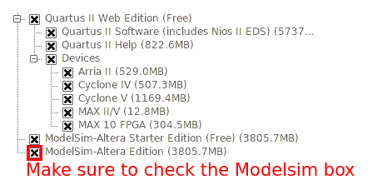
Lab 4 Part I – A Logic Processor in Systemverilog

Welcome to the Quartus and Systemverilog tutorial. In this tutorial you will re-create the serial logic processor from lab 3 using a hardware description language instead of manually placing and connecting TTL chips on a breadboard. Although you will be writing code to describe your hardware, it is absolutely critical to understand that you are making real hardware, not just simulating it. When you declare gates and registers in your code, you are instantiating real, physical, components inside your FPGA and forming real connections between them. (Actually, your FPGA already has the components inside it, and it would be more accurate to say your code “enables them” rather than “creates them” although silicon compilers do exist which actually create gates from blank silicon).

Quartus Instillation:

You can use Quartus on the EWS computers (both Windows and Linux) or install it on your own machine for free. For Windows EWS machines, Quartus can be found in the start menu if it is installed. On Linux machines, you need to first load the “Altera” module before running Quartus from a terminal. TODO – Verify EWS launch steps on both Windows and Linux

module load Altera
quartus

To install Quartus on your own machine, download the install files from the Altera website. You will need to register with Altera to access the download, which is over 4GB in size.

https://dl.altera.com/15.0/?edition=web

For Linux users, Extract the download contents and run the install script. You do NOT need sudo privileges if you install to your home directory (default). The script will open an “install wizard” style screen.

tar -xf Quartus-web-15.0.0.145-linux.tar
./setup.sh

If you installed to the default directory, you can now launch Quartus with the following command:

~/altera/15.0/quartus/bin/quartus

TODO – Windows install instructions.

During the install, make sure you check the “ModelSim-Altera Edition” box.

TODO – verify that the USB blaster driver is installed

Creating a New Project in Quartus

Part 1 of this lab is organized as a tutorial to help you get familiar with Quartus and the Systemverilog language by implementing the “logic processor” of lab 3. Begin by launching Quartus then clicking:

File → New Project Wizard

Note that this is NOT the same as the “New File” button. You will almost always create a project first and add files later. You will be prompted to specify a working directory for the project. You should be careful where you save your project, as following “bad practices” can lead to mysterious errors when moving to another machine, especially for labs 7, 8, and 9.

- If you are working on an EWS machine, save your project to a new (empty) directory on a flash drive FIRST. Don’t save it and move it later.
- Don’t save to the U:/ drive or the desktop on the EWS machines. Both the U:/ drive and your EWS desktop are network locations and will cause your compile times to be very long (hours). Save to a flash drive.
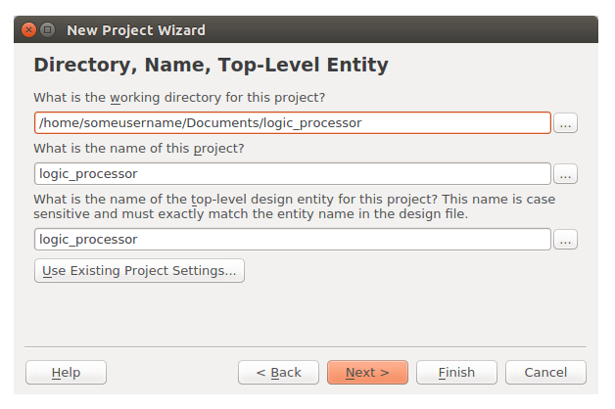
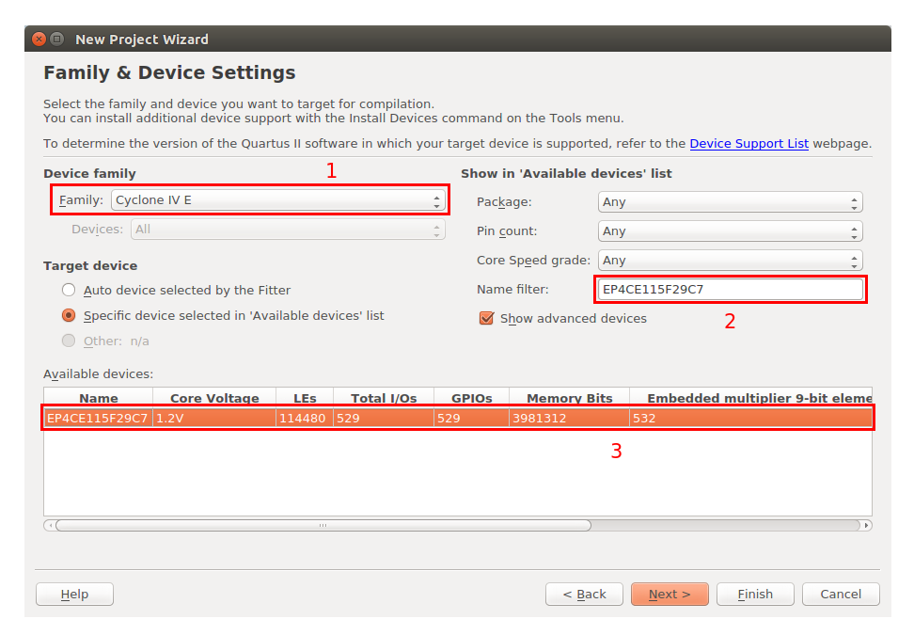
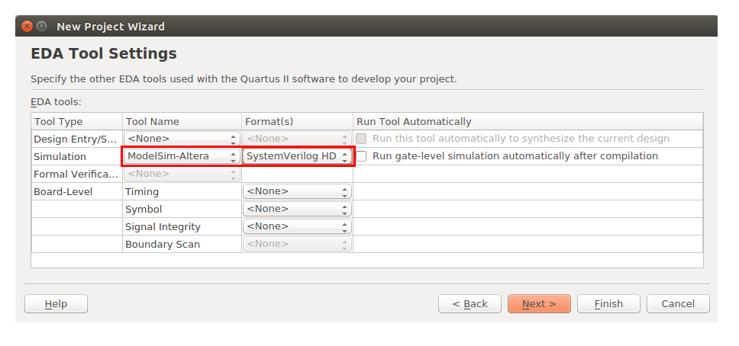
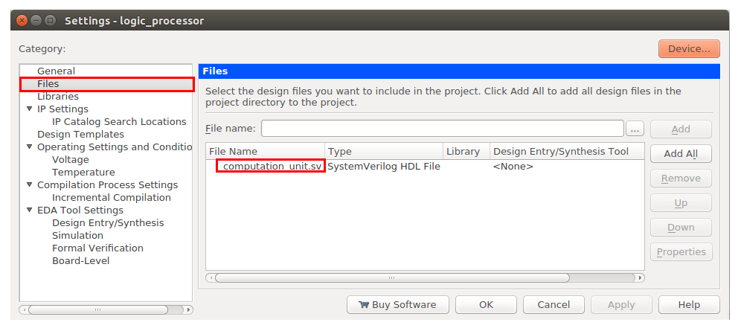
- If you chose to install Quartus on your own machine, you should keep the files there and demo from your machine. You do not need to copy them to the lab machine if it already works.
- If you want to restart a lab or re-use code from a previous lab, create a new project from scratch in a new (empty directory) and COPY any .sv files you want to re-use into that new directory and use the . Do NOT include the files from another directory.

Click “Next” and you will see the “Project Type” page of the wizard. Select “Empty Project”.

Click “Next” and you will see the “Add Files” page of the wizard. Since this is a new lab, you will just click “Next” without adding any files. Adding files through this page has exactly the same effect as adding the files later through the “Project → Add/Remove Files in Project” window.

Click “Next” and you will see the “Family and Device Settings” menu of the wizard. Make sure the “Cyclone IV E” is selected from the “Family” drop-down menu then select “EP4CE115F29C7” from the “Available devices” list.

Click “Next” and you will see the “EDA Tool Settings” menu of the wizard. In the “Simulation” row, make sure that “ModelSim-Altera” and “SystemVerilog HDL” are selected.

You can now click “Finish”, or click “Next” to view a final summary screen.

Creating the Function Unit

In Systemverilog, you will create “modules” which contain arbitrary combinational logic and/or register structures. Additionally, modules can connect to or be nested in other modules. You will begin by creating a module for the “function unit” of the logic processor. To create the module, select “File → New” then choose the “Systemverilog HDL File” option. Note that the file won’t be saved or added to the project until you type something into it and select “File → Save” . Make sure that you save this file in the same directory as your project. You should also verify that the file was added to the project by checking for its existence on the “Project → Add/Remove Files in Project” window. Note that “saving a file” is not the same as “adding a file to the project”.
Once you have created “function_unit.sv” and added it to the project, write the following code in the file:

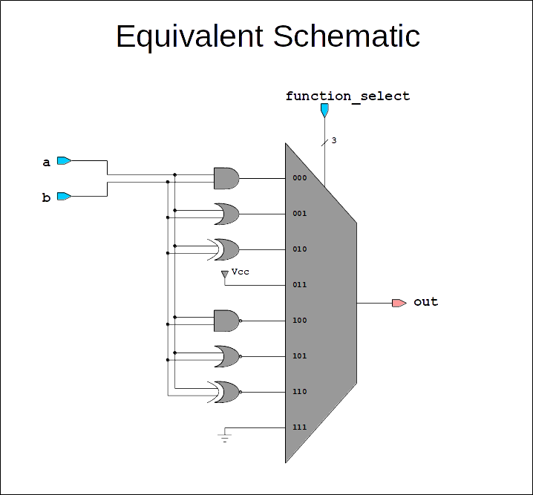
Please note that the above code represents a piece of hardware, and NOT a sequence of instructions. After synthesis, Quartus will produce a price of hardware logically equivalent to the schematic given with the code. Let’s now examine some specific parts of the code:
// Declare a module with the name 'function_unit'
module function_unit
(
// Specify input and output "pins" for this module
input logic[2:0] function_select,
input logic a,
input logic b,
output logic out
);

// All combinational logic must be declared inside an always_comb block
// or an assign statement
always_comb begin

// Create a 1-bit 8-to-1 multiplexer that switches
// between the outputs of various logic operations.
case (function_select)
// Condition: Action
3'b000: out = a & b;
3'b001: out = a | b;
3'b010: out = a ^ b;
3'b011: out = 1'b1;
3'b100: out = ~(a & b);
3'b101: out = ~(a | b);
3'b110: out = ~(a ^ b);
3'b111: out = 1'b0;
endcase

end

endmodule

This is similar to a class declaration in other languages. The “module” keyword is always followed by a name for the module (similar to a class name in other languages) and a list of I/O pins. Like a class, the code in the module declaration is a template, which becomes real hardware when it is instantiated somewhere else. Later, you will instantiate one copy of the function unit in your top-level module. It is a good practice to name your module the same as your file and to only include one module per file. Some Systemverilog parsers, such as the one used by Modelsim, are known to fail when a file contains multiple module declarations.
module function_unit
(
// Specify input and output "pins" for this module
input logic[2:0] function_select,
input logic a,
input logic b,
output logic out
);
...
endmodule
input
logic
[2:0]
function_select
Name
Direction
Datatype
Dimensions

A module declaration also contains a list of pins, separated by commas, which will become the visible interface that external hardware sees when instantiating this module. It is a good practice to explicitly write out “input” or “output” as well as “logic” before each pin, even though there are rules for inferring the datatype implicitly. There are more advanced variations of pin declarations, such as including a dimension before the “logic” datatype to represent ROMs or RAMs. You can also use other datatypes in place of “logic”, such as enumerated datatypes, structs, “wire”, or “reg”. Note that “wire” and “reg” are somewhat archaic datatypes carried over from the original Verilog language, and you should consider never using them at all, since the “logic” datatype can do everything that “wire” and “reg” can do with less confusion.

Before you implement any hardware (code), the synthesizer needs to know if you want to create registers on your logic outputs and be made aware of any clock signals. Since the function unit is purely combinational (no registers or clocks), you will create an “always_comb” block. Other types of blocks are “always_ff” and “always_latch”. Technically, there is also a generic “always” block carried over from the original Verilog language, but it is considered by some to be a bad practice, as it will suppress certain warnings and sanity checks such as accidentally creating combinational loops. The “begin” and “end” statements are nearly 1-to-1 equivalent to “{“ and “}” in C++. They are used to wrap certain multi-line blocks of code such as always blocks, multi-line “if” statements, and multi-line “for” statements. It is not clear why they are not also used to signify the beginning and ending of other constructs such as modules and case statements, so it may take time to learn where they are needed.
always_comb begin
...
end

This is perhaps the most deceptive piece of code you’ve seen so far, because it looks like a case statement from C++ and at first appears to do a similar function. However, it is important to once again emphasize that this code represents a MUX and a few gates, not a sequence of instructions. At every moment in time, your circuit is continuously evaluating a & b, a | b, a ^ b, and all the other operations in every part of your project in parallel even though only one of the operations will have its result propagated to the output signal. There is no “program counter” that “skips” operations that aren’t used like in C++.
// Create a 1-bit 8-to-1 multiplexer that switches
// between the outputs of various logic operations.
case (function_select)
// Condition: Action
3'b000: out = a & b;
3'b001: out = a | b;
3'b010: out = a ^ b;
3'b011: out = 1'b1;
3'b100: out = ~(a & b);
3'b101: out = ~(a | b);
3'b110: out = ~(a ^ b);
3'b111: out = 1'b0;
endcase
3
b
Bit-Width
Radix
'
b
111
Value
Binary
Radix Options
o
Octal
d
Decimal
h
Hex

The conditions in case statements are always constant values or the “default” keyword. You will need to use if-else statements if you need more dynamic control. Additionally, you will need to use “begin” and “end” statements for each case that spans multiple lines (more than 1 semicolon). The value before the tick ' is always written in decimal and represents the bit-width of your constant, 3 bits in this case. The character after the tick represents the radix of that constant, and can be any of “b” (binary), “o” (octal), “d” (decimal), or “h” (hex). The string after the radix character is the value of your constant. Note that it doesn’t matter what radix you use to write out your constant, it will always be synthesized down to one or more binary signals. The radix exists as a convenience for the programmer.

Make sure that you save your code to “function_unit.sv” before moving on to the next module.
Creating the Register Unit

The function unit was purely combinational, now you will create a module that contains registers. Create a new SystemVerilog file , add it to the project, copy the code below into the file, and save the file as “register_unit.sv”. The equivalent schematic can be found on the next page.
module register_unit
(
// Rising edge triggered clock
input logic clk,

// Clears registers to 0 if reset is high during a rising clock edge
input logic reset,

// Set to high to enable 1-bit right shifts each clock cycle for both registers a and b.
input logic shift_enable,

// Set to high to load data from parallel inputs. Has priority over shift_enable.
input logic a_load_enable,
input logic b_load_enable,

// Serial data inputs - Feedback from the routing unit
input logic a_serial_in,
input logic b_serial_in,

// Parallel data inputs - From switches
input logic[3:0] a_parallel_in,
input logic[3:0] b_parallel_in,

// Serial data outputs - Sent to the computation unit
output logic a_serial_out,
output logic b_serial_out,

// Parallel data outputs - For viewing on the hex displays
output logic[3:0] a_parallel_out,
output logic[3:0] b_parallel_out
);

// Declare internal storage for this module
logic[3:0] a_storage;
logic[3:0] b_storage;

// Compute the next-state of registers a_storage and b_storage at each rising clock edge
always_ff @(posedge clk)
begin

if (reset)
// Synchronous reset
a_storage <= 4'h0;
else if (shift_enable)
a_storage <= {a_serial_in, a_storage[3:1]};
else if (a_load_enable)
a_storage <= a_parallel_in;

// Prioritized behavior of B register. This if-else chain is independent of the one for
// A above and operates in parallel with it (both registers update in the same clock cycle)
if (reset)
b_storage <= 4'h0;
else if (shift_enable)
b_storage <= {b_serial_in, b_storage[3:1]};
else if (b_load_enable)
b_storage <= b_parallel_in;

end

// Each 'assign' statement is basically shorthand for a 1-line always_comb block.
assign a_serial_out = a_storage[0];
assign b_serial_out = b_storage[0];
assign a_parallel_out = a_storage;
assign b_parallel_out = b_storage;

endmodule
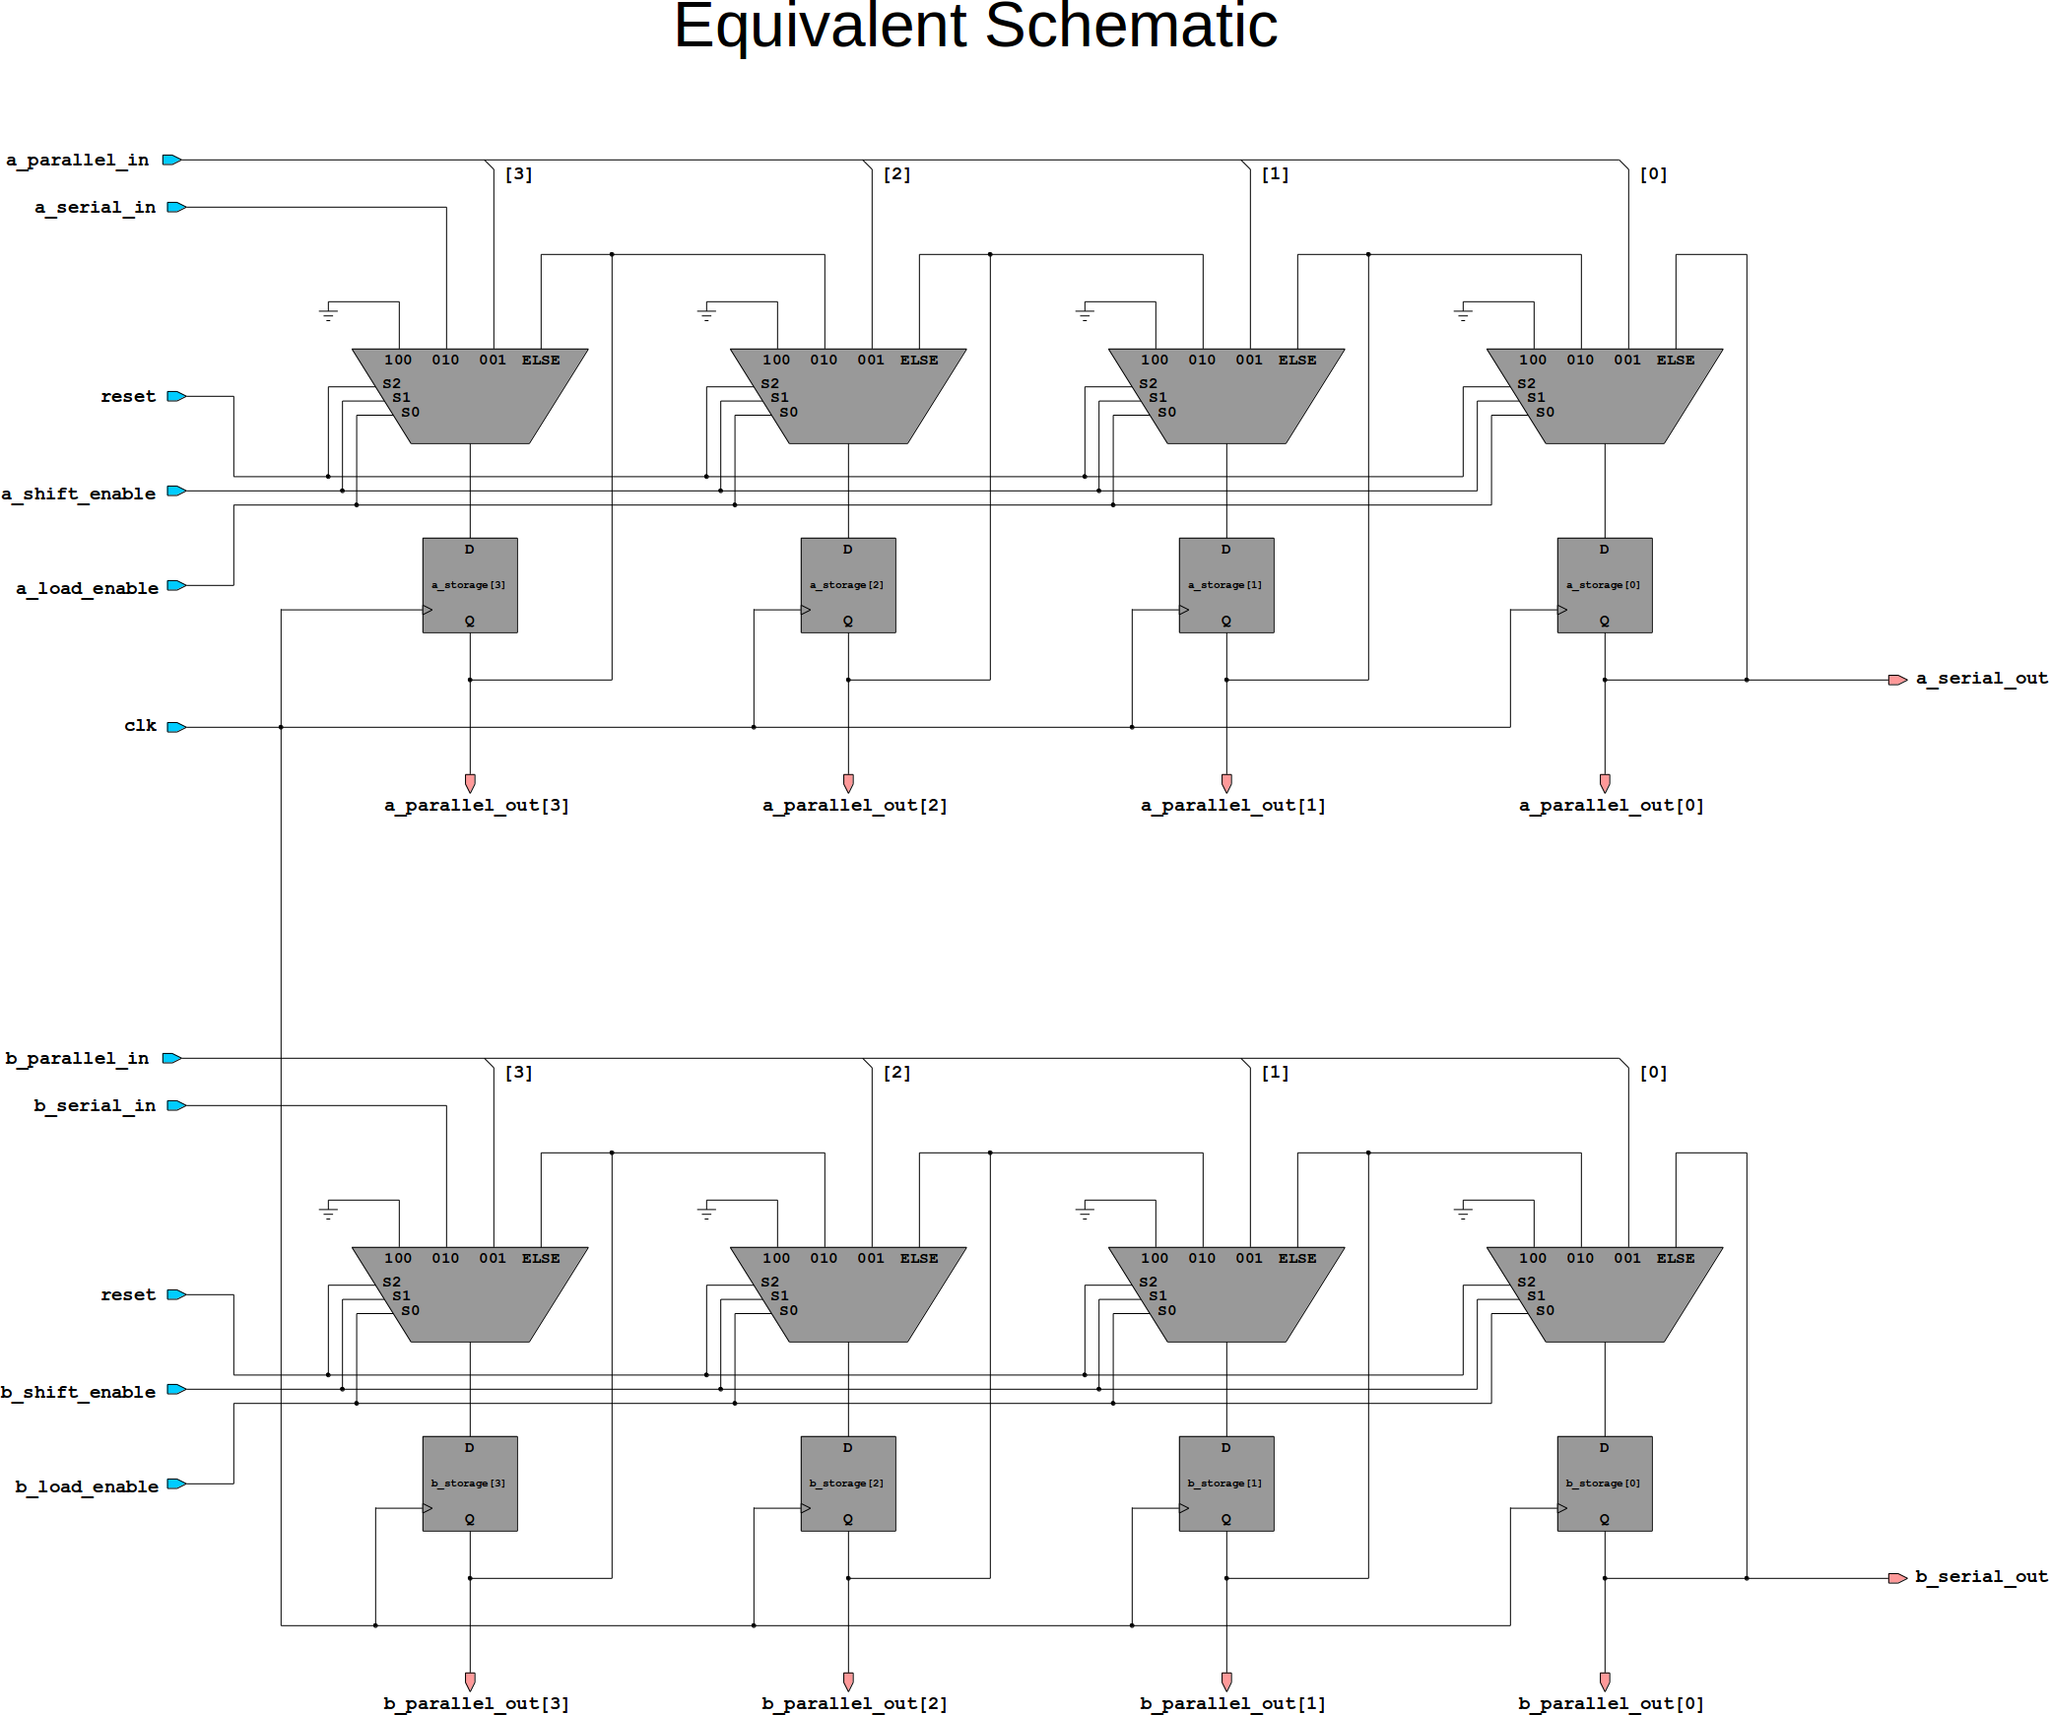
Let’s examine some of the new constructs in the register unit that may be unfamiliar, starting with the “always_ff” block. The “@(posedge clk)” instructs the synthesizer to attach a flip flop to all “logic” signals assigned within that block. Note that it is also possible to create flip flops for other datatypes such as structs and enums in the same way. Each line in this “always_ff” block (delimited by semicolons ; ) is evaluated in parallel, using the value that each input held just before the active clock edge. This is different than the behavior of the “always_comb” block of the function unit, where dependencies between assignments within an “always_comb” block where honored immediately.
always_ff @(posedge clk)
begin
...
end

At this point, you may have noticed that the “always_comb” block of the function unit used “=” while the “always_ff” block of the register unit used “<=”. This is not a typo, and is perhaps one of the more confusing aspects of SystemVerilog that will be on every hardware interview and every SystemVerilog exam you take. The “=” is called a “blocking assignment” because it waits for dependencies between assignments. For example, suppose some code assigns a value to some signal x on line 142 and signal y is computed using x as an input on line 169, the new value of x will be propagated through as fast as the logic can operate and affect signal y immediately. Conversely, “<=” is referred to as a “non-blocking” assignment because it assumes that there are no combinational dependencies between different assignments. The final moral of the story is:
always_comb
always_ff
<=
=
Blocking
Non Blocking
Where to use each assignment type

Always use “=” for “always_comb” and always use “<=” for “always_ff”.

Following the above convention will save you from a lot of mysterious problems, as failing to do so is perhaps the most common reason why a circuit will behave differently in Modelsim than on the real FPGA board. Technically, the SystemVerilog language allows you to use either type of assignment in any type of block, but there’s really no reason to do so. As a final note, the names “blocking” and “non blocking” may seem reversed, since the behavior of a typical “always_ff” is to “block” until a clock edge, yet you use “non blocking <=” assignments. You should think of “blocking” as “blocking all dependents until all previous lines have stabilized” and NOT “blocking until a clock edge”. If this is confusing, don’t worry too much. All you really need to know is the use the right type of assignment for “always_comb” and “always_ff” blocks.

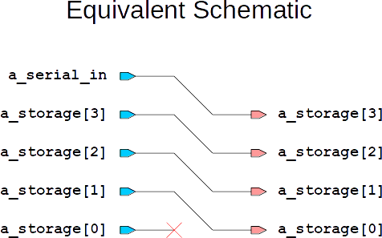
Here’s another useful line which represents a right logical shift by one bit position. The [3:1] operation is similar to a slice operation in Python, except that the larger index is typically on the left. Technically, the real index ordering requirement is to match the ordering of the signal declaration “logic[3:0]”. Another difference is that both the upper and lower bits are outputted from the slice (Python does not include the last element in a slice operation, but SystemVerilog does).
a_storage <= {a_serial_in, a_storage[3:1]};

The “{ … }” represents a concatenation operation. All input signals within the curly braces are separated by commas and are joined to form a new signal, with the leftmost signal in the list becoming the most significant bit(s) in the new signal. By looking at the equivalent schematic for the bit shift operation, you may notice that it only contains wires. Bit-slicing, bit shifting by a constant amount, and concatenation are almost always free, in that they don’t usually cost any extra hardware (gates or registers) to implement.

Assign statements are basically just one-line “always_comb” blocks. It would have perfectly acceptable to wrap the last 4 lines of the register_unit in an always_comb block, so which option you choose is mostly a stylistic decision. Since “assign” statements are combinational, you should use blocking “=” assignments with them.
assign b_parallel_out = b_storage;

The novelty of these signal declarations isn’t the declaration itself, but where the signals are defined. If you look at the whole code above, you’ll notice that these signals were declared outside of the port list. As you may expect, these are local/internal signals to the module which normally aren’t accessed from the outside. Weather these signals become flip-flops or intermediate combinational results depends on what type of always block updates them. Note that it would also be acceptable to read and write directly to “a_parallel_out” and “b_parallel_out” directly, making them both the storage registers and output signals, but this would have been too confusing for an introductory tutorial.
// Declare internal storage for this module
logic[3:0] a_storage;
logic[3:0] b_storage;
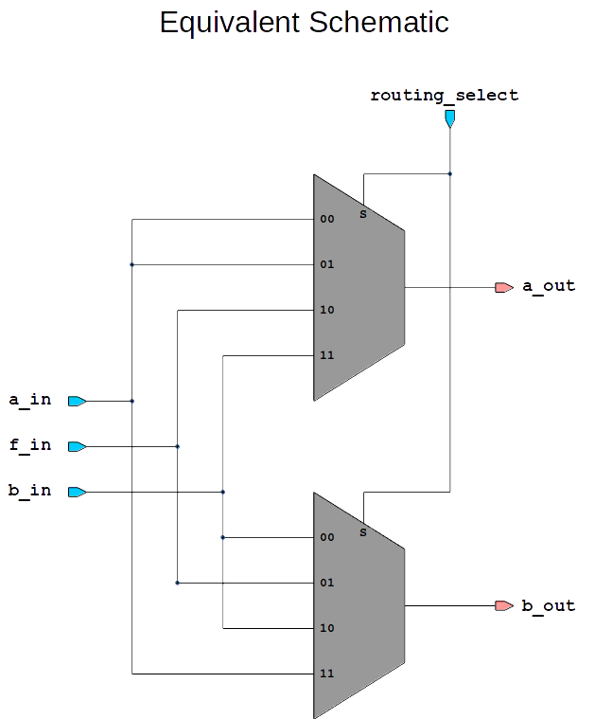
Creating the Routing Unit

Make sure to save “register_unit.sv” before moving on. Create a new SystemVerilog file , copy the following code into the file, save the file as “routing_unit.sv”, and add the file to the project.
module routing_unit
(
input logic[1:0] routing_select,
input logic a_in,
input logic b_in,
input logic f_in,
output logic a_out,
output logic b_out
);

always_comb
begin

// Create a 2-bit 4-to-1 MUX with
// a_in, b_in, and f_in as data inputs and
// a_out and b_out as outputs
case (routing_select)
2'b00: begin
a_out = a_in;
b_out = b_in;
end
2'b01: begin
a_out = a_in;
b_out = f_in;
end
2'b10: begin
a_out = f_in;
b_out = b_in;
end
2'b11: begin
a_out = b_in;
b_out = a_in;
end
endcase

end

endmodule

There’s nothing new going on here except that each case is now multi-line, and so “begin” and “end” delimiters are necessary.

Creating the Control Unit
package enums;

// List of all possible
// states for the control
// unit.
typedef enum
{
IDLE,
SHIFT_1,
SHIFT_2,
SHIFT_3,
HOLDING
} state_t;

endpackage

Building state machines can either be really easy or really hard. The easy way, which uses a custom enumerated datatype for the state is demonstrated below. You will create two files for the control unit: “enums.sv” and “control_unit.sv”. Copy the short package definition into the “enums.sv”, save it, and add it to the project. TODO – You left off here. Finish writing a description of the control unit and try to create an equivalent schematic.

// The only reason why this enum is packaged in another file is so it can
// also be read from testbench.sv. In most cases, you can just declare
// your state enum in the same file as your state machine without a package.
import enums::state;

module control_unit
(
input logic clk,
input logic reset,
input logic execute,
output logic shift_enable
);

// Declare a register which holds the current state.
enums::state cur_state;

// Transition function for the state machine
// Based on the current state, reset, and execute
// inputs, the next state is calculated and updated
// once every rising clock edge
always_ff @(posedge clk)
begin

// 'begin' and 'end' statements are almost exactly equivalent
// to '{' and '}' in C++. They denote multi-line blocks of
// code within if statements, case statements, and always blocks.
// Note that there is only one line of code for each if-statement
// below, so the usual begin-end 'brackets' were omitted for
// style purposes.
if (reset)
cur_state <= enums::IDLE;
else if (cur_state == enums::IDLE && execute)
// Above: 'state == IDLE' refers to the value of the state register
// just before a clock edge. When a register is read within an
// always_ff block (more precisly, in a block containing <=
// assignments), it referrs to the value of that register just
// before the clock edge.
// Below: 'state <= SHIFT_1' refers to a value that is written
// to a register right after the rising clock edge.
cur_state <= enums::SHIFT_1;
else if (cur_state == enums::SHIFT_1)
cur_state <= enums::SHIFT_2;
else if (cur_state == enums::SHIFT_2)
cur_state <= enums::SHIFT_3;
else if (cur_state == enums::SHIFT_3 && execute)
// Recall that we do not want to begin another cycle until
// the 'execute' switch has been returned to the off
// position.
cur_state <= enums::HOLDING;
else if (cur_state == enums::SHIFT_3 && !execute)
// In this case, the user has returned the 'execute' switch
// to the off position in the middle of a computation and
// the processer can be immediatly primed for another operation.
cur_state <= enums::IDLE;
else if (cur_state == enums::HOLDING && !execute)
cur_state <= enums::IDLE;

// In any other case (else), the 'state' register will maintain
// its previous value. You do not need to cover every case
// in an 'always_ff' block but you do for an 'always_comb' block.

end

// Output function of the state machine. Since this is a Mealy machine,
// the output will depend on both the current state and the execute input.
// Note that an 'assign' statement is basically a 1-line always_comb block.
assign shift_enable
= (cur_state == enums::IDLE & execute)
| (cur_state == enums::SHIFT_1)
| (cur_state == enums::SHIFT_2)
| (cur_state == enums::SHIFT_3);

endmodule

This document created Spring 2017 using Quartus 15.0 for Linux and is based on the previous lab 4 manual, and intro to Quartus tutorial.

