# Relational Databases with MySQL Week 4 Coding Assignment

**Points possible:** 70

|  |  |  |
| --- | --- | --- |
| Category | Criteria | % of Grade |
| Functionality | Does the code work? | 25 |
| Organization | Is the code clean and organized? Proper use of white space, syntax, and consistency are utilized. Names and comments are concise and clear. | 25 |
| Creativity | Student solved the problems presented in the assignment using creativity and out of the box thinking. | 25 |
| Completeness | All requirements of the assignment are complete. | 25 |

**Instructions:** Using a text editor of your choice, write the queries that accomplishes the objectives listed below. Take screenshots of the queries and results and paste them in this document where instructed below. Create a new repository on GitHub for this week’s assignments and push this document, with your Java project code, to the repository. Add the URL for this week’s repository to this document where instructed and submit this document to your instructor when complete.

**Coding Steps:**

Write 5 stored procedures for the employees database.

Write a description of what each stored procedure does and how to use it.

Procedures should use constructs you learned about from your research assignment and be more than just queries.

**Screenshots:**

1. **Number_employees_in_dept procedure takes a department number as input and returns the number of employees who have ever been in that department. This could be used for management reports.**

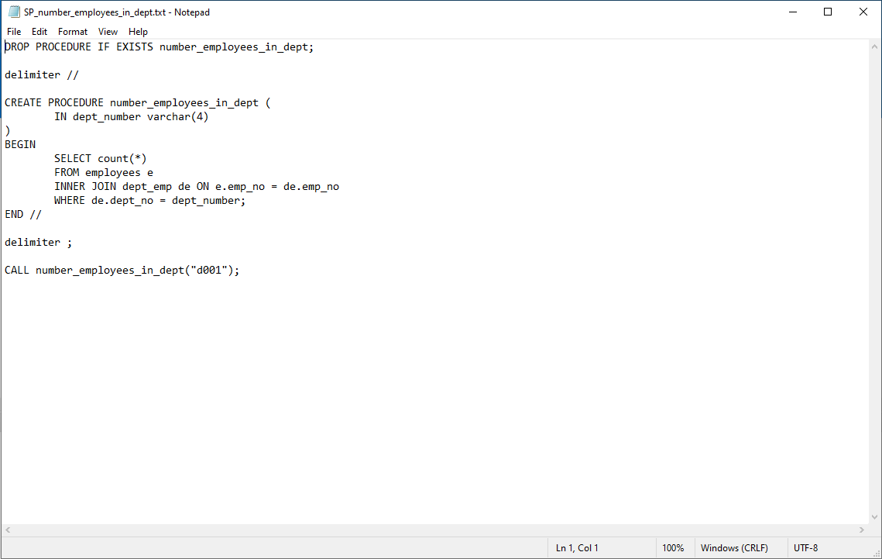

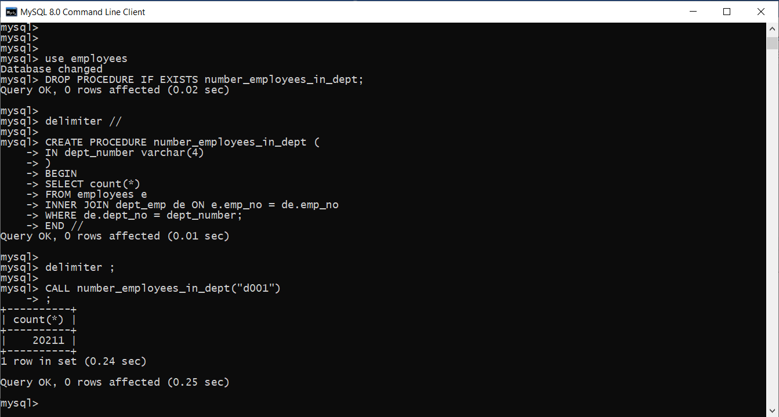

1. **Number_employees_currently_in_dept procedure takes a department number as input and returns the number of employees who are currently in that department. This could be used for any number of reports when a current count is needed. For instance, getting the correct number of gift cards to a manager for their department party.**

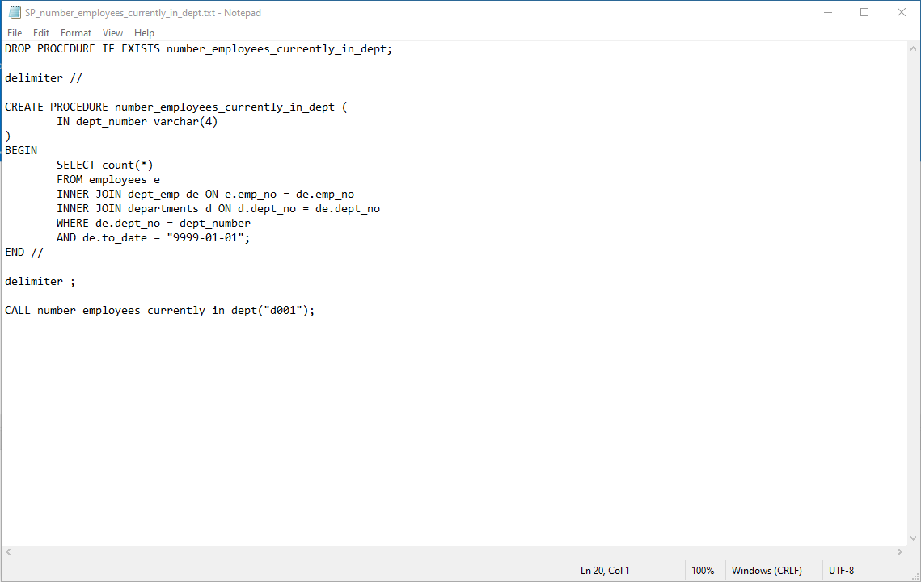

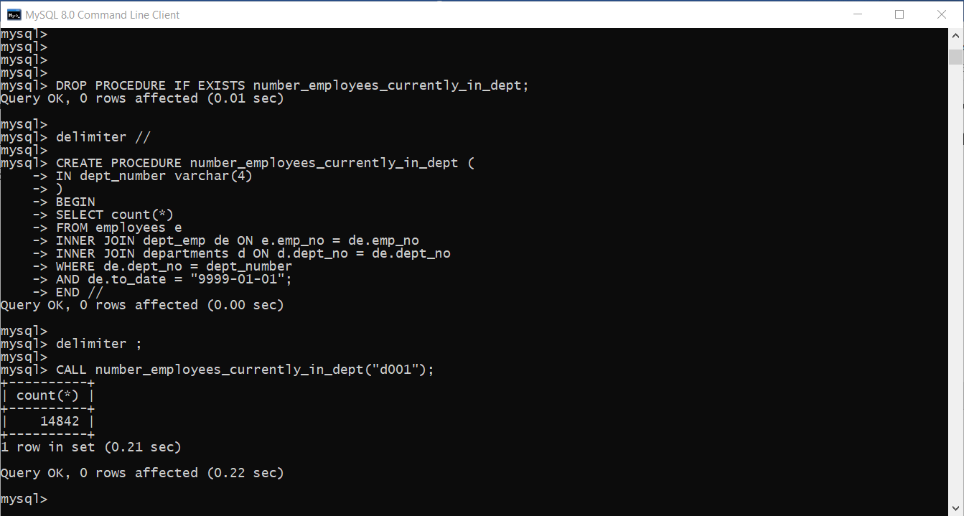

1. **Salary_category procedure takes an employee number and assigns a salary category to a variable based on the value of the current salary. This is used as an intermediary procedure that will be called in the next procedure.**

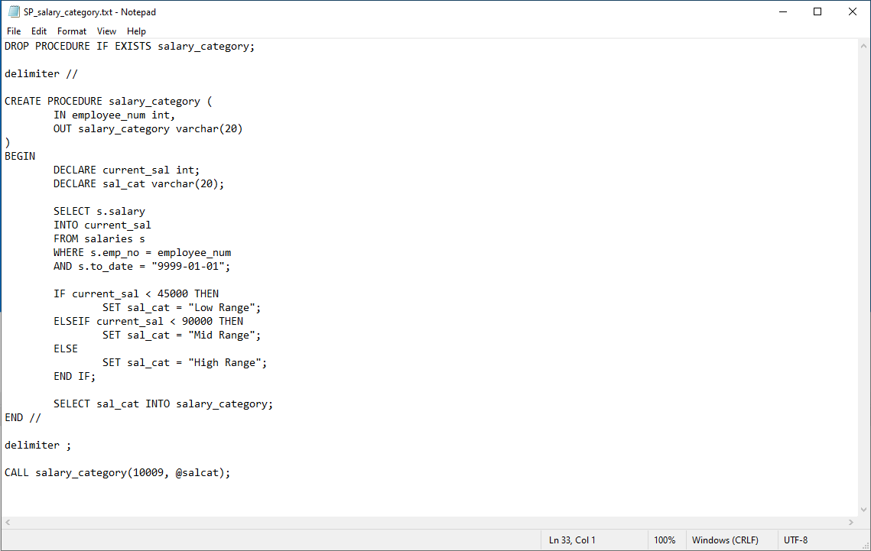

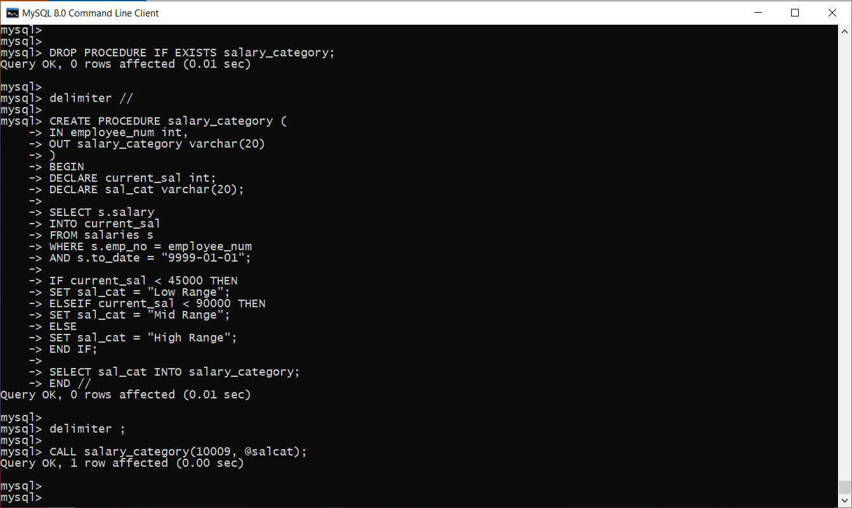

1. **The emp_salary_cat procedure takes an employee number and calls the salary_category procedure to obtain the salary range category, which can then be output. This could be helpful when reviewing an employee for salary adjustment.**

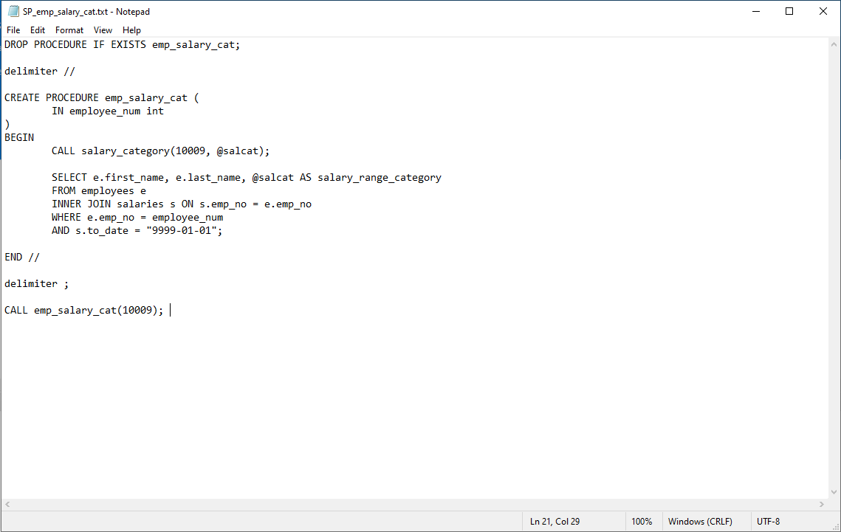

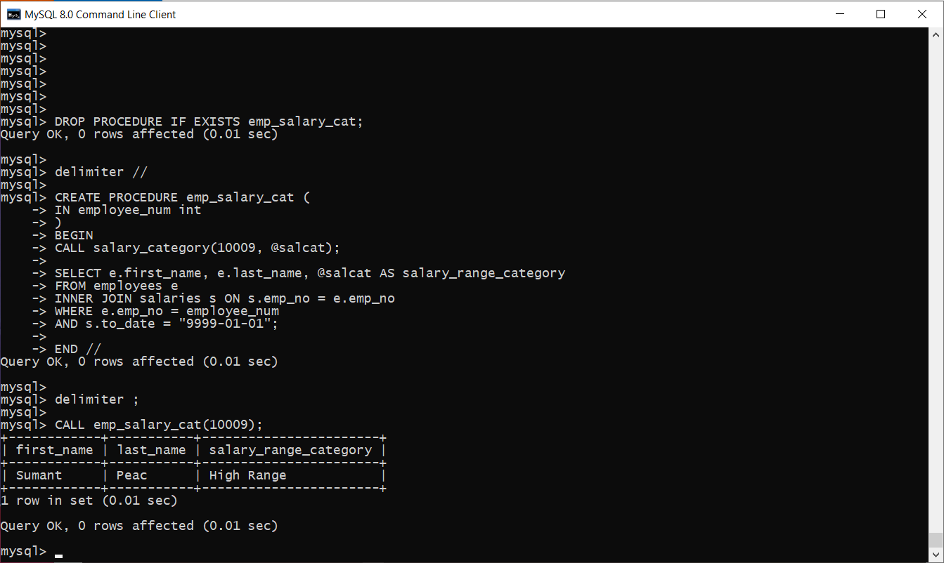

1. **Find_current_department procedure takes an employee number and finds their current department name. This can be used for reporting.**

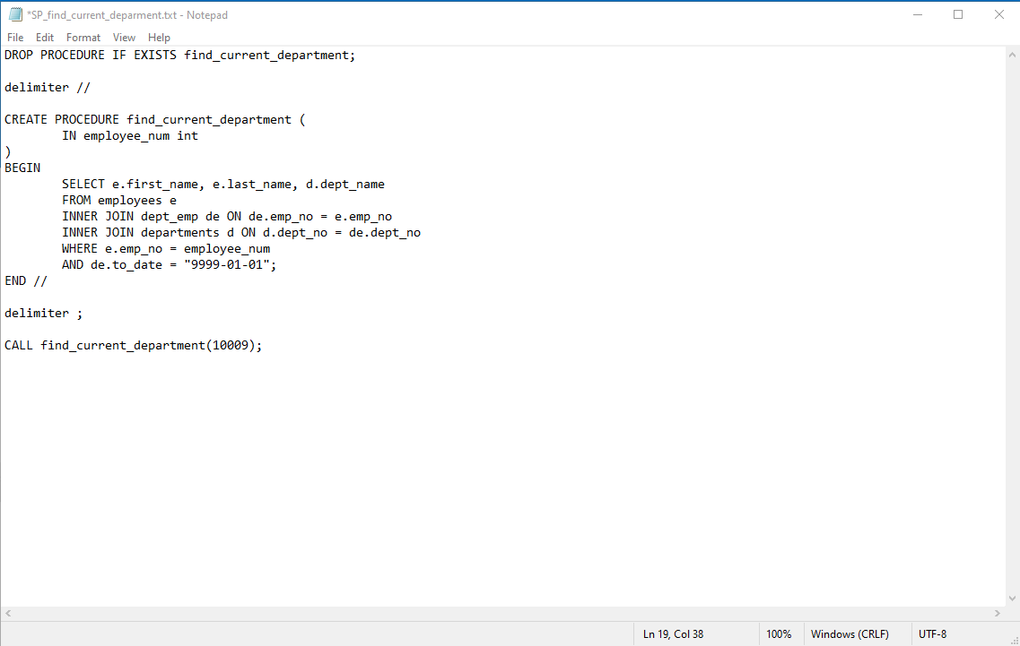

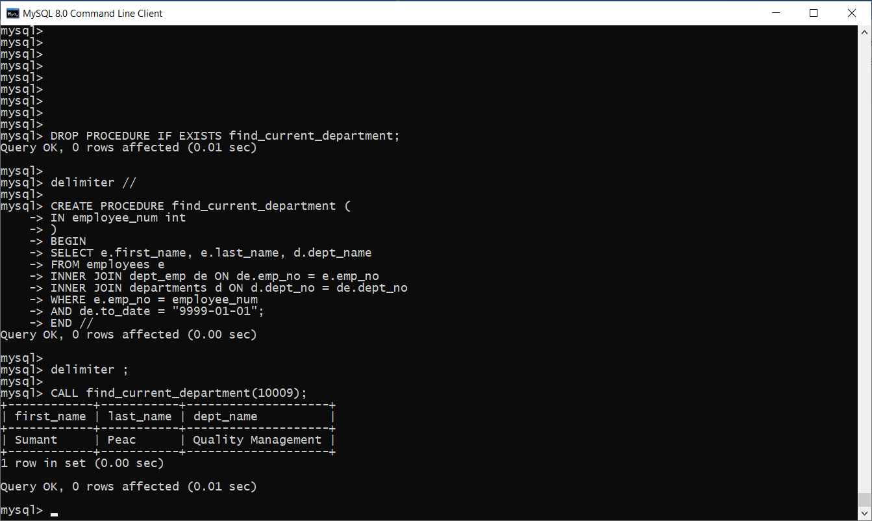

**URL to GitHub Repository:**

[**https://github.com/csgarza1984/BESD-MySQL-Week4.git**](https://github.com/csgarza1984/BESD-MySQL-Week4.git)