# Relational Databases with MySQL Week 6 Coding Assignment

**Points possible:** 70

|  |  |  |
| --- | --- | --- |
| Category | Criteria | % of Grade |
| Functionality | Does the code work? | 25 |
| Organization | Is the code clean and organized? Proper use of white space, syntax, and consistency are utilized. Names and comments are concise and clear. | 25 |
| Creativity | Student solved the problems presented in the assignment using creativity and out of the box thinking. | 25 |
| Completeness | All requirements of the assignment are complete. | 25 |

**Instructions:** In Eclipse, or an IDE of your choice, write the code that accomplishes the objectives listed below. Ensure that the code compiles and runs as directed. Take screenshots of the code and of the running program (make sure to get screenshots of all required functionality) and paste them in this document where instructed below. Create a new repository on GitHub for this week’s assignments and push this document, with your Java project code, to the repository. Add the URL for this week’s repository to this document where instructed and submit this document to your instructor when complete.

**Coding Steps:**

This week you will be working together as a **team** to create a full CRUD application.

Your console CRUD application will need to use a database to store all the application data.

As a team, decide what you want your project to do. Get instructor approval early in the week before beginning development.

You need to have at least 3 entities.

Users should be able to interact via the console (i.e. Scanner(System.in)))

Use git to collaborate.

Everyone will be graded on their individual contributions.

**Project Name:**

How to checkout /check-in/Renew a book at a library

**Project Team Members:**

Christine Garza and Mamta Nath

**My Contribution to the Project:**

Mamta and I discussed the project and she sent an ERD which I then normalized to get rid of many-to-many relationships. I provided the updated ERD.

**Mamta’s original ERD**

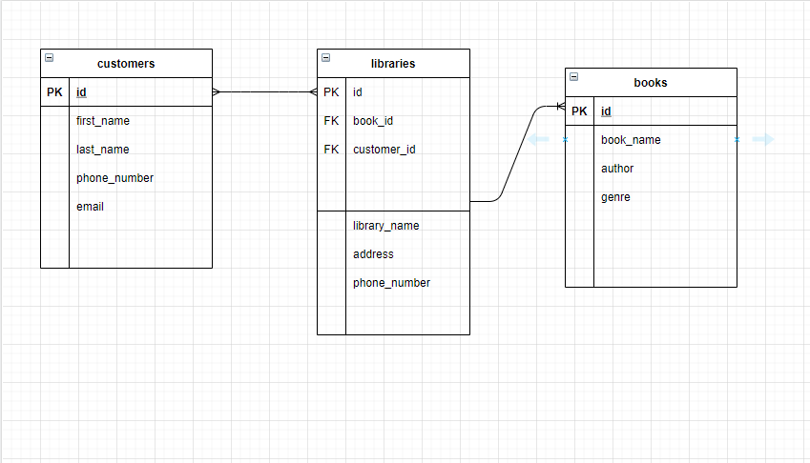

**My revised ERD with the rationale that the whole database (schema) is the library and the tables are customers, books, and transactions (checking in, checking out, renewing).**

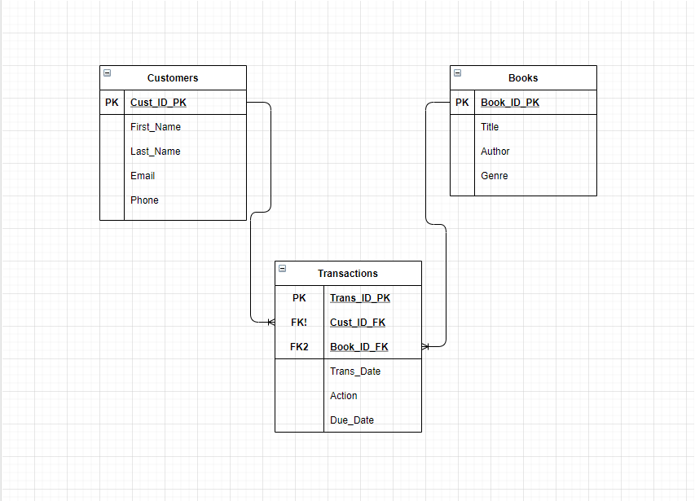

After discussions via email and Zoom calls, we decided on an approach. Mamta created the git repository and added the initial code. I added the code for the customerDao.

I then reviewed and tested all code and provided feedback so we could discuss changes. We made revisions and then I tested all options again. I provided the screenshots of the code and the running application with database results.

Mamta was on a shortened schedule due to a prior commitment, so we needed to have the project completed by Tuesday. This meant she provided more code and I provided the review.

We definitely had our challenges using git, as neither of us had much prior experience other than pushing our code assignments for this class. I wrote code that I pushed to git, but then Mamta had also written code to resolve the same issue and we ended up having conflicts. I’ve since learned that I should have done a pull from the command line before modifying the code. I confused the pull with the pull request. I think if we hadn’t spent as much time figuring out git, we could have improved the code to include more error checking. The positive outcome is that we’re both a little more experienced with git now. I definitely have a better understanding of it, and want to practice with it more.

**Screenshots of Code:**

File was too large to submit with screenshots added within Word doc and only one file is allowed to be submitted. The following files are in the git repository:

* **Screenshots of Code.docx**
* **Running Application Screen Shots.docx**

**URL to GitHub Repository:**

[**https://github.com/MamtaGit-personal/MySQL-week6.git**](https://github.com/MamtaGit-personal/MySQL-week6.git)

**The repository below is my attempt at an alternate solution without using stored procedures.**

[**https://github.com/csgarza1984/MySQL-FinalProject-AlternateSolution.git**](https://github.com/csgarza1984/MySQL-FinalProject-AlternateSolution.git)