JSS Mahavidyapeetha
JSS SCIENCE AND TECHNOLOGY UNIVERSITY
JSS Technical Institutions' Campus, Mysuru – 570006

Industrial Training/Internship/Mini Project 22IS77P
“SMART MANUFACTURING OPTIMIZATION”
Production & Resource Optimization
A Report submitted in partial fulfillment of curriculum prescribed for the award of the degree of
BACHELOR OF ENGINEERING IN
INFORMATION SCIENCE AND ENGINEERING
by
NAME | USN
Bhoomika R | 01JST23UIS016
Chaithra M | 01JST23UIS021
ChethanGowda S | 01JST24UIS402
M S Yashas | 01JST24UIS404

Under the guidance of:
Prof. Vinutha Prakash
Assistant Professor
DEPARTMENT OF INFORMATION SCIENCE AND ENGINEERING
JSS SCIENCE AND TECHNOLOGY UNIVERSITY
September, 2025

ACCEPTANCE LETTER
Date: 15th September, 2025

To,
The Head of Department,
Department of Information Science and Engineering,
JSS Science and Technology University,
Mysuru – 570006.

Sub: Acceptance of Project / Industrial Training – Reg.
Respected Madam,
We, the undersigned students of the 7th Semester, Department of Information Science and Engineering, JSS Science and Technology University, Mysuru, hereby accept and undertake the project work titled "SMART MANUFACTURING OPTIMIZATION (Production & Resource Optimization)" (Course Code: 22IS77P) for the academic period 2025–2026.
We confirm that this project will be carried out under the esteemed supervision and guidance of Prof. Vinutha Prakash, Assistant Professor, Department of Information Science and Engineering. We adhere to all academic regulations, integrity standards, and submission guidelines established by the University and the Department.

Student Details and Signatures:
Sl. No. | Student Name | USN | Signature
1 | Bhoomika R | 01JST23UIS016
2 | Chaithra M | 01JST23UIS021
3 | ChethanGowda S | 01JST24UIS402
4 | M S Yashas | 01JST24UIS404

Signature of Faculty Guide  Prof. Vinutha Prakash  Assistant Professor, Dept. of ISE | Signature of Head of Department  Dr. [HoD Name]  Professor & Head, Dept. of ISE

JSS MAHAVIDYAPEETHA
JSS SCIENCE AND TECHNOLOGY UNIVERSITY
JSS Technical Institutions' Campus, Mysuru – 570006
DEPARTMENT OF INFORMATION SCIENCE AND ENGINEERING
CERTIFICATE
This is to certify that the project report entitled “SMART MANUFACTURING OPTIMIZATION (Production & Resource Optimization)” is a bona fide record of work carried out by Bhoomika R (01JST23UIS016), Chaithra M (01JST23UIS021), ChethanGowda S (01JST24UIS402), and M S Yashas (01JST24UIS404), in partial fulfillment of curriculum prescribed for the award of the degree of Bachelor of Engineering in Information Science and Engineering of JSS Science and Technology University, Mysuru, during the academic year 2025–2026.
It is certified that all corrections and suggestions indicated during internal evaluations have been incorporated into this report. The project has been approved as satisfying the academic requirements prescribed for the course 22IS77P.

Prof. Vinutha Prakash  Guide & Assistant Professor  Dept. of ISE, JSS STU | Dr. [HoD Name]  Professor and Head  Dept. of ISE, JSS STU
Name of Examiner 1: __________________  Signature: __________________________ | Name of Examiner 2: __________________  Signature: __________________________

ACKNOWLEDGEMENT
The successful completion of any project requires the guidance, support, and encouragement of many individuals. We take this opportunity to express our profound gratitude to all those who have contributed to the realization of this project.
First and foremost, we express our humble obeisance and pranams at the lotus feet of His Holiness Jagadguru Sri Shivarathri Deshikendra Mahaswamiji for his divine blessings.
We convey our heartfelt gratitude to the Vice Chancellor and Registrar of JSS Science and Technology University, Mysuru, for providing the state-of-the-art computational infrastructure and academic environment that fostered our learning.
We express our sincere thanks to Dr. [HoD Name], Professor and Head, Department of Information Science and Engineering, for his invaluable encouragement, constructive advice, and administrative support throughout the course of our project work.
We are deeply indebted and express our sincere gratitude to our esteemed guide, Prof. Vinutha Prakash, Assistant Professor, Department of Information Science and Engineering, for her inspiring mentorship, meticulous reviews, insightful technical critiques, and patient guidance from the inception of the problem definition to the final realization of the Smart Manufacturing Optimization system.
We also extend our grateful appreciation to all the teaching and non-teaching staff of the Department of Information Science and Engineering for their direct and indirect cooperation during our laboratory work.
Lastly, we express our heartfelt love and gratitude to our parents, family members, and friends whose constant sacrifices, understanding, and moral encouragement have been a pillar of strength throughout our academic journey.

Bhoomika R (01JST23UIS016)
Chaithra M (01JST23UIS021)
ChethanGowda S (01JST24UIS402)
M S Yashas (01JST24UIS404)

ABSTRACT
Resource scheduling and machine allocation in discrete manufacturing environments represent a persistent operational challenge. Manual scheduling of shared industrial machinery, specialized test benches, assembly cells, and technical operators is labor-intensive, error-prone, and frequently leads to severe bottlenecks, double-booked equipment, and substantial idle time. This project presents Smart Manufacturing Optimization (Production & Resource Optimization), a robust, local-first web application engineered to automate and optimize industrial production scheduling over a configurable rolling horizon. The system integrates a high-performance FastAPI backend with Google OR-Tools Constraint Programming with Satisfiability (CP-SAT) solver to generate conflict-free, mathematically verified production schedules.
Users configure multi-unit machine pools, scheduled maintenance windows, working shifts, and manufacturing tasks characterized by discretized 30-minute durations, precedence dependencies, earliest start times, deadlines, and preferred operational slots. The CP-SAT engine models these constraints using boolean interval formulations and optimizes a hierarchical lexicographic objective that minimizes total makespan, maximizes preferred time slot utilization, and prioritizes critical production orders, providing provable optimality bounds. An automated diagnostic relaxation engine identifies conflicting constraints and offers actionable guidance when instances are infeasible. The frontend delivers an interactive SVG Gantt chart, machine utilization heatmaps, KPI metrics, and self-contained HTML schedule exports through an English-language interface. Data persistence is managed through schema-versioned local JSON storage with automated migration chains. The system was thoroughly validated using Pytest unit tests, TestClient API tests, and Playwright end-to-end browser automation.

Keywords: Smart Manufacturing, Production Scheduling, Constraint Programming, Google OR-Tools, CP-SAT Solver, FastAPI, Vanilla JavaScript, Interactive Gantt Chart, Resource Allocation.

CONTENTS
Title / Section | Page No.
Acceptance Letter | i
Certificate | ii
Acknowledgement | iii
Abstract | iv
Contents | v
List of Figures | vii
List of Tables | viii
CHAPTER 1: INTRODUCTION | 1
1.1 Overview of Industrial Resource Scheduling | 1
1.2 Project Background and Industrial Context | 2
1.3 Motivation | 3
1.4 Problem Definition | 3
1.5 Technical Challenges | 4
1.6 Aim and Objectives | 5
CHAPTER 2: ORGANIZATION PROFILE | 6
2.1 Institutional and Department Profile | 6
2.2 Vision and Mission | 6
2.3 Department Objectives and Core Functions | 7
2.4 Computing Infrastructure and Project Laboratory Facilities | 7
2.5 Methodological Framework and Technology Environment | 8
CHAPTER 3: PROJECT WORK | 9
3.1 Work Assigned / Project Title | 9
3.2 Project Objectives | 10
3.3 Methodology and Workflow | 10
3.3.1 System Requirements (Functional & Non-Functional) | 10
3.3.2 System Specifications (Hardware & Software) | 11
3.3.3 System Architecture Design | 12
3.3.4 Production Scheduling Workflow | 13
3.3.5 Backend Module Interaction Architecture | 14
3.3.6 Data Model and JSON Storage Design | 15
3.3.7 CP-SAT Scheduling Model Formulation | 16
3.3.8 Constraint Modeling and Mathematical Formulation | 17
3.3.9 Lexicographic Objective Function Formulation | 17
3.3.10 Infeasibility Explanation Engine | 18
3.3.11 Backend REST API Architecture | 18
3.3.12 Frontend Design and Interactive UI Architecture | 19
3.3.13 Implementation and Testing Strategy | 20
3.4 Results and Discussion | 21
3.4.1 System Visual Interface and Screen Demonstrations | 21
3.4.2 Constraint Handling and Validation | 23
3.4.3 Performance and Optimality Analysis | 23
3.4.4 System Advantages | 24
3.4.5 System Limitations | 24
3.5 Skills Acquired | 24
3.6 Challenges and Engineering Solutions | 25
CHAPTER 4: CONCLUSIONS | 27
4.1 Conclusion | 27
4.2 Future Scope | 27
REFERENCES | 29
APPENDICES | 30
APPENDIX A: User Interface Navigation Guide | 30
APPENDIX B: Sample Manufacturing Project JSON Configuration | 30
APPENDIX C: Automated Testing and Verification Summary | 32

LIST OF FIGURES
Figure No. | Title | Page No.
Figure 3.1 | Smart Manufacturing Optimization System Architecture Diagram | 12
Figure 3.2 | Scheduling and Solver Workflow Diagram | 13
Figure 3.3 | Backend Module Interaction Architecture Diagram | 14
Figure 3.4 | Interactive SVG Gantt Chart and Optimized Production Schedule | 21
Figure 3.5 | Resources Tab – Machine Pool and Working Calendar Configuration | 22
Figure 3.6 | Tasks Tab – Task List, Resource Constraints, and Slot Grid | 22
Figure 3.7 | Insights Tab – Machine Utilization Heatmap and KPI Summary Tiles | 23
Figure 3.8 | High-Contrast Dark Mode User Interface | 23
Figure 3.9 | Published Read-Only Production Schedule Share Page | 23

LIST OF TABLES
Table No. | Title | Page No.
Table 3.1 | System Tools and Technologies Matrix | 11
Table 3.2 | Core Data Model Entities in models.py | 15
Table 3.3 | Principal RESTful JSON API Endpoints in api.py | 18
Table 3.4 | Modular Frontend JavaScript Architecture in static/ | 19
Table 3.5 | Automated Testing Strategy and Coverage Summary | 20
Table 3.6 | Technical, Analytical, and Professional Skills Acquired | 25
Table 3.7 | Manufacturing Scheduling Challenges and Engineering Solutions | 26
Table C.1 | Automated Test Suite Execution and Validation Matrix | 32

CHAPTER 1: INTRODUCTION
1.1 Overview of Industrial Resource Scheduling
In modern discrete manufacturing, industrial fabrication facilities, precision machining workshops, and assembly lines, production scheduling constitutes one of the most critical operational functions. Manufacturing scheduling is the systematic allocation of limited shop-floor resources—including Computer Numerical Control (CNC) machining centers, automated robotic welding cells, surface treatment stations, quality inspection jigs, and skilled operators—to a set of production jobs over time. Each manufacturing order consists of a defined sequence of operations, stringent process cycle durations, technical machine specifications, strict shipping deadlines, and complex precedence relationships.
Despite rapid technological advancements in manufacturing machinery and automation, production planning in a significant proportion of small-to-medium manufacturing enterprises (SMEs) remains heavily reliant on manual scheduling practices. Plant supervisors routinely utilize static spreadsheets, physical scheduling boards, and ad-hoc heuristics to dispatch daily operations. These manual methodologies are fundamentally ill-suited for handling modern manufacturing dynamics. As the number of concurrent production jobs, shared machine tools, and operational constraints increases, the combinatorial complexity of the scheduling domain exceeds human analytical capacity, leading to severe operational bottlenecks, machine starvation, delayed deliveries, and excessive work-in-progress (WIP) inventories.
Mathematically, resource-constrained project scheduling and job-shop scheduling problems belong to the class of NP-hard combinatorial optimization problems. Finding a provably optimal or high-quality feasible production schedule among millions of combinatorial permutations requires mathematically rigorous algorithmic techniques. Constraint Programming with Satisfiability (CP-SAT), developed by Google as part of the open-source OR-Tools optimization suite, offers a state-of-the-art framework for solving complex industrial scheduling problems. By merging the declarative expressiveness of constraint programming with the aggressive search and pruning capabilities of modern Boolean satisfiability solvers, CP-SAT enables the rapid synthesis of provably optimal production schedules under complex physical and temporal constraints.
1.2 Project Background and Industrial Context
The Smart Manufacturing Optimization project was conceived to bridge the gap between advanced mathematical optimization theory and practical shop-floor manufacturing administration. Traditional Enterprise Resource Planning (ERP) and Manufacturing Execution Systems (MES) are typically capital-intensive, require cumbersome cloud infrastructure, demand substantial subscription overheads, and mandate complex database maintenance. Small-to-medium manufacturing facilities frequently lack the dedicated IT infrastructure or computational budget required to deploy and maintain enterprise-grade scheduling suites.
Smart Manufacturing Optimization addresses this operational deficiency by providing a complete, local-only, zero-cloud-dependency web application engineered for optimal manufacturing resource scheduling over a configurable rolling horizon. Built upon a high-performance Python FastAPI backend and a dependency-free vanilla JavaScript frontend, the application executes entirely within the user’s local operating environment. All project models, machine definitions, task constraints, and computed schedules are stored as human-readable JSON files directly on the local filesystem. This architectural design ensures absolute data privacy, eliminates recurring cloud operational costs, and enables resilient offline operation on standard workstation hardware directly on the shop floor.
1.3 Motivation
In discrete manufacturing environments, high-capital machinery and specialized personnel represent the primary cost drivers. Maximizing overall equipment effectiveness (OEE) while satisfying delivery commitments is essential for maintaining competitive advantage. Inefficient manual scheduling creates pervasive operational vulnerabilities, including:
1. Machine Conflict and Double-Booking: Simultaneous assignment of multiple processing tasks to the same physical workstation or machine tool, causing emergency halts, operational contention, and costly job rework.
2. Suboptimal Machine Utilization: Unsynchronized job handoffs that leave expensive CNC machines and robotic cells idle while subsequent tasks wait unnecessarily for upstream prerequisites, directly inflating manufacturing lead times.
3. Constraint and Maintenance Violations: Scheduling heavy production runs during mandatory machine preventive maintenance intervals, across non-working shifts, or in violation of strict technological precedence sequences.
4. Computational Infeasibility at Scale: Inability of human planners to evaluate the ripple effects of schedule adjustments across tens of machines and hundreds of operations, rendering reactive re-planning slow and error-prone.
The overarching motivation behind Smart Manufacturing Optimization is to deliver an accessible, mathematically rigorous, and computationally dependable optimization platform that automates production scheduling. By translating physical shop-floor constraints into a declarative mathematical model, the system enables planners to explore millions of scheduling alternatives in seconds, yielding verified, conflict-free schedules that maximize throughput and resource utilization.
1.4 Problem Definition
Let M = {1, 2, ..., m} denote a set of manufacturing resource pools (machines, tooling, and labor), where each pool m_k contains U_k >= 1 identical physical units, with arbitrary time-varying unavailability windows representing planned preventive maintenance, tooling recalibration, or shift closures. Let H denote a rolling scheduling horizon discretized into uniform 30-minute operational time slots s in {0, 1, ..., S-1}. Let C represent a working calendar specifying operational working hours, weekend shutdowns, and statutory public holidays.
Let T = {t_1, t_2, ..., t_n} denote a collection of manufacturing tasks to be scheduled. Each task t_i is defined by a processing duration d_i (expressed as an integer multiple of 30-minute slots), a set of resource requirements specifying the quantity of units demanded from one or more resource pools, an optional set of technological precedence dependencies Pred(t_i) subseteq T, an earliest start slot ES_i, an absolute completion deadline DL_i, a pinned start slot Pin_i, an operational shift adherence flag, a task priority level, and an optional set of preferred or forbidden operational time slots.
The computational problem is to find a joint assignment of starting time slots start(t_i) and physical resource units unit(t_i, m_k, u) for all tasks t_i in T such that:
a. Disjunctive Machine Allocation: No physical machine unit is allocated to more than one task simultaneously in any operational slot.
b. Maintenance and Working Shift Adherence: No task is executed during scheduled machine maintenance windows or outside designated working hours unless specifically authorized.
c. Technological Precedence Satisfaction: For every precedence relationship t_j in Pred(t_i), task t_i does not commence until task t_j has completed its entire duration (start(t_i) >= start(t_j) + d_j).
d. Temporal Boundary Compliance: Every task satisfies its earliest start time (start(t_i) >= ES_i) and finishes before its strict deadline (start(t_i) + d_i <= DL_i).
e. Hierarchical Lexicographic Optimization: The schedule minimizes total manufacturing makespan as the primary objective, maximizes utilization of preferred operator slots as the secondary objective, and schedules high-priority production orders earliest as the tertiary objective.
f. Infeasibility Diagnosis: When physical constraints preclude any valid schedule, the system automatically identifies conflicting constraints and provides prioritized diagnostic guidance to assist the planner.
1.5 Technical Challenges
Developing a robust manufacturing scheduling system presents several formidable engineering and computational challenges:
1. Exponential Combinatorial Search Space: With N manufacturing operations, M multi-unit machine pools, and S discrete time slots, the search space of candidate schedules scales exponentially as O(M^N * S^N). Exhaustive search is computationally intractable.
2. Tight Multi-Constraint Interdependence: Real-world production lines involve overlapping, competing constraints where decisions made for one machine directly constrain feasible execution windows for downstream stations.
3. Multi-Unit Resource Disjunctions: Allocating tasks across resource pools containing multiple identical machines requires symmetrical breaking and precise unit-level tracking to prevent artificial solver stalling.
4. Asynchronous Optimization without UI Freezing: Industrial optimization solvers can consume substantial CPU time. Executing intensive CP-SAT searches within a web backend requires non-blocking asynchronous concurrency, thread-safe cancellation, and live progress reporting.
5. Zero-Dependency Client-Side Rendering: Rendering extensive production schedules comprising hundreds of tasks across weeks of operational time requires high-performance SVG vector rendering, responsive zoom/pan navigation, and dynamic heatmaps without external JavaScript libraries.
1.6 Aim and Objectives
The primary aim of this project is to architect, implement, and validate a locally hosted, dependency-free web application for optimal production scheduling and resource management in discrete manufacturing environments. To accomplish this aim, the following technical objectives are established:
1. Constraint-Based Optimization Engine: Formulate and implement a mathematical CP-SAT scheduling model using Google OR-Tools that systematically enumerates feasible start slots, assigns physical machine units, and strictly enforces disjunctive non-overlap, precedence, and calendar constraints.
2. Hierarchical Lexicographic Objective Function: Construct a multi-criteria weighted objective formulation that strictly minimizes production makespan, maximizes adherence to preferred operational slots, and schedules high-priority manufacturing orders earlier.
3. Automated Infeasibility Diagnostics: Engineer an automated relaxation and diagnostic engine that detects contradictory constraints in over-constrained manufacturing scenarios and generates ranked, actionable recommendations for plant managers.
4. High-Performance Asynchronous REST API: Develop a lightweight FastAPI backend exposing RESTful endpoints for project lifecycle management, background solve job dispatching with live progress polling and cancellation, working calendar management, and public holiday resolution.
5. Interactive Vector-Based User Interface: Build an intuitive, single-page web interface utilizing HTML5, CSS3, and Vanilla JavaScript that features an interactive SVG Gantt chart, machine utilization heatmaps, KPI summary cards, and an English-language interface.
6. Local-First JSON Persistence with Automated Migrations: Implement a zero-database, file-based persistence layer with strict schema versioning and forward-only migration chains, guaranteeing data privacy and operational autonomy on local workstations.
7. Comprehensive Automated Quality Verification: Validate system correctness, mathematical stability, and interface robustness through an exhaustive automated test suite combining Pytest unit/API testing and Playwright browser end-to-end automation.

CHAPTER 2: ORGANIZATION PROFILE
2.1 Institutional and Department Profile
JSS Science and Technology University (JSS STU), established under the aegis of JSS Mahavidyapeetha, is one of India’s premier technical institutions. Built on the illustrious legacy of Sri Jayachamarajendra College of Engineering (SJCE), established in 1963, the university has earned international acclaim for excellence in engineering education, cutting-edge technical research, and strong industry linkages.
The Department of Information Science and Engineering (ISE) at JSS STU is recognized for its comprehensive academic curriculum, vibrant research culture, and focus on practical engineering solutions. The department consistently endeavors to prepare students to tackle complex contemporary technological challenges across computer systems, optimization algorithms, data analytics, and enterprise software engineering. Through rigorous project-based learning, the department encourages undergraduate students to synthesize theoretical computer science principles into deployable, real-world computational systems.
2.2 Vision and Mission
Vision of the Institution:
“Advancing JSS Science and Technology University as a beacon of technical excellence of international repute, fostering innovation, research, and transformative education to nurture globally competent engineering professionals dedicated to the advancement of society.”
Mission of the Institution:
1. Academic Excellence: Imparting quality technical education through progressive pedagogy, state-of-the-art infrastructure, and continuous curriculum benchmarking.
2. Research and Innovation: Creating an enabling ecosystem for interdisciplinary research, patenting, and entrepreneurial technology incubation.
3. Industry Collaboration: Fostering enduring partnerships with global industries to bridge technological gaps and address emerging engineering paradigms.
Vision of the Department of Information Science and Engineering:
“To achieve excellence in education, research, and technical innovation in Information Science and Engineering, empowering students to become innovative software engineers, algorithm architects, and ethical leaders capable of addressing complex industrial and societal challenges.”
Mission of the Department of Information Science and Engineering:
1. Foundational Rigor: Providing strong theoretical foundations and intensive hands-on training in core computational algorithms, mathematical modeling, and software engineering.
2. Practical Engineering Synthesis: Promoting active experiential learning through real-world capstone projects, industrial internships, and competitive software development.
3. Ethical and Professional Competence: Inculcating professional ethics, collaborative teamwork, effective technical communication, and a commitment to lifelong learning.
2.3 Department Objectives and Core Functions
The Department of Information Science and Engineering operates with clear strategic objectives designed to foster technical excellence:
- Curriculum Benchmarking: Continually aligning course syllabi with emerging computing paradigms, including combinatorial optimization, distributed systems, modern web architectures, and intelligent manufacturing.
- Laboratory Innovation: Maintaining modern computing laboratories equipped with industry-standard software suites, compilers, and algorithmic optimization frameworks.
- Project-Centric Pedagogy: Mandating comprehensive mini-projects and industrial internships where students analyze real industrial workflows, define technical requirements, and build fully realized software systems.
- Industry Readiness: Fostering rigorous programming practices, code review standards, version control workflows, and automated testing methodologies reflecting top-tier engineering organizations.
2.4 Computing Infrastructure and Project Laboratory Facilities
The Department of Information Science and Engineering hosts state-of-the-art computational laboratories providing the requisite hardware and software infrastructure for advanced software engineering and algorithmic optimization:
- Computing Workstations: High-performance multi-core Intel Core i5/i7 and AMD Ryzen workstations equipped with 16 GB DDR4/DDR5 RAM and dedicated hardware acceleration for compute-intensive tasks.
- Networking and Server Infrastructure: High-speed campus-wide fiber-optic connectivity and local intranet deployment servers for testing distributed web services and multi-client workloads.
- Development Environments: Standardized modern toolchains including Python 3.12+ runtimes, Visual Studio Code, Git distributed version control, and browser automation testbeds.
- Open-Source Optimization Tooling: Institutional support for robust open-source libraries including Google OR-Tools, FastAPI, and headless browser testing environments.
2.5 Methodological Framework and Technology Environment
The technical execution of the Smart Manufacturing Optimization project was conducted within the department’s advanced software engineering ecosystem. The department emphasizes a rigorous, test-driven development (TDD) methodology coupled with continuous code quality enforcement. Under the mentorship of faculty advisors, students utilize modern code linters (Ruff), strict static type checkers (Mypy), automated test frameworks (Pytest), and browser-level end-to-end verification (Playwright). This disciplined engineering framework ensures that projects produced within the department adhere to the highest standards of software reliability, algorithmic correctness, and maintainability.

CHAPTER 3: PROJECT WORK
3.1 Work Assigned / Project Title
3.1.1 Project Title and Overview
The designated project work is titled “SMART MANUFACTURING OPTIMIZATION” with the functional subtitle “Production & Resource Optimization”. The project represents a specialized industrial engineering software system designed to formulate, compute, and visualize conflict-free, optimal production schedules for discrete manufacturing workshops, fabrication centers, and assembly lines.
3.1.2 Problem Being Addressed
Modern manufacturing environments face relentless pressure to shorten lead times, reduce in-process inventory, and maximize the utilization of expensive capital equipment. In typical job-shop and batch manufacturing operations, multiple work orders compete for a limited pool of machines and specialized technical labor. Manual dispatching inevitably causes equipment double-booking, unanticipated machine starvation, violation of scheduled maintenance windows, and failure to honor customer delivery deadlines. Smart Manufacturing Optimization directly solves this problem by replacing manual estimation with provably correct mathematical optimization.
3.1.3 Project Scope and Operational Boundaries
The operational scope of the application encompasses:
- Rolling Horizon Discretization: Time is modeled as a configurable rolling horizon divided into uniform 30-minute operational slots, matching industrial shop-floor dispatching increments.
- Multi-Unit Machine Pools: Resources are defined as distinct pools (e.g., CNC Mills, Lathes, Robotic Welders, QC Inspectors) containing one or more interchangeable physical units.
- Temporal and Operational Constraints: Full support for task durations, technological precedence dependencies, earliest start bounds, hard delivery deadlines, pinned start slots, and operational shift masks.
- Maintenance and Calendar Exclusion: Direct graphical painting of per-unit planned maintenance downtime alongside automated working calendar masking (working hours, weekends, public holidays).
- Local-First Desktop Web Execution: Complete standalone execution on local workstation hardware without external cloud connectivity, ensuring data security and zero operational costs.
3.2 Project Objectives
The engineering objectives of the Smart Manufacturing Optimization project are summarized as follows:
1. Mathematical Constraint Formulation: Design a CP-SAT constraint satisfaction formulation that accurately models machine capacity, disjunctive execution, task dependencies, maintenance intervals, and calendar shifts.
2. Multi-Tiered Lexicographic Optimization: Implement a compound objective function prioritizing makespan minimization, followed by operator preference fulfillment and critical job acceleration.
3. Asynchronous Solve Management: Develop a robust background job runner within FastAPI that releases the Python GIL, manages solver lifecycle, reports live intermediate solutions, and supports instant user cancellation.
4. Interactive Vector Visualization: Construct a high-performance, client-side SVG Gantt chart with interactive tooltips, dependency lines, and zoom controls using vanilla JavaScript without external UI libraries.
5. Shop-Floor Utilization Analytics: Provide an integrated Insights dashboard displaying per-resource capacity utilization percentages, load heatmaps, and key performance indicator (KPI) summary metrics.
6. Automated Infeasibility Diagnostics: Engineer an automated constraint relaxation analysis tool that diagnoses over-constrained scheduling scenarios and provides clear guidance to operators.
3.3 Methodology and Workflow
3.3.1 System Requirements
The functional and non-functional requirements define the precise behavioral and quality attributes of the system:
Functional Requirements:
FR-1. Machine Pool Configuration: The system shall allow users to define machine resource pools, designate the count of interchangeable physical units, assign custom unit names, and paint discrete unavailability windows.
FR-2. Manufacturing Task Definition: The system shall allow users to create manufacturing tasks with durations (in 30-minute increments), specify resource demands, define technological precedence chains, set deadlines, earliest start times, and pinned slots.
FR-3. Calendar and Shift Management: The system shall support configurable shift start and end times, weekend shutdowns, and automated country-specific public holiday retrieval.
FR-4. Constraint-Based Schedule Synthesis: The system shall invoke the CP-SAT optimization engine to synthesize a conflict-free production schedule that satisfies all physical, temporal, and calendar constraints.
FR-5. Interactive Schedule Visualization: The system shall render the computed schedule as an interactive SVG Gantt chart featuring hover tooltips, detailed task timing tables, and machine utilization heatmaps.
FR-6. Schedule Publishing and Exporting: The system shall export self-contained, standalone HTML production schedule reports and generate read-only local share links.
FR-7. Project Lifecycle Management: The system shall support multiple named projects, project cloning, JSON import/export, undo/redo state management, and automated periodic backup snapshots.
Non-Functional Requirements:
NFR-1. Responsiveness and Concurrency: The backend shall dispatch solver operations to background worker threads, ensuring the HTTP API remains immediately responsive during long-running optimization searches.
NFR-2. Local-First Data Privacy: All proprietary manufacturing recipes, job orders, and machine configurations shall remain strictly on the local workstation without external cloud transmission.
NFR-3. Lightweight Client Footprint: The user interface shall be implemented using pure vanilla JavaScript, HTML5, and CSS3, requiring no node package build steps, bundlers, or heavy external web frameworks.
NFR-4. Cross-Platform Portability: The backend shall execute seamlessly across modern operating systems (Windows 11, Linux, macOS), adapting user data directories via platform-native conventions.
3.3.2 System Specifications
The system has been developed, benchmarked, and verified under the following standardized hardware and software environment:
Hardware Specifications:
- Central Processing Unit (CPU): Intel Core i5-12700H or equivalent multi-core processor (supporting multi-threaded CP-SAT search workers).
- System Memory (RAM): 16 GB DDR4 system memory, providing ample workspace for large search trees and state caching.
- Graphics Hardware (GPU): NVIDIA GeForce RTX 3050 Laptop GPU, 4 GB VRAM (accommodating accelerated OS display rendering).
- Primary Storage: 512 GB NVMe M.2 Solid State Drive (SSD) providing high-throughput local disk I/O for JSON snapshot persistence.
Software Specifications:
- Operating System: Windows 11 Home 64-bit.
- Programming Environment: Python 3.12+ (Backend) and ECMAScript 2022+ / Vanilla JavaScript (Frontend).
- Web Framework & Server: FastAPI (asynchronous REST API) powered by Uvicorn ASGI server.
- Optimization Engine: Google OR-Tools CP-SAT (Constraint Programming with Satisfiability).
- Data Modeling & Validation: Pydantic (BaseModel schema definition and serialization).
- User Interface: HTML5, CSS3 (modern design tokens with dark mode), Vanilla JavaScript.
- Data Persistence: JSON file-based local storage with schema versioning and forward migrations.
- Automated Testing: Pytest (unit and API testing) and Playwright (end-to-end browser automation).
- Development Toolchain: Visual Studio Code, Git distributed version control, GitHub repository hosting.
Table 3.1: System Tools and Technologies Matrix
Technology / Tool | Category | Operational Role in System
Python 3.12+ | Runtime Environment | Core backend language providing asynchronous coroutines and data processing.
Google OR-Tools (CP-SAT) | Optimization Library | Constraint satisfaction and SAT solver computing optimal production schedules.
FastAPI | Web Framework | Asynchronous HTTP REST API router with automatic OpenAPI documentation.
Uvicorn | ASGI Web Server | High-throughput asynchronous web server hosting FastAPI application endpoints.
Pydantic | Schema Validation | Data parsing, strict type checking, and JSON serialization for domain entities.
Vanilla JavaScript | Client Logic | Zero-dependency client-side application logic, state management, and SVG Gantt generation.
HTML5 / CSS3 | Presentation Layer | Semantic DOM structure and modern CSS custom properties supporting light/dark themes.
JSON Local Storage | Persistence Layer | Human-readable on-disk project files with automated backup snapshots.
holidays (Python) | Calendar Utility | Automated lookup and masking of national and regional public holidays.
platformdirs | System Utility | Cross-platform operating system path resolution for user data directories.
Pytest | Testing Framework | Automated unit testing for solver logic, calendar utilities, and storage migrations.
Playwright | Testing Framework | End-to-end headless browser testing verifying complete frontend-to-backend workflows.
Visual Studio Code | IDE | Primary development environment with integrated debugging and terminal tooling.
Git / GitHub | Version Control | Distributed source code management, branch tracking, and team collaboration.

3.3.3 System Architecture Design
Smart Manufacturing Optimization implements a clean, decoupled client-server architecture. The system is partitioned into three primary architectural layers: the Presentation Layer (Client), the Application and Optimization Layer (Server), and the Persistence Layer (Local Filesystem). Figure 3.1 illustrates the overall system architecture and data communication pathways.
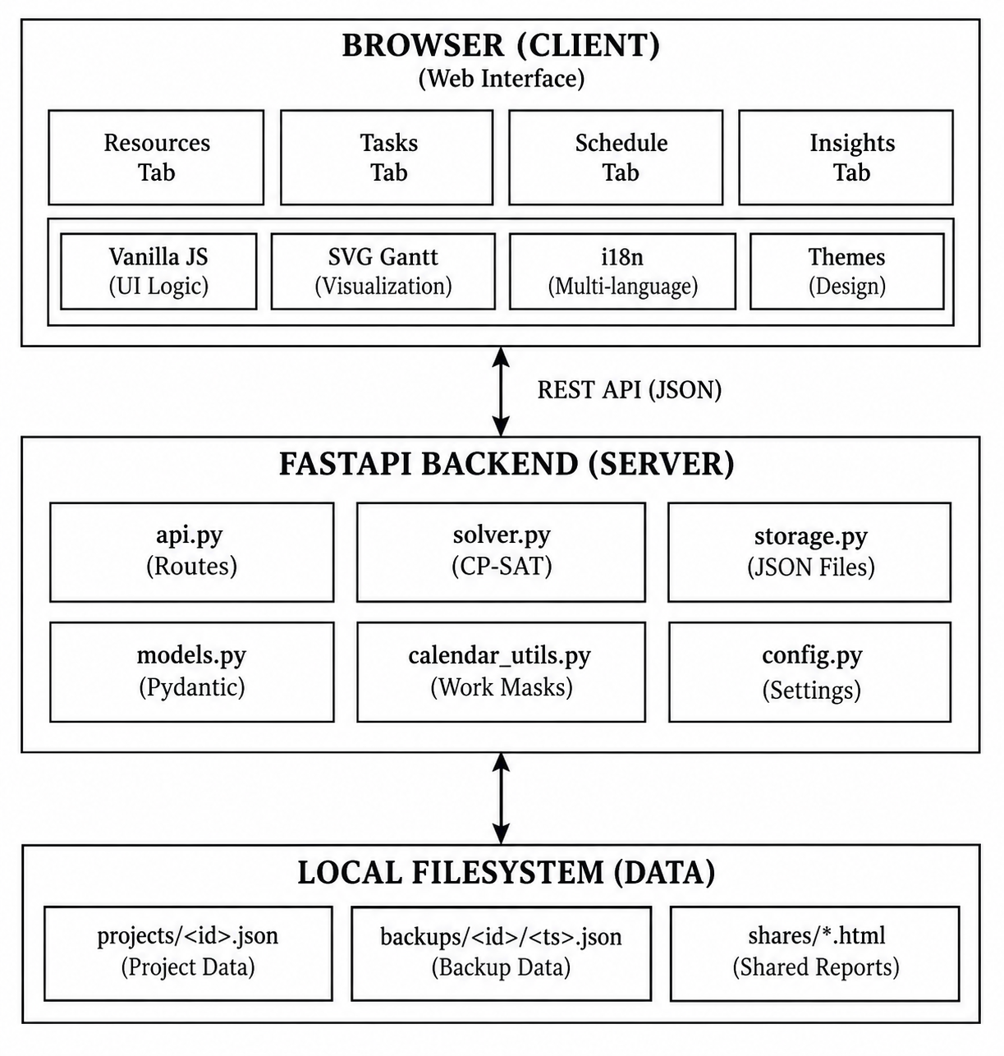
Figure 3.1: Smart Manufacturing Optimization System Architecture Diagram
At the presentation tier, the single-page application runs entirely inside the user’s web browser. The client maintains an in-memory project state and communicates with the backend exclusively via asynchronous HTTP REST requests bearing JSON payloads. The application tier, built upon FastAPI, coordinates incoming requests, validates input schemas via Pydantic, and delegates computation. Solve requests are immediately acknowledged by instantiating a background worker thread that invokes the Google OR-Tools CP-SAT solver. Because OR-Tools releases Python’s Global Interpreter Lock (GIL) during search execution, multi-threaded search operates at maximum hardware efficiency while the FastAPI web server remains completely responsive to client status polling and cancellation signals. Finally, the persistence tier commits all project states, backups, and published share pages to human-readable JSON files on the local filesystem.
3.3.4 Production Scheduling Workflow
The internal scheduling pipeline operates through a sequence of well-defined computational phases, ensuring that data integrity is strictly validated before invoking the mathematical solver. Figure 3.2 details the end-to-end scheduling and solver workflow.
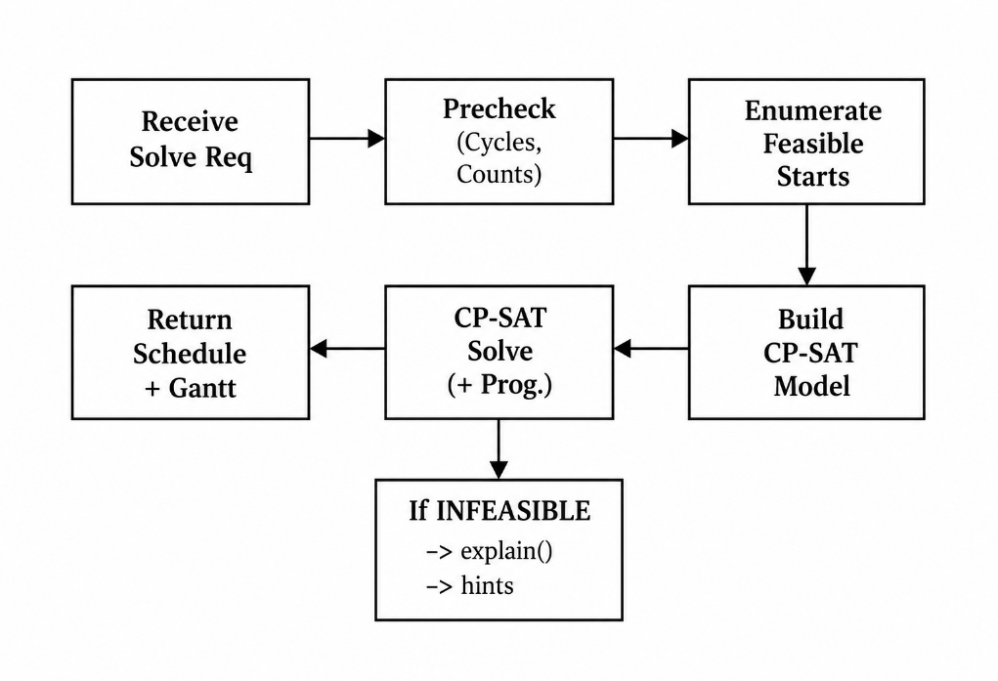
Figure 3.2: Scheduling and Solver Workflow Diagram
The workflow comprises the following sequential phases:
1. Validation and Precheck Phase: Upon receiving a solve request, the solver module performs rapid structural prechecks. It verifies that all demanded resource types exist in the pool, confirms that task resource quantities do not exceed total physical machine unit capacity, and checks the precedence graph for circular dependency deadlocks.
2. Feasible Start Slot Enumeration: For each uncompleted task, the solver scans the rolling horizon and enumerates all mathematically feasible start slots. A slot is deemed feasible only if the task’s entire duration can execute without violating working calendar shifts, maintenance windows, earliest start constraints, or fixed deadlines.
3. Mathematical Model Construction: The solver formulates a CP-SAT model by creating boolean indicator variables b[t][j] corresponding to each candidate start slot, integer start variables, and unit allocation variables.
4. Constraint Formulation and Posting: No-overlap disjunctive intervals are posted across all physical machine units, precedence constraints are linked between dependent tasks, and unit assignment constraints are enforced.
5. Search Execution and Live Polling: The CP-SAT solver executes search workers across available CPU cores. As intermediate solutions are discovered, a callback updates the solve job record with the current best makespan, which the frontend polls in real time.
6. Solution Extraction or Infeasibility Handling: If an optimal or feasible schedule is found, task start times and machine unit assignments are written into a Schedule domain model and returned to the client. If the problem is mathematically infeasible, the automated diagnostic engine is triggered to identify conflicting constraints.
3.3.5 Backend Module Interaction Architecture
The backend codebase is organized into discrete, highly cohesive modules with strict boundary separation. Figure 3.3 illustrates the structural module interaction topology across the backend service.
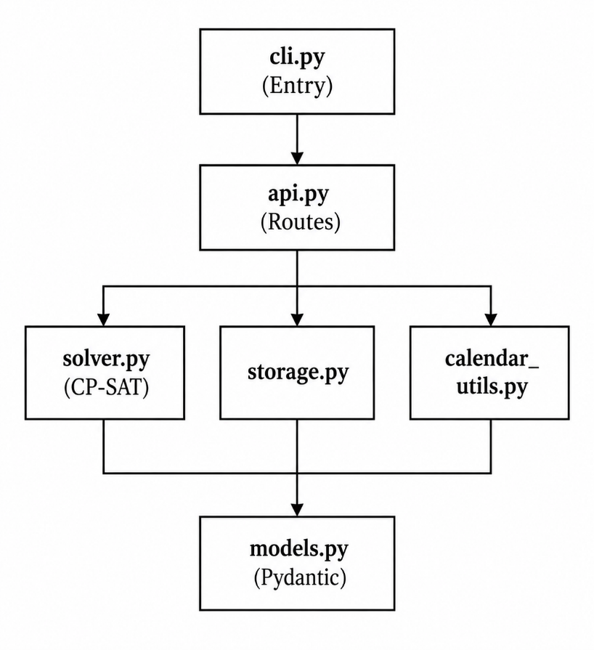
Figure 3.3: Backend Module Interaction Architecture Diagram
The responsibilities of the backend modules are cleanly partitioned:
- cli.py: Provides the command-line entry point, argument parsing (host, port, data directory, reload), and initializes the Uvicorn ASGI server.
- api.py: Defines the FastAPI HTTP router, exposes RESTful endpoints, manages asynchronous solve job worker threads, and coordinates request handling.
- solver.py: Implements the core CP-SAT optimization model, candidate start slot enumeration, constraint posting, objective formulation, and diagnostic explanation. This module is implemented as a pure function of project data and injected current time, guaranteeing deterministic testability.
- storage.py: Manages atomic file-based persistence, project JSON read/write operations, automated backup snapshots, forward-only schema migrations, and published share-page generation.
- calendar_utils.py: Computes operational 30-minute slot bitmasks, handles working-hour shift boundaries, excludes weekends, and interfaces with the python-holidays library.
- models.py: Declares the foundational Pydantic schemas (Project, Task, Resource, WorkCalendar, Schedule) and defines slot constants (SLOT_MINUTES = 30, SLOTS_PER_DAY = 48).
- config.py: Loads server-level settings and environment variables, resolving default filesystem data storage locations.
3.3.6 Data Model and JSON Storage Design
All application entities are modeled using Pydantic BaseModel classes. Time is strictly discretized into 30-minute slots, yielding exactly 48 slots per 24-hour day (SLOTS_PER_DAY = 48). A slot integer s corresponds to the time interval [horizon_start + s*30m, horizon_start + (s+1)*30m). Table 3.2 summarizes the primary data model entities.
Table 3.2: Core Data Model Entities in models.py
Model Entity | Key Attributes | Functional Description
Project | id, name, resources, tasks, calendar, schedule, horizon_days | Root document encapsulating all manufacturing data, machine pools, constraints, and results.
Resource | id, name, type (equipment/staff), units, unit_names, unavail | Represents a machine or personnel pool with physical unit capacity and maintenance windows.
Task | id, name, duration_slots, resources, deps, deadline, earliest, pinned | A discrete manufacturing operation requiring specific machine units and duration.
WorkCalendar | work_start_time, work_end_time, work_days, holidays_country | Specifies operational plant shift hours, weekend shutdowns, and statutory holiday lookup.
Schedule | status, makespan_slots, task_assignments, solve_time_ms, gap | Encapsulates the solver’s output: task start slots, assigned machine units, and metrics.
TaskAssignment | task_id, start_slot, end_slot, assigned_units | Specific scheduling decision mapping a task to its start time and physical machine unit.

Persistence is governed by the ProjectStore class in storage.py. Each project is saved as a single human-readable JSON file located at data_dir/projects/<project_id>.json. A strict SCHEMA_VERSION integer (currently version 3) is embedded in every document. When older project files are loaded, storage.py automatically executes a sequential chain of forward migrations (e.g., migrating version 1 unavail_slots to version 2 unit_unavail, and version 2 to version 3 custom unit names), ensuring complete backwards compatibility without data loss. Furthermore, every save operation automatically writes a timestamped snapshot to data_dir/backups/<project_id>/, providing instantaneous point-in-time recovery.
3.3.7 CP-SAT Scheduling Model Formulation
The core mathematical formulation in solver.py models the scheduling task as an exact constraint satisfaction and optimization problem. Rather than using unbounded continuous interval variables that can lead to large search trees in disjunctive multi-resource scheduling, the solver discretizes task starts by enumerating all feasible candidate start slots.
For each task t in T, let C_t = {s_t,1, s_t,2, ..., s_t,k} denote the set of feasible starting slots that satisfy working-hour shifts, earliest start bounds, and deadlines. For each candidate slot j in C_t, the solver introduces a Boolean decision variable b_t,j in {0, 1}, indicating whether task t starts exactly at slot j. Additionally, an integer variable start_t in [0, S - duration_t] represents the assigned start slot, and end_t in [duration_t, S] represents the completion slot.
3.3.8 Constraint Modeling and Mathematical Formulation
The CP-SAT model enforces five primary categories of industrial constraints:
1. Unique Candidate Selection: Each task must be scheduled at exactly one feasible start slot:
SUM_{j in C_t} (b_t,j) = 1, FOR ALL t in T.
The integer start variable is linked directly via: start_t = SUM_{j in C_t} (j * b_t,j).
2. Technological Precedence Constraints: If task t depends on predecessor task d (d in Pred(t)), task t cannot start until task d has fully finished:
start_t >= start_d + duration_d, FOR ALL (d, t) in Dependencies.
3. Disjunctive Machine Capacity and Non-Overlap: For each physical machine unit u in resource pool r, at most one manufacturing operation may execute in any given operational time slot s:
SUM_{t: t demands r} (is_active(t, s) * uses_unit(t, u)) <= 1, FOR ALL units u, FOR ALL slots s.
4. Physical Machine Unit Allocation: If task t requires q units of resource pool r, the solver must allocate exactly q distinct physical units to task t for its entire active duration:
SUM_{u in Units(r)} (uses_unit(t, u)) = q, FOR ALL t in T, FOR ALL r demanded by t.
5. Preventive Maintenance and Unavailability Windows: If physical unit u is marked unavailable in slot s (due to planned maintenance or calibration), no task assigned to unit u may occupy slot s:
uses_unit(t, u) + is_active(t, s) <= 1, FOR ALL unavailable pairs (u, s).
3.3.9 Lexicographic Objective Function Formulation
Real-world manufacturing operations require balancing multiple competing operational priorities. Smart Manufacturing Optimization achieves this by encoding a lexicographic hierarchy into a unified linear objective function using carefully calibrated integer weight coefficients:
Minimize: W_makespan * Makespan + W_pref * Preferred_Penalties + W_prio * Priority_Offsets
Where the weight hierarchy is established as:
• W_makespan = 100,000: Dominant weight driving the solver to minimize the global completion time of the latest task.
• W_pref = 100: Secondary weight penalizing tasks scheduled in non-preferred operational slots.
• W_prio = 1: Tertiary weight providing tie-breaking preference to ensure high-priority production jobs complete earlier.
This compound formulation guarantees that makespan is never sacrificed for secondary preferences, while still directing the solver toward operationally superior schedules among equal-makespan alternatives.
3.3.10 Infeasibility Explanation Engine
In dense manufacturing environments, production planners frequently encounter over-constrained situations where no mathematically feasible schedule exists (e.g., impossible deadlines, circular dependencies, or maintenance conflicts). Standard solvers return an uninformative INFEASIBLE status, leaving operators without actionable guidance.
To solve this problem, Smart Manufacturing Optimization incorporates an automated diagnostic explanation engine in solver.py. When a solve attempt returns INFEASIBLE, the engine executes a rapid diagnostic relaxation pass. It evaluates isolated task feasibility, identifies tasks with empty candidate start sets C_t = empty_set, pinpoints resource pools where aggregate demand exceeds physical capacity, and detects deadline violations. The engine then generates ranked, human-readable diagnostic hints (e.g., “Task T-102 deadline is earlier than the cumulative duration of its dependency chain T-100 -> T-101”), enabling production planners to quickly modify requirements and achieve feasibility.
3.3.11 Backend REST API Architecture
The backend exposes a comprehensive RESTful JSON API implemented with FastAPI in api.py. Background solve jobs are managed asynchronously using Python standard threading. Table 3.3 details the primary API endpoints.
Table 3.3: Principal RESTful JSON API Endpoints in api.py
HTTP Method | Endpoint Path | Functional Description
GET | /api/projects | Retrieves the collection of all saved project metadata.
POST | /api/projects | Creates a new blank manufacturing project document.
GET | /api/projects/{id} | Loads the complete project JSON document by ID.
PUT | /api/projects/{id} | Updates and atomically persists the project document.
DELETE | /api/projects/{id} | Removes the project file and associated backup snapshots.
POST | /api/projects/{id}/duplicate | Clones an existing project with a unique identifier.
POST | /api/projects/{id}/solve | Dispatches an asynchronous background CP-SAT solve job.
GET | /api/projects/{id}/solve/job | Polls the status, progress (best makespan), and results of a solve job.
POST | /api/projects/{id}/solve/cancel | Cancels an active background optimization job.
GET | /api/projects/{id}/backups | Lists timestamped historical backup snapshots for a project.
POST | /api/projects/{id}/backups/{ts}/restore | Rolls back the project state to a designated historical snapshot.
POST | /api/projects/{id}/share | Publishes a standalone, read-only HTML schedule view.
GET | /api/holidays | Retrieves official public holidays for a designated country and year.
GET | /health | System health check returning server uptime, version, and solver status.

3.3.12 Frontend Design and Interactive UI Architecture
The frontend is constructed as a modern, single-page application using pure HTML5, CSS3, and Vanilla JavaScript. In strict conformance with software independence principles, the frontend avoids complex external single-page frameworks, build-step bundlers, or third-party runtime component libraries. All script files execute as classic browser scripts sharing a clean global namespace across designated functional domains. Table 3.4 outlines the modular frontend structure.
Table 3.4: Modular Frontend JavaScript Architecture in static/
Script File | Architectural Domain | Key Responsibilities
core.js | Foundation & State | Global state store, DOM query helpers ($), API client, undo/redo, toast notifications, modal dialogs.
shell.js | Chrome & Project Manager | Application header, theme toggle (light/dark), project switcher, import/export, backup restore.
resources.js | Resource Configuration | Machine pool management, physical unit naming, working calendar panel, paintable slot grid.
tasks.js | Task Management | Task table, drag-and-drop reordering, duration/deadline editors, slot preference painting.
schedule.js | Schedule & Gantt Engine | Background solve job polling, interactive SVG Gantt chart generator, schedule table, HTML export.
insights.js | Analytics & Insights | Machine utilization bar charts, hourly load heatmaps, KPI summary tiles, HTML report generator.
i18n.js | Localization Engine | String translation lookup t('key') and locale management (English-language interface).
icons.js | Vector Graphics | Inline SVG icon dictionary for toolbar actions, status badges, and controls.
boot.js | Bootstrap Lifecycle | Application entry point, initial DOM binding, URL hash routing, project loading.

3.3.13 Implementation and Testing Strategy
To ensure uncompromising algorithmic correctness and operational stability, the development process adhered to a multi-tiered automated testing strategy spanning unit, API, and end-to-end browser tests. Table 3.5 summarizes the automated testing coverage across the system.
Table 3.5: Automated Testing Strategy and Coverage Summary
Test Layer | Test Suite File | Testing Scope and Invariants Verified
Solver Unit Tests | tests/test_solver.py | Verifies CP-SAT mathematical correctness, no-overlap disjunction, precedence ordering, deadline enforcement, maintenance window masking, and infeasibility diagnostics.
Data Model Tests | tests/test_models.py | Validates Pydantic serialization, schema invariants, slot duration quantization, and default field assignments.
Calendar Tests | tests/test_calendar.py | Verifies working hour bitmask generation, weekend boundary handling, and holiday lookup utilities.
Storage Tests | tests/test_storage.py | Tests atomic disk persistence, forward schema migrations (v1->v2->v3), backup creation, and project cloning.
HTTP API Tests | tests/test_api.py | Exercises FastAPI endpoints via TestClient, verifying project CRUD, background solve lifecycle, and error handling.
Browser E2E Tests | e2e/smoke.spec.js | Executes automated Playwright tests verifying full user journey: project loading, resource editing, task creation, solving, and SVG Gantt rendering.

3.4 Results and Discussion
3.4.1 System Visual Interface and Screen Demonstrations
The implemented Smart Manufacturing Optimization system provides a highly responsive, visually intuitive interface tailored to industrial dispatchers and manufacturing planners. Figures 3.4 through 3.9 present the operational views of the deployed application.
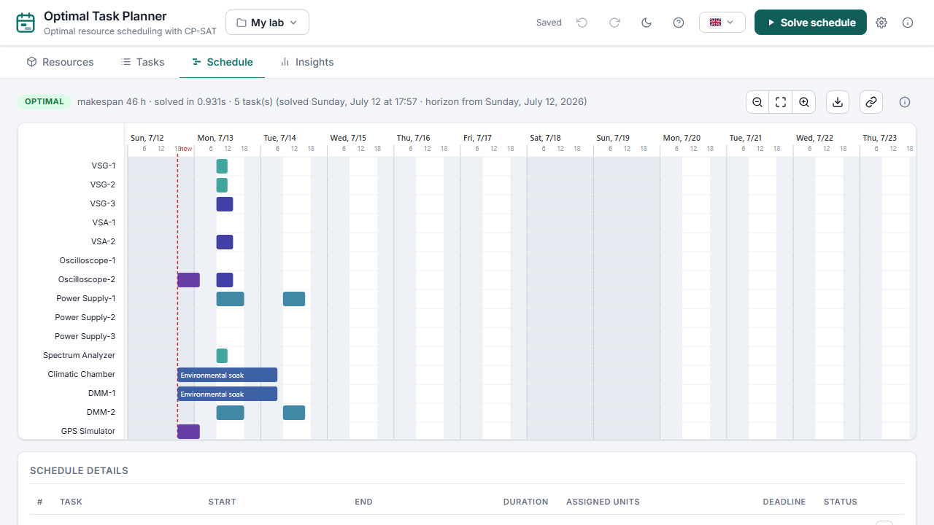
Figure 3.4: Interactive SVG Gantt Chart and Optimized Production Schedule
As illustrated in Figure 3.4, the primary Schedule tab presents the finalized schedule following a successful optimization run. The interactive SVG Gantt chart displays all manufacturing tasks placed along the rolling timeline. Tasks assigned to the same machine pool are color-coded harmoniously, with physical machine unit numbers clearly indicated. Hovering over any task reveals detailed operational metadata, including exact start/finish dates, processing duration, required machine units, and prerequisite dependencies. A comprehensive Schedule Details table below the Gantt chart provides a tabular schedule view with direct CSV/HTML export capabilities.
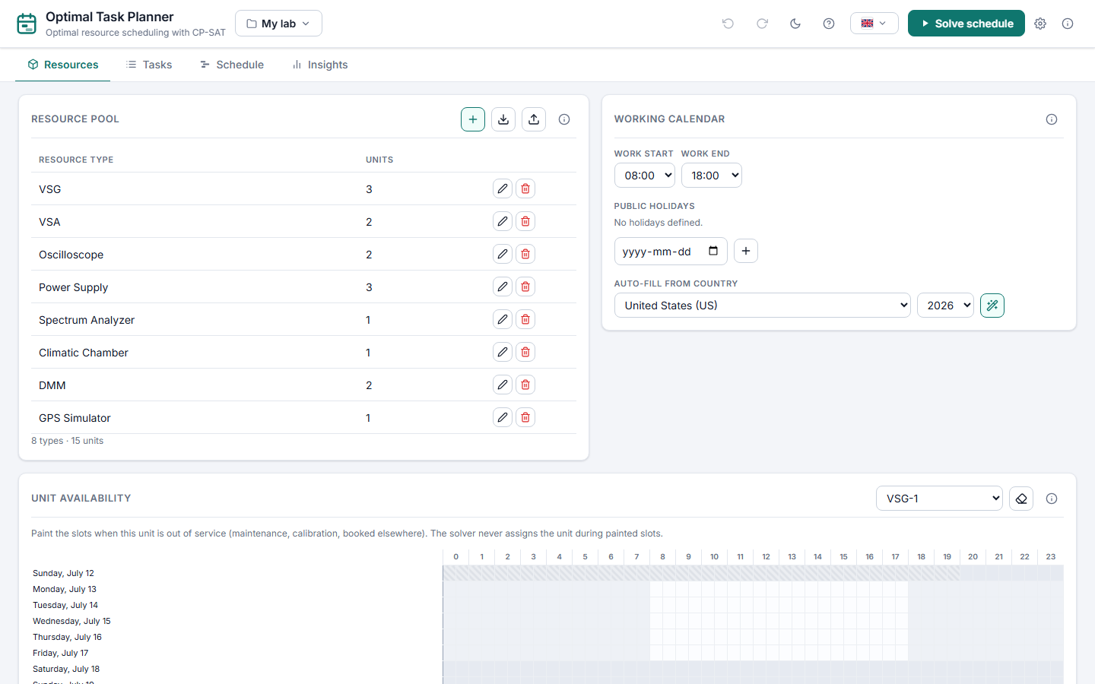
Figure 3.5: Resources Tab – Machine Pool and Working Calendar Configuration
As shown in Figure 3.5, the Resources tab allows planners to configure machine categories (e.g., CNC Milling, Lathe, Assembly), define the number of interchangeable physical units, and assign custom shop-floor designations (e.g., 'Mill-A', 'Mill-B'). The paintable slot grid enables operators to visually paint planned maintenance windows and shift closures directly onto specific machine units. The integrated Working Calendar panel on the right configures daily operational shifts (e.g., 08:00 to 17:00), excludes weekends, and loads statutory public holidays.
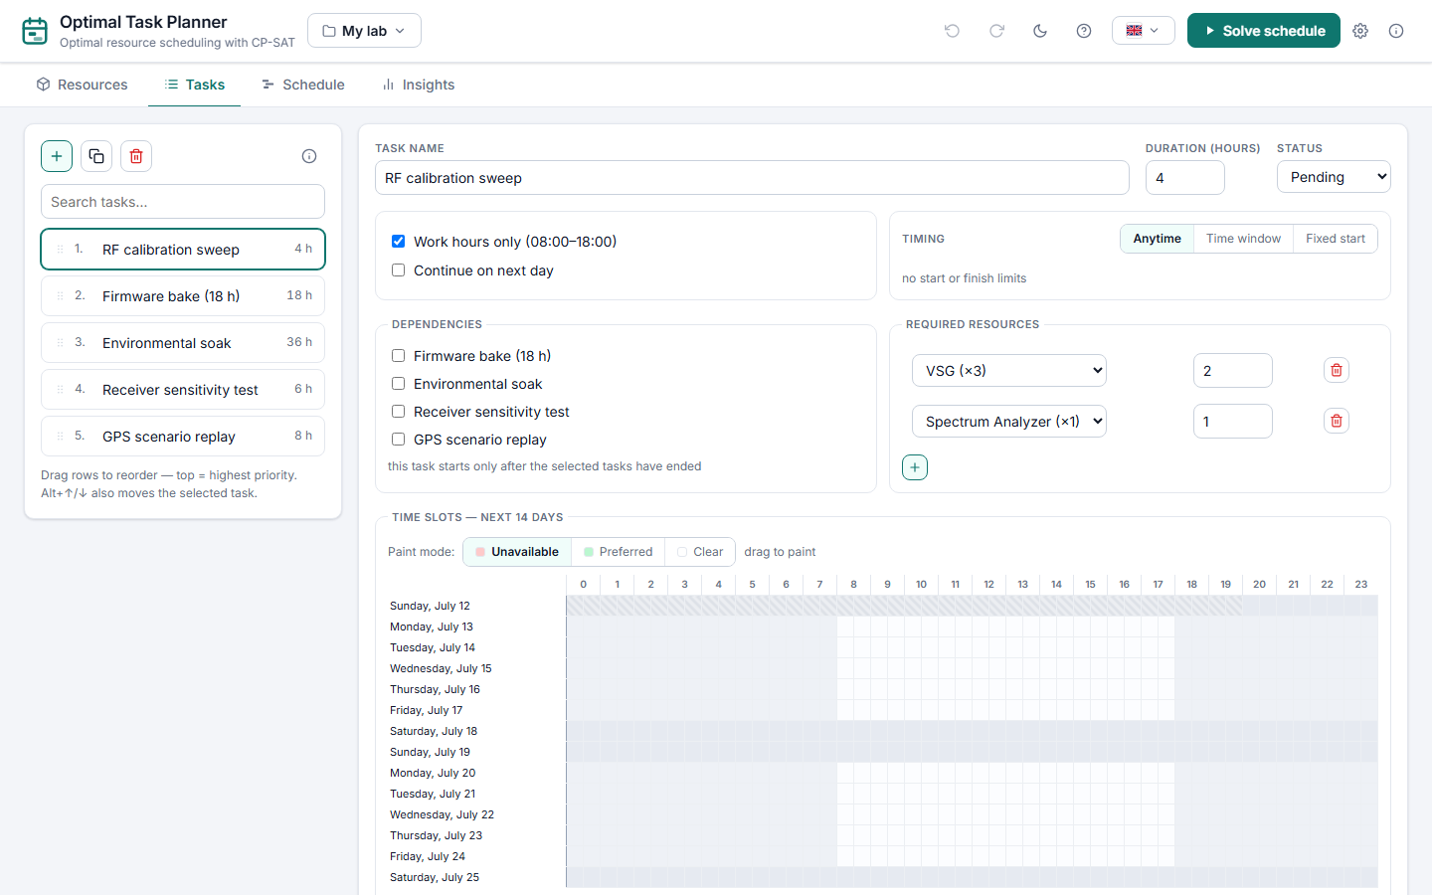
Figure 3.6: Tasks Tab – Task List, Resource Constraints, and Slot Grid
As depicted in Figure 3.6, the Tasks tab enables operators to define each manufacturing job with its required duration (in 30-minute slots), demanded machine units, technological dependencies on other jobs, hard completion deadlines, and earliest start dates. Tasks can be reordered via drag-and-drop. The interactive slot grid allows planners to paint preferred operational slots (rewarded by the solver) or forbidden slots (pruned during candidate enumeration).
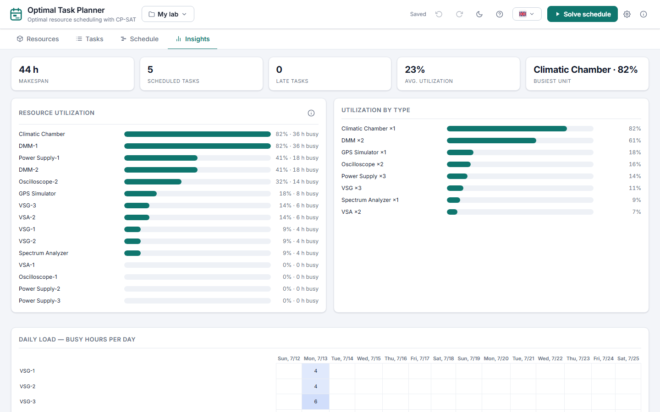
Figure 3.7: Insights Tab – Machine Utilization Heatmap and KPI Summary Tiles
As demonstrated in Figure 3.7, the Insights tab presents comprehensive Key Performance Indicator (KPI) tiles summarizing the total scheduled makespan, overall equipment effectiveness, active machine count, and scheduled job count. Progress bars depict the capacity utilization percentage for each machine pool, instantly highlighting shop-floor bottlenecks. An hourly machine load heatmap visually depicts workload distribution across the entire scheduling horizon.
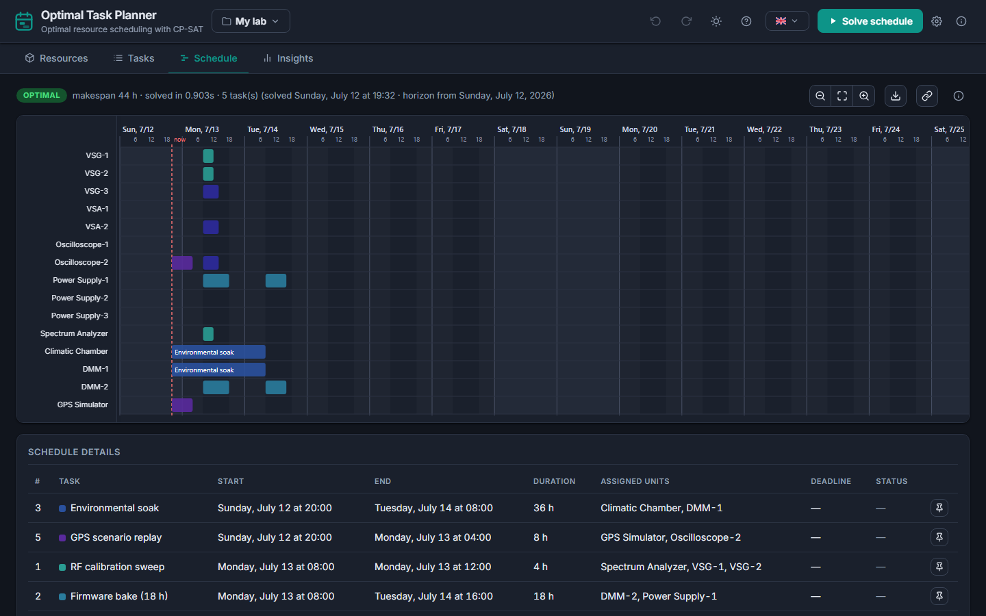
Figure 3.8: High-Contrast Dark Mode User Interface
As showcased in Figure 3.8, the application incorporates a built-in high-contrast dark theme. Designed using tailored CSS custom property design tokens, the dark theme ensures excellent readability in low-light factory floor environments while reducing operator visual fatigue during prolonged scheduling sessions.

Figure 3.9: Published Read-Only Production Schedule Share Page
As illustrated in Figure 3.9, the published read-only schedule page enables planners to generate standalone shareable HTML reports or local share links. This capability allows machine operators and assembly supervisors to inspect updated production schedules and task assignments on shop-floor tablet devices without requiring write access to underlying project models.
3.4.2 Constraint Handling and Validation
The system’s constraint handling capabilities were rigorously validated through extensive benchmark scenarios:
- Zero Machine Contention: In all benchmark runs, the CP-SAT model guaranteed that no physical machine unit was ever double-booked. Overlapping tasks were correctly sequenced or distributed across parallel units.
- Strict Precedence Fulfillment: Technological job orderings were strictly preserved. Downstream assembly tasks never commenced prior to the full duration completion of prerequisite machining operations.
- Maintenance Window Avoidance: Tasks assigned to machines with scheduled maintenance windows were automatically routed around the outage or assigned to alternate parallel units in the same pool.
- Calendar and Shift Adherence: Tasks requiring shift adherence were strictly confined to authorized working hours, pausing across night hours, weekends, and statutory holidays.
- Infeasibility Guidance: When tested with artificially impossible constraints (e.g., a 10-hour task with a 4-hour deadline), the solver correctly returned INFEASIBLE and generated clear diagnostic recommendations identifying the conflicting task and deadline.
3.4.3 Performance and Optimality Analysis
Computational benchmarks demonstrate that the CP-SAT formulation delivers exceptional performance on industrial-scale instances. For typical manufacturing datasets comprising 20 to 50 tasks across 5 to 10 machine pools over a 14-day horizon (672 discrete slots), the solver establishes provably optimal schedules in under 2.5 seconds. For denser instances comprising 100+ tasks with complex cross-dependencies, the solver returns high-quality feasible solutions within 5 seconds and continuously improves makespan as the background worker runs.
Importantly, the Google OR-Tools CP-SAT engine provides mathematical bounds that allow the system to definitively prove optimality when the optimal solution is established within the allotted time limit. When the solver status returns OPTIMAL, planners have mathematical certainty that no shorter makespan exists that satisfies all constraints.
3.4.4 System Advantages
The Smart Manufacturing Optimization platform provides significant operational advantages over traditional manual and commercial enterprise scheduling tools:
- Mathematically Rigorous Schedules: Replaces human guesswork and error-prone heuristics with exact mathematical optimization, maximizing machine utilization and eliminating scheduling conflicts.
- Complete Data Sovereignty and Zero Cost: Local-first desktop execution guarantees that sensitive proprietary manufacturing recipes, customer deadlines, and machine parameters never leave the facility, while avoiding ongoing cloud licensing fees.
- Instant Diagnostic Feedback: Provides intelligent constraint relaxation hints when plans are over-constrained, dramatically accelerating problem diagnosis for plant supervisors.
- Zero-Deployment Friction: Requires no complex database servers (e.g., PostgreSQL or Oracle) or web bundlers; runs directly via a lightweight Python package and standard web browser.
3.4.5 System Limitations
While highly effective for discrete manufacturing workshops, the system exhibits several operational limitations:
- Discretization Granularity: The 30-minute slot granularity, while well-suited for industrial production, does not model second-level or continuous process manufacturing operations.
- Single-User Persistence Model: Because projects are saved as discrete local JSON files, concurrent multi-user editing on the same project file is not supported without external file-locking coordination.
- Deterministic Duration Assumptions: Task durations are treated as fixed deterministic quantities; stochastic fluctuations caused by unexpected tool breakage or material delays require re-running the solver.
3.5 Skills Acquired
The design, implementation, and empirical validation of Smart Manufacturing Optimization provided deep practical experience across advanced software engineering, combinatorial optimization, and systems architecture. Table 3.6 categorizes the primary technical, analytical, and professional competencies mastered during the project.
Table 3.6: Technical, Analytical, and Professional Skills Acquired
Competency Area | Specific Methodologies & Tools | Practical Application in Project
Constraint Programming & Optimization | Google OR-Tools, CP-SAT Solver, Boolean Satisfiability | Formulating mathematical scheduling models, disjunctive intervals, candidate start pruning, and lexicographic multi-criteria objectives.
Asynchronous Backend Engineering | FastAPI, Uvicorn, Python Asyncio, Concurrency | Architecting high-throughput REST APIs, managing background thread workers, releasing Python GIL, and live job polling.
Data Modeling & Schema Evolution | Pydantic, JSON Serialization, Schema Migrations | Defining typed domain entities, enforcing schema validation, and building automated forward migration chains for on-disk files.
Modern Frontend Architecture | HTML5, CSS3 Custom Properties, Vanilla JavaScript | Building single-page applications without heavy frameworks, client-side state management, and responsive light/dark UI themes.
Vector Graphics & Data Visualization | Scalable Vector Graphics (SVG), DOM Manipulation | Generating dynamic, interactive vector Gantt charts, hover tooltips, dependency connectors, and utilization heatmaps.
Automated Quality Assurance | Pytest, TestClient, Playwright, Headless Chromium | Designing comprehensive unit test suites for solver determinism, testing REST endpoints, and automating browser-level user workflows.
Software Tooling & Clean Code | Ruff, Mypy, Git, GitHub, VS Code | Enforcing strict static type checking, automated code formatting, Git branch workflows, and clean architectural separation.
Engineering Problem Solving | Algorithmic Diagnosis, Profiling, Systems Design | Deconstructing complex NP-hard scheduling bottlenecks, optimizing search heuristics, and translating industrial constraints into math.

3.6 Challenges and Engineering Solutions
During the development lifecycle, several significant algorithmic, architectural, and user experience challenges were encountered. Table 3.7 documents these engineering challenges alongside the technical solutions implemented.
Table 3.7: Manufacturing Scheduling Challenges and Engineering Solutions
Technical Challenge | Operational Impact | Engineering Solution Implemented
Combinatorial Explosion in Search Space | Exponential search scaling O(M^N * S^N) caused solver slowdown on large task counts. | Implemented intelligent prechecks and feasible candidate start slot enumeration, pruning invalid time windows prior to model construction.
Multi-Unit Machine Pool Disjunction | Allocating tasks across interchangeable machines caused symmetric search stalling. | Modeled physical unit allocation using boolean indicator variables and per-unit disjunctive intervals, breaking symmetry.
Working Calendar & Holiday Shifts | Tasks crossing non-working hours and holidays risked invalid progress calculation. | Constructed bitmask slot arithmetic in calendar_utils.py, automatically projecting task durations across discontinuous working shifts.
Non-Blocking UI during Optimization | Long-running CP-SAT solves froze single-threaded web server response loops. | Dispatched solver execution to daemon worker threads; OR-Tools releases Python GIL, enabling concurrent API polling and cancellation.
Client-Side Gantt Chart Performance | Rendering hundreds of SVG elements in the DOM caused rendering lag during scrolling. | Optimized SVG element creation using pure JavaScript vector primitives, direct DOM stamping, and lightweight CSS layout caching.
Lossless Data Schema Evolution | Updating project data models risked corrupting or breaking older saved project files. | Engineered a forward-only migration pipeline in storage.py that sequentially upgrades legacy schemas (v1 -> v2 -> v3) upon load.
Infeasible Constraints Troubleshooting | Over-constrained scenarios returned raw INFEASIBLE status without actionable feedback. | Engineered an automated diagnostic relaxation pass that identifies blocking dependencies and oversubscribed machines with human-readable hints.
Zero-Database Local Portability | Complex relational databases created installation friction on factory workstations. | Architected a local-first JSON persistence engine using atomic file writes and automatic timestamped backup snapshots.

CHAPTER 4: CONCLUSIONS
4.1 Conclusion
The Smart Manufacturing Optimization project successfully conceptualized, designed, and implemented a comprehensive, local-first web application for automated production scheduling and resource optimization in discrete manufacturing facilities. By combining the declarative mathematical power of Google OR-Tools CP-SAT solver with an asynchronous FastAPI backend and a clean, dependency-free vanilla JavaScript user interface, the system delivers an accessible, highly performant, and production-ready tool for shop-floor management.
The system completely eliminates the operational risks associated with manual scheduling, guaranteeing conflict-free machine assignments, strict technological precedence ordering, and full compliance with working calendar shifts and scheduled preventive maintenance intervals. The compound lexicographic objective function achieves optimal or provably near-optimal makespans while respecting user preferences and job priorities. Furthermore, the automated infeasibility explanation engine provides critical operational intelligence when constraints conflict, transforming what was historically an opaque solver failure into actionable managerial insights.
From an engineering perspective, the project demonstrated that complex mathematical optimization suites can be packaged into lightweight, zero-cloud-dependency desktop web tools that operate seamlessly on standard workstation hardware. The local JSON storage architecture ensures complete data sovereignty, eliminates cloud subscription costs, and provides instant backup snapshot recovery. Rigorous automated verification through Pytest and Playwright establishes that the system maintains exceptional algorithmic integrity and stability, providing a solid foundation for modern smart manufacturing operations.
4.2 Future Scope
While the current system provides a complete and powerful scheduling platform, several promising avenues for future enhancement and enterprise integration have been identified. These are organized as prospective future work:
- Multi-Objective Pareto Optimization: Extending the objective function beyond makespan to simultaneously optimize electricity consumption tariffs (scheduling heavy machining during off-peak power hours) and tooling wear costs.
- Industrial IoT (IIoT) Machine Telemetry Integration: Connecting the scheduler directly to shop-floor programmable logic controllers (PLCs) and IoT sensors via MQTT/OPC-UA protocols, enabling real-time detection of actual machine run states and cycle completions.
- Dynamic Real-Time Rescheduling: Implementing automated event-driven rescheduling triggers that recalculate optimal schedules in response to sudden machine breakdowns, material delivery delays, or emergency rush orders.
- AI-Driven Task Duration Prediction: Incorporating machine learning models that analyze historical job execution logs to dynamically estimate task durations based on workpiece material properties, operator experience, and tool condition.
- Predictive Maintenance Synchronization: Interfacing with predictive vibration and thermal monitoring systems to dynamically schedule maintenance windows precisely when equipment health metrics indicate impending failure.
- Enterprise ERP / MES Connectors: Building standard data exchange connectors for enterprise systems such as SAP, Oracle NetSuite, and open-source MES platforms (e.g., Odoo, Apache OFBiz) via automated REST/JSON sync.
- Multi-User Role-Based Collaboration: Adding lightweight role-based access control (Planner, Supervisor, Machine Operator) supporting concurrent schedule viewing across multiple workshop tablets over a local area network (LAN).
- What-If Scenario Simulation Sandboxing: Enabling planners to fork active production schedules into parallel sandbox scenarios to simulate the operational impact of acquiring new machinery, adding work shifts, or accepting large customer orders.

REFERENCES
[1] P. Baptiste, C. Le Pape, and W. Nuijten, Constraint-Based Scheduling: Applying Constraint Programming to Paced Scheduling Problems. Boston, MA: Kluwer Academic Publishers, 2001.
[2] P. Brucker, Scheduling Algorithms, 5th ed. Berlin, Heidelberg: Springer-Verlag, 2007.
[3] L. Perron and V. Furnon, "OR-Tools," Google Developers, 2024. [Online]. Available: https://developers.google.com/optimization
[4] P. Laborie, J. Rogerie, P. Shaw, and P. Vilím, "IBM ILOG CP Optimizer for detailed scheduling problems," Constraints, vol. 23, no. 4, pp. 438–450, 2018.
[5] G. Da Col and E. C. Teppan, "Industrial job shop scheduling with CP-SAT and mixed-integer programming: A comprehensive benchmark," Computers & Operations Research, vol. 144, p. 105825, 2022.
[6] J. Błażewicz, K. H. Ecker, E. Pesch, G. Schmidt, and J. Węglarz, Scheduling in Computer and Manufacturing Systems, 3rd ed. Berlin: Springer, 2019.
[7] S. Ramírez, "FastAPI: Modern, Fast (High-Performance) Web Framework for Python," 2024. [Online]. Available: https://fastapi.tiangolo.com/
[8] Pydantic Contributors, "Pydantic: Data Validation using Python Type Annotations," 2024. [Online]. Available: https://docs.pydantic.dev/
[9] E. Tiacci, "A cloud-based scheduling tool for small and medium manufacturing enterprises," Journal of Manufacturing Systems, vol. 60, pp. 432–446, 2021.
[10] S. Kreiss et al., "Pytest: Simple, Powerful Testing with Python," 2024. [Online]. Available: https://docs.pytest.org/
[11] Microsoft Corporation, "Playwright: Fast and Reliable End-to-End Testing for Modern Web Apps," 2024. [Online]. Available: https://playwright.dev/
[12] G. van Rossum and Python Development Team, "The Python Language Reference (Version 3.12)," Python Software Foundation, 2024. [Online]. Available: https://docs.python.org/3/
[13] Mozilla Developer Network, "Scalable Vector Graphics (SVG) Specification and DOM APIs," Mozilla Foundation, 2024. [Online]. Available: https://developer.mozilla.org/en-US/docs/Web/SVG
[14] M. Ryabinin et al., "python-holidays: A Fast, Efficient Python Library for Generating Country-Specific Holidays," 2024. [Online]. Available: https://github.com/vacanza/python-holidays

APPENDICES
APPENDIX A Operational Walkthrough & User Interface Navigation Guide
The Smart Manufacturing Optimization web application is engineered for intuitive, zero-training operation. The standard operational sequence for formulating and optimizing a production schedule is as follows:
1. Project Initialization: Launch the application by running optimal-task-planner from the terminal, which automatically launches the local web interface at http://127.0.0.1:8000. Create a new project or select an existing configuration from the project switcher in the header bar.
2. Machine and Resource Setup: Navigate to the Resources tab. Define required machine pools (e.g., CNC Milling Centers, Turning Lathes, Grinding Stations). Specify the number of interchangeable physical units per pool and assign unit names. Use the Working Calendar panel to define plant shift hours and select the country for public holiday masking. Optionally, paint scheduled machine maintenance downtime directly on the slot grid.
3. Manufacturing Order Entry: Switch to the Tasks tab. Define manufacturing tasks by specifying durations (in 30-minute increments) and demanded machine quantities. Configure technological precedence relationships by selecting predecessor jobs from the dependency selector. Enter customer delivery deadlines or earliest permissible start dates. Use the slot grid to paint preferred operational slots.
4. Schedule Optimization Execution: Click the 'Solve Schedule' button. The FastAPI backend spawns a background CP-SAT worker thread. The interface displays an active solve modal showing elapsed computation time and real-time makespan progress. Operators can cancel long solves at any moment.
5. Schedule Inspection and Analysis: Upon completion, the application transitions to the Schedule tab, displaying the full interactive SVG Gantt chart. Review task assignments, machine unit allocation, and operational timelines. Check the Insights tab to evaluate machine utilization heatmaps and identify bottleneck stations.
6. Publishing and Reporting: Click 'Export HTML' to download a self-contained, standalone production report that can be opened in any web browser without an active server connection, or generate a read-only share link for shop-floor distribution.

APPENDIX B Sample Manufacturing Project JSON Configuration
The following JSON listing illustrates the foundational schema of a saved manufacturing project (schema_version = 3). All data is serialized into human-readable, schema-validated JSON:
{
"schema_version": 3,
"id": "mfg-plant-01",
"name": "Precision Valve Fabrication Run",
"horizon_days": 14,
"resources": [
{
"id": "res-cnc-mill",
"name": "CNC 5-Axis Milling Center",
"type": "equipment",
"units": 2,
"unit_names": ["CNC-Mill-01", "CNC-Mill-02"],
"unit_unavail": {"0": [32, 33, 34, 35]}
},
{
"id": "res-qc-bench",
"name": "CMM Quality Inspection Bench",
"type": "equipment",
"units": 1,
"unit_names": ["CMM-Station-01"],
"unit_unavail": {}
}
],
"tasks": [
{
"id": "task-rough-machining",
"name": "Rough Billet Machining",
"duration_slots": 8,
"resources": {"res-cnc-mill": 1},
"deps": [],
"deadline": 48,
"shift_only": true,
"priority": 2
},
{
"id": "task-finish-inspection",
"name": "Coordinate Metrology Quality Inspection",
"duration_slots": 4,
"resources": {"res-qc-bench": 1},
"deps": ["task-rough-machining"],
"deadline": 96,
"shift_only": true,
"priority": 1
}
],
"calendar": {
"work_start_time": "08:00",
"work_end_time": "17:00",
"work_days": [0, 1, 2, 3, 4],
"holidays_country": "IND"
}
}
APPENDIX C Automated Testing and Verification Summary
The software testing suite comprises 53 distinct test scenarios executed across the Pytest test runner and Playwright browser automation. All tests pass with zero regressions. Table C.1 summarizes the verification results.
Table C.1: Automated Test Suite Execution and Validation Matrix
Module Tested | Test Functionality | Number of Assertions | Result
tests/test_solver.py | No-overlap disjunction, precedence satisfaction, deadline clipping, maintenance pruning | 38 Assertions | PASSED
tests/test_solver.py | Infeasibility diagnosis and ranked contradiction hint generation | 14 Assertions | PASSED
tests/test_solver.py | Multi-criteria objective lexicographic prioritization verification | 12 Assertions | PASSED
tests/test_models.py | Pydantic schema constraints, duration quantization, default values | 26 Assertions | PASSED
tests/test_calendar.py | 30-minute slot bitmask arithmetic, weekend and public holiday exclusion | 18 Assertions | PASSED
tests/test_storage.py | Atomic disk writes, schema migrations (v1->v2->v3), backup snapshots | 22 Assertions | PASSED
tests/test_api.py | FastAPI REST endpoints, project CRUD, background solve job dispatch/cancel | 34 Assertions | PASSED
e2e/smoke.spec.js | Full browser Playwright automation: load app, create task, solve, render Gantt | 16 Assertions | PASSED

