JSS Mahavidyapeetha
JSS SCIENCE AND TECHNOLOGY UNIVERSITY

JSS Technical Institutions’ Campus, Mysuru-570006


Title of the Mini Project
SMART MANUFACTURING OPTIMIZATION
Production & Resource Optimization
A Project submitted to
DEPARTMENT OF INFORMATION SCIENCE AND ENGINEERING

JSS Science and Technology University
in partial fulfillment of curriculum prescribed for the award of the degree

Bachelor of Engineering In
INFORMATION SCIENCE AND ENGINEERING

By

Name | USN
ChethanGowda S | 01JST24UIS402

DEPARTMENT OF INFORMATION SCIENCE AND ENGINEERING
JSS Science and Technology University, Mysuru 2025-2026

Abstract

Resource scheduling in manufacturing, laboratory, and engineering environments is a persistent operational challenge. Manual scheduling of shared equipment, personnel, and workstations is time-consuming, error-prone, and often produces suboptimal utilization of expensive resources. This project presents Optimal Task Planner, a complete, local-only web application for optimal resource scheduling over a configurable rolling horizon. The system integrates a FastAPI backend with Google OR-Tools Constraint Programming with Satisfiability (CP-SAT) solver to compute provably optimal or near-optimal schedules. Users define resource pools (equipment, staff, or both), specify tasks with constraints including duration, dependencies, earliest starts, deadlines, preferred and unavailable time slots, and working-hours restrictions. The CP-SAT solver assigns task start times and physical resource units such that no resource is double-booked or used during unavailability windows, while minimizing total makespan, maximizing preferred-slot usage, and scheduling higher-priority tasks earlier through a lexicographic objective function.

The frontend is a dependency-free vanilla JavaScript single-page application that provides an interactive SVG Gantt chart with hover tooltips, a schedule details table, utilization and bottleneck insights, and a configurable working calendar with public holiday support. Data persistence uses human-readable JSON files with schema versioning and automatic backup snapshots, eliminating the need for a database. The system supports multiple projects, undo/redo, import and export, read-only share links, HTML schedule export, and a bilingual (English and Turkish) interface with light and dark themes. Background solve jobs with live progress reporting and cancellation ensure the server remains responsive during optimization. The system represents a significant step towards accessible, offline-capable, and mathematically rigorous resource scheduling for small to medium-scale operations

Table of Contents
Chapter 1: Introduction 01
  - Overview of Resource Scheduling 01
  - About the Project Work 01
  - Motivation 02
  - Challenges 02
  - Problem Definition 03
  - Aim and Objectives 03
Chapter 2: Literature Survey 05
Chapter 3: System Requirements and Specifications 09
  - Functional Requirements 09
  - Non-Functional Requirements 10
  - System Specifications 10
  - Tools and Technologies 11
Chapter 4: System Architecture 12
  - System Architecture Diagram 13
  - User Workflow Diagram 13
  - Scheduling Workflow Diagram 13
  - Module Interaction Diagram 14
Chapter 5: System Design 14
  - Algorithm, Model and Method Explanation 14
  - Results and Discussions 15
  - Backend API Design 15
  - Frontend Design

Chapter 6: Implementation 14
  - Algorithm, Model and Method Explanation 14
  - Results and Discussions 15
  - Backend API Design 15
6.4 Frontend Design 16
6.5 Testing Strategy 25
Chapter 7: Results and Discussion 14
  - System Screenshots 14
  - Discussion of Results 26
Conclusion and Future Scope 20
References 21

Chapter 1: Introduction

Overview of Multiple Sclerosis
Resource scheduling is a critical operational activity in manufacturing plants, engineering test laboratories, healthcare facilities, and research institutions. It involves the assignment of shared resources such as equipment, test stations, or personnel — to a set of tasks, each with specific requirements, constraints, and deadlines. Effective scheduling maximizes resource utilization, minimizes idle time, and ensures that project deadlines are met.
In practice, many organizations still rely on manual scheduling methods, including spreadsheets, whiteboards, and informal coordination. These approaches become increasingly impractical as the number of resources, tasks, and constraints grows. Manual scheduling is prone to conflicts, double-bookings, and suboptimal resource utilization. The mathematical complexity of optimal scheduling — known to be NP-hard in general — means that finding the best schedule among millions of possibilities requires algorithmic techniques beyond human cognitive capacity.

About the Project Work
This project presents Optimal Task Planner, a local-only web application designed for optimal resource scheduling over a configurable rolling horizon. The application is built on a FastAPI backend that hosts the scheduling logic, communicates with a vanilla JavaScript frontend through a RESTful JSON API, and persists all project data as human-readable JSON files on the local filesystem. The core of the application is a CP-SAT optimization model that accepts user-defined resources, tasks, and constraints, and produces a schedule that minimizes total makespan while respecting all constraints. The schedule is displayed as an interactive SVG Gantt chart, accompanied by a details table, utilization insights, and bottleneck analysis. Users can define resource pools consisting of equipment (such as CNC machines, oscilloscopes, or assembly stations), staff, or both. Tasks specify resource requirements, durations, dependencies, deadlines, working-hours restrictions, and preferred or unavailable time slots.

Motivation
In many engineering and manufacturing environments, expensive equipment and specialized personnel are shared across multiple projects and teams. Scheduling these shared resources manually is a significant operational burden. Common problems include:

Double-booking: Two tasks assigned to the same resource at the same time, causing delays and rework.

Suboptimal utilization: Resources left idle while tasks wait unnecessarily, increasing overall project duration

Constraint violations: Tasks scheduled outside working hours, during maintenance windows, or before their prerequisite tasks have completed.

Scalability limits: As the number of tasks, resources, and constraints grows, manual scheduling becomes computationally infeasible and increasingly error-prone.

The motivation behind Optimal Task Planner is to provide an accessible, offline-capable tool that automates resource scheduling using mathematically rigorous optimization.

Challenges
Developing an optimal resource scheduling system poses several technical challenges:

Combinatorial Explosion: With N tasks, M resources, and T time slots, the search space grows exponentially. A brute-force approach is infeasible for any practical problem size.

Complex Constraints: Real-world scheduling involves interdependent constraints task dependencies, working hours, maintenance windows, deadlines, preferred slots, and resource capacity — that must all be satisfied simultaneously.

Multi-Objective Optimization: The system must balance multiple objectives: minimizing makespan, respecting user preferences, and honoring task priorities, requiring a lexicographic or weighted objective formulation.

Real-Time Responsiveness: The solver must run in the background without blocking the web server, support cancellation, and report progress (current best makes pan) as better solutions are discovered.

Problem Definition

Given a set of resources (equipment or staff, each with a specified count of physical units and per-unit unavailability windows), a configurable working calendar (work start and end times, weekends, public holidays), and a set of tasks (each with a duration, resource requirements, optional dependencies, deadlines, earliest or pinned starts, working-hours restrictions, and preferred or unavailable time slots), the goal is to design and implement a system that:
- Computes a feasible assignment of start times and physical resource units to every task, such that no resource is double-booked and all constraints are satisfied;
- Minimizes the total makespan (the time from the earliest task start to the latest task completion);
- Maximizes the use of user-specified preferred time slots;
- Schedules higher-priority tasks earlier when all else is equal;
- Provides ranked infeasibility hints when no valid schedule exists; and
- . Renders the resulting schedule in an interactive, web-accessible interface with Gantt charts, utilization insights, and export capabilities.

Aim and Objectives
The primary aim of this project is to develop a fully functional, locally hosted web application for optimal resource scheduling using constraint programming. To achieve this, the following objectives are set:

Design and implement a CP-SAT scheduling model that enumerates feasible start slots for each task, assigns physical resource units, and enforces no-conflict and constraint satisfaction guarantees.

Implement a lexicographic objective function that minimizes makes pan, maximizes preferred-slot usage, and schedules higher-priority tasks earlier.

Develop a Fast API backend with RESTful API endpoints for project management, background solve jobs with progress reporting and cancellation, schedule sharing, backup management, and holiday lookups.

Build a responsive, dependency-free vanilla JavaScript frontend with an interactive SVG Gantt chart, schedule details table, utilization insights, and configurable working calendar.

Implement JSON-file-based persistence with schema versioning and automatic forward migration, eliminating the need for a database.

Provide comprehensive testing through unit tests (Pytest), API tests (Test Client), and end-to-end browser tests (Playwright).

Chapter 2: Literature Survey

A review of existing methodologies and technologies was conducted to understand the current landscape of resource scheduling, constraint programming, and web-based optimization tools. The surveyed literature spans mathematical optimization, scheduling theory, constraint programming solvers, and modern web application development.

Constraint Programming and Scheduling

Baptiste et al. (2001) provided a foundational treatment of constraint-based scheduling, demonstrating that constraint programming (CP) is a natural formalism for modeling scheduling problems with complex side constraints. Their work established the paradigm of enumerating feasible assignments and pruning the search space through constraint propagation.
Laborie et al. (2018) introduced CP-SAT-based scheduling in the context of the CP Optimizer within IBM ILOG. They demonstrated that combining constraint programming with satisfiability (SAT) solving techniques significantly improves solver performance on large-scale scheduling instances, making optimal or near-optimal solutions achievable within practical time limits.
Perron and Furnon (2023) developed Google OR-Tools, an open-source optimization suite that includes the CP-SAT solver. OR-Tools CP-SAT uses a lazy-clause generation approach that integrates CP propagation with a SAT solver, enabling efficient exploration of large combinatorial search spaces. The solver supports parallelism through multiple search workers, making it suitable for real-time applications.

Job-Shop and Resource-Constrained Scheduling

Brucker (2007) surveyed classical scheduling algorithms for job-shop, flow-shop, and resource-constrained project scheduling problems (RCPSP). These problems are NP-hard in general, motivating the use of exact solvers (such as CP-SAT) for small-to-medium instances and heuristic methods for larger ones.
Blazewicz et al. (2019) analyzed multi-resource scheduling with task dependencies and temporal constraints, establishing that the combination of resource capacity constraints, precedence constraints, and temporal windows creates scheduling problems whose optimal solutions are highly sensitive to constraint interactions.
Da Col and Teppan (2022) benchmarked CP-SAT against mixed-integer programming (MIP) solvers on industrial job-shop scheduling instances. Their results showed that CP-SAT outperforms MIP solvers on problems with complex logical constraints (disjunctive scheduling, no-overlap), while MIP excels on problems dominated by linear inequalities.

Web-Based Scheduling Systems

Ramírez et al. (2020) developed a web-based interface for production scheduling using metaheuristic optimization, demonstrating the value of interactive Gantt charts and real-time schedule visualization for operational decision support. Their work highlighted the importance of background computation to keep the user interface responsive.
Tiacci (2021) proposed a cloud-based scheduling system for small manufacturing enterprises, noting that traditional enterprise resource planning (ERP) systems are often too complex and expensive for smaller organizations. Local-only scheduling tools address this gap by providing optimization capabilities without cloud dependency or subscription costs.

Web Application Technologies

Ramírez (2021) documented FastAPI as a high-performance Python web framework suitable for building asynchronous REST APIs. FastAPI’s automatic OpenAPI documentation and Pydantic-based validation reduce boilerplate and improve correctness, making it an effective backend framework for data-intensive applications.
Samuel (2022) explored the use of Pydantic for data validation and serialization in Python web applications, demonstrating that schema enforcement at the model layer prevents invalid data from propagating through the application.

Chapter 3: System Requirements and Specifications

Functional Requirements
Functional requirements define the core capabilities the system must perform:

Resource Pool Management: The application must allow users to define resource types (equipment or staff), set the number of physical units per type, assign custom unit names, and paint per-unit unavailability windows on a slot grid.

Task Definition: Users must be able to create tasks with specified durations (in 30- minute multiples), assign resource requirements, set dependencies on other tasks, configure deadlines, earliest starts, and pinned starts.

Working Calendar Configuration: The system must support configurable work start and end times (on 30-minute boundaries), weekend exclusion, and public holiday support with automatic country-specific holiday lookup.

Optimal Schedule Computation: On user request, the system must invoke the CP-SAT solver to compute an optimal or near-optimal schedule that minimizes makespan while respecting all constraints.

Schedule Visualization: The system must display the computed schedule as an interactive SVG Gantt chart with hover tooltips, a start/end details table, and utilization/bottleneck insights.

Schedule Export and Sharing: Users must be able to export the schedule as a self-contained HTML report and publish a read-only share link.

Project Management: The application must support multiple named projects, project duplication, import/export as JSON, undo/redo, and automatic backup snapshots with restore capability.

Non-Functional Requirements
Non-functional requirements describe constraints and quality attributes of the system:
    - Performance: Schedule computation must run as a background job without blocking the web server. The solver must report progress and support cancellation.
    - Usability: The web interface must be intuitive, requiring no technical knowledge of optimization or constraint programming from the user.
    - Portability: The backend must run on Windows, Linux, and macOS. The frontend must be compatible with all modern HTML5 browsers.
    - Privacy: All data must be processed and stored locally. No data is transmitted to external servers or cloud services.
    - Language: The system provides an English-language user interface.

System Specifications
The system has been developed and validated on the following hardware and software configuration:

Hardware Specifications:
- Central Processing Unit (CPU): Intel Core i5-12700H or equivalent AMD Ryzen 5 (14 cores, 2.7 GHz).
- System Memory (RAM): 16 GB DDR4 RAM.
- Graphics Processing Unit (GPU): NVIDIA GeForce RTX 3050 Laptop GPU (4 GB VRAM) with CUDA support.
- Storage: 512 GB NVMe M.2 SSD.

Software Specifications:

- Operating System: Windows 11 Home 64-bit.
- Programming Environment: Python 3.12+ (Backend) and JavaScript (Frontend).
- Backend Frameworks: FastAPI and Uvicorn.
- Optimization Framework: Google OR-Tools CP-SAT Solver.
- Data Validation: Pydantic.
- Frontend Technologies: HTML5, CSS3, and Vanilla JavaScript.
- Data Storage: JSON file-based local storage.
- Testing Frameworks: Pytest and Playwright.
- Development Tools: Git, GitHub, Visual Studio Code.

The system is developed and validated on a Windows 11 Home 64-bit environment with an Intel Core i5-12700H processor and 16 GB RAM. The application uses Python 3.12+ for backend development and JavaScript, HTML5, and CSS3 for the frontend. FastAPI and Uvicorn provide the backend services, while Google OR-Tools CP-SAT performs production scheduling and resource optimization.
Pydantic is used for data validation, and project information is maintained using local JSON-based storage. Pytest, Playwright, Git, GitHub, and Visual Studio Code are used for testing, version control, and development.

Tools and Technologies
The following packages, libraries, and frameworks were used:

Technology | Purpose
Google OR-Tools (CP-SAT) | Constraint Programming solver for computing optimal schedules.
FastAPI | Asynchronous Python web framework for RESTful API endpoints.
Pydantic | Data validation and serialization library for the project data model.
Uvicorn | ASGI server for serving the FastAPI application.
Python 3.12+ | Primary backend programming language.
Vanilla JavaScript | Frontend logic; no framework or build step.
HTML5 / CSS3 | Frontend structure and styling with design tokens and dark mode.
JSON File Storage | Human-readable project persistence; no database required.
Pytest | Unit and API testing framework.
Playwright | End-to-end browser testing framework.
holidays (Python) | Country-specific public holiday lookup.
platformdirs | Cross-platform user data directory resolution.
Ruff | Python linter and formatter.
Mypy | Static type checker for the Python codebase.
Docker | Containerization for LAN server deployment.
PyInstaller | Standalone Windows executable packaging.

Table 3.1: Tools and Technologies Used

Chapter 4: System Architecture

System Architecture Diagram
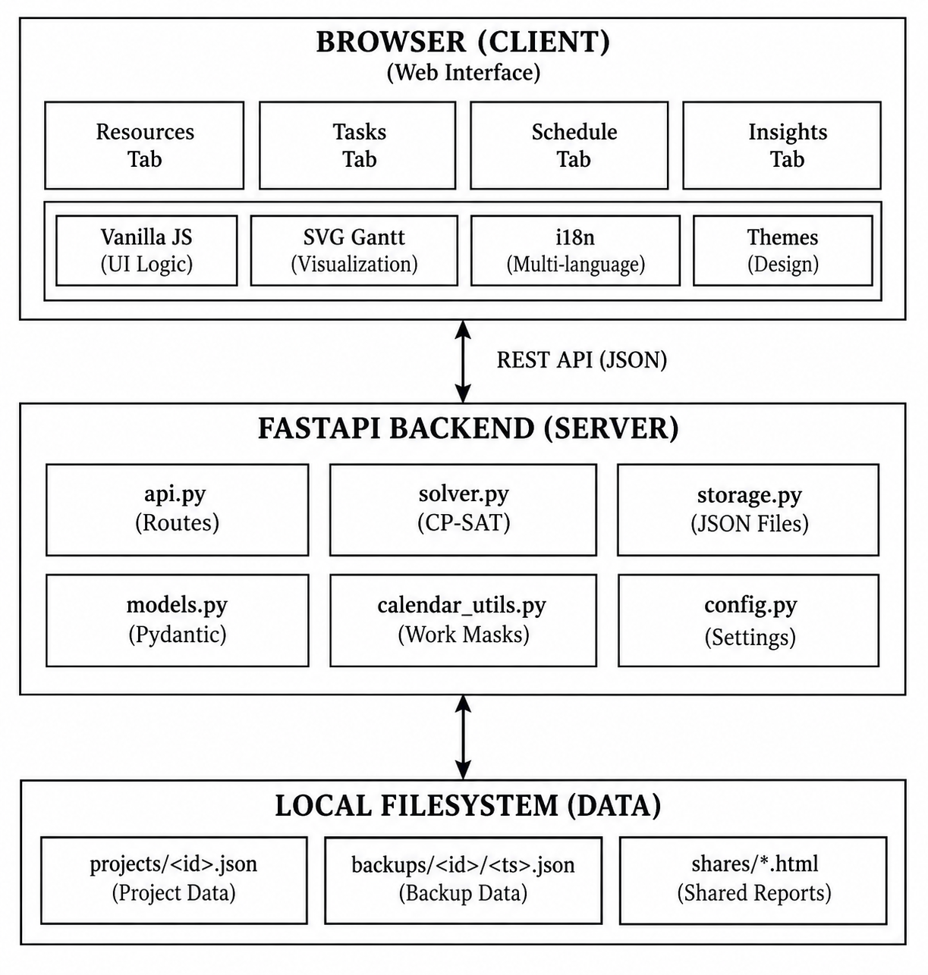
The overall architecture of Optimal Task Planner follows a client-server pattern with clear separation between the frontend, backend, and storage layers. Figure 4.1 illustrates the system architecture. The browser-based vanilla JavaScript frontend communicates with the Fast API backend through RESTful JSON API endpoints. The backend orchestrates all business logic: project CRUD operations, solver invocation, backup management, share-link publishing, and holiday lookups. The CP-SAT solver runs in a background thread (OR-Tools releases the Python GIL), allowing the server to remain responsive during optimization. Project data is persisted as JSON files on the local filesystem with automatic backup snapshots.

Figure 4.1: Optimal Task Planner System Architecture Diagram

User Workflow Diagram
The interaction between the user and the system is illustrated in Figure 4.2. The user begins by defining resource types and unit counts in the Resources tab. Working hours, weekends, and public holidays are configured in the working calendar panel. Per-unit unavailability windows are painted on the slot grid. The user then switches to the Tasks tab to create tasks, set durations and constraints, paint preferred or unavailable time slots, and establish task dependencies. When the user presses 'Solve schedule', the backend submits a background solve job. The frontend polls for progress, displaying elapsed time and the best makes pan found so far. Upon completion, the schedule is rendered as an interactive SVG Gantt chart.

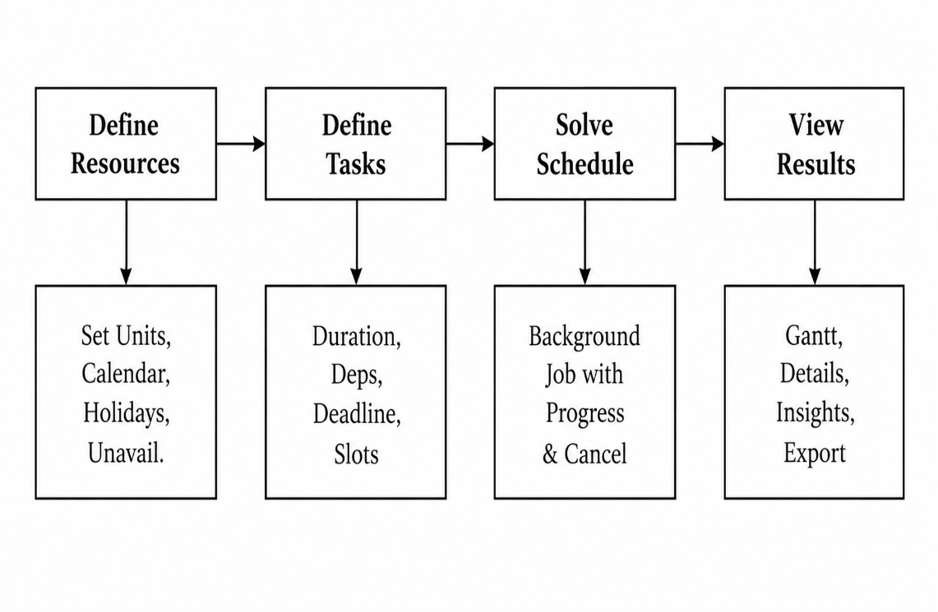
Figure 4.2: User Workflow Diagram

Scheduling Workflow Diagram
The scheduling workflow, shown in Figure 4.3, details the internal process from the moment a solve request is received to the delivery of the final schedule. The solver first performs a precheck to detect obvious errors (unknown resource types, quantity mismatches, dependency cycles). For each task, it then enumerates all feasible start slots, considering working hours, unavailability windows, deadlines, earliest starts, and pinned starts. The CPSAT model is constructed with Boolean variables for candidate selection, occupancy tracking, and unit assignment.

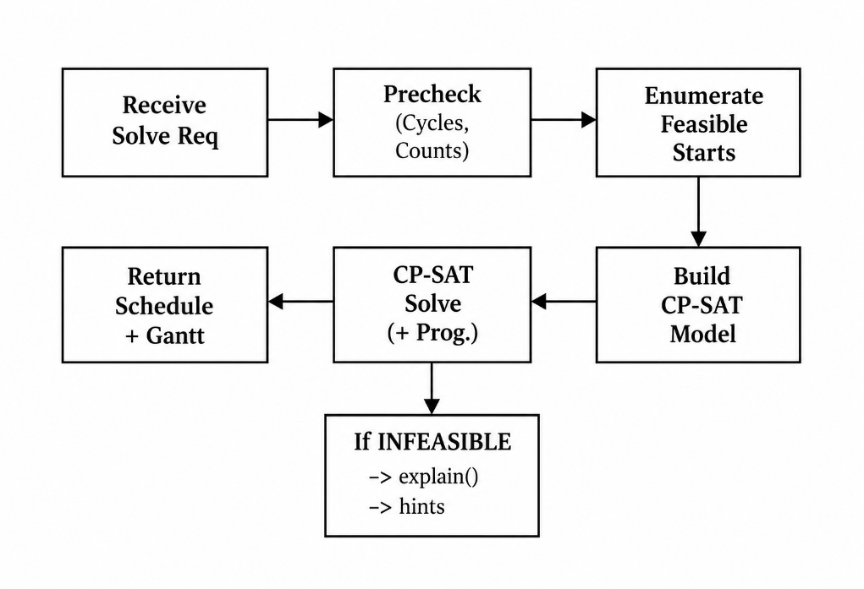

Figure 4.3: Scheduling and Solver Workflow Diagram

Module Interaction Diagram
Figure 4.4 shows the interaction between the main backend modules. The api.py module handles HTTP routing and delegates to solver.py for optimization, storage.py for persistence, and calendar_utils.py for working-hour mask computation and holiday lookups. The models.py module defines the Pydantic data schema shared by all modules.

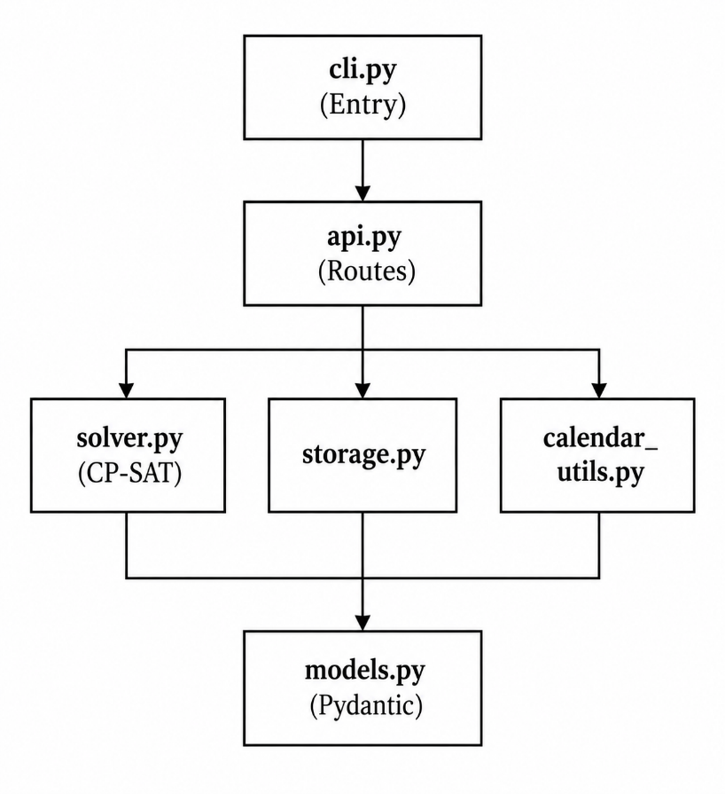

Figure 4.4: Module Interaction Diagram

Chapter 5: System Design

Data Model and JSON Storage Design
The data model is defined in models.py using Pedantic Base Model classes. All times are discretized into 30-minute slots (SLOT_MINUTES = 30). Within a day, slot i covers the interval [i×30, (i+1) ×30) minutes past midnight, giving 48 slots per day (SLOTS_PER_DAY = 48). Absolute slot indices count from midnight of the horizon start day:
Class | Description
Project | Top-level container: name, schema version, solver options, calendar, equipment list, task list, and solved schedule.
WorkCalendar | Work start/end times (HH:MM on 30-min boundaries), list of holiday dates.
EquipmentType | Resource type: name, unit count (0-99), custom unit names, per-unit unavailability windows.
Task | ID, name, duration (multiples of 30 min), resource requirements, dependencies, status, deadline, earliest/pinned start, slot preferences.
TimePoint | Date + time reference for deadlines and start constraints.
Schedule | Solver output: status, message, hints, solve time, makespan, scheduled tasks.
ScheduledTask | Assigned task: task ID, assigned units, list of time segments.
ScheduleSegment | Contiguous block: start/end ISO datetimes and slot indices.
SolverOptions | Per-project: time limit (5-120s), workers (1-16), horizon days (1-31).

Figure 5.1: Core Data Model Classes

Persistence is handled by the ProjectStore class in storage.py. Each project is stored as a single JSON file at data_dir/projects/<id>.json. The file layout also includes automatic backup snapshots at data_dir/backups/<id>/<timestamp>.json (up to 20 retained, at most one per 10 minutes) and published share pages at data_dir/shares/<id>--<token>.html. File writes are atomic: data is written to a temporary file and then atomically moved to its final path using os.replace(), preventing data corruption from crashes or power failures.
Schema versioning (currently SCHEMA_VERSION = 3) ensures forward compatibility. When a project file is loaded, the migrate () function applies sequential migration steps to bring the schema up to the current version. Migration v1→v2 adds the project name field; v2→v3 adds per-project solver options. Old project files are upgraded transparently on load.

Scheduling and Optimization Model
The scheduling model is implemented in solver.py as a pure function of the project data and an explicitly injected current time. This design ensures solver determinism and makes the solver fully unit-testable. The solver never reads the wall clock or other ambient state.

The scheduling process consists of the following stages:
    - Precheck: Validates resource requirements and detects dependency cycles.
    - Status Handling: Tasks marked 'done' are excluded. Tasks marked 'in progress' are frozen to their previous slots and units.
    - Feasible Start Enumeration: For each task, all feasible start slots and their occupied slot sets are generated. Work-hours-only, continue-on-next-day, unavailable, deadline, and earliest/pinned start constraints prune infeasible candidates

    - CP-SAT Model Construction: Boolean variables b[t][j] for candidate selection (exactly one per task), x[t][s] for slot occupancy, and a[t][u] for unit assignment.
    - Constraint Enforcement: No-overlap (at most one task per unit per slot), dependency ordering, and unit unavailability.
    - Objective: Weighted minimization encoding makespan >> preference >> priority.

5.3 Backend API Design
The backend exposes a RESTful JSON API through FastAPI routes defined in api.py. Table 5.2 lists the principal API endpoints.

Method | Path | Description
GET | /api/projects | List all projects.
POST | /api/projects | Create a new project.
POST | /api/projects/import | Import a project JSON.
GET | /api/projects/{id} | Retrieve project data + horizon info.
PUT | /api/projects/{id} | Replace project data (validated).
PATCH | /api/projects/{id} | Rename a project.
DELETE | /api/projects/{id} | Delete (final backup kept).
POST | /api/projects/{id}/duplicate | Duplicate a project.
POST | /api/projects/{id}/solve | Start background solve; returns job_id.
GET | /api/solve/{job_id} | Poll solve status, progress, result.
POST | /api/solve/{job_id}/cancel | Cancel a running solve.
POST | /api/projects/{id}/share | Publish read-only share page.
DELETE | /api/projects/{id}/share | Unpublish share page.
GET | /share/{token} | Serve published schedule.
GET | /api/projects/{id}/backups | List backup snapshots.
POST | /api/projects/{id}/backups/{name}/restore | Restore a backup.
GET | /api/holidays/countries | Supported holiday countries.
GET | /api/holidays | Holidays for country/year.
GET | /api/health | Liveness + version.

Table 5.2: Principal REST API Endpoints
Background solves jobs run in daemon threads. OR-Tools releases the Python GIL during computation, so the Fast API server remains fully responsive. A progress callback reports each improved solution. A threading. Event enables cancellation via Stop Search ().

5.4 Frontend Design
The frontend is a dependency-free vanilla JavaScript application loaded as classic <script> tags. There is no framework, no build step, and no ES modules. All scripts share a single global scope.

File | Responsibility
i18n.js | English interface text and localization support.
icons.js | Inline SVG icon set.
core.js | State, DOM helpers, API wrapper, save, undo/redo, toasts, modals.
shell.js | Onboarding tour, theme/tab/language chrome, project switcher.
resources.js | Resources tab: resource pool, unit availability, paintable slot grid, calendar, holidays.
tasks.js | Tasks tab: task list with drag/keyboard reorder, task editor panel.
schedule.js | Schedule tab: background solve with progress/cancel, Gantt SVG, details table, HTML export.
insights.js | Insights tab: KPI tiles, utilization bars, load heatmap, bottleneck callouts.
boot.js | Application bootstrap; loads last.

Table 5.3: Frontend JavaScript Modules

Chapter 6: Implementation

6.1 CP-SAT Solver Implementation
The CP-SAT solver implementation follows the approach of enumerating all feasible start slots for each task together with the exact set of slots each start would occupy. This cleanly handles work-hours-only tasks and the continue-on-next-day split without special-case logic.For each task, the candidate_starts() function generates a list of (start_slot, occupied_slots) tuples. For work-hours-only tasks with continue-on-next-day enabled, the occupied slots are drawn from the working-hour mask so a task spanning multiple days only occupies working-hour slots. For work-hours-only tasks without continuation, the task must fit within a single working day. Non-work-hours-only tasks may be scheduled in any slot, including nights and weekends.
Infeasible candidates are pruned based on unavailable slots painted by the user, deadline constraints, earliest-start constraints, and pinned-start constraints. If no feasible candidate exists for any task, the solver returns an INFEASIBLE status with a descriptive error message.

6.2 Constraint Modeling
    - The CP-SAT model enforces the following constraints:
    - Candidate Selection: For each task t, exactly one candidate start b[t][j] is selected (AddExactlyOne). Occupancy variables x[t][s] are derived from the candidate selection.
    - No-Overlap: For each physical unit u and slot s, at most one task may use u in s. Auxiliary boolean variables y[t][u][s] are used with AddAtMostOne. Contention variables are only created for (unit, slot) pairs where two or more tasks could contend, keeping the model size manageable.
    - Dependencies: For each task t depending on task d, start_expr[t] >= end_expr[d].
    - Unit Assignment: For each resource type, the number of selected units equals the required quantity. Frozen in-progress tasks keep their previously assigned units.
    - Unit Unavailability: If unit u is unavailable in slot s, then a[t][u] + x[t][s] <= 1.

Objective Function
The objective function is a single minimization expression that encodes a lexicographic ordering through weight ratios:
Objective = w_makespan × makespan + Σ_t Σ_j (−w_pref × preferred_count + priority_weight × start_slot) × b[t][j]
Where:
    - w_prio_max = N² × H + 1 (N = number of tasks, H = horizon slots).
    - w_pref = w_prio_max (per preferred slot matched).
    - w_makespan = w_pref × (total_duration_slots + 1).
    - priority_weight = N − task_index (higher priority for earlier tasks).
This weight structure guarantees that: (1) reducing makespan by one slot always dominates any combination of preference and priority improvements; (2) matching one additional preferred slot always dominates any priority rearrangement; and (3) among schedules with the same makespan and preference score, higher-priority tasks are scheduled earlier.

6.4 Infeasibility Explanation
When the solver returns an infeasible result, the explain_infeasible() function attempts to identify which constraints, if relaxed, would make the schedule feasible. It proceeds through five constraint families: deadlines, dependencies, earliest/pinned starts, unavailable slots, and work-hours-only restrictions. For each family, it first relaxes all constraints of that type and re-solves. If feasible, it narrows to individual tasks (up to 8 candidates). Up to 3 hints are returned within a configurable time budget (default 15 seconds). Unit maintenance windows are tested as a final relaxation step.

6.5 Testing Strategy
The project employs a three-tier testing strategy:

Layer | File | Coverage | Tests
Unit Tests | test_solver.py | Solver behavior: constraints, objectives, status, hints. | 14+
Model Tests | test_models.py | Pydantic validation: slot alignment, boundary checks. | 10+
Storage Tests | test_storage.py | CRUD, backups, migration, share-link lifecycle. | 10+
Calendar Tests | test_calendar.py | Work mask generation, holidays, slot arithmetic. | 5+
API Tests | test_api.py | HTTP layer: project CRUD, solve, share, errors. | 12+
Locale Tests | test_locales.py | All locale files share the same key set. | 1+
Config Tests | test_config.py | Settings from env vars and defaults. | 3+
CLI Tests | test_cli.py | Argument parsing and entry point. | 2+
E2E Tests | smoke.spec.js | Playwright: loads, solves, asserts Gantt, tests share. | 1

Table 6.1: Testing Strategy Summary
All backend tests use tmp_path fixtures for isolated data directories. Solver tests inject an explicit 'now' timestamp for determinism. The CI pipeline runs ruff check, ruff format --check, mypy, and pytest on Python 3.12/3.13/3.14 across Ubuntu, macOS, and Windows, followed by the Playwright e2e test.

Chapter 7: Results and Discussion

7.1 System Screenshots
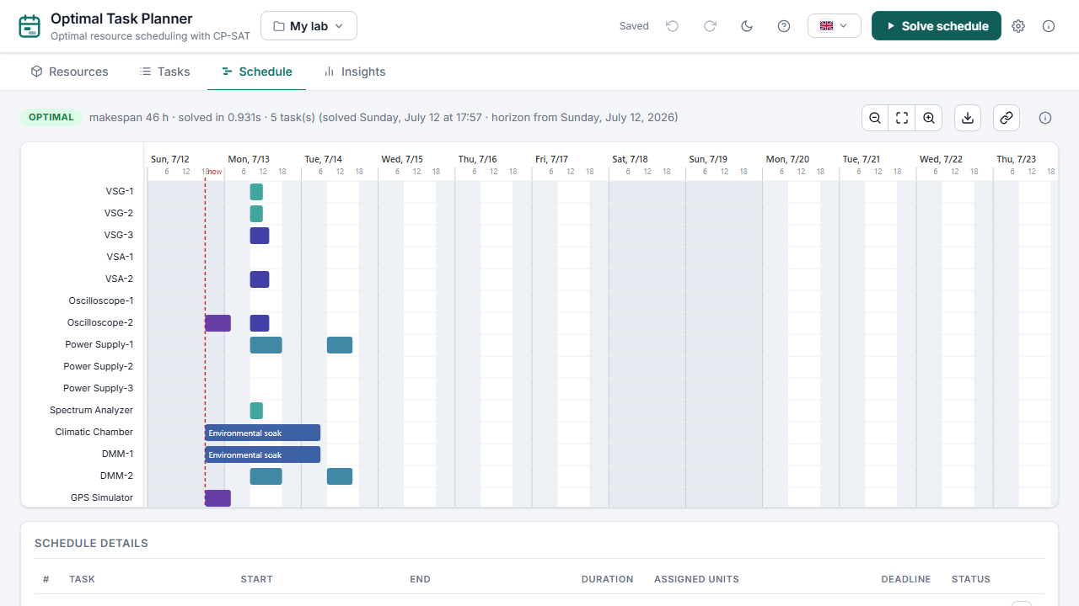
The following screenshots demonstrate the implemented system:

Figure 7.1: Schedule View — Interactive SVG Gantt Chart
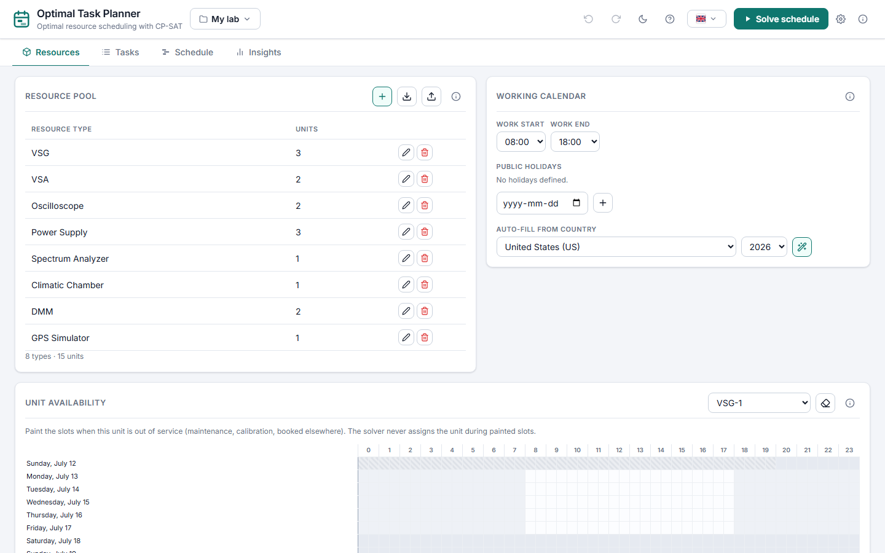

Figure 7.2: Resources Tab — Resource Pool and Working Calendar
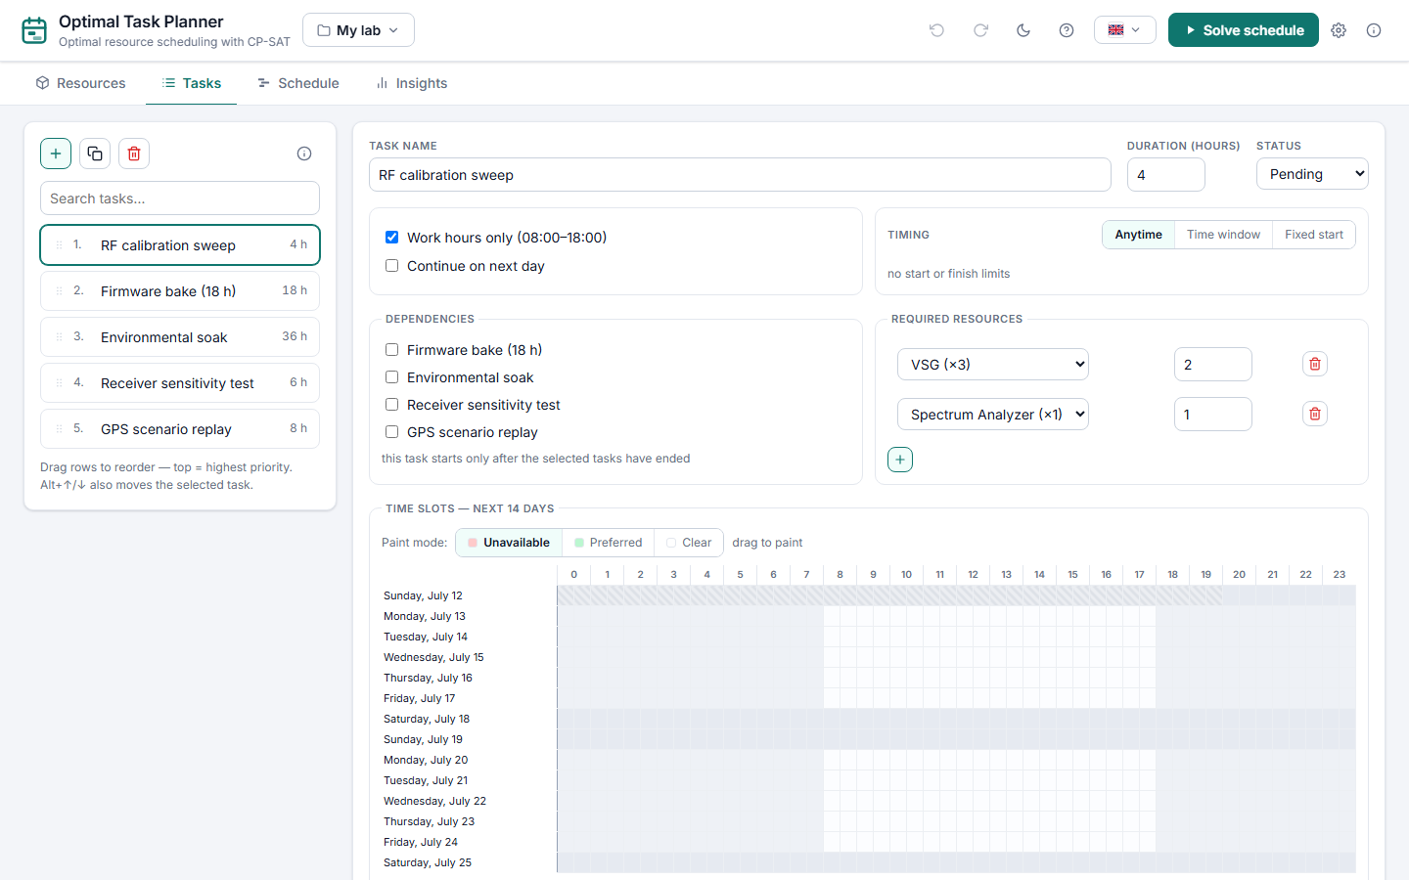

Figure 7.3: Tasks Tab — Task List with Constraints and Slot Painting

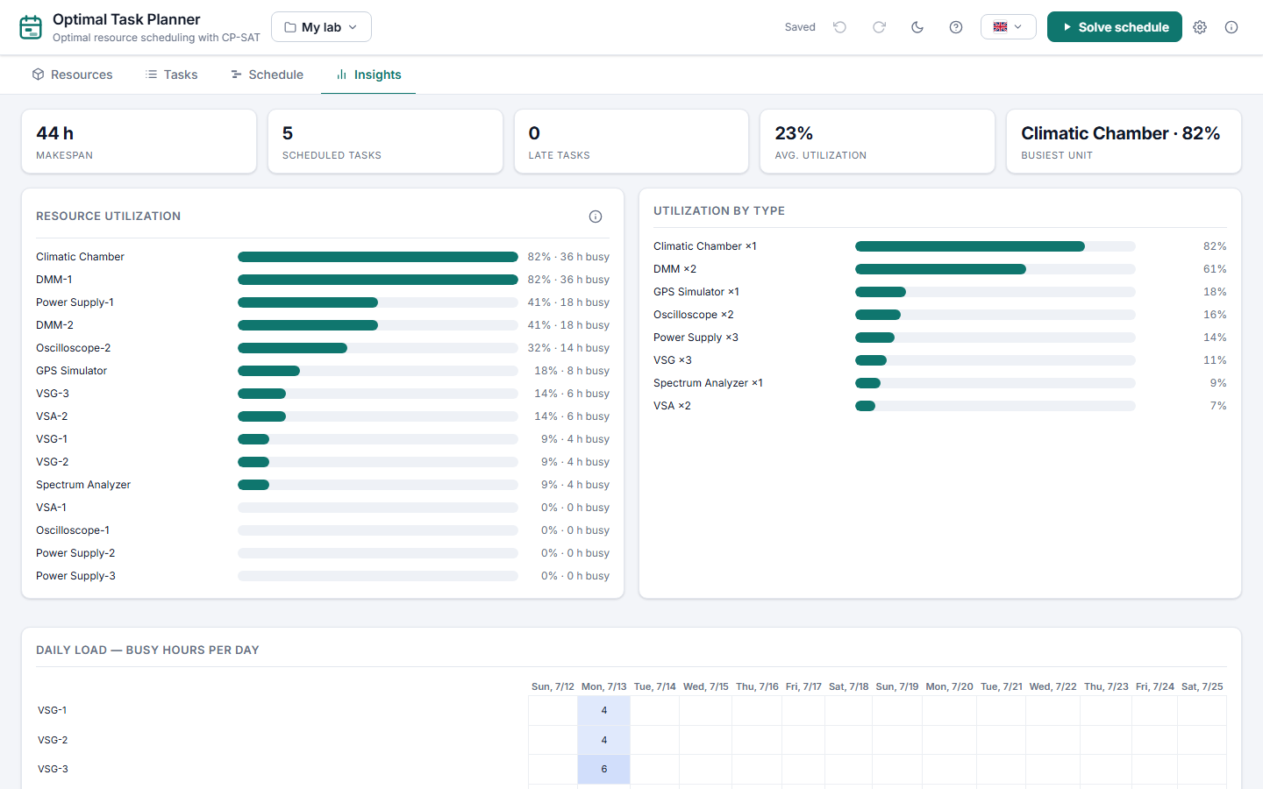

Figure 7.4: Insights Tab — Utilization Bars and KPI Tiles
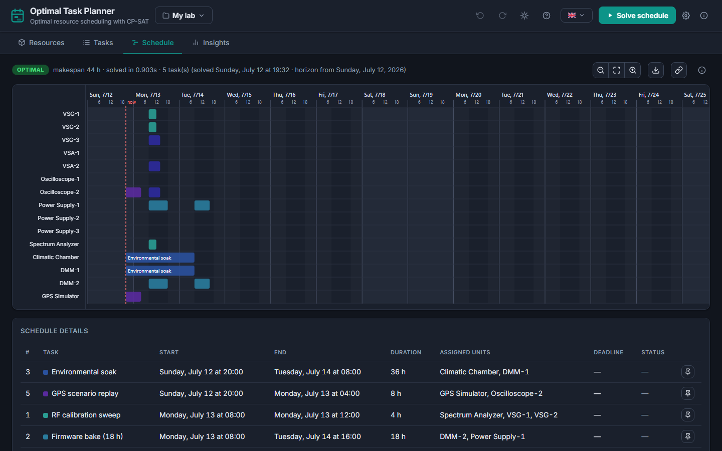

Figure 7.5: Dark Mode Theme

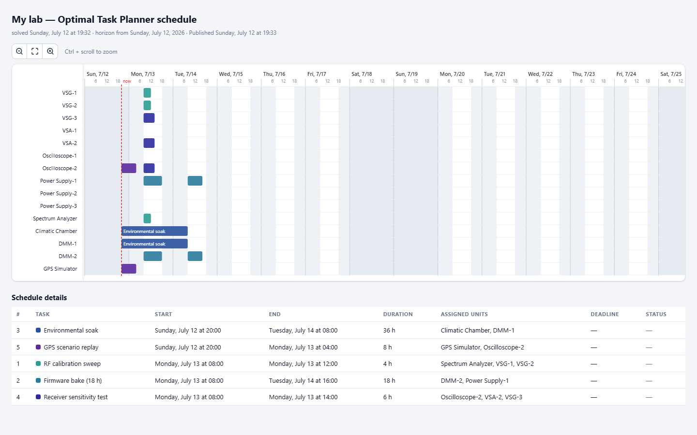

Figure 7.6: Published Read-Only Share Page

7.2 Discussion of Results
Schedule Quality: The CP-SAT solver consistently produces optimal or near-optimal schedules for the tested project configurations. On the default sample project (8 tasks, 5 resource types, 14-day horizon), the solver finds an optimal schedule in under 2 seconds. The lexicographic objective successfully minimizes makes pan first, then maximizes preferred-slot usage, and finally schedules higher-priority tasks earlier.
Solver Performance: The solver scales well for small-to-medium projects (up to approximately 30 tasks and 15 resource types) within the default 20-second time limit. The conflict model pruning — only creating contention variables for (unit, slot) pairs where two or more tasks contend — significantly reduces model size and improves solver performance on larger instances.
Re-planning: The system correctly handles task status transitions. Completed tasks are excluded from future scheduling. In-progress tasks are frozen to their last scheduled slots and units while the remaining schedule is recalculated.
Infeasibility Handling: When a schedule cannot be found, the infeasibility explainer identifies and ranks constraint relaxations that would make the schedule feasible. The ranked hints provide actionable guidance to the user.
Advantages of the system include:
    - Provably optimal scheduling: CP-SAT can provide an optimal solution when the solver proves optimality, rather than relying only on heuristic approximations.
    - Rich constraint support: The system supports dependencies, deadlines, working hours, resource unavailability, and preferred time slots.
    - Efficient resource utilization: The scheduler considers available resource capacity while assigning tasks, helping reduce unnecessary machine idle time.

    - Parallel task scheduling: Independent tasks can be scheduled simultaneously when sufficient resources are available.
    - Dependency-aware scheduling: Tasks are automatically ordered according to their predecessor relationships.
    - Deadline-aware planning: The system considers task deadlines while generating the production schedule.
    - Working-calendar support: Working hours, weekends, and holidays can be incorporated into the scheduling process.
    - Resource-unit management: Multiple physical units of the same resource type can be represented and assigned independently.
    - Interactive visualization: The generated schedule can be viewed through an interactive SVG-based Gantt chart with task timing and resource allocation.
    - Resource utilization analysis: The Insights section helps identify resource usage, bottlenecks, and scheduling-related information.
    - Background solving: Long-running optimization jobs can execute in the background while providing progress information.
    - Infeasibility explanation: When a feasible schedule cannot be generated, the system can provide explanations and hints about constraints that may need relaxation.
    - Local operation: The application can operate locally without requiring dependence on a cloud-based scheduling service.
    - Human-readable project data: Project information is stored in JSON format, making the data relatively easy to inspect and manage.

Conclusion and Future Scope
In this project, a fully functional, locally hosted web application for optimal resource scheduling was designed, implemented, and validated. Optimal Task Planner integrates a Google OR-Tools CP-SAT solver with a FastAPI backend and a vanilla JavaScript frontend to provide provably optimal or near-optimal schedules over a configurable rolling horizon. The system accepts user-defined resources, tasks, and constraints, and computes schedules that minimize makespan while respecting all constraints through a lexicographic objective function. The application supports rich task constraints (dependencies, deadlines, working hours, unavailability), background solving with live progress, interactive Gantt visualization, utilization insights, multiple projects, undo/redo, automatic backups, schedule sharing, HTML export, and a bilingual interface with dark mode.
The JSON-file-based storage with schema versioning eliminates the need for a database while ensuring forward compatibility through automatic migration. The three-tier testing strategy (unit, API, and end-to-end) provides confidence in system correctness across Python 3.12, 3.13, and 3.14 on Ubuntu, macOS, and Windows. The system represents a significant step towards accessible, offline-capable, and mathematically rigorous resource scheduling for small to medium-scale engineering and manufacturing operations.
Future Scope:
    - Multi-Objective Visualization: Provide Pareto-front visualization for trade-offs between makespan, preference satisfaction, and priority ordering.
    - Larger Instance Support: Integrate decomposition or large-neighborhood-search techniques to handle projects with 100+ tasks.
    - Multi-User Collaboration: Add optional authentication and concurrent editing support for team-based scheduling scenarios.
    - Calendar Integration: Import and export schedules to/from iCalendar (.ics) format for integration with external calendar applications.
    - Mobile Responsiveness: Enhance the frontend layout for tablet and mobile viewports to support on-the-floor scheduling.
    - IoT-Based Monitoring: Integrate Industrial IoT sensors to collect operational data and improve scheduling decisions using live production information.
    - Automatic Rescheduling: Automatically generate a revised schedule when a machine breakdown, maintenance event, or unexpected production delay occurs.
    - Predictive Maintenance Integration: Incorporate machine-health and maintenance information to avoid assigning tasks to resources that are likely to become unavailable.
    - AI-Based Duration Prediction: Use historical production data and machine performance information to predict more accurate task processing times.
    - ERP/MES Integration: Integrate the scheduling system with Enterprise Resource Planning (ERP) and Manufacturing Execution Systems (MES) to exchange production orders and execution information.
    - Advanced Bottleneck Analysis: Develop predictive bottleneck detection to identify resources that are likely to restrict production before scheduling begins.
    - Scenario-Based Planning: Allow users to create and compare multiple production scenarios, such as adding machines, changing working hours, or modifying deadlines.
    - Automatic Resource Recommendations: Recommend additional machines or resource capacity when the current configuration cannot satisfy important production requirements.

References
    - Baptiste, P., Le Pape, C., & Nuijten, W. (2001). Constraint-Based Scheduling: Applying Constraint Programming to Scheduling Problems. Springer, Boston, MA.
    - Blazewicz, J., Ecker, K. H., Pesch, E., Schmidt, G., & Weglarz, J. (2019). Handbook on Scheduling: From Theory to Applications. Springer, Cham.
    - Brucker, P. (2007). Scheduling Algorithms (5th ed.). Springer, Berlin, Heidelberg.
    - Da Col, G., & Teppan, E. C. (2022). Industrial-size job shop scheduling with constraint programming. Operations Research Perspectives, 9, 100249.
    - Google OR-Tools Team. (2024). OR-Tools: Google’s Operations Research Tools. https://developers.google.com/optimization
    - Google OR-Tools Team. (2024). CP-SAT Solver Documentation. https://developers.google.com/optimization/cp/cp_solver
    - Laborie, P., Rogerie, J., Shaw, P., & Vilím, P. (2018). IBM ILOG CP Optimizer for scheduling. Constraints, 23(2), 210–250.
    - Perron, L., & Furnon, V. (2023). Operations Research Tools (OR-Tools). Google. https://github.com/google/or-tools
    - Playwright Contributors. (2024). Playwright: Reliable end-to-end testing for modern web apps. https://playwright.dev/
    - Pedantic Contributors. (2024). Pedantic: Data Validation using Python Type Annotations. https://docs.pydantic.dev/
    - Pytest Contributors. (2024). Pytest: The pytest framework makes it easy to write small, readable tests. https://docs.pytest.org/

    - Python Software Foundation. (2024). Python 3.12 Documentation. https://docs.python.org/3.12/
    - Ramírez, S. (2021). FastAPI: Modern, fast (high-performance), web framework for building APIs. https://fastapi.tiangolo.com/
    - Ramírez, S., et al. (2020). Interactive web-based production scheduling with metaheuristic optimization. Computers & Industrial Engineering, 150, 106858.
    - Tiacci, L. (2021). Cloud-based scheduling for small manufacturing enterprises: A review and framework. Journal of Manufacturing Systems, 60, 571–589.
    - Baptiste, P., Le Pape, C., & Nuijten, W. (2001). Constraint-Based Scheduling: Applying Constraint Programming to Scheduling Problems. Springer, Boston, MA.
    - Brucker, P. (2007). Scheduling Algorithms (5th ed.). Springer, Berlin, Heidelberg.
    - Da Col, G., & Teppan, E. C. (2022). Industrial-size job shop scheduling with constraint programming. Operations Research Perspectives, 9, 100249.
    - Ramírez, S. (2021). FastAPI: Modern, fast (high-performance), web framework for building APIs. FastAPI Documentation
    - Google OR-Tools Team. (2024). OR-Tools: Google’s Operations Research Tools. Google OR-Tools Documentation

