Horonotace — Specification v0.1
Contents

Horonotace — a notation for describing clock movements
Čeština · English

Specification v0.1 · working draft for review
Status | Draft — for expert review
Date | 22 June 2026
Author | David Knespl (Czech Horological Society)
Intended for | conservators, museum curators, clockmakers and researchers, for comment
Contact for comments | see §14

0. Summary for the hurried
Horonotace is a proposed way to record an entire clock movement in a uniform, machine-readable form — drive, gear train, escapement, oscillator, striking work, indication elements — so that from the same record one can:
- draw a schematic diagram of the movement (a kinematic diagram) as well as a front view of the dial,
- compute the gear ratio, the beat count, and where applicable the error of an astronomical indication,
- cite it in scholarly text and store it in a collections database.
The goal is something like “musical notation” or a “chemical formula” for clock movements: an unambiguous, economical and shareable description that today is missing (§3).
What we need from you: please review in particular the terminology (§9), the faithfulness of the construction description (§5–6) and the scope (§2), and tell us what is missing, what is named incorrectly, and whether you would use such a record in your own practice. Specific questions are in §12. The complete notation (vocabulary, model, example) is in §8.

1. Motivation
Today we describe clock movements either in free text (inconsistent, not convertible to computation), or with a technical drawing (precise, but laborious and not machine-readable), or with a photograph (which shows the state, not the function). For collection records, conservation documentation and comparative study, a middle layer is missing: a concise formal description of the function and topology of the movement — what drives what, how many teeth each has, how it strikes, what it indicates.
Established notations from other fields serve as inspiration: SMILES in chemistry (a linear encoding of a molecule), PGN in chess, MEI/ABC in music. All of them separate substance from rendering and are readable by both human and machine (references §14).

2. Scope — what the notation describes and what it does not
Covered (by intent): tower clocks (both birdcage/posted and flatbed frames); table, wall and case interior movements (plated); astronomical clocks and astronomical dials (astrolabe, calendarium, planetary indication).
Not yet covered (out of scope for v0.1): pocket and wristwatches, purely electric/quartz movements, manufacturing/workshop drawings (tolerances, materials, ironwork).
Two levels of detail — the description need not be complete: a block level (only the functional trains and the flow between them, when the details of the wheels are unknown) and a wheel level (individual wheels and pinions with tooth counts). Only what is documented can be described; the undocumented is not invented.

3. State of the art — why we are doing this
A review showed that a formal, machine-readable notation for a whole clock movement does not exist. There are only partial means:
- mechanical kinematic diagrams — the international standard ISO 3952 defines graphical symbols for kinematic diagrams of mechanisms; in Czech engineering practice “kinematic diagrams” (Reuleaux, Artobolevsky — references §14). These address mechanisms in general, not the clock’s train as a whole (escapement, striking, astronomical indication).
- horological literature describes individual aspects (formulae for the beat count, catalogues of escapements) in text and drawing, not in a uniform format.
- Ludwig Oechslin uses in his books (notably Priestermechaniker, 1996) his own graphical discipline — the “elevation between the plates”: horizontal lines = plates, verticals = arbors, a bracket with a number = a wheel with its teeth, a horizontal = mesh, named outputs = indications. It is not a formalism, more a consistent draughting convention.
Horonotace fills this gap: it joins the mechanical kinematic diagram (ISO 3952) with horological glyphs and Oechslin’s elevation into a single, computable format. Details: docs/oechslin-roegel.md, docs/reserse-prior-art.md.

4. How the notation is organized — five layers
We deliberately separate substance from rendering. Everything else is generated from a single source description.
Layer | What it is | For what | Status
A — model | a structured record of the movement (a text file) | source of truth; computed from | done in v0.1
B — linear notation | a short string for text/citation | writing by hand, into an article | planned
C — gear elevation | a schematic side view of the movement | “how the movement is assembled” (axially) | prototype
D — dial view | a schematic front view of the dial | “what is indicated and how” | prototype
E — front view of the gear train | wheels as pitch circles | planar arrangement of the arbors (depthing) | prototype
Layers C and E are two orthographic projections of the same movement (from the side and from the front).
Layer A is a graph (a network), not a tree — the gear train and the coupling of the going and striking trains form loops. Neither the conservator nor the curator has to write layer A by hand; the goal is a convenient form/tool. This specification describes it so that it is clear everything the record captures.

5. What the description is made of
A movement is made up of five kinds of data:
- elements — everything physical: wheels, pinions, escape wheel, anchor, pendulum, drums, weights, hammers, bells, hands, levers… Each has a type (from a controlled vocabulary, §8.6) and, depending on the type, further fields (a wheel has zuby, a drum has prumer and otacky).
- arbors — axes. Coaxial elements (a wheel + pinion on the same axis) share an arbor; a mesh arises between elements on different arbors. This also includes concentric tubes (Sun / Moon / zodiac hands stacked above one another).
- links — edges between elements: gear mesh, drive, motion flow, striking release, locking, indicator drive.
- trains — functional blocks (drive, going train, escapement, oscillator, striking train, motion work/indication, complication).
- construction — the type of supporting structure: plates, birdcage/posted frame, flatbed frame.
An important distinction: the abstract network (elements–arbors–links) is independent of the frame type. The construction type affects only the spatial rendering, not the computation of the gear ratios. Tower clocks have a frame (birdcage/posted or flatbed); the wheels are mounted in the frame’s uprights and cross-bars — not between plates as in interior movements. Complications (moon phase, calendarium) are usually on the dial side, outside the frame — the notation can tell this apart.

6. How to read the movement diagram (layer C)
Layer C draws the movement from the side as a kinematic diagram in the spirit of Oechslin’s elevation:
- a vertical line = an arbor (axis); colour distinguishes the individual paths / trains.
- a horizontal segment = a wheel or pinion; length proportional to the tooth count, the number by the segment = the tooth count.
- two segments one above the other on adjacent arbors that touch = a mesh.
- a black square on an arbor = a fixed connection of the wheel to the axis.
- the frame is a rectangle around the gear train; a dashed dividing line separates off the dial side (complications outside the frame).
- the escape wheel = a segment with saw-tooth ends (or dots for a pin-wheel escapement), with the anchor above it, and a label krok: to the right.
- striking control (levers) is drawn right by its wheel (“in-situ” layout); a dashed edge = release, a dotted one with a lock symbol = locking.
- winding on the winding arbor: winding square + winding crank + ratchet wheel with pawl.
- below hangs the weight on a cable from the drum; the pendulum is indicated below the escapement.
Example — a typical tower movement (going + striking, flatbed frame):
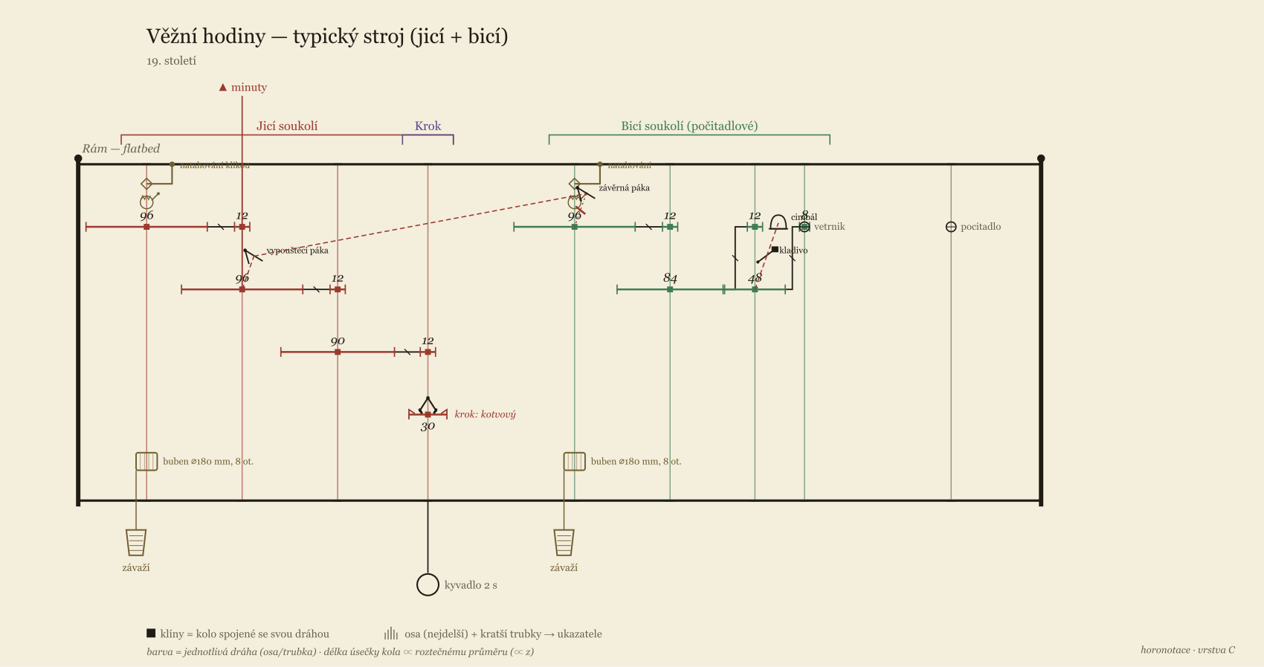
Elevation of a tower movement
Figure labels are in Czech (renderer localisation is planned).
On the left the red going train (great wheel 96 → center wheel 96 → third wheel 90 → escape wheel 30, seconds pendulum, anchor escapement); on the right the green striking train (96 → 84 → pin wheel 48 → fly, count wheel). The striking-control levers sit by their wheels; at the top, on both great-wheel arbors, crank winding. The tooth counts here are illustrative for a common 19th-century movement, but the going-train ratio yields a real seconds pendulum.

7. Dial view (layer D)
The elevation shows the mechanics, not how the indication looks from the front. Layer D draws a schematic front view. So far it has two templates: concentric scales (rings of hours, minutes, calendar) and a stereographic astrolabe (astronomical clocks).
Example — an imaginary Italian tower movement, concentric dial:
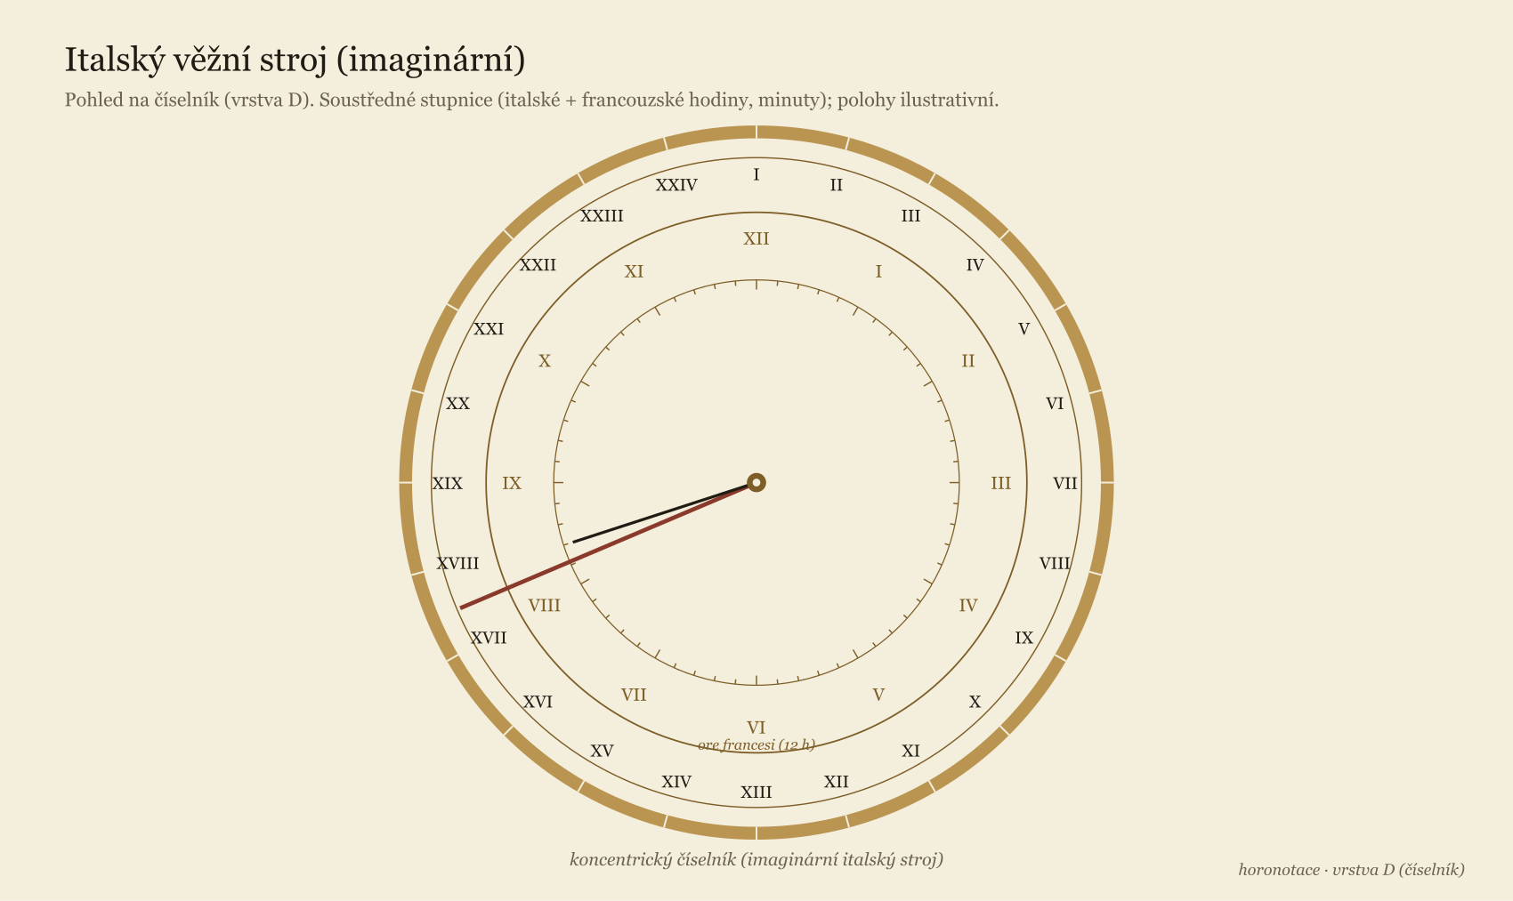
Concentric Italian dial
Concentric scales: the outer 24 Italian hours (I…XXIV from sunset), the middle 12 French hours, the inner minute scale; a long Italian hand + a minute hand.
Astrolabe (astronomical clock). For astronomical clocks, layer D constructs the astrolabe geometrically correctly as a stereographic projection. Note the convention: the Prague astronomical dial is projected from the north pole (unlike the common European astrolabe, from the south pole) — the radius of the declination circle is r(δ) = r_E·tan(45°+δ/2), so the Tropic of Cancer is the outer (largest) one, the Tropic of Capricorn the inner one; the ecliptic is an eccentric circle tangent to both tropics, and both the horizon and twilight (−18°) are eccentric circles for the given geographic latitude. (A specific existing movement — e.g. an astronomical dial — is deliberately not given here as a model dial; the template is generic.)

7b. Front view of the gear train (layer E)
The elevation (C) shows the axial stacking, the dial (D) the front indication. A third projection — the front view of the gear train — draws the wheels as pitch circles and shows the planar arrangement of the arbors: where they sit, how the wheels overlap. It is the counterpart of the conservator’s depthing plan. It is read as follows:
- a circle = a wheel (radius ∝ tooth count); coaxial wheels share a center (arbor/axis) — for astronomical clocks the astrolabe thus naturally appears as concentric rings,
- the touching of two circles = a mesh (a dashed connector = the mesh axis, a small ring = the point of mesh),
- the escape wheel has a saw-tooth rim; a pinion is a small solid ring; • = an arbor.
Two modes:
- schematic (without new data) — the arbor positions are computed from the tooth counts (constant module; separate movements, e.g. going and striking, are drawn one below the other),
- faithful (depthing plan) — when each toothed arbor has a poloha: [x, y] field (mm), it is drawn according to the actual measured positions.
Example — a tower movement (going train above, striking train below):
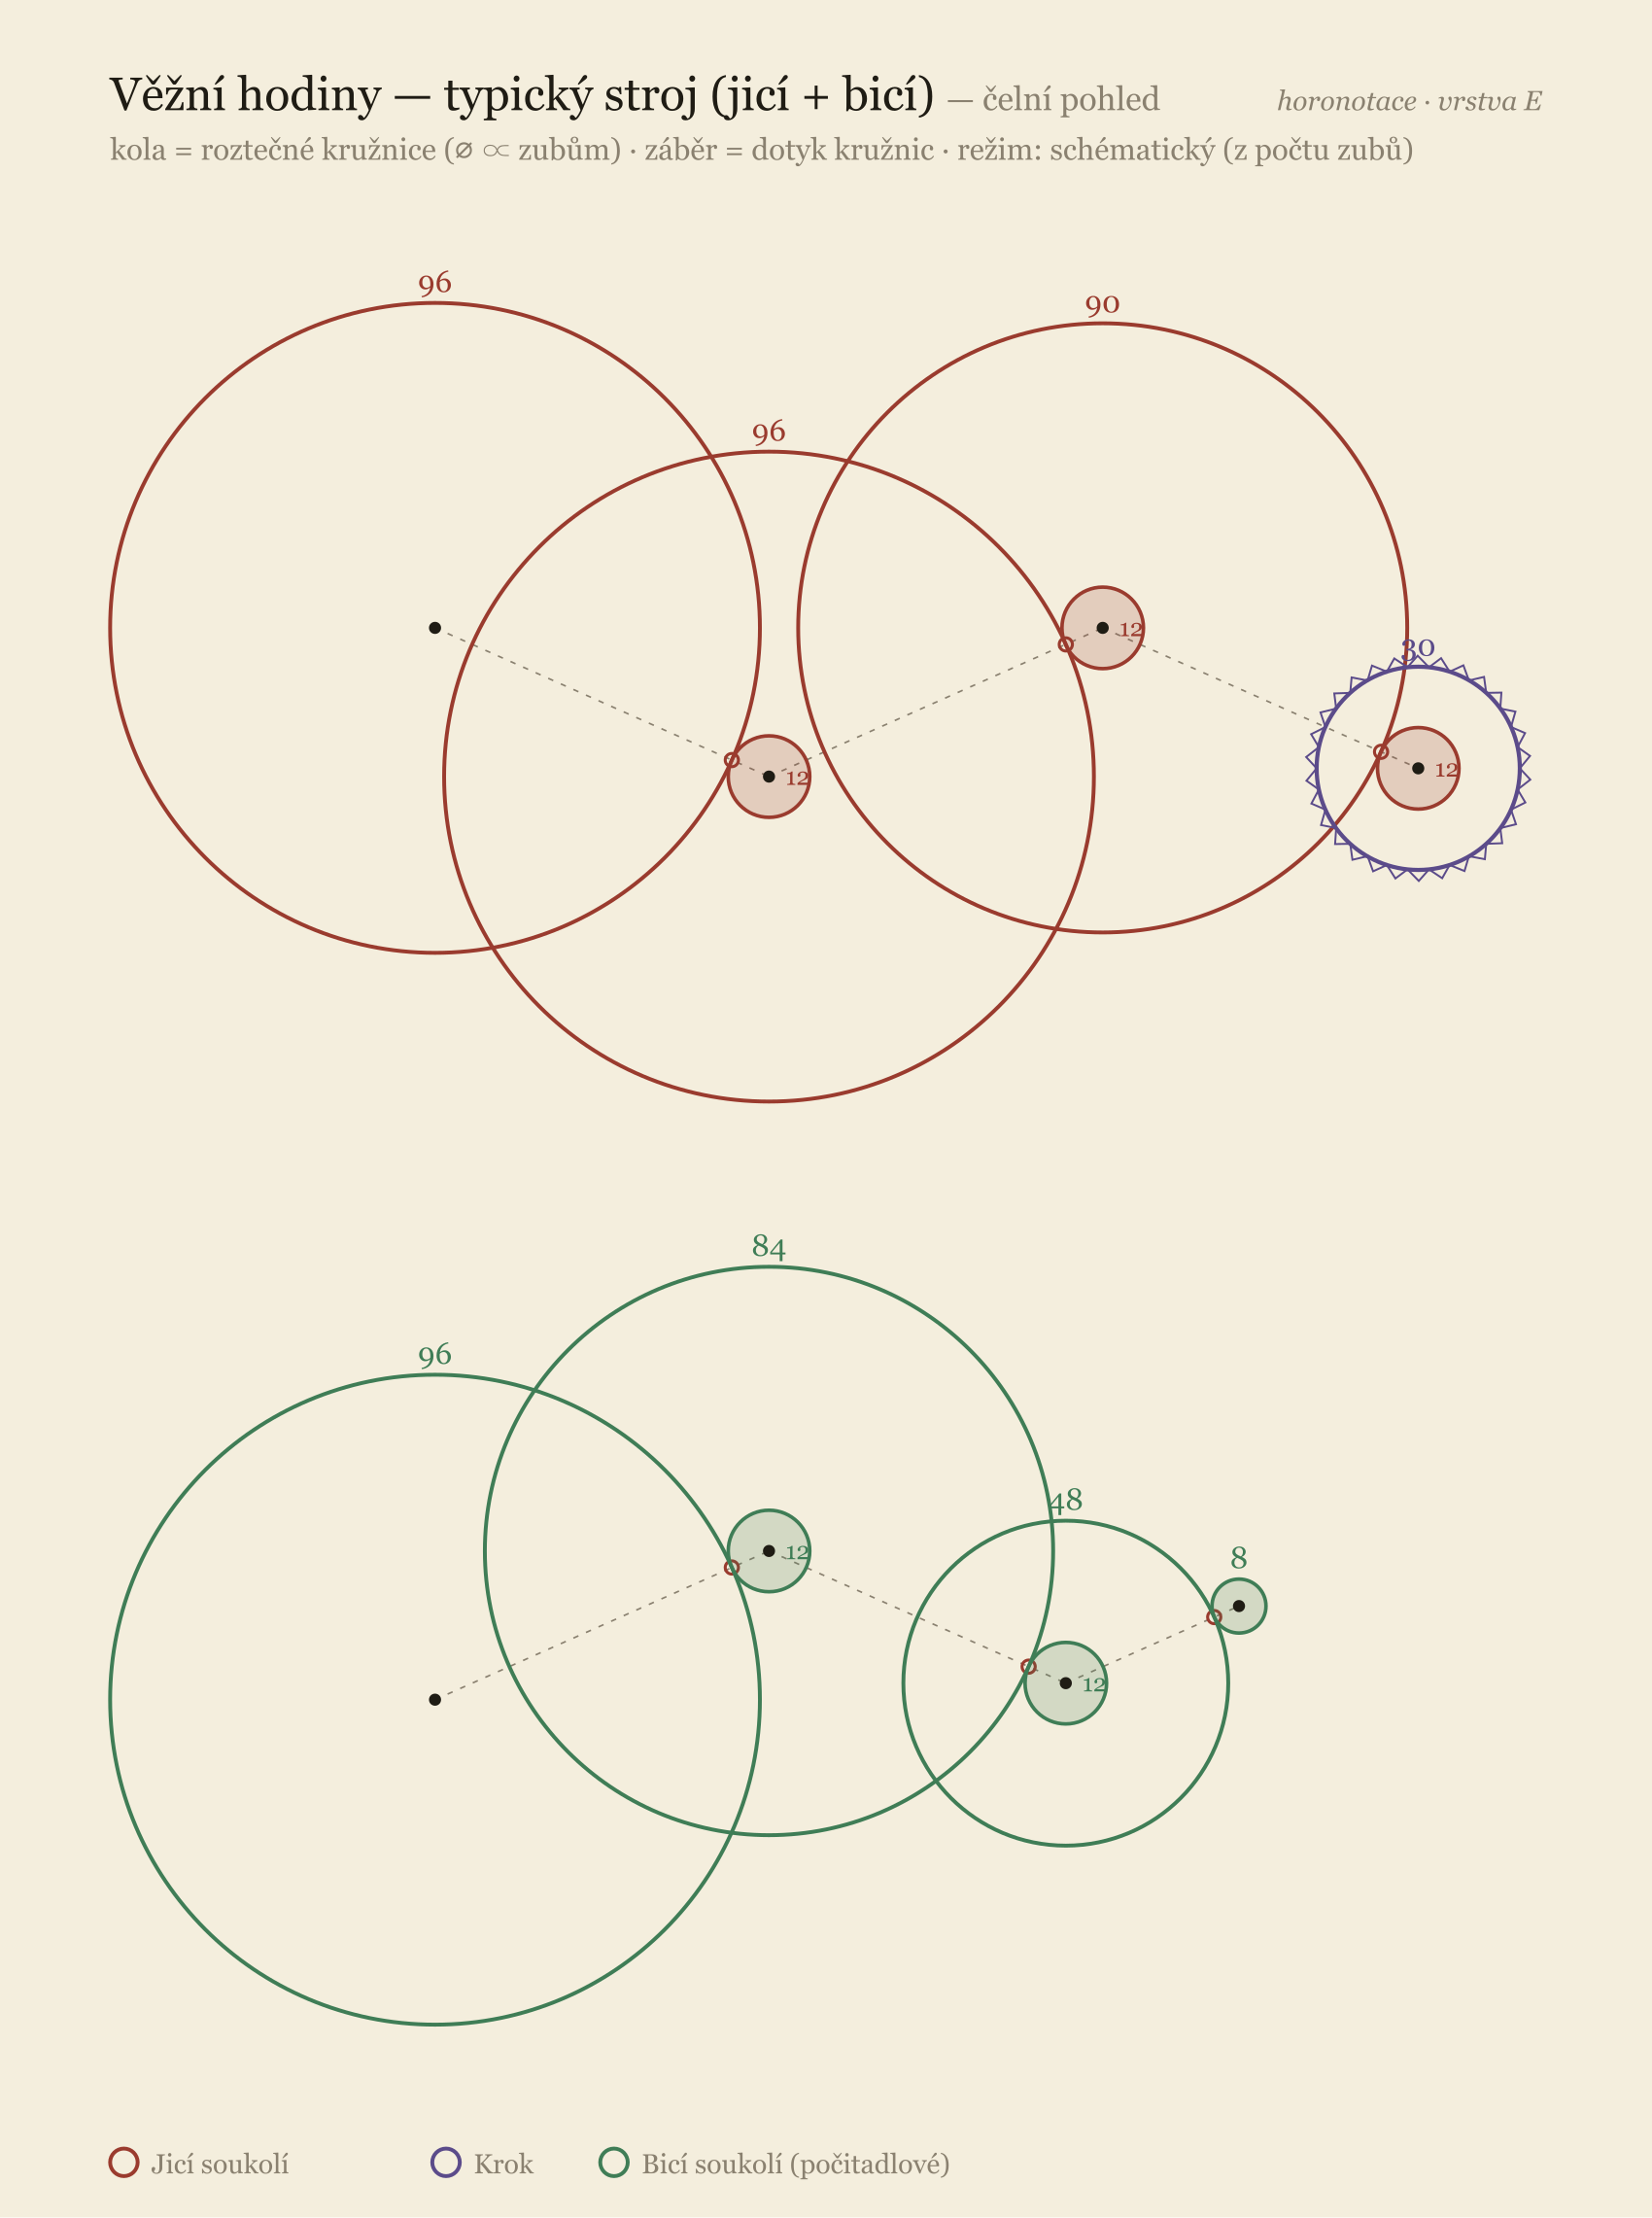
Front view of the gear train of a tower movement
Prototype: tools/render_front.py.

8. The complete notation
This chapter contains the complete notation record: the file structure, the vocabulary and a full example. The format is textual (YAML), validated against a JSON Schema (schema/).

8.1 File structure
horonotace: "0.1"
hlavicka: { … } # metadata, citace (§8.2)
stroj:
konstrukce: { … } # typ nosné konstrukce
ustroji: [ … ] # úroveň 1: funkční bloky
prvky: [ … ] # úroveň 2: kola, pastorky, krok, kyvadlo, cimbály, ručky…
hridele: [ … ] # sdílené osy (souosé prvky)
vazby: [ … ] # hrany: záběr, tok, spouštění, blokování, pohon, pohání

8.2 Header (hlavicka, citation)
hlavicka:
nazev: "Věžní hodiny, kostel sv. …"
autor: "Jan Prokeš ze Sobotky" # výrobce / firma
misto: "Sobotka"
datace: "1868" # rok nebo rozsah „1860–1870"
typ: vezni # vezni|stolni|nastenne|skrinove|astronomicke|orloj|jine
inv: "H-1234" # inventární číslo
sbirka: "Hodinárium ČSH"
wikidata: Q729370 # volitelně (plán: i CIDOC-CRM)
pozn: "…"

8.3 Element (prvky[])
Everything physical is a typed element. The common fields are id, typ; further fields depend on the type (the model is extensible).
- id: stredni-kolo
typ: kolo
role: minutove # funkční role (volitelně)
ustroji: jdouci # příslušnost k bloku úrovně 1
zuby: 96 # u kol/pastorků
pozn: "nese minutovou ručku"

8.4 Arbor (hridele[]) — a shared axis
- id: h-stredni
nese: [p-stredni, stredni-kolo] # kola/pastorky na téže ose
perioda: "1 h" # doba 1 otáčky (volitelně)
- id: h-slunce
osa: os-astrolab # soustředné trubky (Stützrohr) na společné ose →
nese: [kolo-slunce, rucka-slunce] # vrstva C je kreslí v jednom sloupci nad sebou
poloha: [0, 0] # volitelně: skutečná poloha v plotně [x, y] v mm →
# čelní pohled (vrstva E) ji použije pro věrný depthing plán

8.5 Links (vazby[]) — edges
- { typ: zaber, z: stredni-kolo, do: p-treti } # převod = zuby(z)/zuby(do)
typ | Meaning | z → do
pohon | the drive spins the first wheel | drive → wheel
zaber | gear mesh | driving → driven (wheel or pinion)
tok | flow of force/motion between trains (level 1) | train → train
spousteni | the going train releases the striking; a lever frees a lever (let-off / actuation) | element/train → element/train
blokuje | a member locks/blocks another (the striking-work lock, a pawl) | lever/wheel → train/element
pohani | the train drives an indication element | element → hand/indication

8.6 The complete controlled vocabulary
The typ/role/druh values are anchored to the horological glossary (sources §14). The slug is ASCII without diacritics; the Czech term is the preferred form from the glossary.
Drive and winding
typ | cs | en | de
zavazi | závaží | weight | Gewicht
buben | lanový buben (prumer,otacky,lano) | drum | Trommel
pero | péro tažné | mainspring | Zugfeder
perovnik | perovník | mainspring barrel | Federhaus
snek / zavitek | závitek / šnek | fusee | Schnecke
retizek-snekovy | řetízek šnekový | fusee chain | Schneckenkette
rohatka | rohatka | ratchet wheel | Sperrad
zapadka | západka | pawl / click | Sperrklinke
klika | natahovací klika | winding crank | Aufzugskurbel
natahovaci-ctyrhran | natahovací čtyřhran | winding square | Aufzugsvierkant
klicek | natahovací klíček | winding key | Aufzugschlüssel
Gear train — kolo (+ role), pastorek, cevkovy-pastorek
role (of kolo) | cs | en | de
hlavni | hlavní / hnací kolo | great wheel | Grundrad
spodni | kolo spodní / hřídelové | barrel wheel | Federhausrad
minutove | kolo minutové | center wheel | Minutenrad
mezitimni | kolo mezitimní | third wheel | Zwischenrad
sekundove | kolo sekundové | fourth wheel | Sekundenrad
kolickove | kolíčkové kolo | pin wheel | Stiftenrad
stridne | kolo střídné | minute wheel | Wechselrad
hodinove | kolo hodinové | hour wheel | Stundenrad

typ | cs | en | de
pastorek | pastorek (zuby = počet listů) | pinion | Trieb
cevkovy-pastorek | cévkový pastorek | lantern pinion | Laternengetriebe
Escapement — krok with a druh field (the escapement type, table below). The escapement is composed of component symbols — escape-wheel types and anchor/pallet types (for the mapping druh → components see docs/kroky.md):
- escape wheel: krokove-kolo (saw-tooth), korunove-kolo (crown — verge escapement), kolickove-kolo (pin-wheel — Amant), cylindrove-kolo;
- anchor / member: kotva (recoil), kotva-grahamova (deadbeat), vreteno, kotva-pakova (lever), paleta-kolikova, cylindr, detent, paleta.
druh | cs | en | de
vretenovy | vřetenový krok | verge | Spindelhemmung
kotvovy | kotvový (vratný) krok | anchor / recoil | Ankerhemmung
grahamuv | Grahamův krok | deadbeat | ruhende Hemmung
amantuv | Amantův krok | pin-pallet (Amant) | Stiftenhemmung
robertuv | Robertův krok | Robert | älterer Stiftengang
brocotuv | Brocotův krok | Brocot | Brocot-Hemmung
valeckovy | válečkový / cylindrový | cylinder | Zylinderhemmung
chronometrovy | chronometrový krok | chronometer / detent | Chronometerhemmung
volny-kotvovy | volný kotvový (pákový) | lever | Ankerhemmung (frei)
hippuv | Hippův přerušovač | Hipp toggle | Hipp-Hemmung
Oscillator
typ | cs | en | de
kyvadlo | kyvadlo (perioda, kompenzace: rostove/rtutove/invarove) | pendulum | Pendel
lihyr / foliot | lihýř / foliot | foliot | Waag
setrvacka | setrvačka | balance | Unruhe
vlasek | vlásek | hairspring | Spirale
Striking train and control — two systems: count-wheel (locking-plate) and rack-and-snail. Documentation docs/bici-regulace.md.
typ | cs | en | de
zaverka | závěrka (počítací kolo) | locking plate | Schloßscheibe
pocitadlo | počitadlo | count wheel | Zählrad
pocetnik | početník (rack) | rack | Schlagrechen
stupnice | stupnice (snail) | snail | Staffel
srdcovka | srdcovka | warning / hoop wheel | Herzscheibe
posuvka | posůvka | lifting cam | Hebenocke
vypousteci-kolo | vypouštěcí kolo | let-off | Auslösung
vypousteci-paka | vypouštěcí páka | lifting piece | Auslösehebel
zaverna-paka | závěrná páka | locking lever | Sperrhebel
zapadka-pocetniku | západka početníku | rack hook | Rechenfanghebel
sberaci-palec | sběrací palec | gathering pallet | Hebedaumen
vetrnik | větrník | fly / fan | Windfang
kladivko | kladivo | hammer | Hammer
cimbal / zvon | cimbál / zvon (pocet) | bell / gong | Glocke
Motion work and indication
typ | cs | en | de
cifernik | ciferník | dial | Zifferblatt
rucka | ručka (ukazuje: hodiny/minuty/vteriny/datum/mesic/…) | hand | Zeiger
soukoli-rucek | kvadratura (převod ručiček) | motion work | Wechselgetriebe
indikace | indikace (druh: kalendar/lunace/faze-mesice/equation/astrolab/tellurium/planetarium) | indication | Anzeige
Construction (stroj.konstrukce.typ)
typ | cs | en | de
desky | plotny / desky | plates | Platinen
klecovy-ram | klecový rám | birdcage / posted frame | Vogelkäfig-Gestell
flatbed-ram | flatbed rám | flatbed frame | Flachbett-Gestell

8.7 A complete example — a simple weight-driven movement with an escapement
A minimal but complete record: weight drive with a drum and winding, a going train, an anchor escapement, a seconds pendulum, and a minute and hour hand.
horonotace: "0.1"
hlavicka:
nazev: "Ukázkový jicí stroj"
typ: nastenne
datace: "ilustrativní"
stroj:
konstrukce: { typ: desky, material: "mosaz" }
ustroji:
- { id: pohon, typ: pohon, nazev: "Závažový pohon" }
- { id: jdouci, typ: soukoli-jdouci, nazev: "Jicí soukolí" }
- { id: krok, typ: krok, nazev: "Krok" }
- { id: oscilator, typ: oscilator, nazev: "Kyvadlo" }
- { id: ukazovaci, typ: ukazovaci, nazev: "Ručky" }
prvky:
- { id: zavazi, typ: zavazi, ustroji: pohon }
- { id: buben, typ: buben, ustroji: pohon, prumer: "40 mm", otacky: 6, lano: "struna" }
- { id: hlavni-kolo, typ: kolo, role: hlavni, ustroji: jdouci, zuby: 96 }
- { id: p-stredni, typ: pastorek, ustroji: jdouci, zuby: 12 }
- { id: stredni-kolo, typ: kolo, role: minutove, ustroji: jdouci, zuby: 90 }
- { id: p-krokove, typ: pastorek, ustroji: jdouci, zuby: 12 }
- { id: krokove-kolo, typ: krokove-kolo, ustroji: krok, zuby: 30 }
- { id: kotva, typ: kotva, ustroji: krok }
- { id: krok-typ, typ: krok, druh: kotvovy, ustroji: krok }
- { id: kyvadlo, typ: kyvadlo, ustroji: oscilator, perioda: "2 s" }
- { id: rucka-m, typ: rucka, ukazuje: minuty, ustroji: ukazovaci }
- { id: rucka-h, typ: rucka, ukazuje: hodiny, ustroji: ukazovaci }
- { id: kvadratura, typ: soukoli-rucek, ustroji: ukazovaci }
hridele:
- { id: h-barrel, nese: [buben, hlavni-kolo], perioda: "6 h" }
- { id: h-stredni, nese: [p-stredni, stredni-kolo], perioda: "1 h" }
- { id: h-krokove, nese: [p-krokove, krokove-kolo, kotva] }
vazby:
- { typ: pohon, z: zavazi, do: buben }
- { typ: zaber, z: hlavni-kolo, do: p-stredni } # 96/12 = 8
- { typ: zaber, z: stredni-kolo, do: p-krokove } # 90/12 = 7,5
- { typ: tok, z: jdouci, do: krok }
- { typ: tok, z: krok, do: oscilator }
- { typ: pohani, z: stredni-kolo, do: rucka-m }
- { typ: pohani, z: kvadratura, do: rucka-h }
From this record both the gear ratio and the beat count are computed (§11), and both the elevation (layer C) and the hands (layer D) are drawn. Runnable form: examples/ukazka-jednoduchy.yaml → render/ukazka-jednoduchy.svg. For larger, documented examples see §10 and examples/.

9. Component catalogue (symbols)
For each type there is a schematic symbol. The complete sheet (48 symbols):
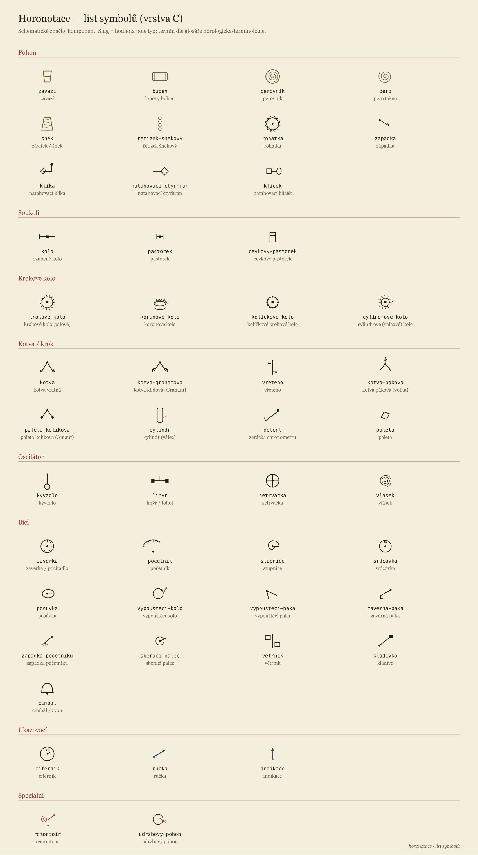
Sheet of symbols
Figure labels are in Czech (renderer localisation is planned).
In the diagrams the escapement is not assembled from separate pictures of each type, but from component symbols — escape-wheel types (saw-tooth krokove-kolo, crown korunove-kolo for the verge escapement with a foliot, pin kolickove-kolo for the Amant escapement, cylinder) and anchor/pallet types (recoil, deadbeat Graham, verge, lever, pin pallet, cylinder, detent). For the mapping druh → components see docs/kroky.md.
Documentation: docs/symboly.md, docs/kroky.md, docs/bici-regulace.md.

10. A detailed example — the gear train of the Prague Old Town astronomical dial
As a real example of a gear train (notably the concentric tubes of the astrolabe), the Prague astronomical dial is recorded from documented sources (§14); its dial is not given here as a model (see §7):
- astrolabe — a common pinion of 24 teeth drives the concentric rings 365 / 366 / 379 (zodiac / Sun / Moon),
- moon phase — a ring of 57 teeth,
- calendarium — a wheel of 365 teeth,
- wrought birdcage/posted frame; the moon phase and calendarium are on the dial side, outside the frame.
Elevation (layer C):
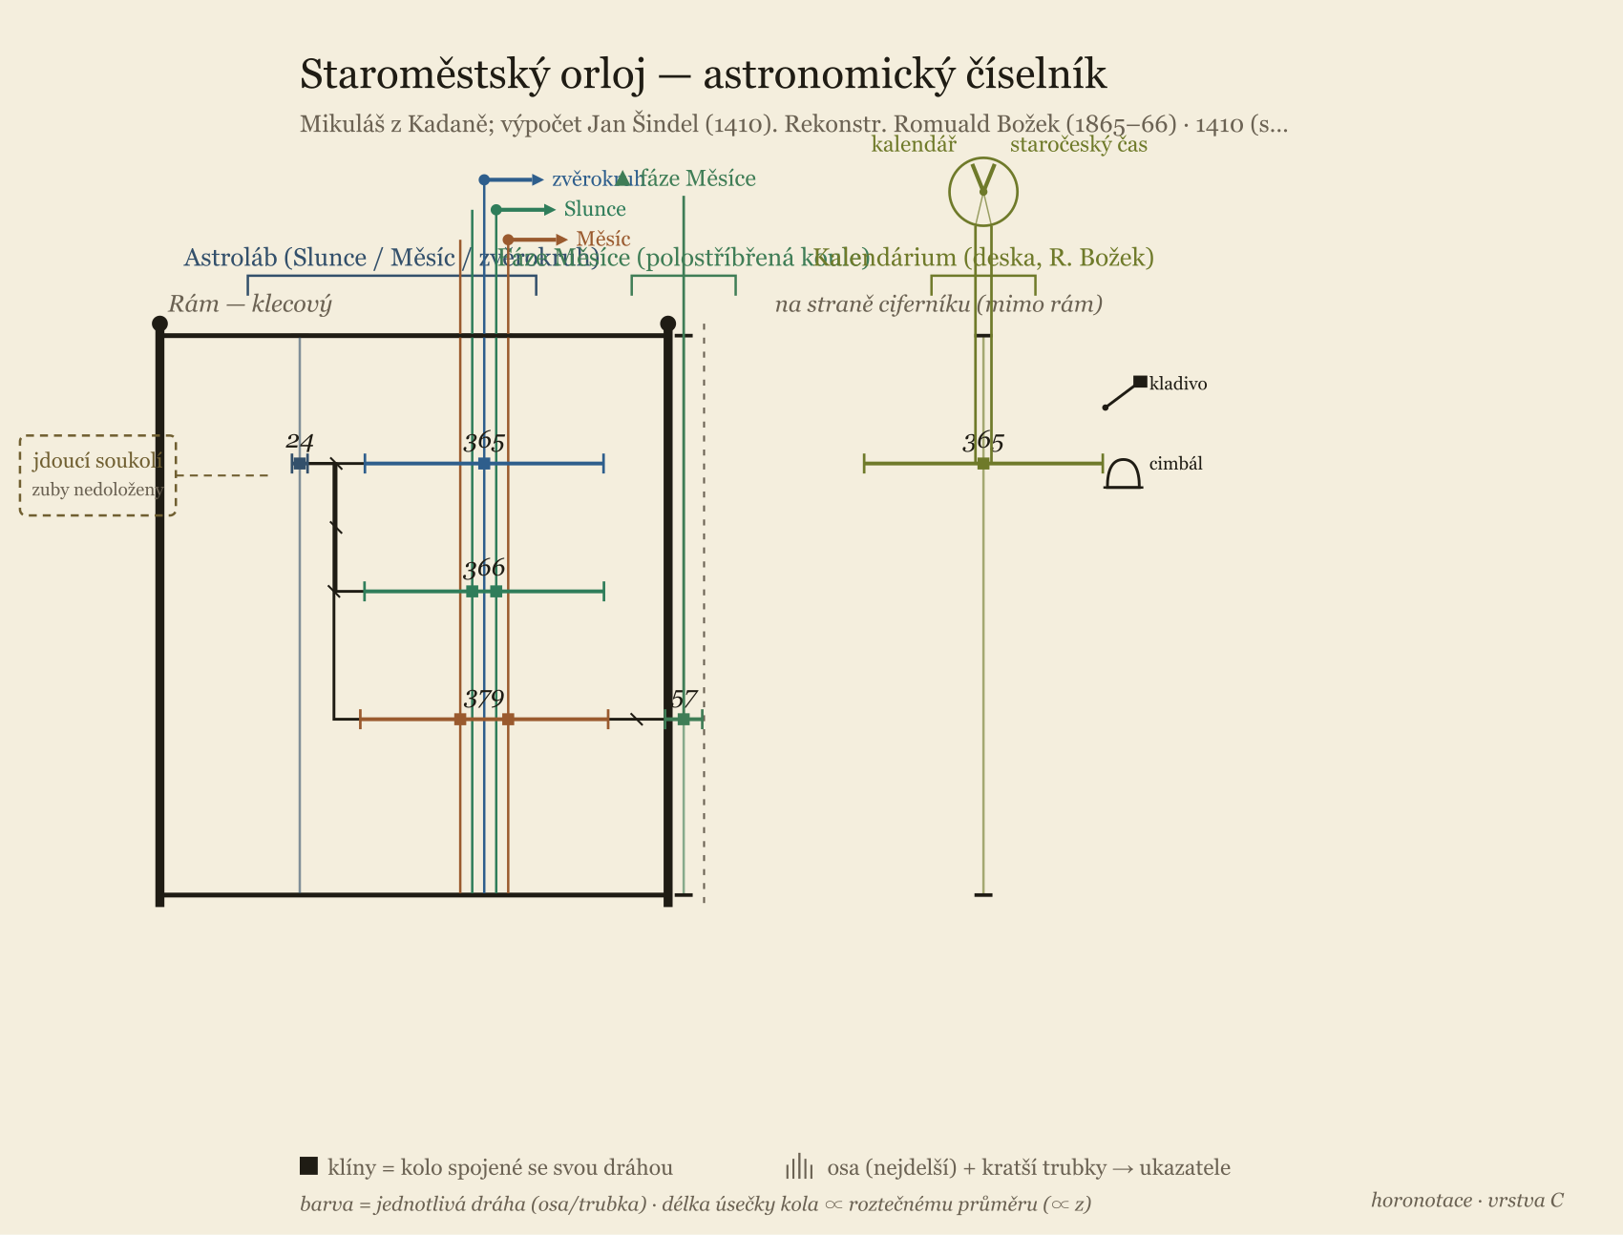
Elevation of the Prague astronomical dial
Record: examples/praga-orloj.yaml. The tooth counts of the going train of the astronomical dial are not unambiguously documented in the public sources — in the record they are marked as undocumented, and we do not invent them.
A historical variant (the 16th-century state, four “sides” after Táborský’s Report on the Astronomical Dial of 1570 and the burgomaster’s Letter of 1410) is captured by examples/praga-orloj-taborsky.yaml — an example of how the notation can also carry a record based on an archival source, where the author mostly does not give the tooth counts.

11. What is computed from the model
- the overall gear ratio of the train = the product of the tooth-count ratios along the path of meshes (i = (Z₁/z₁)(Z₂/z₂)…),
- the beat count per hour of the oscillator from the ratio between the center and escape wheels and the escape wheel’s tooth count,
- the running duration / time from the drum diameter, the number of turns and the weight’s travel,
- astronomical ratios and error — the periods are stored as exact fractions with a sense of rotation; for an indication, optionally the target astronomical period and the computed drift (after the model of Oechslin’s documentation practice, §14).

12. Questions for review
We ask in particular for your opinion on:
- Terminology — are the Czech terms correct and in accordance with your practice? What is named wrongly? (notably §8.6: striking control, winding)
- Faithfulness of construction — does the distinction plates / birdcage-posted frame / flatbed frame and dial side outside the frame capture the reality of both tower and interior movements?
- Scope — is a whole group of components missing (repeater, musical work, automaton figures, equation of time, seconds-stop…)?
- Granularity — is the twofold level (block / wheels) enough, or do you need a finer one (pivots, bearings, materials) for conservation documentation?
- Legibility of the diagram (layer C) — is the elevation comprehensible? What would you draw differently?
- Use — can you imagine deploying it for a collection record, a conservation report or a comparative study? What would have to be added?
- Movement identification — which fields in the header (maker, dating, inv. no., collection, location) are indispensable?

13. How to comment
Please make comments on the individual points with a reference to the chapter number, ideally with an example from a specific movement (even a photo/sketch helps); terminology comments with the source or regional usage given.
Channels for comments:
- GitHub Issues: https://github.com/csh-cz/horonotace/issues (preferred — with the chapter number for each comment),
- contact: David Knespl, Czech Horological Society.
Source repository (model, schema, examples, renderers): https://github.com/csh-cz/horonotace.

14. References

Inspiration — notations in other fields
- Weininger, D. (1988): SMILES, a Chemical Language and Information System. Journal of Chemical Information and Computer Sciences 28(1), 31–36.
- Portable Game Notation (PGN) — Edwards, S. J. (1994): standard specification for recording chess games.
- Music Encoding Initiative (MEI), music-encoding.org; ABC notation (Chris Walshaw).

Mechanical kinematic diagrams (classical)
- ISO 3952-1 to -4: Kinematic diagrams — Graphical symbols (1st ed. 1981). The international standard of graphical symbols for kinematic diagrams of mechanisms.
- Reuleaux, F. (1875): Theoretische Kinematik. Grundzüge einer Theorie des Maschinenwesens. Vieweg, Braunschweig.
- Artobolevsky, I. I. (1975–1980): Mechanisms in Modern Engineering Design. Mir, Moscow (a catalogue of kinematic diagrams of mechanisms).

Graphical gear elevation — the main inspiration
- **Oechslin, L. (1996): *Astronomische Uhren und Welt-Modelle der Priestermechaniker im
  - Jahrhundert.*** — the model for the “elevation between the plates” (verticals = arbors, a bracket = a wheel with its teeth, a horizontal = mesh, named outputs = indications). The main inspiration for layer C. Internal analysis: docs/oechslin-roegel.md.

Horological terminology and construction (Czech and German)
- Špatný, F. (1882): Německo-český slovník pro hodináře a pouzdráře hodinářské. (digital copy at MZK)
- Sušický, V. R. (1900): Hodinářství. Pro praktickou potřebu hodinářů a škol odborných.
- Sladkovský, J. (1947): Učebnice odborné nauky hodinářské. (notably the striking train)
- Hajn, M. (1953): Základy jemné mechaniky a hodinářství.
- Martínek, Z. & Řehoř, J. (1964): Základy hodinářství. (the model for block granularity)
- Dietzschold, C. (1905): Die Hemmungen der Uhren. archive.org (escapements / Hemmungen)
- Further period sources in the glossary of the horologicka-terminologie skill: Saunier (1887), Gros (1913), Šumavský (1851).

The Prague astronomical dial (example §10)
- Horský, Z. & Procházka, E. (1964): Pražský orloj (the astrolabe tooth counts).
- orloj.eu — description of the gear train and indications.

Metadata standards (planned, v0.2)
- Getty AAT (Art & Architecture Thesaurus), Wikidata, CIDOC-CRM — mapping of the vocabulary and header for museum records.

This document is a working draft of version 0.1 and will change according to comments. Thank you for the time given to reviewing it.

