**存储过程及触发器**

1. **存储过程**
2. 用户注册的存储过程(add_user)

|  |
| --- |
| CREATE PROCEDURE add_user  @u_nickname varchar(14),  @u_password char(32),  @u_sex char(1),  @u_email varchar(20),  @u_intro varchar(200)  AS  DECLARE @u_id char(10)  SET @u_id = (SELECT cast(floor(rand()*10000000000)as bigint))  INSERT INTO tb_user VALUES(@u_id,@u_nickname,@u_password,@u_sex,@u_email,@u_intro,GETDATE())  GO  -- 测试  EXECUTE add_user 'abc','123','0','1622135447@qq.com','暂无' |

1. 用户选择词典的存储过程（choose_dictionary）

该存储过程用于用户来选择词典，选择四级/六级词典（01/02），同时更新计划表(tb_plan),默认设定计划每天背词数为50个。

|  |
| --- |
| CREATE PROCEDURE choose_dictionary  @u_id char(10),  @p_select char(2),  @p_daywords int = 50  AS  DECLARE @p_id char(8), @p_leave_total int, @p_total int, @p_leave_days int  SET @p_id = (SELECT cast(floor(rand()*100000000)as bigint))  SELECT @p_total = COUNT(*) FROM all_words WHERE w_id like @p_select + '%'  SET @p_leave_total = @p_total - (SELECT COUNT(*) FROM tb_word_record WHERE u_id=@u_id AND w_id=@p_select+'%')  SET @p_leave_days = ceiling(cast(@p_leave_total as float)/@p_daywords)  IF EXISTS (SELECT * FROM tb_plan WHERE u_id=@u_id)  UPDATE tb_plan SET p_select=@p_select, p_daywords=@p_daywords, p_leave_total=@p_leave_total,  p_total=@p_total, p_leave_days=@p_leave_days, update_time=GETDATE()  WHERE u_id=@u_id  ELSE  INSERT INTO tb_plan VALUES(@p_id,@u_id,@p_select,@p_daywords,@p_leave_total,@p_total,@p_leave_days,GETDATE())  GO  -- 测试  EXECUTE choose_dictionary '6592330246','01' |

1. 用户调整计划的存储过程（adjust_plan）

该存储过程用于用户来调整计划，即调整每日的背词数量，同时刷新计划表（tb_plan）中的剩余天数。

|  |
| --- |
| CREATE PROCEDURE adjust_plan  @u_id char(10),  @p_daywords int  AS  DECLARE @p_leave_total int, @p_leave_days int  SELECT @p_leave_total = p_leave_total FROM tb_plan WHERE u_id = @u_id  SET @p_leave_days = ceiling(cast(@p_leave_total as float)/@p_daywords)  UPDATE tb_plan SET p_daywords=@p_daywords,p_leave_days=@p_leave_days, update_time=GETDATE()  WHERE u_id=@u_id  GO  -- 测试  EXECUTE adjust_plan '6592330246',10 |

1. 生成今日词汇的存储过程（get_today_words）

该存储过程用于生成用户每日须背的词汇表。若用户此前无此词典的学习记录，则今日词汇的组成仅为今日新学，即直接随机从词典中抽取指定数量的单词出来；若用户有此词典的学习记录，则今日词汇的组成为须复习（日期距今最近一天学习单词的1/3）**+**今日新学。

|  |
| --- |
| CREATE PROCEDURE get_today_words  @u_id char(10)  AS  DECLARE @p_daywords int, @p_select char(2), @old_words int  SELECT @p_daywords = p_daywords, @p_select = p_select FROM tb_plan WHERE u_id=@u_id  SELECT @old_words = count(*) FROM hasrecord_words WHERE u_id=@u_id AND w_id like @p_select + '%' AND study_date = (SELECT min(study_date) FROM hasrecord_words WHERE study_date<=getdate())  IF EXISTS (SELECT * FROM tb_word_record WHERE u_id=@u_id)  -- 有单词学习记录 则单词组成为 需复习单词+今日新学  BEGIN  SELECT * FROM (SELECT TOP (@old_words/3) u_id,w_id,w_spell,w_pronun,w_c_paraph FROM hasrecord_words WHERE u_id=@u_id AND w_id like @p_select + '%' AND study_date = (SELECT min(study_date) FROM hasrecord_words WHERE study_date<=getdate()) GROUP BY u_id,w_id,w_spell,w_pronun,w_c_paraph,wrong_nums) a  UNION ALL  SELECT * FROM (SELECT TOP (@p_daywords) u_id=@u_id,w_id,w_spell,w_pronun,w_c_paraph FROM all_words WHERE w_id like @p_select + '%' AND w_id NOT IN (SELECT w_id FROM tb_word_record WHERE u_id = @u_id) order by newid()) b  ORDER BY w_id  END  ELSE  -- 无单词学习记录 则单词组成仅仅为今日新学  SELECT TOP (@p_daywords) u_id=@u_id,w_id,w_spell,w_pronun,w_c_paraph FROM all_words WHERE w_id like @p_select + '%' ORDER BY NewID()  GO  -- 测试  EXECUTE get_today_words '6592330246' |

另外，此存储过程生成的今日词汇表会存储到临时表##temp_todaywords中，便于用户一天内多次访问。

|  |
| --- |
| -- 存入临时表  -- 创建临时表  CREATE TABLE ##temp_todaywords (  u_id char(10) not null,  w_id char(6) not null,  w_spell varchar(50) not null,  w_pronun nvarchar(50) not null,  w_c_paraph nvarchar(255) not null,  CONSTRAINT un_wid unique(w_id)  )  -- 临时表插入数据  INSERT INTO ##temp_todaywords EXECUTE get_today_words '6592330246'  -- 查询临时表  SELECT * FROM ##temp_todaywords  -- 删除临时表  if OBJECT_ID('tempdb..##temp_todaywords') is not null  drop table ##temp_todaywords |

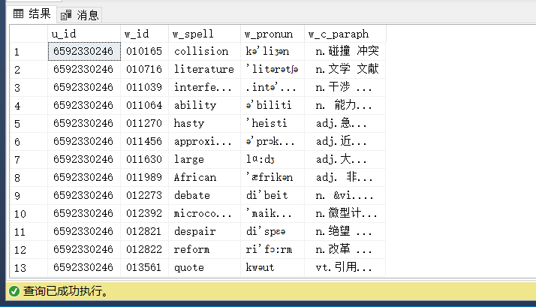

1. 得到单词四个选项的存储过程(get_options)

该存储过程用于生成每个单词对应的中文选项。其过程运用了Levenshtein Distance (编辑距离)算法，通过此算法来找到与当前单词拼写字符串相似度最高的4个单词选项。

|  |
| --- |
| CREATE PROCEDURE get_options  @w_id char(6)  AS  DECLARE @w_spell varchar(50), @dictionary char(2)  SELECT @w_spell = w_spell FROM all_words WHERE w_id=@w_id  SELECT @dictionary=LEFT(@w_id,2)  SELECT TOP 4 w_id,w_spell,w_pronun,w_c_paraph,(SELECT dbo.edit_distance_within(@w_spell,all_words.w_spell,10)) AS similarity FROM all_words WHERE w_id like @dictionary+'%' AND ((SELECT dbo.edit_distance_within(@w_spell,all_words.w_spell,10)) BETWEEN 0 AND 9) ORDER BY similarity  GO  -- 测试  EXECUTE get_options '025000' |

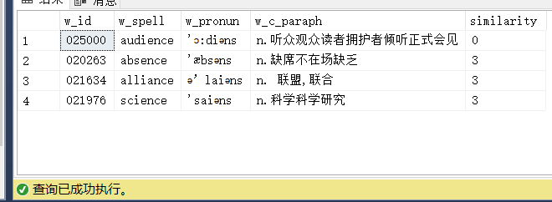

1. 用户单击选项的存储过程(select_option)

该存储过程用于用户单击选项时一系列处理的存储过程。用户选择时，触发触发器tr_recite， 同时更新单词记录表（tb_word_record），选错时错误次数（wrong_nums）+1。

|  |
| --- |
| CREATE PROCEDURE select_option  @u_id char(10),  @w_id char(6), -- 当前词汇id  @select_id char(6) -- 选择选项的词汇id  AS  DECLARE @w_r_id char(10), @wrong_nums int  SET @w_r_id = (SELECT cast(floor(rand()*10000000)as bigint))  IF EXISTS (SELECT * FROM tb_word_record WHERE u_id=@u_id AND w_id=@w_id)  BEGIN  SELECT @wrong_nums=wrong_nums FROM tb_word_record WHERE u_id=@u_id AND w_id=@w_id  IF @w_id != @select_id  -- 选错  SET @wrong_nums = @wrong_nums+1  UPDATE tb_word_record SET wrong_nums=@wrong_nums WHERE u_id=@u_id AND w_id=@w_id  END  ELSE  BEGIN  SET @wrong_nums=0  IF @w_id != @select_id  -- 选错  SET @wrong_nums = @wrong_nums+1  INSERT INTO tb_word_record VALUES(@w_r_id,@u_id,@w_id,@wrong_nums,GETDATE())  END  GO  -- 测试  EXECUTE select_option '6592330246','014377','014377' |

1. 触发器tr_recite触发的存储过程(update_study_record)

该存储过程用于用户背单词时学习记录表(tb_study_record)的更新以及计划表(tb_plan)的更新。用户选对时，删除今日词汇表(临时表##temp_todaywords)中的一行该单词数据；用户选错时，会重新插入该单词数据至今日词汇表。同时更新/插入学习记录表和计划表的数据。

|  |
| --- |
| CREATE PROCEDURE update_study_record  @u_id char(10), -- word_record表更新/插入行的用户id  @w_id char(6), -- word_record表更新/插入行的词汇id  @isRight int-- 是否选对 0错 1对  AS  DECLARE @s_r_id char(10),@w_spell VARCHAR(50),@w_pronun nvarchar(50),  @w_c_paraph nvarchar(255),@s_wrong int,@s_total int,  @p_leave_total int,@p_leave_days int,@p_daywords int,@cur_date date  SET @s_r_id = (SELECT cast(floor(rand()*10000000)as bigint))  SET @cur_date = GETDATE()  SELECT @w_spell = w_spell,@w_pronun = w_pronun,@w_c_paraph =w_c_paraph  FROM all_words WHERE w_id = @w_id  SELECT @p_leave_total =p_leave_total,@p_leave_days =p_leave_days,@p_daywords=p_daywords FROM tb_plan WHERE u_id=@u_id  -- 从临时表中删除该行 当日学习单词-1  DELETE FROM ##temp_todaywords WHERE u_id =@u_id AND w_id = @w_id  IF EXISTS (SELECT * FROM tb_study_record WHERE u_id ='6592330246' AND study_date =@cur_date) -- 当日有学习记录，则为更新记录  IF @isRight = 0  -- 选错  BEGIN  SELECT @s_wrong =count(*) FROM tb_word_record WHERE u_id=@u_id AND wrong_nums > 0 AND study_date = @cur_date  -- 重新插入临时表尾部 错词重新学习 当日单词+1  INSERT INTO ##temp_todaywords VALUES(@u_id,@w_id,@w_spell,@w_pronun,@w_c_paraph)  UPDATE tb_study_record SET s_wrong=@s_wrong WHERE u_id=@u_id  END  ELSE  -- 选对  BEGIN  -- plan表中剩余单词总数减1  SET @p_leave_total= @p_leave_total -1  -- 更新tb_study_record  SELECT @s_total = s_total FROM tb_study_record WHERE u_id =@u_id AND study_date =@cur_date  UPDATE tb_study_record SET s_total=@s_total + 1  END  ELSE  -- 当日无学习记录，则为插入记录  IF @isRight = 0  -- 选错  BEGIN  -- 插入临时表  INSERT INTO ##temp_todaywords VALUES(@u_id,@w_id,@w_spell,@w_pronun,@w_c_paraph)  -- 插入study_record  SET @s_total =0  INSERT INTO tb_study_record VALUES(@s_r_id,@u_id,@s_total,@s_wrong,@cur_date)  END  ELSE  -- 选对  BEGIN  -- plan表中剩余单词总数减1  SET @p_leave_total= @p_leave_total -1  -- 插入到tb_study_record  SELECT @s_wrong =s_wrong FROM tb_study_record WHERE u_id =@u_id  SET @s_wrong=0  SET @s_total=1  INSERT INTO tb_study_record VALUES(@s_r_id,@u_id,@s_total,@s_wrong,@cur_date)  END  -- 更新plan表剩余天数  SET @p_leave_days = ceiling(cast(@p_leave_total as float)/@p_daywords)  UPDATE tb_plan SET p_leave_total=@p_leave_total,p_leave_days=@p_leave_days, update_time=@cur_date |

1. get_options存储过程调用的算法函数(edit_distance_within)

|  |
| --- |
| /*  **@param s和t为比较字符串  * @param d为限定最大编辑操作次数  * @return 最少编辑操作次数(-1即为超过最大编辑操作次数)  */  CREATE FUNCTION edit_distance_within(@s nvarchar(4000), @t nvarchar(4000), @d int)  RETURNS int  AS  BEGIN  DECLARE @sl int, @tl int, @i int, @j int, @sc nchar, @c int, @c1 int,  @cv0 nvarchar(4000), @cv1 nvarchar(4000), @cmin int  SELECT @sl = LEN(@s), @tl = LEN(@t), @cv1 = '', @j = 1, @i = 1, @c = 0  WHILE @j <= @tl  SELECT @cv1 = @cv1 + NCHAR(@j), @j = @j + 1  WHILE @i <= @sl  BEGIN  SELECT @sc = SUBSTRING(@s, @i, 1), @c1 = @i, @c = @i, @cv0 = '', @j = 1, @cmin = 4000  WHILE @j <= @tl  BEGIN  SET @c = @c + 1  SET @c1 = @c1 - CASE WHEN @sc = SUBSTRING(@t, @j, 1) THEN 1 ELSE 0 END  IF @c > @c1 SET @c = @c1  SET @c1 = UNICODE(SUBSTRING(@cv1, @j, 1)) + 1  IF @c > @c1 SET @c = @c1  IF @c < @cmin SET @cmin = @c  SELECT @cv0 = @cv0 + NCHAR(@c), @j = @j + 1  END  IF @cmin > @d BREAK  SELECT @cv1 = @cv0, @i = @i + 1  END  RETURN CASE WHEN @cmin <= @d AND @c <= @d THEN @c ELSE -1 END  END  GO  -- 测试  SELECT dbo.edit_distance_within('surface','sdsadas',10) |

测试结果:

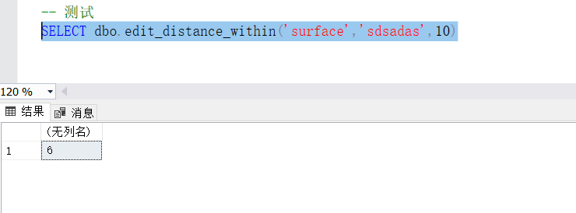

1. **触发器**

1.用户背词的触发器(tr_recite)

该触发器用于用户背词时的处理，调用update_study_record存储过程。

|  |
| --- |
| CREATE TRIGGER tr_recite ON tb_word_record  AFTER INSERT,UPDATE  AS  DECLARE @u_id char(10), -- 插入/更新用户id  @w_id char(6), -- 插入/更新当前词汇id  @before_wrong_nums int,-- 插入/更新前的wrong_num  @after_wrong_nums int,-- 插入/更新后的wrong_num  @isRight int-- 是否选对 0错 1对  SELECT @u_id =u_id, @w_id =w_id, @after_wrong_nums=wrong_nums FROM INSERTED  SELECT @before_wrong_nums=wrong_nums FROM DELETED  IF (@before_wrong_nums = @after_wrong_nums OR @after_wrong_nums =0)  -- wrong_nums未发生改变或after_wrong_nums为0,即为选对了  SET @isRight = 1  ELSE  -- 选错了  SET @isRight = 0  EXECUTE update_study_record @u_id,@w_id,@isRight |

2.用户自动打卡的触发器(tr_clock)

该触发器用于用户背完今日词汇时的处理，自动生成打卡记录。

|  |
| --- |
| CREATE TRIGGER tr_clock ON tb_study_record  AFTER UPDATE  AS  DECLARE @u_id char(10), -- 插入/更新用户id  @s_total int, -- 插入/更新当日学习单词数  @p_daywords int -- 用户计划每天学习单词数  SELECT @u_id =u_id, @s_total =s_total FROM INSERTED  SELECT @p_daywords= p_daywords FROM tb_plan WHERE u_id=@u_id  IF @s_total = @p_daywords  INSERT INTO tb_clock(u_id,clock_time)VALUES(@u_id,GETDATE()) |