class04.R
cyrusshabahang
2026-01-16
x <- 1:50
plot(x)
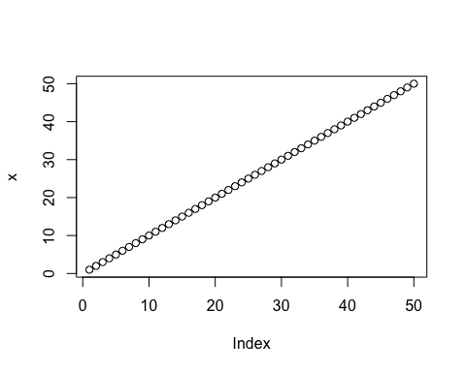
plot(x, sin(x), type = "l", col = "blue", lwd = 3,
xlab = "Is it lunch time yet?")
