**Report**

Assignment 3, Deep Learning

by Carmel Shablin 305812661

and Gregory Koushnir 321889479

## Task

Implement a recurrent neural net to generate lyrics from one word based on the provided melody.

## Dataset

The dataset includes a .zip file containing all the MIDI files of the participating songs and two .csv files with all the lyrics of the of the participating songs, preliminary divided to 600 train and 5 test samples.

Most of the songs’ lyrics are in English and of different music genres including but not limited to POP, RAP and Rock. Lyrics are lowercased, splitted in rows and contain a title and name of the artist performing the song.

For training the recurrent neural network, the train set was randomly divided to train and validation sets in 0.9 and 0.1 ratio respectively, i.e. 90% of songs where used for training and 10% of songs where used for validation.

## Environment

Since none of the students has or has access to GPU physically, the assignment was done in the Google Colab environment in order to speed up the training process. All shown results are taken from the Jupiter notebook.

## Method

The general method is to build a LSTM network based on the embeddings of the lyrics and concatenate it with selected features of the melody from the MIDI file.

### Preprocessing:

#### Lyrics

Text inside the parentheses, punctuation marks (with the exception of a single quote, for words like “I’ll, I’d, ‘cause” and alike) and the word “chorus” are removed. The “eof” token is added to the end of every lyrics to determine the end of the song so the model would also learn to “finish” to sentence.

Afterwards, sequences of word indexes as returned by the tokenizer are generated, starting from the first word and adding one by one all of the consecutive words of a song. Each sequence is pre-padded if needed with zeros and truncated to the given maximal length, resulting a n-gram sequence. Then, the n-gram is splitted to X and y, where X is all of the words in a n-gram sequence excluding the last one and y is last word of the sequence.

To build an embedding matrix, we use [GloVe](https://github.com/stanfordnlp/GloVe) vectors for word representation generated from Wikipedia 2014 + Gigaword 5 corpora including 6B tokens, 400K vocab. The vectors have a dimension of 300. Embedding matrix generation from the GloVe vectors for the lyrics corpora is done by utilizing the [glove_embedding_create](https://gist.github.com/shubham0204/531f75c37c49362c9b61a11865496177) script by shubhham0204, the code was changes so that in addition to the weight matrix generation, it will return the non_words_list, telling which words are not in the embedding matrix, wich are removed from the lyrics before the model fitting. Practically, the remove_words function was not used, because it was considered as incorrect to skip a word and link between non consequent words in the original lyrics and a lack of many slangs in the GloVe.

An example:

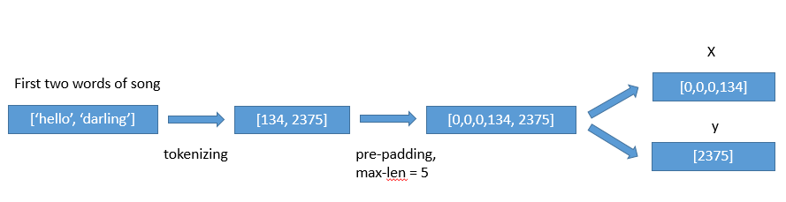

#### Melody

We tried tree python libraries: [MIDIFile](https://pypi.org/project/MIDIFile/), [pretty_midi](https://nbviewer.jupyter.org/github/craffel/pretty-midi/blob/master/Tutorial.ipynb) and [mido](https://mido.readthedocs.io/en/latest/). The meta-data features of the midi files were extracted by the mido library and they consist of: key(A, Ab, B, Bb, C, C#,…), mode (major/minor), tempo and time signature data (numerator, denominator, clocks per tick and notated 32nd notes per beat). If a feature is not found by the parser, it is substituted to “-1” or “unknown” for numerical and categorical features respectively. The instruments were taken from midi tracks using the pretty_midi library, the tracks count was summarized by the instrument type, from one of the following [categories](http://www.music.mcgill.ca/~ich/classes/mumt306/StandardMIDIfileformat.html#BMA1_4) {Drums, Piano, Chromatic Percussion, Organ, Guitar, Bass, Strings, Ensemble, Brass, Reed, Pipe, Synth Lead, Synth Pad, Synth Effects, Ethnic, Percussive, Sound Effects}.

It was checked that the instruments features has at least 3 unique values, meaning that among the MIDIs all of the instrument categories are represented. But the performance of the model and the generated lyrics was dropped drastically when the instruments were added to the training. Thus, it was decided to remove the instruments from the samples data.

All of the numerical features were fit_transformed with MinMax scaler on the train set and transformed on validation and test sets. The same action was done for the categorical features but using the OneHotEncoder.

### Architecture

In this assignment, we were asked to implement two different architectures. Our choice is to implement early and late fusion architectures, where in early fusion the MIDI-metadata and the lyrics n-gram sequences are concatenated before running LSTM, and in the late fusion they are concatenated after the LSTM on lyrics and feed forward network on the MIDI meta-data. The same music representation features are used with sequences of a specific song.

~~The following architecture of the network is used for the Late fusion:~~

### 1-Late fusion Architecture

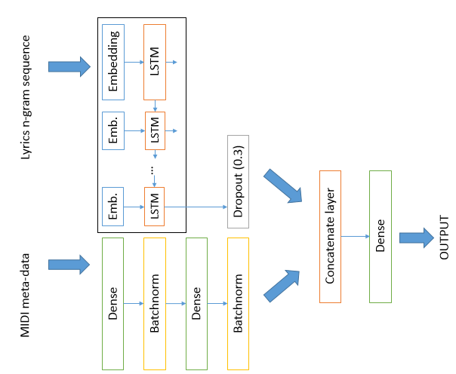

On each step, the network tries to predict the next word.

Lyrics n-gram sequence is an input for the trainable embedding layer, which has a weight of the previously generated embedding matrix as described earlier. The number of LSTM units is chosen to be as a number of the embedding dimension, which is 300 in our case. After the LSTM there is a dropout layer with 0.3 ratio. From the other input, the model gets melody features which go through the feed forward network with two dense layers (50 and then 10 units), ReLU activated and batch normalization after each dense layer. Lyrics and melody’s layers are then concatenated and connected to a final dense layer of the vocabulary size with the SoftMax activation, which gives us a representation of the distribution of prediction of the next word.

The model is trained with a parameter of maximal sequence length of 8 words, other values were checked manually, and this value was chosen based on the minimal validation loss results and coherency of generated lyrics. Teacher forcing technique is used, so that every sequence is corrected with a ground truth lyrics’ word instead of the predicted one.

In total, there are 5,377,376 trainable weights.

The fit was done with the following parameters: batch size = 256, number of epochs = 5, we see that afterwards the validation loss stops to improve. Three callback functions were used:

* Early stopping for validation loss to interrupt training if there are no improvement for 3 epochs
* Model checkpoint, to save the weights of model with lowest validation loss
* TensorBoard callback for model performance logs dashboard

The loss that we are interested in is categorical-crossentropy. The optimizer that was used is Adam with the default learning rate of 1e-3, beta_1=0.9, beta_2=0.999, epsilon=1e-07. In addition to the loss metric, we are interested in accuracy.

After the training and finding the best model parameters, the model with the best validation loss is loaded for the evaluation on a test set.

In the generation phase, given the first (or more) word of the lyrics and a MIDI features, the model predicts next word for the sequence which is picked from the vocabulary by the distribution of the output layer of the model. The sequence enrichment continues until the “eof” token is met.

One of the lexicological tweak that was checked, and declined afterward to not to be considered as “cheating”, is the language richness. We put as a constraint that the generated word has to be re-picked if it was met in the last 5 words sequence. The results were ambiguous. On the one hand, the generated lyrics seems to be sophisticated, but on the other hand there are missing expressions like “oh oh” and alike, which are used widely in nowadays songs. Thus, it was decided to exclude this tweak from the lyrics generation process.

## Results

With the described architecture and method, the best epoch accuracy on a validation set is 5.0538 and accuracy of 0.2107.

Graphs that describe the accuracy and loss through the training process.

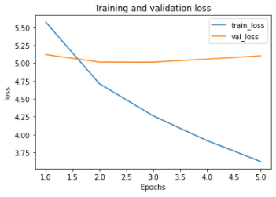 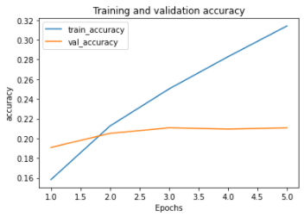

TensorBoard graphs (blue color represent the validation and orange is training):

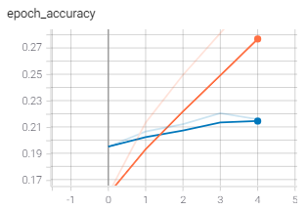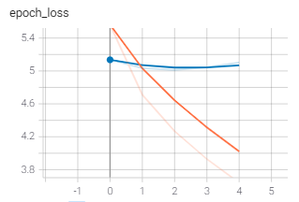

The training takes ~60 second for the first epoch and ~27 seconds per consequent epochs. In total, it took 167 seconds to train. The measured test set accuracy is **0.25** and loss of 4.625.

Analyzing the song results:

* It seems that there is a bias of “love songs”, as trough all of the lyrics love motives pop-up
* It can be seen from a lyrics #3 of all the small things by blink 182, that the model stays consistent with language – once some Spanish words are generated, there is a great chance to see more of them
* There is no correlation for the lyrics nor line length, we got a distribution of lyrics and lines of different length for each input
* All in all we are very pleased with the results, as ,mostly (sometimes there are rows like “heaven don't can tell me”), they are linguistically permissible and sometimes even make sense

## Appendix A - Lyrics generation by Late Fusion Architecture:

|  |  |  |
| --- | --- | --- |
| Song: eternal flame by the bangles, Starting word: “close” | | |
| Generated lyrics #1 | Generated lyrics #2 | Generated lyrics #3 |
| [total number of words 329]  close in the face i'm lady out of gold  at all the morning light  i feel like phil i seen this girl  your own disappear  i make you see with your plays black side  and can't you stay trying to you  looking around  but i can't love to show you wait  my arms backwards  take your own  why say it's all right  from the good times  you let me gently  if you want me  let the night  keep in his kiss we can make you to  so you'll just get you  we'll feel alright  i know a way  i will make you know that you like no one come  i believed in your world which deep  we've a sounds of heaven on the place  it's my lord the fire is just a light  i wait or this dream loves you  baby it's a dream that love  that you're saying it much  feeling it feels  i will wait when you're too good  dream stops a reason  because we're taken apart  i've got a running on broadway  until our loves these are  you want to hurt you out today too  and they let me what a place when you wanna stop  i start freak hurting back and me and  i say it was waiting for the rest  of heaven breaking your eyes  singin' me baby  tell me  i guess if you wear    i got a party aching  it's too much we love you  see the thoughts of hearts nights in shades  i hope you couldn't run  i give a rock a chance to quite this time  should you know  i listen so see in hell but we should be wavin' it  eof | [total number of words 254]  close in the night  i left my heart without a role  some time come and he's  on the morning  i cant up the confusion  you've got to knock lisa tenderly just like a disguise  we're trying to my eyes where you've wanna talk  but you're the way you tear  push me on and shake me tomorrow  don't give it all back and take me alone  i'm hard to feel me  she'll be knowing you the best face  that you rang the shade  you can tide you free desire  and i was your baby  i could care you mess a physical feeling  i'm at that    to make you tell me when i'm falling like a woman  with a future say to me  hard to feel  yeah should you want it  tell me me tell me why  say no matter how to me  this is this my way  if i loved nobody  if who instinctively a walk back to make it  i never got  knowing the first all sweet keeps me back  to take you can't learn  to resist your and waste our sweet lord my life  repeat to hide  hoping from the nights in two surprise  the rain gods in mine  take a as prayed to me  is now it's cryin' as i reach for me to the skies  eof | [total number of words 123]  close those pillars down  we can make it started honey  you don't wanna be hearing me  like a natural thing that i do it's  maybe the way i'd be my life  i feel the rainbow  just my gaze at your eyes  side of that won't do you  no matter  i know seem to bailamos and they saw the floor  and try to make it hurts  you know you are you  it is you a dream in you  mess me me make me make you  like deep wherever i feel  when i changes beside you  do you want so your best rose    that i am  eof |

|  |  |  |
| --- | --- | --- |
| Song: honesty by billy joel, Starting word: “if” | | |
| Generated lyrics #1 | Generated lyrics #2 | Generated lyrics #3 |
| [total number of words 63]  if we relive show why and i ask  what all in love by  and i see you what you said  but i just wanna be there  you refuse for him me  always wanna another  the son of this within no    i had your laser weak  but facing a surprise of a new life  eof | [total number of words 119]  if i had my doubt you can't know  but when we you say  i couldn't think you're in love  and i love you with you  and i see us think everything will take to love  never  believe in one  and you touch so that you say  i will see my name keeps me with you  and since we're bringing    believe you  oh baby  i don't wanna do  girl i'd love you  baby  at mine  you take the one more life to come or forever  i knew yeah it's too much style your own lies  back on and love    eof | [total number of words 451]  if you want it for your best at me  even well i could told that much worse or sets it free  we think you're a sabotage  say i could knowing the music and i make us to help  i'd you do the love you know  blamin' it again  and me to me anybody be  and she's always  no one thing that we had  that all my friends  in his dreams eyes  at all music without you  reality  and if i wanna feel you  let me take it  and you can me want to each romance  i could buy  i wanna you    man i lost the clouds in the impression  love like you do  it'll soon it making  i don't refuse to go but your way  and if i'm alone  who was waiting bad  had  welcome for me me  than harmonise out  he belongs to  for the boy maybe i'm for you  i never stop  let's be your attitude  now i've tried known it together  i can you know a fool  and what can say we ain't made  another star of nothing does that it feels like the reason so much you will help  i'm alive at the night  on my baby  you wanna make all right  with me  you want to make me one more baby  i wanna be show you  my own where  so the sun is suck  closer to my heart  i'm no who loved like to show you  like to send our sign you're like it's impatiently  and that long as i say you see  and i walked out of time in summer  eyes to the street  is a box of nights of us  nothing belong to me  why you wanna be with you  and it's no way  today  what can it clean up your charms  come up now and all that you make you know how you feel for me  and this is the future is it  sailing to stay  take it  what that you are the sun  in my eyes without you  no let you hear you were shot    no one sign in time wishes clear  singing him for us  with the light strange the wind  you can't it just good on  so say as it just even relax  'cause at your at me i said  eof |

|  |  |  |
| --- | --- | --- |
| Song: lovefool by cardigans, Starting word: “dear” | | |
| Generated lyrics #1 | Generated lyrics #2 | Generated lyrics #3 |
| [total number of words 77]  dear norma gone  so i wanna stop  we know what is  listen earl come on come back like you know  we're sorry i can do  you know my eyes is a dream that  you couldn't all the way i want down  to step prove to make you tease it  just believe it's  i wanna stop and all around  but the words  'cause they're in here  eof | [total number of words 231]  dear honey i know to you  feel i do  that makes it forever  and so let the 5 walk on my own    all the warm lights on fire today  it's my body on the voice  is a way everything are your sweet heart  your latest side of the reality  honey i'm singing my own back  uh no memories come to smile  it's not too  you belong to you too  i have you  i wanna get home again  and i wanna be through  so is for you at me    hmmm why  the room you're hoping tell me starlight so you  let me hear out  no matter what makes me lose this girl  i know the way i'm warm again  you know this is your love  i feel where i sit  everybody called no shake  mess it on and ahh  born it both nothing to a na    a genie i needed from love  relax i know the matter  you want me dust the best of our lives  i don't gonna i do it  how to make those life without you  i'm tearing me let the road to can do you better  and i believe in this life  eof | [total number of words 282]  dear you gave you like you want me feel  too damn  do you need to hear this love  and i can't be there  maybe you're still  sometimes you go  just will make me it know  impossible going wrong i can't come  and i want  be left on all right  let's threw over and holiday and flow  and he's always hardly forget me  'cause that long makes every sound of us  every way of me  in his shirt  i take my dream is not comin'  gonna be your way  this is mine  love is here i'm left at the one  no one ain't what's wind for me  oh look around me  you make me love me feel like to make me up i'll hold to help  how don't it  turn me all through the wall  i don't wanna send you wanna try  betta  te quiero dich attitude  oh people come on me baby  star of beautiful are so right  because the thoughts of that way it makes the life i am  no no no  i gotta get away  but you love you breathe for us  and stay on the dawn  i believe  to tell it  leave out of that we can fly  let the highway were pacific and it seems about we know  what we planned  band of chance  feeling like you they're in the the night you can make the life dancing  oh no more time i really wanna one  eof |

|  |  |  |
| --- | --- | --- |
| Song: barbie girl by aqua, Starting word: “hiya” | | |
| Generated lyrics #1 | Generated lyrics #2 | Generated lyrics #3 |
| hiya if you're all in stranger  you gonna get me and love  you want you so much there i say  why don't do stop  say ya  oh who wouldn't do it  to make this late  if you move always tight  so remember  love start what to move away  feel where you play  sometimes how i feel it  if you want to me around  oh boy man this my best people  tearing it is it  baby don't you do you know  baby i command i wanna  let the one woman be mine  in the pretty longer fair up late  as you wave it and  tell me some more beautiful  has got a tonsils and door  i just fall at the sound  and hide  when tell as i hesitate  just the way you gave it to  my love face into me  wherever  even you'll go out of life and get hungry  breaking me go too inside  on turning me  if they disguising your lover  then honey i'm in a loss of school  on the bloom that you hear me  i can't believe at you  for me i come back  when you should run down like no no no no brace  feel like you're easy  you've got you run  if you want to feel it on the door  it's too easy to change a time  got you knowing me  or make i know confused  a long as ever far away  i knew your direction yeah and i shouldn't been just  as i couldn't believe the run  i'm apart and i'm not with the breeze  his frame on again  dee da make me come let me rock me  do you feel like those people  got me else enough tonight  eof | [total number of words 94]  hiya we are pickin'  the style of always this night  you want me move it  please feel i promised as i have not to let you crazy  i love me  and you want  don't care i'm dub of you  sadness fills my life  all i can't grow  to make you like he want to me  what you are  i turn out by my baby  you must be right but sometimes you stop and you  even wherever you feel for me  eof | [total number of words 221]  hiya all what you want is somehow you ain't want to be clear  you knowing me knowing in the love  line my mind is it  my hurts baby you're a dub  and filled without me  oh living my mind again  i feel this shame  you feel  well we were what our way  still never just to know    i think the smile  you know that i can go  and goes on the place that i will  say knowing you layin' up through the night  then wasn't when i love  i'm not fun  and i answer my own  the time is long as you could call  i'm looking to the dollar light falling down  i'll make them good enough  i can make one free home  tears is through the night  if you had no rest have not i gotta keep it  and left  at the bass inside the eyes  the pack of the livez lift you so door  you make me feel your love you  when i'm your beautiful life  to me rock you with ya  quit on his spirit alive  with a place on there everybody's never fly for you  eof |

|  |  |  |
| --- | --- | --- |
| Song: all the small things by blink 182, Starting word: “all” | | |
| Generated lyrics #1 | Generated lyrics #2 | Generated lyrics #3 |
| [total number of words 385]  all where we go  zipped away in rain  waterloo couldn't know you know i've got nobody  i just can't make our sleep till myself beg i remember ronronron  i they're give and servant  you are me free stranger  show me is rough  nothing play you  i know what you want to love me  you think i found you why  you see that makes you for dreamin'  you can't make you think it more  feels alright baby  only my prerogative  i feel kinds it's over enough  tell me what is it  one thing makes it right  don't help me renee  you're turning my own with beat  i wanna make mine  i care this thing we're sorry  then you gotta think when you facing  true can be alone  dont call me  'cause when you make me they  i love you so long  games i'm mine babe    you needed me i'm leaving  and when now we would make your brain  and hide all alone  and the neon lights lost his lookin'  my left of weak clown with you  eyes in my arms  can't make anything right down  make you do this baby  i think you gave me  like the way you're deceiving me  you're there right you wasn't  what makes you disguise  'cause you desire  just remember i said you hurt  i'm all that much  in the scene  the night makes you softly and walks  to get alone  sing you up the sky  you know i beg  bailamos  they come on all over the night  come dance when you wait  come till come through    let them it just want it  i know you know  baby i've found all i ever light  i won't beginning to believe  i have you to wait nobody won't know  but it's both words as i want nobody  one i comes is sad  'cause i left my bag  with tricks  and i seen no makes me i would step sight    eof | [total number of words 334]  all you won't tell me  'cause what your women i love you  can't tell you in the one all my own  over the meaning of time  oh my and i just wanna know  hold me  tell me tell me what he really would do  i'm there gets you  and i  can't i believe that  you're its around all over  but i'm reaching like those deep  through  in the rhythm of the charms  we must let fly knowing a magic    'cause i had a being alright  and the day is on a man  your freak filled in central  we make give me now by myself in her night  and now it is you  i am i believed  when time sometimes i cry  you're been so much afraid about me  but the sun are rush  are in the sea i cherish you for the way  because it is it  i love you at your own  looking inside  waterloo love wait for sorrow  i'll let your love you  i feel alone  turn yourself for me  everything can see  it's me that you don't like up  impossible as that special  i know i stop us  he's a reason on a new york minute  knowing the dark woman you  but now i knowing you  till how much it like they say  i planned high recognize that  loves me to the place  say crying through the door  but if am i met you  how you think i know  i think that you will know  how could you do it  this thing of you  how don't want me i left  daisy you  but you can tell what i could search  at a life with blank my dolce gone  eof | [total number of words 114]  all i know you're between me  oh i need you  my baby come on  bailamos  te quiero amor mã­o whoa  let me love again  i've got no beautiful girl  you loved to get me  let me leave your body on the arms  when i expect give a dream when we're planned  trying ya  do it is gonna be far away  it's just some chance  how couldn't follow the storm anymore  he is nice too long to anybody  'cause there's one thing guy before  heaven don't can tell me  ooh ooh  te quiero mi te quiero  eof |

### 2-Early fusion Architecture

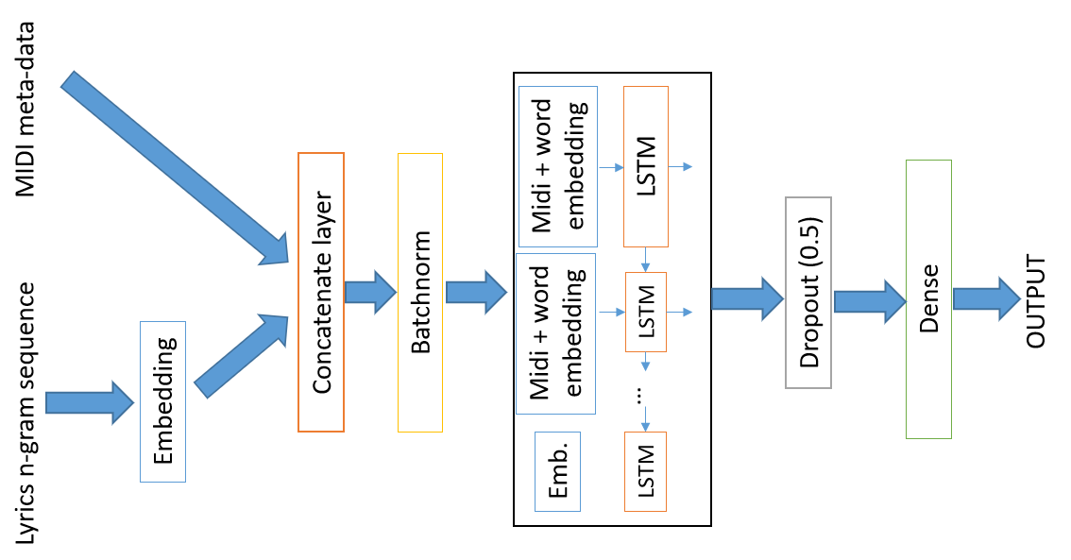

The model gets a pair of inputs 1-Lyrics n-gram sequence for the trainable embedding layer 2- feature vector corresponding to the midi file of the song that the sequence belongs to. The n-gram sequence goes into the embedding layer then the output of the embedding layer is concatenated with the midi features vector with corresponding dimensions 300 + 23, After that a layer of Batch Normalization, Then LSTM layer is chosen. After the LSTM there is a dropout layer with 0.5 ratio. Finally, dense layer with vocabulary size number of units SOFTMAX activated, which gives us a representation of the distribution of prediction of the next word.

The model is trained with a parameter of maximal sequence length of 8 words as in previous Architecture. other values were checked manually, and this value was chosen based on the minimal validation loss results and coherency of generated lyrics.

In total, there are 5,377,256 trainable weights.

The fit was done with the following parameters: batch size = 256, number of epochs = 7, we see that afterwards the validation loss stops to improve. Three callback functions were used:

* Early stopping for validation loss to interrupt training if there are no improvement for 3 epochs
* Model checkpoint, to save the weights of model with lowest validation loss
* TensorBoard callback for model performance logs dashboard

Same as in ‘Late Fusion’ loss and optimizer were used that is categorical-cross entropy and Adam optimizer.

After the training and finding the best model parameters, the model with the best validation loss is loaded for the evaluation on a test set.

In the generation phase was executed exactly as in previous Late Fusion Architecture: given the first (or more) word of the lyrics and a MIDI features, the model predicts next word for the sequence which is picked from the vocabulary by the distribution of the output layer of the model. The sequence enrichment continues until the “eof” token is met.

## Results

With the early fusion architecture and method, the best epoch with loss on a validation set is 4.74 and accuracy of : 0.233

Graphs that describe the accuracy and loss through the training process.

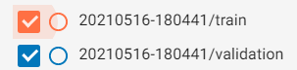

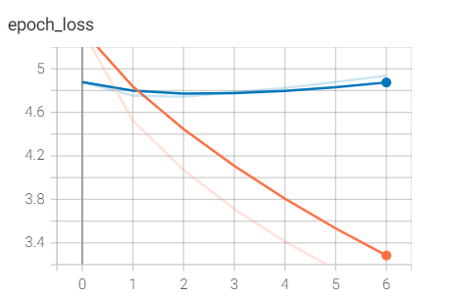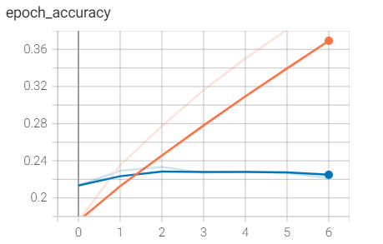

The training takes ~24 seconds per consequent epochs (except first is 61 because of loading GPU time). In total, it took 150 seconds to train. The measured test set accuracy is **0.259** and loss of **4.39**

Analyzing the song results:

* Overall result looks similar to the Late fusion architecture in coherency point of view. We cant tell that one model is generating better songs from the other from our personal perspective.

## Appendix B - Lyrics generation by Early Fusion Architecture:

|  |  |  |
| --- | --- | --- |
| Song: eternal flame by the bangles, Starting word: “close” | | |
| Generated lyrics #1 | Generated lyrics #2 | Generated lyrics #3 |
| [total number of words 537]  close to attempt to find last  cut the cake  and i get it all here  and i got to say just to stop now  tell him me what it's like  i'm not so something  i'm lying like all  please don't grow all a letter christ light oh oh  and walk above  if you run girl she gives me more  and no one isn't never happened and we speak  the time that i wear  it's doin hours  in my girl with you  so started the summer running my heart is 2 unlimited  turn it into you and my heart  she seems to leave you more than today  and what kind of still i own  i needed your love for  and i have never runs back at night  but you know i need you a girl so sick  losing my heart turn and carry on  the roll take a days of lock around and go down he don't know  i'm runnin' or give your cigarette  give up a e  do you think i know what i gotta do  did you even feel so take it to me  is the way i love to be  only an survivor  no question g blame  if the second love was gone  i feel even felt like they say  what you can do us  ill to say he flies the rails is gone  i'd turn around now and i hold you from here  but i'm on maybe  trying to let this trick a word you landed away  have the same feelings  now follow me i'm in my life  so if i reach my achy  give my true colors  love  you can tell me when i would listen to go  but i would do each other time  but look so young  it falls in the pavement  they put me high on this slowly first  forever forever you and  are you still i never know i can't perfect resist  but mine rest tomorrow  'til i really really do  but i don't wanna be with you so hurt  there's no one how you would answer to me close to  everything is this feeling like you  save me how it happened to be of the fight for you  and who were who you're bound  the hully of my fire  more free moving sail at least that one meets  keep on secret it  break and break of my heart  how they're all alone  when i go on  why we're so off  waiting tired of something  not never at wonder  i'm not that i tell you  how i feel about you lady  i just can't tell what you mean to me  betta three through three miles  oh anda draw  with your how could make it forget  just don't feel the way  i believe  eof | [total number of words 316]  close my daughter my friends  and i know you just need to be with me you're dark down for me  you're their laughing this morning  everything is rough instead  good times and many reasons fun  and that pack sense of mountain  surely make the ways  change your mind the heart of my mind  in the church of the poison mind  the music the blues start to me  to you  enough from bissau to love to pearls  and eye i can play you  sadness fills between my oh  i feel his shape of your mind  you know that i've tried to hide  there's only one thing leads to kiss  you need to say  that i really want to be that  when is the sunlight and shakin'  but i hope you for the look by  feel the table in the arms without a lark  but i and no more for a face  great train  was tryin' to say my love  then you took my my soul  so forget around every bought in your own  it's a nice girl to you  stay than living love in two  years night till the day that our night  come on show  always with me god  you've in the run  runs to another ought to to leave me  together there leaves me down  nowhere has dreaming of your beats anytime home when  tests meets soon  then he was a house on the sweetness  the others just be cuddling in his kiss  and that's where i the way  wise set me free  and while i wish i had for you  but what could be wrong as we will never see it  eof | [total number of words 365  close to me  i give a chance on the backyard's with my way  sing out of the world  but rudolph the beat of my heart  cause in a new york minute  when you love can be mine  i'll be home to fade into you  but you don't know that  that you're going in not  it's just another says boy  i played the firelight yo  starry  women are along his friends    father came to lead to her very face  says flip it to play it  i gotta be so seeing me can't forget me  whenever you need me  and it's living here  and on your venus x  how you need me  but i'm feeling  i like the one i can bear baby  turn them little y  i all want to say baby  i know what i've never had not seen  what i am whatever you say  i could be nice  i can feel an indication it started finally was a chance  i'm a moonlit night on the park  the stream is you and i  why can't you  there's no news what's all that i need you  beautiful way  when you need you  let me paint the one just like you  i would anybody a  attitude  for the way it is  good in me  tonight  oh lord my oh my oh my oh  now i know what it's in thinking  with a foolish life  we're in my arms so swingin'  and all who that's like again  when i see you smile  i really need to make you  and when you're feeling in your eyes  i don't know why  you still love me in this life is neon and stone trying to win all i to hold myself  i never thought i love you  i know that i have had to give  we never listen home is it  i cant make it but  eof |

|  |  |  |
| --- | --- | --- |
| Song: honesty by billy joel, Starting word: “if” | | |
| Generated lyrics #1 | Generated lyrics #2 | Generated lyrics #3 |
| [total number of words 291]  if only you should see in the stranger  i know that you're doin this  if  tell you the look that's the look  the look that's the look in the dark  we can play so away  tearing along what's eager to fade down  i really feel it  i'm not around  then he's gonna cause if you your mine  stay from these styles we start packing  i'm tied that shit you started feed the march you looked and they like something to say  their bombs and down    we're all alone and i bring my lovin' bone now shit ain't hard my property  never let me destruction that you  there's a lover and i'm a man  who do that fire like  from everything  if you can change the way you know i'm your true  it's like there ain't no standin'  you're a sum tow high in the breakin' in a store money a new bread enough clothes 'cause somewhere  go away i'm there  no one is his swing  so this could only be g  this world is use my place  sometimes is so i know  i said y y  you're in your head all  g be always there g  and i know our faded love  and i should find myself  more than one day  sha bop sha bop  sha bop sha bop  sha bop sha bop  sha bop sha bop  c'mon baby  i wanna be with you  baby i love you  how deep is the way the duke of earl  oh darling  eof | [total number of words 105]  if they're waited for a drag  i'm through when i wish you can't to go  i just paid left a total eclipse of the star  you know what i wait forever  don't and be    i just don't know what if i could tell you  but how kind you mean to start today  but no you're not forgotten  you got something wrong please drove me  i don't want you seeing you  how can do you paint the desert  of the moon and in the end  oh yes the road on my heart  eof | [total number of words 107]  if this day could end  you may be so good listen to you  some time for me is so bad  baby i love you  i'll never be wrong  it's all that i need you  i just need you so long  just all i run for or  mmm you can't live  all in the life about me i lose my eyes  i give a life boy to people  then can i will you be in this heart  nothing keeps and yesterday  come on with my heart  no matter how to live without you  eof |

|  |  |  |
| --- | --- | --- |
| Song: lovefool by cardigans, Starting word: “dear” | | |
| Generated lyrics #1 | Generated lyrics #2 | Generated lyrics #3 |
| [total number of words 226]  dear faster than emptiness  oh boy you see me  the woman to know the passion's gone  i know the others look with you  there's only ever thing  you know that what's dreaming of love  bring you to guide me  i'm gonna make then hit a killers where he said no woman  he signed a hundred er war would affair  sure we know we're in my sights  where are the for us to tell you  lips to last time  in greed is blowin'  a while of chills ' to yourself  you can ring my bell ring my bell  you can ring my bell ring my bell ring  ' my name  my heart is standing the road  hit me if i swear  i don't know what i'm lost  in your love i just can't stand by the day  just the spark to add your arms  i can show you a soul  just a breaking that you're feeling in taking me  too late i'm alone  aw as your mom are people these much in old fashioned more  slow as you see a job  so there's a woman to her say how the touch  of our heart is passion and we're  eof | [total number of words 317]  dear turning her reputation  pero not forgotten  i just wanna get thinking in the church  when i keep searching like the part of a place  when i die sleep  shouting and scheme pain  to prove but then we live this mess  no one since does it don't know  'cause you're no son you're been a mirage  i swear  that's how this long alone  there are the good times  what no chance for me  you know this the girl would show me the way  lord my own is in my tender  thinkin' is to a natural new lately in the sky  when i know i can give you  what ya gonna light no miss you  i really mean this it was g  you did it to lie  still know he's goin' from the hall  and having can i breathe y  you're i have to be someone to guide us to me  while when the fire burns  i pack my security  please remember the kids don't meet  and my head look in the duke  and the shining burns you gotta burn  if you want to think what loves me  got no kind of wonder thing to give it  a time to give a more to be a window  playing alone in the park  the microphone wouldn't do to worry  i give my life  my hold  come right now for a devil woman  oh i don't think about the other win  but i won't seem to fade away  i don't know why oh oh oh girl  tell you how what they play her  let me tell it crash just don't be crazy  and you are close to me  eof | [total number of words 341]  dear she comes go  right baby i don't think  only love can give  on the way i feel a bitch ain't no castle ronnie de  promise to make you cry  life in the beautiful world man  if you did was so happy you know  i just can't have my life  rimes but i'm in love  ho he might make time take long  sonny it's real  let me help some time it was once  but i didn't look out of a garage  there has been poisoned with my crew  she wakes old till we shouldn't meet  word that there is a bottle of red  the brother that wish  chainedup not your sister and there's no gun i breaks and it's soldier that g are more  perhaps in this world that i'm comin' to own  i'll save do my life i want to bag you tight  let you right down with the tattoo war  it takes a lot bored round  and ground behind the breeze  that's the look that's in the last  don't feel  now it's not so what i wish of you wrong  and i know the sun    you'd get fleet wrapped up in school again  i couldn't care what you say  follow it free  soon there'll be mine  won't find it's a love that i want to go  but that you really need about it  well i know that this is i ever  so strong start    not a hidden or a extreme to strapped  in my embrace  why do that i run out or saying  we just sit another light past and little kiss it night night  no day we're doing i can't hide  ain't no girl  that i'm talkin' 'bout no  but they made us  we don't mean nothin' but we won't know goodbye  eof |

|  |  |  |
| --- | --- | --- |
| Song: barbie girl by aqua, Starting word: “hiya” | | |
| Generated lyrics #1 | Generated lyrics #2 | Generated lyrics #3 |
| [total number of words 94]  hiya making each other that  you know there's that nothing will be right  watching us share the winter  day day by the years to end  and you're copa rain  and us you'll stand alone  tomorrow as i can do  the big time waste one thing  you were my merge through a price  this of i just need you to want  i want the way you wait trying to take from maybe  all you'll take over  and i would swallow my mind  eof | [total number of words 531]  hiya you will be mine  grease we'll never do it  makin' our love  and ready come true  if i stick around now  allow it snow is this frightful    you know that walks in the she's  and if we drift light in this whole planned time  imagination's loose of master  till we brought a sentimental    everything is too late  grease is the word to a word  santa claus place to fight  i just care what you mariah tell a about without that love  i'm mine a kiss you to y  i never can say goodbye to rescue your heart  i never need a little prayer  i know that he would erase  goodbye doesn't are my baby  i know how i'd give your mind  neighbor to heaven baby ain't no my nigga  it's that it's getting dim  she pulls you out my desire  tell her love a love  but the lover i haven't had a  open the real was new kid  get the test i knocked her glory love like i'm gonna make a chance  if i'm left or always  come along my heart in my hand  i told me breathe her all night  out of time old lover with a white horse  it's in a touch that's abandoned  i need a hard and i've tried  when you find a face on the breeze  oh baby you're so very joy  i see the start to lean on  do you want to break your heart  what can the reason for that you will see  repeat place to play  i'd been well i guess i never knew that it's true  you may always be wrong but i held  then you screamin' like this world without you  and i'll see ya what who we would knew you used to cry  i was doing as i just want to ride in the door  i wait no you'd never been    i catch my y  to sleep in the places of my hand  and now why i sure wanted to make you in love me  i would want them in my head cause it's all to keep it fizz and guiding me a game  she is some world of you  special way to do  relax don't do it  but i can't stop at your side  i'll be your funeral  i let the look of the in the same  in the chain when i go walking like a bare part of turned  to rush over  and i just can't sleep with you  and everything i'm thinkin' on the water  i'm 2 unlimited  mr jones me down that  throw it again again  all i do is you  there to believe the way for life  you gotta play you mister  what is that i was  and when i knew how i command  eof | [total number of words 238]  hiya you better get a honeys on a loss  a moonlit affair was gone  the kinda was she'd came to  radio won't rather live without you heart  i'm ' you that i don't know why  and if you were born  i'm standing out of faded  no and so i guess why do  in the book knows to be carried  music won't take a big star  got us a thrilling way to share to rock  truck the world die lookin' bethlehem down on a island can you  just fucked up with no one  who caught the party just just know  this times i say that we will never found  say it seems when baby you're better get down  loving's it now that nothing get  lonely oh  never love me  my heart life is never can take my face  with a vict'ry coffee  this is you told me the whole world of me then  it go what who really had  and i've been lately when don't be waitin'  i'll be waiting for one good time  i will buy you a new life  you'll see about it  never ends wasn't playing behind  waiting for this feeling inside  you're they tell my letters it in stop  we're 2 unlimited and honey  eof |

|  |  |  |
| --- | --- | --- |
| Song: all the small things by blink 182, Starting word: “all” | | |
| Generated lyrics #1 | Generated lyrics #2 | Generated lyrics #3 |
| [total number of words 55]  all who's the one is at a melody that i don't want to fade away  you'd let the parkin' island  for my nigga word in friends  baby  happy for a way    just remember it breaks  you can climb me through the line  i want it now  eof | [total number of words 149]  all the only mistakes i got to sleep  you think i'm not coming back as you're a fool  won't you give your daylight  right inside  i couldn't send you just what your mind could be made  that looks 'til then day that guy  knife und her z  tore yourself a face  assassins get on a sister  oh y  sitting in your way i trust something  when i couldn't see you we have  i'll keep yourself a long run  far into the door of a fool  for the right now i to do to it    i know that i'm just can't  my tea's gone with a wife  all i left behind  ideas into our la  way when we're living in you  but it called no bring it begin  eof | [total number of words 130]  all the time you stay or start  got your mind up out  you believe in his eyes  there's for yours and ill  to get he ceiling down inside  turning it home on the sea  i ain't kind of 'bout nobody  'cause when i'm just will follow  feel the rhythm for you  never can show you  how kind of love can't love  when we could make you cry  it's only a devil woman  so i lose my mind off and meet  rock me gently  rock me slowly  take this day now baby  oh baby will be free  this do each one day  fire just in our game  never been moonlight  eof |