**Report**

Assignment 4, Deep Learning

## Task

Implement two tabular data generative architectures: standard GAN, and a modified GAN architecture, which is inferring the inner-worker black box (BB) model.

## Dataset

The datasets include 2 files of taular data

a. German_credit.arff – credit card samples with categorical and numeric features, the target is a good/bad customer.

b. diabetes.arff – for blood measurements and general pregnancy information, target is a patient has diabetes or not.

## Environment

Since none of the students has or has access to GPU physically, the assignment was done in the Google Colab environment in order to speed up the training process. All shown results are taken from the Jupiter notebook.

## Method

The general method is to build a GAN for each dataset, GAN is combined from two NN: one a Generator and the other is Discriminator. The main goal is to make Generator generate samples that are similar to the real ones.

### Preprocessing:

diabetes.arff – all columns were numeric so we just min-max scaled all columns to [-1, 1]

German_credit.arff – some of columns are categorical so for those we performed one-hot-encoding. Than, all of the columns are min-max scaled to [-1, 1]

### Architecture

Similar architecture was implemented (per dataset) for both parts of the assignment. The architecture was chosen empirically and proved to get the best results compared to others.

Diabetic GAN, Generator + Discriminator respectively:

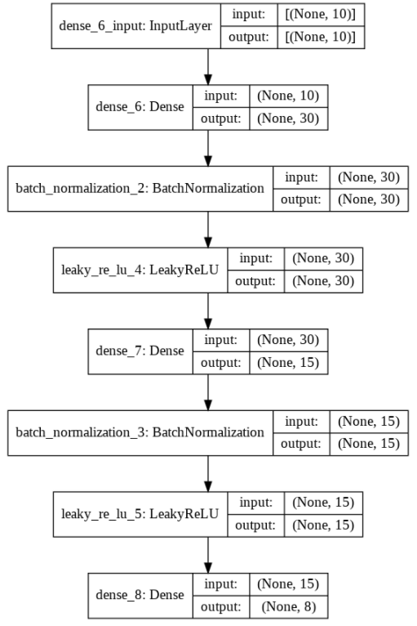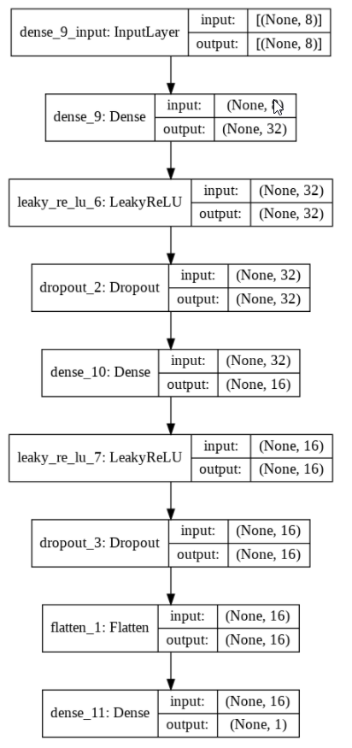

The Generator has two blocks of Dense-BatchNormalization-LeakyReLU between the input and output layers. The output activation function is a hyperbolic tangent, which fits the preprocessing features scaling. The Discriminator has two blocks of Dense-LeakyReLU-Dropout (rate=0.2) between the input and output layers. The D loss is binary-crossentropy on the sigmoid activation of the output neuron. Adam optimizer was used for both the discriminator (learning rate = 2e-4, =0.5) and the combined GAN (learning rate = 2e-4, =0.5) architectures. For the training, equal number of stochastically selected samples from the dataset with target=1 and randomly generated samples from the latent noise (uniformly distributed) vector with dimension of 10 and target=0 were fed to the discriminator to learn to determine between real and generated (fake) samples.

Credit GAN, Generator + Discriminator respectively:

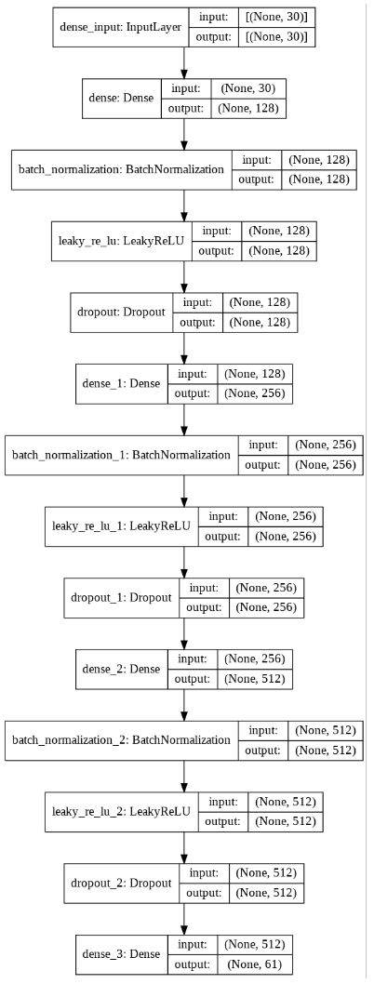 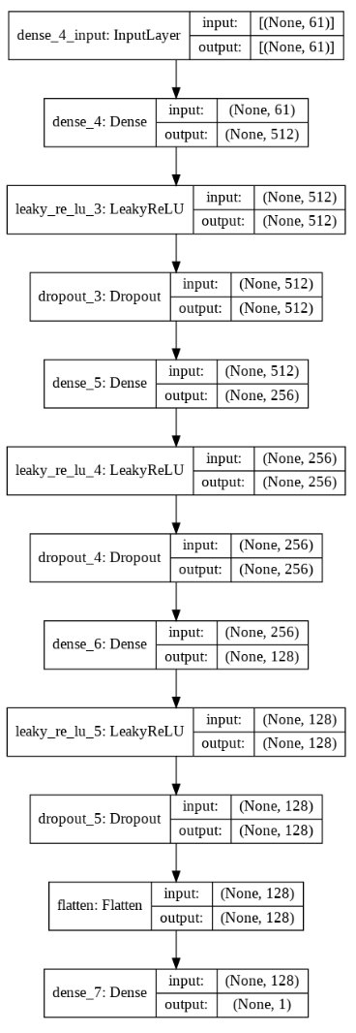

The architecture of the GAN is almost the same as for Diabetic GAN with the following differences:

Dropout layers were added in the Generator (rate=0.25). Generator has three Dense-BatchNormalization-LeakyReLU-Dropout blocks instead of two. Discriminator has three Dense-LeakyReLU-Dropout (rate=0.2) blocks instead of two. Adam optimizer parameters for both the discriminator (learning rate = 1.5e-5, =0.95) and the combined GAN (learning rate = 2e-4, =0.6, =0.999) architectures were changed. The noise latent vector size was changed to 30.

In addition, the number of the hidden units was changed as might be seen from the architecture description in a figure above.

### Part 1

#### Diabetic dataset

1. NA
2. GAN convergence
   1. GAN losses reached convergence as can be seen in plot of ‘3.c’

To achieve the best performance model, each 50 iterations after the first 800 iterations, we check for convergence by measuring the difference of the loss of generator and discriminator and requiring it to be less than 0.2. After that, we check that the discriminator loss is in 0.2 tunnel from 0.5 (the optimal discriminator mistakes in half of samples) and also that the discriminator loss on real and fake images is nearly same (d_fake_accuracy is at most 0.2 from the d_real_accuracy). We save every model that applies the constraint. The model was achieved after 3900 iterations. Both G and D losses were 0.7, D accuracy was 0.42 and the difference between the D’s accuracies for fake and real samples was 0.12.

1. Analysis

Note: it is good enough to plot/analyze the distributions in the normalized range(not original) because all features are numeric and the method preformed to normalize the vectors is rescaling to [-1,1] which is ‘Injective function’

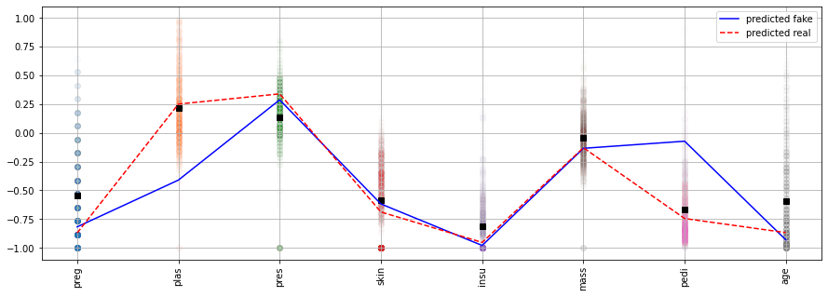

* 1. From the above plot, we may see the feature distribution and the mean value of each feature marked by a black square. For the second and fifth features, the sample that was predicted as a real one the values are much closer to the mean than for the sample that was evaluated as a fake by the discriminator.

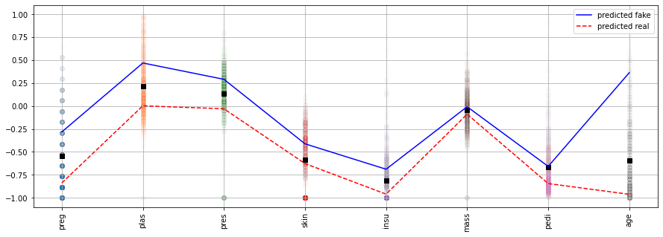

Another example is less obvious which of the samples, fake or real is closer to the mean value. For that we will use L1 (Manhattan) and L2 (Euclidian) distances

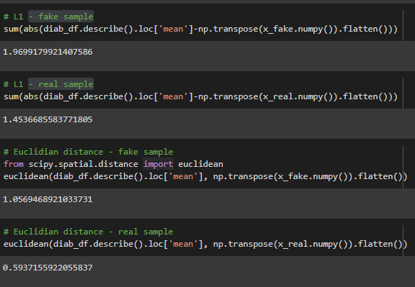

Both L1 and L2 distances are smaller for the sample that was classified as real than for the fake.

* 1. Out of 100 samples 48 were marked as “fake” and 52 as “real”:

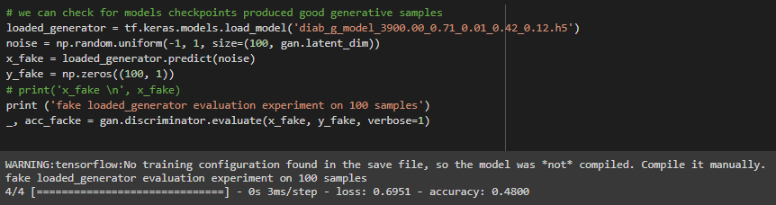

* 1. As can be seen the models did go back and forth there was no consistent leader:

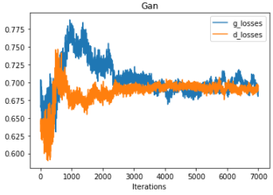 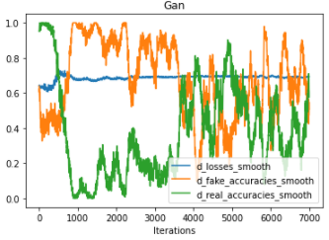

#### Credit dataset

1. NA
2. GAN convergence
   1. GAN losses reached convergence as can be seen in plot of ‘3.c’

The same criteria for a best model selection as used for the diabetic dataset was used. The model that was chosen has the following parameters: trained on 6700 iterations, G has the loss of 0.69 and D’s loss is 0.66, D accuracy was 0.42 and the difference between the D’s accuracies for fake and real samples was 0.09.

1. Analysis

Note: we did not plot/analyze the distributions in the original range because each category feature ‘created’ few numerical features by reforming ‘one hot encoding’ and going back to the original categorial feature is no trivial at all (not is ‘Injective function’), so we stayed with all the numerical features as distance between points is more natural to see and because the model is making decisions based on these numeric features.

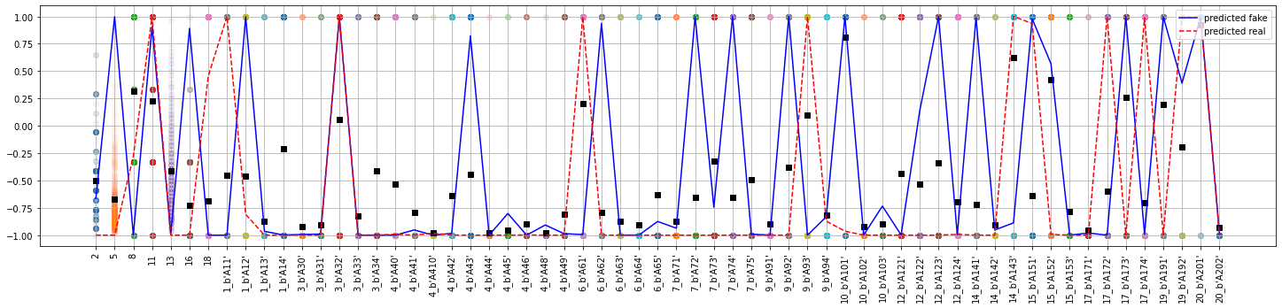

* 1. Because of the binary nature of categorical one-hot encoding, the total amount of features is much greater than in previous case and the distribution is strict {-1,1} (after the preprocessing). Statistically we may see the number of mean values above zero and count the misses by “real” and “fake” samples’ values. In a summary, the count of predicted “fake” misses is greater than the number of predicted “real” misses, which make sense to us. Another example:

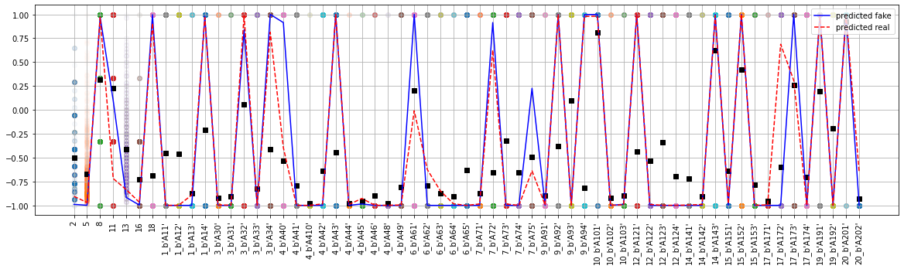

Here as well the result is not so clear. The red dotted line gets closer to the mean values in most of cases where the feature value of “real” and “fake” are not the same. The conclusion may be also examined by measuring the Manhattan and Euclidian distances between the mean and “fake”/”real” sample vectors. The distance from mean to real is smaller than the distance from mean to fake:

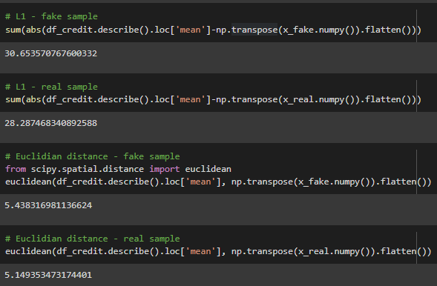

* 1. Out of 100 samples 48 were marked as “fake” and 52 as “real”:

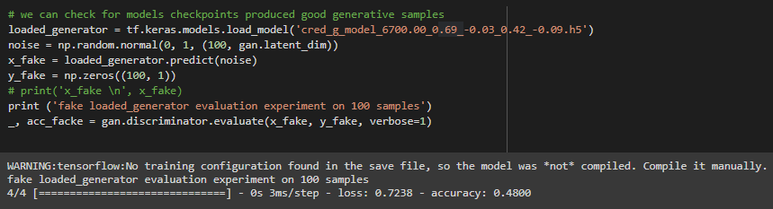

* 1. As can be seen the models did go back and forth and that the “real” prediction was preferable by the discriminator for most of iterations:

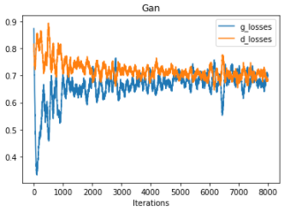 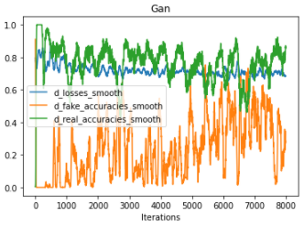

### Part 2

#### Diabetic dataset

1. Random forest trained (on 70%) using 5-fold CV and Grid search and the following found to be the best parameters:

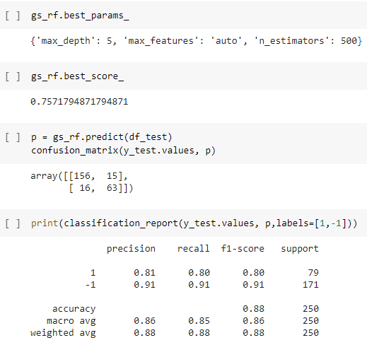

1. NA
2. NA
3. Following information provided:
   1. Random Forest test (30%) performance:

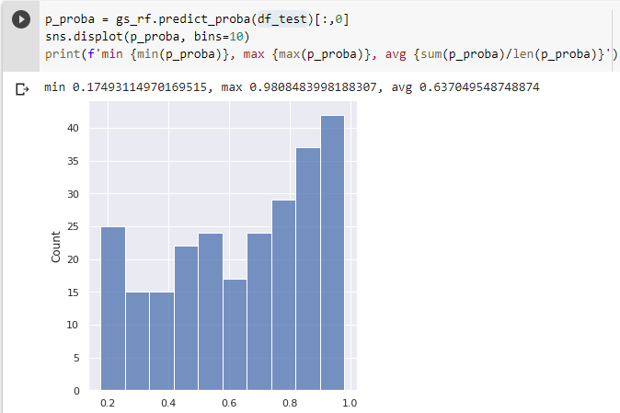

* 1. NA
  2. Statistics on score distribution of BB using generated samples:

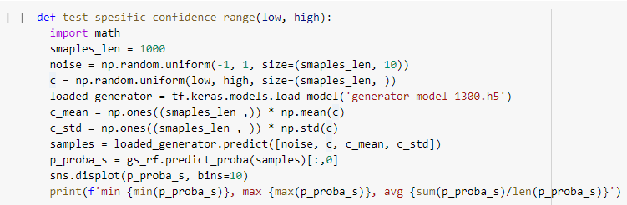

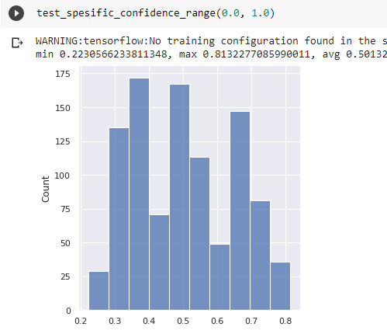

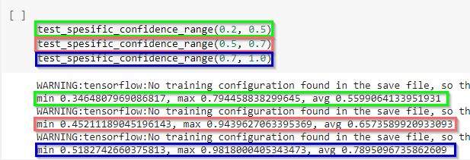

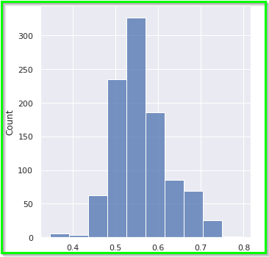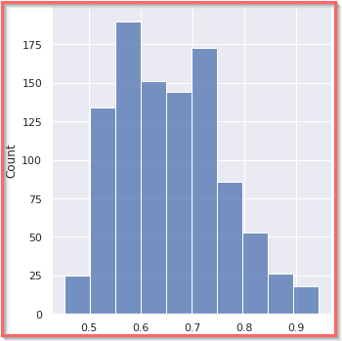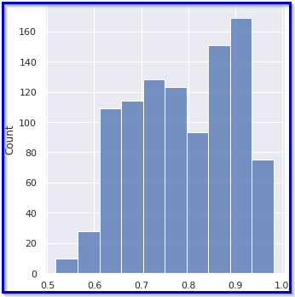

Looks like the resulting distribution is Uniform-alike, boundaries are wide almost as in real distribution (much better than in the other dataset GAN). The perfect expectation would have been close to ~ U(0, 1) same as the distribution of sampled “Confidences”.

Note we did test deferent ranges starting from 0.2 because the BB range also start from that point as can be seen in plot 4.a

We can see that there is correlation between the range of sampled confidence to the range of BB confidence which is what we expected – the mean and range go “right” as the sampled confidence range goes “right”.

We can see that we where less successful in the lower range that is class “0” because we sampled from range [0.2, 0.5] but the majority of output was in range [0.45, 0.7] which is 0.2 off to the “right” with respect to average and range, on the other hand in when sampled from [0.5, 0.7] then the majority of output was in [0.5, 0.8] and avg 0.65 that is very close to expected. when sampled from [0.7, 1.0] then the majority of output was in [0.6, 1.0] and avg 0.79 that is very close to expected.

* 1. Problematic aspect we had encountered influenced the resulting ‘Confidence’ distribution - Firstly our ‘noise’ for generation was sampled from ~ N(0, 1) and the BB output distribution was Normal-alike narrow distribution, we expected it to be more Uniform alike with boundaries close to [0, 1]. So we did sample ‘noise’ from ~ U[-1, 1] this improved greatly the BB output distribution that looked unformal-alike~ U[a, b] still narrow. also we suffer from mode collapse so we added to model as input( for ‘G’ and ‘D’ kind of cGAN) for every batch it’s mean and STD this made it worse because the Discriminator was much better than Generator at this point, we addressed that by 2 actions 1) give Generator a chance to learn better from ‘C’, ‘Y’, ‘mean’, ‘STD’ by connected them to few dense layers and merged back to final layer in Generator. 2) when training Discriminator on ‘Real” example we added noise ~N(0, 0.25) to real samples to make it harder (slower) on Discriminator to be precise. These actions improved greatly convergence:

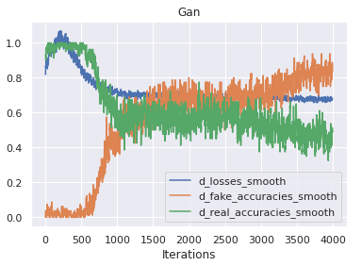 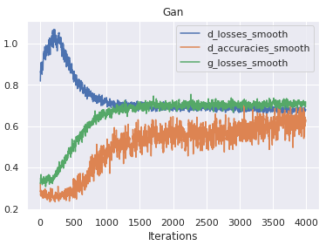

and the distribution to be much wider and the correlation much stronger as seen in 4.c plots.

#### Credit dataset

1. Random forest trained (on 70%) using 5-fold CV and Grid search and the following found to be the best parameters:

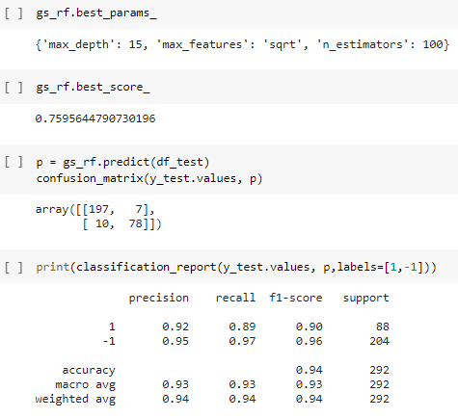

1. NA
2. NA
3. Following information provided:
   1. Random Forest test (30%) performance:

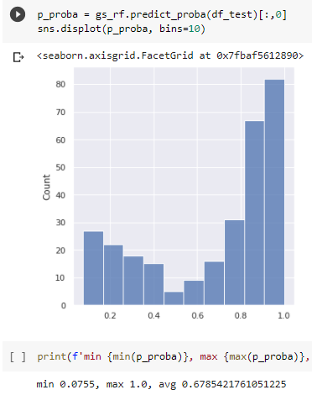

* 1. NA
  2. Statistics on score distribution of BB using generated samples:

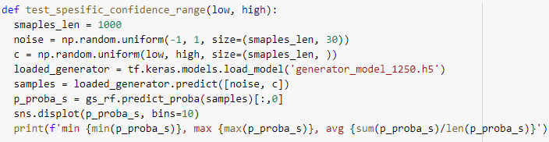

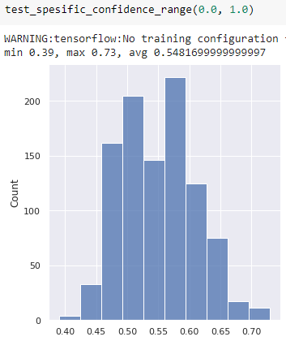

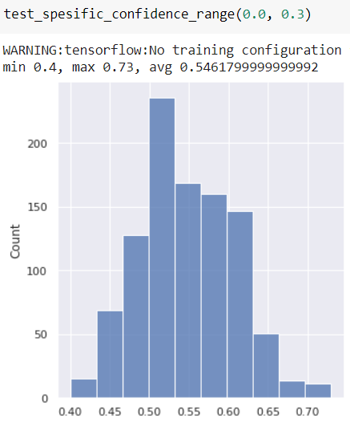 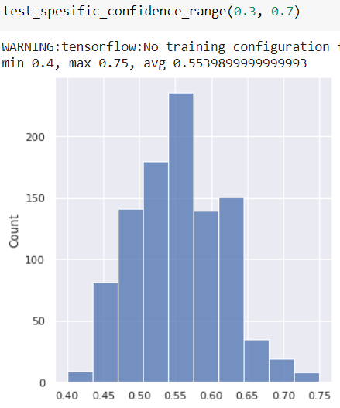 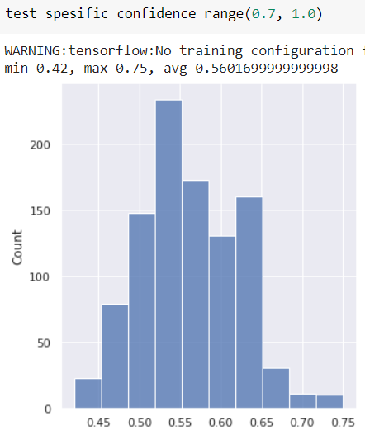

It can be seen that the resulting distribution is lacking samples near the boundaries 0,1. the perfect expectation would have been ~ U(0,1) same as the distribution of sampled “Confidences”. Unfortunately, we lack the correlation that was expected and seen in Diabetic data. The average and range look the same for all sampled Confidence ranges.

* 1. At Early stages of development, the model suffered from not converging – the Discriminator was much better than Generator, as showed below in plot the discriminator can tell what is real and fake and the desire is to fool it by 50% of samples:

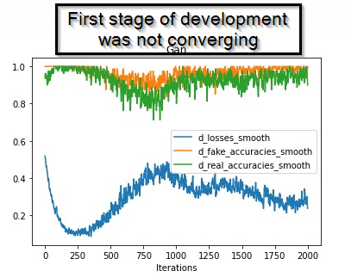

So we had to make them converge / learn in equal rate, we slowed down ‘D’ by changing learning rate by x10 to 0.0002 and later fine-tuned ‘D’ beta_1🡺0.8, ‘G’ beta_1🡺0.6 .

Another problematic aspect we had encountered influenced the resulting ‘Confidence’ distribution - Firstly our ‘noise’ for generation was sampled from ~ N(0, 1) and the BB output distribution was worse from final state it was narrow distribution, we expected it to be more Uniform alike with boundaries close to [0, 1]. So what we did is to sample ‘noise’ from ~ U[-1, 1]. This step improved greatly the BB output distribution that looked less Normal distributed as can be seen in ‘4.c’ plot.

Also loss and accuracies convergence achieved:

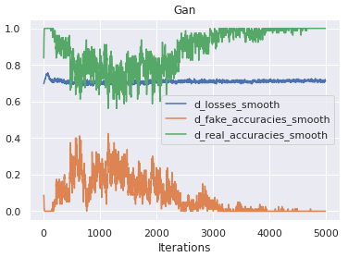 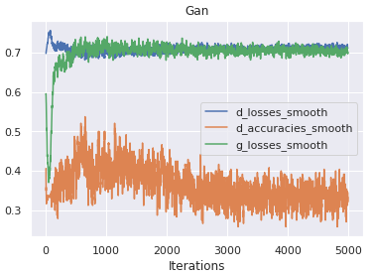

The model is suffering mode collase, we tried all the actiones (cGan alike) prformed described in 4.d (for Diabetic data) unfortunatly it did not improve output destribution results, this may be because of the non numerical (categorail) features that original data obtained, it was more cpmpleax to acheave some covergence in ‘D’ ‘G’ losses and in D_facke_acc vs D_real_acc.