**CS311 DSA Homework 3**

**Your Name: __________________ Univ. ID: _________________**

**Instructions**

* Check **due date** and polices on course webpage.
* Write the answer for each question in the space provided below the question.
* Submit your answers to cs_scu@foxmail.com.
* Submission file name format: CS311_assignmentID_yourID_yourName.doc (or .pdf).

1. (10 points) Given a binary tree as below:

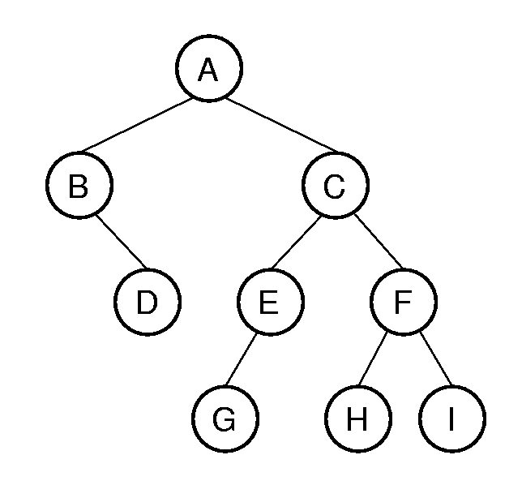

Answer the following questions:

1. What is its height?
2. What is the depth of node D?
3. What is the level of node D? (Note, the first level starts from 0.)
4. What is the length of the path from A to C to F to H?
5. List all nodes of this tree
6. List all leaf nodes of this tree
7. List all internal nodes of this tree
8. List the siblings of node C
9. List all nodes at level 2
10. Draw the left and right subtrees of node C

***Answer***:

2. (10 points) How many leaf nodes are in a non-empty full binary tree with *n* internal nodes?

You need to consider two cases: the **minimum** number and the **maximum** number, as well to prove the result of each one.

***Answer***:

3. (10 points) What is the minimum height of a binary tree with $n$ nodes? And prove it.

***Answer*:**

4. (30 points) Answer the following two questions about Binary Search Tree (BST).

1. Show the BST that results from inserting the values 15, 20, 25, 18, 16, 5, 7 (in that order).
2. Show the enumerations for the tree of in the first question that result from doing a pre-order traversal, an in-order traversal, and a post-order traversal.

***Answer*:**

5. (40 points)

1. Write a binary tree class named **my_Tree** as the basic data structure. (10 points)
2. Write a class named **my_SortedTree** with three methods.
   1. Given sequence of numbers (total number of numbers will be the full tree size 2n-1), sort them in an increasing order. (10 points)
   2. Store the sorted sequence in a full binary tree so that use the "in-order" traverse algorithm can print them in an increasing order. Note that your tree MUSH be a full tree. (10 points)

For example, given "14 23 13 18 11 26 16" as input, your program should sort them first, so that the sequence is "11 13 14 16 18 23 26", then insert those seven numbers into tree structure one by one, it should be

16

23

18

13

11

14

26

* 1. Use in-order traverse algorithm to print all of them in increasing order. (10 points)

In the main method, you should call those three methods one by one to show all of them work well. You can assume that all numbers in sequence are different. You can assume that we will provide enough numbers to fill a full tree.

**Sample Run**:

Please Enter Numbers:

14 23 13 18 11 26 16

After sorting them, you will get:

11 13 14 16 18 23 26

Do you want to print them?

YES (screenshot of the running results)

In-order traverse (increasing order):

11 13 14 16 18 23 26

***Answer***: