**CS311 DSA Project 3**

**Your Name: _________________________ Univ. ID: ____________________**

**Instructions**

* Demo deadline: lab class today, Submission deadline: check **due date** on course webpage
* Remember to comment your code
* Remember to take screenshots of the running results
* Zero mark will be given if your program does not compile, or gets into an infinite loop (does not terminate)
* **Submission guide**
  + Create a new folder named with CS311_Proj3_yourID
  + Archive your code files and this .doc file into **CS311_Proj3_yourID.zip (or .rar)**
  + Submit **the archived file** to cs_scu@foxmail.com

**Problems**

A minimum spanning tree (MST) or minimum weight spanning tree for a weighted, connected, undirected graph is a spanning tree with a weight less than or equal to the weight of every other spanning tree.

Consider the following graph as an example, write an algorithm to find the MST of the graph.

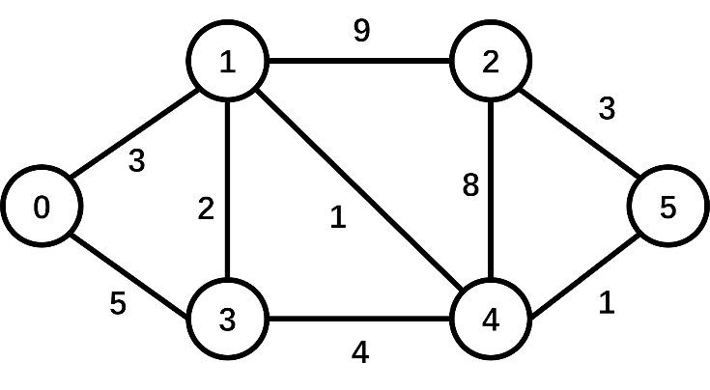

**What to turn in**

1. A .cpp file that includes your codes for MST.
2. This .doc file.

**How to turn in**

See 'Submission guide' above.

**PROJECT REPORT**

**Your Solutions**Show your ideas, and the process to find the MST (no need to show your code here).

Some screenshots of the results of your program's execution.