CS311 DSA Project 3

Your Name: _________________________ Univ. ID: ____________________

Instructions
- Demo deadline: lab class today, Submission deadline: check due date on course webpage
- Remember to comment your code
- Remember to take screenshots of the running results
- Zero mark will be given if your program does not compile, or gets into an infinite loop (does not terminate)
- Submission guide
  - Create a new folder named with CS311_Proj3_yourID
  - Archive your code files and this .doc file into CS311_Proj3_yourID.zip (or .rar)
  - Submit the archived file to cs_scu@foxmail.com

Problems
A minimum spanning tree (MST) or minimum weight spanning tree for a weighted, connected, undirected graph is a spanning tree with a weight less than or equal to the weight of every other spanning tree.
Consider the following graph as an example, write an algorithm to find the MST of the graph.

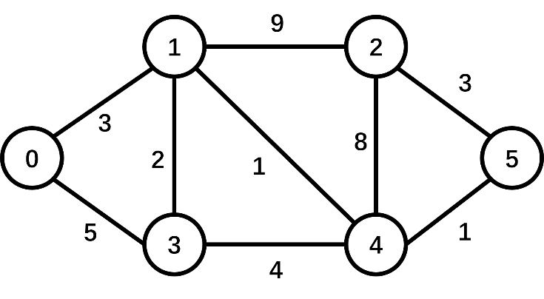

What to turn in
- A .cpp file that includes your codes for MST.
- This .doc file.
How to turn in
See 'Submission guide' above.

PROJECT REPORT

Your Solutions
Show your ideas, and the process to find the MST (no need to show your code here).
Some screenshots of the results of your program's execution.

