Test Report

Date and Time: June 02, 2025 11:05

Test executor: csheg

# Test: Open the web site and create screenshot

Status: PASS

## Steps:

1. Page opened: https://billyal.netlify.app/

Screenshot 1:

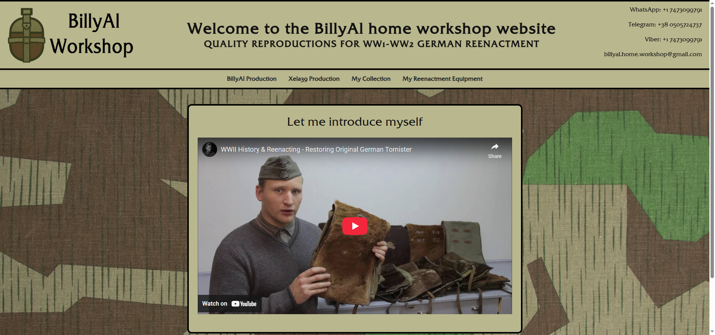

2. The element found and selected.

3. Second page opened.

Screenshot 2:

