1. Set Operations

I am using the UNION SET operator to select the titles from the "new_table" that I created and display them along with

the titles from the bob ross table that I imported from csv on github. You can see the titles from the new_table have been

compiled together with the titles in the bob ross table.

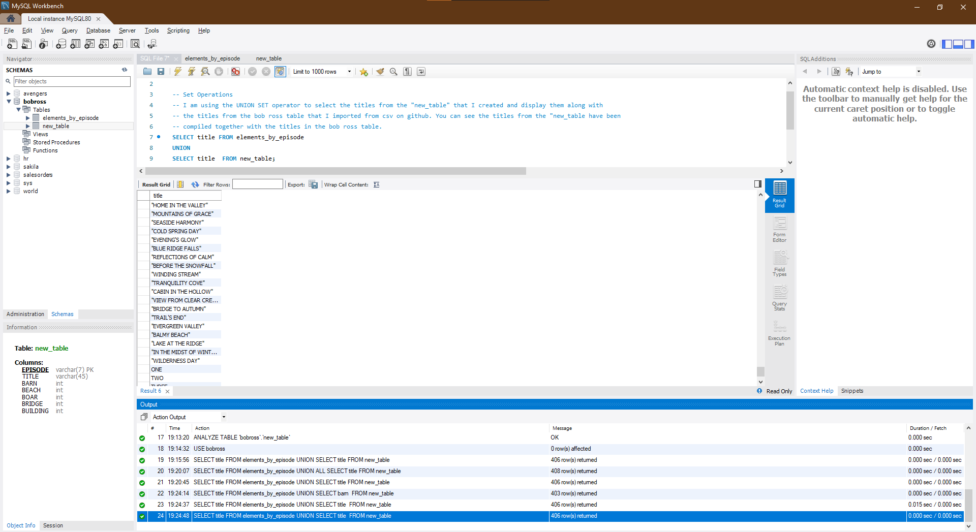

SELECT title FROM elements_by_episode

UNION

SELECT title FROM new_table;

1. Subqueries

The original query selects all elements from the elements_by_episode table and the subquery returns all episodes that include 0 apple_frames and 1 cabin.

This returns me 69 rows meeting the specified criteria from both the outer query and the inner subquery.

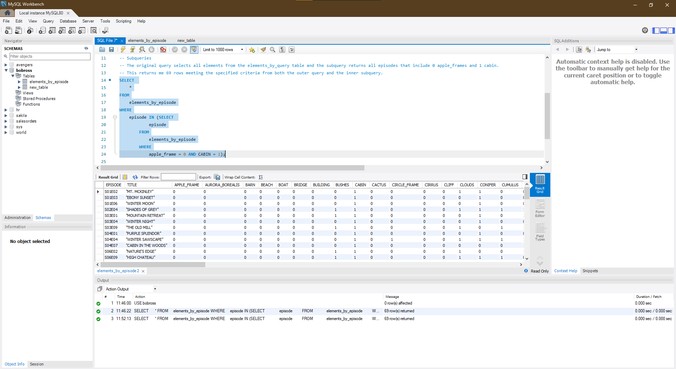

SELECT

*

FROM

elements_by_episode

WHERE

episode IN (SELECT

episode

FROM

elements_by_episode

WHERE

apple_frame = 0 AND CABIN = 1);

3) Order of operation of queries

This follows all 7 of the sql query commands in order of operations. We have 2 rows returned that meet the specified criteria in all of the queries.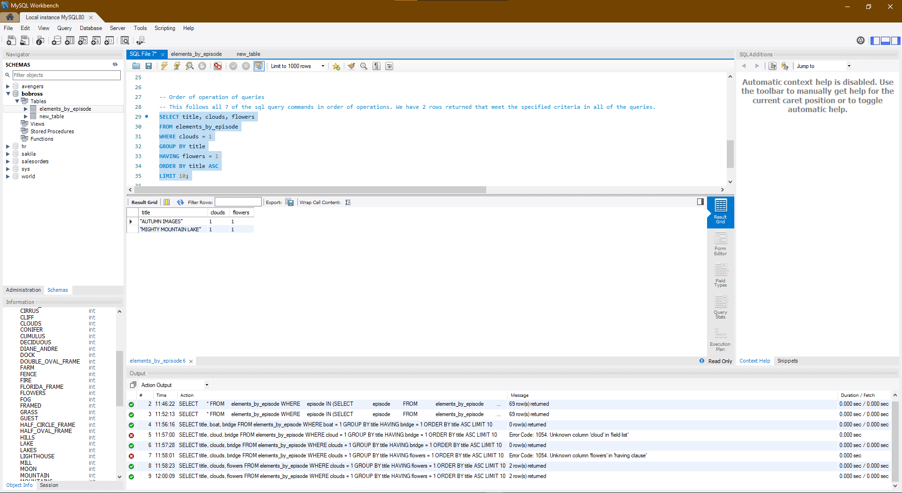

SELECT title, clouds, flowers

FROM elements_by_episode

WHERE clouds = 1

GROUP BY title

HAVING flowers = 1

ORDER BY title ASC

LIMIT 10;

4) Creating, altering, and dropping tables

In this exercise I will alter the table that I made originally to use the set operators on. I will add a new column for clouds to it using the ALTER TABLE command

I have also written a query that will erase the table from the database that I left as a commented out query just to demonstrate how to remove this table

from the database without actually doing so in case I need it for further queries.

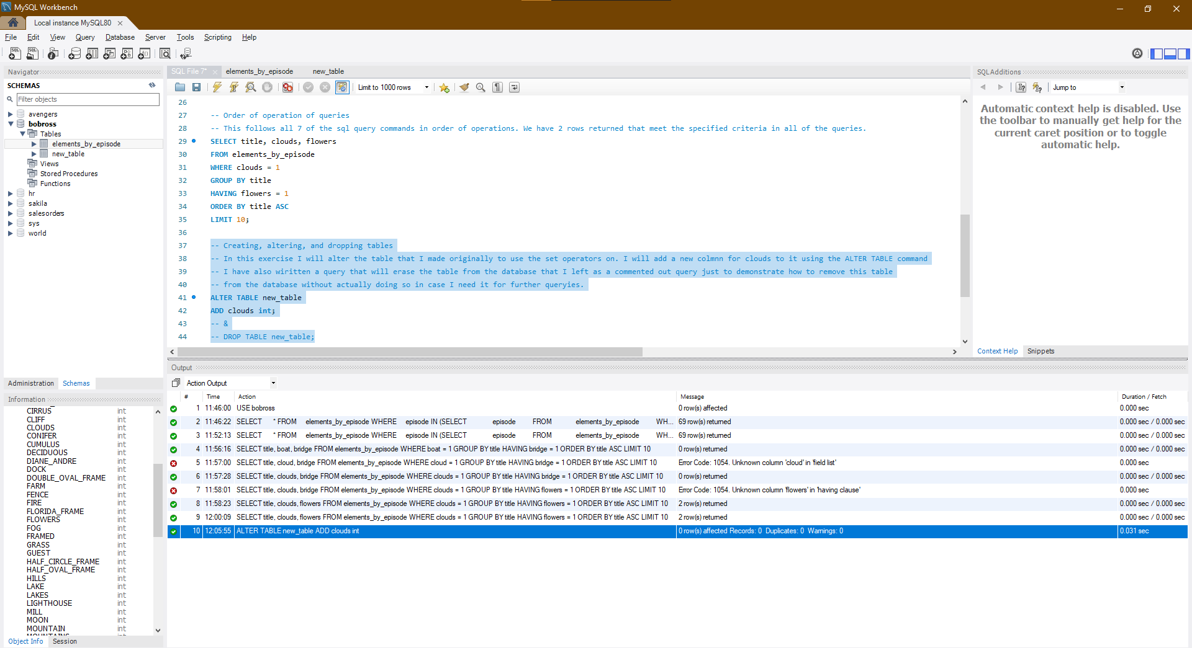ALTER TABLE new_table

ADD clouds int;

-- &

-- DROP TABLE new_table;

5) Associations

Association tables are used for many-to-many relationships between two objects.

They consist of at least two foreign keys, each of which references one of the two objects.

In this case the two table being used share a relationship using the "episode" column.

In both tables, the "episode" column is the primary key.

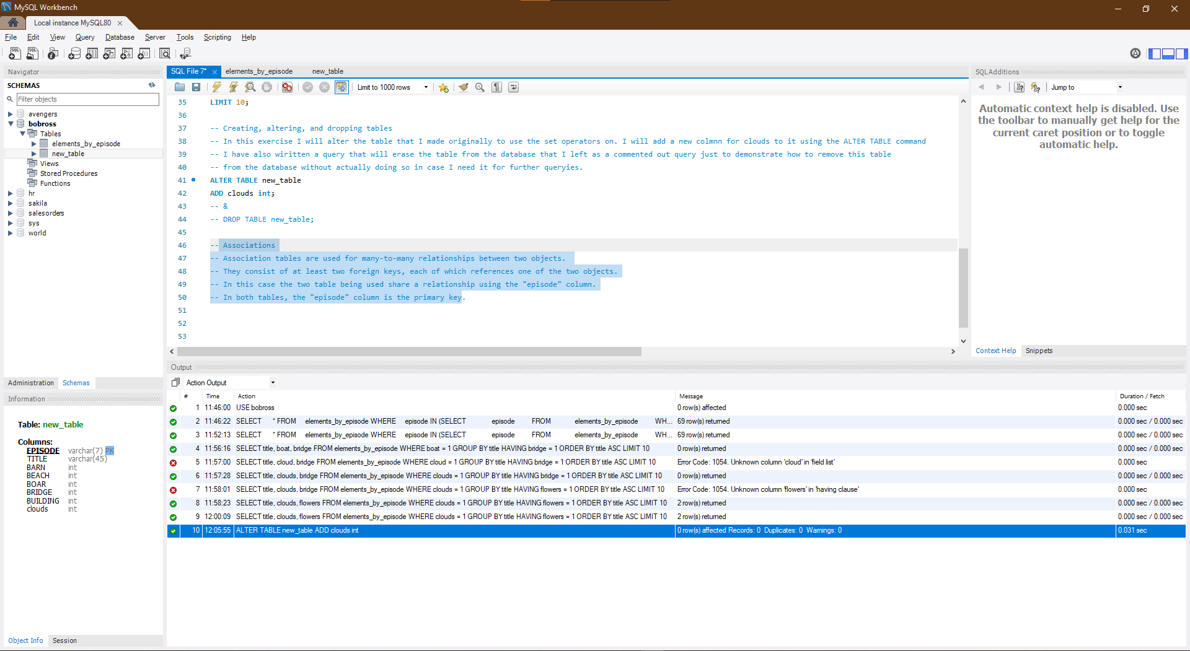

6) Joins and multiple table joins

A JOIN is used to combine rows from two or more tables based on a column that they both share. I will demonstrate an inner join clause on the

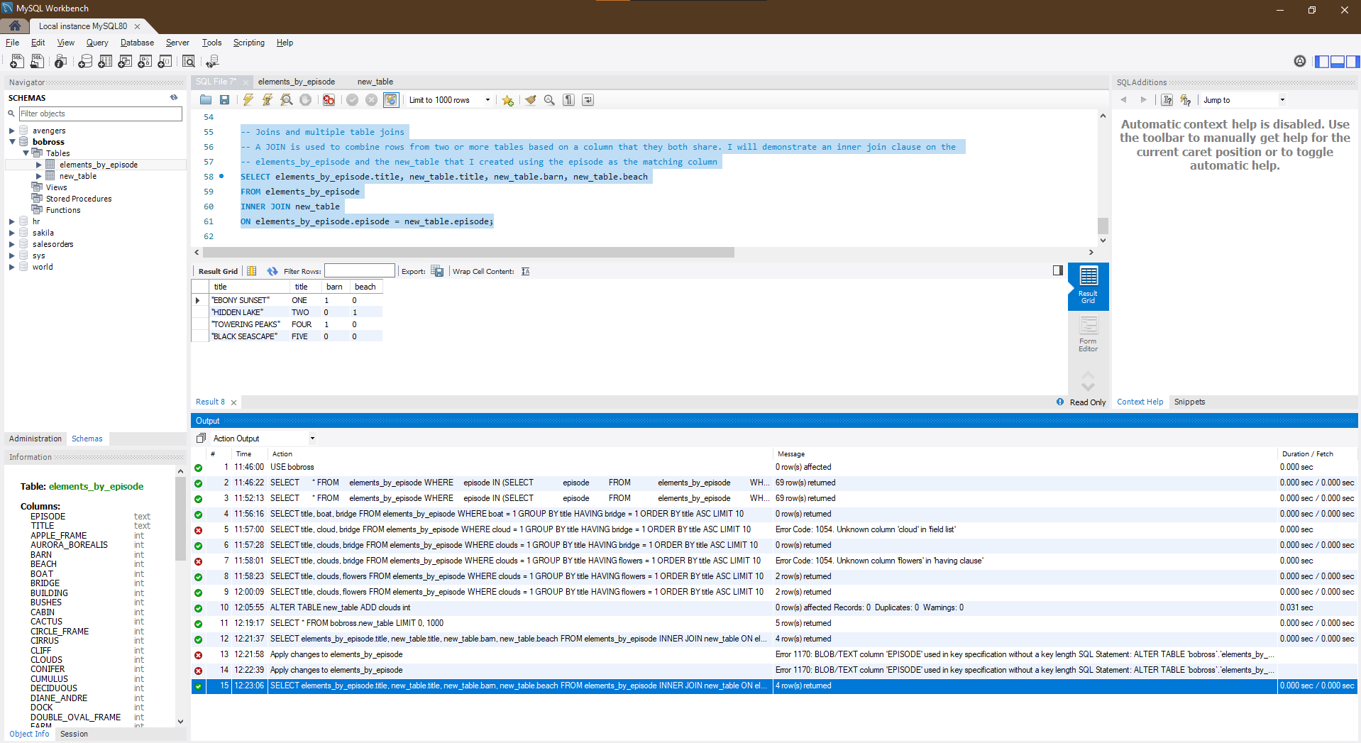elements_by_episode and the new_table that I created using the episode as the matching column

SELECT elements_by_episode.title, new_table.title, new_table.barn, new_table.beach

FROM elements_by_episode

INNER JOIN new_table

ON elements_by_episode.episode = new_table.episode;