Comprehensive Linux Operations

Project Overview
This project spans various aspects of Linux system administration, including file management, user and group management, service control, process handling, and more. You will be completing tasks that simulate real-world scenarios, providing hands-on experience with Linux commands and configurations.

Project Breakdown

Part 1: Creating and Editing Text Files (20 minutes):
Scenario: You are tasked with documenting the configurations and settings for a new server. You'll use different text editors to create and update these documents.
1.Using Nano:
Create and Open File with Nano:
Create a file server_config.txt using Nano:
nano server_config.txt

2. Add the following content:
Server Name: WebServer01
IP Address: 192.168.1.100
OS: Ubuntu 20.04

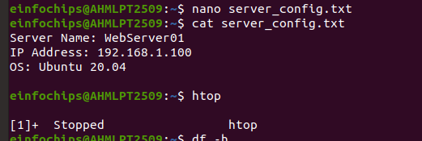
- Save and exit (Ctrl+O, Enter, Ctrl+X).

Server Name: WebServer01
- specifies the name of the server
- used to identify the server within a network or system.

IP Address: 192.168.1.100
- IP address of the server,
- IP address is used to identify and locate the server within a network.

OS: Ubuntu 20.04
- operating system running on the server,
- which is Ubuntu 20.04. This information is useful for knowing the environment and compatibility for software and applications.

3. Using Vi:
1. Edit the same file with Vi:
vi server_config.txt

2. Append the following text:
Installed Packages: Apache, MySQL, PHP
- Save and exit (Esc, :wq).
Enter Insert Mode:
- Press i to enter insert mode.
- see -- INSERT -- at the bottom of the terminal, indicating that you can now edit the file.
3. Append the Specified Content:
Installed Packages: Apache, MySQL, PHP

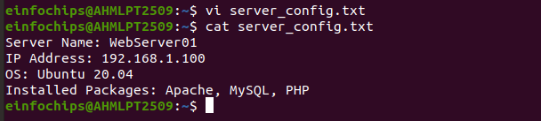
4. Save and Exit:
- Press Esc to exit insert mode.
- Type :wq and press Enter. This command writes the file (saves it) and quits Vi.

4. Using Vim:
1.Further edit the file with Vim:
vim server_config.txt

2.Add the following text:
Configuration Complete: Yes
- Save and exit (Esc, :wq).

3. Enter Insert Mode:
- Press i to enter insert mode.
- see -- INSERT -- at the bottom of the terminal, indicating that you can now edit the file.

4. Add the Specified Content:
vim server_config.txt

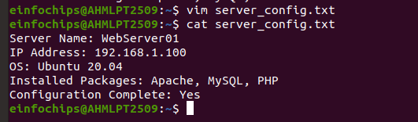
5. save and Exit:
- Press Esc to exit insert mode.
- Type :wq and press Enter. This command writes the file (saves it) and quits Vim.

Part 2: User & Group Management (20 minutes):
Scenario: You need to set up user accounts and groups for a new team joining the project.
- Adding/Removing Users:
Add a new user developer:
sudo adduser developer
- sudo: This stands for "superuser do" used to execute commands with superuser (root) privileges. need root privileges to add a new user.

- adduser: add a new user to the system. It is more user-friendly than the useradd command because it creates a home directory and sets up the user's environment.

- developer: This is the username of the new user you are adding.

- After running the sudo adduser developer command,

Enter Password:
- enter your own password to confirm , necessary privileges to run the sudo command.
Set User Password:
- enter a password for the new user (developer), need to enter it twice to confirm.

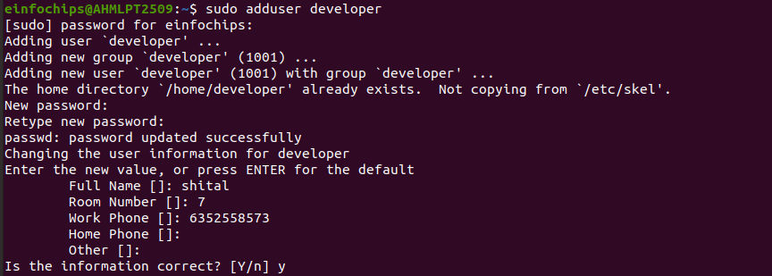

2. Remove the user developer:
sudo deluser developer

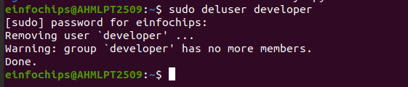

- sudo: stands for "superuser do" and is used to execute commands with superuser (root) privileges. You need root privileges to remove a user.

- deluser: This is a command to remove a user from the system. It removes the user's entry from the /etc/passwd file, effectively deleting the user account.

- developer: This is the username of the user you are removing.

User Deletion: The deluser command will remove the user account from the system.

Home Directory:
- By default, the deluser command does not remove the user's home directory.
- If you also want to remove the home directory, you need to add the --remove-home option:
sudo deluser --remove-home developer

Group Membership: The user will be removed from any groups they were a member of.

Example of Removing a User and Their Home Directory:
- If you want to remove the user developer and also delete their home directory.
sudo deluser --remove-home developer
- Execute sudo deluser developer to remove the user.
- execute sudo deluser --remove-home developer to also remove the user's home directory.

2. Force Removal:
- If the user is currently logged in or if there are running processes belonging to the user, you might need to forcefully remove the user:
sudo deluser --force --remove-home developer

3. Managing Groups:
1. Create a group devteam:
sudo groupadd devteam

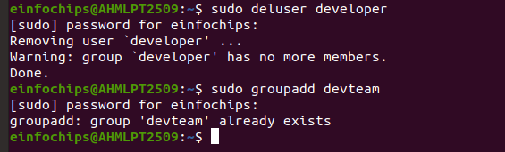

- sudo: This stands for "superuser do" and is used to execute commands with superuser (root) privileges. You need root privileges to add a new group.

GID Assignment:
- system assigns a unique group ID (GID) to the new group. This GID is used to identify the group within the system.
cd /etc/group
cat /etc/group | grep devteam
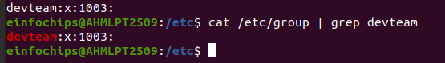
- x: placeholder for the group password (not commonly used).
- 1003: The unique GID assigned to the group.

2. Add the user developer to the devteam group:
sudo usermod -aG devteam developer
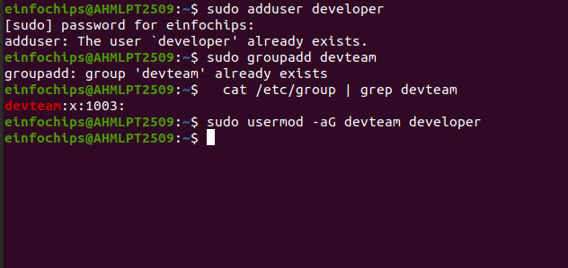
3. Remove the user developer from the devteam group:
sudo gpasswd -d developer devteam

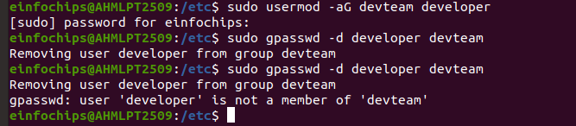

# Part 3: File Permissions Management (20 minutes):
Scenario: Ensure that only the appropriate users have access to specific files and directories.
1. Understanding File Permissions:
View permissions for server_config.txt:
ls -l server_config.txt
- Discuss the output (e.g., -rw-r--r--).
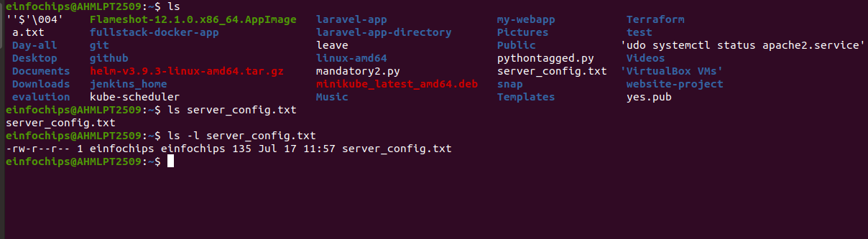
2. Changing Permissions and Ownership:
1. Change permissions to read/write for the owner and read-only for others:
chmod 644 server_config.txt

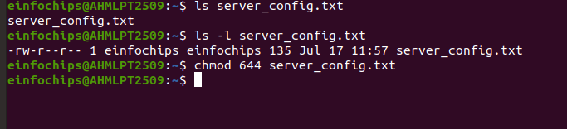
2.Verify the change:
ls -l server_config.txt

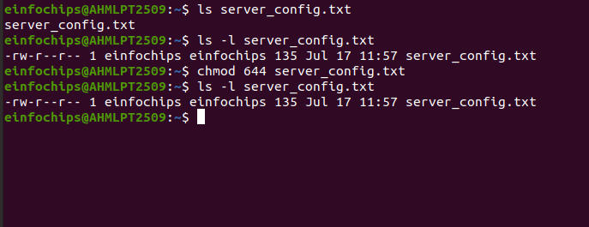

3. Change the owner to developer and the group to devteam:
sudo chown developer:devteam server_config.txt

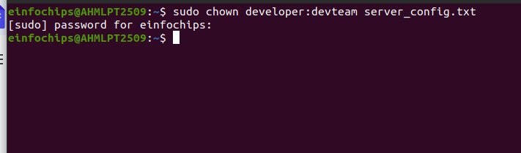

4. Verify the change:
ls -l server_config.txt

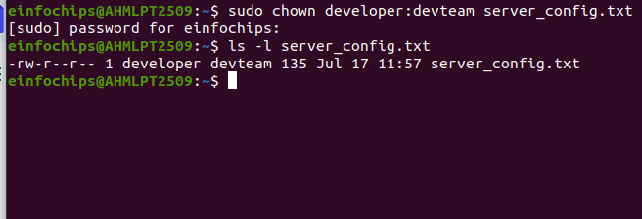

# Part 4: Controlling Services and Daemons (20 minutes):
Scenario: Manage the web server service to ensure it is running correctly and starts on boot.
- Managing Services with systemctl:
1.Start the Apache service:
sudo systemctl start apache2

2. Stop the Apache service:
sudo systemctl stop apache2

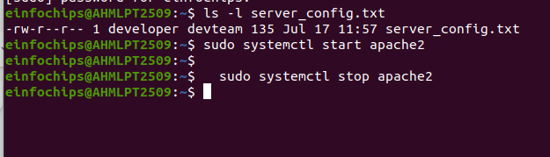
3. Enable the Apache service to start on boot:
sudo systemctl enable apache2

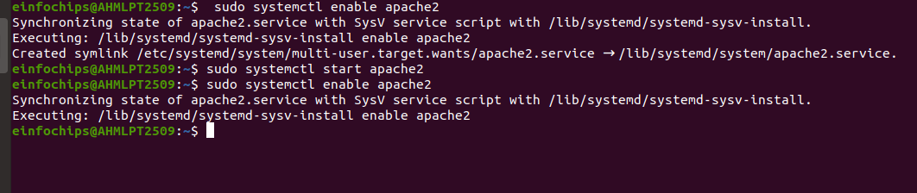

4. Disable the Apache service:
sudo systemctl disable apache2

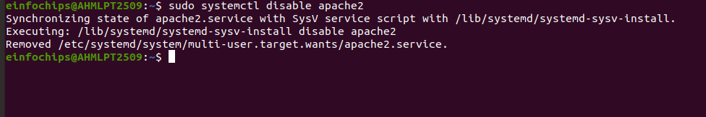

5. Check the status of the Apache service:
sudo systemctl status apache2

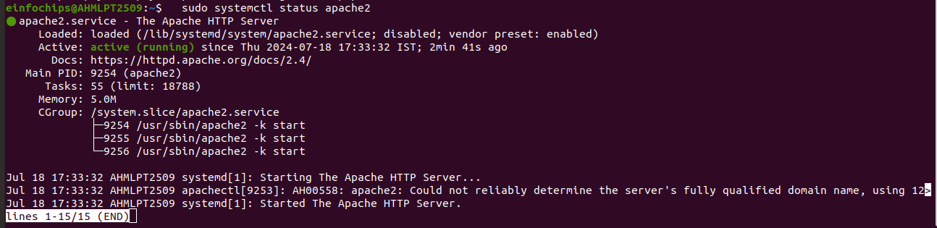

2. Understanding Daemons:
- Discuss the role of the sshd daemon in providing SSH access to the server.

# Part 5: Process Handling (20 minutes):
Scenario: Monitor and manage processes to ensure the server is performing optimally.
- Viewing Processes:
1. List all running processes:
ps aux

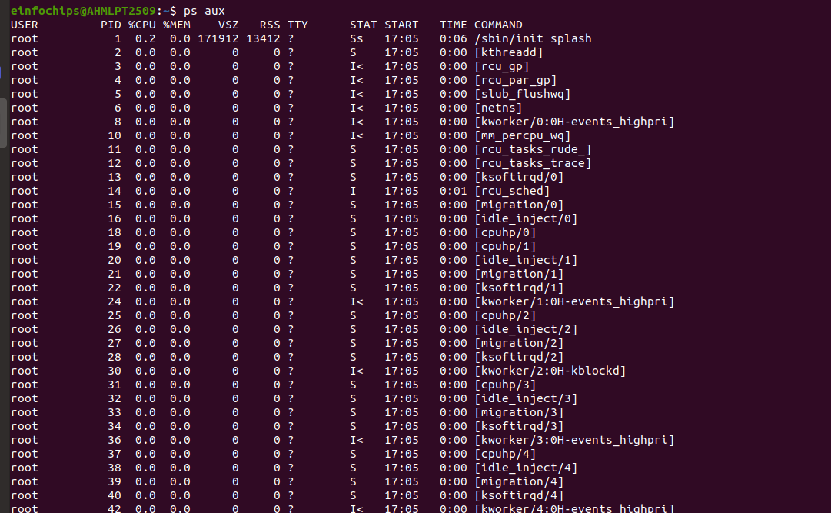

2. Use top to view processes in real-time:
top

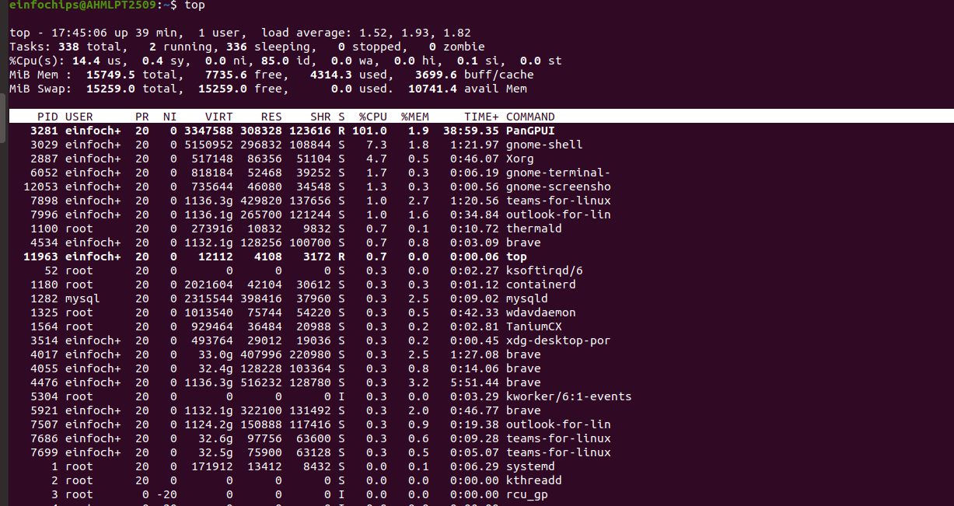

- Managing Processes:
1. Identify a process to kill using ps or top, then kill it:
kill <PID>
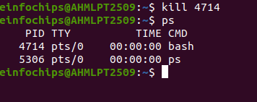

3. Change the priority of a process (e.g., running sleep with a lower priority):
nice -n 10 sleep 100 &
4.Change the priority of the process using renice:
renice +10 <PID>
