# **Project Overview**

Create a private git repo that has a maven project. In Jenkins create 2 freestyle project, one to compile that maven project and other to test that maven project. Create a pipeline view of the project.

## **Step 1. Private Git Repo**

Creating private git repo

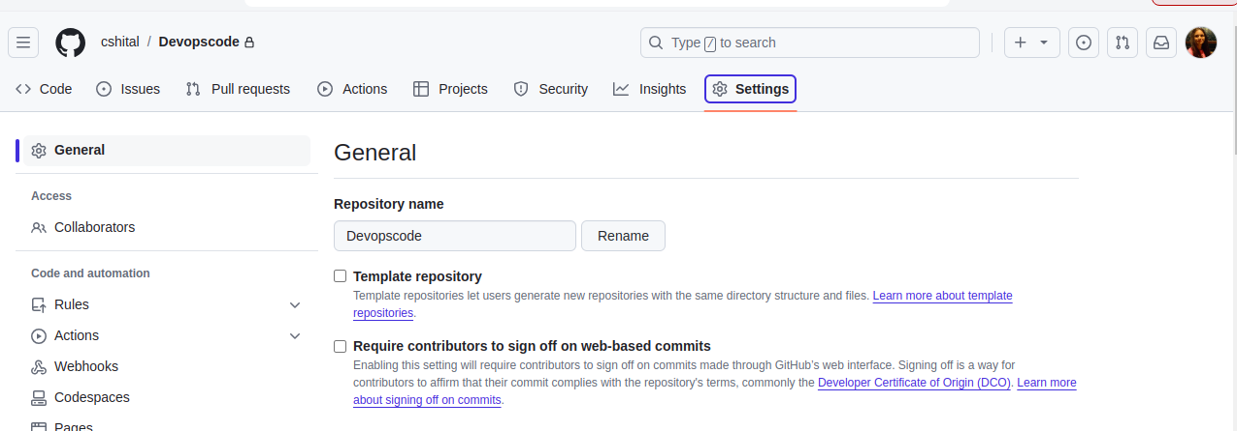

Generating personal access token

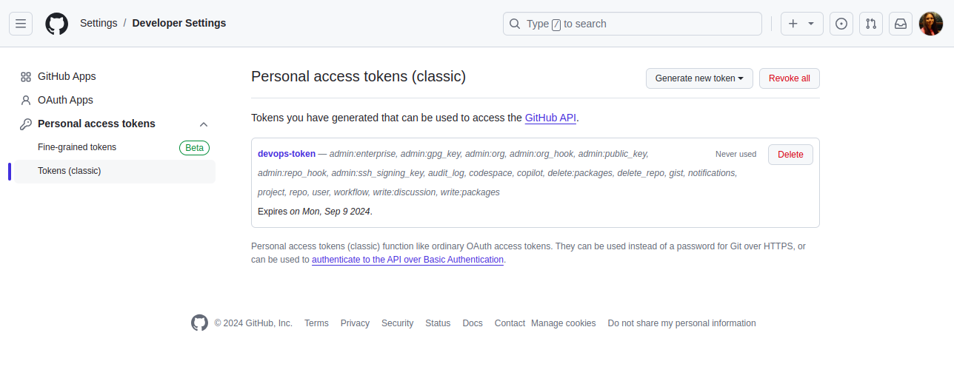

## **Step 2. Compile maven project**

Creating new freestyle project to Compile code using maven

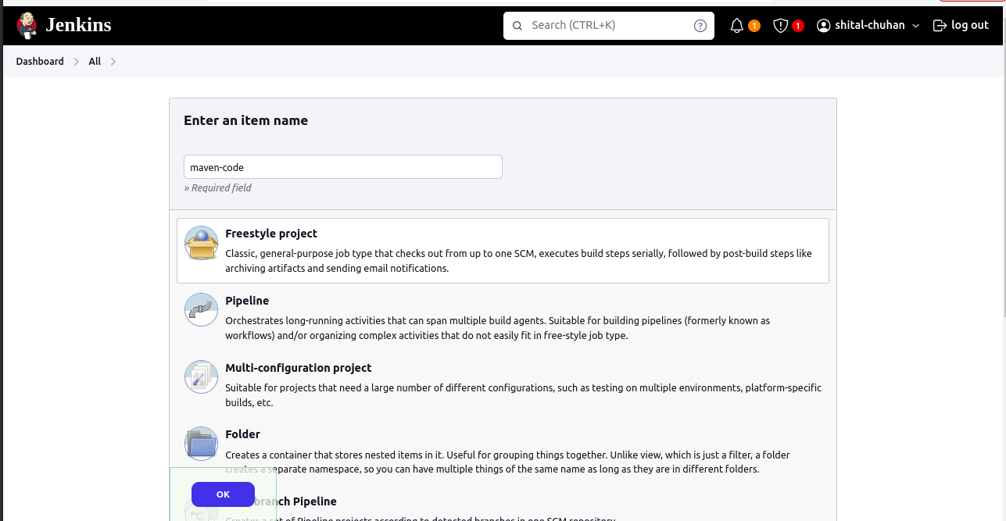

Setting up git credentails in jenkins

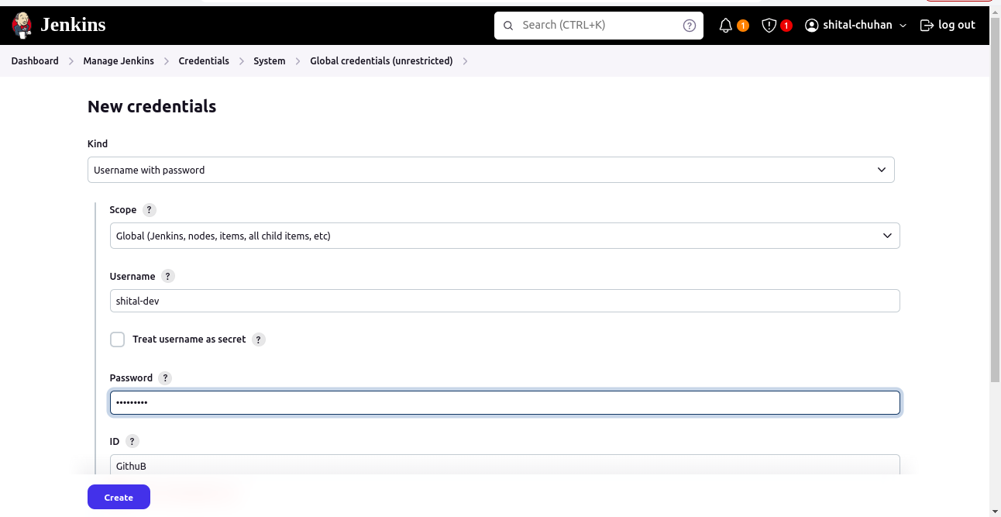

Configuring Freestyle Project

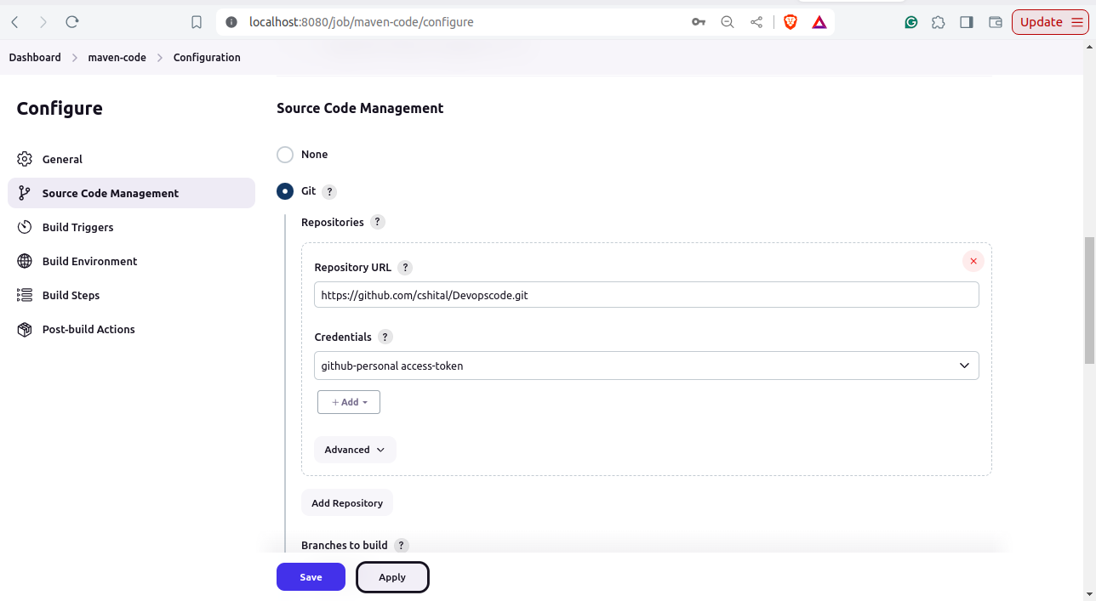

Setup Maven Installation in Jenkins

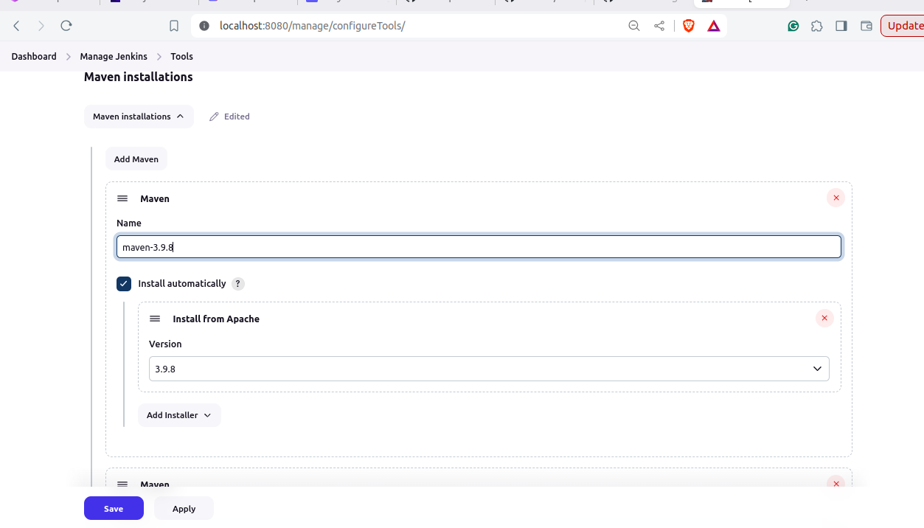

Setup Maven Build Steps compile

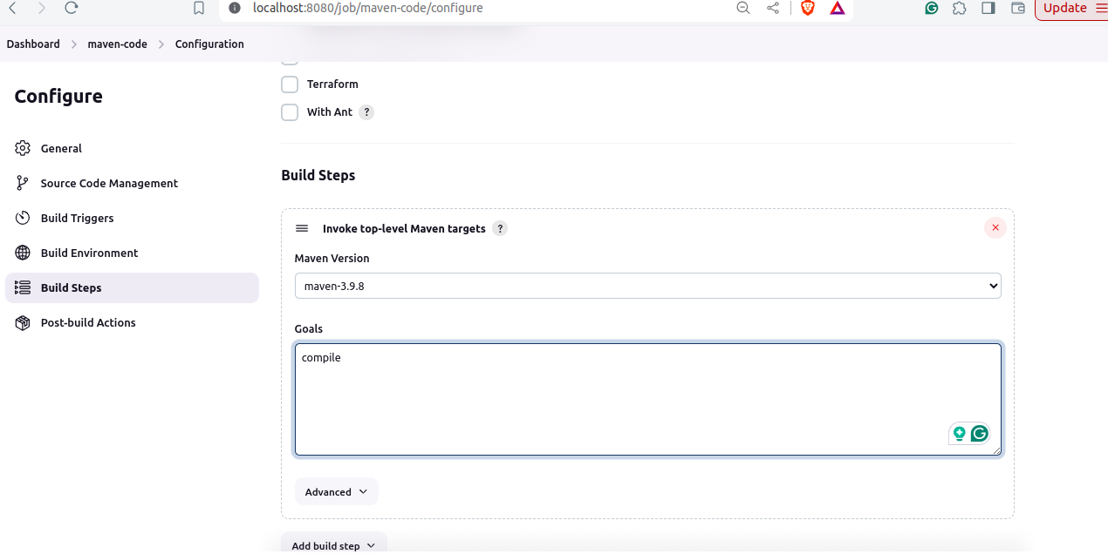

Build "Maven Compile" Project

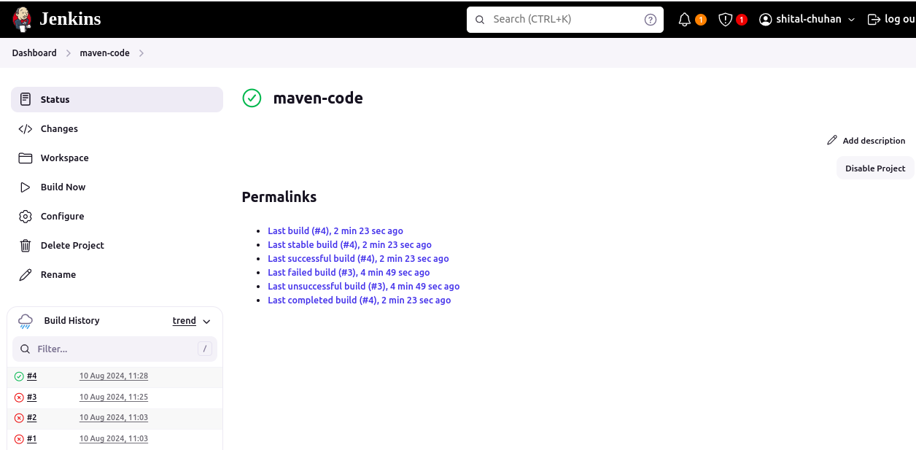

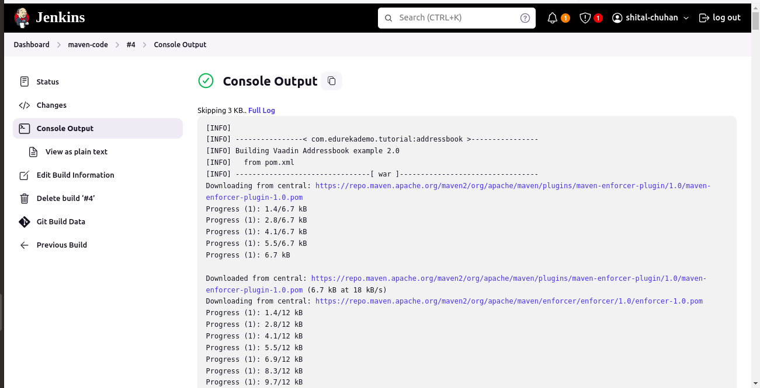

## **Step 3. Test maven project**

Creating new freestyle project to Test code using maven

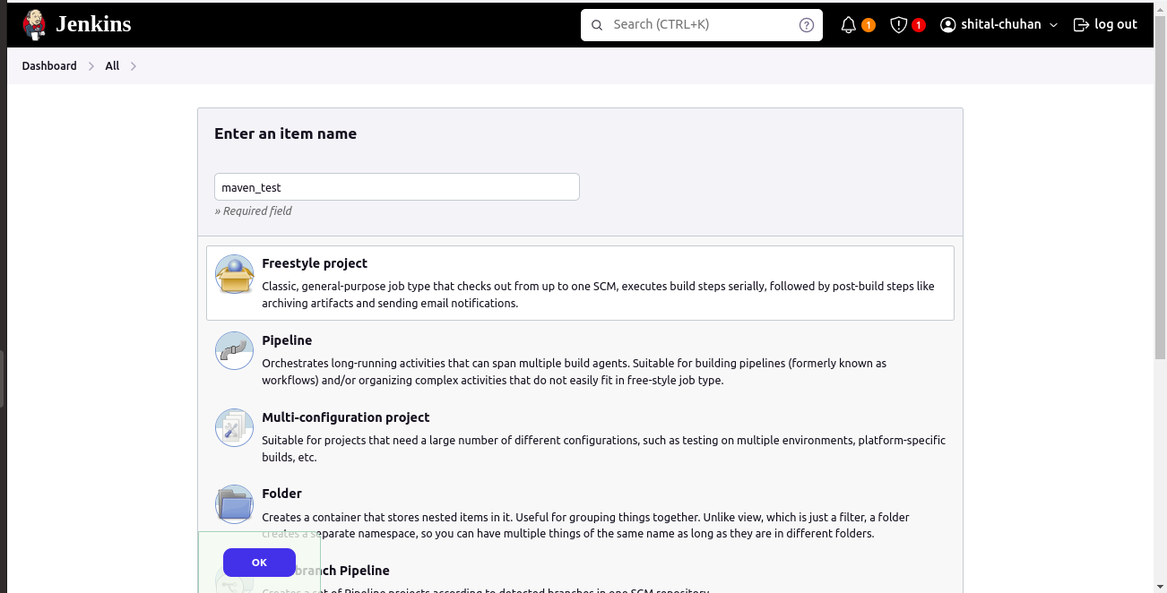

Configuring Freestyle Project

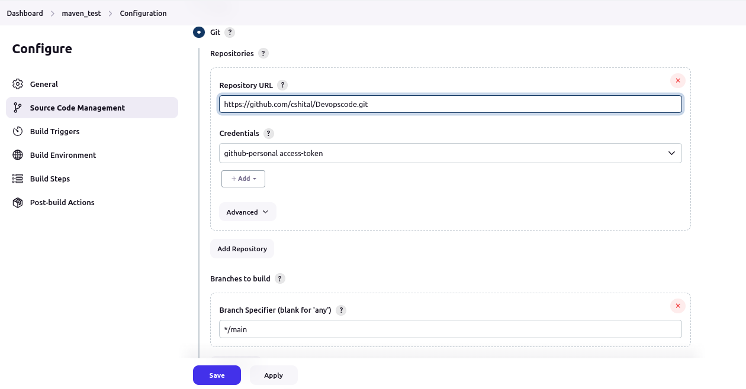

Setup Maven Build Steps test

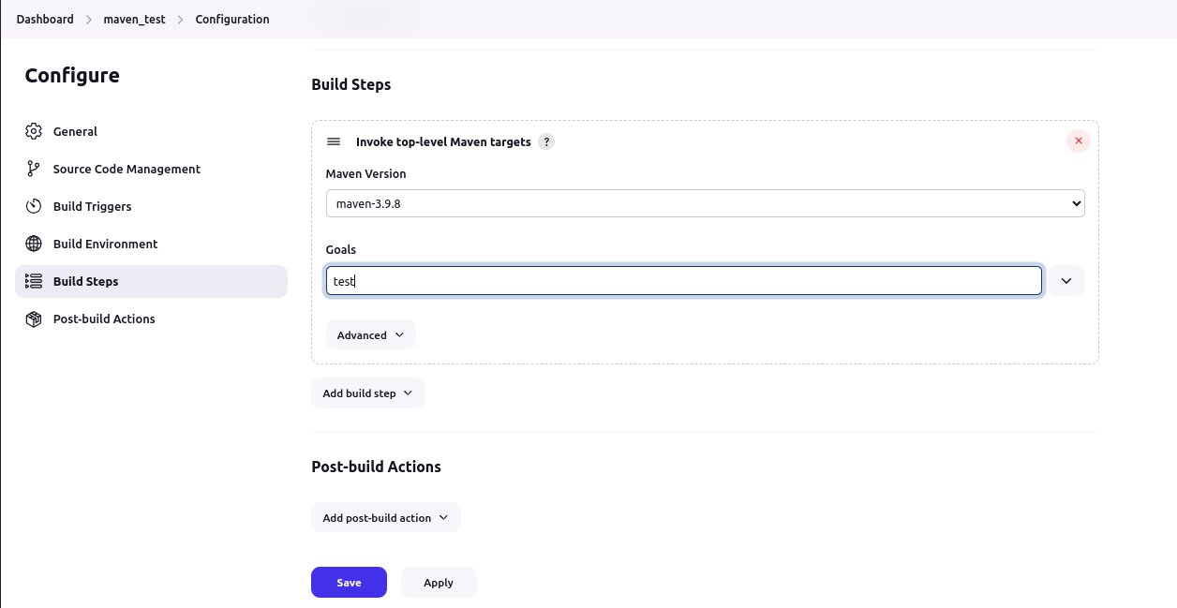

Build "Maven Test" Project

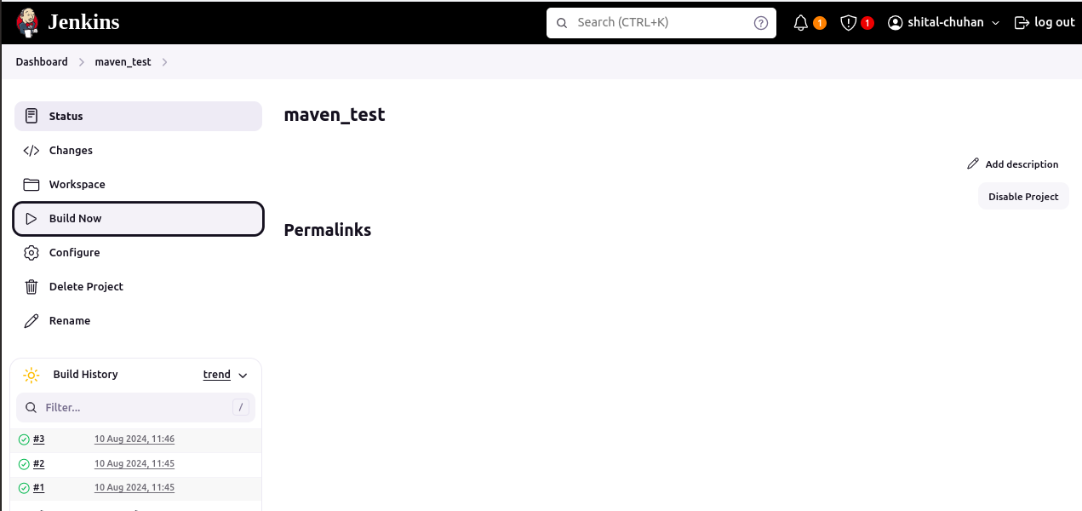

## **Step 4. Pipeline view**

* Create Pipeline View of Above mention project
* Create new "build pipeline" in jenkins

