## **Project 01**

# **Project Overview**

Your organization is implementing continuous integration (CI) practices to streamline the software development lifecycle. As part of this initiative, you will create a Jenkins declarative pipeline for building a simple Maven project hosted on GitHub. This project aims to automate the build process, ensure code quality, and facilitate continuous delivery (CD).

## **Setup Jenkins Job**

* Create a new Jenkins pipeline job.
* Configure the job to pull the Jenkinsfile from the GitHub repository.

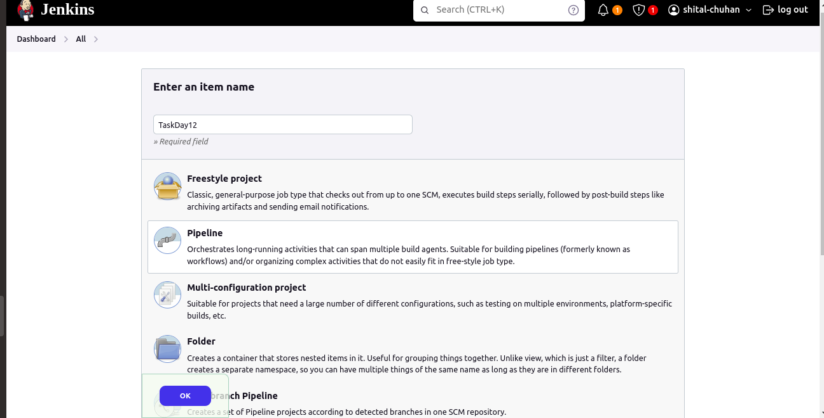

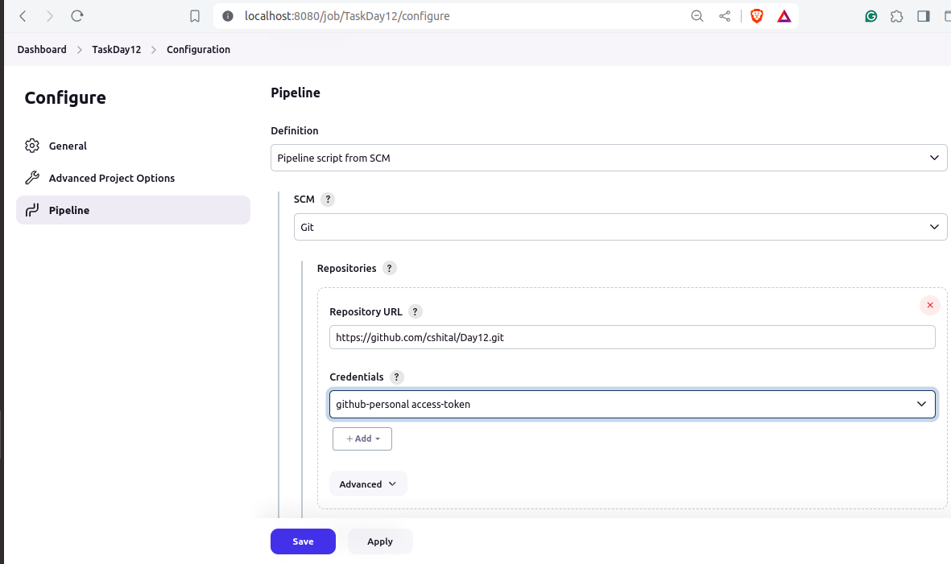

## **Create Jenkinsfile**

* Write a declarative pipeline script (Jenkinsfile) that includes the following stages:
* Clone Repository: Clone the Maven project from the GitHub repository.
* Build: Execute the Maven build process (mvn clean install).
* Test: Run unit tests as part of the Maven build.
* Archive Artifacts: Archive the build artifacts for future use.

Jenkinsfile

pipeline {

agent any

tools {

maven 'maven-3.9.8'

}

parameters{

choice(choices:['test','compile','package'], description:"select maven Goal", name:"userChoice")

}

stages {

stage('Checkout') {

steps {

script {

git branch: 'main',

credentialsId: 'Github',

url: ' <https://github.com/cshital/Devopscode.git> '

}

}

}

stage('Build') {

steps {

sh 'mvn clean install'

}

}

stage('Test'){

steps{

sh "mvn ${params.userChoice}"

}

}

stage('Archive Artifacts') {

steps {

archiveArtifacts artifacts: '**/target/*.jar', allowEmptyArchive: true

}

}

}

post {

always {

echo 'Pipeline finished.'

}

success {

echo 'Pipeline succeeded.'

}

failure {

echo 'Pipeline failed.'

}

}

}

## **Configure Pipeline Parameters**

* Allow the pipeline to accept parameters such as Maven goals and options for flexibility.
* Ensure the pipeline can be easily modified for different build configurations.

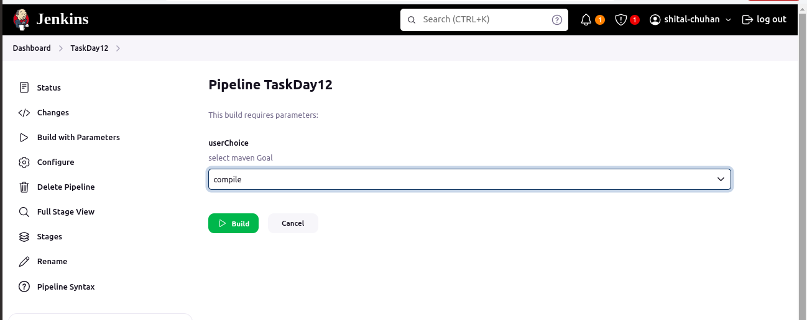

## **Run the Pipeline**

* Trigger the Jenkins pipeline job manually or set up a webhook for automatic triggering on GitHub repository changes.
* Monitor the build process through Jenkins' UI and console output.

