# **Day 18 Task**

## **Project Overview**

This project automates the deployment of a three-tier web application consisting of a frontend (Nginx web server), a backend (Node.js application), and a database (MySQL server) using Ansible roles. The solution leverages Ansible Galaxy roles for efficient configuration and deployment.

## **Deliverables**

## **Directory Structure**

The project is organized in the following directory structure:

Day18/

├── roles/

│ ├── frontend/

│ │ ├── tasks/

│ │ ├── templates/

│ │ └── meta/

│ │ └── main.yml

│ ├── backend/

│ │ ├── tasks/

│ │ ├── templates/

│ │ └── meta/

│ │ └── main.yml

│ └── database/

│ ├── tasks/

│ ├── templates/

│ └── meta/

│ └── main.yml

├── inventory.ini

│

├── deploy.yml

├── test.yml

│

└── README.md

**1. Ansible Project Directory Structure** Organized directory structure with roles, playbooks, inventory, and configuration files.

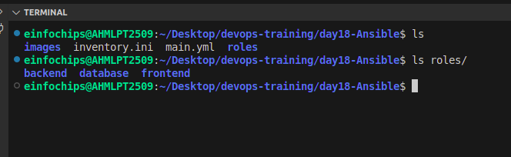

**2. Role Definitions and Dependencies** meta/main.yml files for each role defining dependencies. Customized roles with necessary configurations.

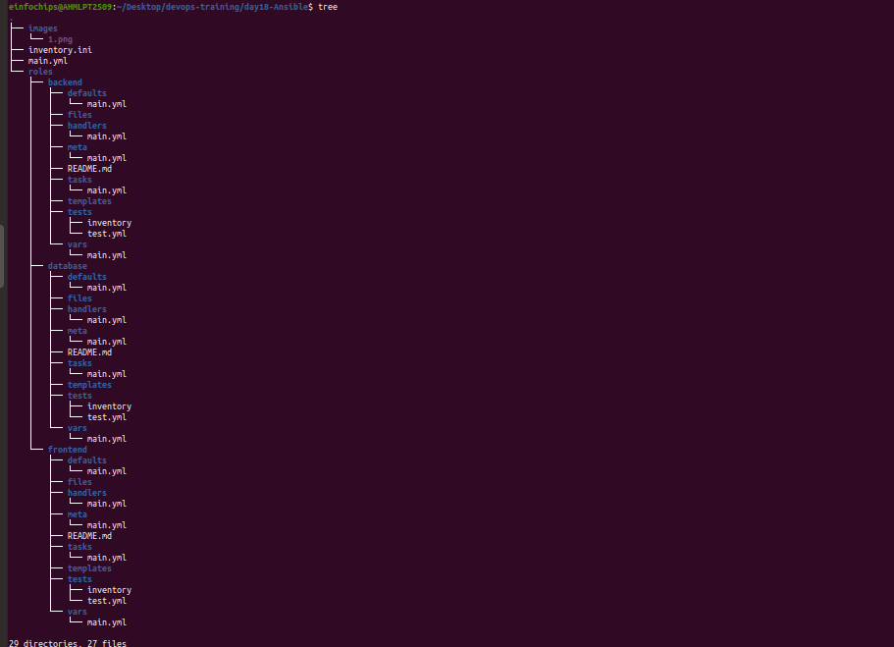

**3. Inventory File** Inventory file defining groups and hosts for frontend, backend, and database tiers.

[frontend]

app-node-01 ansible_host=35.93.45.82 ansible_user=ubuntu ansible_ssh_private_key_file=/home/einfochips/Downloads/ansible-shital.pem

[backend]

backend-01 ansible_host=35.93.45.82 ansible_user=ubuntu ansible_ssh_private_key_file=/home/einfochips/Downloads/ansible-shital.pem

[database]

db-01 ansible_host=35.93.45.82 ansible_user=ubuntu ansible_ssh_private_key_file=/home/einfochips/Downloads/ansible-shital.pem

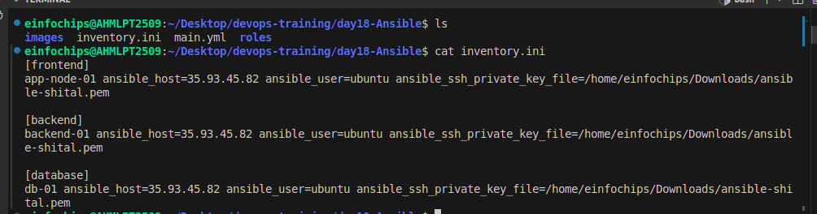

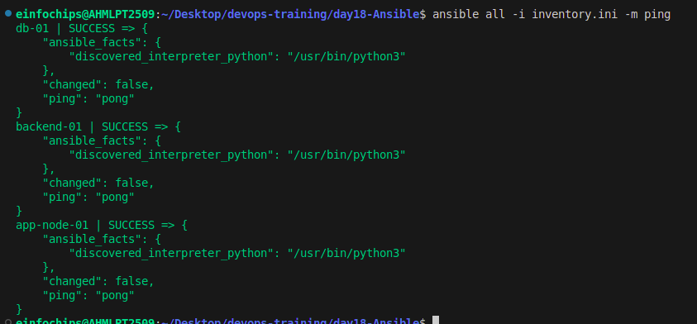

**4. Playbook for Deployment (main.yml)** Playbook that orchestrates the deployment of the three-tier application.

---

- name: Full Stack Application

hosts: app

become: yes

tasks:

- name: update_cache

apt:

update_cache: yes

- hosts: app

become: true

roles:

- frontend

- hosts: backend

become: true

roles:

- backend

- hosts: database

become: true

roles:

- database

**5. Playbook for Testing (test.yml)** Playbook that verifies the deployment and functionality of each tier.

