# **Day 22 Task**

## **1. Configuring Jobs and Targets**

* Task: Set up a Prometheus server to monitor multiple services running on different nodes.
* Deliverables:
  + Configure Prometheus with jobs for monitoring different services like web servers, databases, and system metrics.
* prometheus.yml

# Load rules once and periodically evaluate them according to the global 'evaluation_interval'.

rule_files:

# - "first_rules.yml"

# - "second_rules.yml"

- "alert_rules.yml"

# A scrape configuration containing exactly one endpoint to scrape:

# Here it's Prometheus itself.

scrape_configs:

# The job name is added as a label `job=<job_name>` to any timeseries scraped from this config.

- job_name: "prometheus"

# metrics_path defaults to '/metrics'

# scheme defaults to 'http'.

static_configs:

- targets: ["localhost:9090"]

- job_name: 'node_exporter'

static_configs:

- targets: ['13.235.78.105:9100']

# webserver target setup

- job_name: "nginx"

static_configs:

- targets: ["13.235.78.105:80"]

# database target setup

- job_name: "mysql"

static_configs:

- targets: ["13.235.78.105:9104"]

# system metrics setup

- job_name: "system_metrics"

static_configs:

- targets: ["13.235.78.105:9100"]

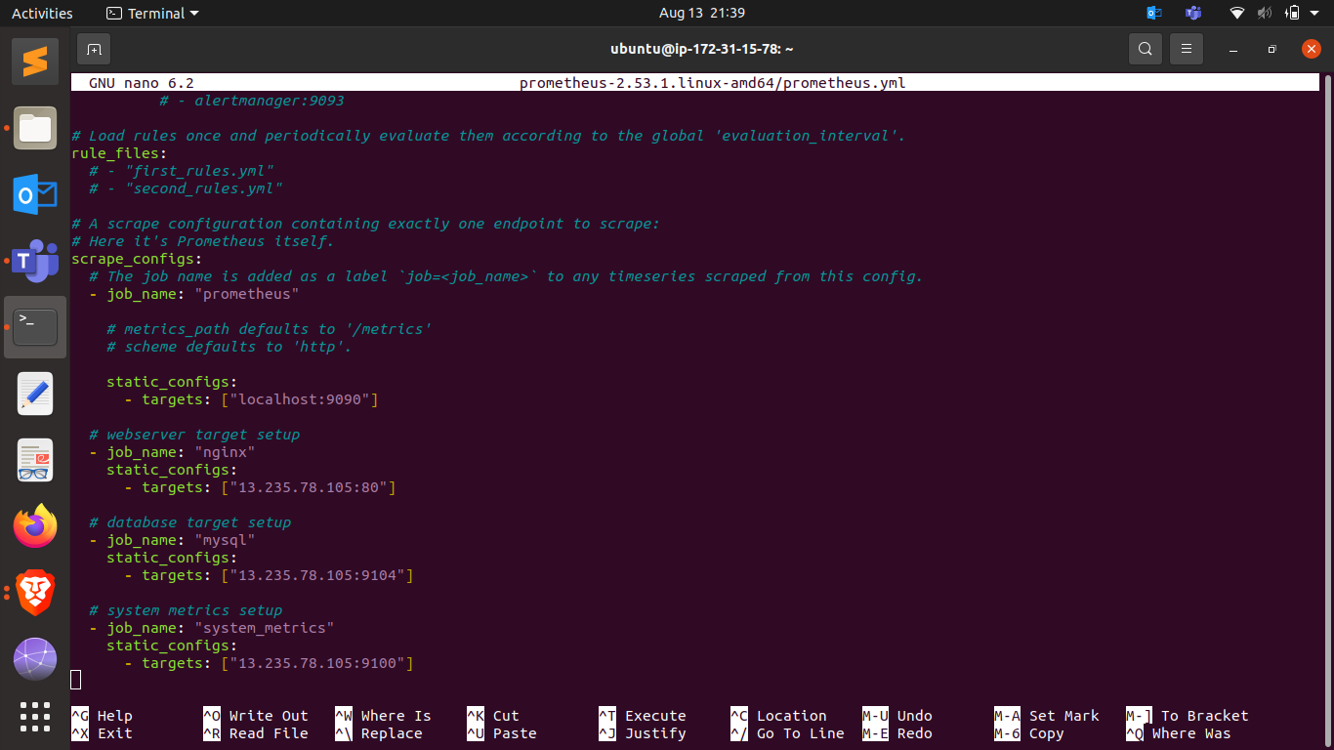

## **2. Using Exporters (Node Exporter)**

* **Task:** Use Node Exporter to monitor system-level metrics like CPU, memory, disk usage, and network statistics.
* Deliverables:
  + Install and configure Node Exporter on all nodes.
  + Ensure Node Exporter metrics are being correctly scraped by Prometheus.

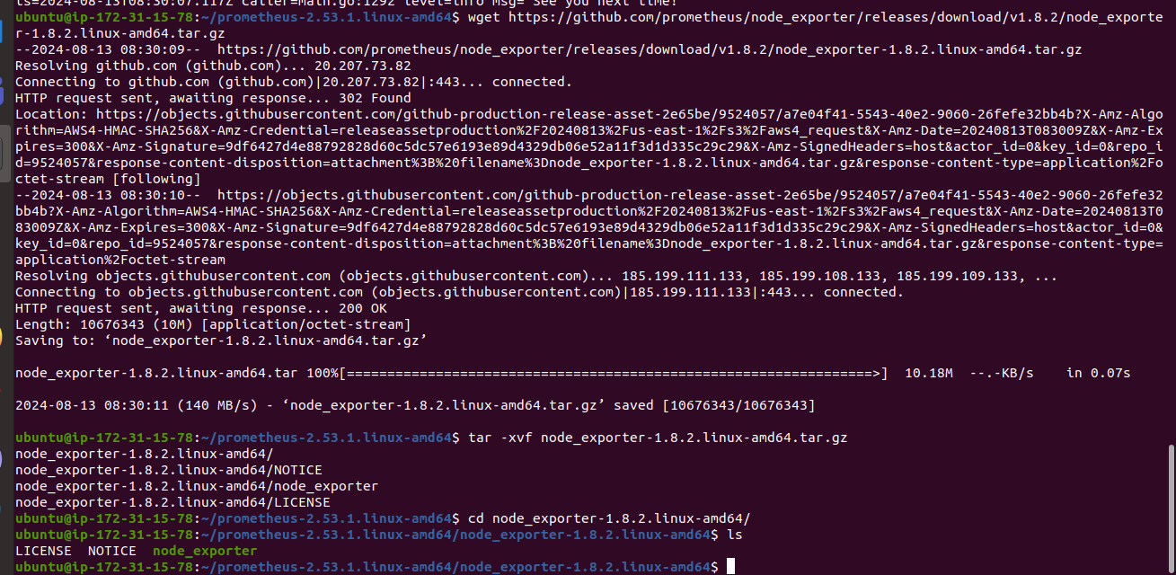

### **3. Hands-on Exercise: Setting Up Exporters**

* **Task:** Configure at least two different types of exporters (e.g., Node Exporter and MySQL Exporter) and integrate them with Prometheus.

Deliverables:

* + Demonstrate successful data collection from both exporters.
  + Create a basic Prometheus dashboard to visualize key metrics from these exporters.

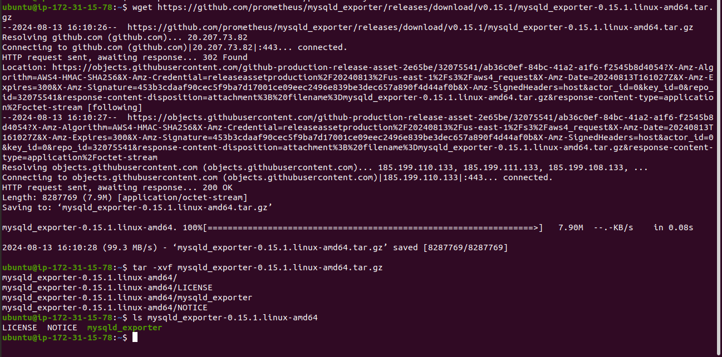

## **4. Introduction to PromQL**

* **Task:** Learn and implement basic PromQL queries to extract meaningful data from the metrics collected.
* Deliverables:
  + Write basic queries to retrieve metrics like average CPU usage, memory consumption, and disk I/O over time.

**Graph of average CPU usage**

avg(rate(node_cpu_seconds_total{mode="user"}[5m])) by (instance)

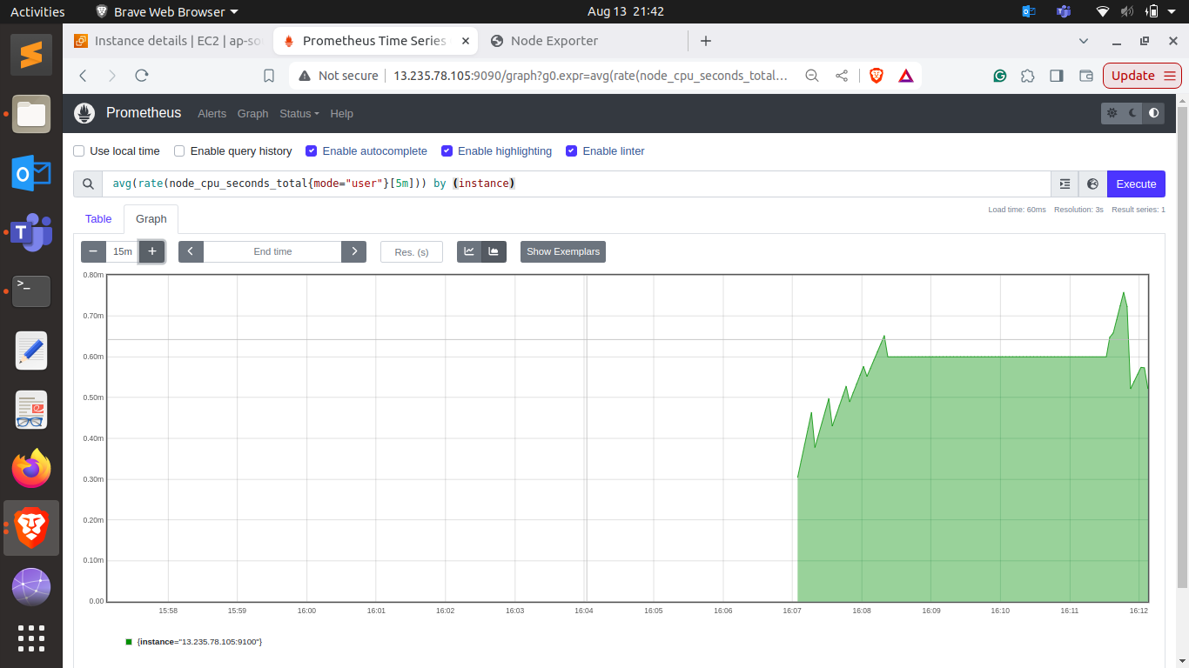

**Graph of memory consumption**

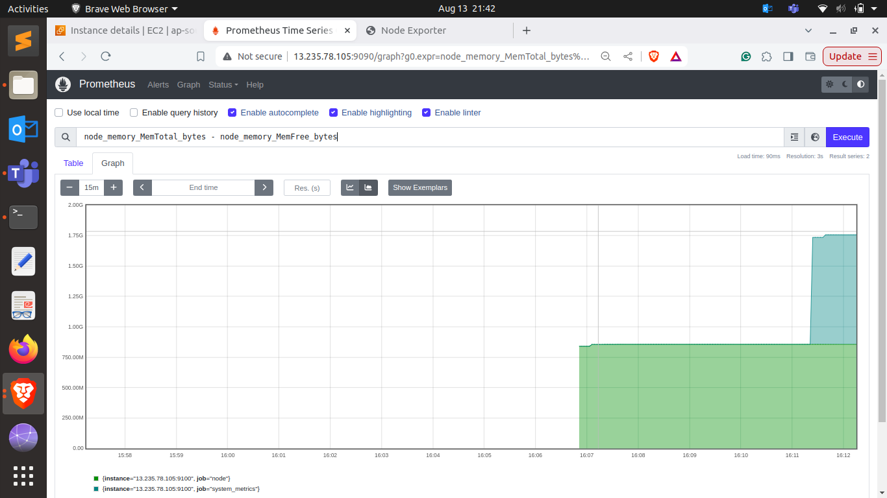

**Graph of disk I/O over time**

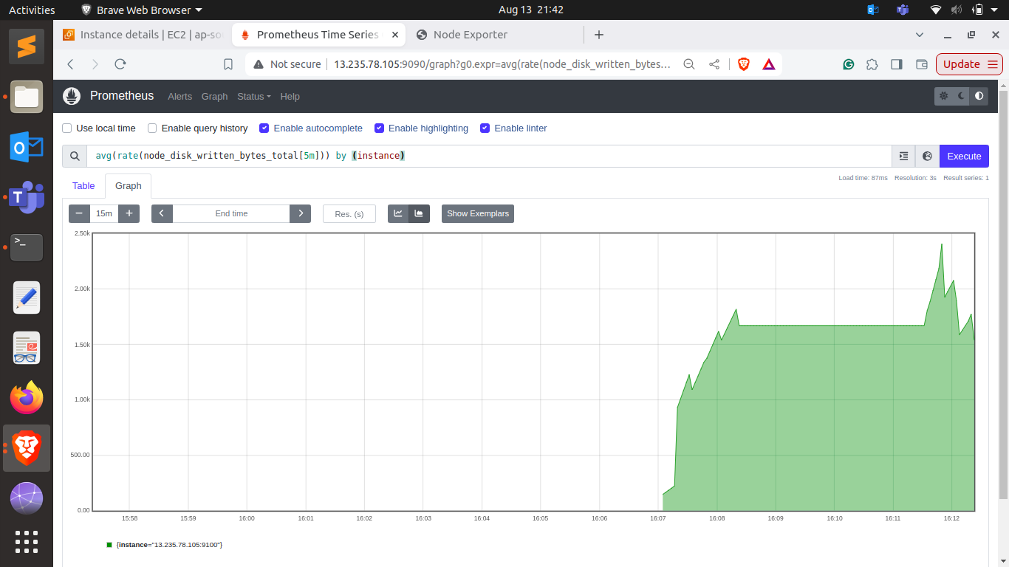

## **5. Basic Queries (Selectors, Functions, Operators)**

* **Task:** Create PromQL queries using selectors, functions, and operators to filter and manipulate time-series data.
* Deliverables:
  + Write PromQL queries to calculate the 95th percentile of CPU usage.
  + Use functions like rate(), increase(), and histogram_quantile() to perform more complex analysis.

## **6. Advanced Queries and Aggregations**

* **Task:** Perform advanced data aggregation using PromQL.
* Deliverables:
  + Write queries to calculate the total memory usage across all nodes.
  + Aggregate data to find the maximum disk space usage among all nodes.

**Graph of total memory usage across all nodes**

sum(node_memory_MemTotal_bytes - node_memory_MemFree_bytes)

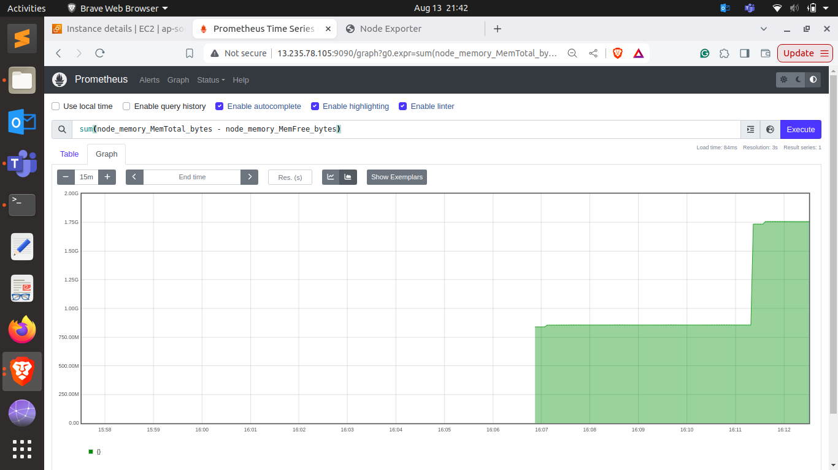

**Graph of maximum disk space usage among all nodes**

max(node_filesystem_size_bytes - node_filesystem_free_bytes)

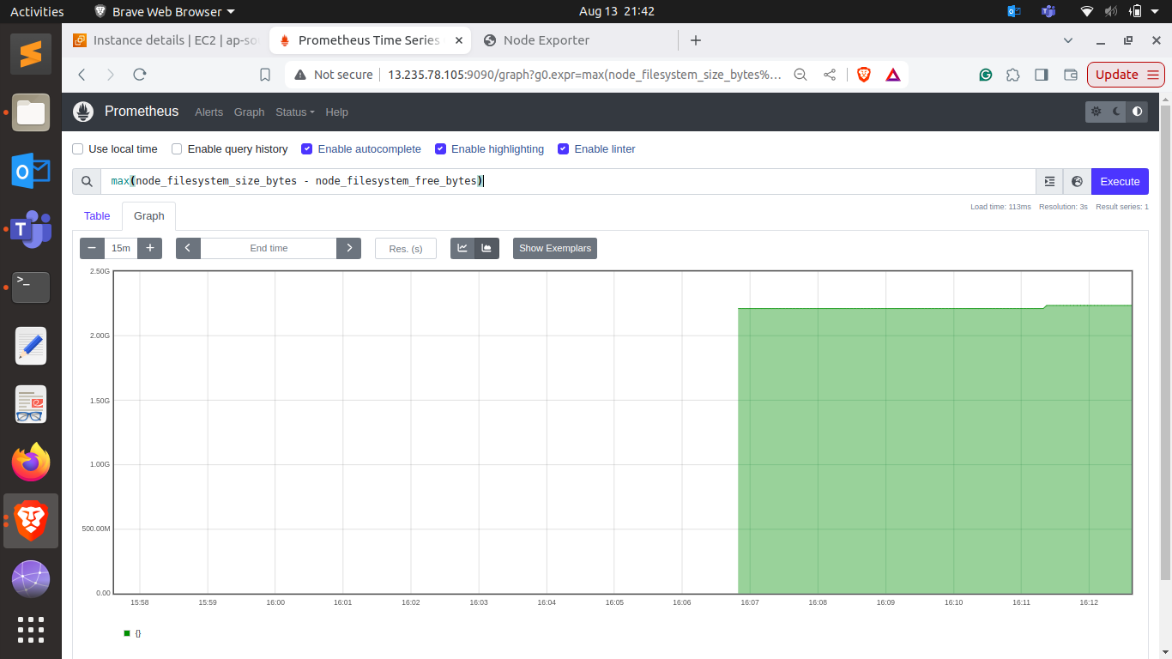

## **7. Configuring Alertmanager**

* **Task:** Set up Alertmanager to handle alerts generated by Prometheus.
* Deliverables:
  + Configure Alertmanager with Prometheus.
  + Create routing rules to manage alert notifications based on severity and service type.

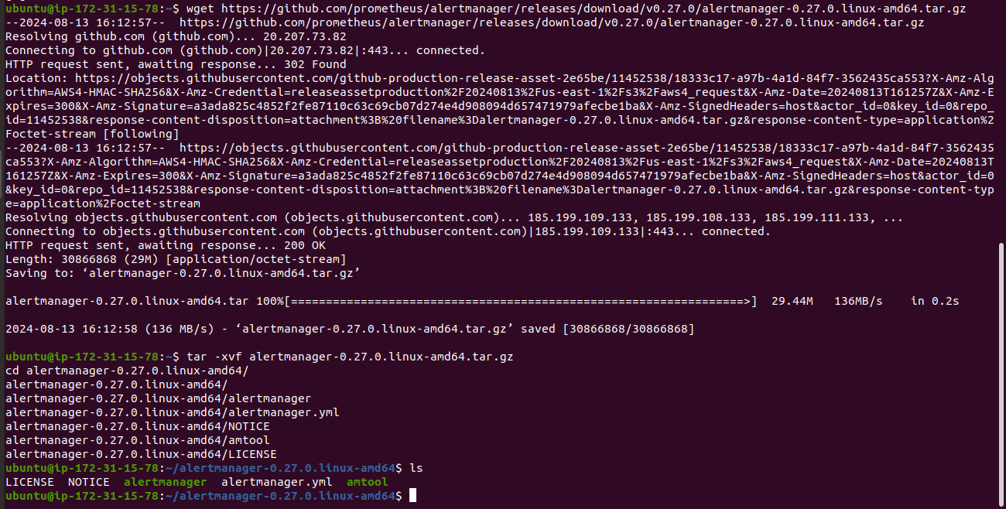

## **8. Writing Alerting Rules**

* **Task:** Write custom alerting rules in Prometheus to trigger alerts based on specific conditions.
* Deliverables:
  + Create alerting rules for high CPU usage, memory leaks, and disk space running low.
  + Ensure alerts are correctly generated and sent to Alertmanager.

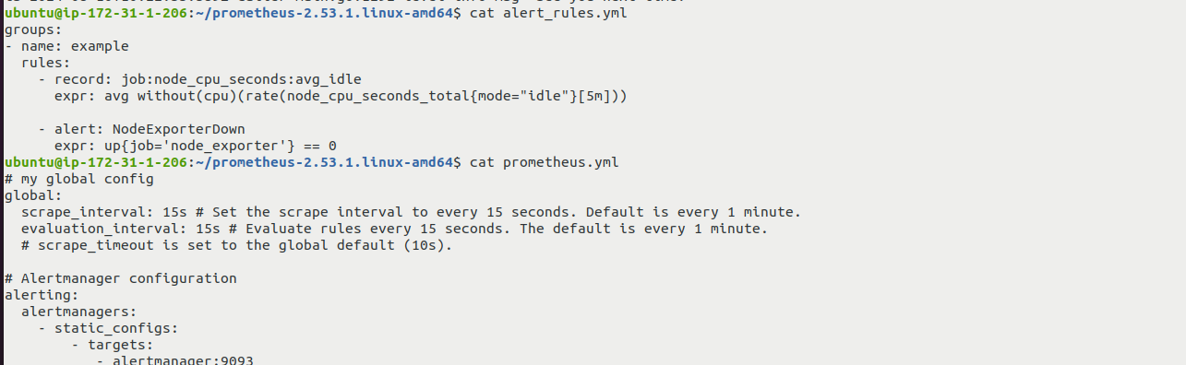

## **9. Setting Up Notification Channels (Email, Slack, etc.)**

* **Task:** Integrate Alertmanager with multiple notification channels and Slack.
* Deliverables:
  + Set up Email notifications for critical alerts.
  + Integrate Slack for real-time alerts and notifications.

**Creating Prometheus Channel on Slack**

**Adding Incoming webhooks**

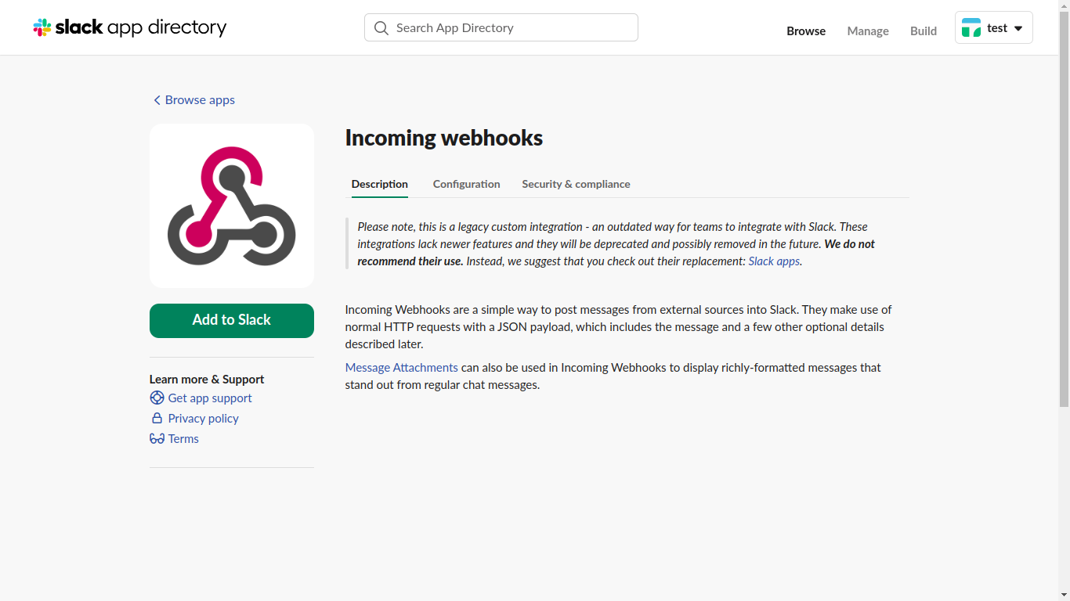

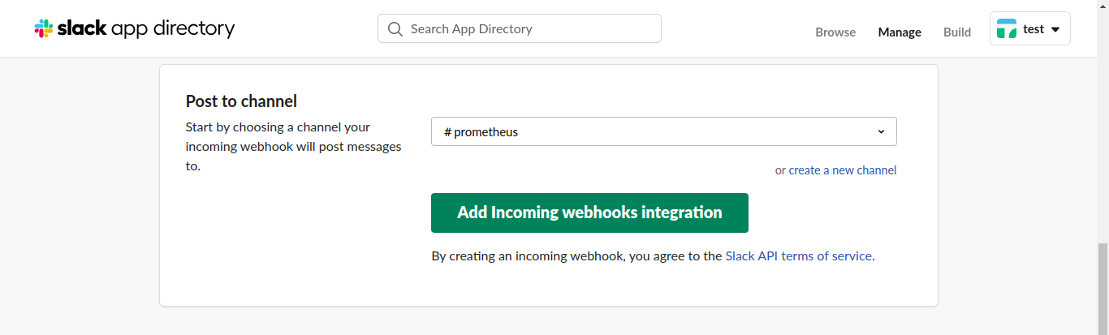

Setting up alertmanager.yml

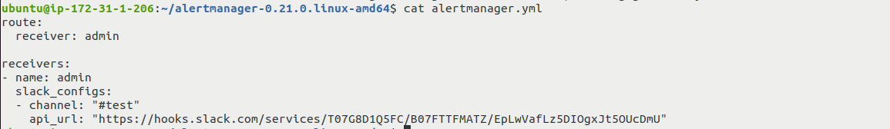

## **10. Hands-on Exercise: Creating Alerts**

* **Task:** Test the entire alerting pipeline by creating and triggering custom alerts.
* Deliverables:
  + Simulate a scenario where a node exceeds 90% CPU usage and ensure alerts are triggered and sent to both Email and Slack.
  + Validate the alerts in both notification channels.

Alert recieved on Alert Manager and forwarder to slack

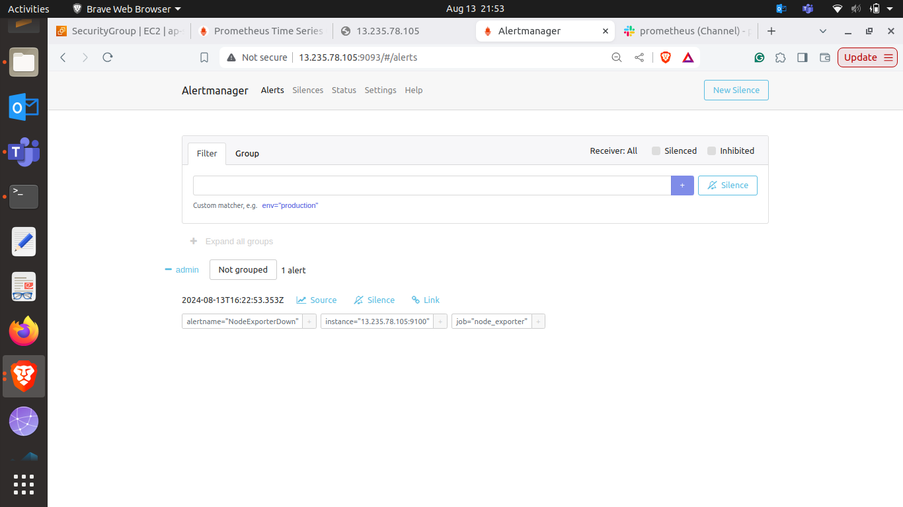

Alert shown in slack on prometheus channel

