# **Day 25 Task**

**Deploying a Path-Based Routing Web Application on AWS**

**Objective:**

* To evaluate your skills in deploying a web application on AWS using EC2 instances, configuring security groups, and setting up an Application Load Balancer (ALB) with path-based routing. You will deploy two simple web applications, configure the ALB to route traffic based on the URL path, and terminate all resources once the project is complete.

**Project Scenario:**

* A small company needs to deploy two lightweight web applications, "App1" and "App2," on AWS. The traffic to these applications should be routed through a single Application Load Balancer (ALB) based on the URL path. The company has opted for t2.micro instances for cost efficiency. Project Steps and Deliverables:

## **EC2 Instance Setup (30 minutes):**

* Launch four EC2 t2.micro instances using the Amazon Linux 2 AMI.
* SSH into each instance and deploy a simple web application:
  + Deploy "App1" on two instances.
  + Deploy "App2" on the other two instances.
* Assign tags to the instances for identification (e.g., "App1-Instance1," "App1-Instance2," "App2-Instance1," "App2-Instance2").

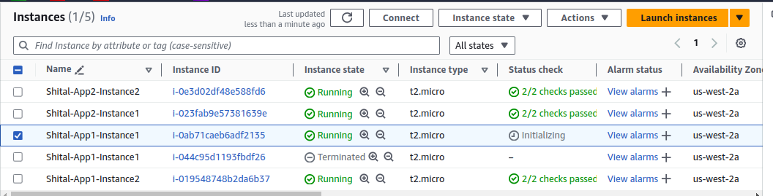

## **Security Group Configuration (20 minutes):**

* Create a security group for the EC2 instances that allows inbound HTTP (port 80) and SSH (port 22) traffic from your IP address.
* Create a security group for the ALB that allows inbound traffic on port 80.
* Attach the appropriate security groups to the EC2 instances and ALB.

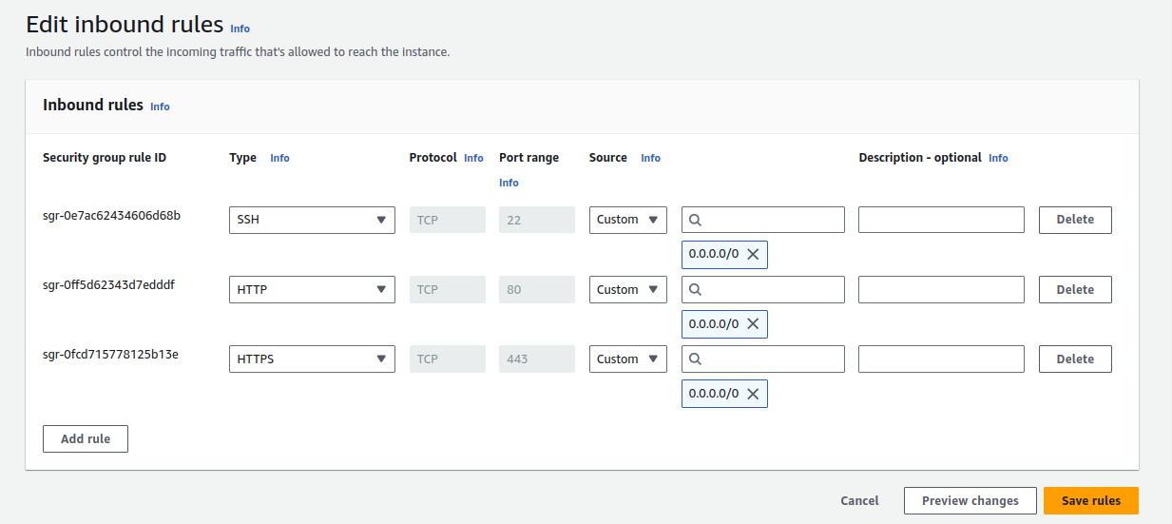

## **Application Load Balancer Setup with Path-Based Routing (40 minutes):**

Create an Application Load Balancer (ALB):

* Set up an ALB in the same VPC and subnets as your EC2 instances.

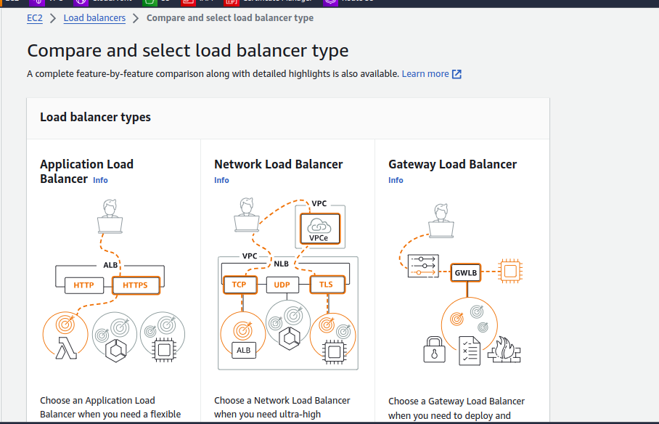

Configure the ALB with two target groups:

Target Group 1: For "App1" instances.

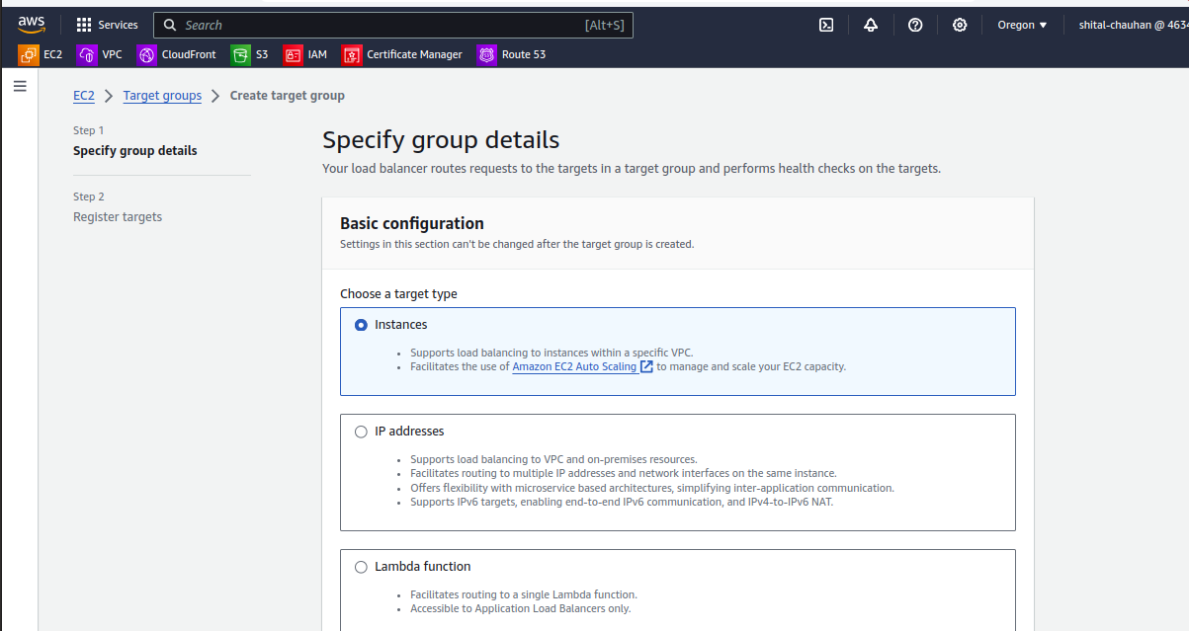

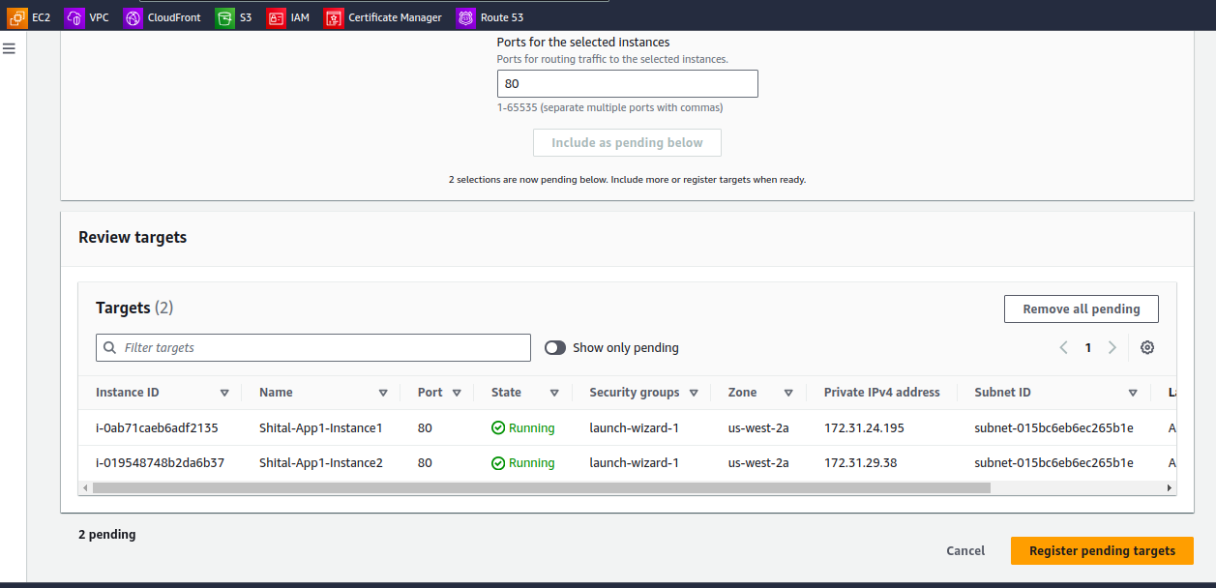

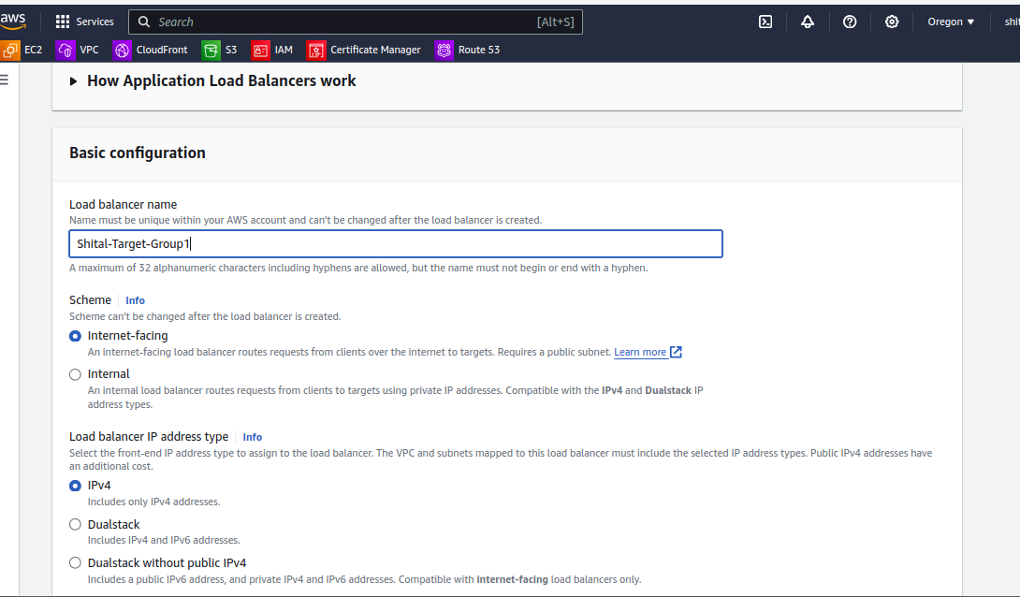

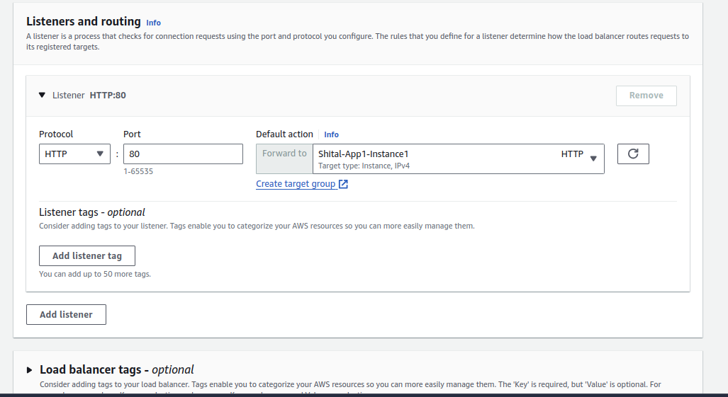

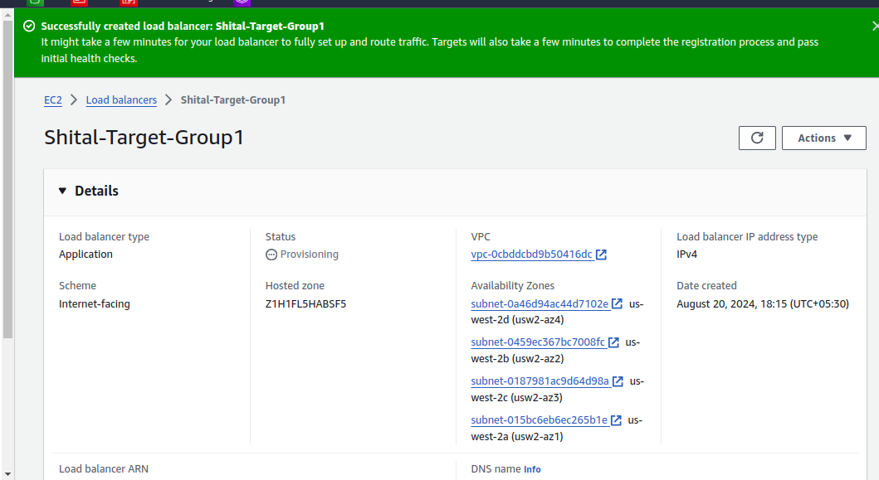

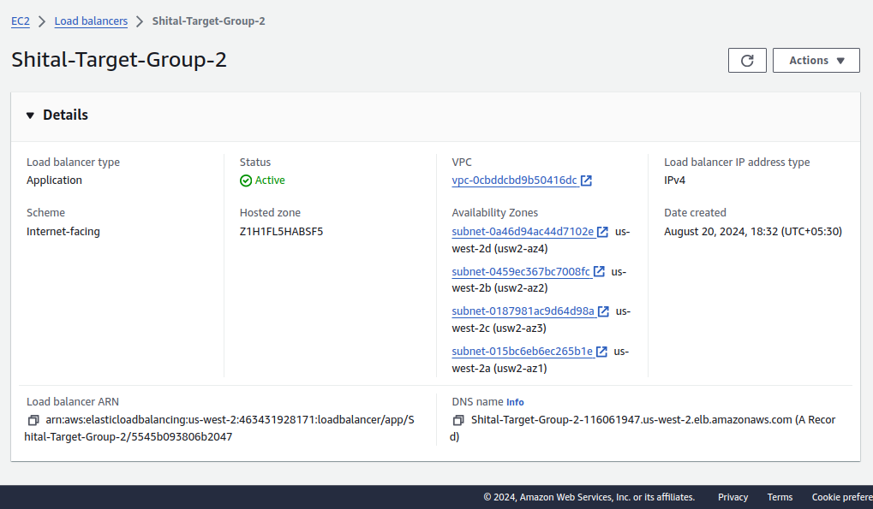

* + - Target Group 2: For "App2" instances.
  + Register the appropriate EC2 instances with each target group.
* Configure Path-Based Routing:
  + Set up path-based routing rules on the ALB:
    - Route traffic to "App1" instances when the URL path is /app1.



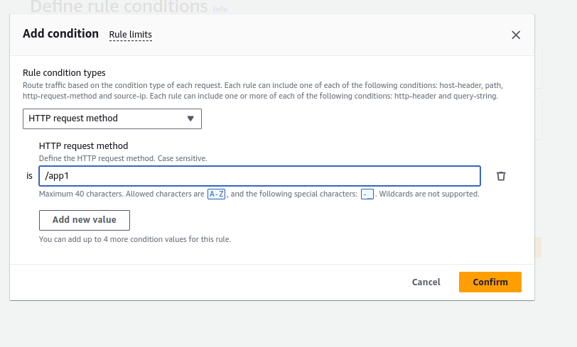

* Route traffic to "App2" instances when the URL path is /app2.
* Set up health checks for each target group to ensure that the instances are healthy and available.

## **Testing and Validation (20 minutes):**

* Test Path-Based Routing:
  + Access the ALB's DNS name and validate that requests to /app1 are correctly routed to the "App1" instances and that /app2 requests are routed to the "App2" instances.
* Security Validation:
  + Attempt to access the EC2 instances directly via their public IPs to ensure that only your IP address can SSH into the instances.

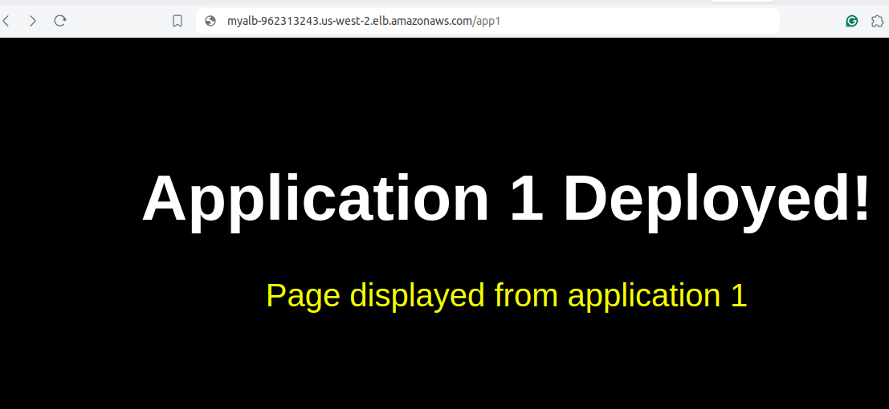

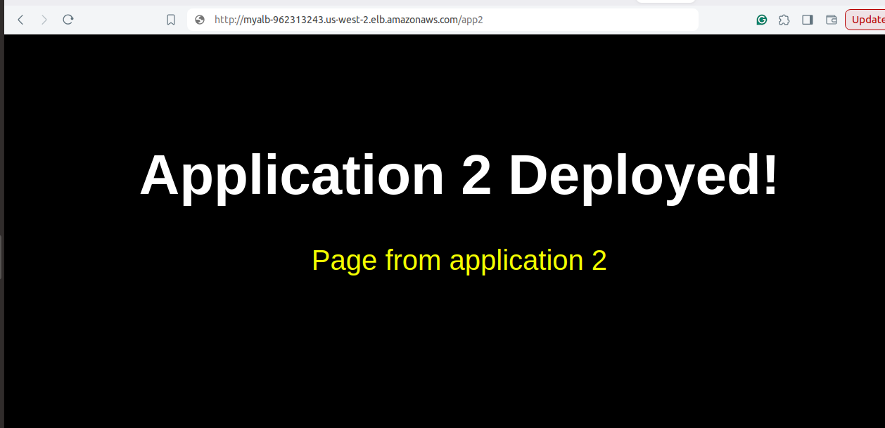

## **Resource Termination (10 minutes):**

Terminate EC2 Instances:

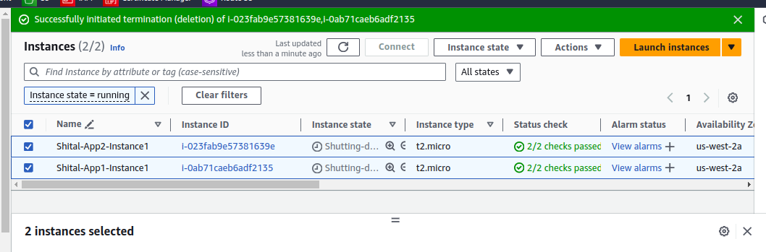

Delete Load Balancer:

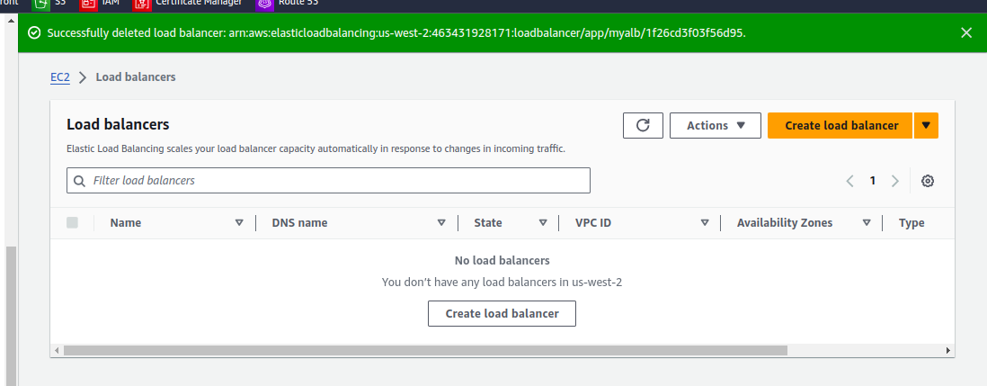

Delete Load Balancer and Target Groups:

