**Project 02**

### **Deploying a Python Flask App Using Minikube Kubernetes**

#### **Overview**

This project guides you through deploying a Python Flask application using Minikube Kubernetes. You'll use Git for version control, explore branching and fast-forward merges, and set up Kubernetes services and deployment pods, including ClusterIP and NodePort service types.

#### **Prerequisites**

* Minikube installed
* kubectl installed
* Git installed
* Python installed

#### **Project Steps**

### **1. Set Up Git Version Control**

**1.1. Initialize a Git Repository**

Create a new directory for your project:  
  
mkdir flask-k8s-project

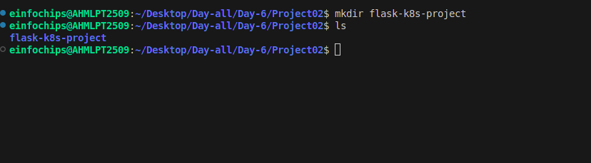

cd flask-k8s-project

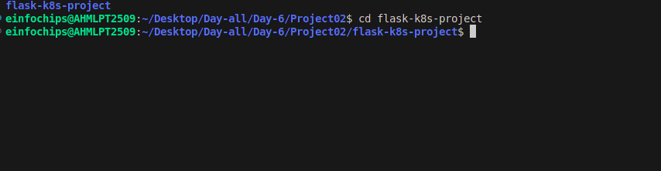

**1.2 Initialize a Git repository:**

sh  
Copy code  
git init

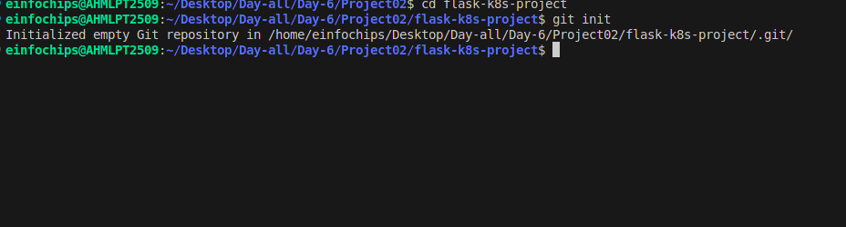

**1.3 Install Python 3 if not already installed:**

sudo apt update

sudo apt install python3

sudo apt install python3-venv

**1.4. Create a Python Flask Application**

Create a virtual environment:  
  
python -m venv venv

python3 -m venv venv

source venv/bin/activate

**1.5 Install Flask:**  
sh  
Copy code  
pip install Flask

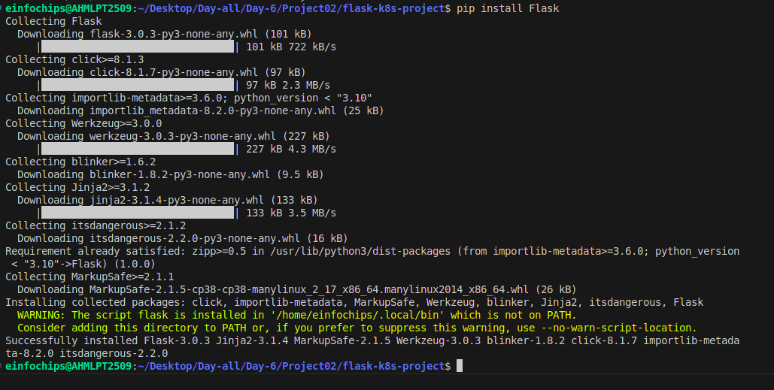

**1.6 Create an app.py file with the following content:**

python  
Copy code  
from flask import Flask

app = Flask(__name__)

@app.route('/')

def hello_world():

return 'Hello, Kubernetes!'

if __name__ == '__main__':

app.run(host='0.0.0.0', port=5000)

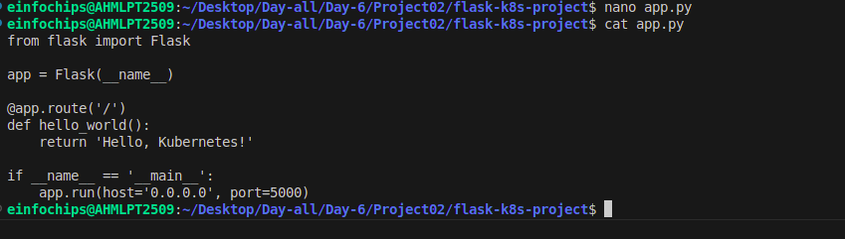

**1.7 Create requirements.txt**

Create a requirements.txt file to list the dependencies:  
Copy code  
Flask

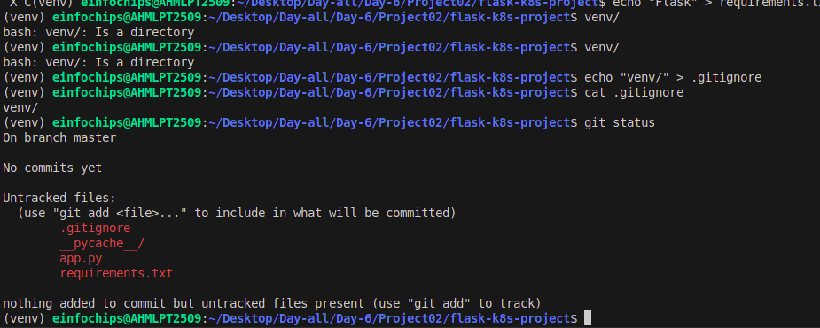

**1.8 Create a .gitignore file to ignore venv:**  
Copy code  
venv

**Create .gitignore**

echo "venv" > .gitignore

**1.9. Commit the Initial Code**

Add files to Git:  
  
git add .

Commit the changes:  
  
git commit -m "Initial commit with Flask app"

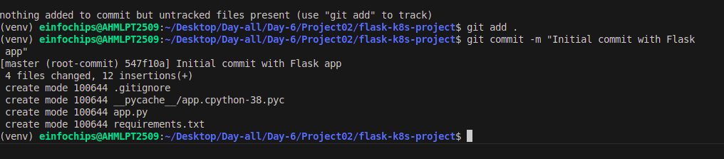

### **2. Branching and Fast-Forward Merge**

**2.1. Create a New Branch**

Create and switch to a new branch feature/add-route:  
  
git checkout -b feature/add-route

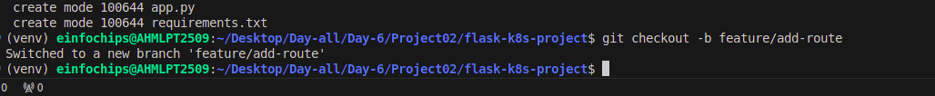

**2.2. Implement a New Route**

Modify app.py to add a new route:  
  
@app.route('/newroute')

def new_route():

return 'This is a new route!'

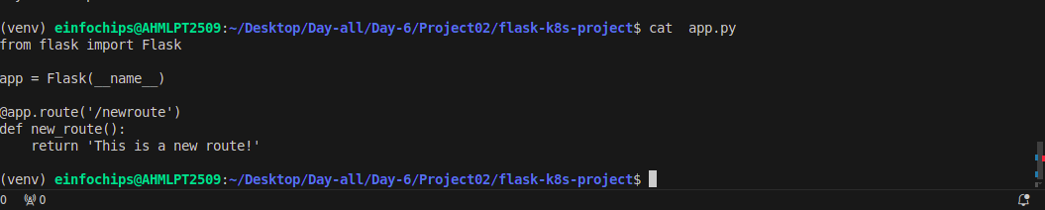

Commit the changes:  
  
git add .

git commit -m "Add new route"

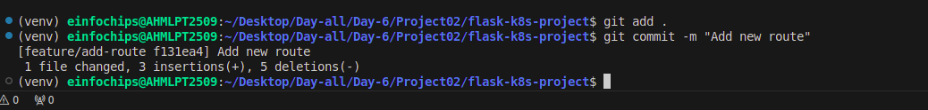

**2.3. Merge the Branch Using Fast-Forward**

Switch back to the main branch:  
  
git checkout main

git checkout -b main

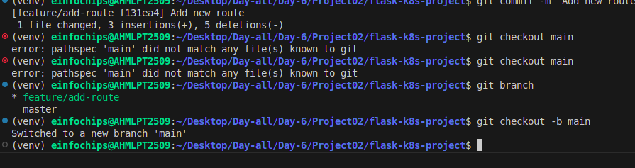

Merge the feature/add-route branch using fast-forward:  
  
git merge --ff-only feature/add-route

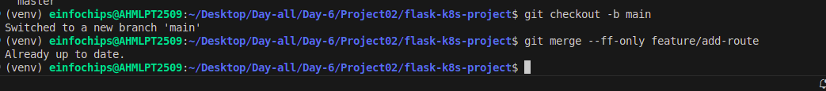

Delete the feature branch:  
  
git branch -d feature/add-route

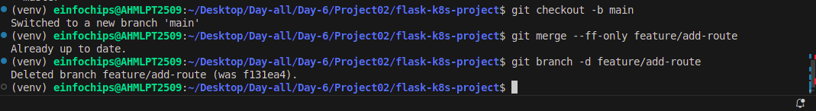

### **3. Containerize the Flask Application**

**3.1. Create a Dockerfile**

Create a Dockerfile with the following content:  
  
FROM python:3.8-slim

WORKDIR /app

COPY requirements.txt requirements.txt

RUN pip install -r requirements.txt

COPY . .

EXPOSE 5000

CMD ["python", "app.py"]

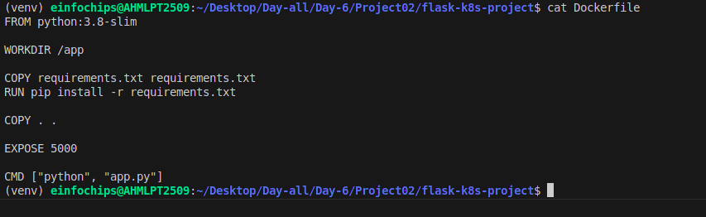

**3.2. Build and Test the Docker Image**

Build the Docker image:  
  
docker build -t flask-k8s-app .

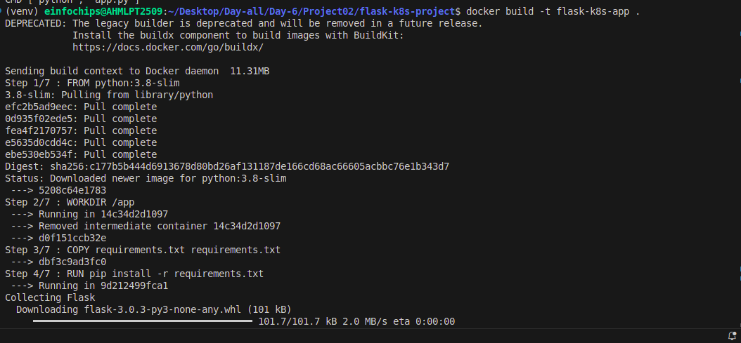

Run the Docker container to test:  
  
docker run -p 5000:5000 flask-k8s-app



1. Access <http://localhost:5000> to see the app running.

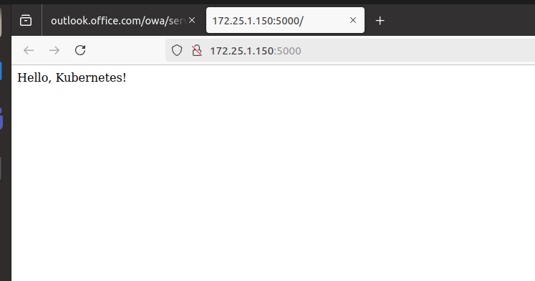

### **4. Deploying to Minikube Kubernetes**

**4.1. Start Minikube**

Start Minikube:  
  
minikube start

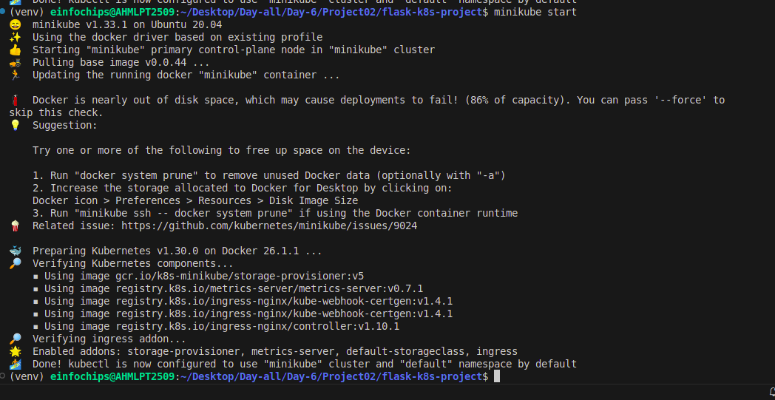

**4.2. Create Kubernetes Deployment and Service Manifests**

Create a deployment.yaml file:  
  
apiVersion: apps/v1

kind: Deployment

metadata:

name: flask-app

spec:

replicas: 2

selector:

matchLabels:

app: flask-app

template:

metadata:

labels:

app: flask-app

spec:

containers:

- name: flask-app

image: flask-k8s-app:latest

ports:

- containerPort: 5000

Create a service.yaml file for ClusterIP:  
  
apiVersion: v1

kind: Service

metadata:

name: flask-service

spec:

selector:

app: flask-app

ports:

- protocol: TCP

port: 80

targetPort: 5000

type: ClusterIP

Create a service-nodeport.yaml file for NodePort:  
  
apiVersion: v1

kind: Service

metadata:

name: flask-service-nodeport

spec:

selector:

app: flask-app

ports:

- protocol: TCP

port: 80

targetPort: 5000

nodePort: 30001

type: NodePort

**4.3. Apply Manifests to Minikube**

Apply the deployment:  
  
kubectl apply -f deployment.yaml

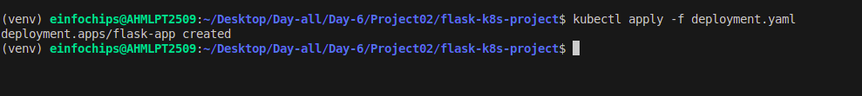

Apply the ClusterIP service:  
  
kubectl apply -f service.yaml

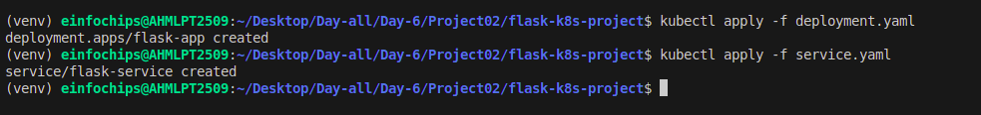

Apply the NodePort service:  
  
kubectl apply -f service-nodeport.yaml



**4.4. Access the Application**

Get the Minikube IP:  
  
minikube ip

Access the application using the NodePort:  
  
curl http://<minikube-ip>:30001

### **5. Clean Up**

Stop Minikube:  
  
minikube stop

Delete Minikube cluster:  
  
minikube delete

### **6. Making Changes to the Flask Application**

**6.1. Create a New Branch for Changes**

Create and switch to a new branch feature/update-message:  
  
git checkout -b feature/update-message

**6.2. Update the Application**

Modify app.py to change the message:  
  
@app.route('/')

def hello_world():

return 'Hello, Kubernetes! Updated version.'

@app.route('/newroute')

def new_route():

return 'This is a new route!'

**6.3. Commit the Changes**

Add and commit the changes:  
  
git add .

git commit -m "Update main route message"

### **7. Merge the Changes and Rebuild the Docker Image**

**7.1. Merge the Feature Branch**

Switch back to the main branch:  
  
git checkout main

Merge the feature/update-message branch:  
  
git merge --ff-only feature/update-message

Delete the feature branch:  
  
git branch -d feature/update-message

**7.2. Rebuild the Docker Image**

Rebuild the Docker image with a new tag:  
  
docker build -t flask-k8s-app:v2 .

### **8. Update Kubernetes Deployment**

**8.1. Update the Deployment Manifest**

Modify deployment.yaml to use the new image version:  
  
apiVersion: apps/v1

kind: Deployment

metadata:

name: flask-app

spec:

replicas: 2

selector:

matchLabels:

app: flask-app

template:

metadata:

labels:

app: flask-app

spec:

containers:

- name: flask-app

image: flask-k8s-app:v2

ports:

- containerPort: 5000

**8.2. Apply the Updated Manifest**

Apply the updated deployment:  
sh  
Copy code  
kubectl apply -f deployment.yaml

**8.3. Verify the Update**

Check the status of the deployment:  
sh  
Copy code  
kubectl rollout status deployment/flask-app

### **9. Access the Updated Application**

**9.1. Access Through ClusterIP Service**

Forward the port to access the ClusterIP service:  
  
kubectl port-forward service/flask-service 8080:80

1. Open your browser and navigate to <http://localhost:8080> to see the updated message.

**9.2. Access Through NodePort Service**

1. Access the application using the NodePort:  
     
   curl http://<minikube-ip>:30001