# **Project 02**

## **Project Setup**

### **1.1 Initialize a Git Repository**

Create a new directory for your project and initialize Git:

mkdir nodejs-advanced-k8s-project

cd nodejs-advanced-k8s-project

git init

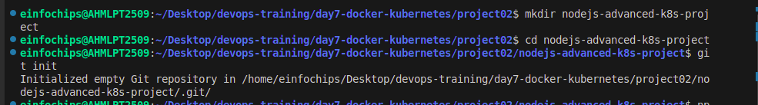

1.2 Create Initial Files Create the initial Node.js application and Docker-related files:

npm init -y

npm install express redis body-parser

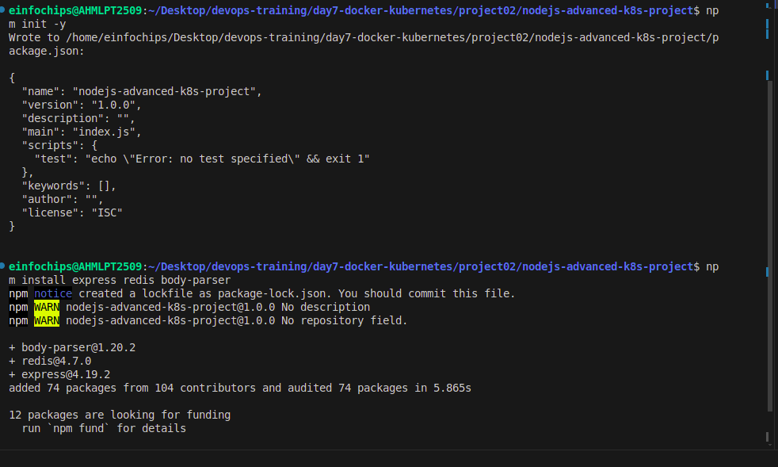

create app.js

const express = require('express');

const bodyParser = require('body-parser');

const redis = require('redis');

const app = express();

const PORT = process.env.PORT || 3000;

// Connect to Redis

const redisClient = redis.createClient({

url: `redis://${process.env.REDIS_HOST}:${process.env.REDIS_PORT}`

});

redisClient.on('error', (err) => console.error('Redis Client Error', err));

app.use(bodyParser.json());

app.get('/', async (req, res) => {

const visits = await redisClient.get('visits');

if (visits) {

await redisClient.set('visits', parseInt(visits) + 1);

} else {

await redisClient.set('visits', 1);

}

res.send(`Hello, World! You are visitor number ${visits || 1}`);

});

app.listen(PORT, () => {

console.log(`Server is running on port ${PORT}`);

});

Dockerfile

FROM node:18

WORKDIR /usr/src/app

COPY package*.json ./

RUN npm install

COPY . .

EXPOSE 3000

CMD ["npm", "start"]

create .dockerignore

nano .dockerignore

node_modules

.npm

## **1. Build and push Docker image:**

docker build -t shital37/nodejs-advanced-app:latest .

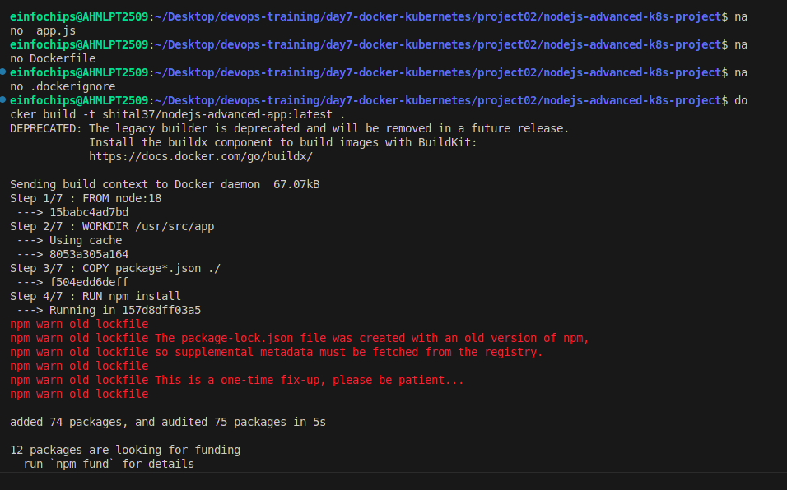

docker push shital37/nodejs-advanced-app:latest

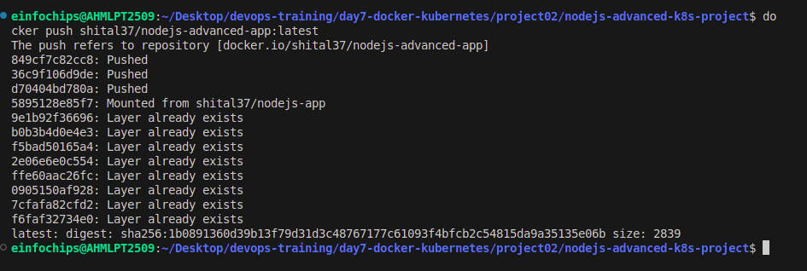

## **2. Advanced Kubernetes Configuration**

2.1 Deployment Configuration

Create kubernetes/deployment.yaml to deploy the Node.js application with Redis dependency:

mkdir kubernetes

nano deployment.yaml

apiVersion: apps/v1

kind: Deployment

metadata:

name: nodejs-advanced-app-deployment

spec:

replicas: 2

selector:

matchLabels:

app: nodejs-advanced-app

template:

metadata:

labels:

app: nodejs-advanced-app

spec:

containers:

- name: nodejs-advanced-app

image: shital37/nodejs-advanced-app:latest

ports:

- containerPort: 3000

env:

- name: PORT

valueFrom:

configMapKeyRef:

name: app-config

key: PORT

- name: REDIS_HOST

valueFrom:

configMapKeyRef:

name: redis-config

key: REDIS_HOST

- name: REDIS_PORT

valueFrom:

configMapKeyRef:

name: redis-config

key: REDIS_PORT

- name: NODE_ENV

valueFrom:

secretKeyRef:

name: app-secrets

key: NODE_ENV

- name: redis

image: redis:latest

ports:

- containerPort: 6379

2.2 ConfigMap for Application and Redis Create kubernetes/configmap.yaml to manage application and Redis configurations:

nano configmap.yaml

apiVersion: v1

kind: ConfigMap

metadata:

name: app-config

data:

PORT: "3000"

---

apiVersion: v1

kind: ConfigMap

metadata:

name: redis-config

data:

REDIS_HOST: "redis"

REDIS_PORT: "6379"

2.3 Secret for Sensitive Data Create kubernetes/secret.yaml to manage sensitive environment variables:

nano secret.yaml

apiVersion: v1

kind: Secret

metadata:

name: app-secrets

type: Opaque

data:

NODE_ENV: cHJvZHVjdGlvbg== # Base64 encoded value for "production"

2.4 Service Configuration Create kubernetes/service.yaml to expose the Node.js application:

nano service.yaml

apiVersion: v1

kind: Service

metadata:

name: nodejs-advanced-app-service

spec:

selector:

app: nodejs-advanced-app

ports:

- protocol: TCP

port: 80

targetPort: 3000

type: LoadBalancer

2.5 Horizontal Pod Autoscaler with Scale-Up and Scale-Down Policies Create kubernetes/hpa.yaml to manage autoscaling:

nano hpa.yaml

apiVersion: autoscaling/v2beta2

kind: HorizontalPodAutoscaler

metadata:

name: nodejs-advanced-app-hpa

spec:

scaleTargetRef:

apiVersion: apps/v1

kind: Deployment

name: nodejs-advanced-app-deployment

minReplicas: 2

maxReplicas: 5

metrics:

- type: Resource

resource:

name: cpu

target:

type: Utilization

averageUtilization: 50

- type: Resource

resource:

name: memory

target:

type: Utilization

averageUtilization: 70

behavior:

scaleUp:

stabilizationWindowSeconds: 30

selectPolicy: Max

policies:

- type: Pods

value: 2

periodSeconds: 30

- type: Resource

resource: cpu

value: 2

periodSeconds: 30

scaleDown:

stabilizationWindowSeconds: 30

selectPolicy: Min

policies:

- type: Pods

value: 1

periodSeconds: 30

- type: Resource

resource: memory

value: 1

periodSeconds: 30

2.6 Vertical Pod Autoscaler Configuration Create kubernetes/vpa.yaml to manage vertical scaling:

nano vpa.yaml

apiVersion: autoscaling.k8s.io/v1beta2

kind: VerticalPodAutoscaler

metadata:

name: nodejs-advanced-app-vpa

spec:

targetRef:

apiVersion: apps/v1

kind: Deployment

name: nodejs-advanced-app-deployment

updatePolicy:

updateMode: "Auto"

2.7 Redis Deployment Add a Redis deployment configuration to kubernetes/redis-deployment.yaml:

nano redis-deployment.yaml

apiVersion: apps/v1

kind: Deployment

metadata:

name: redis-deployment

spec:

replicas: 1

selector:

matchLabels:

app: redis

template:

metadata:

labels:

app: redis

spec:

containers:

- name: redis

image: redis:latest

ports:

- containerPort: 6379

Add Redis service configuration to kubernetes/redis-service.yaml:

nano redis-service.yaml

apiVersion: v1

kind: Service

metadata:

name: redis-service

spec:

selector:

app: redis

ports:

- protocol: TCP

port: 6379

targetPort: 6379

type: ClusterIP

2.8 Apply Kubernetes Configurations Apply all configurations to your Minikube cluster:

kubectl apply -f kubernetes/redis-deployment.yaml

kubectl apply -f kubernetes/redis-service.yaml

kubectl apply -f kubernetes/configmap.yaml

kubectl apply -f kubernetes/secret.yaml

kubectl apply -f kubernetes/deployment.yaml

kubectl apply -f kubernetes/service.yaml

kubectl apply -f kubernetes/hpa.yaml

kubectl apply -f kubernetes/vpa.yaml

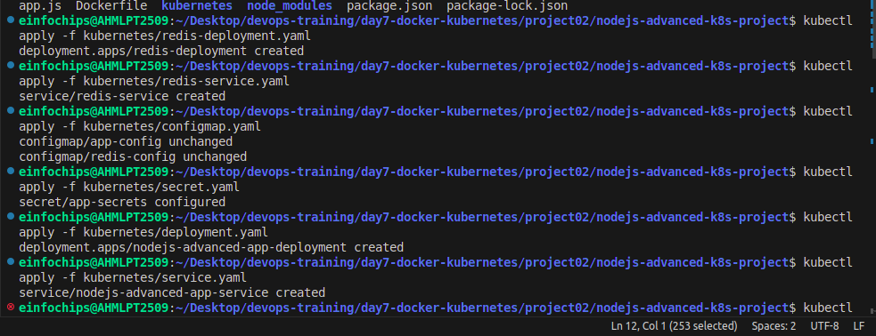

2.9 Verify Deployments and Services Check the status of your deployments and services:

kubectl get all

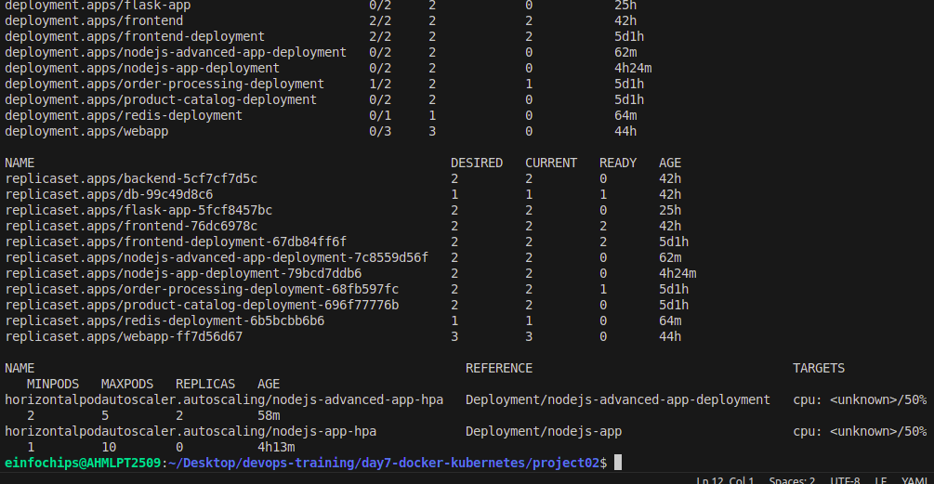

Access the application via Minikube:

minikube service nodejs-advanced-app-service –url

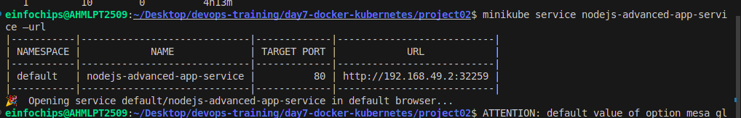

2.10 Testing Scaling Simulate load on the application to test the HPA:

kubectl run -i --tty --rm load-generator --image=busybox --restart=Never -- /bin/sh

Inside the pod, run the following command to generate load while true; do wget -q -O- [http://nodejs-advanced-app-service](http://nodejs-advanced-app-service/); done

2.11 Validate Autoscaling Behavior Observe the HPA behavior:

kubectl get hpa

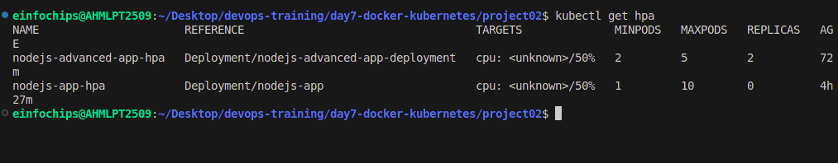

Watch the scaling events and verify that the application scales up and down based on the policies you configured.

## **3. Project Wrap-Up**

3.1 Review and Clean Up After completing the project, review the configurations and clean up the Minikube environment if needed:

minikube delete