## **Project Overview**

## Stage 1: Setting Up the Kubernetes Cluster and Static Web App

Set Up Minikube: Ensure Minikube is installed and running on the local Ubuntu machine. Verify the Kubernetes cluster is functioning correctly.

minikube start

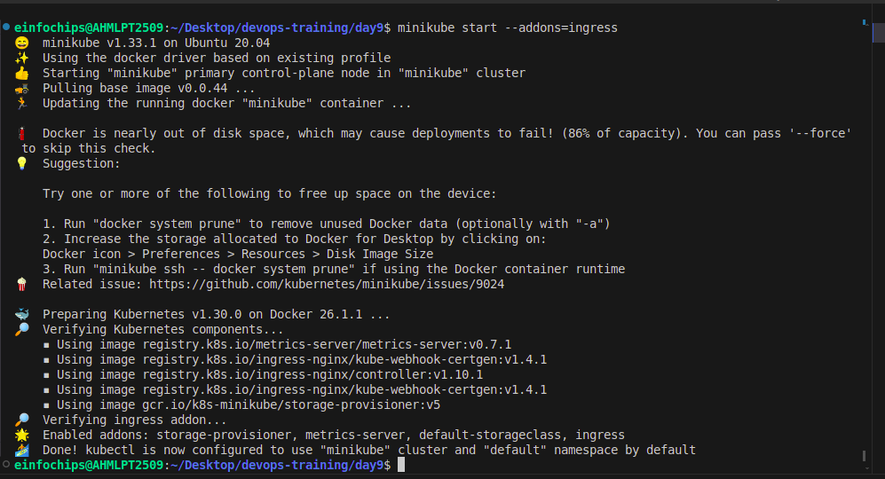

## **Deploy Static Web App:**

* Create a Dockerfile for a simple static web application (e.g., an HTML page served by Nginx).
* Build a Docker image for the static web application.

Create index.html

nano index.html

<!doctype html>

<html>

<body>

<head>

<title> Static web</title>

</head>

<body>

<p> Welcome to my Static web site!<p>

</body>

</html>

Create Dockerfile

FROM nginx:1.10.1-alpine

COPY index.html /usr/share/nginx/html

EXPOSE 80

CMD ["nginx", "-g", "daemon off;"]

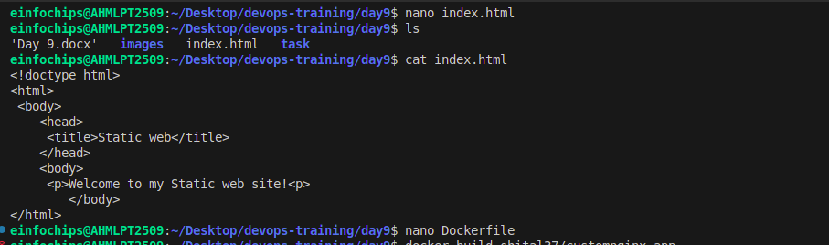

Build image:

docker build -t shital37/customnginx-app .

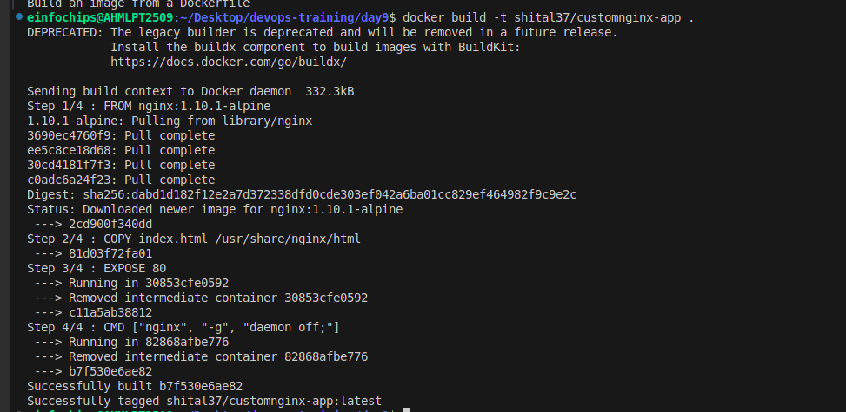

Push the Docker image to Docker Hub or a local registry.

docker push shital37/customnginx-app:latest

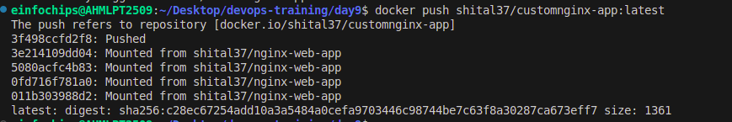

## **Kubernetes Deployment:**

* Write a Kubernetes deployment manifest to deploy the static web application.
* Write a Kubernetes service manifest to expose the static web application within the cluster.
* Apply the deployment and service manifests to the Kubernetes cluster.

Create frontend-delpoyment.yml

nano frontend-delpoyment.yml

apiVersion: apps/v1

kind: Deployment

metadata:

name: frontend

labels:

app: nginx

spec:

replicas: 1

selector:

matchLabels:

app: nginx

template:

metadata:

labels:

app: nginx

spec:

containers:

- name: nginx

image: shital37/customnginx-app:latest

ports:

- containerPort: 80

resources:

limits:

cpu: 50m

requests:

cpu: 20m

---

apiVersion: v1

kind: Service

metadata:

name: nginx-service

spec:

selector:

app: nginx

ports:

- protocol: TCP

port: 80

targetPort: 80

type: NodePort

Create backtend-delpoyment.yml

nano backtend-delpoyment.yml

apiVersion: apps/v1

kind: Deployment

metadata:

name: backend

spec:

replicas: 1

selector:

matchLabels:

app: backend

template:

metadata:

labels:

app: backend

spec:

containers:

- name: backend

image: hashicorp/http-echo

args:

- "-text= This is test message from backend"

ports:

- containerPort: 5678

---

apiVersion: v1

kind: Service

metadata:

name: backend-service

spec:

selector:

app: backend

ports:

- protocol: TCP

port: 80

targetPort: 5678

Apply the deployment and service manifests to the Kubernetes cluster.

kubectl apply -f frontend-delpoyment.yml

kubectl apply -f backend-delpoyment.yml

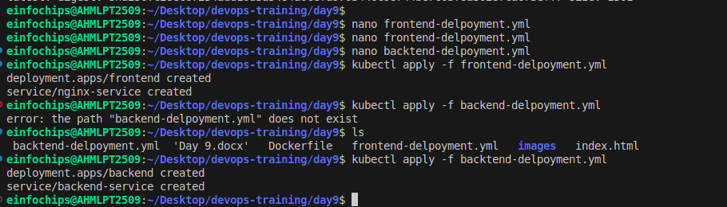

## **Stage 2: Configuring Ingress Networking**

Install and Configure Ingress Controller:

minikube start --addons=ingress

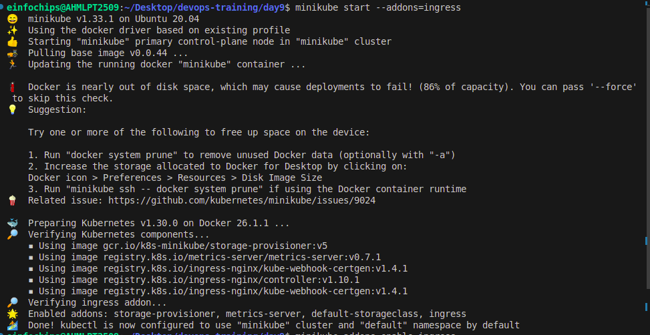

Install an ingress controller (e.g., Nginx Ingress Controller) in the Minikube cluster. Verify the ingress controller is running and accessible.

minikube addons enable ingress

kubectl get pods -n kube-system

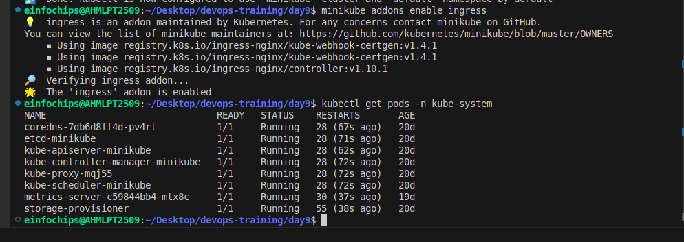

Create Ingress Resource:

* Write an ingress resource manifest to route external traffic to the static web application.
* Configure advanced ingress rules for path-based routing and host-based routing (use at least two different hostnames and paths).
* Implement TLS termination for secure connections.
* Configure URL rewriting in the ingress resource to modify incoming URLs before they reach the backend services.
* Enable sticky sessions to ensure that requests from the same client are directed to the same backend pod.

create ingress-resource.yaml

nano ingress-resource.yaml

apiVersion: networking.k8s.io/v1

kind: Ingress

metadata:

name: static-web-app-ingress

annotations:

nginx.ingress.kubernetes.io/rewrite-target: /

nginx.ingress.kubernetes.io/ssl-redirect: "true"

nginx.ingress.kubernetes.io/affinity: "cookie"

nginx.ingress.kubernetes.io/session-cookie-name: "route"

spec:

rules:

- host: myapp.com

http:

paths:

- path: /home

pathType: Prefix

backend:

service:

name: nginx-service

port:

number: 80

- path: /page

pathType: Prefix

backend:

service:

name: backend-service

port:

number: 80

tls:

- hosts:

- myapp.com

secretName: tls-secret

Apply the ingress-resource.yaml

kubectl apply -f ingress-resource.yaml

Update /etc/hosts

sudo nano /etc/hosts

Add the following line (replace with the actual Minikube IP):

<minikube-ip> myapp.com

192.168.49.2 myapp.com

Get the Minikube IP using:

minikube ip

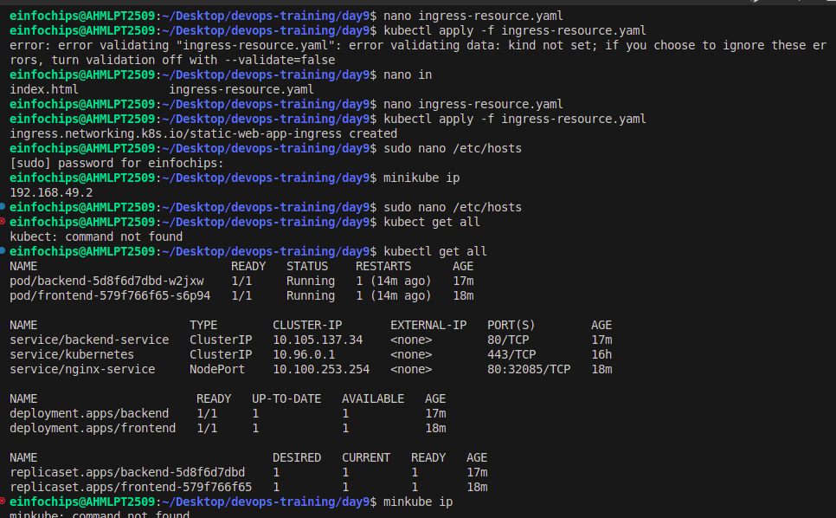

Check all resources

kubectl get all

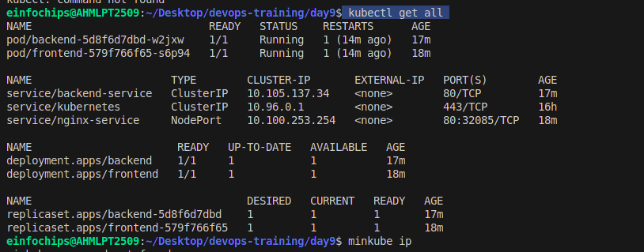

Check ingress

kubectl get pods -n ingress-nginx

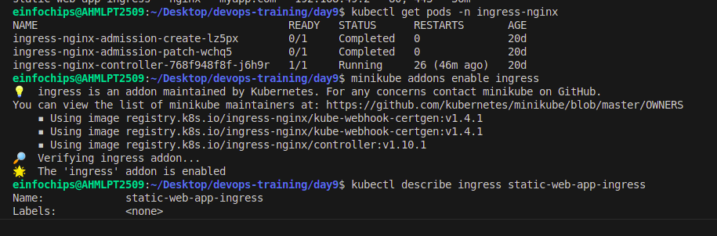

Generating a Self-Signed SSL/TLS Certificate

openssl req -x509 -nodes -days 365 -newkey rsa:2048 -keyout tls.key -out tls.crt -subj "/CN=myapp.com/O=myapp"

### Creating a Kubernetes Secret

kubectl create secret tls tls-secret --cert=tls.crt --key=tls.key

Verifying the Secret

kubectl get secret tls-secret

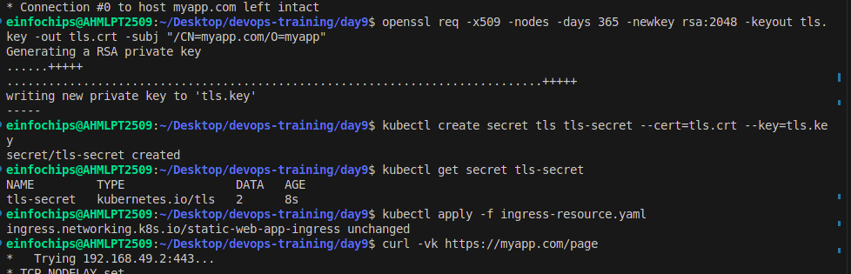

Check output using

https://myapp.com/home

[https://myapp.com/page](https://webapp.com/page)

Results:

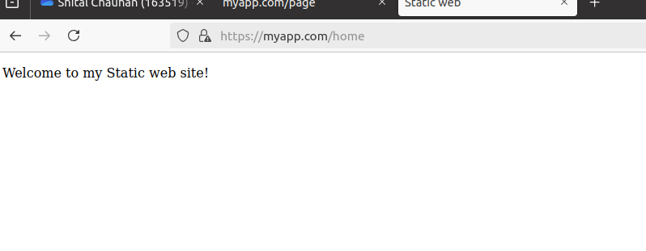

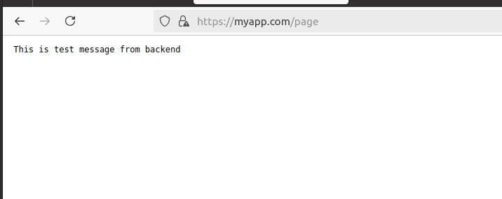

## **Stage 3: Implementing Horizontal Pod Autoscaling**

* Configure Horizontal Pod Autoscaler:
* Write a horizontal pod autoscaler (HPA) manifest to automatically scale the static web application pods based on CPU utilization.
* Set thresholds for minimum and maximum pod replicas.

### **Stress Testing:**

* Perform stress testing to simulate traffic and validate the HPA configuration.
* Monitor the scaling behavior and ensure the application scales up and down based on the load. Deliverables:
* Horizontal pod autoscaler YAML file

Create hpa.yaml

nano hpa.yaml

apiVersion: autoscaling/v2

kind: HorizontalPodAutoscaler

metadata:

name: nginx-app-hpa

spec:

scaleTargetRef:

apiVersion: apps/v1

kind: Deployment

name: frontend

minReplicas: 1

maxReplicas: 5

metrics:

- type: Resource

resource:

name: cpu

target:

type: Utilization

averageUtilization: 5

Apply hpa.yaml

kubectl apply -f hpa.yaml

Documentation or screenshots of the stress testing process and scaling behavior

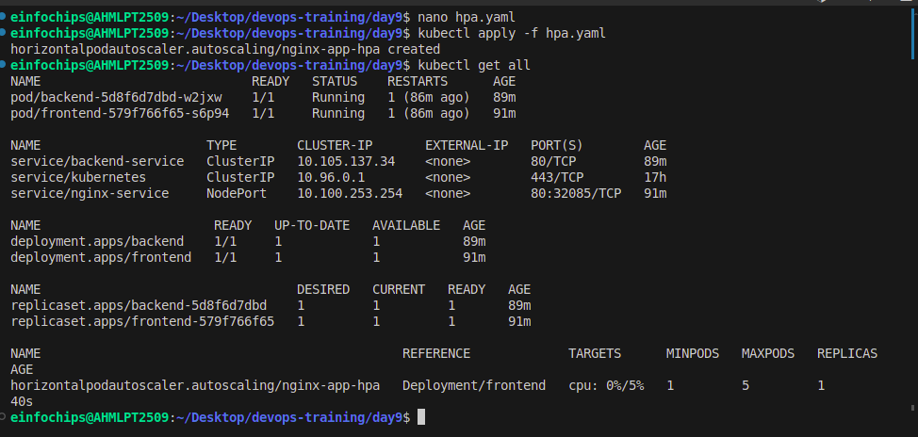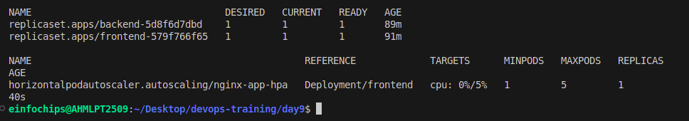

## **Stage 4: Final Validation and Cleanup**

### **Final Validation:**

Validate the ingress networking, URL rewriting, and sticky sessions configurations by accessing the web application through different hostnames and paths.

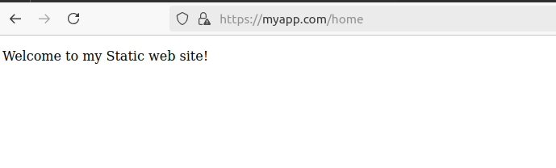

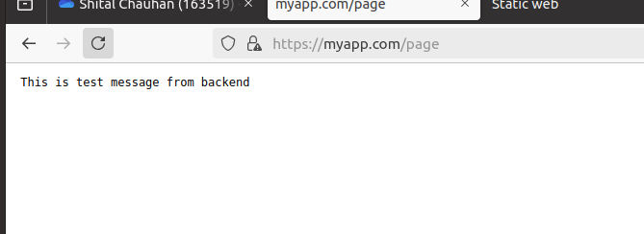

Verify the application's availability and performance during different load conditions.

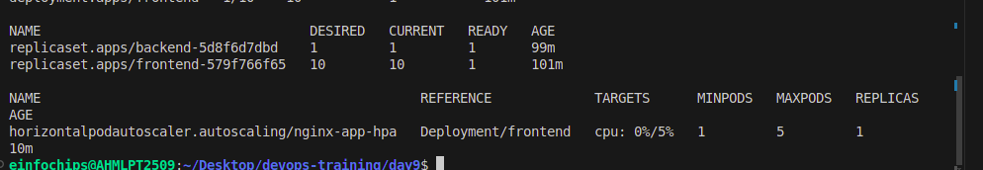

### **Cleanup:**

Provide commands or scripts to clean up the Kubernetes resources created during the project (deployments, services, ingress, HPA). Delete deployments:

kubectl delete deployment frontend

kubectl delete deployment backend

Delete Services:

kubectl delete service frontend-service

kubectl delete service backend-service

Delete ingress:

kubectl delete ingress static-web-app-ingress

Delete hpa:

kubectl delete hpa nginx-app-hpa

