***I am colin***

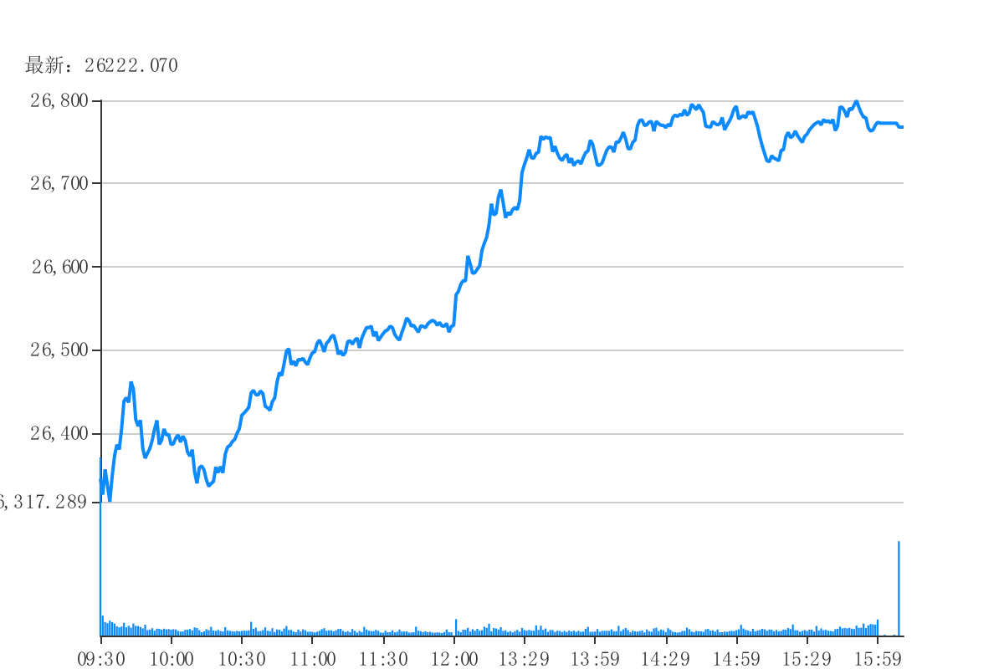

## Line

|  |  |  |  |  |
| --- | --- | --- | --- | --- |
| 1 | 2 | 3 | 4 | 5 |
|  |  |  |  |  |