**電通二甲微處理器實驗 實驗結報**

|  |  |  |  |
| --- | --- | --- | --- |
| **實驗名稱** | 音樂教室 | | |
| **組別** | 十一 | **組員** | 尤竣賢、蔣毓哲 |

1. **實驗目的**

如何使 Arduino 發出特定旋律的聲音?

1. Arduino 接喇叭如何接線?

2. 如何使用 tone library?

3. 如何演奏一段音樂?

4. 如何使用 4x4 鍵盤演奏音樂?

5. 如何發報摩斯電碼?

1. **實驗步驟**

1.Arduino 演奏一段特定的音樂, 旋律不得是小蜜蜂

2.使用 4x4 鍵盤演奏音樂

3.發報摩斯電碼

1. **程式碼**

**1.**

**#define NOTE_C3 131**

**#define NOTE_CS3 139**

**#define NOTE_D3 147**

**#define NOTE_DS3 156**

**#define NOTE_E3 165**

**#define NOTE_F3 175**

**#define NOTE_FS3 185**

**#define NOTE_G3 196**

**#define NOTE_GS3 208**

**#define NOTE_A3 220**

**#define NOTE_AS3 233**

**#define NOTE_B3 247**

**#define NOTE_C4 262**

**#define NOTE_CS4 277**

**#define NOTE_D4 294**

**#define NOTE_DS4 311**

**#define NOTE_E4 330**

**#define NOTE_F4 349**

**#define NOTE_FS4 370**

**#define NOTE_G4 392**

**#define NOTE_GS4 415**

**#define NOTE_A4 440**

**#define NOTE_AS4 466**

**#define NOTE_B4 494**

**#define WHOLE 1**

**#define HALF 0.5**

**#define QUARTER 0.25**

**#define EIGHTH 0.125**

**#define SIXTEENTH 0.0625**

**int tune[] = { NOTE_G3, NOTE_E4, NOTE_D4,**

**NOTE_C4, NOTE_C4, NOTE_G3, NOTE_E4,**

**NOTE_D4, NOTE_C4, NOTE_D4, NOTE_B3,**

**NOTE_G3, NOTE_E4, NOTE_D4, NOTE_C4,**

**NOTE_C4, NOTE_A3, NOTE_C4, NOTE_A3,**

**NOTE_C4, NOTE_A3, NOTE_C4, NOTE_D4,**

**NOTE_E4, NOTE_D4, NOTE_C4, NOTE_C4,**

**NOTE_E4, NOTE_F4, NOTE_E4, NOTE_C4,**

**NOTE_C4, NOTE_C4, NOTE_C4, NOTE_D4,**

**NOTE_E4, NOTE_F4, NOTE_E4, NOTE_D4,**

**NOTE_C4, NOTE_A3, NOTE_C4, NOTE_A3,**

**NOTE_C4, NOTE_A3, NOTE_C4, NOTE_D4,**

**NOTE_E4, NOTE_D4, NOTE_G3, NOTE_E4,**

**NOTE_D4, NOTE_C4, NOTE_C4};**

**float duration[] = { EIGHTH, EIGHTH, EIGHTH, EIGHTH,**

**HALF, EIGHTH, EIGHTH, EIGHTH, EIGHTH, QUARTER, QUARTER,EIGHTH,**

**EIGHTH, EIGHTH, EIGHTH, QUARTER, EIGHTH, EIGHTH, EIGHTH,**

**EIGHTH, EIGHTH, EIGHTH,EIGHTH, EIGHTH, EIGHTH, EIGHTH,**

**QUARTER, EIGHTH, EIGHTH, QUARTER, EIGHTH, EIGHTH, EIGHTH,**

**EIGHTH, QUARTER, QUARTER, EIGHTH, SIXTEENTH, EIGHTH,**

**SIXTEENTH+EIGHTH, EIGHTH, QUARTER, EIGHTH,EIGHTH, EIGHTH,**

**EIGHTH, EIGHTH, EIGHTH, HALF, EIGHTH, EIGHTH, EIGHTH, EIGHTH, QUARTER};**

**int length;**

**void setup()**

**{**

**pinMode(8, OUTPUT);**

**length = sizeof(tune)**

**sizeof(tune[0]);**

**}**

**void loop()**

**{**

**for (int x=0; x<length; x++)**

**{**

**tone(8, tune[x]);**

**delay(2500 *duration[x]);**

**noTone(8);**

**}**

**delay(5000);**

**}**

**2.**

**#include <Keypad.h>**

**const byte ROWS = 4; // 4 Rows**

**const byte COLS = 4; // 4 Columns**

**char keys[ROWS][COLS] =**

**{**

**{'A', 'B', 'C', 'D'}, {'E','F','G', 'H'},**

**{'I', 'J', 'K', 'L'}, {'M', 'N', 'O', 'P'}**

**};**

**int tune[]={};**

**byte rowPins[ROWS] = {5, 4, 3, 2};**

**byte colPins[COLS] = {9, 8, 7, 6};**

**Keypad keypad = Keypad( makeKeymap(keys), rowPins, colPins, ROWS, COLS);**

**void setup()**

**{**

**pinMode(10, OUTPUT);**

**}**

**void loop()**

**{**

**char x = keypad.getKey();**

**if (x!= NO_KEY) // 有按下按鍵**

**{**

**if(x=='A')**

**{**

**tone(10, 261);**

**delay(300);**

**noTone(10);**

**}**

**else if(x=='B')**

**{**

**tone(10, 294);**

**delay(300);**

**noTone(10);**

**}**

**else if(x=='C')**

**{**

**tone(10, 329);**

**delay(300);**

**noTone(10);**

**}**

**else if(x=='D')**

**{**

**tone(10, 349);**

**delay(300);**

**noTone(10);**

**}**

**else if(x=='E')**

**{**

**tone(10, 392);**

**delay(300);**

**noTone(10);**

**}**

**else if(x=='F')**

**{**

**tone(10, 440);**

**delay(300);**

**noTone(10);**

**}**

**else if(x=='G')**

**{**

**tone(10, 493);**

**delay(300);**

**noTone(10);**

**}**

**else if(x=='H')**

**{**

**tone(10, 523);**

**delay(300);**

**noTone(10);**

**}**

**else if(x=='I')**

**{**

**tone(10, 587);**

**delay(300);**

**noTone(10);**

**}**

**else if(x=='J')**

**{**

**tone(10, 659);**

**delay(300);**

**noTone(10);**

**}**

**else if(x=='K')**

**{**

**tone(10, 698);**

**delay(300);**

**noTone(10);**

**}**

**else if(x=='L')**

**{**

**tone(10, 784);**

**delay(300);**

**noTone(10);**

**}**

**else if(x=='M')**

**{**

**tone(10, 880);**

**delay(300);**

**noTone(10);**

**}**

**else if(x=='N')**

**{**

**tone(10, 988);**

**delay(300);**

**noTone(10);**

**}**

**else if(x=='O')**

**{**

**tone(10, 1046);**

**delay(300);**

**noTone(10);**

**}**

**else if(x=='P')**

**{**

**tone(10, 1175);**

**delay(300);**

**noTone(10);**

**}**

**}**

**}**

**3.**

**char*morse[]={"01","1000","1010","100",**

**"0","0010","110","0000",**

**"00","0111","101","0100",**

**"11","10","111","0110",**

**"1101","010","000","1",**

**"001","0001","11","1001",**

**"1011","1100"};**

**const byte Buzzer =10;**

**char chr,index;**

**char*ptr;**

**void setup()**

**{**

**pinMode(Buzzer,OUTPUT);**

**Serial.begin(9600);**

**}**

**void loop()**

**{**

**if(Serial.available())**

**{**

**chr=Serial.read();**

**Serial.println(chr);**

**if((chr-'A')>=0 && (chr-'Z')<=0)**

**{**

**index=chr-'A';**

**ptr=morse[index];**

**while(*ptr!='\0')**

**{**

**if(*ptr=='0')**

**{**

**tone(Buzzer,440,100);**

**delay(100);**

**}**

**else**

**{**

**tone(Buzzer,440,300);**

**delay(300);**

**}**

**ptr++;**

**delay(100);**

**}**

**delay(300);**

**}**

**else**

**{**

**delay(700);**

**}**

**}**

**}**

1. **實驗結果及分析**

了解怎麼利用喇叭放出聲音，有內嵌聲音或是利用外部按鍵創作音樂

1. **心得討論**

這次接圖比較簡單相對程式比較好了解，主要麻煩的是譜的製作

**修正電路圖**

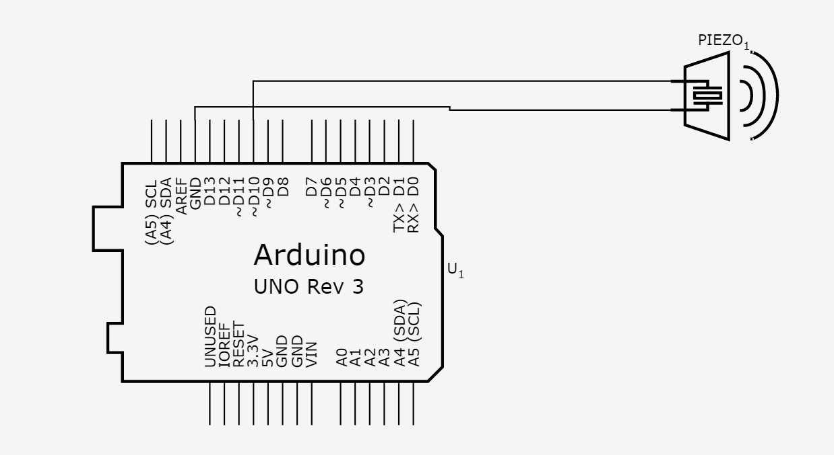

1. **修正程式碼**